**Lab 9**

**Problem statement:** Create the database table with the entries mentioned: [rollNo, studName, studDept, passingYear, classGrades] Grades should be either {First Class, Second Class, Pass}

Design the UI as given below and show the appropriate result through PHP script

**PHP Code:**

<!DOCTYPE html>

<html>

<head>

<title>Input Form</title>

</head>

<body>

<h1>Input Form</h1>

<form action ="display.php" method="POST">

<label for="year">Enter Year:</label>

<input type="number" name="year" id="year" required><br><br>

<label>Class Grades:</label><br>

<input type="radio" name="grades" value="First Class" id="firstClass">

<label for="firstClass">First Class</label><br>

<input type="radio" name="grades" value="Second Class"

id="secondClass">

<label for="secondClass">Second Class</label><br>

<input type="radio" name="grades" value="Pass" id="pass">

<label for="pass">Pass</label><br>

<input type="radio" name="grades" value="Fail" id="fail">

<label for="fail">Fail</label><br><br>

<input type="submit" name="submit" value="Submit">

</form>

</body>

</html>

<?php

$conn = mysqli_connect('localhost', 'root', 'password', 'wtl_9');

if(isset($_POST['submit'])) {

$year = $_REQUEST['year'];

$grades = $_REQUEST['grades'];

$sql = 'SELECT * FROM student WHERE passingyear = ? AND

classGrade = ?';

$stmt = mysqli_prepare($conn, $sql);

mysqli_stmt_bind_param($stmt, 'si', $year, $grades);

mysqli_stmt_execute($stmt);

$result = mysqli_stmt_get_result($stmt);

if (mysqli_num_rows($result) > 0) {

while ($row = mysqli_fetch_assoc($result)) {

echo '<p>Roll No: ' . $row['rollNo'] . '</p>';

echo '<p>Name: ' . $row['stuName'] . '</p>';

echo '<p>Department: ' . $row['stuDept'] . '</p>';

echo '<p>Passing Year: ' . $row['passingyear'] . '</p>';

echo '<p>Class Grades: ' . $row['classGrade'] . '</p>';

echo '<hr>';

}

} else {

echo 'No records found';

}

mysqli_close($conn);

}

?>

**Output:**

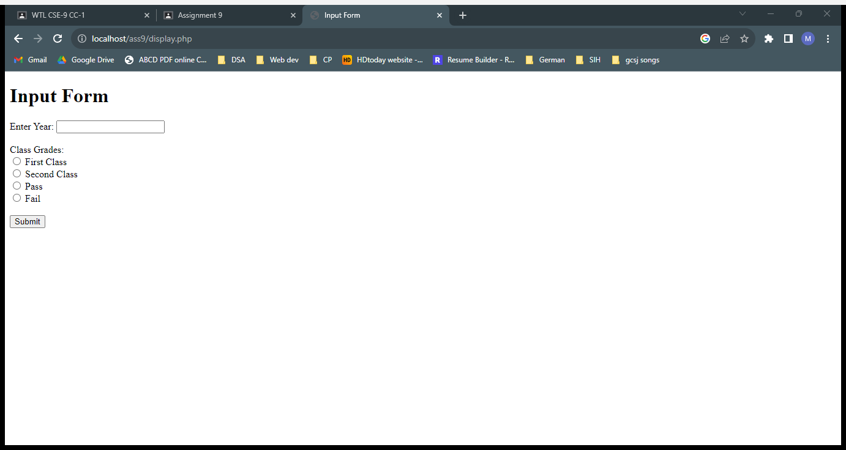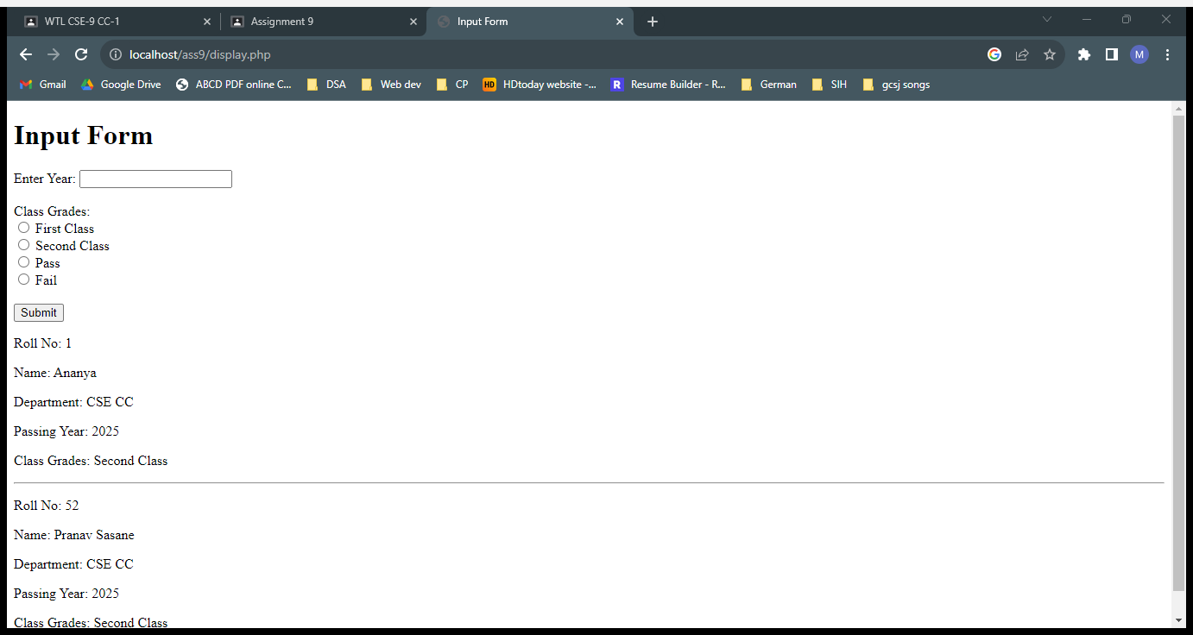

**Explanation:**

The PHP code takes requests through form action, and executes the necessary SQL query.