**­**

**OOP LAB**

**PROJECT REPORT**

**Submitted To: Sir Atif bajwa**

**_____________________________________________________________________________________________________________________________________________________________________________________________________________________________________**

**Student Name: Abdul Rehman Sarfaraz**

**Muqadus Khalid**

**Muhammad Arham**

**Muhammad Nouman**

**______________________________________________________________________________________________________________________________________________________________________________________________________________________________________**

**Reg. Number: 2012203**

**2012233**

**2012225**

**2012227**

**______________________________________________________________________________________________________________________________________________________________________________________________________________________________________**

**Header Files:**

Following are the header files that we have used:

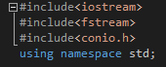

**Iostream:** stands for standard input-output stream.

**Fstream**: It is used to create files, write information to files, and read information from files.

**conio.h**: It is a non-standard header file used in C++ programming. This file contains console input-output functions which are mostly used by MS-DOS compilers. .

**CLASS 1:** This class is just to display name and project info:

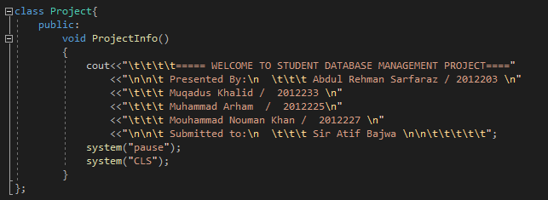

**CLASS 2:** This class just contains the Data members: and friend class of next class. Name student.

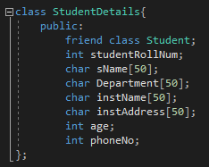

**Class 3:** This class inherited the 2nd class and its also the friend of 2nd class, it contains 6 functions, **getAll, Delete, SearchData, Disp_SearchData,** and **Display_List _Only.**

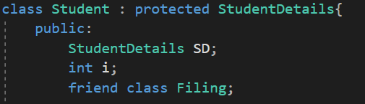

**Function 1 of Class 3:**

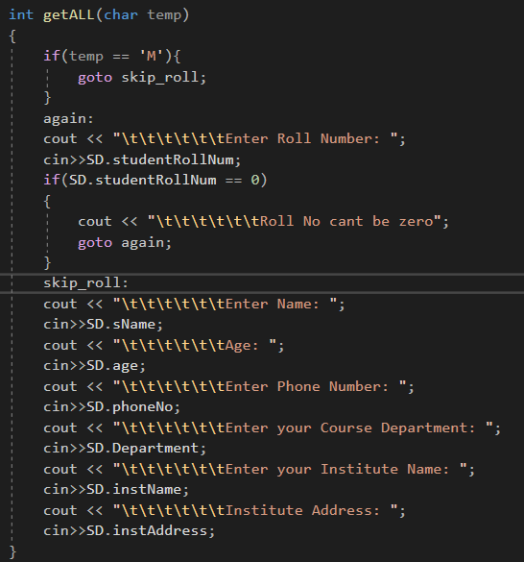

**Function 2,3,4,5,6 of Class 3:**

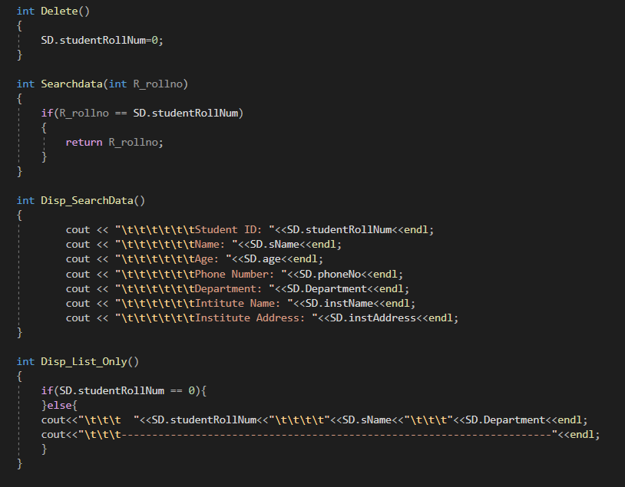

**Main Function :**

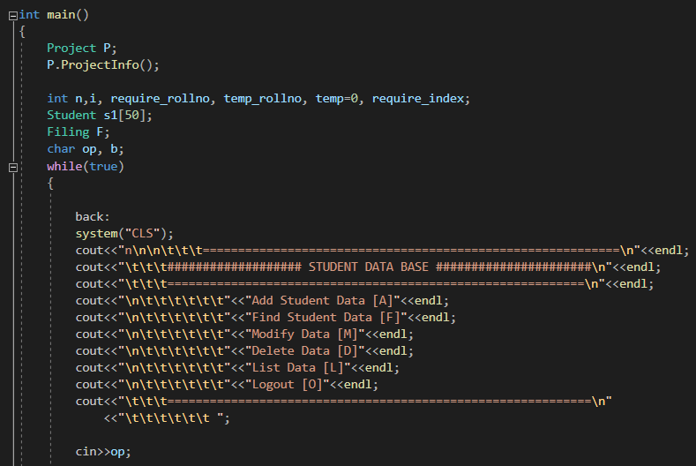

**Process to input Data:**

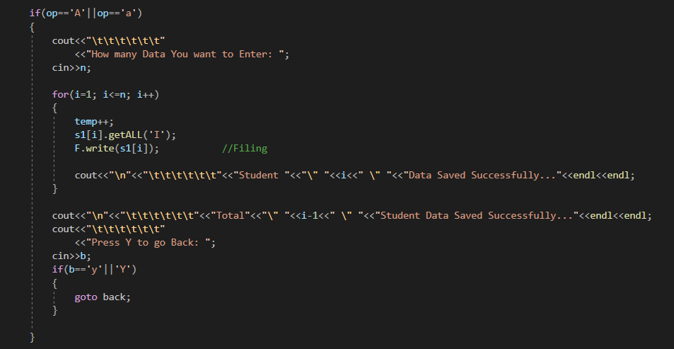

**Process to Find Data:**

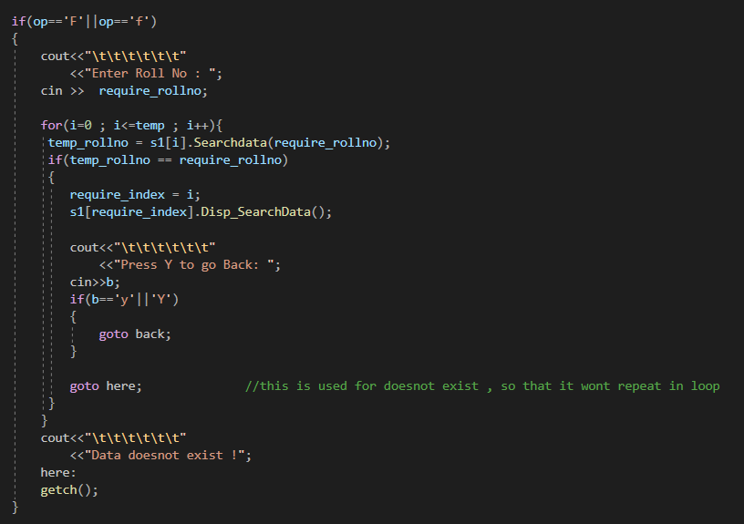

**Process to Modify Data:**

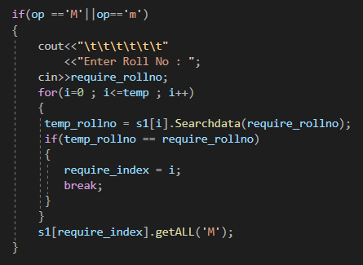

**Process to Delete Data:**

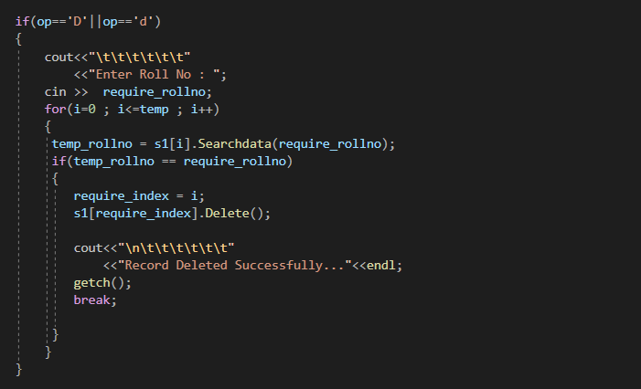

**Process to List All Data:**

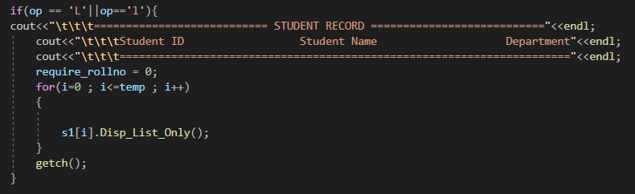

**Logout:**

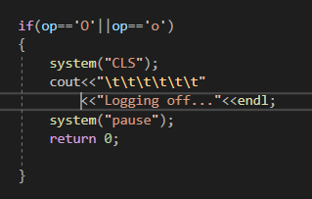

**OUTPUT:**

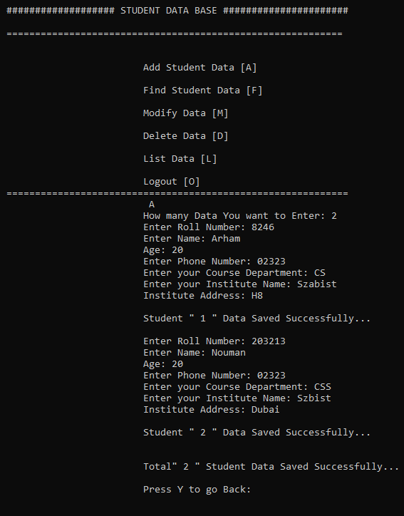

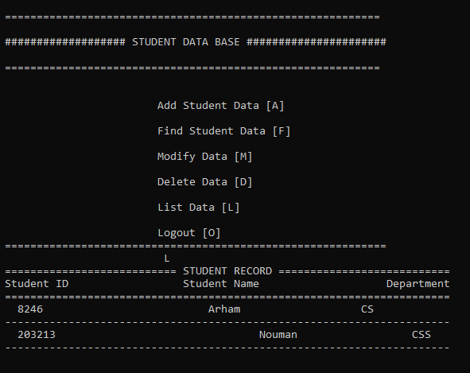

**LOG FILE:**

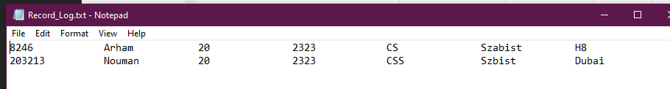

**Record Deletion:**

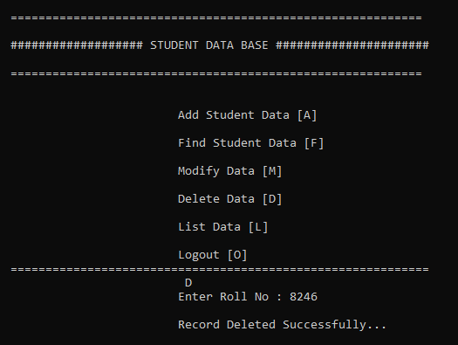

**After Deletion:**

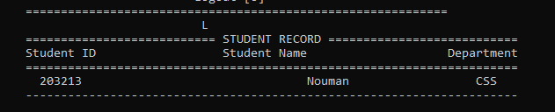

**Similarly you can modify and find data like that**