AbdullRahman Ismael

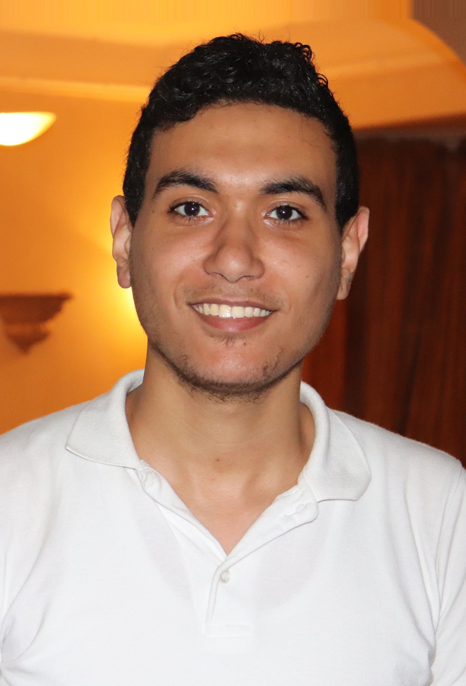

**Website**: <https://abdullrahman.website> **Phone** : +201210811347

**Email** : [abdullrahman.ismael22@gmail.com](mailto:abdullrahman.ismael22@gmail.com) **Address** : Egypt - Alexandria

**Date of birth** : 08/11/1996

====================================================================================

Skills :

- I am offering professional and Web sites using many technologies such as PHP , Javascript , html5 , css3 , ajax , mysql , bootstrap , jquery , etc...

✅ Database - MySQL/ MYSQLI

✅ PSD / sketch to HTML/CSS

✅ working with Photoshop

✅ mobile and adaptive sites development ( with responsive styles in all devices ) And sites have browser compatibility design (Supports all browsers)

✅ Quality work

✅ all responsibility for any problems I take over

you can visit my website to see my Attractive projects by yourself

thank you for reading ^^

=============================================================================

Work experience : 2018 - Present

I worked as freelancer my account facebook and some freelancer site like “upwork” for one year to find out just how things work in the labor market and what the requirements are to be a successful developer .

=============================================================================

Education : 2015 – 2019

Alexandria University

Faculty of Education

I studied science and mathematics at the Faculty of Education, Alexandria University and worked as a teacher for two years, but my greatest interest was in the web and in its languages

=============================================================================

Interests : Reading , Music , Gaming