Racing Game S.P.R.O.G

Its just a racing game trying to reminescence of old top down straight racing games such as “roadfighter”

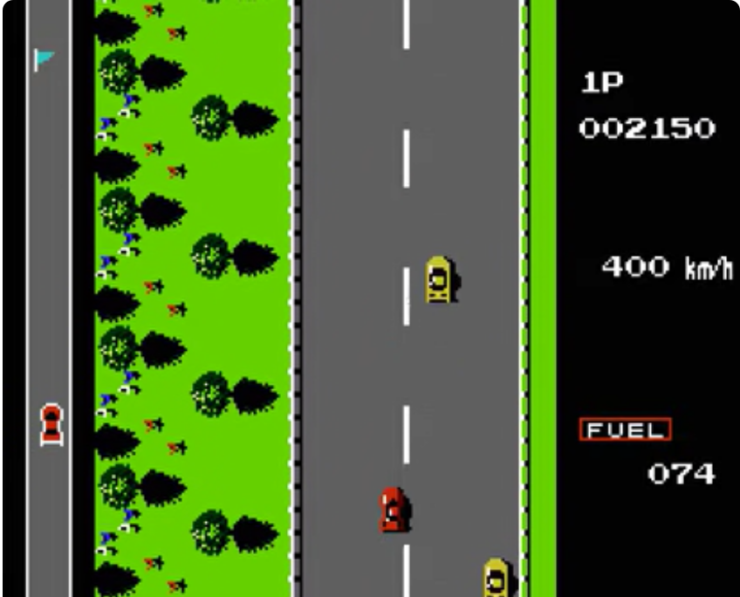
Image : Reference of “roadfighter”

The player is in control of a car; the car shall move

The idea of the game is it to be ported to mobile, to test collissions, to upload it to itch.io and have a sample (beta) for users to play <3

