Newton’s Laws of Motion:

1) Inertia: A body tends to remain at rest or continue to move in a straight line at constant velocity unless it is acted upon by an external force.

2) The acceleration of a body is proportional to the resultan force acting on the body, and this acceleration is in the same direction as the resultan force.

3) For every force acting on a body (action) there is an equal and opposite reacting force (reaction) in which the reaction is collinear to the acting force.

How we calculate force and keep unit consistency:

Force is = mass x acceleration → f = ma

Because a (aceeleration) is = L/T² where L is length y T is time

Force is also = (M)(L/T²)

We need to be able to break down formulas like this to see the units, so we keep our consistency.

Example:
This is the formula for for the friction drag on a body moving through a fluid, such as water:
R_{f} = 1/5 ρ V² SC_{f}
Where R_{f} represents resistance (a force _{f}) due to friction, ρ is the density of water, V is the speed of the moving object, S is the submerged surface area of the body, and C_{f} is an empirical (experimentally determined) drag coefficient for the body.

Since R_{f} is a force, its basic dimensions are of the form: (M)(L/T²)

So, that implies that the dimensions of the right side of the ecuation, when combined, must yield an equivalent form.

Density = (M)/(L³)

Speed = (L)/(T)

Area = (L²)

Combining these we get:

[(M)/(L³)] [(L)/(T)]² [L²]

We collect the dimensions in the numerator and denominator applying these rules:

→ a / b¹ = a x b⁻¹
→ (a / b)² = a² / b²

So:

[(M)/(L³)] [(L)/(T)]² [L²] =

→ (M)/(L³) (L²)/(T²) L²

→ M.L⁻³.L².T⁻².L²

→ M.L.T⁻²

→ M.L/T² → M(L/T²)

Symbol, units and dimensions table:
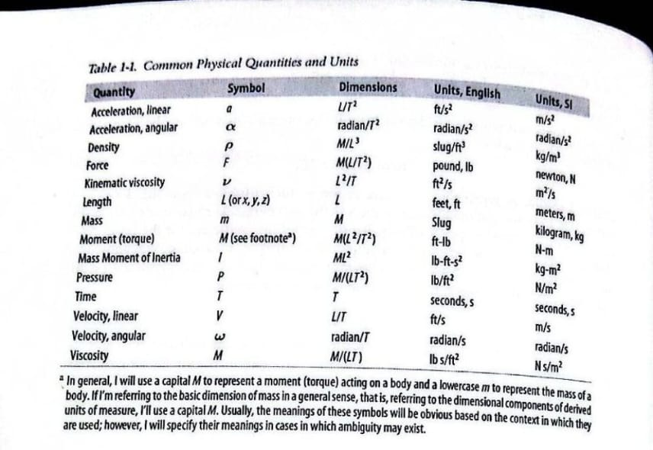

Calculating mass
The total mass of a body is simply the sum of the masses of all elemental particles making up the body.
The mass of each elemental particle is its mass density times its volume, if we asumme that the body is of uniform density, then the total mass of the body is simply the density of the body times the total volume of the body.

Center of gravity
In practice, we will be summing finite numbers of masses, and the formulas will take on the form shown here:
x_{c} = {Σ x₀ m} / {Σ m}
y_{c} = {Σ y₀ m} / {Σ m}
z_{c} = {Σ z₀ m} / {Σ m}
The formulas for calculating the total mass and the center of gravity for a system of discrete point masses can conveniently be written in vector notations as follows:
m_{t} = Σ m_{i}
CG = [Σ (cg_{i}) (m_{i})] / m_{t}
Example:
where m_{t} is the total mass, m_{i} is the mass of each point mass in the system, CG is de combined center of gravity, and cg_{i} is the location of the center of gravity of each point mass in design or coordinates.
Notice that CG and cg_{i} are show as vectores, since they denote position in Cartesian coordinates.
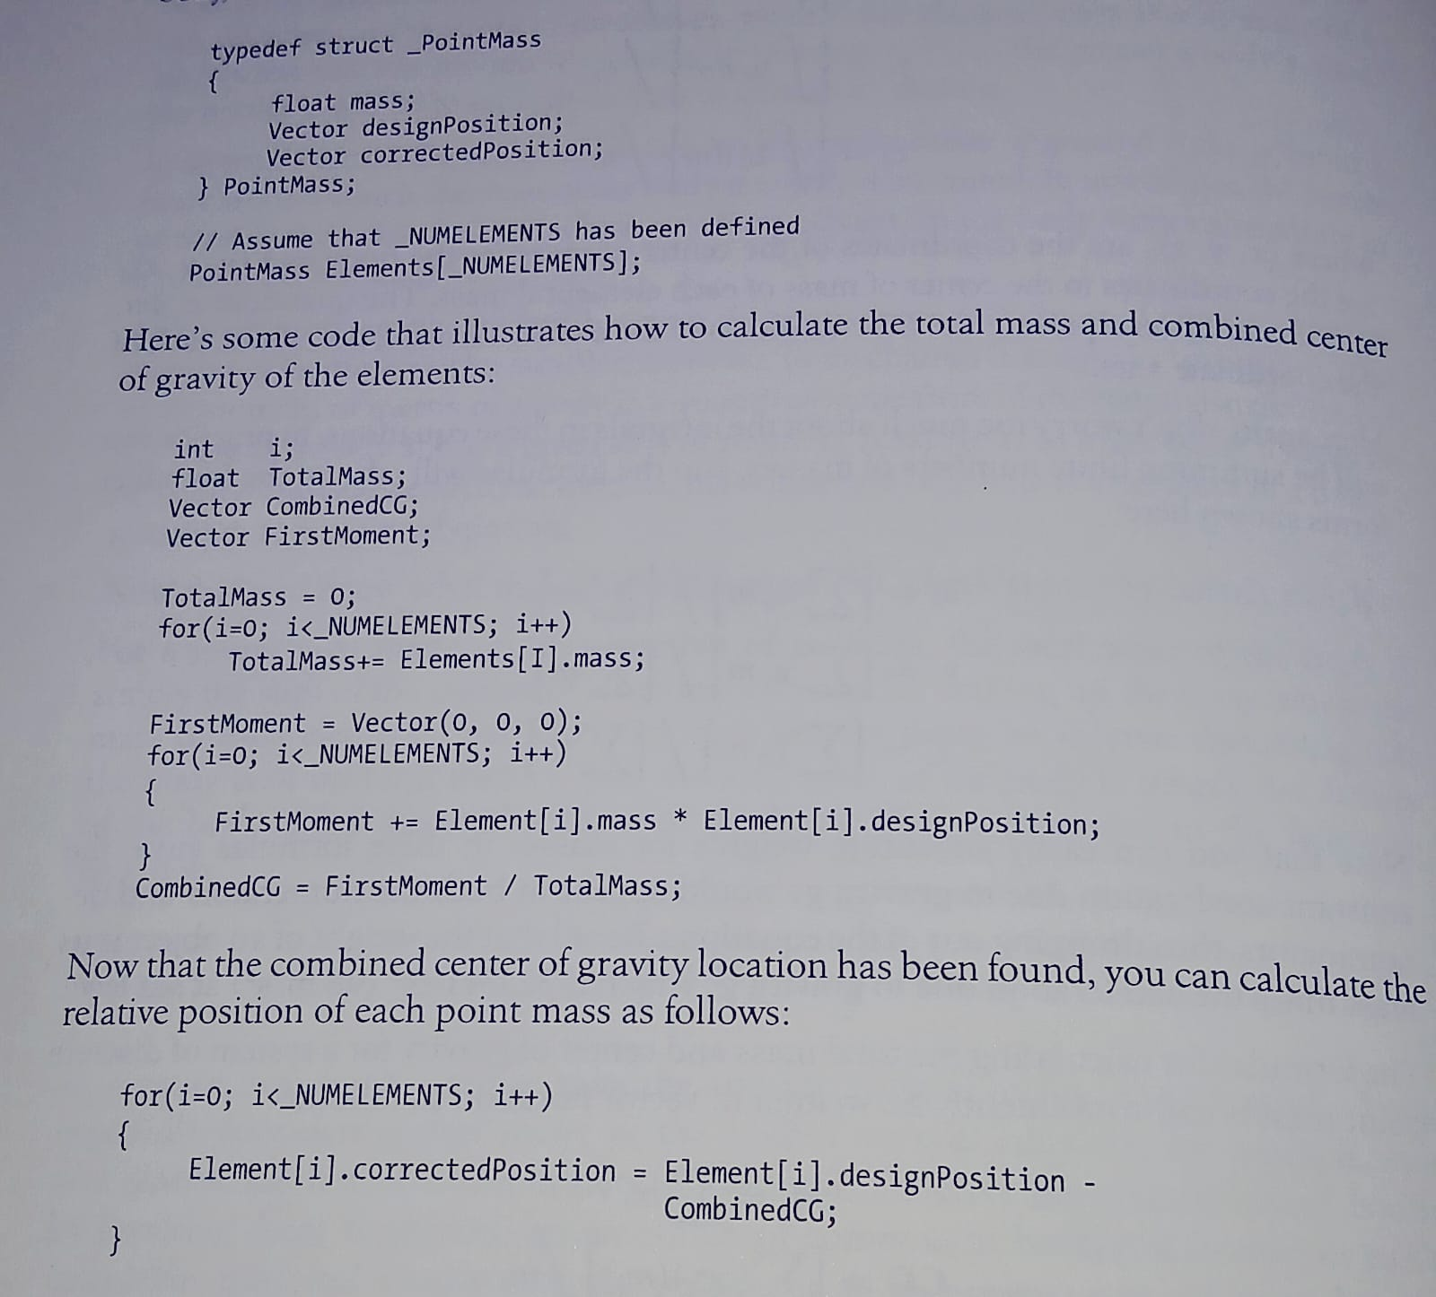

Mass moment of inertia
We need to take de second moment of each elemental mass making up the body about each coordinate axis.
The moment of inertia of an arbitrary body in three dimensions, when calculating moment of inertia about the x-axis, I_{xx}, this distance, r, will be in the yz-plane, such that r²_{x} = y² + z²
Similarly, for the moment of inertia about de y-axis, I_{yy}, r²_{y} = z² + x², and for z-axis, I_{zz}, r²_{z} = x² + y²
The ecuations for mass moment of inertia about the coordinate axes in 3D are:
I_{xx} = ∫ r²_{x} dm = ∫ (y² + z²) dm
I_{yy} = ∫ r²_{y} dm = ∫ (z² + x²) dm
I_{zz} = ∫ r²_{z} dm = ∫ (x² + y²) dm
I_{o} → this is called neutral axis (is passing through the center of mass of the body)
Parallel axis theorem: I = I₀ + md² → where m is the mass of the body and d is the perpendicular distance between the parallel axes.
Sometimes when I_{o} is known to be relatively small and d relatively large, you can safely ignore I_{o}, since the md² term will dominate.
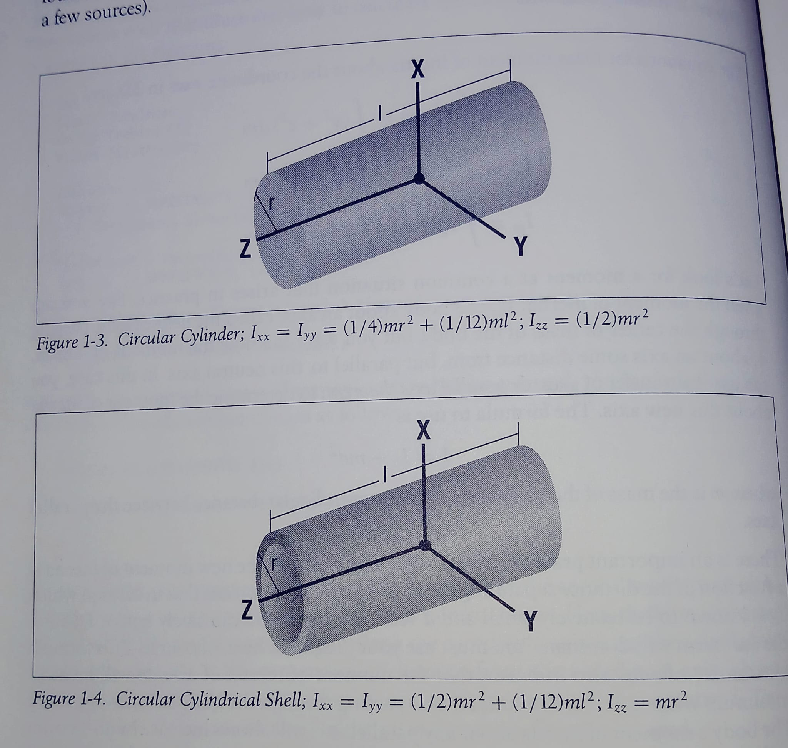
In practice, calculating mass moment of inertia for all the simplest shapes of uniform density is a complicated endeavor, so we will often approximate the moment of inertia of a body about axes passing through its center of mass by using simple formulas for basic shapes that approximate the object, complicated bodies will be brake down into smalles components and take the advantage of the fact that I_{o} may be negligible for certain components, considering its md² contribution to the total body’s moment of inertia.

