Name :- Shivam Dilipsingh Bhadoriya
Course:- BSC – IT

Python Assignmenmt :- Numpy and Pandas

Aim:- Create a 1D NumPy array with 10 integers. Print the array and its data type.

Code:-
# Create a 1D NumPy array with 10 integers. Print the array and its data type.

import numpy as np
list = [1,2,3,4,5,6,7,8,9,10]
print(list)
print(type(list))

Output:-
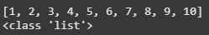

Aim:- Generate an array of 10 random integers between 1 and 100 using NumPy.
Code:-
# Generate an array of 10 random integers between 1 and 100 using NumPy.

import numpy as np

x = np.random.randint(1,101, size=10)

print(x)

Output:-
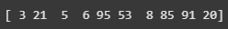

Aim:- Calculate the mean, median, mode, standard deviation, and variance for the array: [12,
15, 12, 18, 21, 24, 24, 24, 27, 30]

Code:-
# Calculate the mean, median, mode, standard deviation, and variance for the array:
# [12, 15, 12, 18, 21, 24, 24, 24, 27, 30]

import numpy as np
import scipy
import statistics as stats
list = [12, 15, 12, 18, 21, 24, 24, 24, 27, 30]
print(list)

print(f"The Mean of The List is :- {np.mean(list)}")
print(f"The Median of The List is :- {np.median(list)}")
print(f"The Standard Daviation of The List is :- {np.std(list)}")
print(f"The Standard Daviation of The List is :- {np.var(list)}")

Output:-
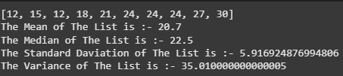

Aim:- Create a list of integers from 1 to 10. Convert it into a NumPy array and apply all five
statistical functions.

Code:-
# Create a list of integers from 1 to 10. Convert it into a NumPy array and apply all five
# statistical functions.

import numpy as np
import scipy
import statistics as stats
list = [1,2,3,4,5,6,7,8,9,10]
print(list)

print(f"The Mean of The List is :- {np.mean(list)}")
print(f"The Median of The List is :- {np.median(list)}")
print(f"The Standard Daviation of The List is :- {np.std(list)}")
print(f"The Variance of The List is :- {np.var(list)}")

Output:-
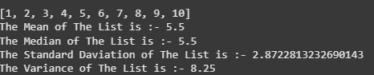
Aim:- Take a list of marks scored by 5 students in 3 subjects. Convert it into a 2D NumPy array
and:
- Calculate the average marks of each student.
- Find the subject with the highest average.

Code:-
import numpy as np

Marks = np.array([[45,35,64],[34,64,36],[43,65,74],[46,46,74],[37,54,32]])

x = np.mean(Marks,axis=1)

y = np.mean(Marks,axis=0)

print("Average marks of each student: ",x)

print("subject with the highest average: ",np.max(y))

Output:-

Aim:- Print the first and last rows of the DataFrame using .head() and .tail().

Code:-
# Print the first and last rows of the DataFrame using .head() and .tail().

import pandas as pd

df = pd.read_csv("data.csv")

print(df.head(3))
print(df.tail(3))

Output:-
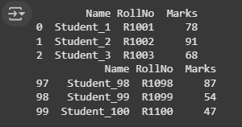

Aim:- Create a DataFrame using the dictionary: {&#39;Product&#39;: [&#39;Pen&#39;, &#39;Notebook&#39;, &#39;Eraser&#39;], &#39;Price&#39;:
[10, 25, 5], &#39;Stock&#39;: [100, 50, 200]}. Print the entire DataFrame.

Code:-
# Create a DataFrame using the dictionary: {Product;: [Pen, Notebook, Eraser],Price:
# [10, 25, 5], Stock: [100, 50, 200]}. Print the entire DataFrame..

import pandas as pd

data = {'Product': ['Pen', 'Notebook', 'Eraser'],
'Price': [10, 25, 5],
'Stock': [100, 50, 200]
}

df = pd.DataFrame(data)

print(df)

Output:-
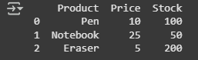
Aim:- Add a new column Discounted_Price = Price - 10%.
Code:-
# Create a DataFrame using the dictionary: {Product;: [Pen, Notebook, Eraser],Price:
# [10, 25, 5], Stock: [100, 50, 200]}. Print the entire DataFrame..

import pandas as pd

data = {'Product': ['Pen', 'Notebook', 'Eraser'],
'Price': [10, 25, 5],
'Stock': [100, 50, 200]
}

df = pd.DataFrame(data)
df['Discount Price'] = df.Price * 0.9

print(df)

Output:-
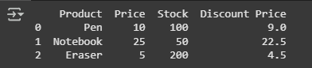

Aim:- Create a sample data.csv file with student details (Name, RollNo, Marks) and:
- Read it using pd.read_csv().
- Print the total number of students.

Code:-
# Create a sample data.csv file with student details (Name, RollNo, Marks) and:
# - Read it using pd.read_csv().
# - Print the total number of students.

import pandas as pd

df = pd.read_csv("data.csv")
print(df)

print(df.count())

Output:-
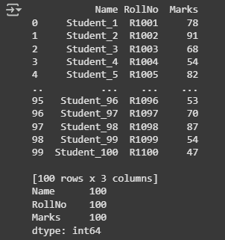

Aim:- Load a CSV file and display only the names of students who scored more than 75 marks.

Code:-
from os import sysconf_names
# Load a CSV file and display only the names of students who scored more than 75 marks.

import pandas as pd

df = pd.read_csv("data.csv")

s_names = df[df["Marks"]>75]["Name"]

print(s_names)

Output:-
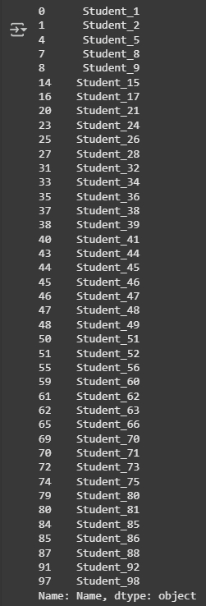

Aim:- Given a DataFrame of employees with Name, Dept, and Salary:
- Retrieve the first 3 rows.
- Retrieve only the Name and Salary columns.
- Display the salaries of employees in the HR department.

Code:-
from os import sysconf_names
# Load a CSV file and display only the names of students who scored more than 75 marks.

import pandas as pd

df = pd.read_csv("data.csv")

s_names = df[df["Marks"]>75]["Name"]

print(s_names)

Output:-
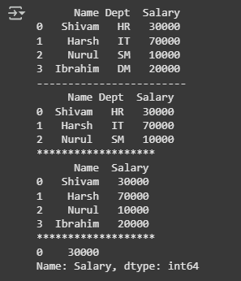

Aim:- Access the value at row index 2 and column index 1 using iloc.

Code:-
# Access the value at row index 2 and column index 1 using iloc.

import numpy as np

emp = { "Name" : ["Shivam","Nurul", "Jarir","Pratham","Harsh"] , "Dept":["IT", "HR","Sales","HR","Finance"], "Salary": [80000, 55000, 62000,64000,45000]}

df = pd.DataFrame(emp)

print(df)

print("*****************")

row = df.iloc[[2],[1]]

print(row)

Output:-
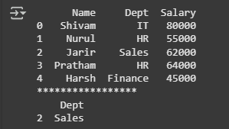

Aim:- Use loc to get the rows where Salary &gt; 50000.

Code:-
# Use loc to get the rows where Salary &gt; 50000.

import pandas as pd
emp = { "Name" : ["Shivam","Nurul", "Jarir","Pratham","Abhii"] , "Dept":["IT", "HR","Sales","HR","Finance"], "Salary": [80000, 45000, 72000,64000,45000]}

df = pd.DataFrame(emp)

print(df)

print("--------------------")

row = df[df["Salary"]>50000]

print(row)

Output:-
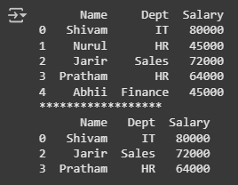

Aim:- Create a DataFrame with at least 5 rows and 3 columns.
- Retrieve the third row using iloc.
- Retrieve the values from the second and fourth rows, and the first two columns using
iloc.

Code:-
# Create a DataFrame with at least 5 rows and 3 columns.
# - Retrieve the third row using iloc.
# - Retrieve the values from the second and fourth rows, and the first two columns using
# iloc.

emp = { "Name" : ["Shivam","Nurul", "Jarir","Pratham","Abhii"] , "Dept":["IT", "HR","Sales","HR","Finance"], "Salary": [80000, 79999, 72000,64000,45000]}

df = pd.DataFrame(emp)

print(df)

print("******************")

row = df.iloc[3,:]

print(row)

row = df.iloc[[2,4],[0,1]]

print(row)

Output:-
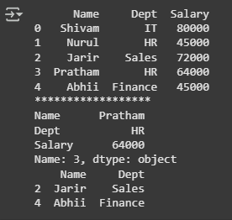

Aim:- Using loc, display:
- All columns for the row with index 0.
- A slice of rows and selected columns using labels.

Code:-
# Using loc, display:
# - All columns for the row with index 0.
# - A slice of rows and selected columns using labels.

emp = { "Name" : ["Shivam","Nurul", "Jarir","Pratham","Abhii"] , "Dept":["IT", "HR","Sales","HR","Finance"], "Salary": [80000, 72000, 72000, 64000, 45000]}

df = pd.DataFrame(emp)

print(df)

print("******************")

row = df.loc[:0]

print(row)

print("******************")

col= df.loc[0:3,["Name","Dept"]]

print(col)

Output:-
