BlockPass
Stellar Instaward Round 1
Completion Report and Customer Development Plan

Submitted to: Stellar Ambassador Chapter Lead
Prepared by: BlockPass team
Date: 6 November 2026
Network: Stellar testnet. Local-currency payments run in a sandbox, and no real money moves.

Contents
1. Executive summary
2. Project overview
3. Deliverable 1: Stellar minting service
4. Deliverable 2: Event storefront and checkout
5. Deliverable 3: Confirmation and logging
6. Work beyond the Statement of Work
7. Testing and evidence
8. Delivery against the 30-day plan
9. Customer development plan
10. Limitations and next steps
Appendix A: Testnet transactions
Appendix B: Photo credits

1. Executive summary
BlockPass is an event ticketing platform for Africa that issues every ticket as a unique, serialized asset on Stellar. This report covers Round 1, a 30-day Instaward to prove that an attendee can choose an event, complete checkout and receive an on-chain ticket automatically.
The minting pipeline, storefront and confirmation flow are built and working on the Stellar testnet. In the final automated run, 24 orders produced 48 unique tickets across 6 events and 8 attendee accounts, and every order was verified independently on Horizon.

Status at a glance
Item | Status | Notes
Deliverable 1: Minting service | Complete | Issuer funding, asset issuance and distribution run on testnet
Deliverable 2: Storefront | Complete | Live at blockpass-events.vercel.app
Deliverable 3: Confirmation and logger | Complete | Hash shown to the attendee; every stage logged
20+ test transactions | Complete | 24 orders verified on Horizon
2-minute demo video | Complete | Captioned, recorded on a local build
Public repository evidence | Complete | All work is on the Staging branch of the public repository

Beyond the SOW, the team added attendee, organizer and administrator dashboards, detailed event profiles, ratings and reviews, and test-mode payments in local currency or a test stablecoin. Section 6 describes these and their limits.

2. Project overview

The problem
Concerts and community events in Africa often face fake tickets, duplicate screenshots at venue gates and little transparency in ticket sales. Hosts rely on spreadsheets or centralized portals that are open to data manipulation and unauthorized ticket reproduction.

The solution
BlockPass is a two-sided platform. Organizers publish events and track sales, and attendees discover events and receive tickets that can't be copied. Each ticket is a unique Stellar asset with a serial number and a public record, so its authenticity can be checked independently of BlockPass.
Attendees never handle a crypto wallet. BlockPass creates a custodial testnet wallet for each email address, which keeps checkout as simple as any ordinary ticketing site.

Objective of this Instaward
Within 30 days, deliver a functional event storefront and an automated Stellar testnet ticket minting pipeline, where attendees can select an event tier, submit their registration and trigger on-chain asset creation and distribution.

How an order works
Step | Stage | What happens
1 | Reserve | One database update takes stock and serial numbers together, so a tier can't oversell and a serial can't repeat.
2 | Provision | The event has its own issuer account, and the attendee receives a custodial testnet wallet.
3 | Pay | The attendee pays in local currency through the sandbox, or in the test stablecoin on Stellar.
4 | Mint | One atomic transaction issues each ticket through the distributor to the attendee. It also carries any stablecoin payment.
5 | Record | The order stores the transaction hash, and each stage is written to the server log and database.

Ticket codes are readable. For example, LAGOSV000031 means Lagos Live Nights, VIP, serial 31.

Technology
Layer | Technology
Web application | Next.js, React and TypeScript
API | Node.js, Express and TypeScript
Database | MongoDB
Blockchain | Stellar testnet, @stellar/stellar-sdk, Horizon
Explorer | StellarExpert

3. Deliverable 1: Stellar minting service

What was delivered
A backend service built on @stellar/stellar-sdk that funds issuer accounts through Friendbot, constructs event-specific asset issuance transactions and distributes unique, serialized ticket assets on the Stellar testnet.
- Each event has its own issuer account, created automatically.
- A platform distributor account routes each ticket to the attendee.
- Each ticket is one asset with a supply of 1, capped by trustlines with a limit of 1.
- An order of up to 10 tickets is issued in one atomic transaction.
- Network timeouts and sequence conflicts are retried without risking a duplicate ticket.

Why it matters
This establishes the blockchain foundation for BlockPass, and proves that event passes can be issued reliably and cheaply on Stellar without operational overhead.

A note on Friendbot
Issuers are funded through Friendbot first. Friendbot was often slow during development, so if it doesn't respond, the distributor creates the account directly. Attendee wallets are always created by the distributor, so a buyer never waits on Friendbot. Some demo event issuers were funded through this fallback.

Evidence
Evidence | Location
Issuance and transaction logic | backend/src/services/stellar/ticketAssets.ts
Commit | 513205fc582a
Repository branch | Staging
StellarExpert transactions | Appendix A lists all 24
Sample transaction | ed8b2c6cae508b06…

4. Deliverable 2: Event storefront and checkout

What was delivered
A responsive web interface in Next.js and React that displays event details and ticket tiers, with an attendee checkout form for name, email and quantity. Submitting the form triggers the backend minting service.

Why it matters
It gives reviewers a tangible entry point for testing the purchase flow from an ordinary attendee's perspective.

Evidence
Evidence | Location
Deployed application | https://blockpass-events.vercel.app
Event selection | Figure 1
Event details and tiers | Figure 2
Checkout form | Figure 3
Phone layout | Figure 4
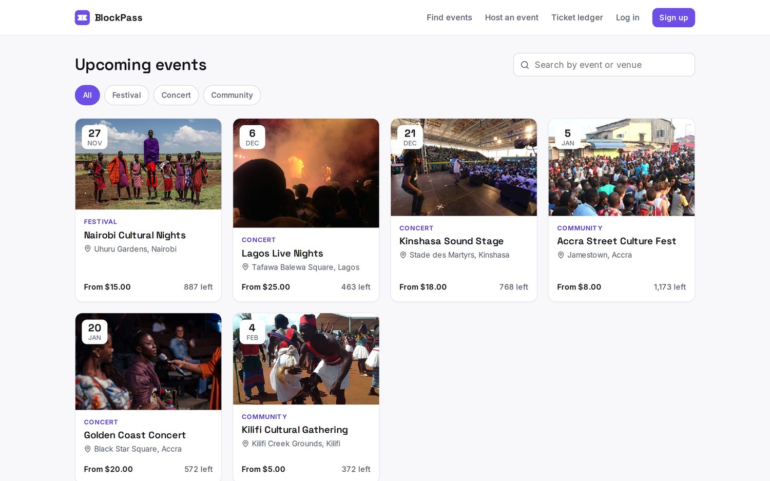
Figure 1. Event selection on the storefront
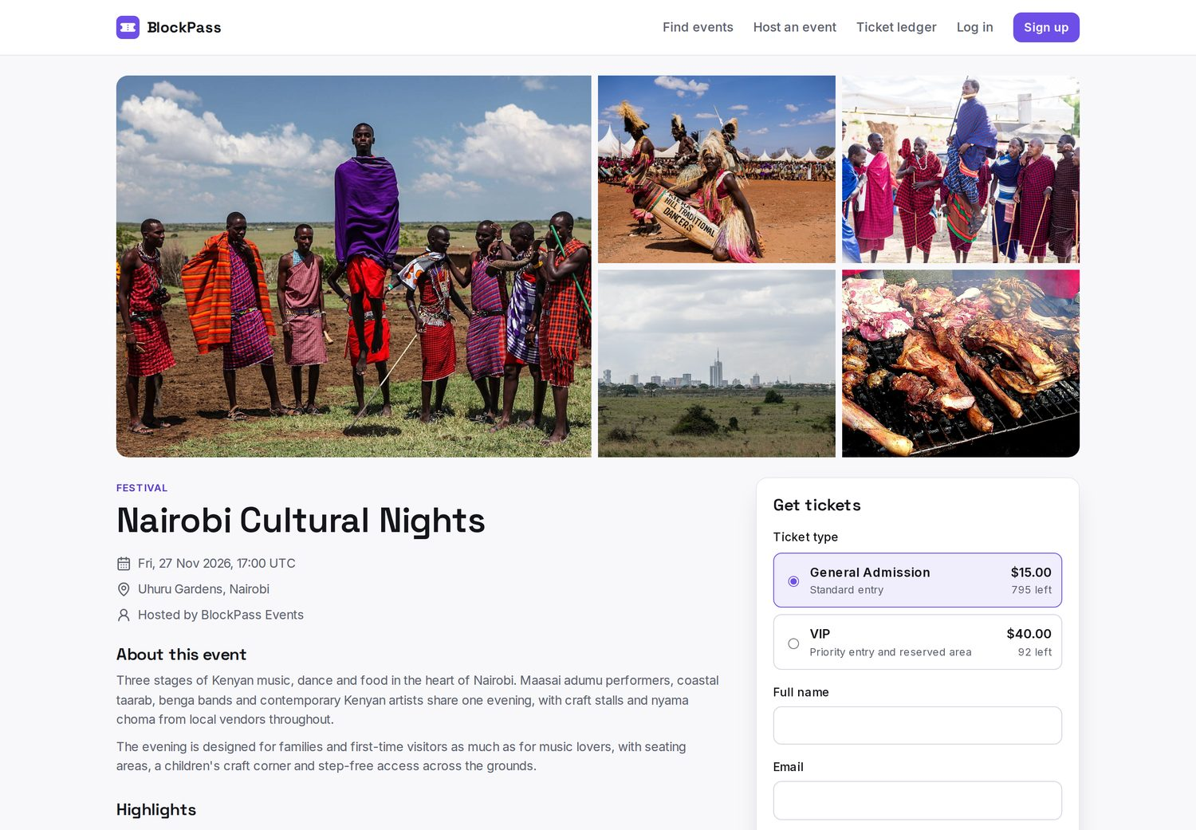
Figure 2. Event profile with gallery, schedule and ticket tiers
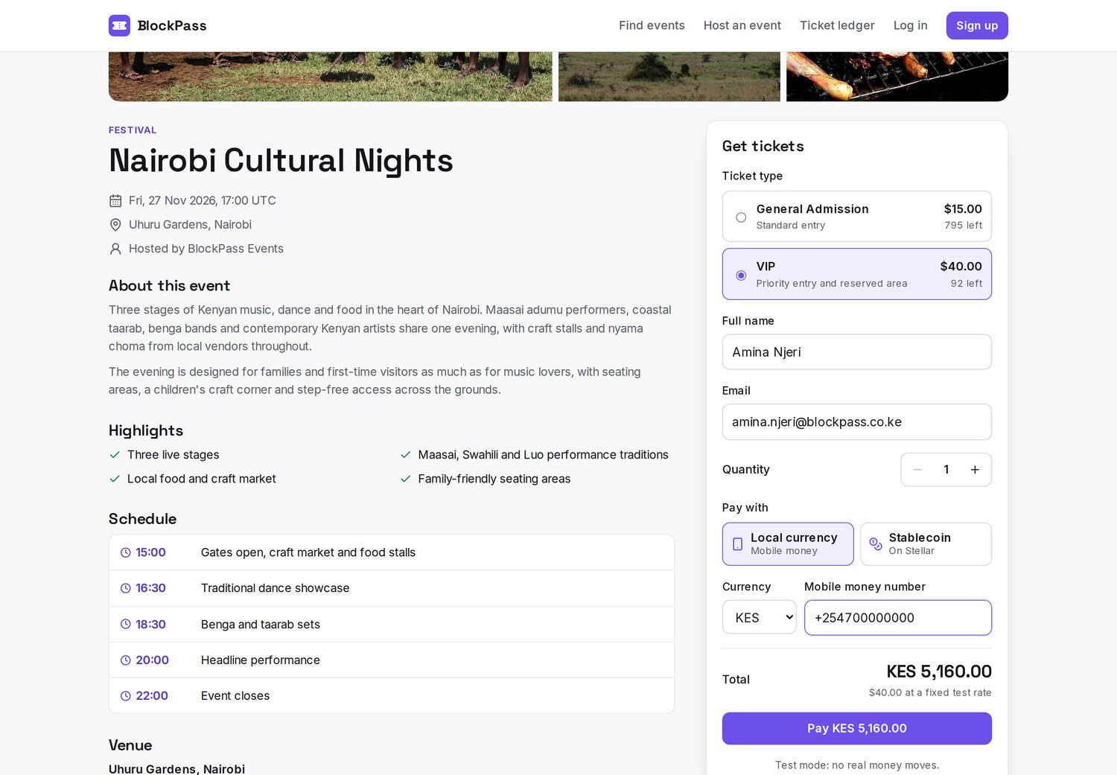
Figure 3. Checkout form with ticket tier, attendee details and payment choice
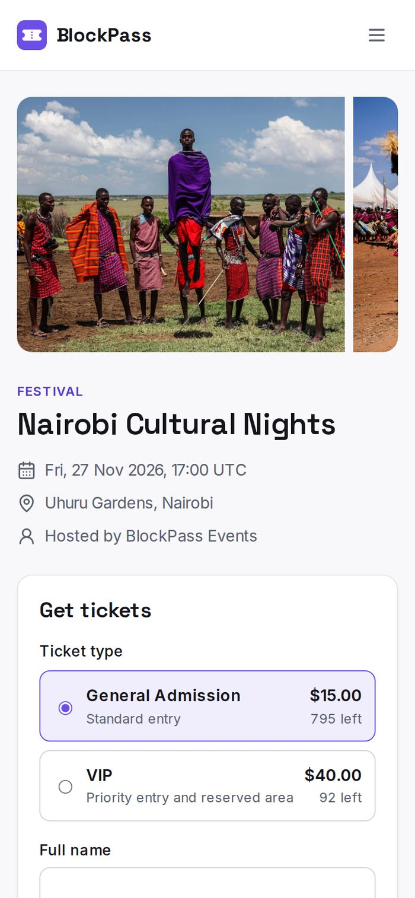
Figure 4. The event page on a phone
Pages were tested at widths from 320 to 2,560 pixels, with no horizontal overflow on any of the 18 routes checked.

5. Deliverable 3: Confirmation and logging

What was delivered
A confirmation screen that receives the Horizon response, presents the transaction status and hash, and shows each ticket. A backend logger records the issued asset parameters in the database and the server log.

Why it matters
It closes the loop on checkout, verifies that the on-chain mint succeeded and provides traceable hashes for auditing.

Evidence
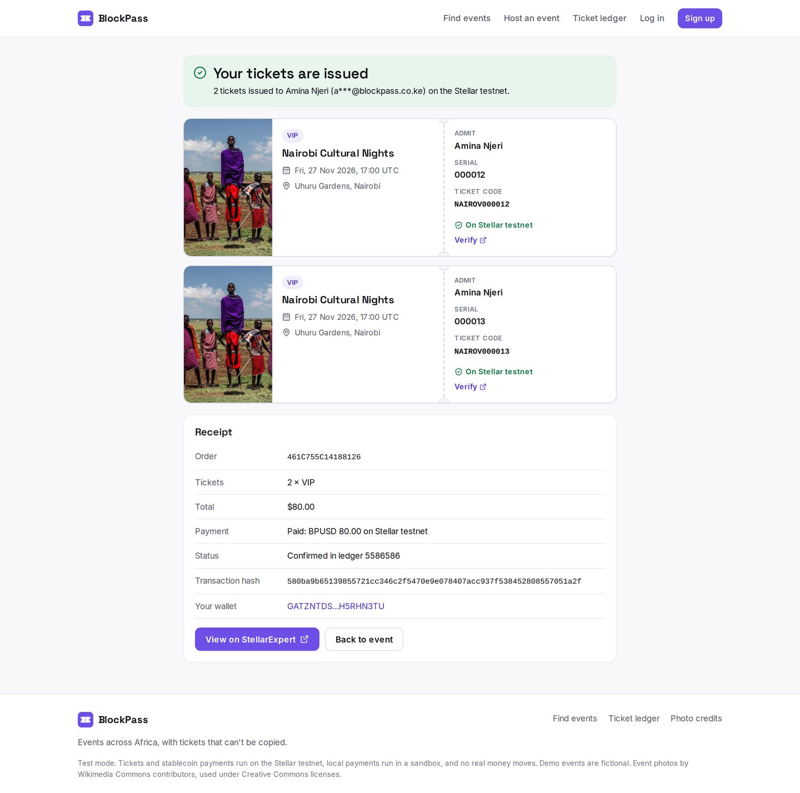
Figure 5. Confirmation screen with issued tickets, receipt and transaction hash
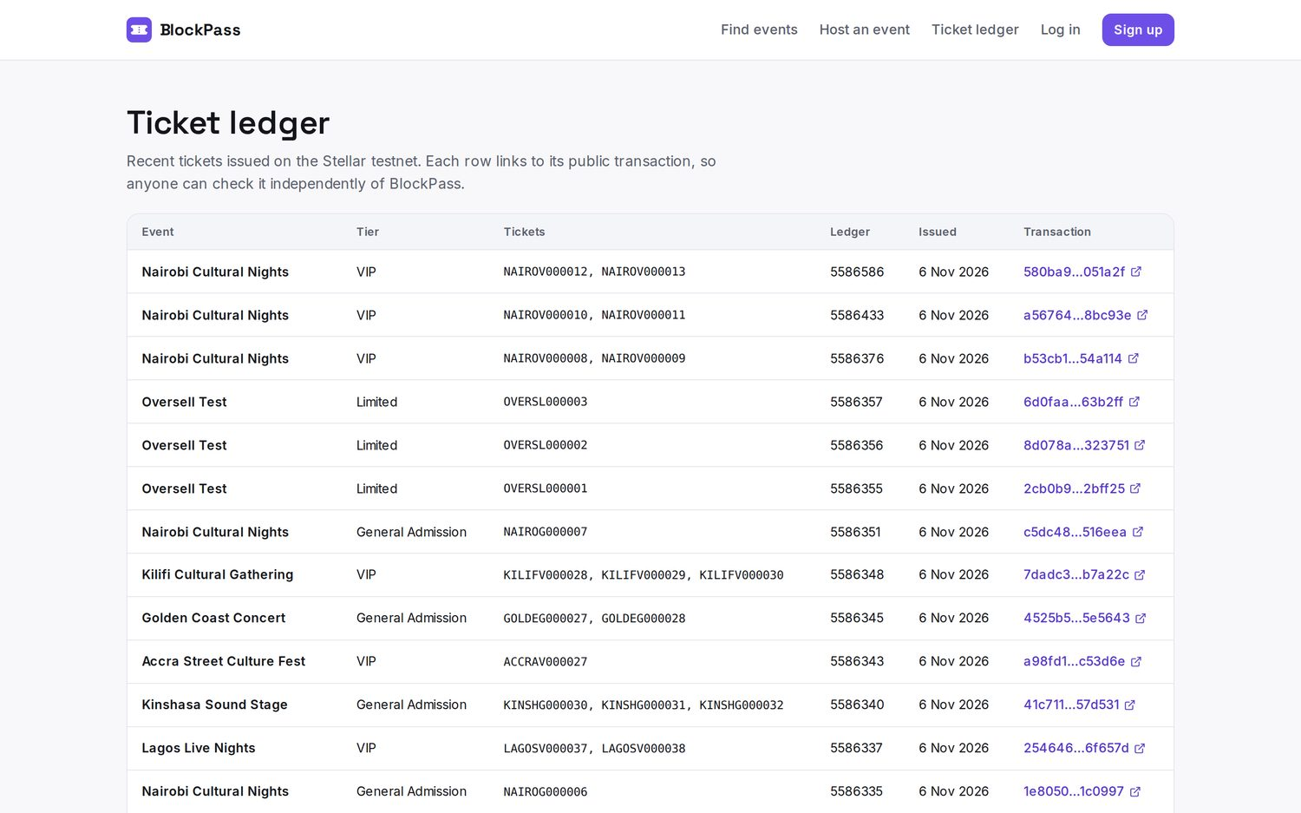
Figure 6. Public ticket ledger, with each row linked to its transaction
Each order writes three stages: order.received, mint.submitted and mint.confirmed, or mint.failed. Attendee email addresses are masked. The file docs/round-one/backend-log-sample.jsonl in the repository contains a complete example.

6. Work beyond the Statement of Work
The following work goes beyond the agreed scope. It is included for transparency and is not needed to satisfy the three deliverables.

Role-based dashboards
- Attendee workspace: tickets, upcoming events and the option to start hosting.
- Organizer workspace: events, sales, attendee lists, CSV export and feedback.
- Administrator workspace: platform totals, minting health, users, event moderation and activity.
Roles are enforced by the API as well as the interface. In testing, attendees and organizers were refused on every administrator endpoint.
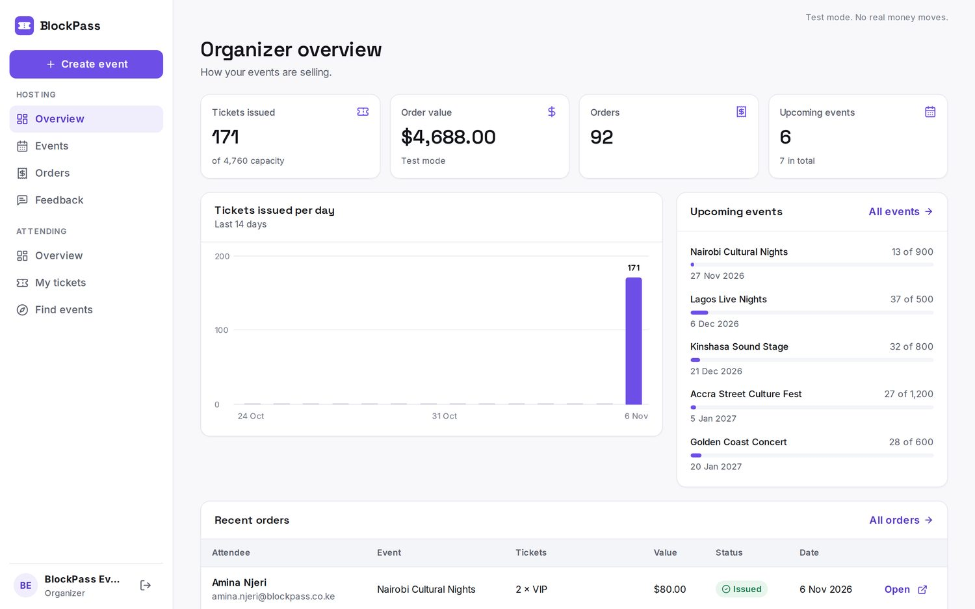
Figure 7. Organizer overview
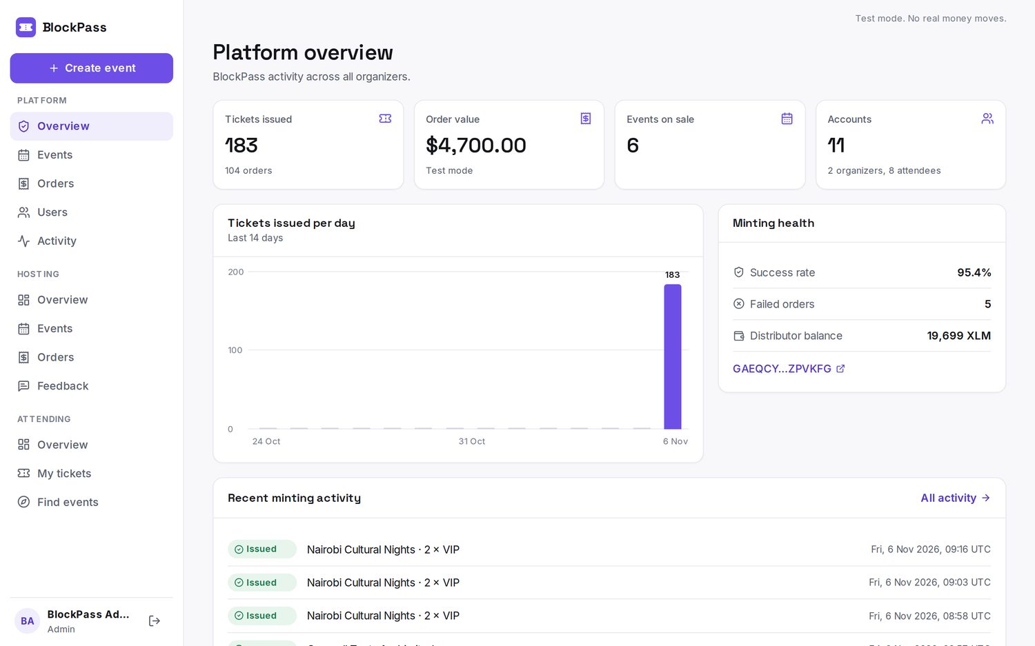
Figure 8. Administrator overview
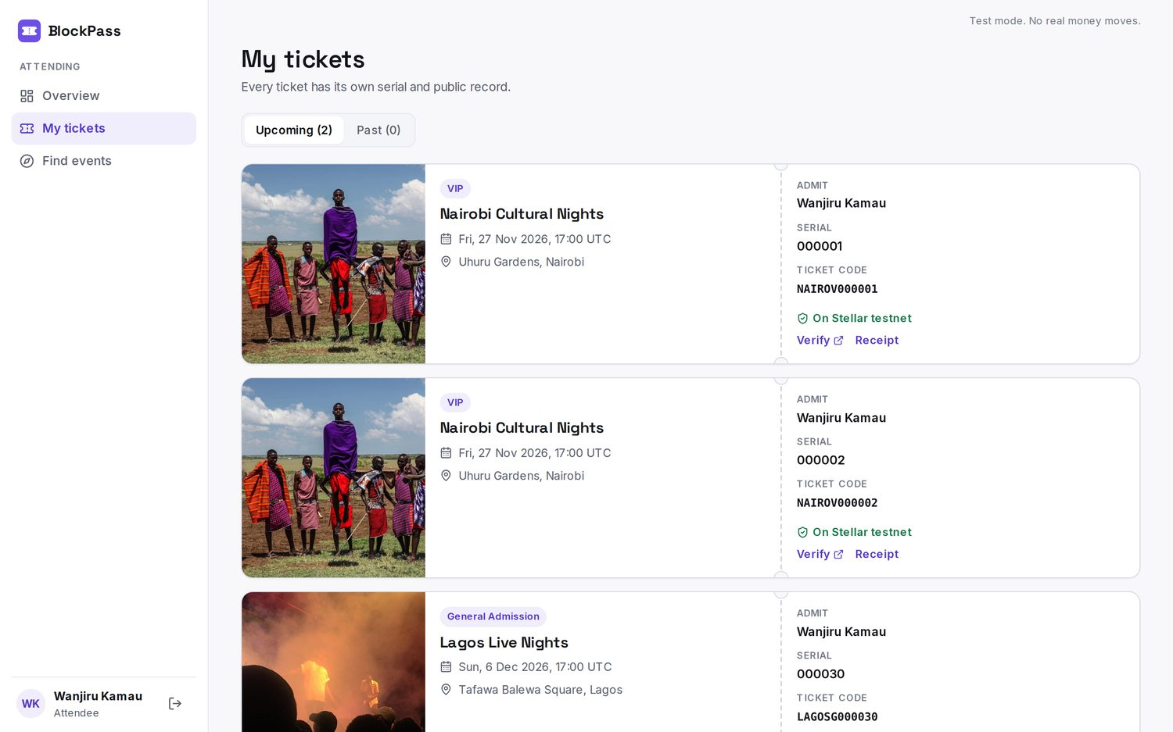
Figure 9. Attendee tickets

Attendee ratings and reviews
Ticket holders can rate and review events, and organizers see the results in a feedback section. The reviews shown in this demo are samples written by the team for a fictional event. They come from real testnet ticket purchases, and each carries a “Sample review” label. They are not customer feedback.
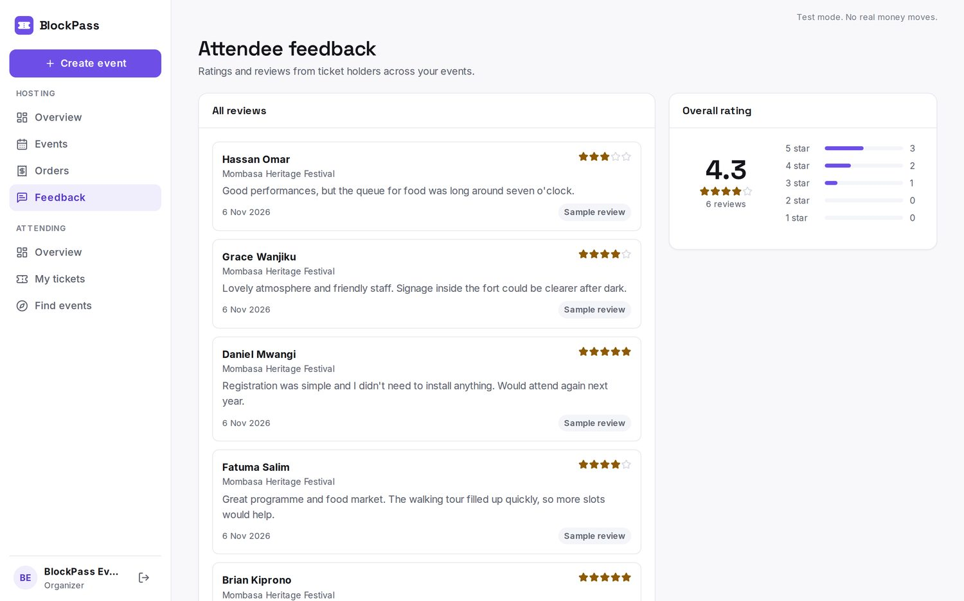
Figure 10. Organizer feedback section, showing labelled sample reviews

Test-mode payments
 | Local currency | Stablecoin
How it works | Mobile money form with a choice of 7 African currencies | Paid in the same atomic transaction that issues the tickets
Current state | Sandbox provider that approves every charge | Runs on Stellar testnet with BPUSD, a test asset
Money moved | None | None; BPUSD has no value
Needed to go live | A merchant account with a provider such as M-Pesa or Flutterwave, and a live rate feed | A real stablecoin such as USDC, mainnet deployment, and a way for attendees to fund a wallet

7. Testing and evidence

Final end-to-end run
The script npm run stellar:e2e sends orders through the public checkout endpoint, then checks each one on Horizon rather than relying on the API's own response. The final run covered both payment methods.
Measure | Result
Orders | 24
Tickets issued | 48
Attendee accounts | 8
Event issuers | 6
Ledger checks | Transaction successful, memo matches, attendee holds exactly 1, supply is exactly 1

Behavior checks
Check | Result
Every issued ticket is unique | Passed
A double submit returns the same order and mints once | Passed
On the deployed site, a stablecoin order and a local currency order each minted and were confirmed on Horizon | Passed
5 concurrent buyers for 3 tickets: 3 issued, 2 refused | Passed
Invalid orders are rejected | Passed
Both payment methods were exercised | Passed
A forced mint failure releases the reserved stock | Passed
33 access control checks across roles | Passed
5 unit tests for asset codes and transaction construction | Passed

The administrator view reports 5 failed orders in the demo database. Four came from an unfunded stablecoin issuer during development, which was found and fixed, and one was a deliberate failure test. Their stock was released, as designed.

8. Delivery against the 30-day plan
Week | Planned work | Output | Status
1 | Repository, environment and Stellar SDK core | Script that creates and funds testnet accounts (npm run stellar:setup) | Done
2 | Asset issuance and serialized ticket logic | Backend function that mints a ticket and returns a Horizon hash (npm run stellar:mint-demo) | Done
3 | Storefront UI and checkout integration | Web UI that triggers on-chain minting | Done
4 | Confirmation flow, testing and documentation | 24 test orders, demo video and this report | Done

Out of scope, as agreed
- Mobile ticket view, dynamic QR codes and offline pass storage
- Organizer gate scanner and on-chain redemption or burn at the gate

9. Customer development plan
This is a forward-looking plan. Round 1 was a technical build, so the assumptions below have not yet been validated with customers. All targets are goals for the next phase, not results.

Goal
Learn whether organizers of small and mid-sized events will move their ticketing to BlockPass, and what they need to do so, before investing in mainnet and live payments.

Customer segments
Segment | Who they are | Why start here
Community event organizers (first focus) | Universities, churches, cultural groups and meetups hosting 100 to 500 people | Fast decisions, little existing tooling, and low risk for a pilot
Independent promoters | Concert and festival promoters hosting 500 to 5,000 people | Feel fraud most directly and sell the most tickets
Venues | Halls and grounds hosting recurring events | One relationship can bring repeat events
Attendees | Urban ticket buyers, mostly on phones and mobile money | They must find the experience as easy as what they use today

The first market is Nairobi, where the team can meet organizers in person. Lagos and Accra follow once the approach is proven, in line with BlockPass's Africa-wide focus.

Hypotheses to test
# | Hypothesis | How we'll test it | Supported if
1 | Fake or duplicated tickets cost organizers real money | Organizer interviews | 8 of 15 report a recent incident
2 | Reconciling sales is a bigger daily pain than fraud | Organizer interviews, review of current tools | It ranks in their top two problems
3 | Attendees value proof of authenticity but won't accept extra steps | Attendee interviews, checkout tests | 80% finish checkout unaided
4 | Organizers will pay a per-ticket fee | Pricing conversations during pilots | 3 organizers agree to a paid second event
5 | Mobile money is required, and stablecoins are a useful option | Payment choice during pilots | Measured share of each method

Discovery interviews
Hold 15 organizer interviews and 30 attendee interviews, using open questions about recent events and not about the product. Each interview is logged in a shared tracker, and findings are reviewed every two weeks.
- Tell us about the last event you ran. How did you sell and check tickets?
- What went wrong? What did it cost you in money or time?
- What have you tried to fix it? Why did you stop?
- Who decides which ticketing tool you use, and how much do you pay today?

Pilot program
Run 3 small pilot events with design-partner organizers, at no cost and on testnet or with live payments once a provider is approved. Pilots start after the gate scanner is ready, because organizers will need to check tickets at the door.

Measures of success
Measure | Next 90 days (target) | How measured
Organizer interviews completed | 15 | Interview tracker
Attendee interviews completed | 30 | Interview tracker
Design-partner organizers signed | 5 | Signed letters of intent
Pilot events run | 3 | Admin dashboard
Checkout completion rate | 80% | Product analytics
Tickets issued in pilots | 500 | Ticket ledger
Organizers who return for a second event | 2 of 3 | Admin dashboard

Timeline
Period | Focus | Output
Days 1 to 30 | Recruit through the Stellar chapter, universities and community groups; run interviews | Interview findings and ranked problems
Days 31 to 60 | Refine the product from findings; sign design partners; build gate scanning | 5 design partners and an updated roadmap
Days 61 to 90 | Run 3 pilots, gather feedback and test pricing | Pilot report and a decision on next steps

Risks
Risk | Response
Crypto is unfamiliar or distrusted | Lead with verified tickets, and keep the technology in the background
Organizers stay with spreadsheets or WhatsApp | Offer free pilots and hands-on setup
Payment provider approval takes time | Start the merchant application early, with sandbox testing in the meantime
Regulation of digital assets and personal data | Take legal advice on stablecoin payments and custody in each market before going live

10. Limitations and next steps

Current limitations
- Everything runs on testnet, and no real money moves.
- The demo events are fictional, and the photos don't show those events.
- Local payments are simulated, and currency rates are fixed test values.
- Confirmation emails aren't sent yet.
- Ticket supply of 1 is enforced by the service. Event issuers stay active so they can keep minting.
- Stellar resets its testnet periodically, which can remove older transactions from explorers.

Next steps
- Begin the customer development plan in Section 9.
- Build the mobile ticket view and organizer gate scanner.
- Apply for a payment provider account and prepare for mainnet.

Appendix A: Testnet transactions
All 24 orders from the final end-to-end run. Each transaction opens on StellarExpert.
# | Event | Tier | Ledger | Transaction
1 | Nairobi Cultural Nights | General Admission | 5586287 | eef09674e0b3ac…
2 | Lagos Live Nights | VIP | 5586289 | ed8b2c6cae508b…
3 | Kinshasa Sound Stage | General Admission | 5586291 | 6fb850a388ed50…
4 | Accra Street Culture Fest | VIP | 5586294 | cf3dfe65bd07b8…
5 | Golden Coast Concert | General Admission | 5586297 | 43c5ff1d6e7a4c…
6 | Kilifi Cultural Gathering | VIP | 5586299 | edb5ee11a84b77…
7 | Nairobi Cultural Nights | General Admission | 5586302 | c7978da4379ff8…
8 | Lagos Live Nights | VIP | 5586305 | fbd7dcc287ad34…
9 | Kinshasa Sound Stage | General Admission | 5586308 | 63d2636c817d08…
10 | Accra Street Culture Fest | VIP | 5586311 | 77823731c131b5…
11 | Golden Coast Concert | General Admission | 5586314 | 4776e75174b8a4…
12 | Kilifi Cultural Gathering | VIP | 5586316 | 8c04b5d0d7755b…
13 | Nairobi Cultural Nights | General Admission | 5586319 | 8f93ca22b99ffb…
14 | Lagos Live Nights | VIP | 5586321 | c8627e4abdad46…
15 | Kinshasa Sound Stage | General Admission | 5586324 | 17545996a870c9…
16 | Accra Street Culture Fest | VIP | 5586327 | 3cae596ee9cc41…
17 | Golden Coast Concert | General Admission | 5586329 | 2fad793d5469c0…
18 | Kilifi Cultural Gathering | VIP | 5586332 | cd00ab4fa12313…
19 | Nairobi Cultural Nights | General Admission | 5586335 | 1e80509e572eb0…
20 | Lagos Live Nights | VIP | 5586337 | 2546460640862e…
21 | Kinshasa Sound Stage | General Admission | 5586340 | 41c7113fb0e125…
22 | Accra Street Culture Fest | VIP | 5586343 | a98fd15b536a63…
23 | Golden Coast Concert | General Admission | 5586345 | 4525b51b249689…
24 | Kilifi Cultural Gathering | VIP | 5586348 | 7dadc3959fd373…

Appendix B: Photo credits
Event photos come from Wikimedia Commons contributors and are used under Creative Commons licenses. They illustrate fictional demo events and don't show those events. Full attribution for each image is in frontend/public/images/CREDITS.md in the repository.

