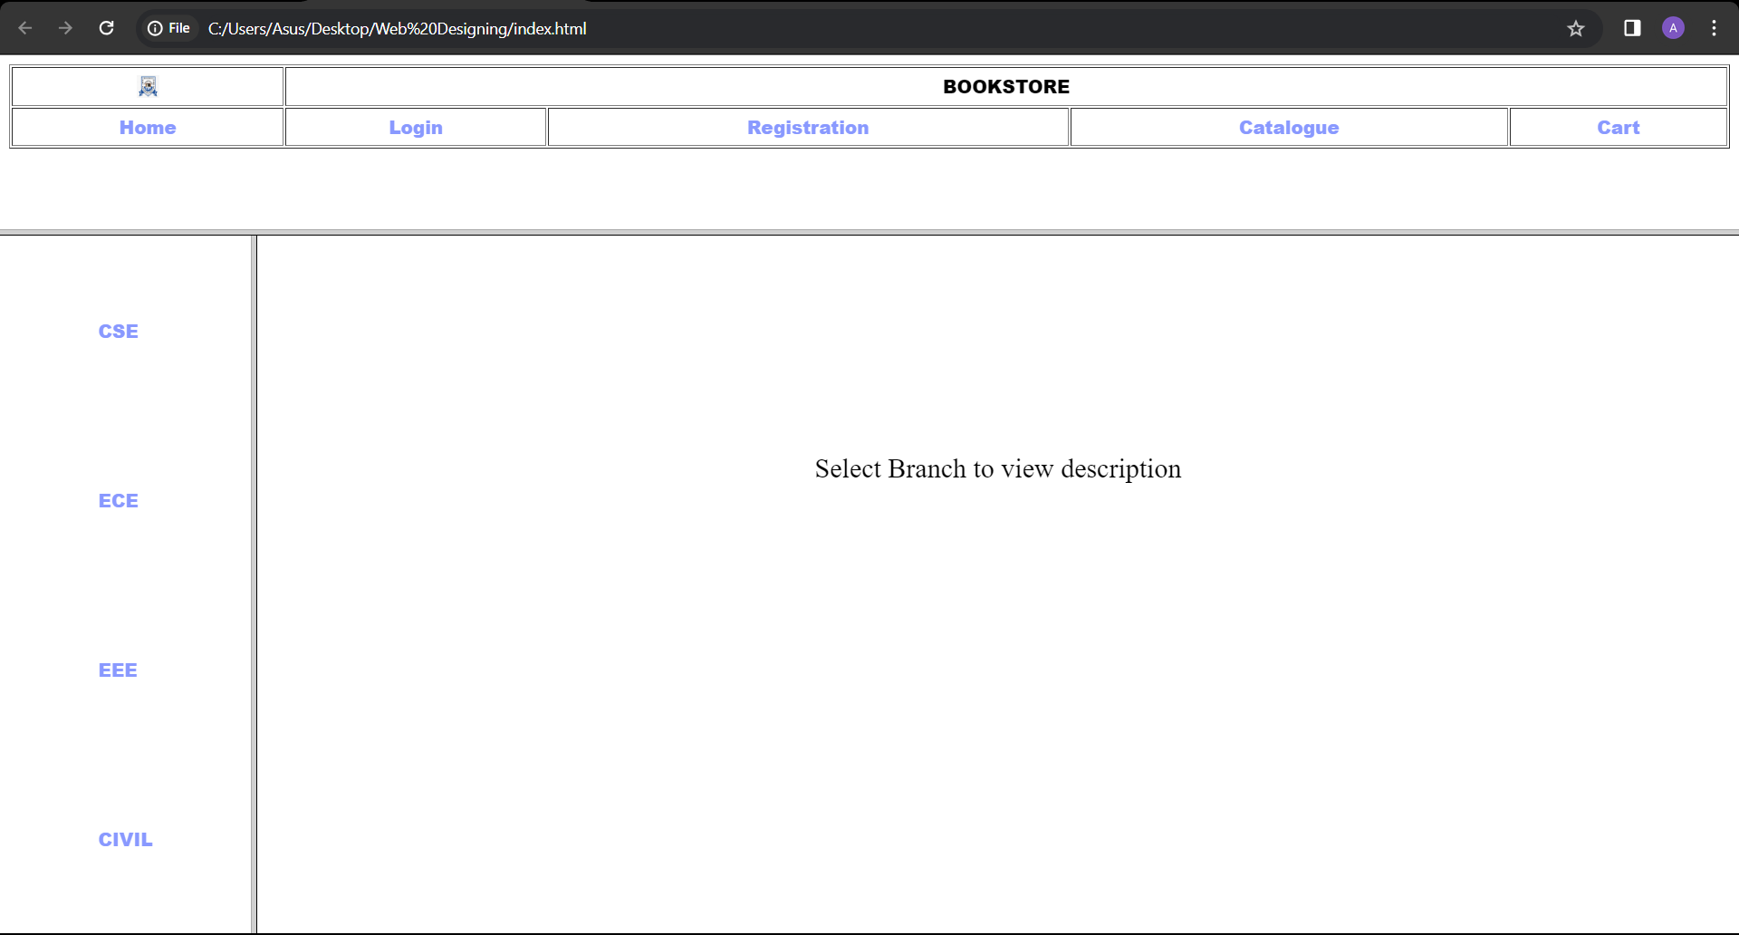

index.html

<html>

<head>

<title>Home page</title>

</head>

<frameset rows="20,80">

<frame src="head.html" name="head_page">

<frameset cols="15,85">

<frame src="dept.html" name="dept_page">

<frame src="description.html" name="des_page">

</frameset>

</frameset>

</html>

head.html

<html>

<head>

<title>Head Page</title>

<style>

a

{

text-decoration: none;

color: #8999ff;

}

</style>

</head>

<body>

<font face="Arial Black" size="3">

<table border="1" cellspacing="2" cellpadding="5"

width="100%">

<tr>

<td align="center">

<img src="https://th.bing.com/th?id=OIP.aVo-Ti-SnzddcplNNX71PgHaGP&w=272&h=229&c=8&rs=1&qlt=90&o=6&pid=3.1&rm=2" width="20"

height="20" alt="Logo"/>

</td>

<td colspan="4" align="center">

BOOKSTORE

</td>

</tr>

<tr>

<td align="center"><a href="description.html"

target="des_page">Home</a>

</td> <td align="center"><a

href="login.html" target="des_page">Login</a>

</td>

<td align="center"><a href="registration.html"

target="des_page">Registration</a></td> <td align="center"><a

href="catalogue.html" target="des_page">Catalogue</a></td> <td

align="center"><a href="cart.html" target="des_page">Cart</a>

</td>

</tr>

</table>

</font>

</body>

</html>

dept.html

<html>

<head>

<title>Departments Page</title>

<style>

a

{

text-decoration: none;

color: #8999ff;

}

</style>

</head>

<body>

<font face="Arial Black" size="4">

<table align="center" height="100%">

<tr>

<td><a href="cse.html" target="des_page">CSE</a></td>

</tr>

<tr>

<td><a href="ece.html" target="des_page">ECE</a></td>

</tr>

<tr>

<td><a href="eee.html" target="des_page">EEE</a></td>

</tr>

<tr>

<td><a href="civil.html" target="des_page">CIVIL</a></td>

</tr>

</table>

</font>

</body>

</html>

desc.html

<html>

<head>

<title> Description page</title>

</head>

<body>

<br><br><br><br><br><br><br><br><br><br>

<font face="TIMES NEW ROMAN" size="5">

<center>

Description of the Website

</center>

</font>

</body>

</html>

cse.html

<html>

<head>

<title> Description page</title>

</head>

<body>

<br><br><br><br><br><br><br><br><br><br>

<font face="TIMES NEW ROMAN" size="5">

<center>

CSE

</center>

</font>

</body>

</html>

civil.html

<html>

<head>

<title> Description page</title>

</head>

<body>

<br><br><br><br><br><br><br><br><br><br>

<font face="TIMES NEW ROMAN" size="5">

<center>

CIVIL

</center>

</font>

</body>

</html>

eee.html

<html>

<head>

<title> Description page</title>

</head>

<body>

<br><br><br><br><br><br><br><br><br><br>

<font face="TIMES NEW ROMAN" size="5">

<center>

EEE

</center>

</font>

</body>

</html>

ece.html

<html>

<head>

<title> Description page</title>

</head>

<body>

<br><br><br><br><br><br><br><br><br><br>

<font face="TIMES NEW ROMAN" size="5">

<center>

ECE

</center>

</font>

</body>

</html>

description.html

<html>

<head>

<title> HOME page</title>

</head>

<body>

<br><br><br><br><br><br><br><br><br><br>

<font face="TIMES NEW ROMAN" size="5">

<center>

Select Branch to view description

</center>

</font>

</body>

</html>

cart.html

<html>

<head>

<title> Cart page</title>

</head>

<body>

<br><br><br><br><br><br><br><br><br><br>

<font face="TIMES NEW ROMAN" size="5">

<center>

CART

</center>

</font>

</body>

</html>

login.html

<html>

<head>

<title> Login page</title>

</head>

<body>

<br><br><br><br><br><br><br><br><br><br>

<font face="TIMES NEW ROMAN" size="5">

<center>

<h2>LOGIN</h2>

<form>

<label for="email">Email: </label>

<input type="email" name="email"><br><br>

<label for="password">Password: </label>

<input type="password" name="password"><br><br>

<input type="submit" name="submit">

</form>

</center>

</font>

</body>

</html>

registration.html

<html>

    <head>

        <title> Registration page</title>

    </head>

    <style>

        body {

            display: flex;

            justify-content: center;

            align-items: center;

            height: 130vh;

            margin: 0;

        }

        form {

            width: 80%;

            padding: 20px;

            border: 1px solid #ccc;

            background-color: #f9f9f9;

        }

    </style>

    <body>

    <br><br><br><br><br><br><br><br><br><br>

        <font face="TIMES NEW ROMAN" size="5">

        <h1>Registration Form</h1>

        <form action="submit.php" method="post">

            <label for="name">Name:</label>

            <input type="text" id="name" name="name" required><br><br>

            <label for="password">Password:</label>

            <input type="password" id="password" name="password" required><br><br>

            <label for="email">E-mail ID:</label>

            <input type="email" id="email" name="email" required><br><br>

            <label for="phone">Phone Number:</label>

            <input type="text" id="phone" name="phone" required><br><br>

            <label>Sex:</label>

            <input type="radio" id="male" name="sex" value="male">

            <label for="male">Male</label>

            <input type="radio" id="female" name="sex" value="female">

            <label for="female">Female</label>

            <input type="radio" id="other" name="sex" value="other">

            <label for="other">Other</label><br><br>

            <label for="dob">Date of Birth:</label>

            <select id="day" name="day">

                <option value="" disabled selected>Day</option>

            </select>

            <select id="month" name="month">

                <option value="" disabled selected>Month</option>

            </select>

            <select id="year" name="year">

                <option value="" disabled selected>Year</option>

            </select><br><br>

            <label>Languages Known:</label>

            <input type="checkbox" id="english" name="languages[]" value="english">

            <label for="english">English</label>

            <input type="checkbox" id="telugu" name="languages[]" value="telugu">

            <label for="telugu">Telugu</label>

            <input type="checkbox" id="hindi" name="languages[]" value="hindi">

            <label for="hindi">Hindi</label>

            <input type="checkbox" id="tamil" name="languages[]" value="tamil">

            <label for="tamil">Tamil</label><br><br>

            <label for="address">Address:</label>

            <textarea id="address" name="address" rows="4" cols="50" required></textarea><br><br>

        <input type="submit" value="Submit">

    </form>

</body>

</html>

        </font>

    </body>

</html>

catalogue.html

<html>

<head>

<title> Catalogue page</title>

</head>

<body>

<br><br><br><br><br><br><br><br><br><br>

<font face="TIMES NEW ROMAN" size="5">

<center>

CATALOGUE

</center>

</font>

</body>

</html>