**Register.html**

<!DOCTYPE html>

<html lang="en">

<head>

<meta charset="UTF-8">

<meta name="viewport" content="width=device-width, initial-scale=1.0">

<link rel="stylesheet" href="reg.css">

<title>Document</title>

</head>

<body>

<img src="static\regpage-bcgrd.jpg" alt="" class="backgroundss">

<div class="bgrd-text">

<h2 style="font-size:25px;">SIGN UP</h2>

<table class="frm" >

<form action="GET">

<tr >

<td>

Name:

</td>

<td>

<input type="text" style="background-color:#0ebf7e84;border:1px solid;" required>

</td>

</tr>

<tr>

<td>

Age:

</td>

<td>

<input type="number" style="background-color:#0ebf7e84;border:1px solid;" required>

</td>

</tr>

<tr>

<td>

Date of birth:

</td>

<td>

<input type="date" style="background-color:#0ebf7e84;border:1px solid;

width:222px;text-align: center;" required>

</td>

</tr>

<tr>

<td>

Gender:

</td>

<td>

Male

<input type="radio" name="abc" required>

Female

<input type="radio" name="abc" required>

</td>

</tr>

<tr>

<td>

Phone number:

</td>

<td>

<input type="tel" style="background-color:#0ebf7e84;border:1px solid;" required>

</td>

</tr>

<tr>

<td>

Country:

</td>

<td>

<input type="text" style="background-color:#0ebf7e84;border:1px solid;" required>

</td>

</tr>

<tr>

<td>

State:

</td>

<td>

<input type="text" style="background-color:#0ebf7e84;border:1px solid;" required>

</td>

</tr>

<tr>

<td>

Address:

</td>

<td>

<textarea style="background-color:#0ebf7e84;border:1px solid;" cols="22" rows="5" required></textarea>

</td>

</tr>

<tr>

<td>

Pincode:

</td>

<td>

<input type="number" style="background-color:#0ebf7e84;border:1px solid; "required>

</td>

</tr>

<tr>

<td>

Select plan:

</td>

<td>

<select name="" id="" style="background-color:#0ebf7e84;border:1px solid; width:225px; text-align: center;" required>

<option value="1">1 month</option>

<option value="2">6 months</option>

<option value="3"> 12 months</option>

<option value="4">24 months</option>

</select>

</td>

</tr>

<tr>

<td>

Username:

</td>

<td>

<input type="text" style="background-color:#0ebf7e84;border:1px solid;" required>

</td>

</tr>

<tr>

<td>

Password:

</td>

<td>

<input type="password" style="background-color:#0ebf7e84;border:1px solid;" required>

</td>

</tr>

</form>

</table>

<br>

<p style="font-size: medium; color: rgb(0, 0, 0);" >

I agree to all the terms and conditions* :

<input type="checkbox" style=" width: 50px;" required>

</p>

<button class="submit">SUBMIT</button>

</div>

</body>

</html>

**reg.css**

*{

font-size: large;

}

.backgroundss{

filter: blur(8px);

height: 820px;

width:100%;

background-position: center;

background-repeat: no-repeat;

background-size: cover;

}

td{

text-align: left;

padding-left:2rem;

padding-right:2rem;

}

.bgrd-text {

background-color: rgba(248, 248, 248, 0.4);

font-family: 'Gill Sans', 'Gill Sans MT', Calibri, 'Trebuchet MS', sans-serif;

color: rgb(20, 20, 20);

position: absolute;

top: 50%;

left: 50%;

transform: translate(-50%, -50%);

width: 30rem;

padding: 20px;

text-align: center;

}

table{

margin:auto;

color: #000000;

}

.submit{

width: 50%;

border: none;

color: rgb(0, 0, 0);

font-weight: bold;

background-color: #0ebf7e;

padding: 14px 28px;

font-size: large;

cursor: pointer;

text-align: center;

}

**sign_in.html**

<!DOCTYPE html>

<html lang="en">

<head>

<meta charset="UTF-8">

<meta name="viewport" content="width=device-width, initial-scale=1.0">

<link rel="stylesheet" href="reg.css">

<title>Document</title>

</head>

<body>

<img src="static\download (1).jpeg" alt="" class="backgroundss">

<div class="bgrd-text">

<h2 style="font-size:25px;">SIGN IN</h2>

<table class="frm">

<form action="GET">

<tr>

<td>

Username:

</td>

<td>

<input type="text" style="background-color:#0ebf7e84;border:1px solid;" placeholder="Username">

</td>

</tr>

<tr>

<td>

Password:

</td>

<td>

<input type="password" style="background-color:#0ebf7e84;border:1px solid;" placeholder="password" required>

</td>

</tr>

</form>

</table>

<a href="" style="text-align: left;text-decoration: none; font-size: medium; padding-left:270px;">Forgot password</a>

<p style="font-size: large; color: rgb(0, 0, 0); text-align: left;

padding-left: 80px; margin:auto;">

Remember me:

<input type="checkbox" style=" width: 50px;" required>

</p>

<br>

<button class="submit">SUBMIT</button>

<br><br>

</div>

</body>

</html>

**sign_in.css**

* {

font-size: large;

}

.backgroundss {

filter: blur(8px);

height: 820px;

width: 100%;

background-position: center;

background-repeat: no-repeat;

background-size: cover;

}

td {

text-align: left;

padding-left: 2rem;

padding-right: 2rem;

}

.bgrd-text {

background-color: rgba(248, 248, 248, 0.4);

font-family: 'Gill Sans', 'Gill Sans MT', Calibri, 'Trebuchet MS', sans-serif;

color: rgb(20, 20, 20);

position: absolute;

top: 50%;

left: 50%;

transform: translate(-50%, -50%);

width: 30rem;

padding: 20px;

text-align: center;

}

table {

margin: auto;

color: #000000;

}

.submit {

width: 50%;

border: none;

color: rgb(0, 0, 0);

font-weight: bold;

background-color: #0ebf7e;

padding: 14px 28px;

font-size: large;

cursor: pointer;

text-align: center;

}

**ifram.html**

<!DOCTYPE html>

<html lang="en">

<head>

<meta charset="UTF-8">

<meta name="viewport" content="width=device-width, initial-scale=1.0">

<link rel="stylesheet" href="ifram.css">

<title>Document</title>

</head>

<body style=" background-color: rgba(121, 236, 125, 0.293);">

<iframe src="choice.html" frameborder="" width="25%" height="840"></iframe>

<iframe src="" name="qwer" frameborder="" height="840" width="73%"></iframe>

</body>

</html>

**choice.html**

<!DOCTYPE html>

<html lang="en">

<head>

<meta charset="UTF-8">

<meta name="viewport" content="width=device-width, initial-scale=1.0">

<link rel="stylesheet" href="choice.css">

<title>Document</title>

</head>

<body>

<img src="static\vertical-view-of-ubud-water-palace-in-bali-indonesia-2BF0K46.jpg" alt="" class="bg">

<div class="bgtext">

<a href="register.html" target="qwer"><button style="font-size: 50px; border-radius: 20px;cursor: pointer;border:none; font-weight: bold; background-color:#091d1547; color: white;">Register</button></a>

<br>

<br>

<br>

<a href="sign_in.html" target="qwer"> <button style="font-size: 50px;border-radius: 20px;cursor: pointer;border:none; font-weight:bold;background-color:#091d1547;color: white;">Sign in </button></a>

</div>

</body>

</html>

**choice.css**

.bg{

filter: blur(8px);

height: 820px;

width: 100%;

background-position: center;

background-repeat: no-repeat;

background-size: cover;

}

.bgtext{

position: absolute;

top: 50%;

left: 50%;

transform: translate(-50%, -50%);

}

**OUTPUT**



**Register page**

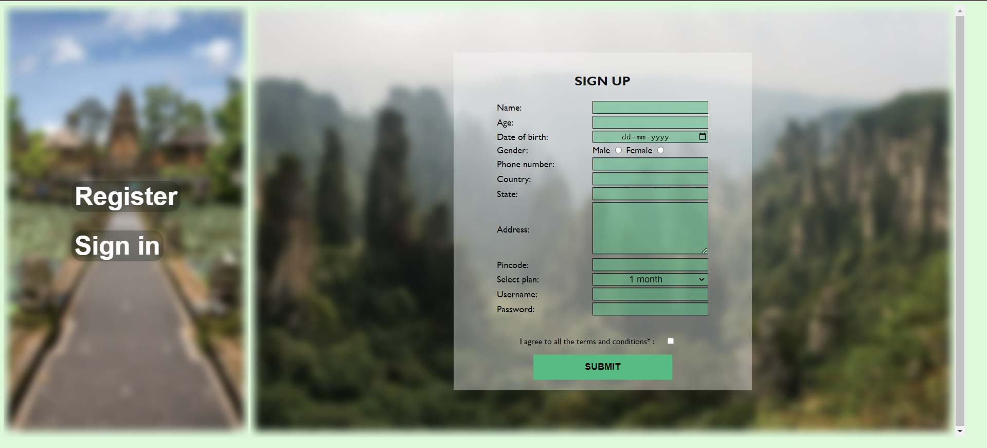

**Sign in page**

