**NATIONAL COLLEGE OF COMPUTER STUDIES**

**(NCCS)**

**Paknajol, Kathmandu**

**A Project Report**

**On**

**"APPLE STORE"**

**Submitted By: Submitted To:**

**Suyog Adhikari Sudil Maharjan**

**Class: 11 (Computer Department)**

**Sec: B**

**LETTER OF CERTIFICATE**

This is to certify that **Mr. Suyog Adhikari** student of NCCS Higher Secondary School, Grade: XI , Section: B , Roll No:34 has duly completed his project on the topic **APPLE STORE** using HTML under the guidance of **Mr. Sudil Maharjan** as for the requirement for Class XI NEB Exam.

Date of Submission: 2076/11/04

NCCS Registration No: NCCSHSS6565

Internal Examiner External Examiner

**DECLARATION**

I hereby, declare that the work reported in this report entitled **“APPLE STORE”** Submitted to the Computer Science Department of NCCS Higher Secondary School is my original work done in the form of partial fulfillment of the requirements of NEB for the +2, under the supervision of **Mr Sudil Maharjan.**

Signature

……………………………..

Student Name: **Suyog Adhikari**

Roll. No: 34

NCCS Registration No: NCCSHSS6565

Date: 2076/11/04

**ACKNOWLEDGEMENTS**

This Report entitled **“APPLE STORE”** is prepared in the partial fulfillment of the requirements of NEB for the +2 Level. It is the result of cooperation and support of teachers and my friends. Most importantly, I would like to express my sincere thanks to my teacher **Mr. Sudil Maharjan** and Head of Computer Science Department **Mr. Dinesh Khadka** for providing suggestion and guidance for preparing this report. Your precious time has certainly helped me in giving the meaning to my project work.

I would also like to express my immense gratitude to Principal, Vice Principal and the Coordinators for giving there allowance to do this project.

Thank You!!

**Suyog Adhikari**

Kathmandu, Nepal

Date: 2074/11/04

Table of Contents

Chapter 1: Introduction to Computer 1

Introduction 1

Importance: 2

Objectives: 2

Chapter 2: Introduction (html): 3

2.2) Types of Tags: 3

Basic Structure of HTML: 4

Character Formatting: 5

Paragraph: 5

Heading: 6

Text Formatting: 6

Font: 7

Horizontal Ruler: 9

Marquee: 9

List: 10

Ordered list: 10

Unordered list: 10

Description list: 11

Nested list: 12

Hyperlink: 12

External link: 13

Internal link: 14

Mail link: 16

Table: 16

Frame and form: 17

Frame: 17

Form: 18

Concept of css: 18

Inline style: 18

Internal style sheet: 19

External style sheet: 20

Chapter 3: Introduction of the Project 22

3.1) Introduction 22

3.2) Scope 22

3.3) Limitation 22

Chapter 4: HTML Coding and Outputs 23

4.1) HTML Codes: 23

HOME PAGE 23

ABOUT US PAGE: 42

CONTACT US PAGE: 48

SIGN UP PAGE: 61

ACCESSORIES PAGE: 66

4.2) Outputs (Screenshots) 80

Chapter 5: CONCLUSION: 85

5.1) Lesson Learnt 85

5.2) Recommendation 85

References: 85

# Chapter 1: Introduction to Computer

## Introduction

Computer is an electronic, Programmable, automatic device that accepts input devices then store and process them, and resulted data are displayed from output devices.

A computer is an electronic device that takes input such as numbers, text, sound, image, animations, video, etc., processes it, and converts it into meaningful information that could be understood, presenting the changed input (processed input) as output. All numbers, text, sound, images, animations, and video used as input are called [data](https://en.wikiversity.org/wiki/Data), and all numbers, text, sound, images, animations, and video returned as output are called information. Input is the raw data entered into the computer by using input devices. OR. Computer is an electronic machine/device which can input data, process them according to the instruction given and then give out the meaning full information. In another word computer is an electronic devices, operating under the control of instruction stored in its own memory that accepts data, produce results and stores the result for future use. A computer is a programmable machine capable of:

* Taking input raw data through the input devices such as keyboard, mouse or any input devices.
* Storing the input data into main memory and disks such hard disks, CD or other medium.
* Processing it at the central processing unit (CPU)
* Giving out the results as output on the screen or the any visuals display unit.

## Importance:

The importance of Computer is highlighted below:

* Computer can ensure more accuracy.
* There is huge contribution of computer in the modern science and technology sectors.
* A computer can transfer data quickly from storage to memory, process it, and then store it again for future use.
* Computer can save valuable time of employees in the office and help industries by making their employees productive and sufficient in any business.
* Computers in the universities will help the researchers and professors to do their calculation quickly and in a better and efficient way.

## Objectives:

The objectives of Computer are highlighted below:

* The main purpose of computer was to reduce the human work hours.
* To develop the whole world and to connect the world as a single town.
* To process, store and transmits a wide variety of information to the peoples.
* To make complex mathematical calculation possible and make tasks easier for human.
* To solve the highly complex work which human cannot solve in a quick basis.

# Chapter 2: Introduction (html):

The inventor of World Wide Web (Tim Berners) also was the person who developed HTML in the 1990’s. The web is based on that language. HTML stands for Hyper Text Markup Language. It is a language for describing web pages. It is a language used for creating webpages containing text, graphics, animation, sound, video and interactive elements.

It is a standard set of codes, called tags, used to format all webpages. The HTML provides a set of rules defining the way tags can be used and combined. It is a document containing HTML tags and plain text. Learning the HTML means learning the tags and rules.

## 2.2) Types of Tags:

The HTML tags are the keywords surrounded by angle brackets; used to describe the content of web page. It has three sections:

1. Tag name
2. Attributes
3. Value of attributes

Example:

<BODY bgcolor=”#ccffcc” text=”green”>

(In this example the BODY is the tag name, bgcolor and text are the attributes and the green are the values.)There are two types of tags:

1. **Paired tags :**  It has two parts the opening and the closing.

* An opening tag is a tag that indicates the start of the HTML commands. It always begins with <….>.
* A closing tag is a tag that indicates the end of the HTML commands. It always begins with </…..>.

1. **Singular tags:** It is a single type of tag that does not have any ending tag. It issues an HTML command without enclosing any text in the page.

Example: <br>, <hr> etc.

### Basic Structure of HTML:

<html>

<head>

<title>………</title>

</head>

<body>

………………………………

……………………………..

……………………………..

</body>

</html>

Attributes used in body tag:

|  |  |  |
| --- | --- | --- |
| **Attributes** | **Values** | **Description** |
| Bgcolor | Color name/ color code | To specify the background color of webpage |
| Background | url of image | To specify image file background image of page |
| Text | Color name/ color code | To specify the color of text in a webpage |
| Link | Color name/ color code | To specify the color of hyper link before clicking |
| Alink | Color name/ color code | To specify the color of active link |
| Vlink | Color name/ color code | To specify the color of visited link |
| Topmargin | Number in pixel | To specify top margin of page |
| Bottommargin | Number in pixel | To specify bottom margin of page |

### Character Formatting:

### Paragraph:

The <p> tag is used to specify the paragraph. When the user uses this tag the computer automatically adds a blank line before and after writing a paragraph.

|  |  |  |
| --- | --- | --- |
| **Attribute** | **Value** | **Description** |
| Align | Left/right/center | To specify the alignment of the paragraph |

{Note: If no alignment is defined for the paragraph then by default the paragraph comes on the left side.}

Example:

<html>

<head>

<title>…..</title>

</head>

<body>

<p align=”right/left/center”>

……………………………………………………

…………………………………………………..

………………..

</p>

</body>

</html>

### Heading:

It is a simple form of text formatting according to heading’s level. It contains of six elements (H1 to H6). To get the biggest heading <H1> tag is used in front of the text the user desires to make as a heading and ends it with </H1> tag; likewise if a smaller heading is needed then <H2>…</H2> tag is used and for even smaller and smaller headings <H3>/<H4>/<H5>.

To create the smallest heading <H6> tag is used.

Example:

<html>

<head>

<title> ….</title>

</head>

<body bgcolor=”#ccffcc” text=”red”>

<h1>…..</h1>

<h2>…..</h2>

<h3>……</h3>

<h4>…….</h4>

<h5>……..</h5>

<h6>……..</h6>

</body>

</html>

### Text Formatting:

There are various types of formatting tags to display html tags in different forms and they are as follows:

|  |  |
| --- | --- |
| Tag | Description |
| <b> | Defines bold text |
| <i> | Defines italicized text |
| <em> | Defines emphasized text |
| <small> | Defines smaller text |
| <strong> | Defines important text |
| <sub> | Defines subscript |
| <sup> | Defines superscript |
| <u> | Defines underlined text |
| <strike> | Defines a strike through text |
| <tt> | Defines teletype text |
| <small> | Defines font size one point smaller |
| <big> | Defines font size one point bigger |
| <abbr> | Defines an abbreviation |
| <q> | Defines inline quotation |
| <blockquote> | Defines a section that is quoted from another source |
| <bdo> | Defines the text direction. |
| <dfn> | Defines the definition term |
| <cite> | Defines citation |
| <acronym> | Defines acronym |
| <address> | Defines an address element |
| <pre> | Defines preformatted text |

### 

### Font:

<Font> this tag is used to specify the font color, size and name.

|  |  |  |
| --- | --- | --- |
| Attributes | Values | Description |
| Face | Font name | To specify the font of text |
| Color | Color name/color code | To specify the color of text |
| Size | 1 to 7 | To specify the font size, default is 3. |

### Horizontal Ruler:

<Hr> tag defines a horizontal ruler. It is an empty tag. It’s attributes are:

|  |  |  |
| --- | --- | --- |
| Attributes | Values | Description |
| Size | Number in pixels | To specify the thickness of line |
| Width | % or number in pixel | To specify the width of line |
| Align | Left/right/center | To specify alignment |
| Color | Color code/ color name | To specify the color of line |

### Marquee:

<Marquee> tag is used to animate (scroll) text or image in different direction with different behaviors.

|  |  |  |
| --- | --- | --- |
| Attributes | Values | Description |
| Direction | Left/right/up/down | To specify the direction of scroll |
| Behavior | Scroll/slide/alternate | To specify the marquee behavior |
| Scrollamount | Number in pixel | To specify scroll amount in pixel |
| Bgcolor | Color name/color code | To specify background color for marquee |
| Loop | Number or infinite | To specify number of repetition |

Example:

<marquee direction=”right” behavior=”alternate” loop=”infinite” scrollamount=”50” bgcolor=”#ccffcc”>……………..</marquee>

### List:

Lists are used to group related pieces of information together, so they are clearly associated with each other and are easy to read. The html has three types of list:

1. Ordered list
2. Unordered list
3. Description list

### Ordered list:

It is a type of list that is used to group a set of related items in a specific order. This is defined in html by <ol>…….</ol> tag. Every item in this list begins with a sequence number. Each item is inserted with <li>…</li> tag that creates a line break and inserts a number at the beginning.

|  |  |  |
| --- | --- | --- |
| **Attributes** | **Values** | **Description** |
| Type | 1/i/I/a/A | Type of numbered list. |
| Start | Number | Starting value of the numbering. |

### Unordered list:

It can be also known as bulleted list. This list groups a set of related items together but does not list it in a particular order. It is defined by <ul>…..</ul> tag. In this list every item begins with a bulletin mark in the beginning.

|  |  |  |
| --- | --- | --- |
| **Attributes** | **Values** | **Descriptions** |
| Type | Disc/circle/square | Used to specify the type of bulleted list. |

### 

### Description list:

It is a type of list that is used to display name/values pairs such as their terms and definitions etc. This list is different from other kinds of list, as they use name and values instead of list items. Description list is defined by <dl>….</dl> elements. The <dl> tag is used with conjunction <dt></dt> to define names/terms and <dd></dd> to define <terms/values>.

### Nested list:

A nested list is a list occurring in the bound of another list nesting the new list inside the original.

Example:<html>

<head>

<title>……</title>

</head>

<body>

<b>classification software</b>

<ol>

<li>…..</li>

<ol type=”a” start=”3”>

<li>……</li>

</ol>

<li>……</li>

<ul type=”square”>

<li>….</li>

<li>…..</li>

</ul>

</ol>

</body>

</html>

### Hyperlink:

Hyperlink is a component of web that is used to jump from one piece of information to another. The piece of information can either be of the same page or on a different web page. When the cursor is moved over to a link then the cursor turns into a small hand.

An anchor<a> element is used to define a link and its important attribute is the href that indicates the link’s destination.

|  |  |  |
| --- | --- | --- |
| **Attributes** | **Values** | **Descriptions** |
| Href | url of webpage or name of bookmark. | To indicate the linked destination |
| Target | _blank  _parent  _self  _top | To specify where to open the linked document. |
| Name(or id) | Section name(user defined) | For specifying specific point on a page. |

Different types of link:

### External link:

It is a link used to jump to different webpages or websites.

Example:

<html>

<head>

<title> external link</title>

</head>

<body alink=”green” link=”red” vlink=”brown”>

<ul>

<li><a href=”<http://www.google.com>”>[www.google.com](http://www.google.com)</li>

</ul>

</body>

</html>

### Internal link:

It is a link used to jump from one part of page to another part of the same page. For this a location on a page is marked by using name attribute in a <a> tag.

Example:

<html>

<head>

<title> internal link</title>

</head>

<body>

<a name=”movie”></a>

<a href=”#book”>click here to go to books </a>

<pre>

Kung Fu panda

</pre>

<a name=”books”></a>

<a href=”#movie”> click here to go to movie </a>

<pre>

Fault in our stars

</pre>

</body>

</html>

### Mail link:

It is used to link e-mail address. The value of href attribute for mail link is <mailto:emailsddress>

Example:

<a href=” <mailto:niki.stha@gmail.com>”>[niki.stha@gmail.com](mailto:niki.stha@gmail.com)</a>

### Table:

Table is a two dimensional structure with rows and columns. <table>…….</table> tag defines the table. In a table <tr> tag divides the table into rows ,<td> tag divides the row in data cells and the <th> tag defines the header information of the table. To merge two or many rows together in a table rowspan is used likewise for the column colspan is used.

Example: <html>

<head>

<title> table <title>

</head>

<body>

<table border=”1”>

<caption align=”top”>…….</caption>

<tr>

<throwspan=2>…. </th>

<throwspan=2>…..</th>

<thcolspan=2>……</th>

</tr>

<tr>

<th>…</th><th>…..</th>

</tr>

<tr>

<td>…..</td>

<td>…..</td>

</tr>

</table>

</body>

</html>

### Frame and form:

### Frame:

It is used to divide the browser window into number of rectangular pane so that different pages can be added to same window. Pages containing frame does not use <body> tag.

The <frameset> element specifies how many columns or rows there will be in the frameset and how much %of space will each of them occupy.

Example:

<html>

<head>

<title>…</title>

</head>

<frameset rows=”…%”>

<frame src=”page1.html”>

<frameset cols=: ….%, ……%”>

<frame src=”page2.html”>

<frame src=”page3.html” name=”fr3”>

</frameset>

</frameset>

</html>

### Form:

An html form is a part of webpage that includes areas where user can enter information to be sent back to the webpage designer or any other email address that is specified on the page. Simply it is an interface for passing data to server. It contains elements like:

1. <input>
2. <text area>
3. <select>
4. <fieldset>

# Concept of css:

CSS stands for cascading style sheets that allows us to specify the style of our page elements differently from the structure of the original document. This separation of structure makes easy to manage and easy to change the style of the document.

The css has its different types such as:

### Inline style:

It is the one in which an individual elements style is declared using the style attributes.

Example:

<html>

<head>

<title> inline style</title>

</head>

<body>

<p>…………………</p>

<p style=”font-size:20pt”>……………..</p>

<p style=”font-size:20pt; color: red; margin-left:20pt”>………..</p>

</body>

</html>

### Internal style sheet:

It is used when an entire document has an unique style. It is defined by the <style> tag in the head section.

Example:

<html>

<head>

<title> internal style sheet </title>

<style type=”text/css”>

H1 {font-family: Arial, sans-serif}

Em {background-color:#800ff; color:white}

P {font-size:36pt; color:green}

.blue {color: blue}

</style>

<body>

<h1 class=”blue”>….</h1>

<hr>

<p>…………………….

……………. </p>

<p class=”blue”>…………….

<em>……………………. </em></p>

</body>

</html>

### External style sheet:

It gives the whole website a uniform look. Separate pages of sites can utilize the same style sheet. To change the style of the whole work changing only a single file is enough nut for that all the websites must be linked with the help of <link> tag.

Example:

A {text-decoration: none}

A: hover {text-decoration: underline; margin-left: 5cm}

Li EM {color: red; font-weight: bold}

UL {margin-left: 2cm}

UL UL {text-decoration: underline; margin-left: 5cm}

[save the file with .css extension as stylesheet.css]

[now creating a new web page]

<html>

<head>

<title> external style sheet </title>

<link rel=”stylesheet” type=”text/css” href=”stylesheet.css”>

</head>

<body>

<h1>……. <em> … </em></h1>

<ul>

<li>….. </li>

<li>…..</li>

<ul>

<li>…. </li>

<li>…. </li>

</ul>

<a href=”http://www.abcd.com”> ……. </a>

</ul>

</body>

</html>

# Chapter 3: Introduction of the Project

## 3.1) Introduction

**Apple Inc.** is an American multinational technology company headquartered in Cupertino, California, that designs, develops, and sells consumer electronics, computer software, and online services. It is considered one of the Big Four technology companies, along with Amazon, Google, and Facebook. Apple was founded by Steve Jobs, Steve Wozniak, and Ronald Wayne in April 1976 to develop and sell Wozniak's Apple I personal computer, though Wayne sold his share back within 12 days.

This Web helps to sale those products that have been manufactured by **Apple Inc.** from various countries. I have some latest technologies provided by the company in their main website. I have used some HTML, CSS and Bootstraps to create this website. This website is not only a static website, it is dynamic. I have linked my every hyperlinks with the main webpage. The main webpage was really helpful to create this webpage.

## 3.2) Scope

Webpage, linked groups of web pages, are the most widely employed method of reaching an audience on the internet. Webpage provides the information of the organization. It helps to save the time. Webpage provides the services to the needed parties. Webpage provides the services to the needed parties. Some people are so busy that they do not have enough time to visit the store and buy the latest tech. With the help of the website they can order/pre-order the product sitting at home. This saves time of both customer and retailer. They also save money at some point (i.e. at some special offers, festivals, ceremony, etc.).

## 3.3) Limitation

Webpage with endless blocks of text and no visuals, or with no useful information, may drive people away. Even the best design is useless until a programmer writes the codes to create the page. This project cannot cover all the dimensions of the study matter due to inadequate duration of the time and resources. This project cannot provide full information about webpage designing.

# Chapter 4: HTML Coding and Outputs

## 4.1) HTML Codes:

### HOME PAGE

<!doctype html>

<html lang="en">

<head>

<meta charset="UTF-8">

<meta name="viewport"

content="width=device-width, user-scalable=no, initial-scale=1.0, maximum-scale=1.0, minimum-scale=1.0">

<meta http-equiv="X-UA-Compatible" content="ie=edge">

<title>Apple-Home</title>

<link rel="stylesheet" href="https://stackpath.bootstrapcdn.com/bootstrap/4.3.1/css/bootstrap.min.css" integrity="sha384-ggOyR0iXCbMQv3Xipma34MD+dH/1fQ784/j6cY/iJTQUOhcWr7x9JvoRxT2MZw1T" crossorigin="anonymous">

<style>

h5{

text-transform: uppercase;

margin: 20px 0;

}

h5 span{

text-transform: lowercase;

}

.course-heading{

text-align: center;

text-transform: uppercase;

color: #7A43B6;

border: 5px solid #7A43B6;

margin: 50px 0;

padding: 10px;

}

.navbar-brand img{

height: 40px;

}

.carousel{

margin-left: 500px;

width: 500px;

height: 500px;

}

.card-group img{

width: 300px;

height: 250px;

}

/*Extra small devices (portrait phones, less than 576px)*/

/*No media query for `xs` since this is the default in Bootstrap*/

/*Small (-sm-) devices (landscape phones, 576px and up)*/

@media (min-width: 576px) {

}

/*Medium (-md-) devices (tablets, 768px and up)*/

@media (min-width: 768px) {

}

/*Large (-lg-) devices (desktops, 992px and up)*/

@media (min-width: 992px) {

}

/*Extra large (-xl-) devices (large desktops, 1200px and up)*/

@media (min-width: 1200px) {

}

</style>

</head>

<body>

<!--Navbar-->

<nav class="navbar navbar-expand-lg navbar-light bg-light">

<a class="navbar-brand" href="home.html"><img src="logo.jpg" alt="logo"></a>

<button class="navbar-toggler" type="button" data-toggle="collapse" data-target="#navbarSupportedContent">

<span class="navbar-toggler-icon"></span>

</button>

<div class="collapse navbar-collapse" id="navbarSupportedContent">

<ul class="navbar-nav mr-auto">

<li class="nav-item active">

<a class="nav-link" href="home.html">Home</a>

</li>

<li class="nav-item dropdown">

<a class="nav-link dropdown-toggle" href="#" id="navbarDropdown" role="button" data-toggle="dropdown">

Products

</a>

<div class="dropdown-menu" aria-labelledby="navbarDropdown">

<a class="dropdown-item" href="#iphone">Iphone</a>

<a class="dropdown-item" href="#ipads">Ipad</a>

<a class="dropdown-item" href="#airpods">Airpods</a>

<a class="dropdown-item" href="#macbook">Mac</a>

<a class="dropdown-item" href="#oswatch">OS Watches</a>

<div class="dropdown-divider"></div>

<a class="dropdown-item" href="accessories.html">Accessories</a>

</div>

</li>

<li class="nav-item">

<a class="nav-link" href="aboutus.html">About Us</a>

</li>

<li class="nav-item">

<a class="nav-link" href="contactus.html">Contact Us</a>

</li>

<li class="nav-item">

<a class="nav-link" href="signup.html">LOG IN/OUT</a>

</li>

</ul>

<form class="form-inline my-2 my-lg-0">

<input class="form-control mr-sm-2" type="search" placeholder="Search">

<button class="btn btn-outline-success my-2 my-sm-0" type="submit">Search</button>

</form>

</div>

</nav>

<section class="breadcrumbs-section">

<div class="container pl-3 p-sm-3">

<div class="row">

<div class="col-12">

<h3 class="course-heading">New Arrivals</h3>

</div>

</div>

</div>

</section>

<!--Carousel-->

<div id="carouselExampleIndicators" class="carousel slide" data-ride="carousel">

<div class="carousel-inner">

<div class="carousel-item active">

<h1 class="display-3">Iphone 11</h1>

<img class="d-block w-100" src="iphone11.jpg" alt="First slide">

</div>

<div class="carousel-item">

<h1 class="display-3">Iphone 11 Pro & Pro Max</h1>

<img class="d-block w-100" src="iphone11pro.jpg" alt="Second slide">

</div>

<div class="carousel-item">

<h1 class="display-3">Airpods Pro</h1>

<img class="d-block w-100" src="airpodspro.jpg" alt="Third slide">

</div>

<div class="carousel-item">

<h1 class="display-3">Ipad Pro 2019</h1>

<img class="d-block w-100" src="ipadpro.jpg" alt="Fourth slide">

</div>

<div class="carousel-item">

<h1 class="display-3">Apple Watch Series 5</h1>

<img class="d-block w-100" src="applewatchseries5.jpg" alt="Fifth slide">

</div>

<div class="carousel-item">

<h1 class="display-3">Macbook Pro 16"</h1>

<img class="d-block w-100" src="macbookpro16.jpg" alt="Sixth slide">

</div>

</div>

<a class="carousel-control-prev" href="#carouselExampleIndicators" role="button" data-slide="prev">

<span class="carousel-control-prev-icon"></span>

</a>

<a class="carousel-control-next" href="#carouselExampleIndicators" role="button" data-slide="next">

<span class="carousel-control-next-icon"></span>

</a>

</div><br><br><br><br><br>

<!--iphones-->

<a name="iphone"></a>

<h3 class="course-heading">Iphones</h3>

<div class="card-group">

<div class="card">

<img class="card-img-top" src="iphone11.jpg" alt="Card image cap">

<div class="card-body">

<h5 class="card-title">Iphone 11</h5>

<p class="card-text"><h6>Just the right amount of everything.</h6>A new dual‑camera system captures more of what you see and love. The fastest chip ever in a smartphone and all‑day battery life let you do more and charge less. And the highest‑quality video in a smartphone, so your memories look better than ever.</p>

</div>

<div class="card-footer">

<small class="text-muted"><a class="btn btn-primary btn-lg" href="https://www.apple.com/iphone-11/" role="button">Learn more</a>

<a class="btn btn-primary btn-lg" href="https://www.apple.com/us/shop/goto/buy_iphone/iphone_11" role="button">Buy</a>

</small>

</div>

</div>

<div class="card">

<img class="card-img-top" src="iphone11promax.jpg" alt="Card image cap">

<div class="card-body">

<h5 class="card-title">Iphone 11 Pro</h5>

<p class="card-text"><h6>And then there was Pro.</h6>A transformative triple‑camera system that adds tons of capability without complexity. An unprecedented leap in battery life. And a mind‑blowing chip that doubles down on machine learning and pushes the boundaries of what a smartphone can do. Welcome to the first iPhone powerful enough to be called Pro.</p>

</div>

<div class="card-footer">

<small class="text-muted"><a class="btn btn-primary btn-lg" href="https://www.apple.com/iphone-11-pro/" role="button">Learn more</a>

<a class="btn btn-primary btn-lg" href="https://www.apple.com/us/shop/goto/buy_iphone/iphone_11_pro" role="button">Buy</a>

</small>

</div>

</div>

<div class="card">

<img class="card-img-top" src="iphone11pro.jpg" alt="Card image cap">

<div class="card-body">

<h5 class="card-title">Iphone 11 Pro Max</h5>

<p class="card-text"><h6>And There was Pro Max.</h6>A bigger and better iphone with bigger screen and battery life.Welcome to the first iPhone powerful enough to be called Pro Max.</p>

</div>

<div class="card-footer">

<small class="text-muted"><a class="btn btn-primary btn-lg" href="https://www.apple.com/iphone-11-pro/" role="button">Learn more</a>

<a class="btn btn-primary btn-lg" href="https://www.apple.com/us/shop/goto/buy_iphone/iphone_11_pro" role="button">Buy</a>

</small>

</div>

</div>

</div>

<!--ipads-->

<a name="ipads"></a>

<h3 class="course-heading">Ipads</h3>

<div class="card-group">

<div class="card">

<img class="card-img-top" src="ipadpro.jpg" alt="Card image cap">

<div class="card-body">

<h5 class="card-title">Ipad Pro</h5>

<p class="card-text"><h6>Meet iPad Pro.</h6>It’s all screen and all powerful. Completely redesigned and packed with our most advanced technology, it will make you rethink what iPad is capable of. And what a computer is capable of.</p>

</div>

<div class="card-footer">

<small class="text-muted"><a class="btn btn-primary btn-lg" href="https://www.apple.com/ipad-pro/" role="button">Learn more</a>

<a class="btn btn-primary btn-lg" href="https://www.apple.com/us/shop/goto/ipad_pro/select" role="button">Buy</a>

</small>

</div>

</div>

<div class="card">

<img class="card-img-top" src="ipadair.jpg" alt="Card image cap">

<div class="card-body">

<h5 class="card-title">Ipad Air</h5>

<p class="card-text"><h6>Power isn’t just for the pros.</h6>iPad Air brings more of our most powerful technologies to more people than ever. The A12 Bionic chip with Neural Engine. A 10.5‑inch Retina display with True Tone. Support for Apple Pencil and the Smart Keyboard. And at just one pound and 6.1 mm thin, carrying all that power is effortless.</p>

</div>

<div class="card-footer">

<small class="text-muted"><a class="btn btn-primary btn-lg" href="https://www.apple.com/ipad-air/" role="button">Learn more</a>

<a class="btn btn-primary btn-lg" href="https://www.apple.com/us/shop/goto/buy_ipad/ipad_air" role="button">Buy</a>

</small>

</div>

</div>

<div class="card">

<img class="card-img-top" src="ipadmini.jpg" alt="Card image cap">

<div class="card-body">

<h5 class="card-title">Ipad mini</h5>

<p class="card-text"><h6>Mini just got mightier.</h6>iPad mini is beloved for its size and capability. And now there are even more reasons to love it. The A12 Bionic chip with Neural Engine. A 7.9‑inch Retina display with True Tone. And Apple Pencil, so you can capture your biggest ideas wherever they come to you. It’s still iPad mini. There’s just more of it than ever.</p>

</div>

<div class="card-footer">

<small class="text-muted"><a class="btn btn-primary btn-lg" href="https://www.apple.com/ipad-mini/" role="button">Learn more</a>

<a class="btn btn-primary btn-lg" href="https://www.apple.com/us/shop/goto/buy_ipad/ipad_mini" role="button">Buy</a>

</small>

</div>

</div>

</div>

<!--airpods-->

<a name="airpods"></a>

<h3 class="course-heading">Airpods</h3>

<div class="card-group">

<div class="card">

<img class="card-img-top" src="airpodpro.jpg" alt="Card image cap">

<div class="card-body">

<h5 class="card-title">Airpods Pro</h5>

<p class="card-text"><h6>Sound that cuts out the noise.</h6>We refined the details of comfort, creating a new class of in-ear headphones with a customizable fit that forms an exceptional seal for Active Noise Cancellation. You’ll feel your music, not your headphones. Choose from three sizes of soft, flexible silicone tips that click into place. Find the best fit — and get the best sound — by using the Ear Tip Fit Test.</p>

</div>

<div class="card-footer">

<small class="text-muted"><a class="btn btn-primary btn-lg" href="https://www.apple.com/airpods-pro/" role="button">Learn more</a>

<a class="btn btn-primary btn-lg" href="https://www.apple.com/us/shop/goto/product/MWP22" role="button">Buy</a>

</small>

</div>

</div>

<div class="card">

<img class="card-img-top" src="airpods.jpg" alt="Card image cap">

<div class="card-body">

<h5 class="card-title">Airpods 2nd Gen.</h5>

<p class="card-text"><h6>More magical than ever.</h6>Now with more talk time, voice-activated Siri access — and a new wireless charging case — AirPods deliver an unparalleled wireless headphone experience. Simply take them out and they’re ready to use with all your devices. Put them in your ears and they connect immediately, immersing you in rich, high-quality sound. Just like magic.</p>

</div>

<div class="card-footer">

<small class="text-muted"><a class="btn btn-primary btn-lg" href="https://www.apple.com/airpods-2nd-generation/" role="button">Learn more</a>

<a class="btn btn-primary btn-lg" href="https://www.apple.com/us/shop/goto/select_airpods" role="button">Buy</a>

</small>

</div>

</div>

</div>

<!--macbook-->

<a name="macbook"></a>

<h3 class="course-heading">Mac</h3>

<div class="card-group">

<div class="card">

<img class="card-img-top" src="macpro.jpg" alt="Card image cap">

<div class="card-body">

<h5 class="card-title">Mac Pro</h5>

<p class="card-text"><h6>Power to change everything.</h6>Say hello to a Mac that is extreme in every way. With the greatest performance, expansion, and configurability yet, it is a system created to let a wide range of professionals push the limits of what is possible.</p>

</div>

<div class="card-footer">

<small class="text-muted"><a class="btn btn-primary btn-lg" href="https://www.apple.com/mac-pro/" role="button">Learn more</a>

<a class="btn btn-primary btn-lg" href="https://www.apple.com/us/shop/goto/buy_mac/mac_pro" role="button">Buy</a>

</small>

</div>

</div>

<div class="card">

<img class="card-img-top" src="macbookpro16.jpg" alt="Card image cap">

<div class="card-body">

<h5 class="card-title">MacBook Pro</h5>

<p class="card-text"><h6>The best for the brightest.</h6>Designed for those who defy limits and change the world, the new MacBook Pro is by far the most powerful notebook we’ve ever made. With an immersive 16-inch Retina display, superfast processors, next-generation graphics, the largest battery capacity ever in a MacBook Pro, a new Magic Keyboard, and massive storage, it’s the ultimate pro notebook for the ultimate user.</p>

</div>

<div class="card-footer">

<small class="text-muted"><a class="btn btn-primary btn-lg" href="https://www.apple.com/macbook-pro-16/" role="button">Learn more</a>

<a class="btn btn-primary btn-lg" href="https://www.apple.com/us/shop/goto/buy_mac/macbook_pro_16" role="button">Buy</a>

</small>

</div>

</div>

<div class="card">

<img class="card-img-top" src="macbookair.jpg" alt="Card image cap">

<div class="card-body">

<h5 class="card-title">MacBook Air</h5>

<p class="card-text"><h6>Four million pixels. One brilliant debut.</h6>With a resolution of 2560-by-1600 for over 4 million pixels, the results are positively jaw dropping. Images take on a new level of detail and realism. Text is sharp and clear. And True Tone technology automatically adjusts the white point of the display to match the color temperature of your environment — making web pages and email look as natural as the printed page. With 48 percent more colors than the previous generation, everything you see is rich and vibrant. The display glass goes right to the edge of the enclosure, making the borders 50 percent thinner than before. So you can focus on what’s on your screen. And you’re going to love what you see.</p>

</div>

<div class="card-footer">

<small class="text-muted"><a class="btn btn-primary btn-lg" href="https://www.apple.com/macbook-air/" role="button">Learn more</a>

<a class="btn btn-primary btn-lg" href="https://www.apple.com/us/shop/goto/macbookair" role="button">Buy</a>

</small>

</div>

</div>

</div>

<!--Oswatches-->

<a name="oswatch"></a>

<h3 class="course-heading">Os Watches</h3>

<div class="card-group">

<div class="card">

<img class="card-img-top" src="oswatch3.jpg" alt="Card image cap">

<div class="card-body">

<h5 class="card-title">Os Watch Series 3</h5>

<p class="card-text"><h6>Stay active. Stay healthy. Stay connected.</h6>Monitor your health. Track your workouts. Get the motivation you need to achieve your fitness goals. And stay connected to the people and information you care about. With Apple Watch Series 3, you can do it all — right from your wrist.</p>

</div>

<div class="card-footer">

<small class="text-muted"><a class="btn btn-primary btn-lg" href="https://www.apple.com/apple-watch-series-3/" role="button">Learn more</a>

<a class="btn btn-primary btn-lg" href="https://www.apple.com/us/shop/goto/buy_watch/apple_watch_series_3" role="button">Buy</a>

</small>

</div>

</div>

<div class="card">

<img class="card-img-top" src="oswatch4.jpg" alt="Card image cap">

<div class="card-body">

<h5 class="card-title">Apple Watch Nike Series</h5>

<p class="card-text"><h6>Get connected through sport.</h6>Apple Watch Nike is the perfect running partner with the Nike Run Club app. Featuring a world of workouts, coaching, and motivation to help take your fitness to the next level. And with Apple Watch Series 5, every Nike watch face is optimized for the new Always-On Retina display.</p>

</div>

<div class="card-footer">

<small class="text-muted"><a class="btn btn-primary btn-lg" href="https://www.apple.com/apple-watch-nike/" role="button">Learn more</a>

<a class="btn btn-primary btn-lg" href="https://www.apple.com/us/shop/goto/buy_watch/apple_watch_nike" role="button">Buy</a>

</small>

</div>

</div>

<div class="card">

<img class="card-img-top" src="oswatch5.jpg" alt="Card image cap">

<div class="card-body">

<h5 class="card-title">Os Watch Series 5</h5>

<p class="card-text"><h6>You’ve never seen a watch like this.</h6>With the new Always-On Retina display, you always see the time and your watch face.</p>

</div>

<div class="card-footer">

<small class="text-muted"><a class="btn btn-primary btn-lg" href="https://www.apple.com/apple-watch-series-5/" role="button">Learn more</a>

<a class="btn btn-primary btn-lg" href="https://www.apple.com/us/shop/goto/apple_watch" role="button">Buy</a>

</small>

</div>

</div>

</div>

<script src="https://code.jquery.com/jquery-3.3.1.slim.min.js" integrity="sha384-q8i/X+965DzO0rT7abK41JStQIAqVgRVzpbzo5smXKp4YfRvH+8abtTE1Pi6jizo" crossorigin="anonymous"></script>

<script src="https://cdnjs.cloudflare.com/ajax/libs/popper.js/1.14.7/umd/popper.min.js" integrity="sha384-UO2eT0CpHqdSJQ6hJty5KVphtPhzWj9WO1clHTMGa3JDZwrnQq4sF86dIHNDz0W1" crossorigin="anonymous"></script>

<script src="https://stackpath.bootstrapcdn.com/bootstrap/4.3.1/js/bootstrap.min.js" integrity="sha384-JjSmVgyd0p3pXB1rRibZUAYoIIy6OrQ6VrjIEaFf/nJGzIxFDsf4x0xIM+B07jRM" crossorigin="anonymous"></script>

</body>

</html>

### ABOUT US PAGE:

<!doctype html>

<html lang="en">

<head>

<meta charset="UTF-8">

<meta name="viewport"

content="width=device-width, user-scalable=no, initial-scale=1.0, maximum-scale=1.0, minimum-scale=1.0">

<meta http-equiv="X-UA-Compatible" content="ie=edge">

<title>Apple-About Us</title>

<link rel="stylesheet" href="https://stackpath.bootstrapcdn.com/bootstrap/4.3.1/css/bootstrap.min.css" integrity="xsha384-ggOyR0iXCbMQv3Xipma34MD+dH/1fQ784/j6cY/iJTQUOhcWr7x9JvoRxT2MZw1T" crossorigin="anonymous">

<style>

h5{

text-transform: uppercase;

margin: 20px 0;

}

h5 span{

text-transform: lowercase;

}

.course-heading{

text-align: center;

text-transform: uppercase;

color: #7A43B6;

border: 5px solid #7A43B6;

margin: 50px 0;

padding: 10px;

}

.navbar-brand img{

height: 40px;

}

/*Extra small devices (portrait phones, less than 576px)*/

/*No media query for `xs` since this is the default in Bootstrap*/

/*Small (-sm-) devices (landscape phones, 576px and up)*/

@media (min-width: 576px) {

}

/*Medium (-md-) devices (tablets, 768px and up)*/

@media (min-width: 768px) {

}

/*Large (-lg-) devices (desktops, 992px and up)*/

@media (min-width: 992px) {

}

/*Extra large (-xl-) devices (large desktops, 1200px and up)*/

@media (min-width: 1200px) {

}

</style>

</head>

<body>

<!--Navbar-->

<nav class="navbar navbar-expand-lg navbar-light bg-light">

<a class="navbar-brand" href="home.html"><img src="logo.jpg" alt="logo"></a>

<button class="navbar-toggler" type="button" data-toggle="collapse" data-target="#navbarSupportedContent">

<span class="navbar-toggler-icon"></span>

</button>

<div class="collapse navbar-collapse" id="navbarSupportedContent">

<ul class="navbar-nav mr-auto">

<li class="nav-item active">

<a class="nav-link" href="home.html">Home</a>

</li>

<li class="nav-item dropdown">

<a class="nav-link dropdown-toggle" href="#" id="navbarDropdown" role="button" data-toggle="dropdown">

Products

</a>

<div class="dropdown-menu" aria-labelledby="navbarDropdown">

<a class="dropdown-item" href="file:///C:/Users/Dell/OneDrive/Desktop/Apple.inc/home.html#iphone">Iphone</a>

<a class="dropdown-item" href="file:///C:/Users/Dell/OneDrive/Desktop/Apple.inc/home.html#ipads">Ipad</a>

<a class="dropdown-item" href="file:///C:/Users/Dell/OneDrive/Desktop/Apple.inc/home.html#airpods">Airpods</a>

<a class="dropdown-item" href="file:///C:/Users/Dell/OneDrive/Desktop/Apple.inc/home.html#macbook">Mac</a>

<a class="dropdown-item" href="file:///C:/Users/Dell/OneDrive/Desktop/Apple.inc/home.html#oswatch">OS Watches</a>

<div class="dropdown-divider"></div>

<a class="dropdown-item" href="accessories.html">Accessories</a>

</div>

</li>

<li class="nav-item">

<a class="nav-link" href="aboutus.html">About Us</a>

</li>

<li class="nav-item">

<a class="nav-link" href="contactus.html">Contact Us</a>

</li>

<li class="nav-item">

<a class="nav-link" href="signup.html">LOG IN/OUT</a>

</li>

</ul>

<form class="form-inline my-2 my-lg-0">

<input class="form-control mr-sm-2" type="search" placeholder="Search">

<button class="btn btn-outline-success my-2 my-sm-0" type="submit">Search</button>

</form>

</div>

</nav>

<!--Jumbotron-->

<h3 class="course-heading">ABOUT US</h3>

<div class="jumbotron">

<h1 class="display-4">Learn, create, and be inspired</h1>

<hr class="my-4">

<p>Write your first line of code, capture an artful photo, or make your own music. Join hands-on sessions happening every day at every Apple Store.Every child is born full of creativity. Nurturing it is one of the most important things educators do. Creativity makes your students better communicators and problem solvers. It prepares them to thrive in today’s world — and to shape tomorrow’s. For 40 years, Apple has helped teachers unleash the creative potential in every student. And today, we do that in more ways than ever. Not only with powerful products, but also with tools, inspiration, and curricula to help you create magical learning experiences.</p>

<a class="btn btn-primary btn-lg" href="https://support.apple.com/" role="button">Learn more</a>

</div>

<script src="https://code.jquery.com/jquery-3.3.1.slim.min.js" integrity="sha384-q8i/X+965DzO0rT7abK41JStQIAqVgRVzpbzo5smXKp4YfRvH+8abtTE1Pi6jizo" crossorigin="anonymous"></script>

<script src="https://cdnjs.cloudflare.com/ajax/libs/popper.js/1.14.7/umd/popper.min.js" integrity="sha384-UO2eT0CpHqdSJQ6hJty5KVphtPhzWj9WO1clHTMGa3JDZwrnQq4sF86dIHNDz0W1" crossorigin="anonymous"></script>

<script src="https://stackpath.bootstrapcdn.com/bootstrap/4.3.1/js/bootstrap.min.js" integrity="sha384-JjSmVgyd0p3pXB1rRibZUAYoIIy6OrQ6VrjIEaFf/nJGzIxFDsf4x0xIM+B07jRM" crossorigin="anonymous"></script>

</body>

</html>

### CONTACT US PAGE:

<!doctype html>

<html lang="en">

<head>

<meta charset="UTF-8">

<meta name="viewport"

content="width=device-width, user-scalable=no, initial-scale=1.0, maximum-scale=1.0, minimum-scale=1.0">

<meta http-equiv="X-UA-Compatible" content="ie=edge">

<title>Apple-Contact Us</title>

<link rel="stylesheet" href="https://stackpath.bootstrapcdn.com/bootstrap/4.3.1/css/bootstrap.min.css" integrity="sha384-ggOyR0iXCbMQv3Xipma34MD+dH/1fQ784/j6cY/iJTQUOhcWr7x9JvoRxT2MZw1T" crossorigin="anonymous">

<style>

h5{

text-transform: uppercase;

margin: 20px 0;

}

h5 span{

text-transform: lowercase;

}

.course-heading{

text-align: center;

text-transform: uppercase;

color: #7A43B6;

border: 5px solid #7A43B6;

margin: 50px 0;

padding: 10px;

}

.navbar-brand img{

height: 40px;

}

/*Extra small devices (portrait phones, less than 576px)*/

/*No media query for `xs` since this is the default in Bootstrap*/

/*Small (-sm-) devices (landscape phones, 576px and up)*/

@media (min-width: 576px) {

}

/*Medium (-md-) devices (tablets, 768px and up)*/

@media (min-width: 768px) {

}

/*Large (-lg-) devices (desktops, 992px and up)*/

@media (min-width: 992px) {

}

/*Extra large (-xl-) devices (large desktops, 1200px and up)*/

@media (min-width: 1200px) {

}

</style>

</head>

<body>

<!--Navbar-->

<nav class="navbar navbar-expand-lg navbar-light bg-light">

<a class="navbar-brand" href="home.html"><img src="logo.jpg" alt="logo"></a>

<button class="navbar-toggler" type="button" data-toggle="collapse" data-target="#navbarSupportedContent">

<span class="navbar-toggler-icon"></span>

</button>

<div class="collapse navbar-collapse" id="navbarSupportedContent">

<ul class="navbar-nav mr-auto">

<li class="nav-item active">

<a class="nav-link" href="home.html">Home</a>

</li>

<li class="nav-item dropdown">

<a class="nav-link dropdown-toggle" href="#" id="navbarDropdown" role="button" data-toggle="dropdown">

Products

</a>

<div class="dropdown-menu" aria-labelledby="navbarDropdown">

<a class="dropdown-item" href="file:///C:/Users/Dell/OneDrive/Desktop/Apple.inc/home.html#iphone">Iphone</a>

<a class="dropdown-item" href="file:///C:/Users/Dell/OneDrive/Desktop/Apple.inc/home.html#ipads">Ipad</a>

<a class="dropdown-item" href="file:///C:/Users/Dell/OneDrive/Desktop/Apple.inc/home.html#airpods">Airpods</a>

<a class="dropdown-item" href="file:///C:/Users/Dell/OneDrive/Desktop/Apple.inc/home.html#macbook">Mac</a>

<a class="dropdown-item" href="file:///C:/Users/Dell/OneDrive/Desktop/Apple.inc/home.html#oswatch">OS Watches</a>

<div class="dropdown-divider"></div>

<a class="dropdown-item" href="accessories.html">Accessories</a>

</div>

</li>

<li class="nav-item">

<a class="nav-link" href="aboutus.html">About Us</a>

</li>

<li class="nav-item">

<a class="nav-link" href="contactus.html">Contact Us</a>

</li>

<li class="nav-item">

<a class="nav-link" href="signup.html">LOG IN/OUT</a>

</li>

</ul>

<form class="form-inline my-2 my-lg-0">

<input class="form-control mr-sm-2" type="search" placeholder="Search">

<button class="btn btn-outline-success my-2 my-sm-0" type="submit">Search</button>

</form>

</div>

</nav>

<section class="breadcrumbs-section">

<div class="container pl-3 p-sm-3">

<div class="row">

<div class="col-12">

<h3 class="course-heading">CONTACT US</h3>

</div>

</div>

</div>

</section>

<section>

<div class="container">

<div class="row">

<div class="col-12">

<p>We are always here to help. If your have requirements/queries about our services; fill up the contact form

below and we'll do our best to reply within 24 hours Alternatively simply pickup the phone and give us a

call.</p>

<hr />

</div>

</div>

</div>

</section>

<section class="form-section">

<div class="container">

<div class="row">

<div class="col-md-6">

<form action="">

<div class="form-row">

<div class="form-group col-md-6">

<input type="text" class="form-control" placeholder="Full name *">

</div>

<div class="form-group col-md-6">

<input type="email" class="form-control" placeholder="Email Address *">

</div>

</div>

<div class="form-row">

<div class="form-group col-md-6">

<input type="number" class="form-control" placeholder="Contact Number *">

</div>

<div class="form-group col-md-6">

<select class="form-control" name="" id="">

<option selected>Country</option>

<option>Nepal</option>

<option>America</option>

<option>England</option>

<option>China</option>

</select>

</div>

</div>

<div class="form-row">

<div class="form-group col-md-12">

<input type="text" class="form-control" placeholder="Subject *">

</div>

</div>

<div class="form-row">

<div class="form-group col-md-12">

<textarea class="form-control" rows="3"></textarea>

</div>

</div>

<div class="form-row">

<div class="form-group col-md-12 text-center">

<button type="submit" class="btn btn-primary"><i class="fas fa-paper-plane"></i> Send Message</button>

</div>

</div>

</form>

</div>

<div class="col-md-6 address">

<h5>Call Us / Facetime</h5>

<p><a href="tel:+800–275–2273"><i class="fas fa-phone"></i> 800–275–2273 </a><br>

</p>

<h5>Email / Website</h5>

<p>

<a href="mailto:applesupport@gmail.com"><i class="fas fa-envelope"></i> applesupport@gmail.com</a><br>

<a href="https://www.apple.com/"><i class="fas fa-globe"></i></i> www.apple.com </a>

</p>

<h5>Working hours</h5>

<p>

Mon - Fri : 9am - 6pm(ET)

</p>

<h5>Address</h5>

<p>

Apple One Apple Park Way Cupertino, CA 95014, (408) 996–1010

</p>

</div>

</div>

</div>

</section><hr>

<footer class="full-footer">

<div class="container top-footer p-md-3 p-1">

<div class="row">

<div class="col-md-3 pl-4 pr-4">

<img class="img-fluid" src="logo.jpg" alt="logo">

</div>

<div class="col-md-3 pl-4 pr-4">

<h3>Important Links</h3>

<a href="https://www.apple.com/legal/privacy/">Privacy Policy</a><br>

<a href="https://www.youtube.com/user/Apple">Youtube Channel Link </a><br>

<a href="https://www.apple.com/newsroom/">Blog Articles </a><br>

<a href="#">Social Media</a>

</div>

<div class="col-md-3 pl-4 pr-4">

<h3>Our Services</h3>

<a href="https://www.apple.com/support/appleid/">Apple ID Support</a><br>

<a href="https://www.apple.com/support/products/">AppleCare Products</a><br>

<a href="https://getsupport.apple.com/">Repair and Service</a><br>

<a href="https://support.apple.com/my-support">Repair Status</a><br>

<a href="http://jobs.apple.com/">Job Opportunities</a><br>

<a href="http://mynews.apple.com/">Email Subscriptions</a><br>

<a href="http://discussions.apple.com/">Apple Support Communities</a><br>

</div>

<div class="col-md-3 pl-4 pr-4">

<h3>Contact Us</h3>

<a href="#"><i class="fas fa-phone"></i> 800–275–2273 </a><br>

<a href="mailto:applesupport@gmail.com"><i class="fas fa-envelope"></i> applesupport@gmail.com </a><br>

</div>

</div>

</div>

<div class="container-fluid bottom-footer pt-2">

<div class="row">

<div class="col-12 text-center">

<p>Copyrights © 2020 - All rights reserved</p>

</div>

</div>

</div>

</footer>

<script src="https://code.jquery.com/jquery-3.3.1.slim.min.js" integrity="sha384-q8i/X+965DzO0rT7abK41JStQIAqVgRVzpbzo5smXKp4YfRvH+8abtTE1Pi6jizo" crossorigin="anonymous"></script>

<script src="https://cdnjs.cloudflare.com/ajax/libs/popper.js/1.14.7/umd/popper.min.js" integrity="sha384-UO2eT0CpHqdSJQ6hJty5KVphtPhzWj9WO1clHTMGa3JDZwrnQq4sF86dIHNDz0W1" crossorigin="anonymous"></script>

<script src="https://stackpath.bootstrapcdn.com/bootstrap/4.3.1/js/bootstrap.min.js" integrity="sha384-JjSmVgyd0p3pXB1rRibZUAYoIIy6OrQ6VrjIEaFf/nJGzIxFDsf4x0xIM+B07jRM" crossorigin="anonymous"></script>

</body>

</html>

### SIGN UP PAGE:

<!doctype html>

<html lang="en">

<head>

<meta charset="UTF-8">

<meta name="viewport"

content="width=device-width, user-scalable=no, initial-scale=1.0, maximum-scale=1.0, minimum-scale=1.0">

<meta http-equiv="X-UA-Compatible" content="ie=edge">

<title>Apple-Sign Up</title>

<link rel="stylesheet" href="https://stackpath.bootstrapcdn.com/bootstrap/4.3.1/css/bootstrap.min.css" integrity="sha384-ggOyR0iXCbMQv3Xipma34MD+dH/1fQ784/j6cY/iJTQUOhcWr7x9JvoRxT2MZw1T" crossorigin="anonymous">

<style>

h5{

text-transform: uppercase;

margin: 20px 0;

}

h5 span{

text-transform: lowercase;

}

.course-heading{

text-align: center;

text-transform: uppercase;

color: #7A43B6;

border: 5px solid #7A43B6;

margin: 50px 0;

padding: 10px;

}

.navbar-brand img{

height: 40px;

}

a{

color: white;

}

/*Extra small devices (portrait phones, less than 576px)*/

/*No media query for `xs` since this is the default in Bootstrap*/

/*Small (-sm-) devices (landscape phones, 576px and up)*/

@media (min-width: 576px) {

}

/*Medium (-md-) devices (tablets, 768px and up)*/

@media (min-width: 768px) {

}

/*Large (-lg-) devices (desktops, 992px and up)*/

@media (min-width: 992px) {

}

/*Extra large (-xl-) devices (large desktops, 1200px and up)*/

@media (min-width: 1200px) {

}

</style>

</head>

<body>

<!--Navbar-->

<nav class="navbar navbar-expand-lg navbar-light bg-light">

<a class="navbar-brand" href="home.html"><img src="logo.jpg" alt="logo"></a>

<button class="navbar-toggler" type="button" data-toggle="collapse" data-target="#navbarSupportedContent">

<span class="navbar-toggler-icon"></span>

</button>

<div class="collapse navbar-collapse" id="navbarSupportedContent">

<ul class="navbar-nav mr-auto">

<li class="nav-item active">

<a class="nav-link" href="home.html">Home</a>

</li>

<li class="nav-item dropdown">

<a class="nav-link dropdown-toggle" href="#" id="navbarDropdown" role="button" data-toggle="dropdown">

Products

</a>

<div class="dropdown-menu" aria-labelledby="navbarDropdown">

<a class="dropdown-item" href="file:///C:/Users/Dell/OneDrive/Desktop/Apple.inc/home.html#iphone">Iphone</a>

<a class="dropdown-item" href="file:///C:/Users/Dell/OneDrive/Desktop/Apple.inc/home.html#ipads">Ipad</a>

<a class="dropdown-item" href="file:///C:/Users/Dell/OneDrive/Desktop/Apple.inc/home.html#airpods">Airpods</a>

<a class="dropdown-item" href="file:///C:/Users/Dell/OneDrive/Desktop/Apple.inc/home.html#macbook">Mac</a>

<a class="dropdown-item" href="file:///C:/Users/Dell/OneDrive/Desktop/Apple.inc/home.html#oswatch">OS Watches</a>

<div class="dropdown-divider"></div>

<a class="dropdown-item" href="accessories.html">Accessories</a>

</div>

</li>

<li class="nav-item">

<a class="nav-link" href="aboutus.html">About Us</a>

</li>

<li class="nav-item">

<a class="nav-link" href="contactus.html">Contact Us</a>

</li>

<li class="nav-item">

<a class="nav-link" href="signup.html">LOG IN/OUT</a>

</li>

</ul>

<form class="form-inline my-2 my-lg-0">

<input class="form-control mr-sm-2" type="search" placeholder="Search">

<button class="btn btn-outline-success my-2 my-sm-0" type="submit">Search</button>

</form>

</div>

</nav>

<form>

<div class="form-group">

<label for="exampleInputPassword1">Username</label>

<input type="text" class="form-control" id="exampleInputPassword1" placeholder="Username">

</div>

<div class="form-group">

<label for="exampleInputEmail1">Email address</label>

<input type="email" class="form-control" id="exampleInputEmail1" placeholder="Enter email">

</div>

<div class="form-group">

<label for="exampleInputPassword1">Password</label>

<input type="password" class="form-control" id="exampleInputPassword1" placeholder="Password">

</div>

<div class="form-group form-check">

<input type="checkbox" class="form-check-input" id="exampleCheck1">

<label class="form-check-label" for="exampleCheck1">Check me out</label>

</div>

<button type="submit" class="btn btn-primary"><a href="home.html">Submit</a></button>

</form>

<script src="https://code.jquery.com/jquery-3.3.1.slim.min.js" integrity="sha384-q8i/X+965DzO0rT7abK41JStQIAqVgRVzpbzo5smXKp4YfRvH+8abtTE1Pi6jizo" crossorigin="anonymous"></script>

<script src="https://cdnjs.cloudflare.com/ajax/libs/popper.js/1.14.7/umd/popper.min.js" integrity="sha384-UO2eT0CpHqdSJQ6hJty5KVphtPhzWj9WO1clHTMGa3JDZwrnQq4sF86dIHNDz0W1" crossorigin="anonymous"></script>

<script src="https://stackpath.bootstrapcdn.com/bootstrap/4.3.1/js/bootstrap.min.js" integrity="sha384-JjSmVgyd0p3pXB1rRibZUAYoIIy6OrQ6VrjIEaFf/nJGzIxFDsf4x0xIM+B07jRM" crossorigin="anonymous"></script>

</body>

</html>

### ACCESSORIES PAGE:

<!doctype html>

<html lang="en">

<head>

<meta charset="UTF-8">

<meta name="viewport"

content="width=device-width, user-scalable=no, initial-scale=1.0, maximum-scale=1.0, minimum-scale=1.0">

<meta http-equiv="X-UA-Compatible" content="ie=edge">

<title>Apple-Accessories</title>

<link rel="stylesheet" href="https://stackpath.bootstrapcdn.com/bootstrap/4.3.1/css/bootstrap.min.css" integrity="sha384-ggOyR0iXCbMQv3Xipma34MD+dH/1fQ784/j6cY/iJTQUOhcWr7x9JvoRxT2MZw1T" crossorigin="anonymous">

<style>

h5{

text-transform: uppercase;

margin: 20px 0;

}

h5 span{

text-transform: lowercase;

}

.course-heading{

text-align: center;

text-transform: uppercase;

color: #7A43B6;

border: 5px solid #7A43B6;

margin: 50px 0;

padding: 10px;

}

.navbar-brand img{

height: 40px;

}

.navbar{

margin-top: -60px;

}

body {

background-image: linear-gradient(to top, #ecedee 0%, #eceeef 75%, #e7e8e9 100%);

min-height: 100vh;

font: normal 16px sans-serif;

padding: 60px 0;

}

.container.gallery-container {

background-color: #fff;

color: #35373a;

min-height: 100vh;

border-radius: 20px;

box-shadow: 0 8px 15px rgba(0, 0, 0, 0.06);

}

.gallery-container h1 {

text-align: center;

margin-top: 70px;

font-family: 'Droid Sans', sans-serif;

font-weight: bold;

}

.gallery-container p.page-description {

text-align: center;

max-width: 800px;

margin: 25px auto;

color: #888;

font-size: 18px;

}

.tz-gallery {

padding: 40px;

}

.tz-gallery .lightbox img {

width: 100%;

margin-bottom: 30px;

transition: 0.2s ease-in-out;

box-shadow: 0 2px 3px rgba(0,0,0,0.2);

}

.tz-gallery .lightbox img:hover {

transform: scale(1.05);

box-shadow: 0 8px 15px rgba(0,0,0,0.3);

}

.tz-gallery img {

border-radius: 4px;

}

.row-title{

text-align: center;

font-size: 15px;

}

.row-footer{

text-align: center;

}

@media(max-width: 768px) {

body {

padding: 0;

}

.container.gallery-container {

border-radius: 0;

}

}

/*Extra small devices (portrait phones, less than 576px)*/

/*No media query for `xs` since this is the default in Bootstrap*/

/*Small (-sm-) devices (landscape phones, 576px and up)*/

@media (min-width: 576px) {

}

/*Medium (-md-) devices (tablets, 768px and up)*/

@media (min-width: 768px) {

}

/*Large (-lg-) devices (desktops, 992px and up)*/

@media (min-width: 992px) {

}

/*Extra large (-xl-) devices (large desktops, 1200px and up)*/

@media (min-width: 1200px) {

}

</style>

</head>

<body>

<!--Navbar-->

<nav class="navbar navbar-expand-lg navbar-light bg-light">

<a class="navbar-brand" href="home.html"><img src="logo.jpg" alt="logo"></a>

<button class="navbar-toggler" type="button" data-toggle="collapse" data-target="#navbarSupportedContent">

<span class="navbar-toggler-icon"></span>

</button>

<div class="collapse navbar-collapse" id="navbarSupportedContent">

<ul class="navbar-nav mr-auto">

<li class="nav-item active">

<a class="nav-link" href="home.html">Home</a>

</li>

<li class="nav-item dropdown">

<a class="nav-link dropdown-toggle" href="#" id="navbarDropdown" role="button" data-toggle="dropdown">

Products

</a>

<div class="dropdown-menu" aria-labelledby="navbarDropdown">

<a class="dropdown-item" href="file:///C:/Users/Dell/OneDrive/Desktop/Apple.inc/home.html#iphone">Iphone</a>

<a class="dropdown-item" href="file:///C:/Users/Dell/OneDrive/Desktop/Apple.inc/home.html#ipads">Ipad</a>

<a class="dropdown-item" href="file:///C:/Users/Dell/OneDrive/Desktop/Apple.inc/home.html#airpods">Airpods</a>

<a class="dropdown-item" href="file:///C:/Users/Dell/OneDrive/Desktop/Apple.inc/home.html#macbook">Mac</a>

<a class="dropdown-item" href="file:///C:/Users/Dell/OneDrive/Desktop/Apple.inc/home.html#oswatch">OS Watches</a>

<div class="dropdown-divider"></div>

<a class="dropdown-item" href="accessories.html">Accessories</a>

</div>

</li>

<li class="nav-item">

<a class="nav-link" href="aboutus.html">About Us</a>

</li>

<li class="nav-item">

<a class="nav-link" href="contactus.html">Contact Us</a>

</li>

<li class="nav-item">

<a class="nav-link" href="signup.html">LOG IN/OUT</a>

</li>

</ul>

<form class="form-inline my-2 my-lg-0">

<input class="form-control mr-sm-2" type="search" placeholder="Search">

<button class="btn btn-outline-success my-2 my-sm-0" type="submit">Search</button>

</form>

</div>

</nav>

<section class="breadcrumbs-section">

<div class="container pl-3 p-sm-3">

<div class="row">

<div class="col-12">

<h3 class="course-heading">Accessories</h3>

</div>

</div>

</div>

</section>

<div class="container gallery-container">

<div class="tz-gallery">

<div class="row">

<div class="col-sm-6 col-md-4">

<a class="lightbox">

<img src="silicone.jpg" alt="Silicone Case">

<div class="row-title">

<h5>Silicone Case</h5>

<h6>$39.00</h6>

</div>

<div class="row-footer">

<a class="btn btn-primary btn-lg" href="#" role="button">Buy</a>

</div>

</a>

</div>

<div class="col-sm-6 col-md-4">

<a class="lightbox">

<img src="clearcase.jpg" alt="Clear Case">

<div class="row-title">

<h5>Clear Case</h5>

<h6>$39.00</h6>

</div>

<div class="row-footer">

<a class="btn btn-primary btn-lg" href="#" role="button">Buy</a>

</div>

</a>

</div>

<div class="col-sm-6 col-md-4">

<a class="lightbox">

<img src="smartcase.jpg" alt="Smart Case">

<div class="row-title">

<h5>Smart Case</h5>

<h6>$129.00</h6>

</div>

<div class="row-footer">

<a class="btn btn-primary btn-lg" href="#" role="button">Buy</a>

</div>

</a>

</div>

<div class="col-sm-6 col-md-4">

<a class="lightbox">

<img src="band.jpg" alt="Band">

<div class="row-title">

<h5>Sport Band</h5>

<h6>$49.00</h6>

</div>

<div class="row-footer">

<a class="btn btn-primary btn-lg" href="#" role="button">Buy</a>

</div>

</a>

</div>

<div class="col-sm-6 col-md-4">

<a class="lightbox">

<img src="leather.jpg" alt="Band">

<div class="row-title">

<h5>Leather Band</h5>

<h6>$39.00</h6>

</div>

<div class="row-footer">

<a class="btn btn-primary btn-lg" href="#" role="button">Buy</a>

</div>

</a>

</div>

<div class="col-sm-6 col-md-4">

<a class="lightbox">

<img src="nikeband.jpg" alt="Nike Band">

<div class="row-title">

<h5>Nike Band</h5>

<h6>$49.00</h6>

</div>

<div class="row-footer">

<a class="btn btn-primary btn-lg" href="#" role="button">Buy</a>

</div>

</a>

</div>

<div class="col-sm-6 col-md-4">

<a class="lightbox">

<img src="powerbeatspro.jpg" alt="Powerbeats Pro">

<div class="row-title">

<h5>Powerbeats Pro</h5>

<h6>$199.95</h6>

</div>

<div class="row-footer">

<a class="btn btn-primary btn-lg" href="#" role="button">Buy</a>

</div>

</a>

</div>

<div class="col-sm-6 col-md-4">

<a class="lightbox">

<img src="beatssolo.jpg" alt="Beats Pro Solo">

<div class="row-title">

<h5>Beats Pro Solo Wireless</h5>

<h6>$249.95</h6>

</div>

<div class="row-footer">

<a class="btn btn-primary btn-lg" href="#" role="button">Buy</a>

</div>

</a>

</div>

<div class="col-sm-6 col-md-4">

<a class="lightbox">

<img src="beatsstudio3.jpg" alt="Beats Studio 3">

<div class="row-title">

<h6>Beats Studio 3</h6>

<h6>$349.95</h6>

</div>

<div class="row-footer">

<a class="btn btn-primary btn-lg" href="#" role="button">Buy</a>

</div>

</a>

</div>

</div>

</div>

</div>

<script src="https://code.jquery.com/jquery-3.3.1.slim.min.js" integrity="sha384-q8i/X+965DzO0rT7abK41JStQIAqVgRVzpbzo5smXKp4YfRvH+8abtTE1Pi6jizo" crossorigin="anonymous"></script>

<script src="https://cdnjs.cloudflare.com/ajax/libs/popper.js/1.14.7/umd/popper.min.js" integrity="sha384-UO2eT0CpHqdSJQ6hJty5KVphtPhzWj9WO1clHTMGa3JDZwrnQq4sF86dIHNDz0W1" crossorigin="anonymous"></script>

<script src="https://stackpath.bootstrapcdn.com/bootstrap/4.3.1/js/bootstrap.min.js" integrity="sha384-JjSmVgyd0p3pXB1rRibZUAYoIIy6OrQ6VrjIEaFf/nJGzIxFDsf4x0xIM+B07jRM" crossorigin="anonymous"></script>

</body>

</html>

## 4.2) Outputs (Screenshots)

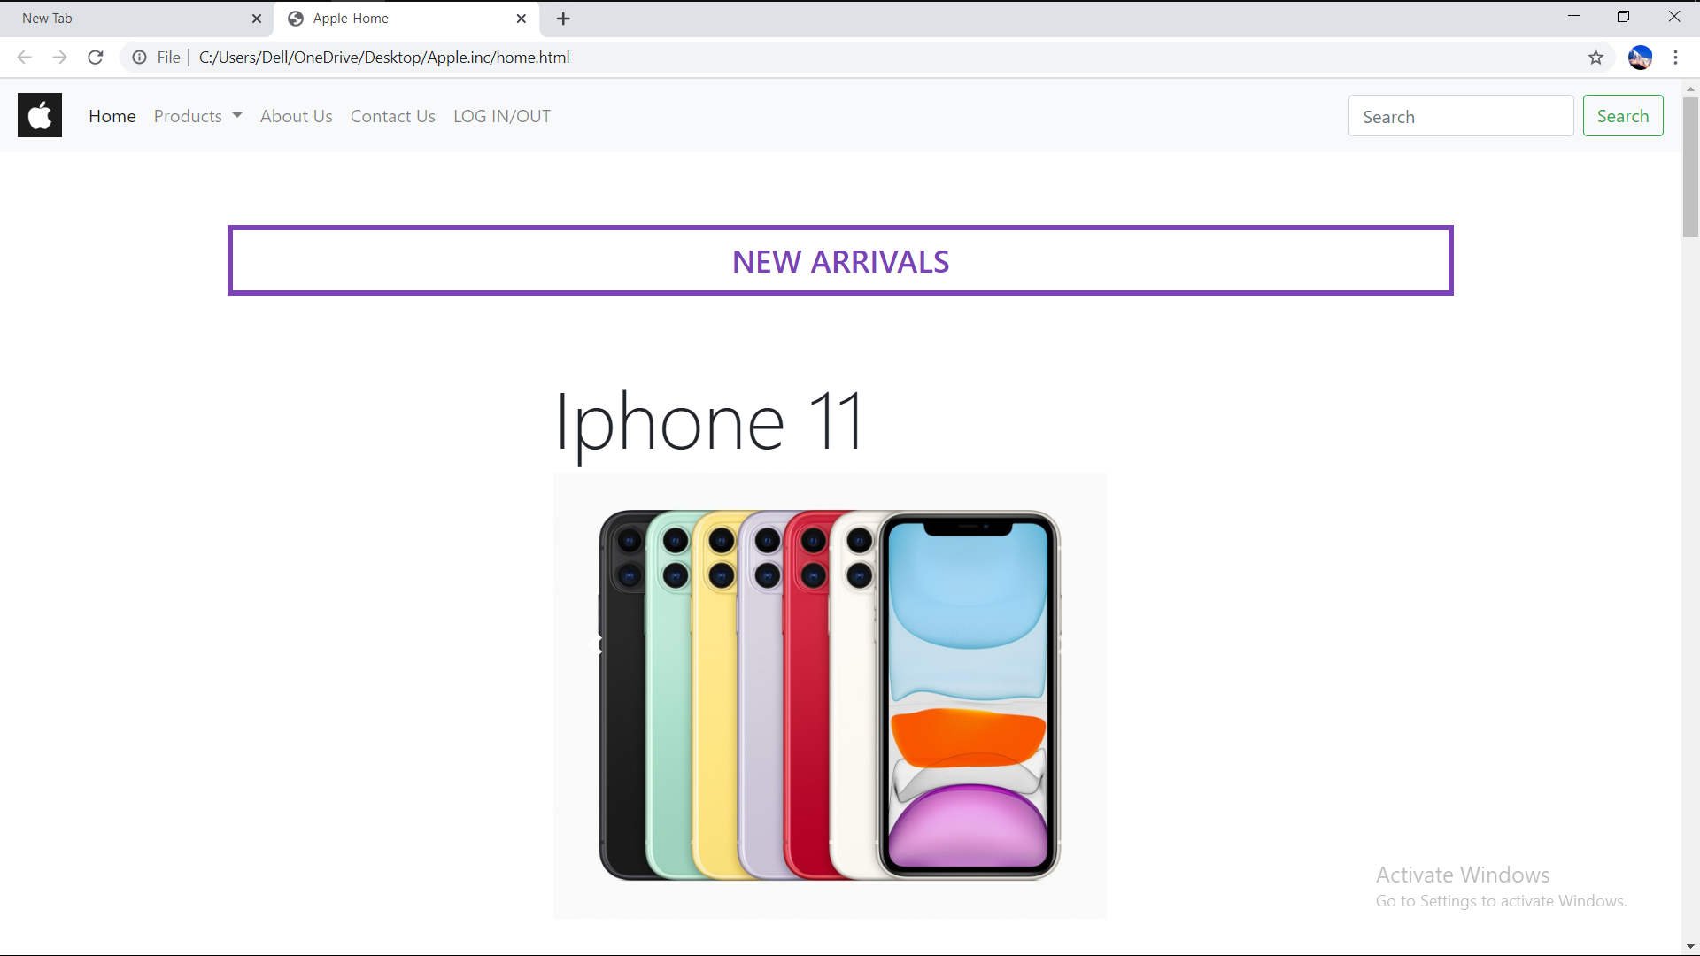

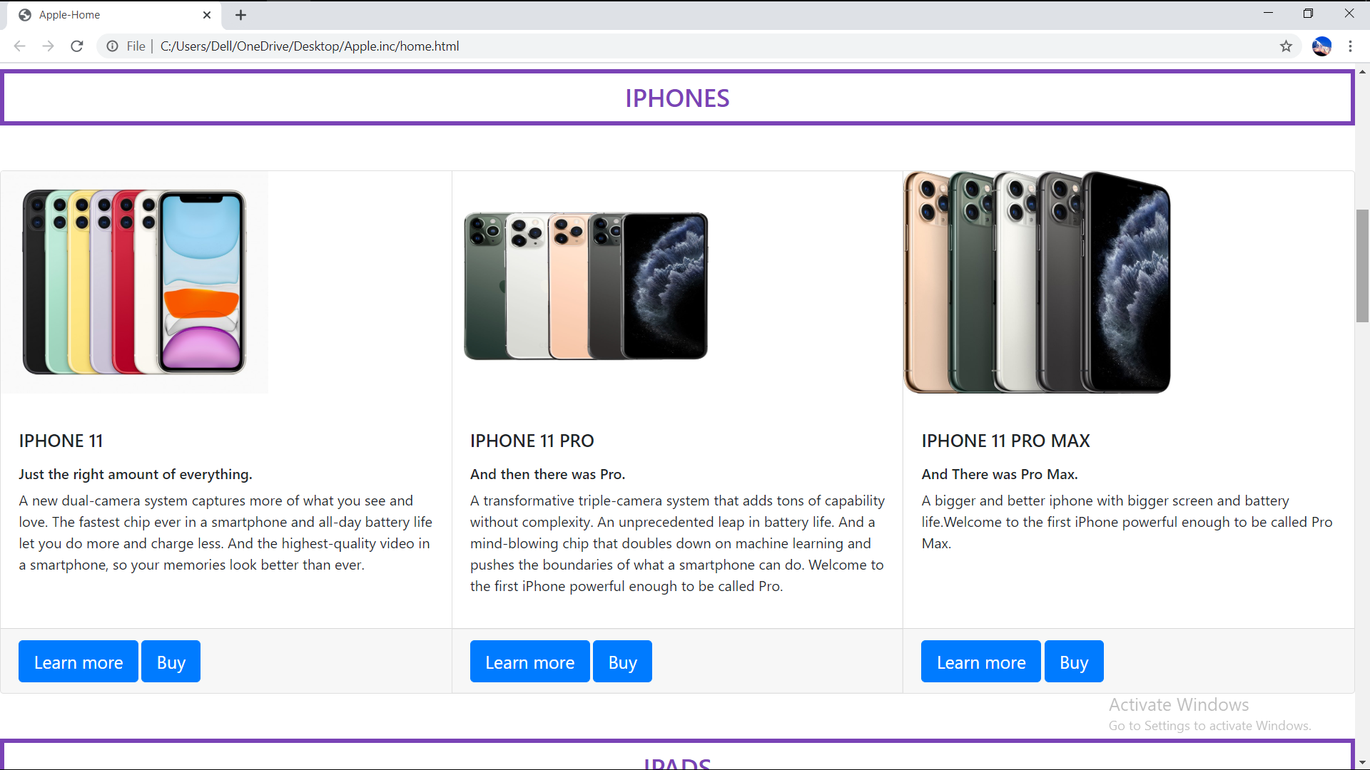

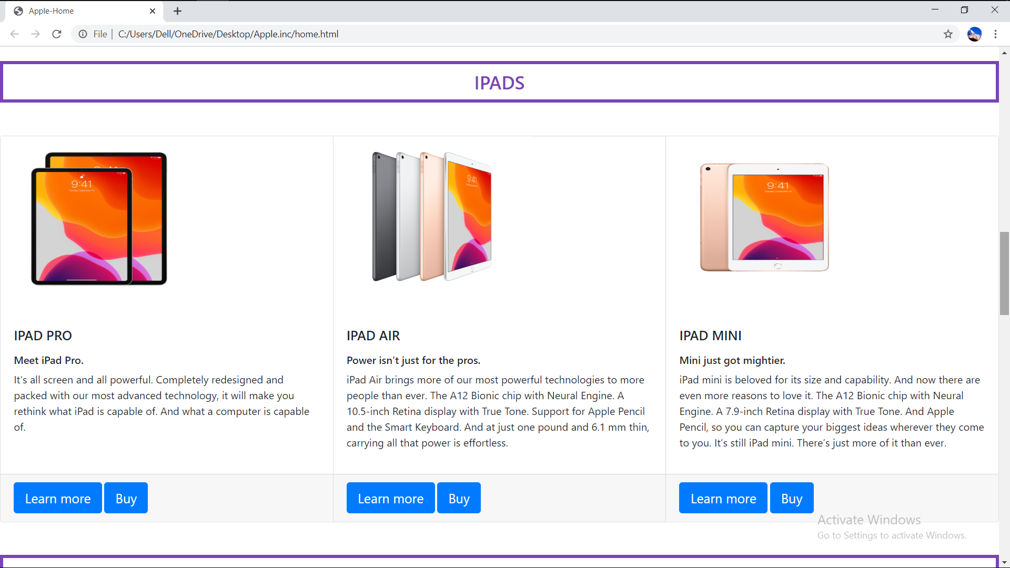

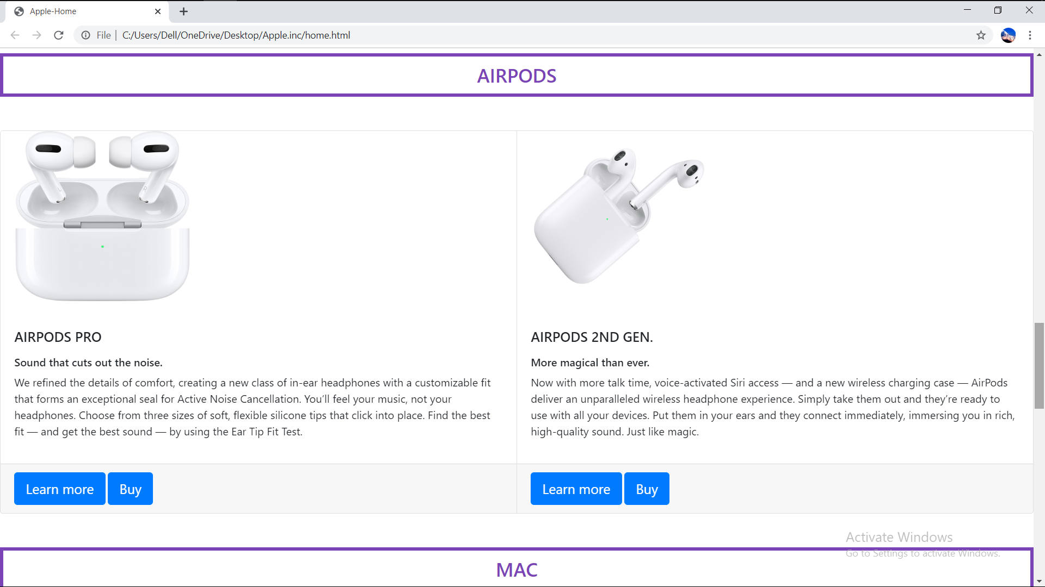

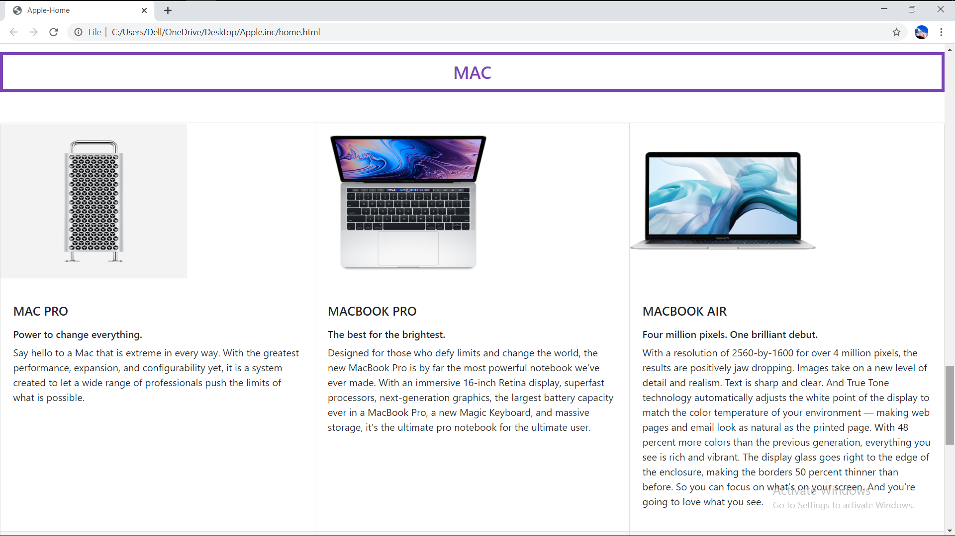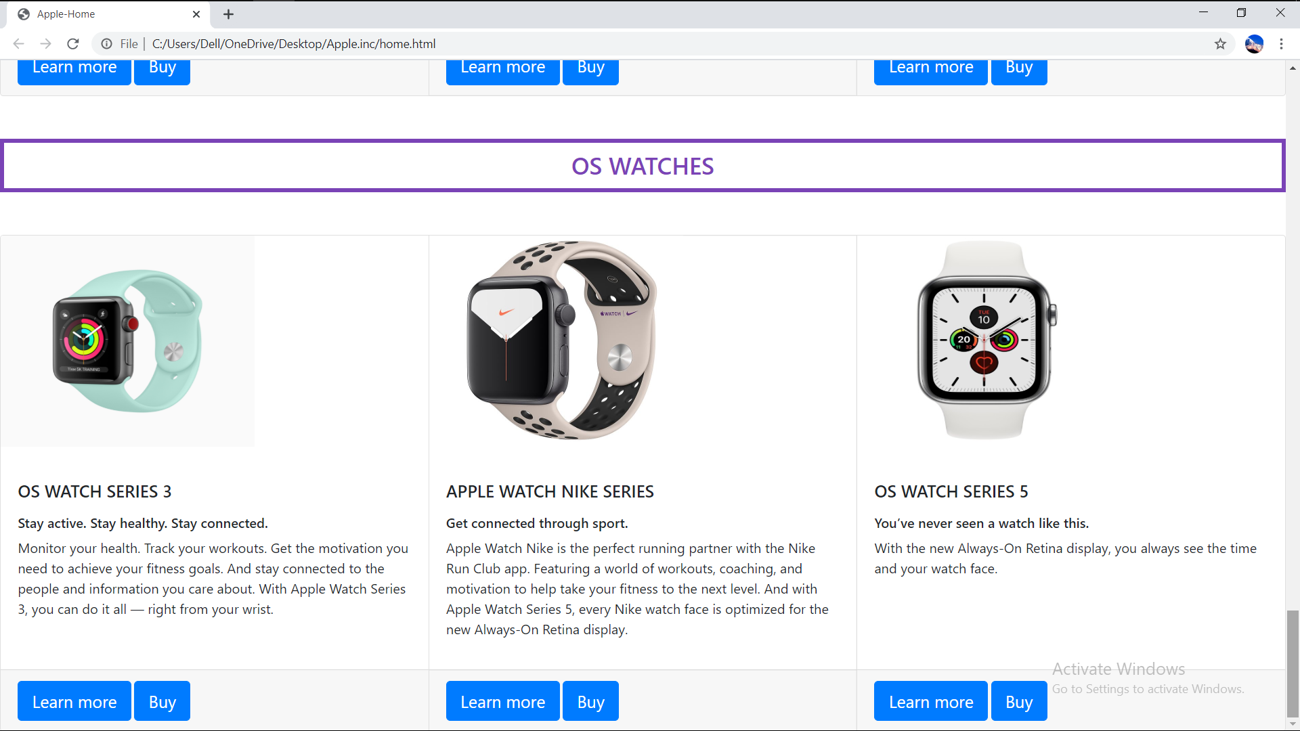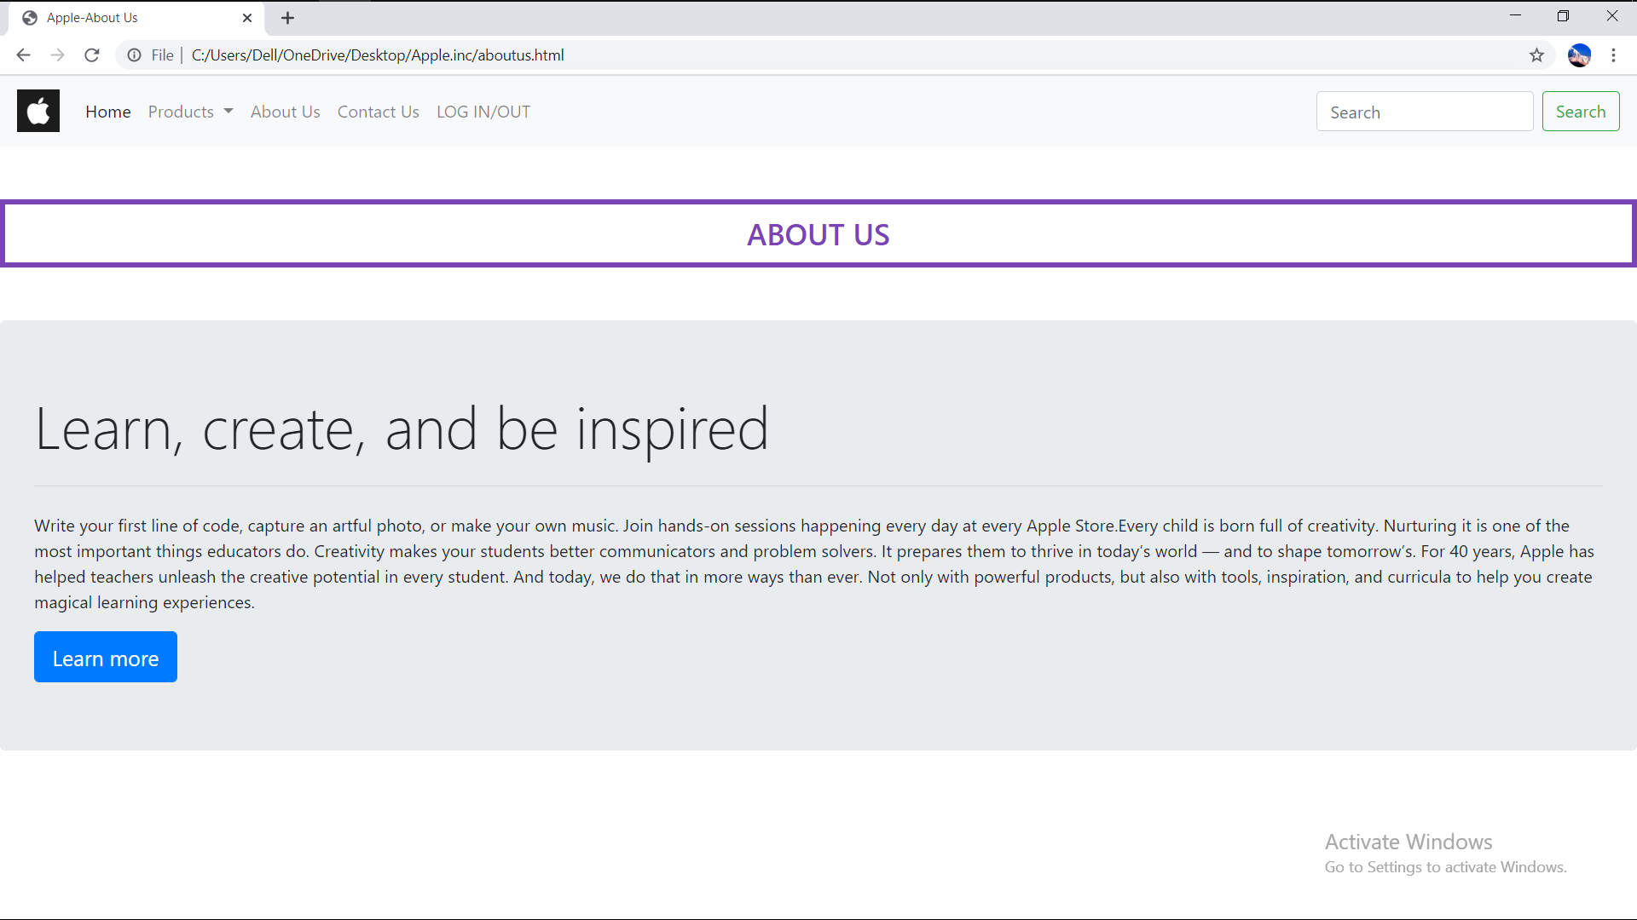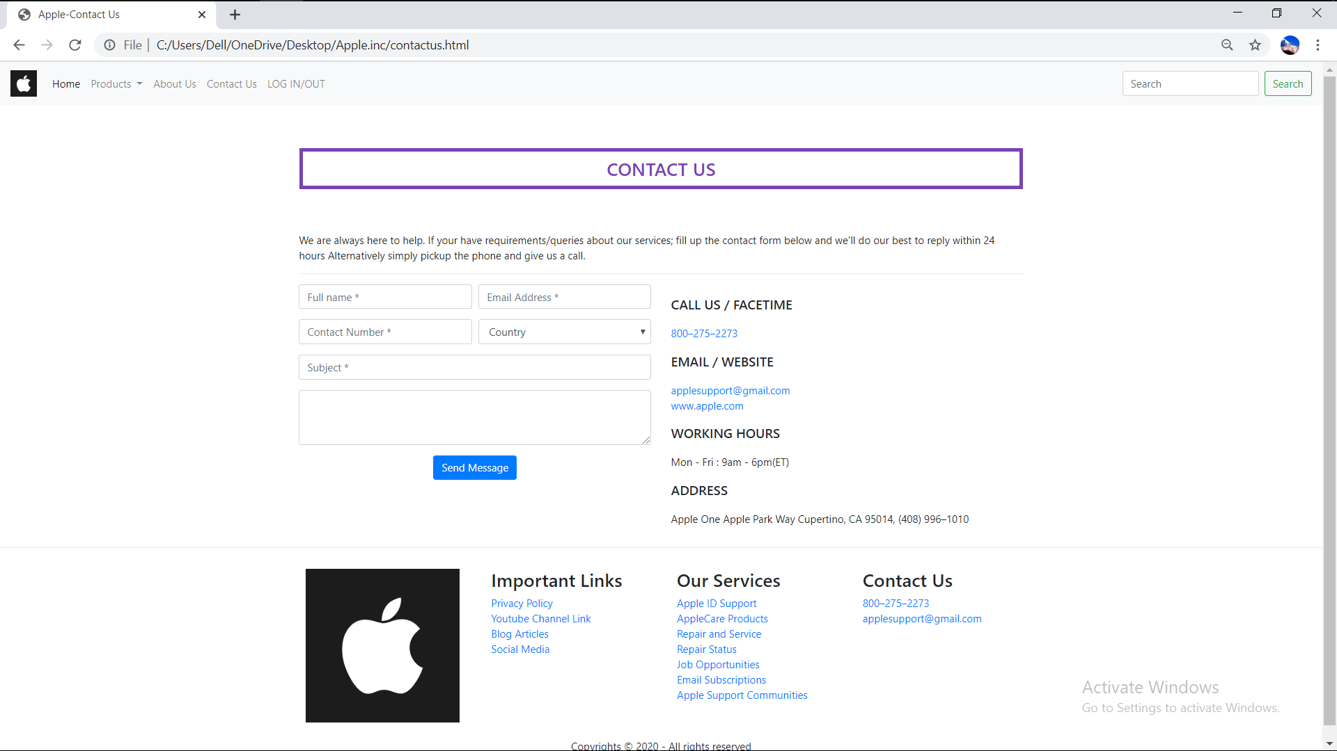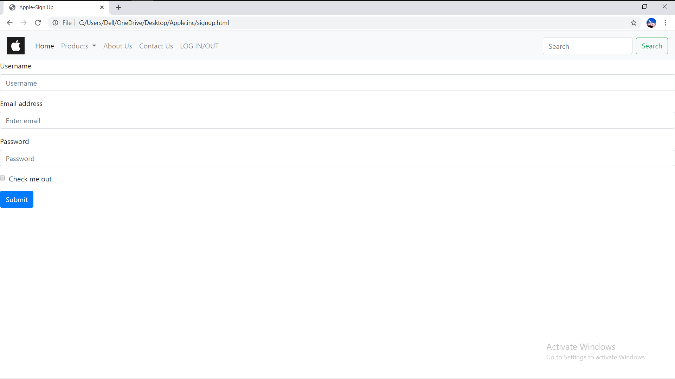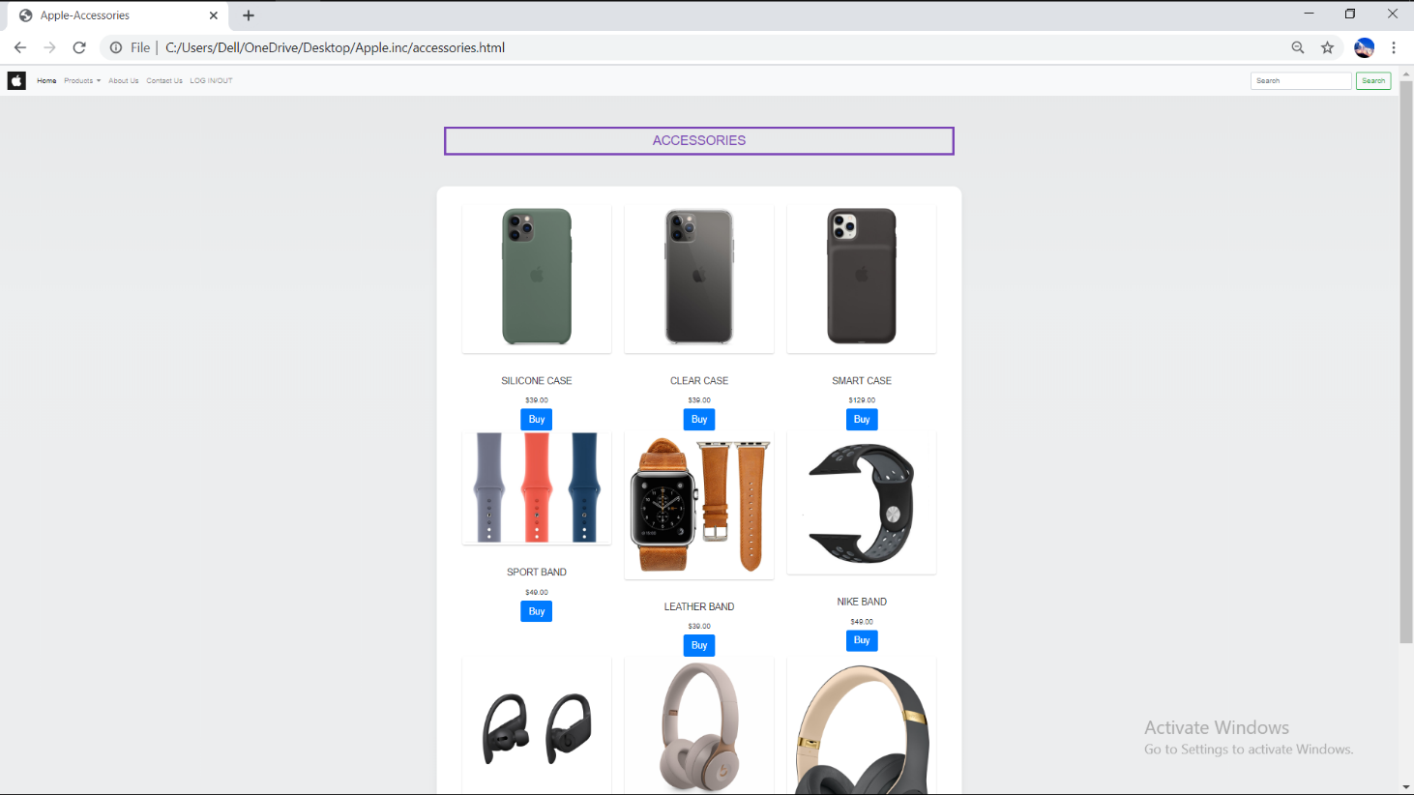

# Chapter 5: CONCLUSION:

Hence, the project work gives information about the HTML in detail and the types of tags and the ways to use those tags. Through the help of this project we were able to understand the meaning of HTML and the types of tags and the proper way of using those tags to create webpage and design it in an attractive way that can catch the eye of the user very easily.

## 5.1) Lesson Learnt

Thus, through this project we were able to gain more knowledge about creating a webpage and the process used to create it. So, I would like to thank our computer teacher once again for assigning us this project and giving us the chance of acknowledging our skills through this project.

## 5.2) Recommendation

After preparing this project, I got a chance to know about the concept of webpage. So, I would like to recommends thank to all the friends, teachers and all the helping hands for providing their supportive ideas to accomplish the project work.

# References:

* Internet
* Subject Teacher
* Friends
* Seniors
* Course book
* Apple Inc.