

**DEVESH GUPTA**

**MCA (1st Year , 1st Sem)**

**ROLL NO. : 22MCF1R18**

**(Computer Game Development and Animation)**

**Assignment- 02**

**Description:**

* Create a Design for *Calculator* with some Features Like Addition, Subtraction and Multiplication only
* Calculator Background must be Pink Colour

**Project Title : Let’s Calculate**

**Tech Used :** HTML, CSS & Java Script

**< SCREENSHOT FILE >**

1. **Starting Page**

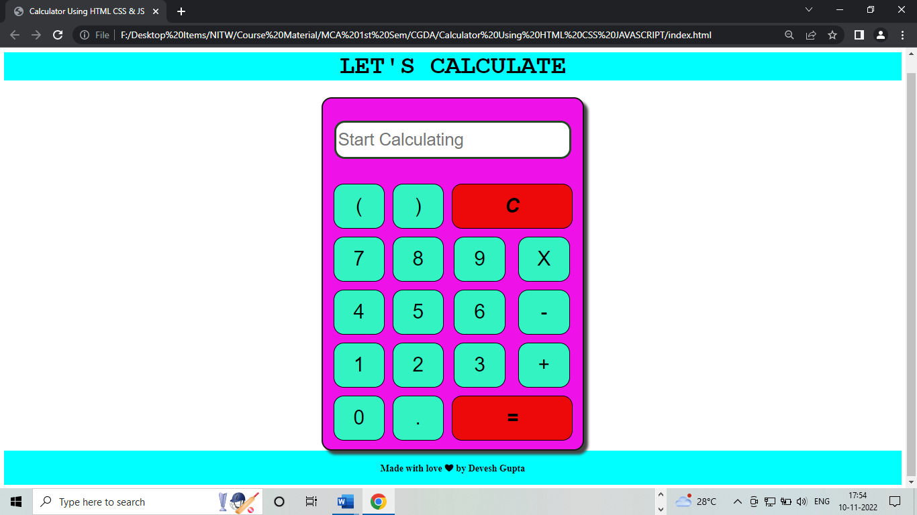

1. **Calculation (150*8)**

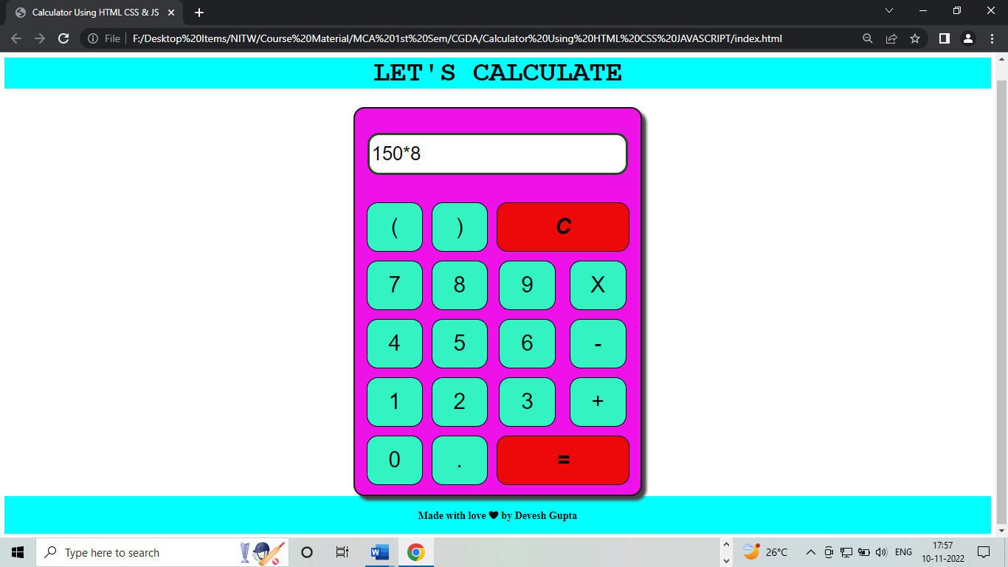

1. **Result (150*8 = 1200)**

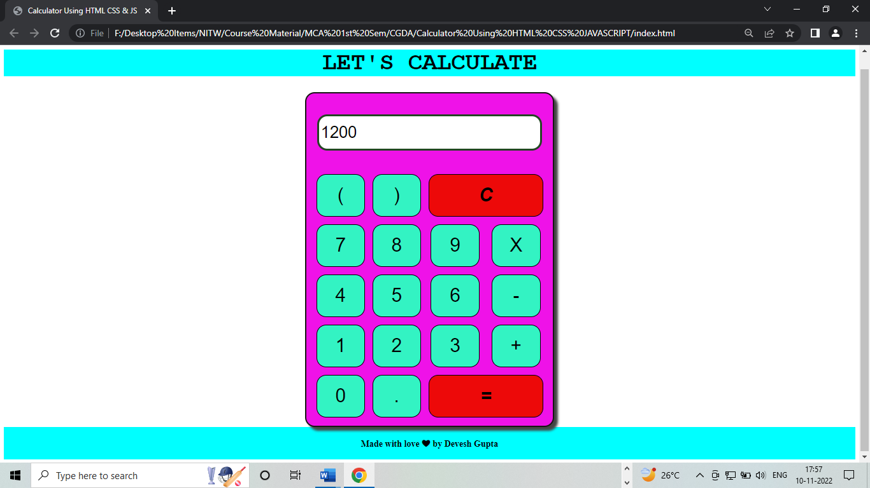

1. **Simplification (7.5-3.4)*5**

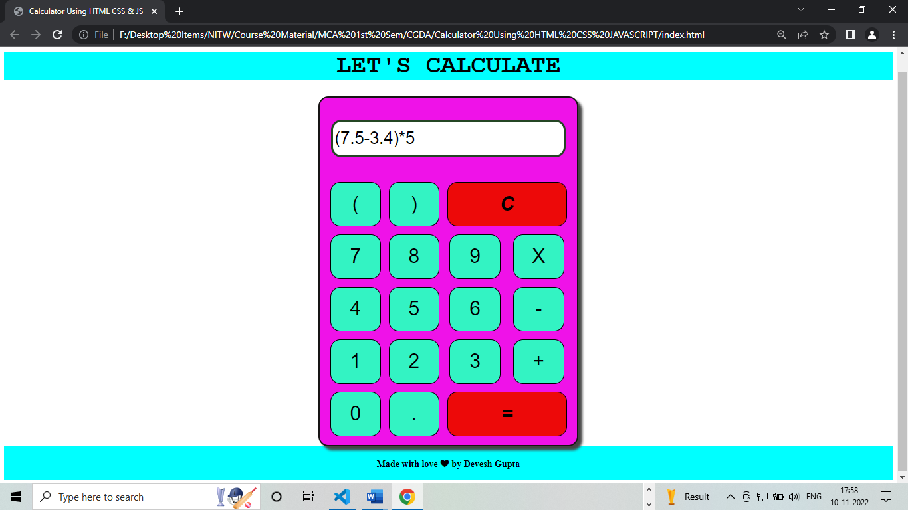

1. **Result (7.5-3.4)*5 = 20.5**

