ASSIGNMENT-4
# Traffic Monitoring System
import cv2
import numpy as np
import os
img = cv2.imread("OIP (1).jpg")
gray = cv2.cvtColor(img, cv2.COLOR_BGR2GRAY)
# ---------- Edge Detection ----------
sobel = cv2.Sobel(gray, cv2.CV_64F, 1, 1, ksize=5)
canny = cv2.Canny(gray, 100, 200)
# ---------- Contours ----------
contours, _ = cv2.findContours(canny, cv2.RETpython traffic_monitoring.pyR_EXTERNAL, cv2.CHAIN_APPROX_SIMPLE)
output = img.copy()
for cnt in contours:
x,y,w,h = cv2.boundingRect(cnt)
cv2.rectangle(output, (x,y), (x+w,y+h), (0,255,0), 2)
area = cv2.contourArea(cnt)
perimeter = cv2.arcLength(cnt, True)
print("Area:", area, "Perimeter:", perimeter)
# ---------- Feature Extraction ----------
orb = cv2.ORB_create()
kp, des = orb.detectAndCompute(gray, None)
orb_img = cv2.drawKeypoints(img, kp, None)

# ---------- Save ----------
os.makedirs("outputs", exist_ok=True)
cv2.imwrite("outputs/sobel.jpg", sobel)
cv2.imwrite("outputs/canny.jpg", canny)
cv2.imwrite("outputs/contours.jpg", output)
cv2.imwrite("outputs/orb.jpg", orb_img)
print("Processing Complete")
INPUT IMAGE
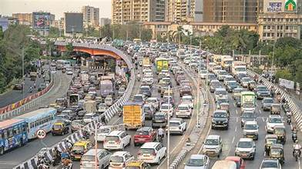
OUTPUT IMAGES
(a)SOBEL IMAGE
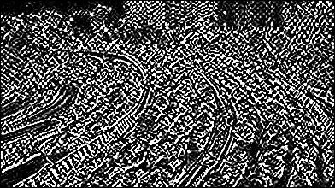
(b) Orb image
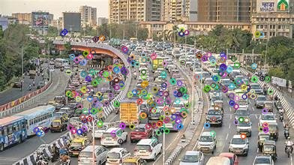
(c) contours image
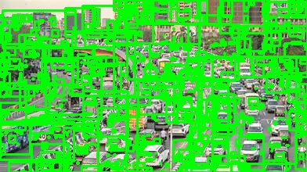
(d) canny image
