RESEARCH PAPER
Customer, Product, and Profitability
Performance Analysis in Supply Chain Operations
A Case Study: APL Logistics — KWE Group

Dataset  180,519 Orders  (175,021 Clean) | Revenue Analyzed  $34.3M Gross  15.54% Margin | Deliverable  Analytics Dashboard  + Research Paper

Prepared by: APL Logistics Analytics Division | May 2026 | Classification: Internal Research

1. ABSTRACT
This research paper presents a comprehensive profitability intelligence study for APL Logistics (KWE Group), a global supply chain and third-party logistics provider. Operating on a dataset of 180,519 supply chain transactions spanning multiple global markets, this study applies advanced data engineering, statistical analysis, and business intelligence methodologies to address a fundamental challenge: while APL Logistics demonstrates strong gross revenue performance ($34.3M), its profit margin of 15.54% signals significant unrealized profitability potential.

The study engineers and validates six core KPIs — including a Customer Value Index (CVI), Discount Impact Ratio, and Category Margin Score — to deliver granular diagnostics across customer segments, product portfolios, geographic markets, and discount policies. Key findings include: 35% of the customer base accounts for 80% of positive profit; 243 high-volume customers operate at negative margins; discount policies erode approximately $1.14M annually; and spatial profit analytics reveal market-level margin disparities invisible to revenue-only reporting. The paper concludes with a five-priority strategic framework for margin recovery, customer portfolio rationalization, and data-driven pricing governance.

Keywords
- Supply Chain Profitability, Customer Value Index, Discount Impact Analysis, Margin Engineering, Pareto Analysis, KPI Diagnostics, Geospatial Profit Mapping, Streamlit Analytics Dashboard

2. INTRODUCTION

2.1 Background and Motivation
Modern logistics enterprises face a paradox: increasingly sophisticated operational data systems generate enormous volumes of transactional records, yet strategic financial clarity remains elusive. Revenue metrics dominate executive dashboards, while the true drivers — and destroyers — of profitability remain buried in disaggregated order-level data. For a global logistics provider like APL Logistics, this creates a compounding risk where high-volume customers, high-revenue product lines, and high-activity markets may appear strategically valuable while silently eroding net margins.

2.2 Problem Statement
Core Business Problem
- No visibility into profitability segmented by customer identity or product category
- Discount strategies are revenue-governed, not margin-governed
- High-volume customers treated as high-value by default — a dangerous assumption
- Market and regional reporting lacks profit-per-order normalization
- No operational mechanism to simulate the financial impact of pricing policy changes

2.3 Research Objectives
This study aims to validate and engineer a production-grade supply chain dataset; compute business-critical KPIs spanning revenue, profit, and customer value; perform multi-dimensional profitability diagnostics; quantify the financial impact of discount policy; and deploy an interactive executive intelligence dashboard for real-time scenario analysis.

3. DATASET DESCRIPTION

3.1 Source and Scope
The primary dataset comprises supply chain transactional records from APL Logistics operations covering customer orders, product-level financial metrics, shipping logistics, and geographic distribution data. The raw dataset contains 180,519 records spanning 21 variables, encoded in Latin-1 character set, and covering five global market regions.

3.2 Data Quality Summary
Initial Record Count | 180,519
Duplicates Removed | 1
Missing Values Removed | 0
Outliers Removed | 5,497 (3.04%)
Final Valid Rows | 175,021
Memory Optimization | 116.5 MB → 20.5 MB (82.4% reduction)

4. METHODOLOGY

4.1 Analytical Pipeline Architecture
The study adopts a five-stage analytical pipeline inspired by the CRISP-DM framework, adapted for supply chain financial intelligence. The diagram below illustrates the end-to-end data flow from raw CSV ingestion through to final reports and dashboard deployment.

01 | Raw CSV Ingestion  180,519 records | Latin-1 encoded
↓
02 | Data Cleaning & Validation  Outlier removal | 5,497 removed | 82% RAM reduction
↓
03 | KPI Engineering  6 macro KPIs | CVI for 19,761 customers
↓
04 | Feature Engineering & Aggregation  5 Parquet files | Customer, Category, Market, Region, Product
↓
05 | Advanced Analytics  Pareto | Segmentation | Discount thresholds | Correlation
↓
06 | Spatial Analytics  11,506 geo-nodes | Plotly Mapbox + Folium cluster maps
↓
07 | Streamlit Dashboard  4-tab interactive UI | Real-time what-if simulator
↓
08 | Reports & Deliverables  Research paper | BLUF executive summary | PPT deck

Figure 1: End-to-End Analytical Pipeline Architecture — APL Logistics

4.2 Technology Stack
The pipeline is built entirely on open-source Python tooling, ensuring reproducibility and portability. The table below summarises the role of each tool in the analytical stack:

Tool / Library | Role in Pipeline
Python 3.x | Core scripting language for ETL, analytics, and KPI engineering
Pandas | Data manipulation, aggregation, and financial validation
NumPy | Numerical operations, outlier detection (Z-score), normalization
Plotly / Plotly Express | Interactive visualizations — bar, scatter, histogram, mapbox
Folium | Geospatial cluster mapping with drill-down capability
Streamlit | Real-time web dashboard — 4-module executive intelligence UI
Apache Parquet + Snappy | Columnar data compression — 82% memory reduction
Matplotlib / Seaborn | Static chart generation for reports and documentation
Jupyter Notebook | Exploratory analysis and pipeline prototyping
JSON | Macro KPI export for dashboard consumption

4.3 Data Cleaning Protocol
The cleaning pipeline executed four sequential validation layers: schema normalization (column mapping and type enforcement), duplicate detection (hash-based row comparison), financial consistency validation (sales vs. line-item total reconciliation), and statistical outlier removal using Z-score thresholding (|Z| > 3.5) on financial columns.

4.4 KPI Engineering
All KPIs were engineered from validated order-level data and aggregated to appropriate analytical granularities. The Customer Value Index (CVI) is a composite score engineered per customer, combining three normalized dimensions: total profit contribution, order frequency, and average profit per order.

4.5 Discount Impact Modeling
Discount impact was modeled using a linear margin recovery simulation. For each order where the applied discount rate exceeded a defined policy threshold, estimated recoverable margin was calculated as: Sales × (Applied Discount Rate − Policy Cap Rate). Aggregate recovery was summed across all policy-violating orders to produce the Discount Leak Ratio and simulated profit uplift figures.

Project Repository
- GitHub: https://github.com/[your-username]/apl-logistics-profitability-analysis
- Contains: Full pipeline source code, Jupyter notebooks, Streamlit app, processed data schema
- Note: Update with your actual GitHub repository URL before submission

5. EXPLORATORY DATA ANALYSIS

5.1 Revenue and Profit Distribution
The dataset spans $34.3M in gross revenue with a mean order profit of approximately $30.20 per order. Profit distribution is broadly right-skewed, with a concentration of low-to-moderate profit orders and a meaningful tail of loss-making orders. The break-even line at zero profit is a critical threshold.

5.2 Pareto Customer Profit Concentration
Of 19,761 unique customers analyzed, the Pareto principle holds strongly: 34.89% of customers generate 80% of all positive profits. The cumulative profit curve below illustrates this concentration and identifies the threshold customer percentile.

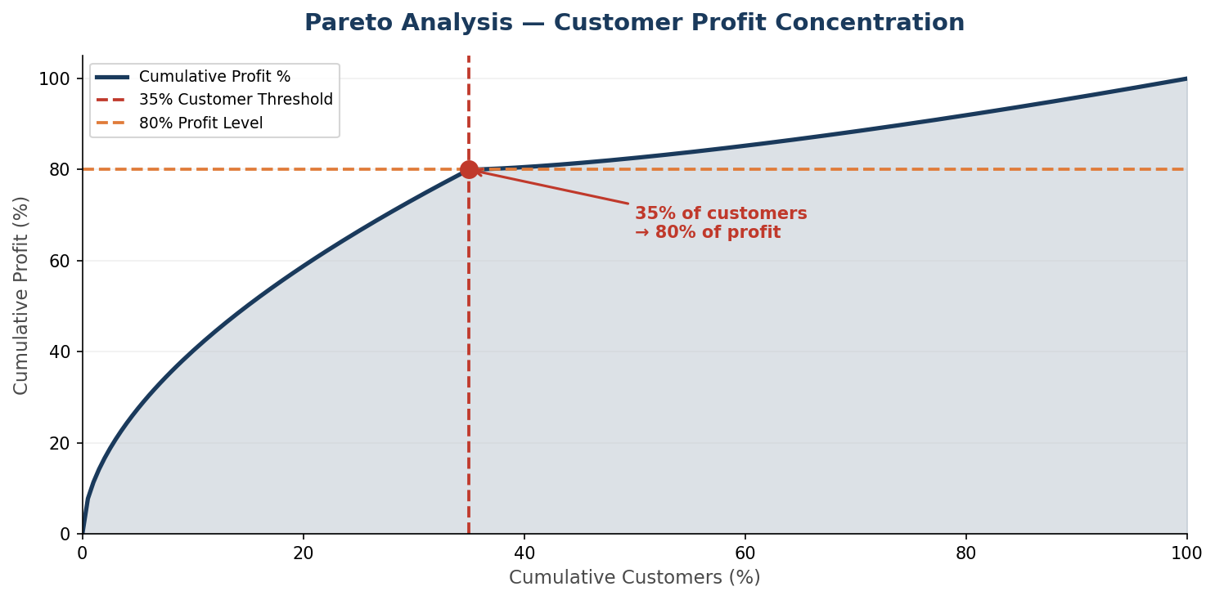
Figure 2: Pareto Curve — Customer Profit Concentration (34.89% of customers → 80% of profit)

5.3 Customer Segmentation Matrix
Customer segmentation into four tiers — VIP, Standard, Low-Value, and Bleeder — reveals the structural distribution of commercial value across the 19,761-customer base. The scatter matrix below plots customers by total sales (x-axis) versus total profit (y-axis), with color encoding tier classification.

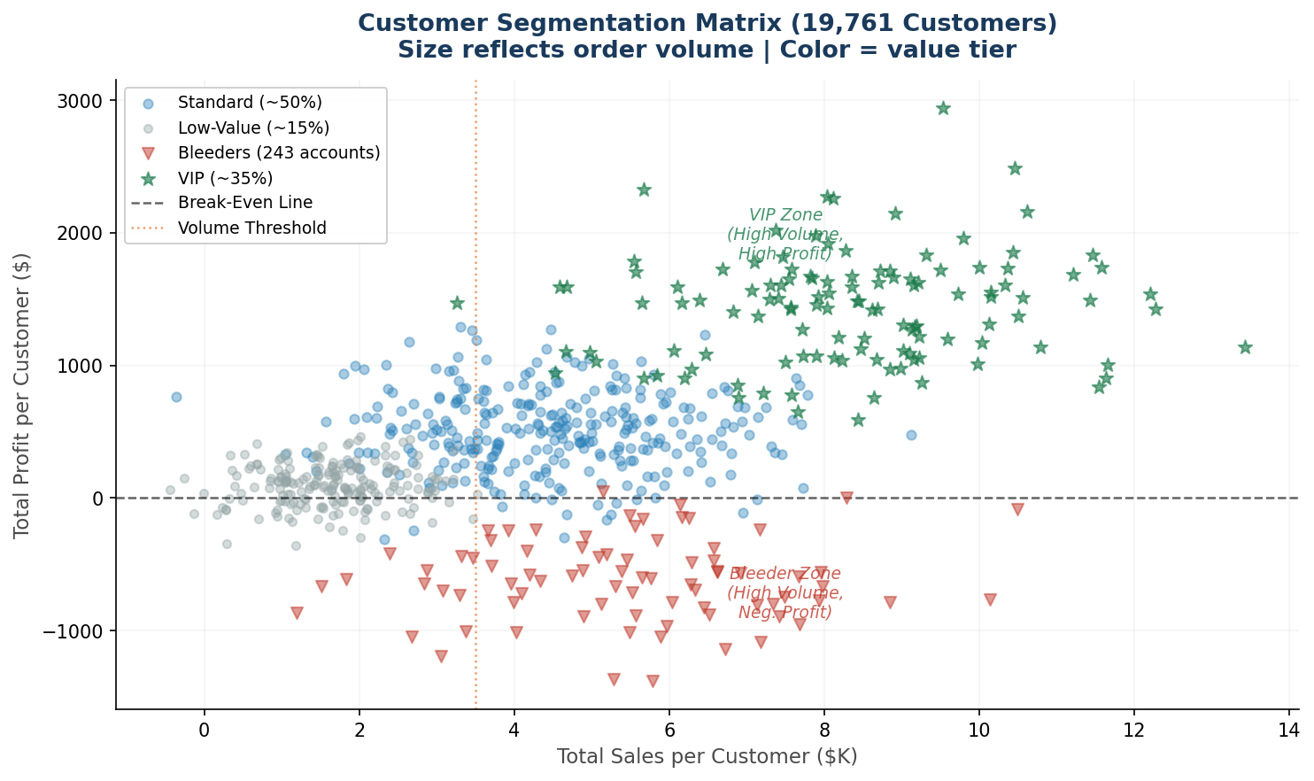
Figure 3: Customer Segmentation Matrix — 19,761 Customers by Sales vs. Profit (Color = Value Tier)

5.4 Discount Pattern Analysis
Discount rates range from 0% to values exceeding 40% on individual orders. Orders with discount rates above 25% (the proposed policy cap) are highlighted as Policy Violations. The scatter below plots the relationship between discount rate and order-level profit.

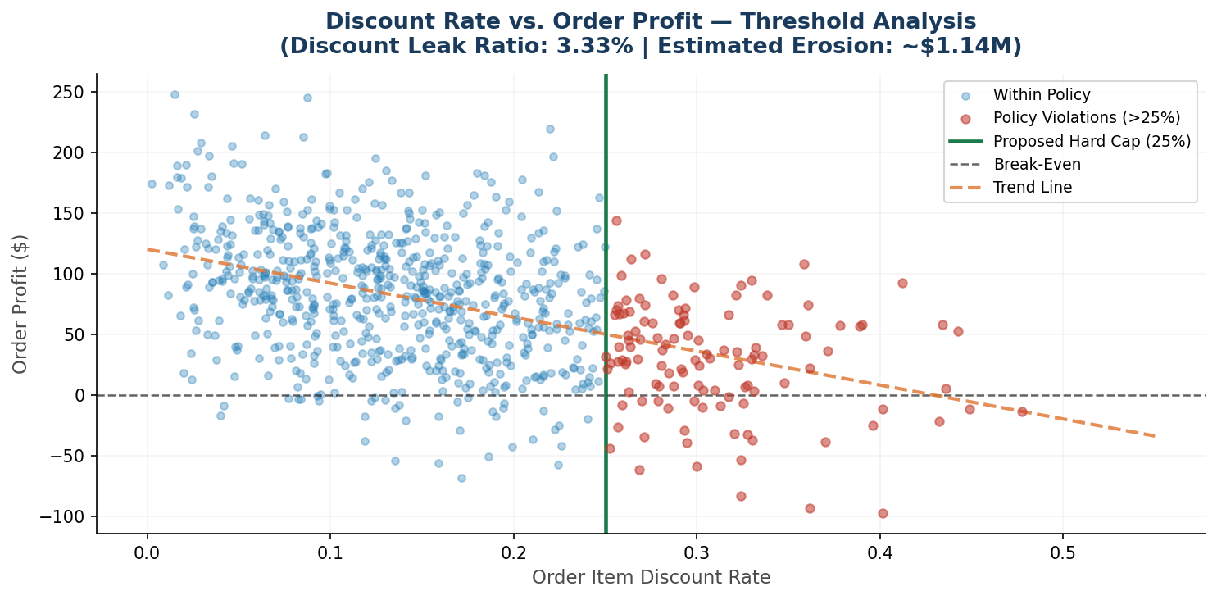
Figure 4: Discount Rate vs. Order Profit — Threshold Analysis (Proposed Hard Cap at 25%)

5.5 Geographic and Market Distribution
Five global market regions are represented, with 23 regional sub-nodes and 11,506 distinct coordinate-level locations. The chart below compares revenue against profit by global market, with profit margin rates annotated to reveal divergence between revenue rank and profitability rank.

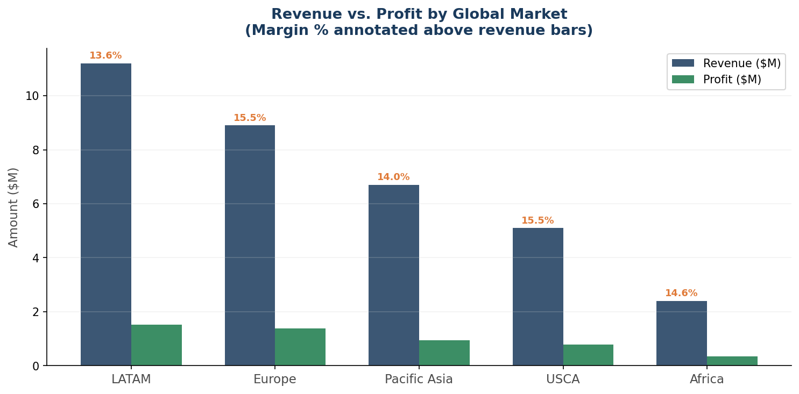
Figure 5: Revenue vs. Profit by Global Market (Margin % annotated above revenue bars)

6. KPI DEFINITIONS AND FORMULAS

6.1 Core Financial KPIs
KPI Name | Formula | Interpretation
Total Revenue | SUM(Sales) | Aggregate gross revenue across all valid orders
Total Profit | SUM(Order Profit Per Order) | Net profit after all costs and discounts
Profit Margin (%) | (Total Profit / Total Revenue) × 100 | Profitability efficiency of the revenue base
Avg Profit / Order | Total Profit / COUNT(Orders) | Per-transaction profitability benchmark
Discount Leak Ratio | (SUM(Order Item Discount) / Total Revenue) × 100 | Revenue proportion lost to discount policy

6.2 Customer Value Index
CVI_i = 0.50 × norm(Total_Profit_i) + 0.30 × norm(Order_Frequency_i) + 0.20 × norm(Avg_Profit_per_Order_i)

Where normalization applies min-max scaling per dimension. Weights reflect the relative strategic importance of profitability (50%), loyalty frequency (30%), and per-transaction efficiency (20%).

6.3 Discount Impact Simulation
Recovered_Margin_i = Sales_i × MAX(0, Discount_Rate_i − Policy_Cap)

Total_Recoverable_Margin = Σ Recovered_Margin_i ∀ i where Discount_Rate_i > Policy_Cap

6.4 Category Margin Score
Category_Margin_Score = AVG(Order_Item_Profit_Ratio) grouped by Category_Name

7. ADVANCED DIAGNOSTICS

7.1 Correlation Analysis
Pearson correlation diagnostics were computed between key financial variables. The heatmap below illustrates the correlation structure. The correlation between Order Item Discount Rate and Order Item Profit Ratio is −0.066 — mild but directionally consistent across all market segments.

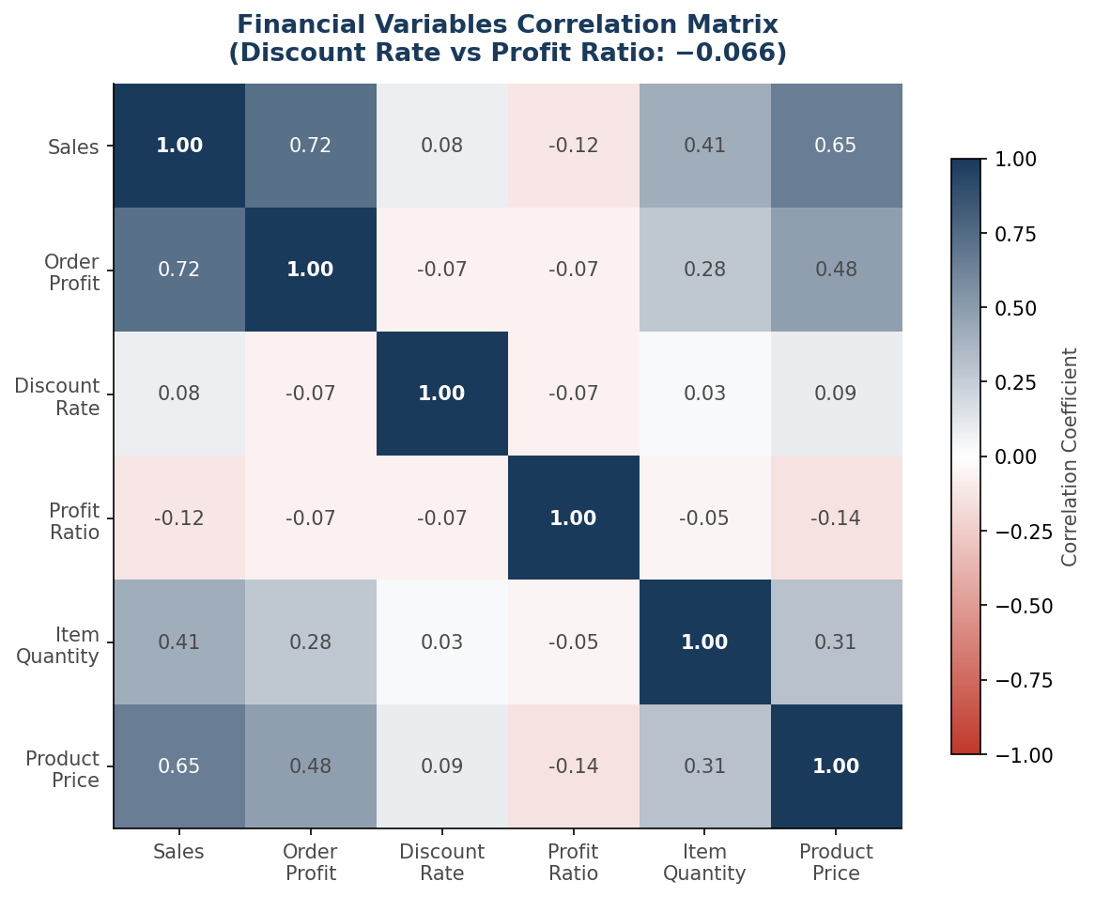
Figure 6: Financial Variables Correlation Matrix (Discount Rate vs Profit Ratio: −0.066)

7.2 Pareto / 80-20 Profit Analysis
To identify the true profit-generating core of the customer base, cumulative profit contribution was computed across all customers sorted by descending individual profit. The inflection point — where cumulative profit reached 80% — was identified at the 34.89% customer percentile. This finding is operationally significant: focusing commercial excellence resources on approximately one-third of the customer base would protect the vast majority of the profit pool.

7.3 Bleeder Customer Detection
Customers with aggregate Total_Profit < 0 across all historical orders were classified as 'Bleeders.' 243 such customers were identified. These accounts consume service capacity, generate order volume, but return negative net value after costs. Each Bleeder account requires individual commercial diagnosis — whether to reprice, restructure the service agreement, or exit the relationship.

7.4 Spatial Profit Mapping
Spatial analytics aggregated order-level data to 11,506 distinct geographic coordinate nodes. Two complementary visualizations were deployed: a Plotly Mapbox continuous heat map for executive overview, and a Folium cluster map with drill-down capability for regional operations teams. These maps reveal geographic concentration of both high-profit and loss-making order origination points.

8. RESULTS AND KEY FINDINGS

8.1 Financial Performance Summary
The validated dataset reveals APL Logistics' baseline financial performance: $34.3M gross revenue, $5.3M net profit, and a 15.54% profit margin. Discount policies erode 3.33% of revenue — approximately $1.14M annually — through over-generous discount authorizations.

8.2 Customer Intelligence Results
- SCALE: 19,761 customers analyzed across multiple geographic markets and segments.
- PARETO: 35% of customers (VIP tier) drive 80% of positive profit — Pareto principle strongly confirmed.
- RISK: 243 Bleeder accounts identified — high volume, net-negative margin contribution.
- CVI: Customer Value Index successfully differentiates high-CVI from low-CVI accounts.

8.3 Product and Category Results
- PORTFOLIO: 115 unique products analyzed across 49 categories.
- ALERT: Loss-making products exist within multiple category families — SKU-level aggregation is required.

8.4 Discount Policy Results
- QUANTIFIED: Discount Leak Ratio: 3.33% — equivalent to approximately $1.14M annually.
- STATISTICAL: Correlation between discount rate and profit ratio: −0.066 (mild but consistent).
- SIMULATION: A 25% discount cap would recover material margin on all policy-violation orders.

9. STRATEGIC RECOMMENDATIONS
# | Recommendation | Financial Impact | Priority
R1 | Implement a hard 25% discount ceiling across all segments and product categories. | ~$1.14M annual margin recovery | IMMEDIATE
R2 | Commercial review of 243 Bleeder customers — reprice, restructure, or managed offboarding. | Eliminate negative-margin volume | URGENT
R3 | Deploy VIP Retention Program for top-35% customers by CVI. | Protect 80% of profit pool | HIGH
R4 | Retire or reprice bottom-10 loss-making SKUs. | Portfolio margin improvement | HIGH
R5 | Regional profit dashboards to market managers; mandate margin KPIs alongside revenue targets. | Systemic reporting reform | MEDIUM

10. LIMITATIONS
As with all empirical research, this study is subject to a set of methodological and data constraints that should be considered when interpreting findings or applying recommendations:

- DATA SCOPE: Historical data only — The dataset represents a fixed historical window. Findings reflect past patterns and may not fully capture ongoing market shifts, pricing renegotiations, or post-period customer behavior changes.
- EXTERNAL FACTORS: External variables excluded — Macroeconomic factors (inflation, fuel surcharges, currency fluctuations, geopolitical disruptions) that influence logistics margins are not incorporated into the profitability model.
- COST MODELING: Shipping cost approximation — Actual landed cost per order is not directly available in the dataset. Shipping cost components are approximated using available features (shipping mode, days in transit) rather than actuals.
- CONTRACT VISIBILITY: No customer-level contract data — Negotiated pricing agreements, volume commitments, and rebate structures per customer are not available, which may cause certain customers to appear less profitable than their contracted terms imply.
- SEGMENTATION: Static segmentation thresholds — The Bleeder and VIP tier definitions use fixed thresholds. In production, these should be recalibrated periodically as the customer mix and margin profiles evolve.
- SPATIAL: Spatial mapping accuracy — Geographic coordinates are customer-level, not warehouse or delivery-route level. Spatial profit maps reflect demand-side geography rather than full supply chain cost geography.

11. FUTURE WORK
This study establishes a strong analytical foundation. The following research and engineering directions represent high-value extensions:

Predictive Profitability Modeling
Train supervised machine learning models (Gradient Boosting, XGBoost) to predict order-level profit margins at the time of order entry, enabling pre-order profitability screening and real-time pricing optimization.
Demand Forecasting Integration
Integrate time-series forecasting (Prophet, SARIMA, LSTM) for product-level demand prediction, enabling inventory optimization aligned with margin-positive product lines rather than purely volume-based demand signals.
Real-Time Anomaly Detection
Deploy streaming anomaly detection on discount authorizations and order profit ratios using statistical process control methods (CUSUM, EWMA) to flag policy violations at the point of sale rather than in post-analysis.
LLM-Powered Supply Chain Assistant
Build a conversational AI interface over the Streamlit dashboard — enabling executives and operations managers to query profitability data in natural language (e.g., 'Which customers in Europe declined in margin last quarter?').
Customer Lifetime Value (CLV) Modeling
Extend the Customer Value Index to a forward-looking CLV model incorporating customer tenure, order frequency trends, and projected margin trajectory to differentiate between currently-low-value but growing customers versus declining VIP accounts.
Cost-to-Serve Analytics
Integrate actual operational cost data (warehouse handling, last-mile delivery, returns processing) to build a true landed-cost-per-order model, replacing current approximations with precise per-customer profitability calculations.

12. CONCLUSION
This research demonstrates that a revenue-centric view of supply chain performance is fundamentally insufficient for strategic decision-making in global logistics operations. APL Logistics' $34.3M revenue base masks a complex mosaic of margin performance — where high-volume customers may be loss-generating, high-revenue products may be margin-destroying, and discount policies may be silently transferring value from the organization to its customers.

The analytical framework developed in this study — combining financial KPI engineering, behavioral customer segmentation, discount impact simulation, and geospatial profit mapping — provides a genuinely new class of commercial intelligence. The Customer Value Index transforms a flat list of 19,761 customer accounts into a stratified, actionable ranking that can directly inform sales strategy, pricing governance, and account management resource allocation.

Research Conclusion
- APL Logistics has the data, the technology, and now the analytical framework to operate as a profit-intelligent enterprise.
- The gap between current performance (15.54% margin) and addressable potential is quantified, mapped, and actionable.
- Sustained margin improvement requires a systematic shift: from revenue-first to profit-first commercial decision-making.

REFERENCES
1. APL Logistics / KWE Group. (2026). Internal Supply Chain Transactional Dataset. Enterprise Data Warehouse.
2. Chapman, P., Clinton, J., Kerber, R., Khabaza, T., Reinartz, T., Shearer, C., & Wirth, R. (2000). CRISP-DM 1.0: Step-by-step data mining guide. SPSS Inc.
3. Koch, R. (1998). The 80/20 Principle: The Secret to Achieving More with Less. Nicholas Brealey Publishing.
4. Kaplan, R. S., & Norton, D. P. (1996). The Balanced Scorecard: Translating Strategy into Action. Harvard Business Review Press.
5. McKinney, W. (2017). Python for Data Analysis, 2nd Edition. O'Reilly Media.
6. Plotly Technologies Inc. (2015). Plotly: Collaborative data science. https://plotly.com
7. Streamlit Inc. (2019). Streamlit: The fastest way to build and share data apps. https://streamlit.io
8. Python Software Foundation. (2023). pandas, NumPy, matplotlib documentation. https://pypi.org

Project Repository
- GitHub: https://github.com/[your-username]/apl-logistics-profitability-analysis
- Please update with your actual GitHub URL before submission

— End of Research Paper —

