Problem 3

SAIC

Made a dockerfile and run the following command to

GITHUB LANGUAGES
For this file I directly used the ruby on rails image in compose file.

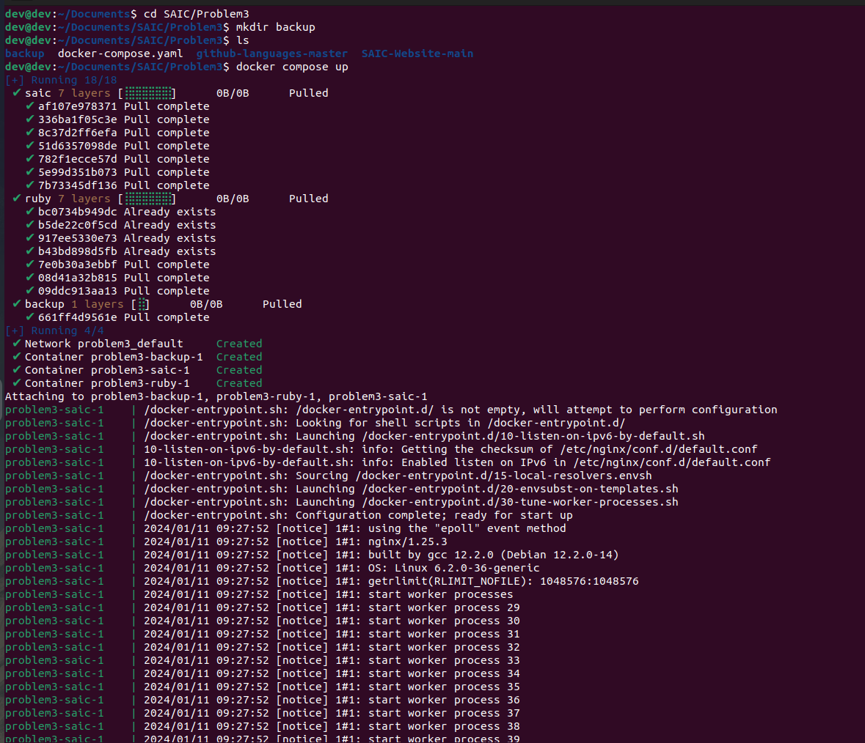
After making the the dockercompose file (the docker compose file is put in the folder) I ran the command docker compose up to build run the files .

As for the network all all the containers are already interconnected so no need to specify a diffrent network type.

For backup a shell script has been made using cron expression

sh -c "sleep 86340 && zip -r /backup/website_backup_$(date +'%Y%m%d%H%M').zip /saic /ruby"

The sleep command is used to introduce a delay before executing the backup command. In this case, sleep 86340 delays the execution for approximately 23 hours and 59 minutes (86340 seconds).

