Challenge 1 - Gain Access to a Remote Server

- (Optional) Installing theVirtual Box
  - Changing the settings
    - Enter Bios settings
    - Go to Advanced then CPU configuration
    - Set the Intel (VMX) virtualization Technology to Enabled
  - Download the Virtual box
    - Just search Virtual box on google and you can download it from virtualbox.org

So after setting up the virtual box and running The VM

This is what I did I tried logging in the saic password secured account by using various common password like 123456, password, saic but none worked.

Then I logged in the guest account. And tried looking if i could find anything.
So the first thing i did was i went into the webbrowser and typed the command “localhost” it opened a website named Xenia(LinuxFox). The first thing i did was googling up Xenia to look up for whether if there is anything related to her any known vullnerabilites. Wasted day and gave up.
Then I found out an old forum which was told me that Xenia was never the name of the fox it was just given by a random stranger.
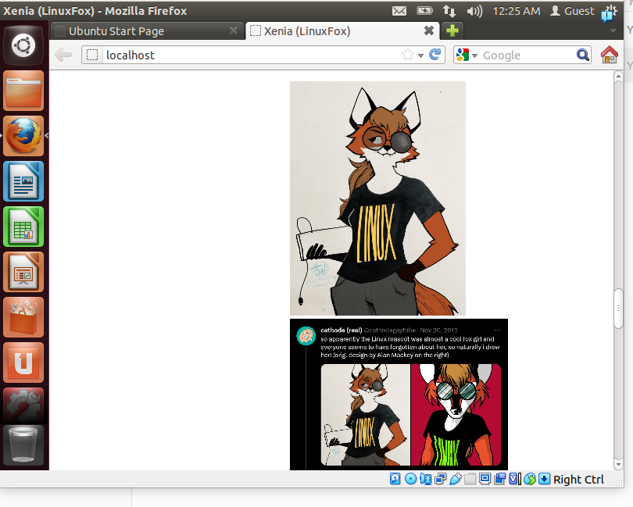
So the next thing I did was searching for Linuxfox got something and tried it but nothing worked.
Then I tried inspecting the website ad nothing worked.
But then I thought since all i need to do is to Find a way to login into the password protected account I should do that. So I did that and after intensive research I was able to find a way,
The method was as follows:
Steps:
1) Reboot your computer, and then as soon as you see the GRUB Loading screen, make sure to hit the ESC key so that you can get to the menu.

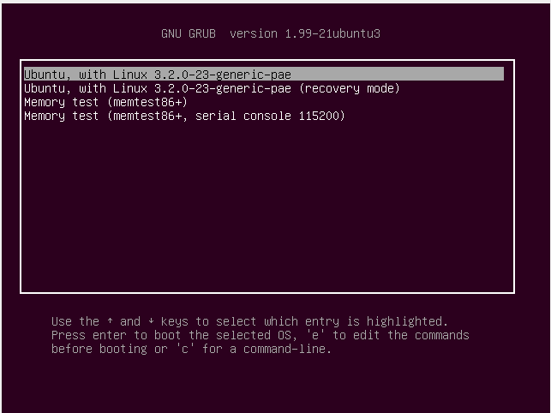
2) When this frub menu is loaded up go to Ubuntu and press ‘e’ key
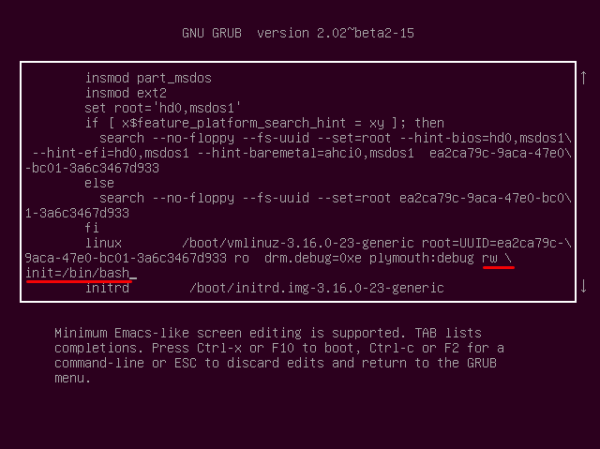
3) Now this will open up a kernel editor
4) Remove the “ro quiet splash” part with the backspace key, and then add this onto the end: rw init=/bin/bash
Press Enter and you will see a shell
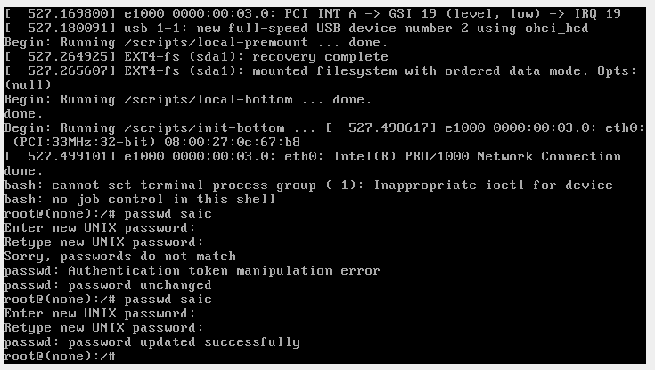
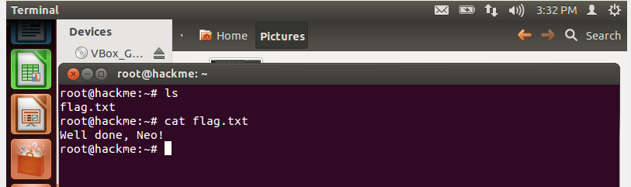
5) Now in this shell simply type passwd and it will let you directly change the password of the root user and then type passwd saic it will let you change the name of the saic
6) After this login into the saic with the new password I had setup and ws able to get in.
7) After this i tried looking for the flag, by switching to root user using su root
And then doing ls and there it was the flag.

