Problem 4
So until now I have build and deployed images locally but now this problem wants to push these images to Dockerhub and automate this entire process.
Part1:
So we can do this in the following manner
1) Login to Dockerhub(If you don’t have a account make ome)
2) Create a Repository Here I created one named saic-test
3) To be able to push and pull images using Docker CLI you need to setup a access token
For this :
Go to securiy in your account there you will be prompted to setup a account
- After that run docker login -u <username>
- At the password promt enter the personal access token
4) After setting all this up setup a bash script running which pushes the built images.
Provided is a simple script can be modified to work with multiple images at once
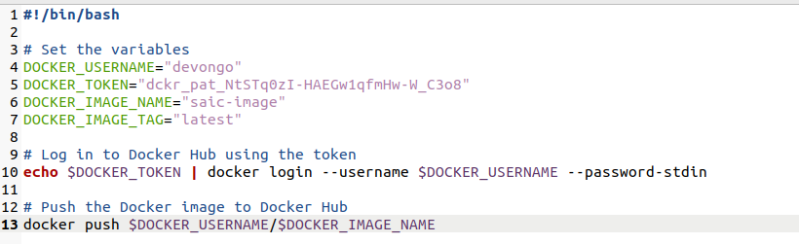

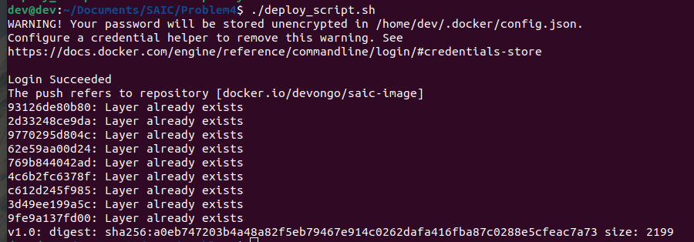
5) Run the bash script and the the file got pushed

Part 2:

“ Runs only on port 3000 inside container”.
Didn’t read this single line on dockerhub wasted 7 hours working on the compose file. Well in the end got it working. Well the solutions is not good enough but this is all i was able to come up with using my current knowledge. Hoping to learn more in future.
Made a compose file which assigns various ports to different instances.
Was unable to do anything further.

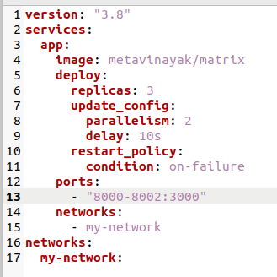

Screenshot of the compose file

