 **Assignment Cover Sheet**

|  |  |  |
| --- | --- | --- |
| **Student Information (For group assignment, please state names of all members)** | | **Grade/Marks** |
| **Name** | **ID** |  |
| Anak Agung Ayu Citra Dewi | E2100295 |  |
| Ida Ayu Sri Pramesti Dewi | E2100299 |  |
|  |  |  |
|  |  |  |

|  |  |  |
| --- | --- | --- |
| **Module/Subject Information** | | **Office Acknowledgement** |
| **Module/Subject Code** | BIT301 |  |
| **Module/Subject Name** | IT Project Management |  |
| **Lecturer/Tutor/Facilitator** | Seetha Letchumi |  |
| **Due Date** | 23 December 2024 |  |
| **Assignment Title/Topic** | Assignment 2 |  |
| **Intake (where applicable)** |  |  |
| **Word Count** | n/a | **Date/Time** |

**Declaration**

* I/We have read and understood the Programme Handbook that explains on **plagiarism**, and I/we testify that, unless otherwise acknowledged, the work submitted herein is entirely my/our own.
* I/We declare that no part of this assignment has been written for me/us by any other person(s) except where such collaboration has been authorized by the lecturer concerned.
* I/We authorize the University to test any work submitted by me/us, using text comparison software, for instances of plagiarism. I/We understand this will involve the University or its contractors copying my/our work and storing it on a database to be used in future to test work submitted by others.

Note: 1) The attachment of this statement on any electronically submitted assignments will be deemed to have the same authority as a signed statement.

2) The Group Leader signs the declaration on behalf of all members.

|  |  |
| --- | --- |
| Signature: | Date: 23rd December 2024 |
| E-mail: Gungcitra2003@gmail.com |  |

|  |
| --- |
| **Feedback/Comments\*** |
| **Main Strengths** |
|  |
|  |
|  |
|  |
|  |
|  |
| **Main Weaknesses** |
|  |
|  |
|  |
|  |
|  |
|  |
| **Suggestions for improvement** |
|  |
|  |
|  |
|  |
|  |
|  |

|  |  |
| --- | --- |
|  | **Student acknowledge feedback/comments** |
|  |
| Grader’s signature | Student’s signature: |
| Date: | Date: 23rd December 2024 |

Note:

1. A soft and hard copy of the assignment shall be submitted.
2. The signed copy of the assignment cover sheet shall be retained by the marker.
3. If the Turnitin report is required, students have to submit it with the assignment. However, departments may allow students up to **THREE** (3) working days after submission of the assignment to submit the Turnitin report. The assignment shall only be marked upon the submission of the Turnitin report.

*Use additional sheets if required.

**Software Development of SchoolHELP: An Educational Resource Management Platform**

**Project Leader:**

Name: Anak Agung Ayu Citra Dewi

Student ID: E2100295

**Project Participant:**

Name: Ida Ayu Sri Pramesti Dewi

Student ID: E2100299

BIT301 - IT Project Management

Faculty of Computing and Digital Technology

HELP University

2024

Table of Contents

Planning Task 1

**Communication Management Plan** 1

**Quality Management Plan** 5

**Risk Management Plan** 10

Monitoring and Controlling Task 26

**Earned Value Analysis** 26

**Issue Tracking** 29

**Quality Control** 33

**Risk Management** 39

Closing Task 60

**Tracking Gantt Chart** 60

Individual Tasks 64

**Deliverables** 64

**Lesson Learned Report** 70

**Peer Evaluation** 75

References 81

# **Planning Task**

## **Communication Management Plan**

**Communication Management Plan**

**Date: November 26th, 2024**

Table 1. Communication management plan

|  |  |  |  |  |
| --- | --- | --- | --- | --- |
| **No.** | **Stakeholders** | **Position** | **Role** | **Communications Plan** |
| 1. | SchoolHELP Admin | Client Representative | Client Stakeholder | Stakeholders hold significant power in a project, which is why, as a project manager, it is important to ensure everyone has clarity about their involvement. In this case, using interactive communication techniques is considered more effective. This approach allows real-time engagement among stakeholders. For instance, video conferencing discussions with stakeholders are particularly effective, especially when stakeholders are spread across a large geographical area. Additionally, face-to-face communication is also effective, as it enables project managers to explain the project’s status and receive immediate feedback. Regarding communication frequency, meetings can be conducted weekly or bi-weekly. |
| 2. | SchoolHELP Administrator | System Administrator | System User | As a system user, the SchoolHELP administrator is one of the stakeholders who will interact directly with the system. Therefore, they need to be informed about how the system works, including step-by-step guidance for using the system, system updates, and more. Considering these needs, interactive communication techniques are suitable, such as conducting a training workshop or demonstration. This ensures clarity about how the system works and provides them with the knowledge to troubleshoot issues. Regarding communication frequency, these sessions can be conducted monthly. |
| 3. | Students | Project Beneficiaries | System Beneficiaries | As stakeholders who do not directly interact with the system but are the project beneficiaries, push communication would be the most appropriate communication technique for students. As the project manager, we can provide students with letters or emails to communicate the outcomes of the project. For the communication frequency, this can be conducted every three months. |
| 4. | Volunteers | Support Contributors | System User | As support contributors and users of the system, it would be more efficient to use interactive communication techniques with them. This could include video conferencing or live chat to inform them about updates and receive real-time feedback. The communication frequency can be conducted weekly. |
| 5. | Seetha Lectumi | Lecturer | Advisor | Push communication techniques would be the most suitable for this stakeholder, considering she is located outside the project manager's and project members' area. For example, emails can be used to request advice or guidance about the project and to send reports informing her about project progress. The communication frequency can be conducted as needed. |
| 6. | Ni Ketut Dewi Ari Jayanti | Lecturer | Advisor | Setting up face-to-face meetings, live chats, and video conferences as communication methods is recommended. These interactive communication techniques will ensure that the advisor is kept informed about the project's progress while providing the project manager and team with real-time recommendations or feedback regarding the project. The communication frequency can be conducted as needed. |
| 7. | Ida Ayu Sri Pramesti Dewi | Student | Team Member | Using interactive communication techniques, such as face-to-face meetings, video conferences, and live chats via online communication platforms like MS Teams, makes it easier to provide updates or inform team members of any changes in the project. The communication frequency can be conducted as needed. |
| 8. | Anak Agung Ayu Citra Dewi | Student | Project Manager | Utilizing online communication platforms, such as MS Teams, to conduct video conferences and live chats, as well as holding face-to-face meetings, ensures real-time feedback from the project manager regarding the project. It also provides more opportunities to explain the project's progress, status, updates, and more. This interactive communication method can be conducted as needed. |

## **Quality Management Plan**

**Quality Management Plan**

**Date: December 1st, 2024**

**Project name:** Software Development of SchoolHELP: An Educational Resource Management Platform

Table 2. Quality management plan

|  |  |  |  |
| --- | --- | --- | --- |
| **No.** | **Project Characteristic/Requirement** | **Quality Standard** | **Metric** |
| 1. | School Registration: Administrators handle school registration and manage accounts | The SchoolHELP admin can efficiently register schools and create accounts for School Administrators through a management process designed to accommodate five typical courses outlined in the use case, as well as two alternative courses, ensuring there are no system errors. | The number of courses specified in the use case can be successfully implemented, and the alternative courses can be accommodated as needed, without any system constraints |
| 2. | Request Submission: Schools can request tutorials or resources like devices | School administrators can efficiently submit requests for assistance through a process designed to handle both tutorial and resource requests, accommodating the three typical courses outlined in the use case, as well as two alternative courses, ensuring there are no system errors. | The system is able to respond and record multiple requests for both tutorial and resource requests aligned with the number of courses in the use case, and the alternative courses can be accommodated as needed, without any system constraints. |
| 3. | Volunteer Registration: Volunteers provide information to create user accounts | The volunteer can efficiently register with SchoolHELP by providing their username, password, full name, email, phone number, occupation, and date of birth, aligned with the two typical courses outlined in the use case, ensuring required information is accurately recorded in the system without any errors or data loss. | The system was able to record and store all required fields that met with the number of courses in the use case without any system constraints. |
| 4. | Request Viewing: Volunteers view school requests, filtered by school, city, or date | The volunteer can efficiently view requests submitted by schools, with options to filter by school, city, or request date. The system accurately displays a list of new status requests, including details such as request date, description, school name, and city, providing details of the request when selecting a request ID, which aligned with the three typical courses outlines in the use case, as well as the two alternatives courses, ensuring there are no system errors. | All detailed requests  are displayed correctly by implementing the number of courses in the use case correctly, and the alternative courses can be accommodated as needed, without any system constraints. |
| 5. | Offer Submission: Volunteers submit offers with remarks and receive updates | The volunteer can efficiently submit an offer for a request by logging in with a valid username and password, and providing remarks for the offer. The system is able to assign the recorded offer with the selected requestID, and set the offer status to pending, based on the three typical courses outlined in the use case, as well as the two alternatives courses, ensuring there are no system errors. | The number of courses in the use case is achieved for submitting offer, ensuring the selected offer is assigned to the selected requestID, and status set to pending without any system constraints |
| 6. | Offer Review: Schools review offers, accept suitable ones, and manage request closures | The school administrator can efficiently review offers for requests, view sorted requests, and access detailed information about each offer. The system is able to let administrators accept an offer, then sends an email to both the volunteer and the school administrator, and updates the offer status, allowing the school administrator to close the request , aligned with the eight typical courses, as well as the three alternatives courses, ensuring there are no system errors. | The number of typical courses, and alternatives courses for the review offers are implemented correctly, ensuring that all submitted offers are assigned with the correct requestID without any system errors. |

## **Risk Management Plan**

**Risk Register for Software Development of SchoolHELP: An Educational Resource Management Platform**

**Date: December 5th, 2024**

Table 3. Risk Management plan

| **ID No.** | **Rank** | **Risk** | **Description** | **Category** | **Root Cause** | **Triggers** | **Potential Responses** | **Risk Owner** | **Probability** | **Impact** | **Status** | **Response Strategy** |
| --- | --- | --- | --- | --- | --- | --- | --- | --- | --- | --- | --- | --- |
| R2 | 1 | Positive Public Attention | The SchoolHELP project has received positive attention as a solution to the post-pandemic education problem. | Market Risk | The project addresses social challenges in education affected by COVID-19. | Positive media coverage and good feedback. | Improved reputation and increased funding and volunteer participation. | Project Manager | High | High | In Progress | Risk exploitation. The team will leverage this positive impact by releasing project news through press releases, hosting online promotional events, and using testimonials from early users. This activity will include a digital ad campaign on TikTok, Instagram, and YouTube to reach a broader audience. The campaign is planned for 1 month (160 hours). The Project Manager will work for 20 hours at $1,200 ($60/hour), and the team will work for 40 hours at $1,200 ($30/hour). Additionally, $1,000 will be allocated for video production and brochure design, and $1,000 for social media advertising. The total estimated cost is $4,400. |
| R4 | 2 | Cost Overruns | The project may exceed the budget due to unexpected expenses or errors in initial estimation. | Financial Risk | Lack of detailed planning during the project initiation phase | Actual expenses exceed the budget | Project delays or reduced deliverable quality. | Project Manager | Medium | High | In Progress | Risk acceptance. The team will use a contingency fund of $5,686 (10% of the total project budget) to cover unexpected costs and will track expenses weekly to stay on budget. This activity will take 1 month (160 hours). The Project Manager will work for 20 hours at a cost of $1,200 ($60/hour), and the team will work for 30 hours at a cost of $900 ($30/hour). An additional $500 is set aside for unexpected software fees, such as buying or renewing licenses for any tools or software needed during the project. The total estimated cost is $2,600. |
| R5 | 3 | Early Project Completion. | The project is completed ahead of schedule, providing extra time for testing or feature improvements. | Financial Risk | Overestimated schedule or highly efficient team. | Tasks completed faster than planned without obstacles | Improved product quality, reduced costs, and enhanced team reputation. | Team Member | Medium | High | In Progress | Risk enhancement. The team will use the extra time for broader testing, improving features based on early user feedback, and preparing technical documentation for system maintenance. This activity is estimated to take 2 weeks (80 hours). The Project Manager will work for 15 hours at $900 ($60/hour), and the team will work for 50 hours at $1,500 ($30/hour). Total estimated cost is $2,400. |
| R6 | 4 | Data Privacy Concerns. | Sensitive data may be exposed due to inadequate security measures | Technology Risk | Lack of encryption and regular security audits | Signs of unauthorized access or data being leaked, such as unusual activity or login attempts. | Loss of trust and potential legal penalties. | Team Member | Medium | High | In Progress | Risk transference. The team will involve a third party to conduct security audits and implement advanced encryption systems. This activity will take 2 weeks (80 hours). The Project Manager will work for 10 hours at $600 ($60/hour), and the team will work for 20 hours at $600 ($30/hour). The security audit by the third party will cost $2,500. Additionally, $1,000 will be allocated for legal advice to ensure the project complies with privacy laws and regulations. The total estimated cost is $4,700. |
| R8 | 5 | Resource Availability Issues | Lack of a skilled team or uneven workload distribution may delay project completion. | People Risk | A small team or a lack of skilled professionals with the specific expertise needed for the project. | Delays in critical task completion, misaligned work priorities. | Delayed project timeline and increased operational costs. | Project Manager | Medium | High | Under Evaluation | Risk escalation. The team will request additional resource allocation or hire temporary contractors. This activity is estimated to take 2 weeks (80 hours). The Project Manager will work for 10 hours at $600 ($60/hour), and the team will work for 20 hours at $600 ($30/hour). Additional hiring costs are estimated at $2,200. Total estimated cost is $3,400 |
| R10 | 6 | Unexpected Feature Enhancements | Stakeholders may request unplanned additional features, affecting the project timeline and budget. | Process Risk | Lack of clear communication about project scope. | Requests for additional features from stakeholders | Increased costs, timeline extensions, and project delays. | Project Manager | Low | High | Under Evaluation | Risk mitigation. The team will implement change management procedures and evaluate the impact of requested changes before approval. This activity will take 2 weeks (80 hours). The Project Manager will work for 20 hours at $1,200 ($60/hour), and the team will work for 30 hours at $900 ($30/hour). Additionally, $1,000 will be allocated for purchasing additional testing tools or software licenses. Total estimated cost is $3,100. |
| R1 | 7 | Limited User Interest. | Users may prefer traditional methods instead of online platforms, reducing website utilization. | Market Risk | Lack of understanding of the benefits of the online system. | Low registrations or declining platform activity. | The platform becomes less effective and struggles to remain sustainable due to low user engagement. | Project Manager | Medium | Medium | In Progress | Risk mitigation. The team will launch educational campaigns through videos, distribute digital brochures, and conduct online workshops for schools. This activity will last 2 weeks (80 hours). The Project Manager will work for 10 hours at $600 ($60/hour), and the team will work for 20 hours at $600 ($30/hour). Additionally, $50 will be allocated for online platform subscriptions, and $100 for enhancing digital materials. The total estimated cost is $1,350 |
| R9 | 8 | Process Adoption Challengess | Users may struggle to understand or use the system initially, causing confusion or frustration.. | Process Risk | Lack of intensive training and clear guidance. | User complaints about usability. | Platform features are underutilized, and project objectives may not be met. | Team Member | Medium | Medium | In Progress | Risk mitigation. The team will provide PDF guides and video tutorials to help new users understand the platform. This activity will last 1 week (40 hours). The Project Manager will work for 5 hours at $300 ($60/hour), and the team will work for 10 hours at $300 ($30/hour). Total estimated cost is $600. |
| R3 | 9 | Market Competition | Competitors may launch advanced platforms that threaten the competitiveness of SchoolHELP | Market Risk | Lack of additional attractive features to enhance user appeal. | Competitors release advanced platforms. | A decline in the number of users engaging with the platform, leading to reduced interest from donors and decreased funding opportunities. | Project Manager | Low | Medium | In Progress | Risk enhancement. The team will add new features like monthly donation reports and student progress tracking while conducting digital marketing campaigns. This activity is planned for 2 weeks (80 hours). The Project Manager will work for 15 hours at $900 ($60/hour), and the team will work for 30 hours at $900 ($30/hour). Total estimated cost is $1,800. |
| R7 | 10 | Infrastructure Limitations | Schools may lack the hardware or internet connections needed to access the platform. | Technology Risk | Outdated devices or slow internet connections | User complaints about slow or inaccessible platform performance. | Users are unable to fully access the platform due to issues like outdated devices, slow internet connections, or compatibility problems. | Team Member | Low | Medium | In Progress | Risk mitigation. The team will develop a lightweight platform version for older devices and slow connections. This activity will take 3 weeks (120 hours). The Project Manager will work for 15 hours at $900 ($60/hour), and the team will work for 40 hours at $1,200 ($30/hour). Total estimated cost is $2,100. |

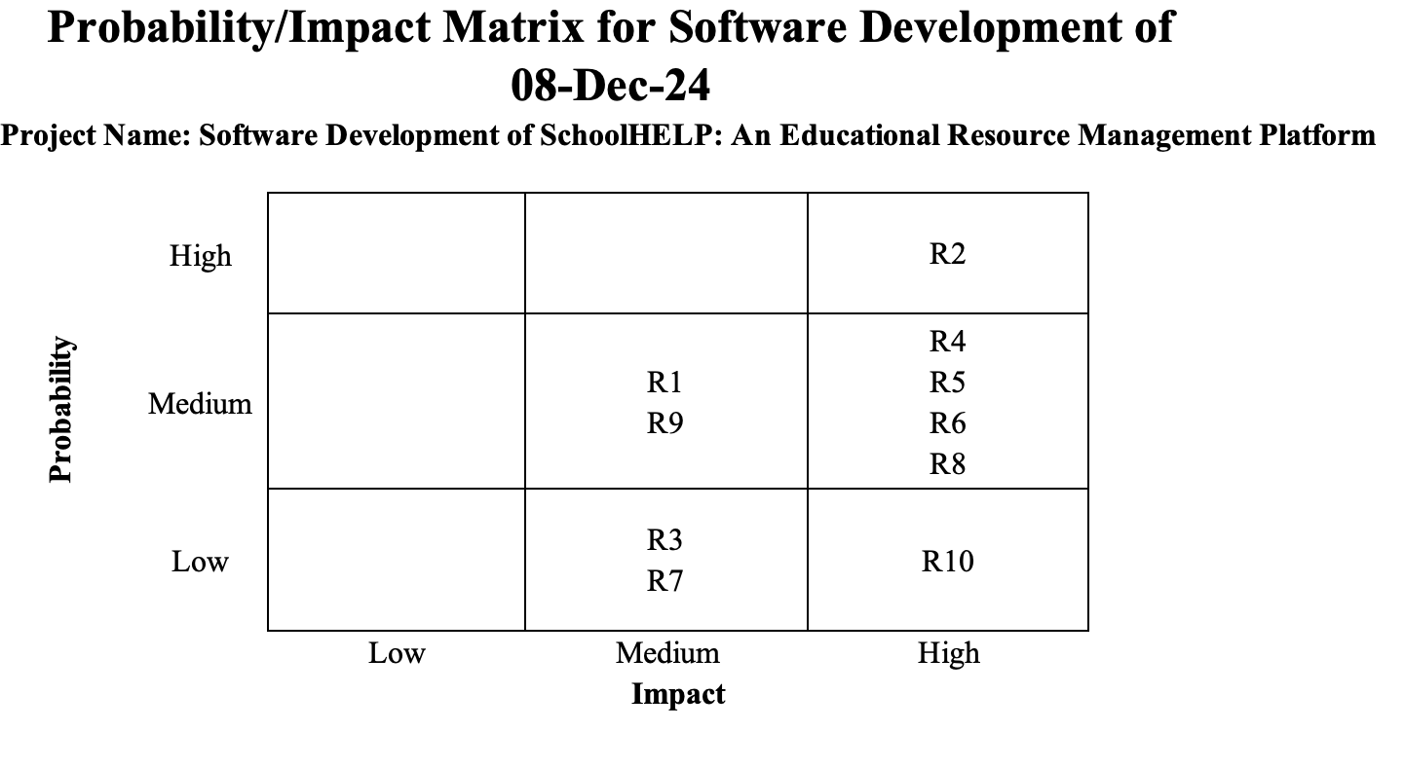

Figure 1. Probability/Impact matrix

# **Monitoring and Controlling Task**

## **Earned Value Analysis**

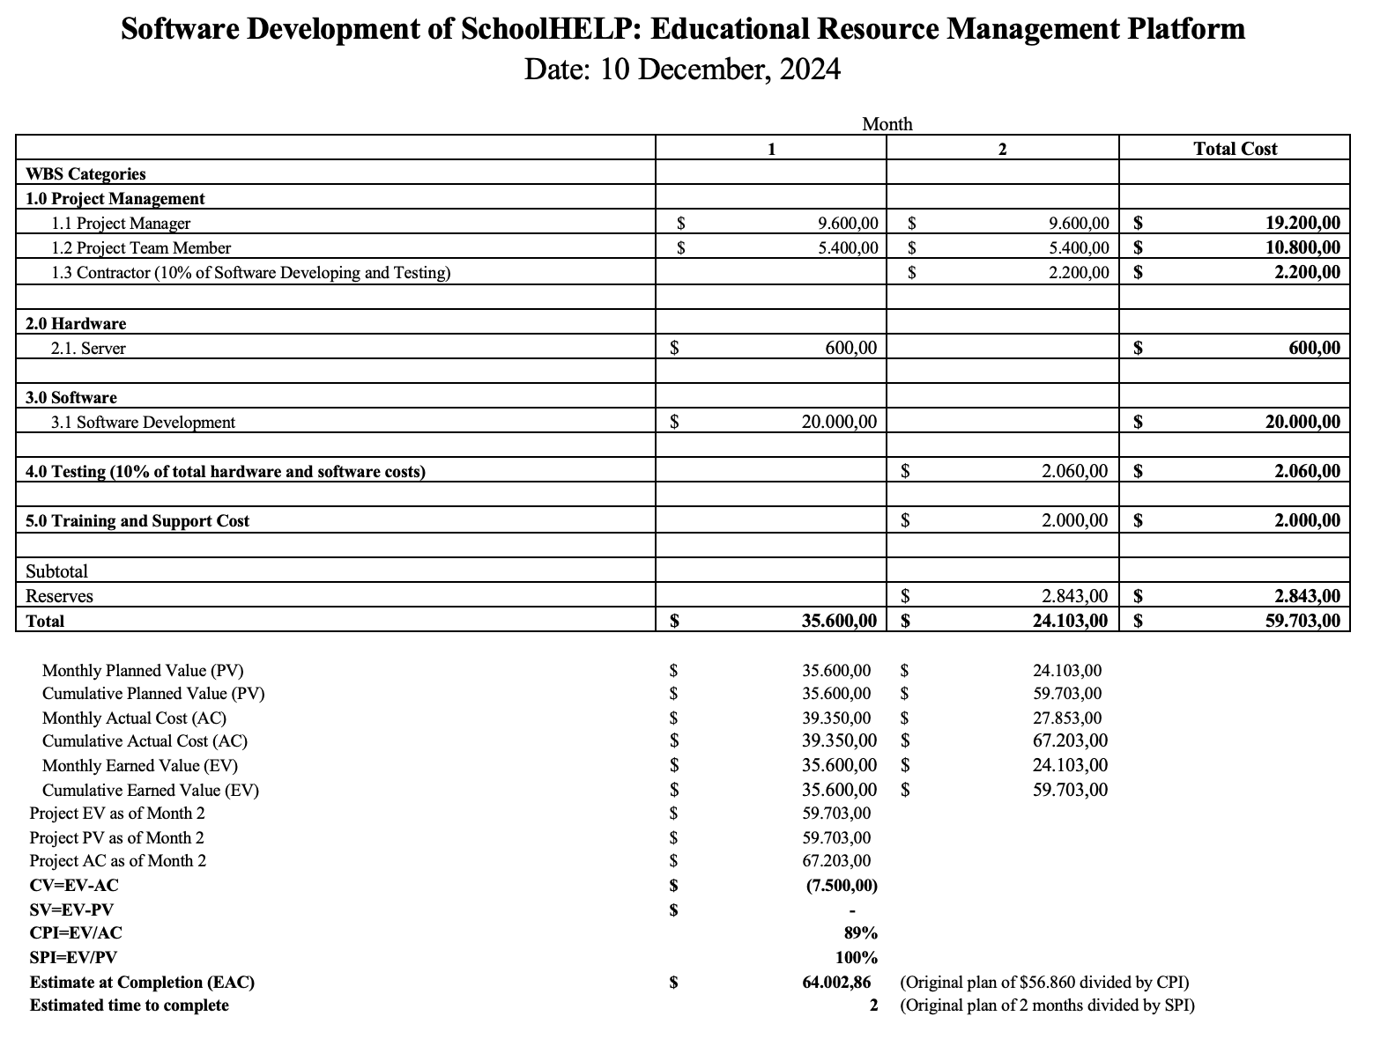

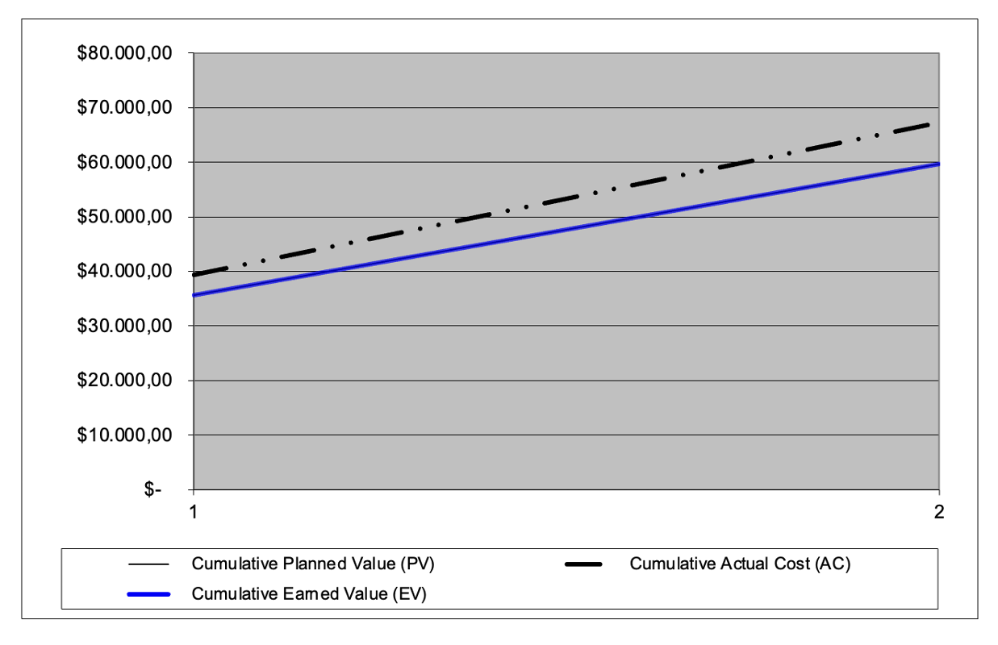

Figure 2. Earned value analysis

Based on the earned value analysis for the SchoolHELP: Educational Resource Management Platform, the project reveals mixed results. Using cost estimates from Assignment 1 as a baseline and the actual costs spent, the project is over budget, because by month 2, the actual cost (AC) is higher than both the planned value (PV) and the earned value (EV). This indicates that the project has spent more than planned for the work completed. However, the project remains on schedule, with no delays in the planned completion time. The project’s performance in terms of scope, time, and cost is further analyzed below.

1. Scope

The project is performing well in terms of scope, as all planned deliverables have been completed as expected. The Earned Value (EV) matches the Planned Value (PV), which indicates that all work scheduled was accomplished without missing any milestones. That means the project is on course to deliver its intended outcomes with no major difference in the defined scope.

1. Time

The project is also performing well in terms of time: no delays have been realized so far, as the schedule variance (SV) of 0 indicates that the project is on schedule. The schedule performance index (SPI) is 1.10 (100%), also indicating that the project is on track and all planned tasks have been completed within the allocated timeline.

1. Cost

In terms of cost, the project is facing some problems due to increased labor hours for the Project Manager and Team Members. From the calculation of cost variance, the CV shows a negative value of $-7,500.00. A negative CV indicates that the project has spent more than the planned budget for the work completed so far.

The Cost Performance Index (CPI) is 0.89 (89%). This indicates the project is over budget because a CPI of less than 1.0 (100%) indicates that a project is exceeding its budget. This project exceeded its budget due to an error in calculating the total hours worked for both the project manager and the team members. The project manager’s hours increased from the initially planned 320 to 400 hours. Similarly, the team members’ hours rose from 360 to 450. This caused a mismatch between the planned and actual budgets under category 1. (Project Management) in the WBS table, specifically in subcategories 1.1 (Project Manager0 and 1.2 (Project Team Member). The table below provides details of the changes reflected in the WBS

Table 4. Planned and actual cost

|  |  |  |  |  |
| --- | --- | --- | --- | --- |
| **WBS** | **Month** | | | |
| **1** | | **2** | |
| **Planned** | **Actual** | **Planned** | **Actual** |
| 1. 1 Project Manager | $9.600 | $12.000 | $9.600 | $12.000 |
| 1.2 Project Team Member | $5.400 | $6.750 | $5.400 | $6.750 |

From the data above, the actual cost for months 1 and 2 of this project can be calculated using the formula below:

|  |
| --- |
| 1st Month actual cost = project manager + project team member + server + software development  = 12.000 + 6.750 + 600 + 20.000  **= 39.350** |

|  |
| --- |
| 2nd Month actual cost = project manager + project team member + contractor + testing + training and support + reserves  = 12.000 + 6.750 + 2.200 + 2.060 + 2.000 + 2.843  **= 27.853** |

## **Issue Tracking**

**Final Issue Tracking**

**December 6th , 2024**

Table 5. Final issue tracking

| **Issue #** | **Issue Description** | **Impact on Project** | **Date Reported** | **Reported By** | **Assigned To** | **Priority(M/H/L)** | **Due Date** | **Status** | **Comments** |
| --- | --- | --- | --- | --- | --- | --- | --- | --- | --- |
| 1 | Financial Analysis not completed | Unable to complete section 7.0 and 10.0 of the business case | November 14, 2024 | Citra | Citra | H | November 15, 2024 | Closed | None |
| 2 | Business case exceeds two pages | Does not meet the given requirements | November 15, 2024 | Citra | Citra | L | November 16, 2024 | Closed | Already adjusted to match the requirement |
| 3 | Determining tasks for the WBS is still unclear | Delay in creating the WBS and planning tasks | November 16, 2024 | Dayu | Dayu | H | November 18, 2024 | Closed | Clarified and updated |
| 4 | Determining depedencies for the gantt chart is still unclear | Delay in completing the gantt chart | November 19, 2024 | Dayu | Dayu | H | November 21, 2024 | Closed | Clarified and finalized |
| 5 | Risk management plan need some adjustment in the response strategy | Delay in completing the report | December 6, 2024 | Citra | Dayu | H | December 9, 2024 | Closed | Already adjusted to match the requirement |
| 6 | Miscalculation in the earned value excel | Analysis will not be accurate | December 10, 2024 | Dayu | Citra | H | December 12, 2024 | Closed | Already recalculated |
| 7 | Risk management need to be updated | Delay in completing the report | December 16, 2024 | Citra | Dayu | H | December 16, 2024 | Closed | Already updated |
| 8 | Update the quality control based on the quality management plan | Delay in completing the report | December 17, 2026 | Dayu | Citra | H | December 18, 2024 | Closed | Already updated |
| 9 | Rearrange the prototypes order and rename some of it | Does not meet the given requirements | December 19, 2024 | Dayu | Citra | M | December 20, 2024 | Closed | None |
| 10 | Tracking gantt chart need to be updated | Delay in completing the report | December 19, 2025 | Citra | Dayu | H | December 19,2024 | Closed | Already updated |

## **Quality Control**

**Quality Control**

**Date: December 17th, 2024**

**Project name:** Software Development of SchoolHELP: An Educational Resource Management Platform

Table 6. Quality control

|  |  |  |  |  |  |
| --- | --- | --- | --- | --- | --- |
| **No.** | **Project Characteristic/Requirement** | **Quality Standard** | **Metric** | **Result** | **Evaluation** |
| 1. | School Registration: Administrators handle school registration and manage accounts | The SchoolHELP admin can efficiently register schools and create accounts for School Administrators through a management process designed to accommodate five typical courses outlined in the use case, as well as two alternative courses, ensuring there are no system errors. | The number of courses specified in the use case can be successfully implemented, and the alternative courses can be accommodated as needed, without any system constraints | The school registration function works as intended, sticking to the described processes outlined in five typical use cases, and two alternatives scenario. | The system meets all quality standards, no major errors need to be fixed. |
| 2. | Request Submission: Schools can request tutorials or resources like devices | School administrators can efficiently submit requests for assistance through a process designed to handle both tutorial and resource requests, accommodating the three typical courses outlined in the use case, as well as two alternative courses, ensuring there are no system errors. | The system is able to respond and record multiple requests for both tutorial and resource requests aligned with the number of courses in the use case, and the alternative courses can be accommodated as needed, without any system constraints. | The system successfully enables school administrator to submit requests for both tutorial and resources, follows the workflow specified in the three typical use cases, as well as the two alternatives use cases. | The system meets all quality standards by correctly implementing use cases scenarios accomodating alternative courses. However, need some minor visual layout adjusment in the submit request forms. |
| 3. | Volunteer Registration: Volunteers provide information to create user accounts | The volunteer can efficiently register with SchoolHELP by providing their username, password, full name, email, phone number, occupation, and date of birth, aligned with the two typical courses outlined in the use case, ensuring required information is accurately recorded in the system without any errors or data loss. | The system was able to record and store all required fields that met with the number of courses in the use case without any system constraints. | The volunteer registration functionality allign with the design, completing two typical use cases as described. | The system works correctly according to the typical use cases scenarios. No system errors to be found. |
| 4. | Request Viewing: Volunteers view school requests, filtered by school, city, or date | The volunteer can efficiently view requests submitted by schools, with options to filter by school, city, or request date. The system accurately displays a list of new status requests, including details such as request date, description, school name, and city, providing details of the request when selecting a request ID, which aligned with the three typical courses outlines in the use case, as well as the two alternatives courses, ensuring there are no system errors. | All detailed requests  are displayed correctly by implementing the number of courses in the use case correctly, and the alternative courses can be accommodated as needed, without any system constraints. | The system enables volunteers to view and filter school requests by school name, city, or request date, and accurately display request details, in alignment with the three typical use cases and two alternatives scenario. | The system meets all quality standards by correctly implementing use cases scenarios accomodating alternative courses. |
| 5. | Offer Submission: Volunteers submit offers with remarks and receive updates | The volunteer can efficiently submit an offer for a request by logging in with a valid username and password, and providing remarks for the offer. The system is able to assign the recorded offer with the selected requestID, and set the offer status to pending, based on the three typical courses outlined in the use case, as well as the two alternatives courses, ensuring there are no system errors. | The number of courses in the use case is achieved for submitting offer, ensuring the selected offer is assigned to the selected requestID, and status set to pending without any system constraints | The system enables volunteers to submit an offer for a request and providing remarks for the offer, while also able to assigned offer with the correct requestID, and set offer status correctly, in alignment with the three typical use cases and two alternatives scenario. | The system runs effectively by correctly implementing use cases scenarios accomodating alternative courses, with no major errors to be fixed. |
| 6. | Offer Review: Schools review offers, accept suitable ones, and manage request closures | The school administrator can efficiently review offers for requests, view sorted requests, and access detailed information about each offer. The system is able to let administrators accept an offer, then sends an email to both the volunteer and the school administrator, and updates the offer status, allowing the school administrator to close the request , aligned with the eight typical courses, as well as the three alternatives courses, ensuring there are no system errors. | The number of typical courses, and alternatives courses for the review offers are implemented correctly, ensuring that all submitted offers are assigned with the correct requestID without any system errors. | The system enables school administrator to review offers, see offer details, accept offers, and close request, while also able to send email to both volunteer and school administrator, and update the offer status, in alignment with the eight typical use cases and three alternatives scenario. | The system works correctly according to the typical use cases scenarios and alternative courses. No system errors to be found. |

## **Risk Management**

**Risk Register for Software Development of SchoolHELP: An Educational Resource Management Platform**

**Date: December 19th, 2024**

| **ID No.** | **Rank** | **Risk** | **Description** | **Category** | **Root Cause** | **Triggers** | **Potential Responses** | **Risk Owner** | **Probability** | **Impact** | **Status** | **Response Strategy** |
| --- | --- | --- | --- | --- | --- | --- | --- | --- | --- | --- | --- | --- |
| R2 | 1 | Positive Public Attention | The SchoolHELP project has received positive attention as a solution to the post-pandemic education problem. | Market Risk | The project addresses social challenges in education affected by COVID-19. | Positive media coverage and good feedback. | Improved reputation and increased funding and volunteer participation. | Project Manager | High | High | The project manager has scheduled and conducted weekly meetings on MS Teams to monitor promotional strategies and media coverage. The focus of these meetings is to ensure that digital strategies are well-organized moving forward. | Risk exploitation. The team will leverage this positive impact by releasing project news through press releases, hosting online promotional events, and using testimonials from early users. This activity will include a digital ad campaign on TikTok, Instagram, and YouTube to reach a broader audience. The campaign is planned for 1 month (160 hours). The Project Manager will work for 20 hours at $1,200 ($60/hour), and the team will work for 40 hours at $1,200 ($30/hour). Additionally, $1,000 will be allocated for video production and brochure design, and $1,000 for social media advertising, resulting in a total cost of $4,400 |
| R4 | 2 | Cost Overruns | The project may exceed the budget due to unexpected expenses or errors in initial estimation. | Financial Risk | Lack of detailed planning during the project initiation phase | Actual expenses exceed the budget | Project delays or reduced deliverable quality. | Project Manager | Medium | High | The project manager has scheduled and conducted weekly meetings on MS Teams to monitor the financial status of the project. These meetings ensure that reserve funds are ready to address any urgent needs or unexpected costs. | Risk acceptance. The team will use a contingency fund of $5,686 (10% of the total project budget) to cover unexpected costs and will track expenses weekly to stay on budget. This activity will take 1 month (160 hours). The Project Manager will work for 20 hours at a cost of $1,200 ($60/hour), and the team will work for 30 hours at a cost of $900 ($30/hour). An additional $500 is set aside for unexpected software fees, such as buying or renewing licenses for any tools or software needed during the project, resulting in a total cost of $2,600. |
| R5 | 3 | Early Project Completion. | The project is completed ahead of schedule, providing extra time for testing or feature improvements. | Financial Risk | Overestimated schedule or highly efficient team. | Tasks completed faster than planned without obstacles | Improved product quality, reduced costs, and enhanced team reputation. | Team Member | Medium | High | The team has planned to use the extra time to enhance features and complete additional testing before launch. | Risk enhancement. The team will use the extra time for broader testing, improving features based on early user feedback, and preparing technical documentation for system maintenance. This activity is estimated to take 2 weeks (80 hours). The Project Manager will work for 15 hours at $900 ($60/hour), and the team will work for 50 hours at $1,500 ($30/hour), resulting in a total cost of $2,400. |
| R6 | 4 | Data Privacy Concerns. | Sensitive data may be exposed due to inadequate security measures | Technology Risk | Lack of encryption and regular security audits | Signs of unauthorized access or data being leaked, such as unusual activity or login attempts. | Loss of trust and potential legal penalties. | Team Member | Medium | High | The risk event has not occurred, encryption protocols and security audits are being planned by the team. | Risk transference. The team will involve a third party to conduct security audits and implement advanced encryption systems. This activity will take 2 weeks (80 hours). The Project Manager will work for 10 hours at $600 ($60/hour), and the team will work for 20 hours at $600 ($30/hour). The security audit by the third party will cost $2,500. Additionally, $1,000 will be allocated for legal advice to ensure the project complies with privacy laws and regulations, resulting in a total cost of $4,700. |
| R8 | 5 | Resource Availability Issues | Lack of a skilled team or uneven workload distribution may delay project completion. | People Risk | A small team or a lack of skilled professionals with the specific expertise needed for the project. | Delays in critical task completion, misaligned work priorities. | Delayed project timeline and increased operational costs. | Team Member | Medium | High | The project manager has requested additional temporary IT specialists to help complete project tasks and ensure the team’s workload is balanced. | Risk escalation. The team will request additional resource allocation or hire temporary contractors. This activity is estimated to take 2 weeks (80 hours). The Project Manager will work for 10 hours at $600 ($60/hour), and the team will work for 20 hours at $600 ($30/hour). Additional hiring costs are estimated at $2,200, resulting in a total cost of $3,400. |
| R11 | 6 | Team Collaboration Challenges | Lack of coordination among team members may cause delays in task completion. | People Risk | The team lacked a clear and structured communication system, such as a regular meeting schedule, use of collaboration tools, and communication guidelines to ensure all team members understood their duties and responsibilities. | Misunderstandings related to tasks or responsibilities. | Schedule weekly coordination meetings and utilize digital collaboration tools. | Project Manager | Medium | High | Team communication has been regularly monitored by the project manager, with weekly meetings scheduled online in MS.Teams or offline meetings to ensure clear coordination. | Risk mitigation. Engage the time of the project manager and one team member during weekly meetings, supported by the use of digital collaboration tools. The project manager spent 2 hours per week leading coordination meetings over 4 weeks, costing $480 (2 hours/week x $60/hour). The team member attended for the same duration, costing $240 (2 hours/week x $30/hour), resulting in a total cost of $720. |
| R10 | 7 | Unexpected Feature Enhancements | Stakeholders may request unplanned additional features, affecting the project timeline and budget. | Process Risk | Lack of clear communication about project scope. | Requests for additional features from stakeholders | Increased costs, timeline extensions, and project delays. | Project Manager | Low | High | The project manager is holding meetings with stakeholders to review the feasibility of additional feature requests before approval. | Risk mitigation. The team will implement change management procedures and evaluate the impact of requested changes before approval. This activity will take 2 weeks (80 hours). The Project Manager will work for 20 hours at $1,200 ($60/hour), and the team will work for 30 hours at $900 ($30/hour). Additionally, $1,000 will be allocated for purchasing additional testing tools or software licenses, resulting in a total cost of $3,100. |
| R1 | 8 | Limited User Interest. | Users may prefer traditional methods instead of online platforms, reducing website utilization. | Market Risk | Lack of understanding of the benefits of the online system. | Low registrations or declining platform activity. | The platform becomes less effective and struggles to remain sustainable due to low user engagement. | Project Manager | Medium | Medium | The team has discussed and prepared plans and schedules for workshops and promotional events to increase user engagement with the platform. | Risk mitigation. The team will launch educational campaigns through videos, distribute digital brochures, and conduct online workshops for schools. This activity will last 2 weeks (80 hours). The Project Manager will work for 10 hours at $600 ($60/hour), and the team will work for 20 hours at $600 ($30/hour). Additionally, $50 will be allocated for online platform subscriptions, and $100 for enhancing digital materials, resulting in a total cost of $1,350. |
| R9 | 9 | Process Adoption Challengess | Users may struggle to understand or use the system initially, causing confusion or frustration. | Process Risk | Lack of intensive training and clear guidance. | User complaints about usability. | Platform features are underutilized, and project objectives may not be met. | Team Member | Medium | Medium | The team is preparing training materials and scheduling onboarding sessions for new users to minimize confusion in platform use. | Risk mitigation. The team will provide PDF guides and video tutorials to help new users understand the platform. This activity will last 1 week (40 hours). The Project Manager will work for 5 hours at $300 ($60/hour), and the team will work for 10 hours at $300 ($30/hour), resulting in a total cost of $600. |
| R3 | 10 | Market Competition | Competitors may launch advanced platforms that threaten the competitiveness of SchoolHELP | Market Risk | Lack of additional attractive features to enhance user appeal. | Competitors release advanced platforms. | A decline in the number of users engaging with the platform, leading to reduced interest from donors and decreased funding opportunities. | Project Manager | Low | Medium | The risk event has not occurred, competitor analysis is ongoing to inform the design of new features. | Risk enhancement. The team will add new features like monthly donation reports and student progress tracking while conducting digital marketing campaigns. This activity is planned for 2 weeks (80 hours). The Project Manager will work for 15 hours at $900 ($60/hour), and the team will work for 30 hours at $900 ($30/hour). Total estimated cost is $1,800. |
| R7 | 11 | Infrastructure Limitations | Schools may lack the hardware or internet connections needed to access the platform. | Technology Risk | Outdated devices or slow internet connections | User complaints about slow or inaccessible platform performance. | Users are unable to fully access the platform due to issues like outdated devices, slow internet connections, or compatibility problems. | Team Member | Low | Medium | The team has provided technology advice and the project manager has directed the team to develop a lightweight version of the platform to address infrastructure limitations in some schools. | Risk mitigation. The team will develop a lightweight platform version for older devices and slow connections. This activity will take 3 weeks (120 hours). The Project Manager will work for 15 hours at $900 ($60/hour), and the team will work for 40 hours at $1,200 ($30/hour), resulting in a total cost of $2,100. |

# **Closing Task**

## **Tracking Gantt Chart**

**Tracking Gantt Chart**

**Date: December 19th, 2024**

**Baseline Gantt Chart**

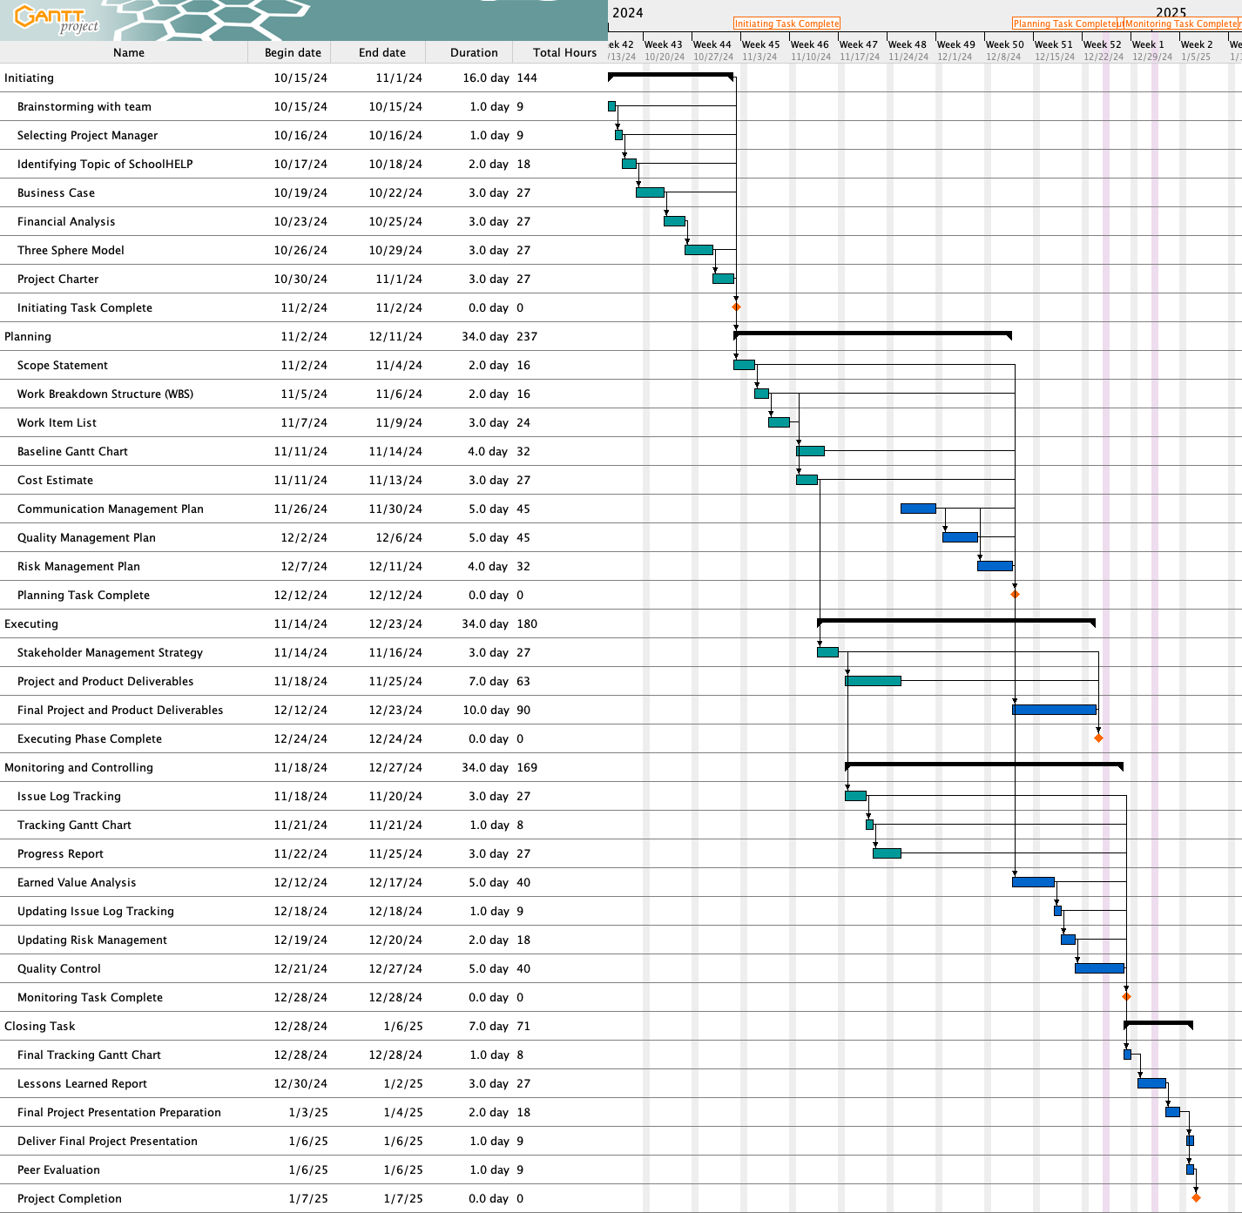

Figure 3. Baseline gantt chart

**Tracking Gantt Chart**

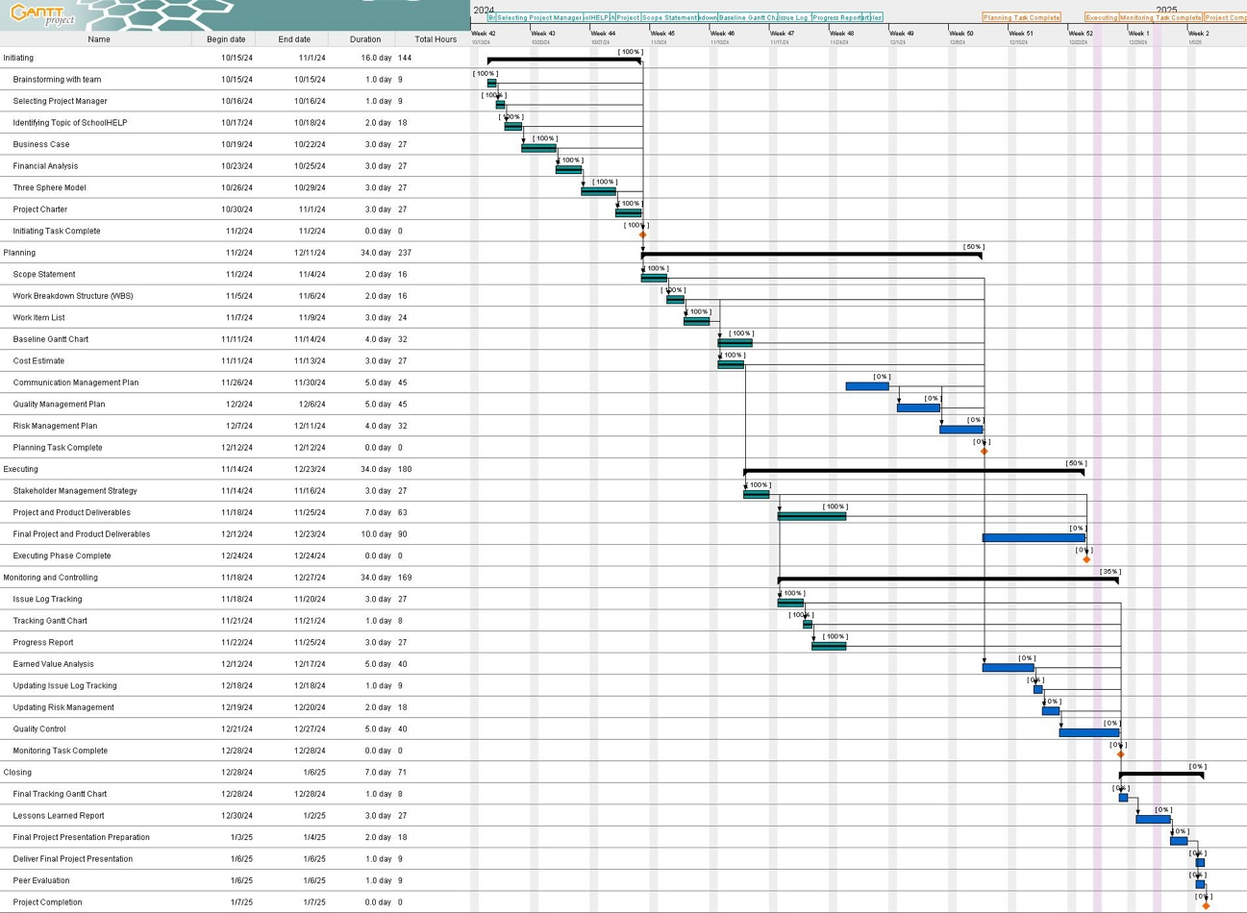

Figure 4. Tracking gantt chart

**Final Tracking Gantt Chart**

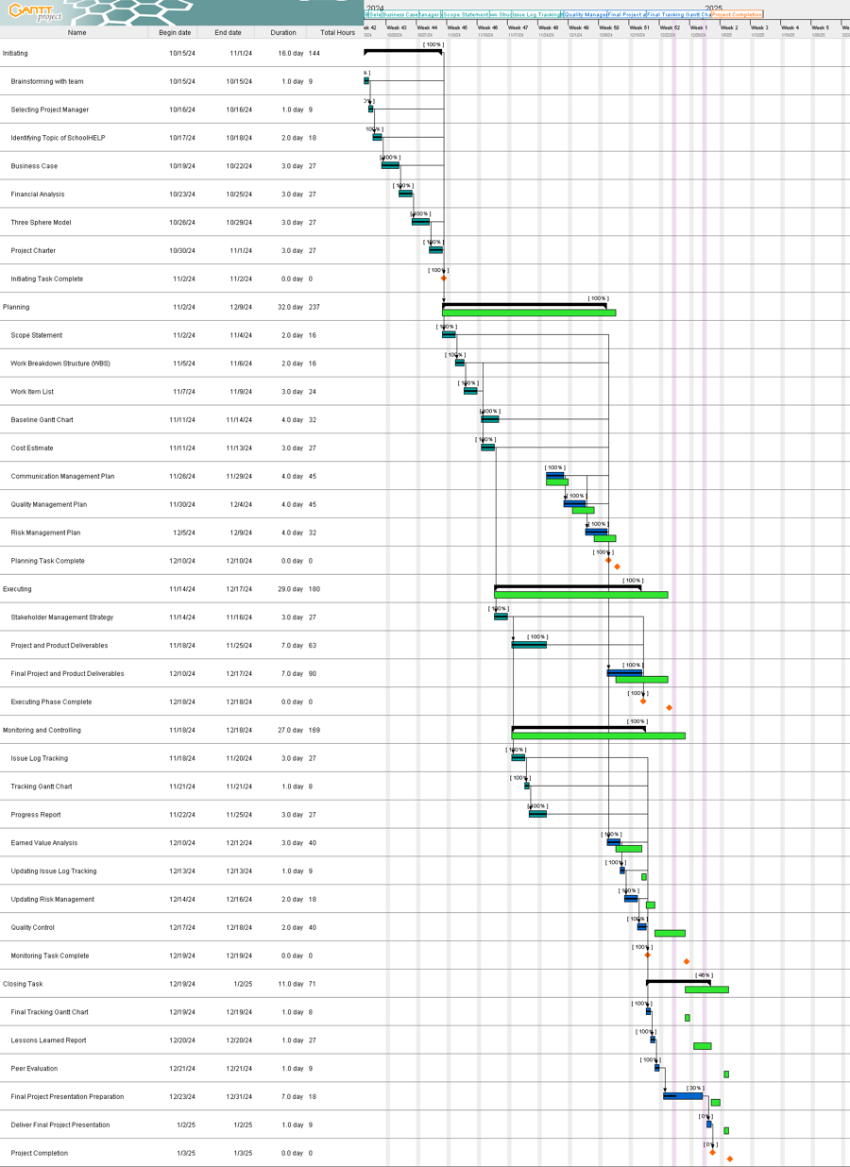

Figure 5. Final tracking gantt chart

Based on the analysis of the comparison between the baseline and tracking Gantt chart, the project runs according to schedule in the initiation phase, and all tasks are successfully completed on time as planned in the baseline Gantt chart. All tasks that must be completed in assignment 1 were successfully completed on time following the predetermined schedule. Our team made some progress when we entered Assignment 2, which started with the planning phase. For example, the Communication Management Plan and Quality Management Plan tasks were completed earlier than scheduled. In the baseline, both tasks were expected to take 5 days, but we managed to complete them within 4 days, this is indicated by the green color on the Gantt chart, which means the task was completed earlier than before. This means that for tasks that depend on these tasks, the progress of their completion will affect the continuation of the following task process. Therefore, the tasks in Assignment 2 were completed earlier than planned. These advances contribute to the acceleration of the overall project completion, so the project, originally planned to be completed on 1/6/25 until the presentation period, will be completed earlier than the baseline with an estimate of 1/2/25, but this still adapts to the presentation schedule.

Our team's success in overcoming various schedule challenges has been balanced with the implementation of strategies such as implementing an early completion strategy by focusing on completing management plans early to provide spare time in handling tasks that have the potential to experience obstacles. We optimized resources by reallocating resources effectively, especially when working on critical tasks, to keep the overall project timeline on track. Overall, the project is progressing very well. The success of completing several tasks ahead of schedule has not only helped offset tasks that could potentially be delayed but also provided a buffer of time that has been utilized to improve the quality of the deliverables.

# **Individual Tasks**

## **Deliverables**

**Prepared by:** Anak Agung Ayu Citra Dewi **Date:** December 20th, 2024

1. Communication channel:

Actively participate in team discussions and also provide updates on changes or completed work. By actively participating in discussions and providing updates, Citra ensured that everyone stayed on track, in order to avoid delays. By communicate regularly, we can avoid misunderstanding, which helped to avoid unnecessary expenses. Keeping everyone updated also ensure that all tasks are within the project scope.

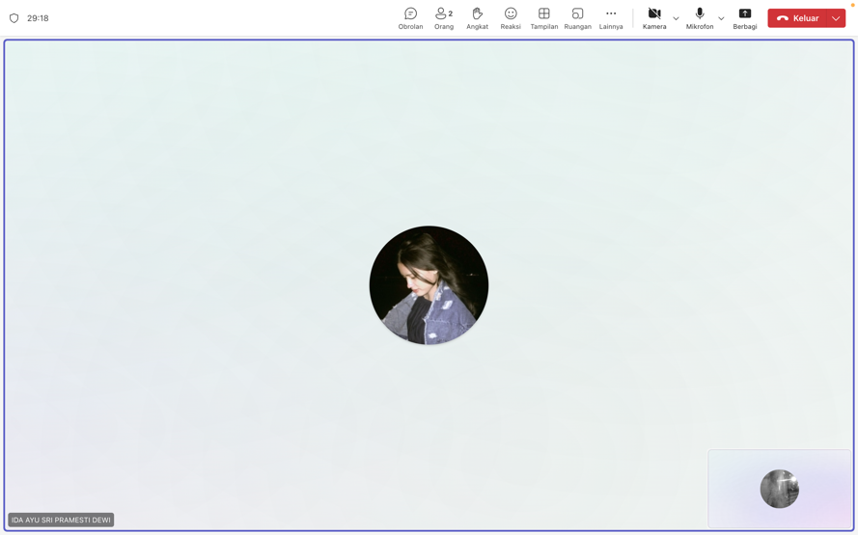

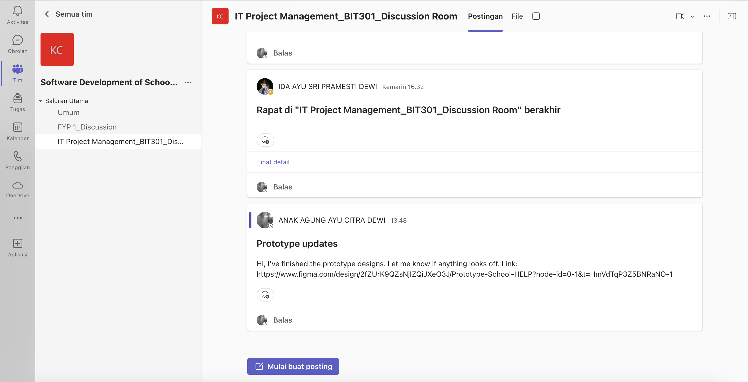

Figure 6. Communication with Teams

1. Communication management plan:

Evaluating the effectiveness of communication methods and techniques, while identifying strategies to enhance stakeholder communication, by applying various communication concepts. A clear communication plan ensured all stakeholders expectations were addressed without any discrepancy from the project’s scope. By making the communication management plant, Citra ensure that the team can address issues quickly and avoid any unnecessary expenses.

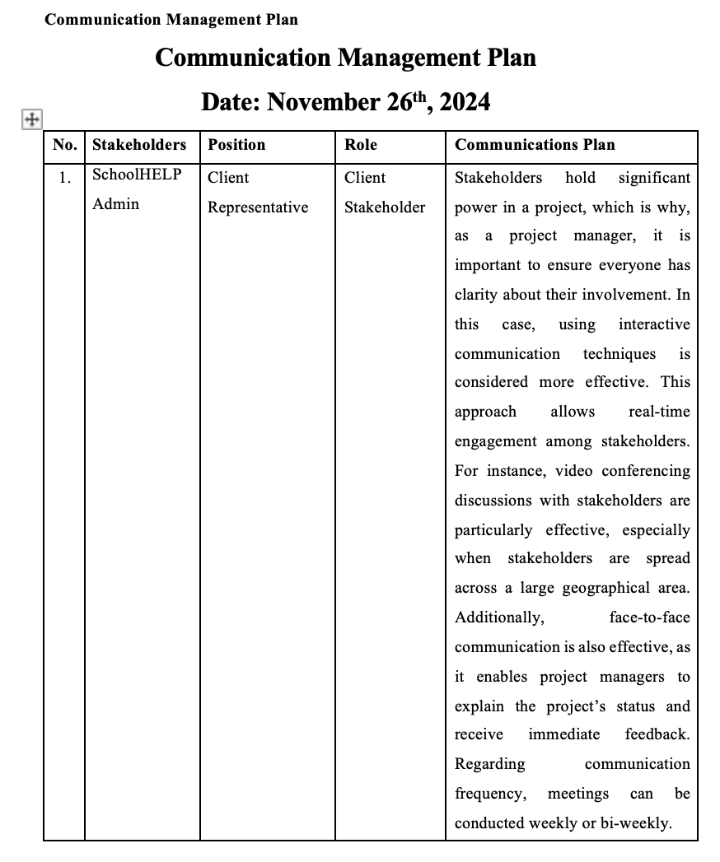

Figure 7. Communication management plan

1. Quality management plan:

To assess the measurement standards for each project characteristic or requirement outlined in the scope statement of Assignment 1. By making the quality management plan, Citra ensure that the project able to delivered as planned, minimize the chance to revising error later, and avoid unnecessary expenses.

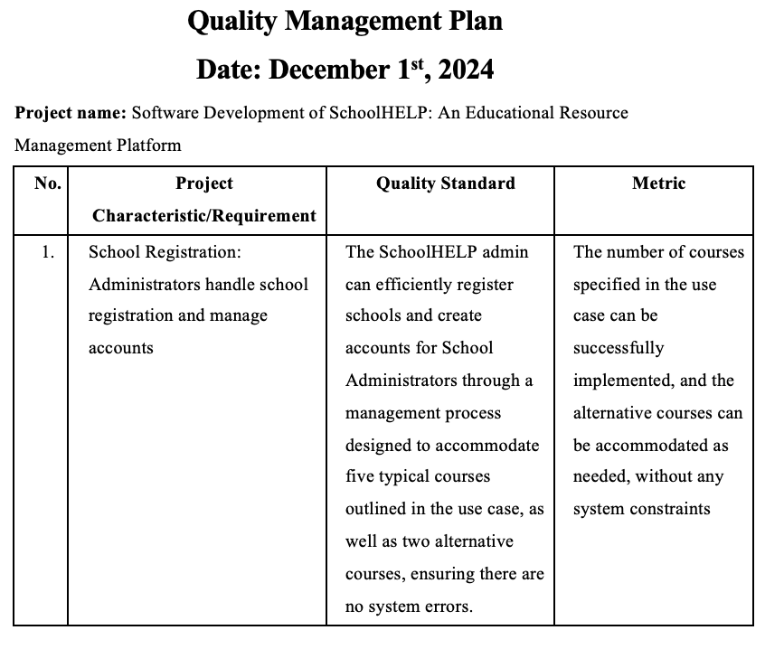

Figure 8. Quality management plan

1. Earned value analysis:

To examine the project’s budget and costs and assess whether it is performing better or worse than expected, considering the triple constraints of Time, Cost, and Scope. The analysis ensured that the project is aligned with the planned scope. By analyzing the budget, Citra ensured that the team able to identified where cost were exceeding. This analysis also helped the team to monitor whether the project was on schedule or not.

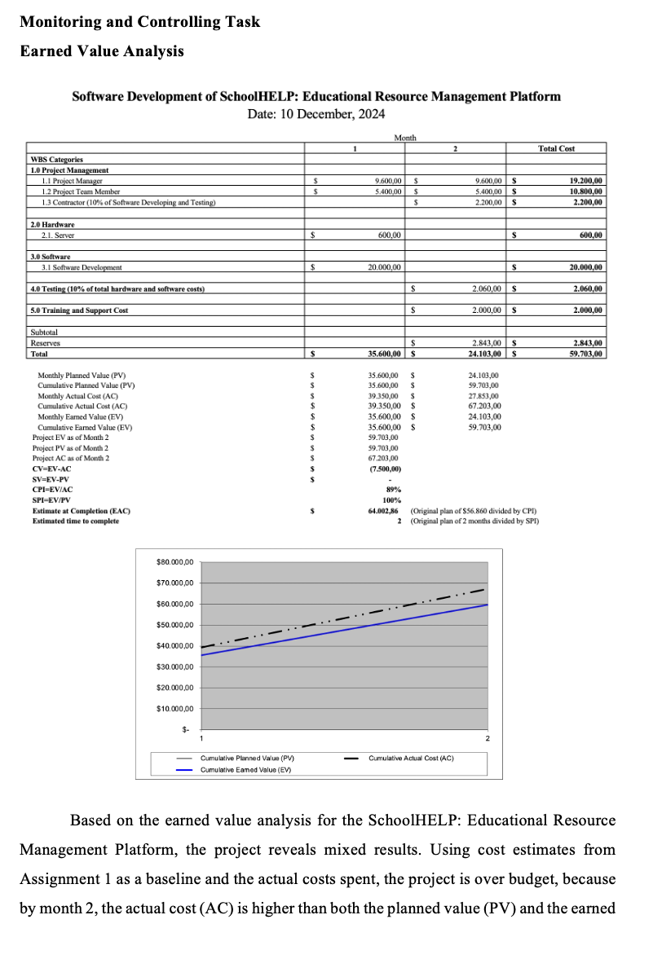

Figure 9. Earned value analysis

1. Quality control:

Quality control is used to assess the project's characteristics against the established quality standards. By making the quality management plan, Citra ensure that the project was delivered similary as what was planned. This also helps identify problems early, saving time and avoiding extra costs.

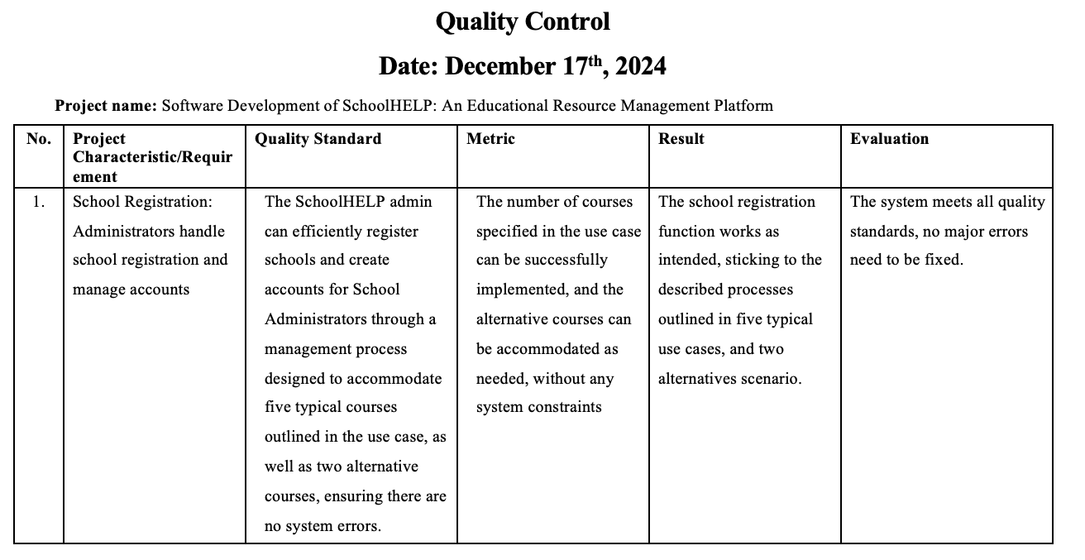

Figure 10. Quality control

1. Prototypes design:

Working on prototype design for SchoolHELP web-based application project using Figma. The prototype addressed all the functional requirements outlined in the project scope. By creating the prototype, Citra contributed to make sure the project completed on time. Last, using a tool like Figma is effective to produce a high-quality design without overspending on other cost. Use the link below to access the prototypes design:

<https://www.figma.com/design/2fZUrK9QZsNjIZQiJXeO3J/Prototype-School-HELP?node-id=5-2502&t=TimEx5xY6o49vb6W-1>

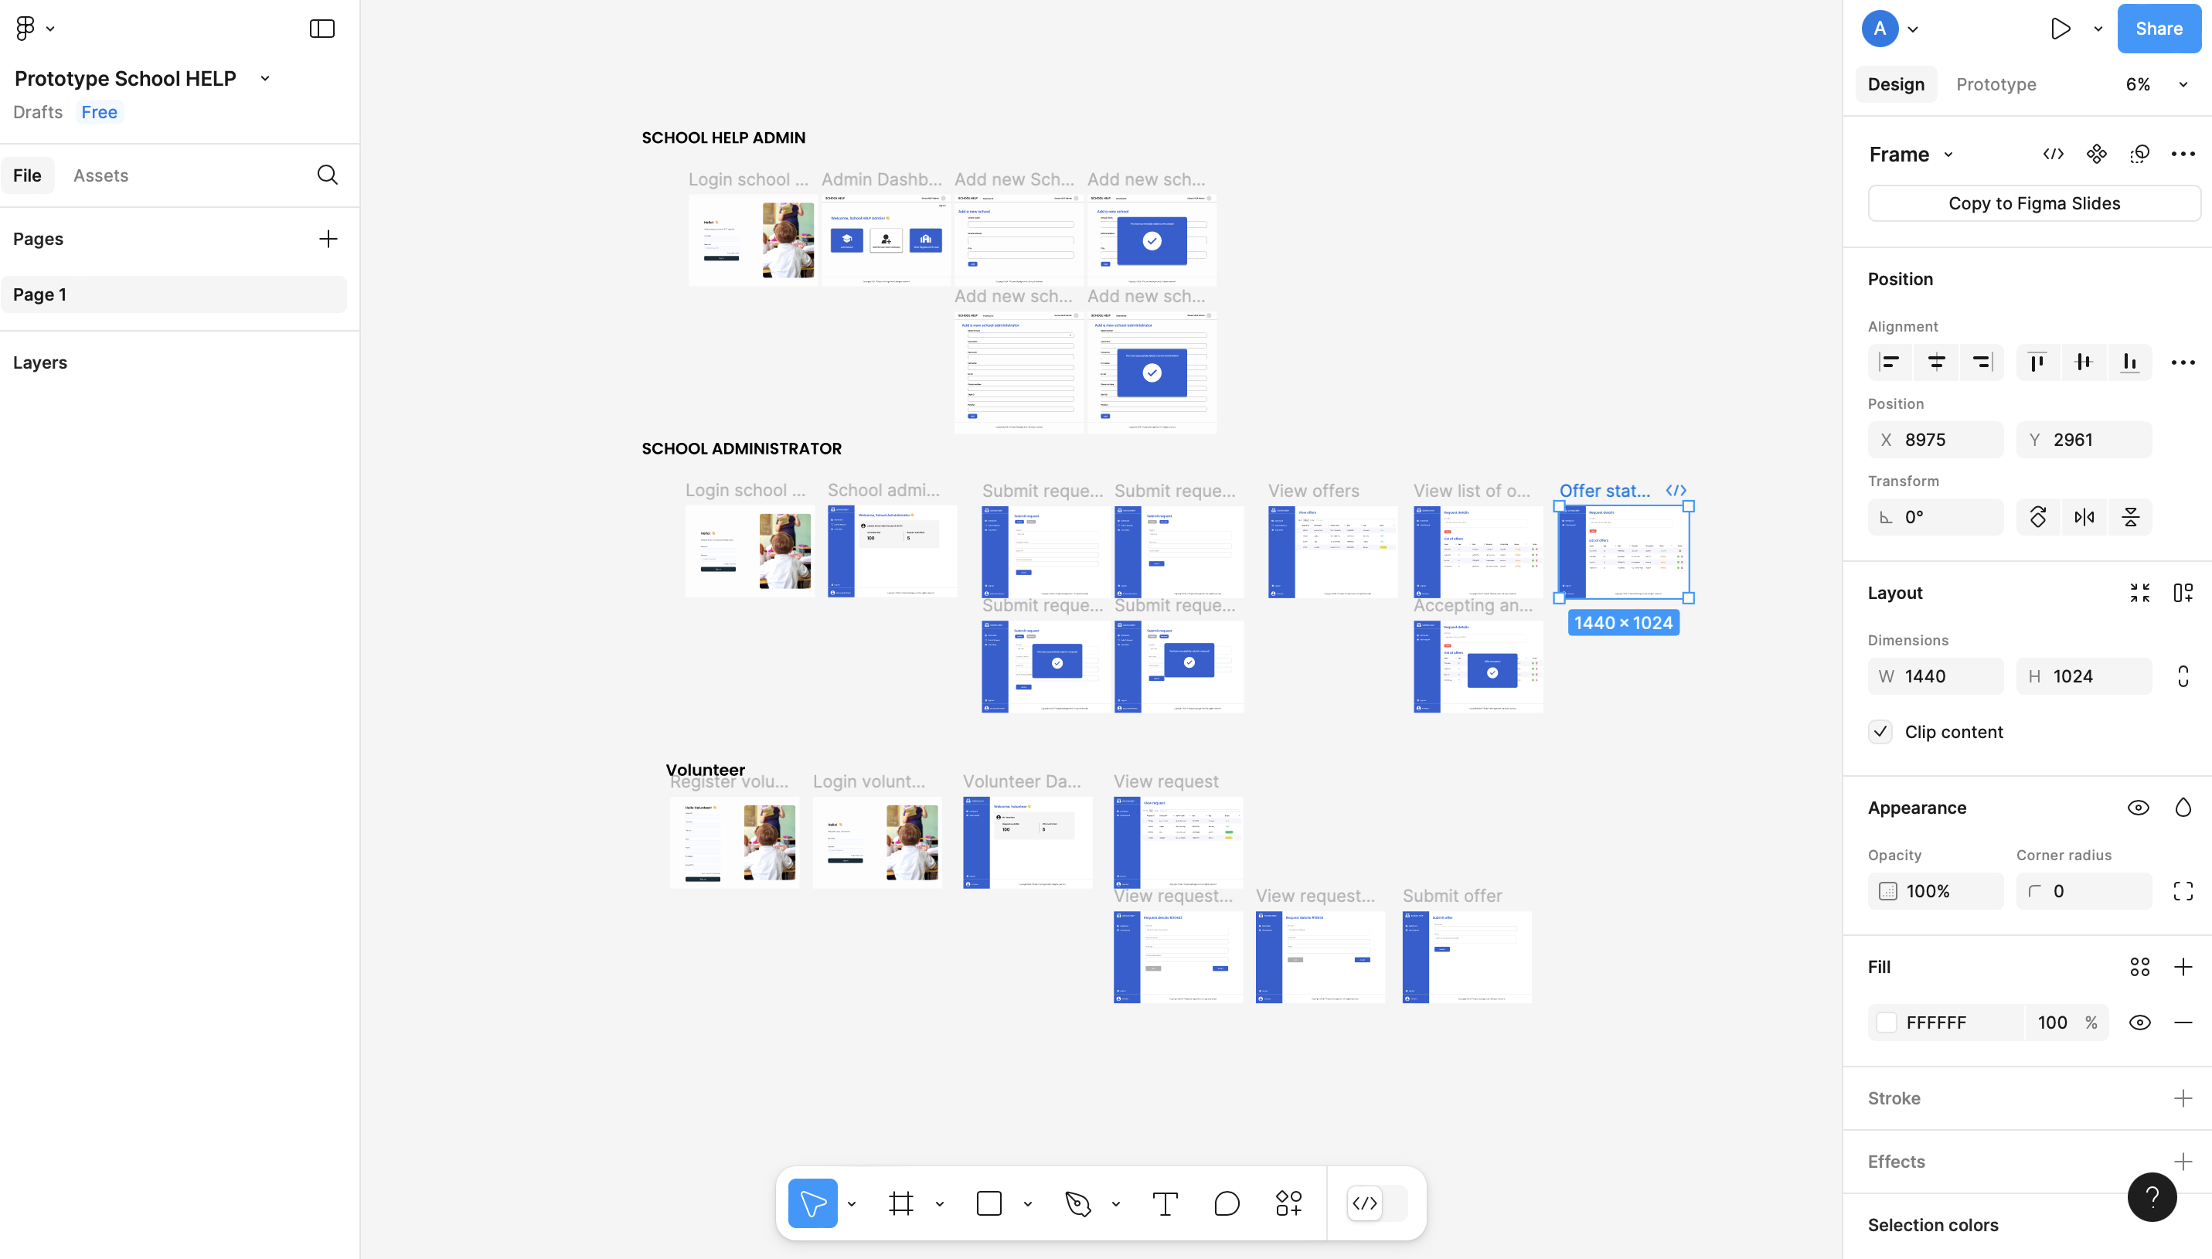

Figure 11. Prototypes design

**Prepared by:** Ida Ayu Sri Pramesti Dewi **Date:** December 20th, 2024

1. Communication channel:

Good communication is the foundation of our team's project success. Through regular communication, each team member can understand the agreed-upon tasks and responsibilities, minimizing the risk of misunderstandings when completing tasks and ensuring a smooth workflow. Dayu always actively participates in team discussions and regularly updates us on the progress of each task. This has helped us stay focused on project goals, complete tasks ahead of schedule, and consistently work within the defined scope.

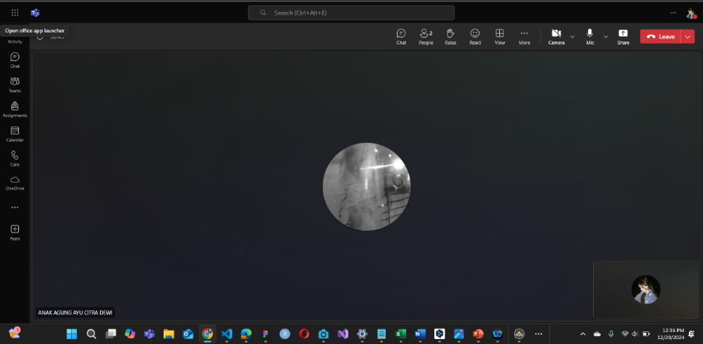

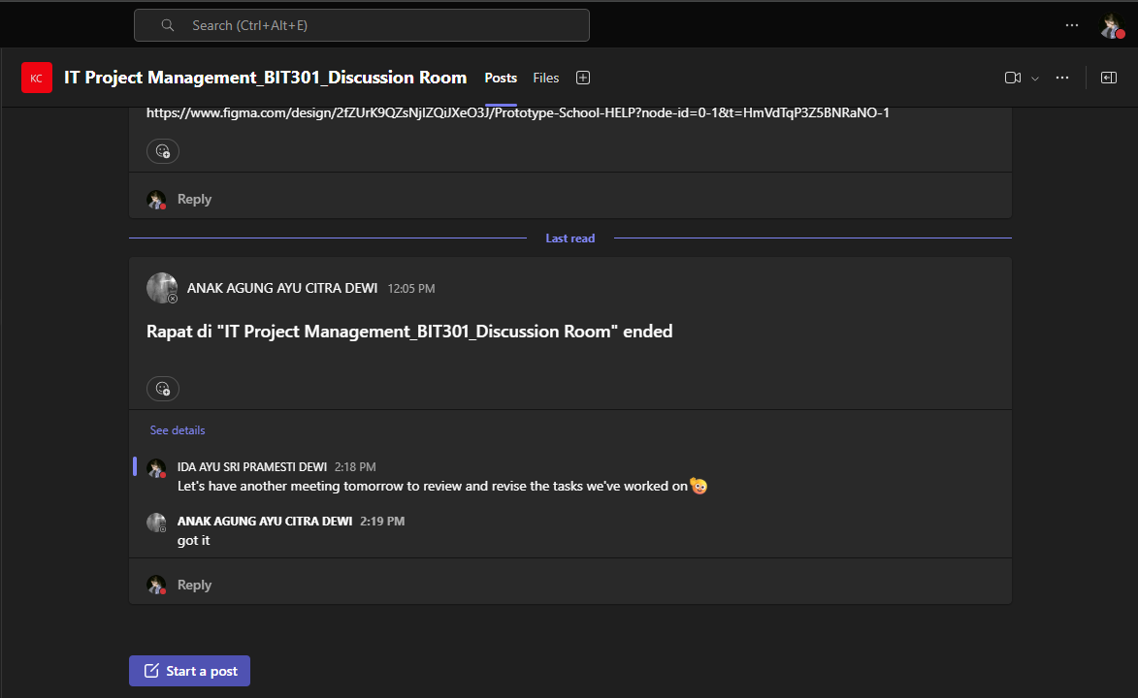

Figure 12. Communication with Team

1. Risk Management Plan:

During the planning phase of the Risk Management Plan, Dayu identified ten potential risks, including both positive and negative risks. Dayu analysed them using a probability/impact matrix to prioritize their criticality. Dayu then developed a risk register to document each risk along with its ranking, customized response strategy, and estimated time and cost for implementation. This process ensures that the project team has a clear framework to proactively address potential challenges while staying aligned with the project schedule, budget, and objectives, thus enabling the team to mitigate risks and capitalize on potential opportunities effectively.

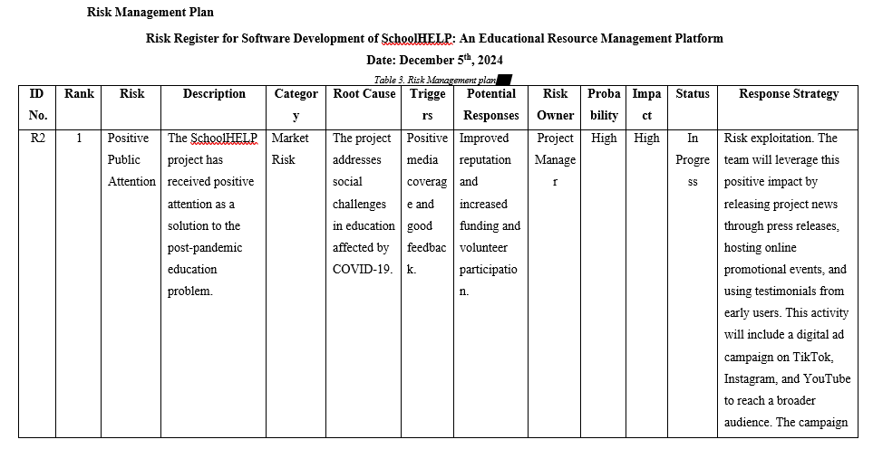

Figure 13. Risk Management Plan

1. Final Issue Tracking

As a team member, Dayu is responsible for managing the Issue Tracking, recording, monitoring, and resolving all problems that arise during the project. This ensures that errors in Earned Value Analysis updates to the Risk Management Plan and revisions to the Gantt Chart are resolved quickly to prevent delays. Each issue is documented in detail, including its impact on the project, priority level, and resolution deadline, ensuring solutions are correctly implemented.

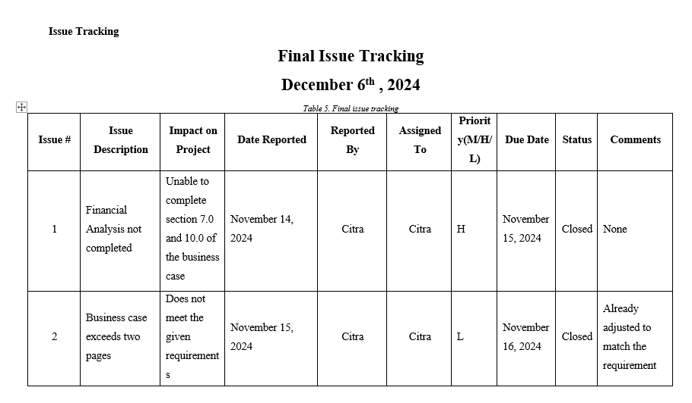

*Figure 14. Issue Tracking*

1. Risk Management

During the Monitoring and Controlling phase of the Risk Management Plan, Dayu is responsible for tracking emerging risks, updating the risk register, and ensuring the planned strategies are well executed. Dayu also discovers new risks during this phase and updates their status, probability, and impact in the risk register. Risk management at this phase is important to mitigate possible adverse impacts by continuously monitoring the risks and evaluating the action steps that have been taken. These regular updates not only help the team address potential issues effectively, but also ensure the project remains aligned with the established scope, schedule, and budget.

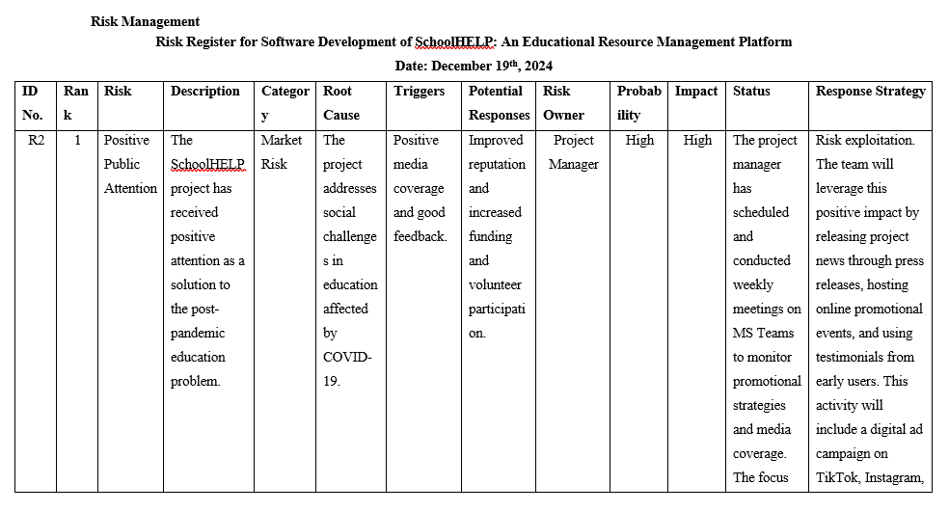

*Figure 15. Risk Management*

1. Final Tracking Gantt Chart

Based on the Gantt chart analysis, Dayu created a baseline and tracked the Gantt chart to monitor project progress. This Gantt chart shows that all tasks in the initiation phase and Assignment 1 were completed on time as planned. In addition, the Gantt chart also records the progress that tasks in Assignment 2 have been completed ahead of schedule. This helped the project run more organized and accelerated the overall project completion time. This Gantt Chart has made us ensure all tasks stay organized, from scheduling to human resources.

Based on the Gantt chart analysis, Dayu created a baseline and tracked the Gantt chart to monitor the progress of the project. This Gantt chart is the final Gantt chart which shows that all tasks in the initiation phase and Assignment 1 have been completed on time as planned. In addition, the Gantt chart also recorded the progress that the tasks in Assignment 2 had been completed ahead of schedule. This helped the project run more organised and accelerated the overall project completion time. This Gantt Chart has made us ensure all tasks stay organised, from scheduling to human resources.

## 

*Figure 16. Final Gantt Chart*

## Presentation Slide

This PowerPoint Presentation is designed as a summary of the assignments during Assignment 1 and 2 periods in the form of PowerPoint slides to save time in understanding the overall project progress. These slides help present the project outcomes in a clear and informative manner.



*Figure 17. Presentation slidet*

## **Lesson Learned Report**

**Lessons-Learned Report**

**Date: December 20th, 2024**

**Prepared by: Anak Agung Ayu Citra Dewi**

|  |
| --- |
| **Project Name:** Software Development of SchoolHELP: An Educational Resource Management Platform  **Project Sponsor:** Educational Organization  **Project Manager:** Anak Agung Ayu Citra Dewi  **Project Dates:** 15th October 2024 – 2nd January 2025  **Final Budget:**  $64.002,86 |
| 1. Did the project meet scope, time, and cost goals?   In the terms of scope and time, the project is going well, as the project has been aable to finish all the deliverables right on schedule with no single milestone missed on time. However, there are cost issues, as the project has ovespent by $7,500 due to increased labor hours. That indicates a proper budget control should have been done for this project.   1. What was the success criteria listed in the project scope statement?   According to the assignment 1, the project success criteria listed in the project scope statement is:  *“With a budget of $56.860 and annual benefits of $56,800, the project connects schools and volunteers for educational support and donations. The web-based system ensures accessibility and aims to improve education by facilitating tutor connections, digital donations, and sustainability. The project will be completed in 2.5 months (15 October 2024 – 7 January 2025) with a useful life of at least one year.”*   1. Reflect on whether or not you met the project success criteria.   The project was successfully completed ahead of schedule on December 23, 2024, meeting all stakeholders requirements and achieving its goal of connecting schools and volunteeers for educational support. However, the budget was exceeded by $7,500, which mean we need to learn to improved cost management in future projects.   1. What were the main lessons your team learned from this project?   There are several lessons we learned from this project:   * **Cost Management**   The main lesson I learned is the importance of cost management. Reflecting on the mistakes we made in the project's financial calculations, we realized the need to improve our cost management skills. Proper planning and monitoring of the budget are crucial to ensure the actual expenses align with the planned budget, avoiding overruns in future projects.   * **Communication**   Another lesson I learned is that good communication leads to good results. Working in a team requires effective communication, where all members must share updates and changes to keep everyone informed with the latest information. This improves teamwork and ensures the project aligns with stakeholder expectations. Additionally, clear communication helps us incorporate feedback effectively, resulting in a successful project.   * **Time management**   Lastly, I learned that time management is critical. With team members handling different tasks, it’s essential to adhere to the planned schedule to ensure the project is completed on time. Proper time management keeps the team aligned and focused, preventing unnecessary delays.   1. Describe one example of what went right on this project.   One example of things that went well in the development of this project is that the project was successfully completed on schedules and there were no delays. The project was completed within the planned time, which make it one of good things happened on this project.   1. Describe one example of what went wrong on this project.   One example of something that went wrong during the development of this project is that the financial budget was miscalculated, causing the project to exceed its planned budget. This issue could have had a serious impact on the project, highlighting the need for proper budget planning in future projects   1. What will you do differently on the next project based on your experience working on this project?   One thing I will consider doing differently in the future is improving financial planning for projects. I will focus on learning how to create accurate budget calculations for all aspects of a project to ensure they align with actual expenses. Additionally, I want to develop the skills to allocate a suitable budget for each task, ensuring that every task is adequately funded |

**Lessons-Learned Report**

**Date: December 20th, 2024**

**Prepared by: Ida Ayu Sri Pramesti Dewi**

|  |
| --- |
| **Project Name:** Software Development of SchoolHELP: An Educational Resource Management Platform  **Project Sponsor:** Educational Organization  **Project Member:** Ida Ayu Sri Pramesti Dewi  **Project Dates:** 15th October 2024 – 2nd January 2025  **Final Budget:**  $64.002,86 |
| 1. Did the project meet scope, time, and cost goals?   The project successfully met the planned scope and time targets. All key deliverables, such as the Gantt Chart, Risk Management Plan, Quality Management Plan, and others, were completed on schedule. The project is progressing well, with no delays at key milestones. In terms of scope, each planned document has been developed appropriately and tailored to the project's needs. However, in terms of cost, the project exceeded the budget by $7,500, primarily due to inaccurate initial estimates for additional labour hours. This indicates that better budget control strategies are necessary for future projects.   1. What was the success criteria listed in the project scope statement?   In the scope statement formulated in Assignment 1, the success criteria for this project include several key aspects. The project is expected to be completed within 2.5 months, specifically from October 15, 2024 - January 7, 2025, with a budget of $56,860. The system developed must be web-based and capable of effectively connecting schools with volunteers to support education through tutorials, device donations, and digital infrastructure. Additionally, the system must ensure accessibility and sustainability of use for at least one year. The criteria also include the completeness of supporting documents, such as the risk management plan, to ensure that risks are appropriately identified and mitigated.   1. Reflect on whether or not you met the project success criteria.   Most of the success criteria for this project were achieved. The project document was completed ahead of schedule on December 23, 2024. This demonstrates success in time efficiency and effective task management. Furthermore, all tasks were correctly completed according to the project scope requirements. However, the main challenge was an overrun in the budget of $7,500 due to the need for additional working hours to refine specific tasks and some extra operational costs. This is a valuable lesson for improving budget planning and enhancing accuracy in cost estimation for future projects.   1. What were the main lessons your team learned from this project?  * **Risk Management**   The team and I learned in this project that managing risks early is very important. Using the Risk Management Plan, we could identify and prepare for possible project risks, like delays or a lack of resources. We also understood that new risks might appear during the project. Because of this, we learned that regularly checking risks and updating solutions is necessary to reduce problems and keep the project on schedule.   * **Time Management**   Finishing all tasks on time showed us that good time planning is essential. The Gantt Chart helped us organize and monitor the schedule for each task, ensuring everything went as planned. We also learned that being flexible with the schedule when problems happen is very important to avoid delays that could affect the project.   * **Communication Management**   We learned that good communication is very important for a project. Using the Communication Management Plan, we ensured all team members and stakeholders received the latest information. However, we also realized that communication can be improved by reviewing and making feedback sessions more effective. This way, every team member can better understand their tasks, making teamwork more efficient.   * **Budget Management**   One big challenge in this project was extra costs caused by unexpected overtime. This taught us the need to plan the budget more accurately at the start of the project. We learned that having additional funds for emergencies and closely monitoring spending during the project are very important.   * **Team Collaboration**   We learned that the success of a project depends a lot on teamwork. Clear task assignments based on each member’s abilities helped us finish tasks faster and better. Regular performance reviews kept the team motivated and focused on the project’s goals.   1. Describe one example of what went right on this project.   One of the things that went right on this project was our ability to complete all deliverables on time according to the predetermined schedule. Gantt charts were very helpful in monitoring the progress of each task, allowing the team to work in an organised manner and focus on priorities or responsibilities. In addition, regular and effective communication through platforms such as Microsoft Teams ensured that team members understood each other's tasks, contributing to the smooth execution of the project.   1. Describe one example of what went wrong on this project.   One of the problems that arose in this project was budget overruns. The leading cause was an inaccurate initial estimate of working hours. This led to additional costs to complete tasks requiring more time than planned. However, all deliverables were completed on time. This challenge has taught us the need to be more careful in preparing budgets and monitoring expenses during the project.   1. What will you do differently on the next project based on your experience working on this project?   For the next project, based on my experience facing challenges with budget planning, I will ensure time and cost estimates are done more carefully through better analysis of each project component. I will also prepare reserve or emergency funds to anticipate unexpected situations that may arise during the project. Additionally, I will conduct monthly budget evaluations to monitor fund usage and make adjustments if needed. These steps are expected to prevent similar financial issues and improve project success in the future. |

## **Peer Evaluation**

**Appendix A – Peer Evaluation (Individual)**

***Completed By: Anak Agung Ayu Citra Dewi (E2100295)***

|  |  |  |  |  |  |
| --- | --- | --- | --- | --- | --- |
| **Skills** | **4 Advanced - exceeds expectations** | **3 Competent - meets expectations** | **2 Progressing - does not fully meet expectations** | **1 Beginning - does not meet expectations** | **Score** |
| Contributions & Attitude | Always cooperative. Routinely offers useful ideas. Always displays positive attitude. | Usually cooperative. Usually offers useful ideas. Generally displays positive attitude. | Sometimes cooperative. Sometimes offers useful ideas. Rarely displays positive attitude. | Seldom cooperative. Rarely offers useful ideas. Is disruptive. |  |
| Cooperation with Others | Did more than others. Highly productive. Works extremely well with others. | Did own part of workload. Cooperative. Works well with others. | Could have shared more of the workload. Has difficulty. Requires structure, directions, and leadership. | Did not do any work. Does not contribute. Does not work well with others. |  |
| Focus, Commitments | Tries to keep people working together. Almost always focused on the task. Is very self-directed. | Does not cause problems in the group. Focuses on the task most of the time. Can count on this person. | Sometimes focuses on the task. Not always a good team member. Must be prodded and reminded to keep on task. | Often is not a good team member. Does not focus on the task. Let others do the work. |  |
| Ability to Communicate | Always listens to, shares with, and supports the efforts of others. Provides effective feedback. Relays a lot of relevant information. | Usually listens to, shares with, and supports the efforts of others. Sometimes talks too much. Provides some effective feedback. Relays some basic information that relates to the topic. | Often listens to, shares with, and supports the efforts of others. Usually does most of the talking. Rarely listens to others. Provides little feedback. Relays very little information that relates to the topic. | Rarely listens to, shares with, or supports the efforts of others. Is always talking and never listens to others. Provides no feedback. Does not relay any information to teammates. |  |
| Accuracy - documentation/deliverables etc. | Work is complete, well-organized, error-free, and done on time or early. | Work is generally complete, meets the requirements of the task, and is mostly done on time. | Work tends to be disorderly, incomplete, inaccurate, and is usually late. | Work is generally sloppy and incomplete, contains excessive errors, and is mostly late. |  |
|  |  |  |  | **TOTAL** | **19 /20** |

Provide appropriate **measurables/milestones/deliverables** to support your answers for the following questions:

1. As a project manager, how effectively did your team member perform i.e. what skillset did he/she demonstrate as a leader? [5 marks]

As the project manager, I can confidently say that our team worked efficiently. We successfully completed all tasks on schedule, with each member delivering high-quality results that aligned with our expectations and plans. In terms of collaboration, Dayu stood out for her strong communication skills. She effectively implemented the feedback provided and was proactive in offering suggestions and ideas to enhance the project's quality. Overall, Dayu demonstrated excellent performance in both her individual responsibilities and as a team member.

1. Would you want to work with this person again? Explain. [5 marks]

I would definitely be open to working with Dayu again. She demonstrated strong performance in both her technical abilities and interpersonal skills. From this experience, it's clear that Dayu is responsible in her role and actively contributes to team discussions. Based on this, I would certainly consider collaborating with her on future projects.

**Appendix A – Peer Evaluation (Individual)**

***Completed By: Ida Ayu Sri Pramesti Dewi (E2100299)***

|  |  |  |  |  |  |
| --- | --- | --- | --- | --- | --- |
| **Skills** | **4 Advanced - exceeds expectations** | **3 Competent - meets expectations** | **2 Progressing - does not fully meet expectations** | **1 Beginning - does not meet expectations** | **Score** |
| Contributions & Attitude | Always cooperative. Routinely offers useful ideas. Always displays positive attitude. | Usually cooperative. Usually offers useful ideas. Generally displays positive attitude. | Sometimes cooperative. Sometimes offers useful ideas. Rarely displays positive attitude. | Seldom cooperative. Rarely offers useful ideas. Is disruptive. |  |
| Cooperation with Others | Did more than others. Highly productive. Works extremely well with others. | Did own part of workload. Cooperative. Works well with others. | Could have shared more of the workload. Has difficulty. Requires structure, directions, and leadership. | Did not do any work. Does not contribute. Does not work well with others. |  |
| Focus, Commitments | Tries to keep people working together. Almost always focused on the task. Is very self-directed. | Does not cause problems in the group. Focuses on the task most of the time. Can count on this person. | Sometimes focuses on the task. Not always a good team member. Must be prodded and reminded to keep on task. | Often is not a good team member. Does not focus on the task. Let others do the work. |  |
| Ability to Communicate | Always listens to, shares with, and supports the efforts of others. Provides effective feedback. Relays a lot of relevant information. | Usually listens to, shares with, and supports the efforts of others. Sometimes talks too much. Provides some effective feedback. Relays some basic information that relates to the topic. | Often listens to, shares with, and supports the efforts of others. Usually does most of the talking. Rarely listens to others. Provides little feedback. Relays very little information that relates to the topic. | Rarely listens to, shares with, or supports the efforts of others. Is always talking and never listens to others. Provides no feedback. Does not relay any information to teammates. |  |
| Accuracy - documentation/deliverables etc. | Work is complete, well-organized, error-free, and done on time or early. | Work is generally complete, meets the requirements of the task, and is mostly done on time. | Work tends to be disorderly, incomplete, inaccurate, and is usually late. | Work is generally sloppy and incomplete, contains excessive errors, and is mostly late. |  |
|  |  |  |  | **TOTAL** | **19 /20** |

Provide appropriate **measurables/milestones/deliverables** to support your answers for the following questions:

1. As a project manager, how effectively did your team member perform i.e. what skillset did he/she demonstrate as a leader? [5 marks]

Throughout our collaboration on this project, Citra has proven to be a highly competent leader through various demonstrated skills. Her communication abilities were exceptional in ensuring information transparency and consistently providing project progress updates to the entire team through both online meetings and face-to-face interactions. She actively motivated team member to deliver their best work in every task. Her time management skills were outstanding, demonstrated by consistently completing each deliverable on schedule while maintaining the established quality standards. Citra also showed an excellent balance between attending to work details and building team spirit. Her structured yet adaptive leadership approach was key to our project's success.

1. Would you want to work with this person again? Explain. [5 marks]

Throughout this project, I will work with Citra again in the future. She is more than just a good leader, she knows how to run projects smoothly while making everyone feel valued and motivated. She uniquely creates a work environment where people want to give their best. She's excellent at managing deadlines and solving problems but does it in a way that keeps the team spirit positive. After seeing how well she led our current project, I'm excited about possibly working with her again because I know we'll achieve even better results together.

# **References**

Indeed Editorial Team. (2024, June 28). *What is stakeholder communication? (Methods and examples)*. Indeed Career Guide. https://uk.indeed.com/career-advice/career-development/stakeholder-communication?

*Different types of communication in project management*. (n.d.). https://www.simpliaxis.com/resources/types-of-communication-in-project-management

**Appendix B: Presentation Rubrics worth 10%**

|  |  |  |  |  |  |  |  |  |  |  |
| --- | --- | --- | --- | --- | --- | --- | --- | --- | --- | --- |
|  | | |  | | **Marks Allocated** | | **Anak Agung Ayu Citra Dewi (E2100295)** | | **Ida Ayu Sri Pramesti Dewi (E2100299)** | |
| **Criteria** | | | | |  | |  | |  | |
| Content | | | Project objectives | | 5 | |  | |  | |
| Tracking Gantt chart | | 5 | |  | |  | |
| Planned versus actual cost | | 5 | |  | |  | |
| What went right | | 5 | |  | |  | |
| What went wrong | | 5 | |  | |  | |
| Was the project a success | | 5 | |  | |  | |
| Work produced (website, mobile app, video, etc) | | 5 | |  | |  | |
| Oral Presentation | | | Project Presentation | | 5 | |  | |  | |
| Materials | | | PP Slides | | 5 | |  | |  | |
|  | | | Total | | 45 | | 0 | | 0 | |
| Criteria | 0: Zero | 1 : Poor | | 2 : Weak | | 3: Satisfactory | | 4: Good | | 5: Excellent | |
| Content | This item not done/not demonstrated | Minimal participation for this task | | Work done is unclear or incomplete | | Minimally completes all required work | | Good attempt to complete all requirements | | Exceeds expectations in fulfilling tasks | |
| Presentation | Did not present | Presenter struggled in the presentation with poor voice projection, no introduction and exceeding time limits | | Communication of the idea was broken and hard to follow exceeding time limit of 5 mins | | Relatively interesting, rehearsed with a fairly smooth delivery that holds audience attention exceeding time limit of 5 mins | | Delivery was clear, rehearsed and within the time limit of 5 minutes | | Presenter was passionate about the topic, energetic, relaxed and confident with a clear delivery within the time limit of 5 mins | |
| Materials | No Slides Prepared | The slides were difficult to read and too much information had been copied onto them. No visual appeal. | | There are many errors in spelling, grammar and punctuation.  Too much information was contained on many slides. Minimal effort made to make slides appealing | | There are some errors in spelling, grammar and punctuation. Too much information on two or more slides. Significant visual appeal. | | Most slides have Information that relfects understanding and effective summarisation Visually appealing/engaging | | All Slides information structured, precise and concise,  Grammatically correct, No spelling errors Slides sesign aestethically pleasing | |

**BIT301 Assignment 2 Marking Rubric**

|  |  |  |  |  |  |
| --- | --- | --- | --- | --- | --- |
| 0: Zero | 1 : Poor | 2 : Weak | 3: Satisfactory | 4: Good | 5: Excellent |
| This item not done/not demonstrated | Minimal participation for this task | Work done is unclear or incomplete | Minimally completes all required work | Good attempt to complete all requirements | Exceeds expectations in fulfilling tasks |

|  |  |  |  |  |  |
| --- | --- | --- | --- | --- | --- |
| **Marking Criteria** |  | | | | |
|  | **Marks** | | **Student ID: E2100295** | **Student ID: E2100299** | |
| **Planning (5+5+5+5+5+5=30%)**  CLO3: propose strategies to facilitate project success by leading a group | | | | | |
| **Communication Plan** – effective communication plan for stakeholders | **5** |  | | |  |
| **Quality standards** defined match project characteristics and requirements. | **5** |  | | |  |
| **Quality Metrics** correctly defined for all quality standards | **5** |  | | |  |
| Positive and negative **risk items** identified and correctly plotted on **probability/impact matrix** | **5** |  | | |  |
| **Risk register** completed accurately with logical ranking of risks | **5** |  | | |  |
| **Risk response strategy** includes realistic time and cost estimates for managing risks. | **5** |  | | |  |
| **Monitoring and Controlling (10+5+5+5=25%)**  CLO2: apply management and entrepreneurial skills to evaluate project feasibility and outcomes | | | | | |
| **Earned Value Analysis** matches Gantt chart with evaluation of project scope, time and cost. | **10** |  | | |  |
| **Issue log** has additional issues listed; includes comments and updates. | **5** |  | | |  |
| **Risk register** updated regularly with comprehensive information given. | **5** |  | | |  |
| **Quality Control** performedthroughout project with results and evaluation recorded. | **5** |  | | |  |

|  |  |  |  |  |  |
| --- | --- | --- | --- | --- | --- |
| **Closing (5+10+5=20%)**  CLO2: apply management and entrepreneurial skills to evaluate project feasibility and outcomes | | | | | |
| **Tracking Gantt chart** consistent with work done, shows progress compared to baseline. | **5** |  | | |  |
| **Final presentation** is comprehensive and well prepared, presentation is clear. | **10** |  | | |  |
| **Lessons Learned report** is detailed; includes evaluation of scope, time and cost and discusses strategies that were taken to meet project objectives. | **5** |  | | |  |
| **Executing (10%)**  CLO1: apply techniques for managing projects according to PMBOK specifications | | | | | |
| Discussion on **project and product deliverables** produced by team member is accurate and shows substantial contribution to the project.  *Discussion of whether the 3 parameters: scope, time and cost are achieved.* | **10** | |  |  | |
| **Teamwork (5+5+5=15%)**  CLO1: apply techniques for managing projects according to PMBOK specifications | | | | | |
| Peer Evaluation | **5** | |  |  | |
| Gives meaningful **contribution** to the project (evident by the comments in the documents) **Active** communication with other team members via the MS TEAMS | **5** | |  |  | |
| Shows **initiative** and is **proactive** in completing tasks. Focus on allocated tasks, Self directed.  **Work** is complete, organized and done on time or early | **5** | |  |  | |
| **ACADEMIC INTEGRITY PENALTY** |  | |  |  | |
| **LATE SUBMISSION (__ x days)** |  | |  |  | |
| **TOTAL** |  | |  |  | |