Question of DATA STRUCTURES.

Q1. What is a Data Structure? Give 3 real-life examples.
Ans. A Data Structure is a method of organizing, storing, and managing data in a computer's memory so that it can be accessed and modified efficiently.
It helps perform operations such as searching, inserting, deleting, and sorting quickly.
Examples:-
1. Plates placed over one another
2. Line of customers in a bank.
3. Books in a Box.

Q2. Differentiate between Linear and Non-Linear Data Structures.
Ans.
Linear Data Structure | Non-Linear Data Structure
Data stored sequentially | Data stored hierarchically
Each element connected to one previous and one next element | One element can connect to many elements
Traversal is simple | Traversal is comparatively complex
Easy to implement | More difficult to implement
Uses less memory | Uses more memory
Examples: Array, Stack, Queue, Linked List | Examples: Tree, Graph

Q3. Explain the Internal Structure of an Array with a Memory Diagram.
Ans. An Array is a collection of similar data elements stored in contiguous memory locations.Each element is identified using an index.
int a[6]={1,2,3,4,5,6};
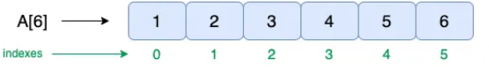
Q4. Write the Algorithm and C Program for Array Insertion.
Ans. Algorithm
- Start
- Read size of array (n)
- Read array elements
- Read position
- Read new element
- Shift all elements from the last towards the insertion position
- Insert the new element
- Increase array size
- Display updated array
- Stop
C - Program
#include <stdio.h>
void main()
{
int array[100];
int i, n, x, pos;
printf("Enter the number of elements in the array \n");
scanf("%d", &n);
printf("Enter the elements \n");
for (i = 0; i < n; i++)
{
scanf("%d", &array[i]);
}
printf("Input array elements are: \n");
for (i = 0; i < n; i++)
{ printf("%d ", array[i]);
}
printf("\nEnter the new element to be inserted: ");
scanf("%d", &x);
printf("Enter the position where element is to be inserted: ");
scanf("%d", &pos);

n=n+1;
for(i = n-1; i >= pos; i--)
array[i]=array[i-1];

array[pos-1]=x;
for (i = 0; i < n; i++)
{
printf("%d ", array[i]);
}
}

Q5. Explain Stack using LIFO Concept with Diagram.
Ans. A Stack is a linear data structure where insertion and deletion happen from the TOP only. It follows the LIFO (Last In, First Out) principle.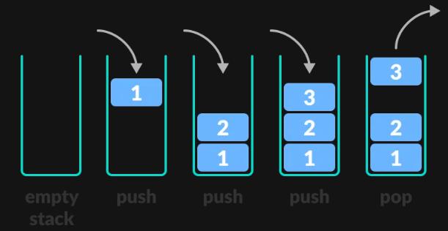

Q6. What is the Difference Between Stack and Queue?
Ans. Both are linear data structures but differ in insertion and deletion order.
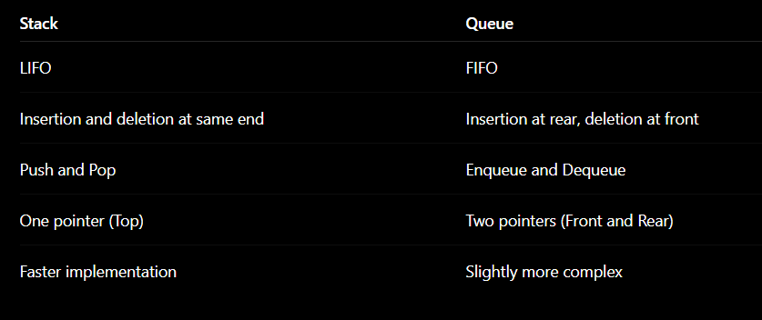

Q7. Write C Code for Enqueue and Dequeue Operations.
C Program.
Ans. Enqueue
- Inserts an element at the rear.
- Checks for overflow before insertion.
Dequeue
- Removes an element from the front.
- Checks for underflow before deletion.

#include<stdio.h>
#define SIZE 5
int queue[SIZE];
int front=-1;
int rear=-1;
void enqueue(int value)
{
if(rear==SIZE-1)
{
printf("Queue Overflow\n");
return;
}
if(front==-1)
front=0;
rear++;
queue[rear]=value;
}
void dequeue()
{
if(front==-1 || front>rear)
{
printf("Queue Underflow\n");
return;
}
printf("Deleted Element = %d\n",queue[front]);
front++;
}
void display()
{
int i;
if(front==-1 || front>rear)
{
printf("Queue Empty\n");
return;
}
for(i=front;i<=rear;i++)
printf("%d ",queue[i]);
printf("\n");
}
int main()
{
enqueue(10);
enqueue(20);
enqueue(30);
display();
dequeue();
display();
return 0;
}

Q8. Explain Singly Linked List with a Node Diagram.
Ans. A Singly Linked List is a linear data structure consisting of nodes, where each node stores:
Data
Address of the next node
The last node stores NULL.

Node Structure:-
struct Node
{
int data;
struct Node *next;
};
