# Case-Study 1

* Problem Statement :- Heat Diffusion is 2-D Rectangular Plate of dimensions 1*1 m^2 , with Thermal diffusivity of 0.0001 m^2/s , with one side at lower temperature 10 degree Celsius and other side with 50 degree Celsius
* Derivation :-
* Code:-

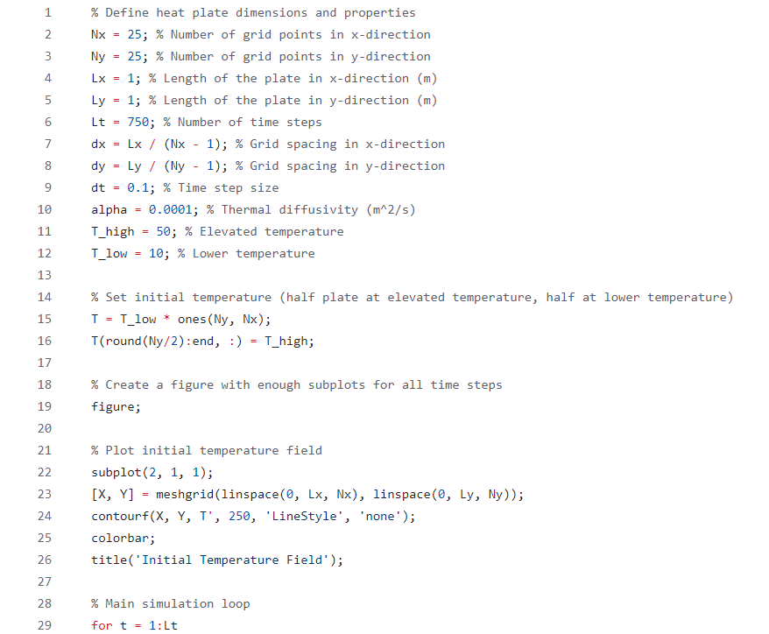

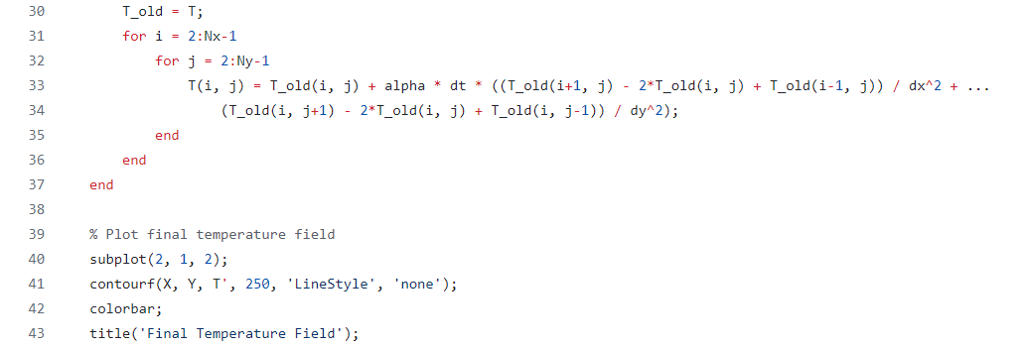

* Result:-

