SYNOPSIS

ON

“SMART HOME AUTOMATION SYSTEM”

Submitted in

Partial Fulfillment of requirements for the Award of Degree

*of*

Bachelor of Technology

*In*

Computer Science and Engineering

Specialization – IOT

**(Project Id: 22_IOT_2A_03)**

**Devashish Mishra – 2101641550035**

**Harsh Verma – 2101641550041**

**Anuj Agnihotri – 2101641550021**

**Adarsh Nigam – 2101641550010**

**Bhavi Katiyar – 2101641550032**

Under the supervision of

**Dr. Subhash Singh parihar**

**(Associate professor)**



**Pranveer Singh Institute of Technology**.

 Kanpur - Agra - Delhi National Highway - 19

Bhauti -Kanpur - 209305.

(Affiliated to Dr. A.P.J. Abdul Kalam Technical University)

1. Introduction

“Home automation” refers to the automatic and electronic control of household features, activity, and appliances. In simple terms, it means you can easily control the utilities and features of your home via the Internet to make life more convenient and secure, and even spend less on household bills.

Home automation is a network of hardware, communication, and electronic interfaces that work to integrate everyday devices with one another via the Internet. Each device has sensors and is connected through Wi-Fi, so you can manage them from your smartphone or tablet whether you’re at home, or miles away. This allows you to turn on the lights, lock the front door, or even turn down the heat, no matter where you are.

There are three main elements of a home automation system: sensors, controllers, and actuators.

* Sensors can monitor changes in daylight, temperature, or motion detection. Home automation systems can then adjust those settings (and more) to your preferences.
* Controllers refer to the devices — personal computers, tablets or smartphones — used to send and receive messages about the status of automated features in your home.
* Actuators may be light switches, motors, or motorized valves that control the actual mechanism, or function, of a home automation system. They are programmed to be activated by a remote command from a controller.

Home automation systems offer a variety of services and functions. Some of the more common features available through these platforms include:

* Remote lighting control
* Appliance control
* Home automation security systems and cameras
* Alarm systems
* Real-time text and email alert
* Keyless entry
* Voice-activated control

**2. Project Objectiv**e

* To control the environment at home, in order to provide the necessary comfort, security and safety.
* To offer remote access to home appliances.
* To monitor home status anytime, anywhere.
* To increase confidence and self-esteem of the elderly or people with physical disabilities inside the house.
* To reduce in-house physical mobility for people with physical disabilities.
* To provide to elderly people's caregivers (i.e. neighbors, family relatives) the opportunity to monitor their home environment.

This should give a clear picture of the project. Objectives should

be clearly specified. What the project ends up to and in what way

this is going to help the end user has to be mentioned.

1. Feasibility Study:

**i). Analysis:**

smart home system composed of multiple devices that are hereby referred to as “nodes” that are independently connected to a cloud based server, hereby referred to as “dashboard”. Each node is connected via Wi-Fi and powered with a battery. For the software part, the node is connected to the server and exchanges data using the MQTT protocol (Message Queuing Telemetry Transport) which is a protocol that is based on the TCP/IP protocol stack and uses the subscribe/publish method. The dashboard will be implemented using and will include a simple login form to a simple member area where we will have a pairing function that pairs a particular device with a particular user. This will allow the user to monitor and control his or her house from any computer or mobile phone remotely. Each node will either have a sensor, relay/switch, or a simple smart plug. There will be one particular node that is special in design and architecture which is the PIN code keypad for the door lock. Nodes use a sensor or a switch connected with a microcontroller that uses Wi-Fi.

**ii). Technical Feasibility:**

**a.** **Power Consumption :**

The ESP8266 uses between 2.5V and 3.6V. But the recommended maximum for the input voltage is 3.3V. Most of the sensors run on 3.3V as well but in case we use 5V sensors, we will then need to add a voltage regulator. The board draws 80 mA, with a Li-Po battery of 3000 mAh, it could last for ~26.25 hours without charging. When implementing a sleep-mode, it could last for days, or even months without charging.

**b.** **communication capacity:**

The ESP8266 uses standard Wi-Fi capabilities (802.11 b/g/n/e/i) with security capabilities of WPA/WPA2 and encryption capabilities of WEP/TKIP/AES. The ESP uses AT commands in order to be communicated to or from using serial (TX/RX).

**c. Economic Feasibility:**

The ESP8266 boards cost 2.46 USD at minimum, and 8 USD in Morocco. The cheapest device or node that could be manufactured will cost no more than 20 USD (all included). The expected budget spent for this project is around 20-30 USD.

**d. Legal Feasibility :**

All software and hardware used in this project are Open Source, some are under GPL License. Codes used are all taken from public github repositories and open source solutions.

**e. Operational Feasibility:**

Some nodes may not be implemented within the final prototype manufacturing process for operational issues. For example, the keypad door locking system needs an actual door and a mechanical lock. The keypad is connected to an ESP8266 board that controls a stepper motor that turns the lock when told to.

4.Methodology/ Planning of work:

Internet of Things comprises of a collection of sensors and actuators which gathers the data from the environment. The data gathered can be further processed to generate information. This system allows the users to remotely control the appliances in their absentia at the home. IoT based Home Automation system was implemented. The Main components of the system are Node MCU (ESP8266) , Relay Board. Many sensors 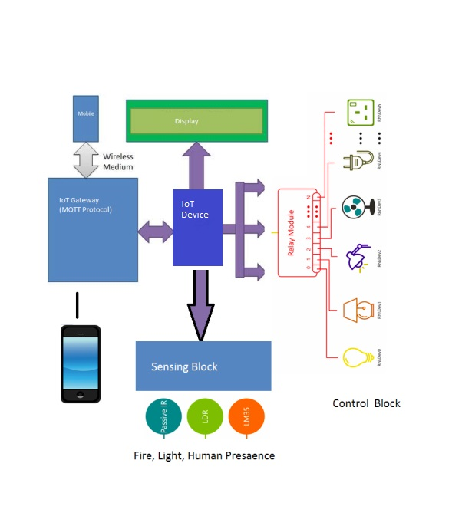and equipments are used to monitor or supervise the home appliance.

**Data Flow Diagram**

5. Tools/Technology Used:

5.1 Hardware Requirements:

1) Node MCU

2) Bread Board

3) Relay board 5-v

4) jumper wire

5) Bulb

6) Holders

7) Plug

5.2 Software Requirements:

1) Arduino IDE

2) sinric pro

6. References:

(1) Bouali, K. (2017, January 30). Specifications [Scholarly project]. Retrieved March 2, 2017. Bouali, K. (2017, February 3). BrainyHAB - Feasibility Study [Scholarly project]. Retrieved March 2, 2017.

(2) Z. (n.d.). STEEPLE Definition | Marketing Dictionary. Retrieved February 25, 2017, from

http://www.mbaskool.com/business-concepts/marketing-and-strategy-terms/6814-steeple.html (2016, July 15).

(3) Espressif Systems Instruction Set [E-Book]. Retrieved April 2, 2017.

MQTT Essentials Part 3: Client, Broker and Connection Establishment. (2015, December 20). (4) Retrieved April 22, 2017, from <http://www.hivemq.com/blog/mqtt-essentials-part-3-clientbroker-connection-establishment>

(5) Mosquitto. (n.d.). Retrieved April 22, 2017, from <http://www.mosquitto.org/>

Z. (n.d.). STEEPLE Definition | Marketing Dictionary. Retrieved February 25, 2017, from <http://www.mbaskool.com/business-concepts/marketing-and-strategy-terms/6814-steeple.html>

https://home-assistant.io/developers/architecture/