INTERNSHIP REPORT
DataPulse AI: Intelligent Data Analysis Platform
Submitted by
Student Name: Badiyani Dev Ketanbhai
Roll No: 2023010776
Semester: 6th

Department / Institute
Department of Computer Applications
Shree V. J. Modha College
Affiliated to Bhakta Kavi Narsinh Mehta University

Internship Duration
From: 05/01/2026 To: 04/02/2026

INTERNSHIP COMPLETION CERTIFICATE

ACKNOWLEDGEMENT

I would like to express my sincere gratitude to Shree V. J. Modha College for providing me the opportunity to undergo my internship and gain valuable practical exposure in a professional academic environment.
I am deeply thankful to my Internship Supervisor and Mentor, Dr. Vishal Pandya, for his constant guidance, support, motivation, and valuable suggestions throughout the internship period. His encouragement, academic support, and technical insights have helped me to enhance my knowledge, practical skills, and understanding of real-world applications.
I would also like to extend my heartfelt thanks to the Head of the Department and all the faculty members of the Department of Computer Applications (BCA) for their continuous support, guidance, and encouragement during the course of my internship.
I am grateful to Shree V. J. Modha College, affiliated to Bhakta Kavi Narsinh Mehta University, for providing me with this academic opportunity and a strong platform to develop my professional and technical competencies through the internship project titled 'DataPulse AI'.
Finally, I would like to thank my parents and friends for their constant encouragement, moral support, and cooperation throughout the internship period.

Student Name: Badiyani Dev Ketanbhai
Roll No.: 2023010776
Semester: 6th
Date: ___/___/______

TABLE OF CONTENTS
Contents
TABLE OF CONTENTS 4
1. INTRODUCTION 6
1.1 Project Overview 6
1.2 Problem Definition 6
1.3 Objectives 6
1.4 Scope of the Project 6
1.5 Hardware & Software Requirements 6
2. SYSTEM ANALYSIS 8
2.1 Existing System 8
2.2 Proposed System 8
2.3 Feasibility Study 8
2.4 Dataset Description 8
3. SYSTEM DESIGN 9
3.1 System Architecture 9
3.2 Data Flow Diagram (DFD) 9
3.3 Database Schema (ERD) 9
4. ALGORITHMS & METHODOLOGY 10
4.1 Large Language Models (LLM) 10
4.2 Natural Language to SQL (LangChain) 10
4.3 Dynamic Visualization Algorithm 10
5. IMPLEMENTATION 11
5.1 Backend Logic (main.py) 11
5.2 Frontend Implementation 21
Snippets from frontend/src/LandingPage.jsx (GSAP Animations): 21
Snippets from ChatbotUI.jsx (Chat & Chart Handling): 24
6. TESTING & VALIDATION 37
6.1 Test Cases 37
7. SCREENSHOTS 38
Landing Page 38
Visualization 39
ChatBotUI 40
8. DAILY WORK DIARY (LOGBOOK) 41
9. CONCLUSION 44
10. Refrences 45

1. INTRODUCTION

1.1 Project Overview
DataPulse AI is a high-performance, neural-inspired data analysis platform designed to bridge the gap between complex datasets and actionable insights. Leveraging advanced Large Language Models (LLMs) and real-time visualization engines, it enables users to interact with their data using natural language. The system eliminates the need for complex SQL queries or manual data crunching, offering a sleek, glassmorphic interface where users can upload CSV files, ask questions in plain English, and receive instant statistical analysis and dynamic charts.

1.2 Problem Definition
In the current data-driven landscape, analyzing large datasets requires technical expertise in tools like SQL, Python, or Excel macros. Non-technical stakeholders often struggle to extract insights quickly. Existing solutions are either too complex (requiring code) or too simplistic (lacking deep analysis). There is a need for a tool that democratizes data analysis by understanding human intent and translating it into precise database operations.

1.3 Objectives
1. To develop a conversational interface for data analysis using LLMs (Llama-3.3).
2. To implement a Neural Query Engine that translates text to SQL.
3. To provide real-time, context-aware visualizations (Bar, Line, Pie charts).
4. To ensure high-speed data parsing and cleaning for uploaded CSV datasets.
5. To create a premium, responsive UI with modern animations using GSAP and Framer Motion.

1.4 Scope of the Project
The scope includes a Web Application accessible via modern browsers. It supports CSV file uploads, automatic schema detection, and persistent chat sessions. The system is designed for business analysts, students, and researchers who need quick insights without writing code. Future scope includes support for multi-file analysis and PDF reporting.

1.5 Hardware & Software Requirements
Hardware:
- Processor: Intel Core i5 or higher
- RAM: 8GB min (16GB recommended)
- Storage: 256GB SSD
- Internet Connection: Active (for LLM API calls)
Software:
- OS: Windows 10/11, macOS, or Linux
- Frontend: React 18, Vite, Tailwind CSS, GSAP, Framer Motion
- Backend: Python 3.10+, FastAPI, Uvicorn
- AI/ML Stack: LangChain, Groq API (Llama-3.3), Pandas, SQLite
- IDE: VS Code

2. SYSTEM ANALYSIS

2.1 Existing System
Traditionally, data analysis is performed manually using spreadsheet software like Microsoft Excel or Google Sheets. For larger datasets, analysts use SQL databases. This process is:
- Time-consuming: Requires manual formula entry or query writing.
- Error-prone: Human errors in syntax or selection.
- Static: Charts must be manually updated if data changes.
- Inaccessible: Requiring specific training to operate effectively.

2.2 Proposed System
DataPulse AI automates this workflow. The proposed system features:
- Natural Language Processing: Users simply ask 'Show me the sales trend over the last year'.
- Autonomous SQL Generation: The system writes and executes the query safely.
- Dynamic Rendering: The frontend automatically chooses the best chart type (Line for trends, Pie for distribution) based on the data returned.
- Aesthetic & UX: A 'Neural' theme with dark mode and smooth animations enhances usability.

2.3 Feasibility Study
Technical Feasibility: formatting the project on modern stacks (React, Python) ensures scalability. The use of cloud based LLM APIs (Groq) offloads heavy computation.
Operational Feasibility: The interface is intuitive (Chat-based), requiring no training for end-users.
Economic Feasibility: Using open/freemium APIs (Groq) and open-source libraries reduces initial costs significantly.

2.4 Dataset Description
The system accepts datasets in CSV (Comma Separated Values) format. Upon upload, the backend uses Pandas to:
1. Read the file into a DataFrame.
2. Clean column names (strip spaces, lowercase, replace special chars).
3. Normalize data types.
4. Store the data in a temporary SQLite database for querying.

3. SYSTEM DESIGN

3.1 System Architecture
The project follows a Client-Server Architecture:
1. Client (Frontend): React.js application hosting the Chatbot UI, Chart Renderer, and Landing Page.
2. Server (Backend): FastAPI server handling API requests, file uploads, and session management.
3. AI Layer: LangChain agents communicating with the Llama-3.3 model via Groq.
4. Database Layer: In-memory SQLite database ('mini_data.db') for transient dataset storage.

3.2 Data Flow Diagram (DFD)
[Placeholder: Paste DFD Image here]
User -> Upload CSV -> Backend -> SQLite DB
User -> Ask Question -> Backend -> LangChain -> Llama 3.3 -> Generate SQL -> Execute on SQLite -> Result -> Frontend -> Render Text/Chart

3.3 Database Schema (ERD)
Since the system works with dynamic user uploads, the schema is flexible. However, a metadata table is used:
- Table 'metadata': Stores {key: 'active_table', value: 'table_name'}
- Table 'dynamic_table': The actual user data, columns depend on the CSV file (e.g., 'id', 'name', 'sales', 'date').

4. ALGORITHMS & METHODOLOGY

4.1 Large Language Models (LLM)
We utilize Llama-3.3-70b-versatile, a state-of-the-art open-weights model, processed via Groq LPUs for near-instant inference. This model is prompted to act as a 'DataPulse Neural Engine', capable of understanding complex analytical intent and formatting responses as JSON for the frontend.

4.2 Natural Language to SQL (LangChain)
Instead of simple keyword matching, we use LangChain's SQL Database Agent. The algorithm follows this 'Chain of Thought':
1. Inspect the database schema (table names, column types).
2. Parse the user's question (e.g., 'average age of users').
3. Generate a syntactic SQL query (SELECT AVG(age) FROM users).
4. Execute the query against the SQLite database.
5. Synthesize the result into a natural language answer.

4.3 Dynamic Visualization Algorithm
1. The LLM is instructed to detect if a visualization is needed.
2. If yes, it formats the output as a specific JSON structure: {type: 'chart', chartType: 'bar', data: [...], axes: ...}.
3. The Frontend parses this JSON. If a chart object is found, it passes the data to the 'ChartRenderer' component.
4. 'ChartRenderer' uses Recharts to plot the data dynamically, handling axes and legends automatically.

5. IMPLEMENTATION

5.1 Backend Logic (main.py)
The core entry point for the FastAPI server.
backend/main.py:
import os
import sqlite3
import pandas as pd
import io
import time
import random
import traceback
from fastapi import FastAPI, UploadFile, File, HTTPException, Response
from fastapi.middleware.cors import CORSMiddleware
from pydantic import BaseModel
from langchain_community.utilities import SQLDatabase
from langchain_community.agent_toolkits import create_sql_agent
from langchain_groq import ChatGroq
from dotenv import load_dotenv

load_dotenv(override=True)

app = FastAPI()

app.add_middleware(
CORSMiddleware,
allow_origins=[
"https://data-pulse-ai-one.vercel.app",
"http://localhost:5173",
"http://localhost:8001",
"http://127.0.0.1:5173",
"http://127.0.0.1:8001"
],
allow_credentials=True,
allow_methods=["*"],
allow_headers=["*"],
)

DB_PATH = "mini_data.db"

def get_conn():
return sqlite3.connect(DB_PATH)

def get_active_table():
try:
conn = get_conn()
cursor = conn.cursor()
cursor.execute("CREATE TABLE IF NOT EXISTS metadata (key TEXT PRIMARY KEY, value TEXT)")
cursor.execute("SELECT value FROM metadata WHERE key='latest_table'")
row = cursor.fetchone()
conn.close()
return row[0] if row else "data_table"
except:
return "data_table"

def set_active_table(name):
conn = get_conn()
cursor = conn.cursor()
cursor.execute("CREATE TABLE IF NOT EXISTS metadata (key TEXT PRIMARY KEY, value TEXT)")
cursor.execute("INSERT OR REPLACE INTO metadata (key, value) VALUES ('latest_table', ?)", (name,))
conn.commit()
conn.close()

@app.get("/")
def status():
return {"status": "online", "engine": "DataPulse Neural"}

@app.post("/upload")
async def upload_dataset(file: UploadFile = File(...)):
try:
payload = await file.read()
df = pd.read_csv(io.BytesIO(payload))

df.columns = [c.strip().replace(" ", "_").lower() for c in df.columns]

base_name = os.path.splitext(file.filename)[0].lower()
table_id = "".join([c if c.isalnum() else "_" for c in base_name])

conn = get_conn()
df.to_sql(table_id, conn, if_exists='replace', index=False)
conn.close()

set_active_table(table_id)

return {
"message": "Dataset indexed",
"columns": df.columns.tolist(),
"table": table_id
}
except Exception as e:
raise HTTPException(status_code=500, detail=str(e))

class Query(BaseModel):
question: str
history: list = []

@app.post("/ask")
def process_query(request: Query):
# 1. Handle Greetings
greetings = ["hi", "hello", "hey", "greetings", "good morning", "good afternoon", "good evening"]
if request.question.strip().lower() in greetings:
return {"answer": "Hello! 👋 I'm DataPulse AI. Please upload a CSV dataset so I can assist you with comprehensive data analysis. Ready when you are!"}

key = os.getenv("GROQ_API_KEY")
if not key:
return {"answer": "Missing API configuration."}

llm = ChatGroq(
model="llama-3.3-70b-versatile",
temperature=0,
api_key=key
)

# 2. Check Dataset
if not os.path.exists(DB_PATH):
# Fallback to general chat if no dataset
try:
response = llm.invoke(request.question)
return {"answer": response.content + "\n\n_(Please upload a CSV file to unlock data analysis capabilities)_"}
except Exception as e:
return {"answer": "I'm ready to analyze your data. Please upload a CSV file to get started."}

# 3. Dataset Exists - Use SQL Agent
try:
active_table = get_active_table()
db_engine = SQLDatabase.from_uri(f"sqlite:///{DB_PATH}")

llm = ChatGroq(
model="llama-3.3-70b-versatile",
temperature=0,
api_key=key
)

agent = create_sql_agent(
llm=llm,
db=db_engine,
agent_type="zero-shot-react-description",
verbose=False,
handle_parsing_errors=True
)

# Build context from history
context_str = ""
if request.history:
context_str = "\n\nPREVIOUS CONVERSATION:\n"
for msg in request.history[-6:]:
role = "User" if msg['role'] == 'user' else "Assistant"
context_str += f"{role}: {msg['content']}\n"

instructions = (
f"\n\nYou are the DataPulse Neural Engine. "
f"\nActive table: '{active_table}'. "
f"{context_str}"
"\n\nRULES:"
"\n1. For charts, provide a summary then JSON inside ```json ... ``` blocks."
"\n2. JSON Format: {\"type\": \"chart\", \"chartType\": \"bar|line|pie|area\", \"data\": [...], \"xAxis\": \"col\", \"yAxis\": \"col\", \"title\": \"text\"}."
f"\n3. You have permission to UPDATE/DELETE records on '{active_table}' BUT ONLY IF the user explicitly confirms in the CONVERSATION (e.g. 'yes', 'proceed')."
"\n - If the user asks to delete/update and hasn't confirmed, DO NOT execute. Instead return: '⚠️ I am about to [action]. Do you want to proceed?'"
"\n4. ALWAYS append the generated SQL query at the very end of your response in a markdown block like this:\n```sql\nSELECT ...\n```"
"\n5. CLASSIFICATION RULE:"
"\n - DATA QUERY (e.g., 'trends', 'average', 'count', 'specific columns', 'plot'): Generae SQL to query the database."
"\n - GENERAL QUERY (e.g., 'what is python?', 'tell me a joke', 'general advice', 'unrelated topics'): Answer directly based on your knowledge. DO NOT generate SQL. DO NOT mention the database."
)

max_retries = 3
base_delay = 2

for attempt in range(max_retries):
try:
# FORCE chart generation if keywords are present
input_text = request.question + instructions
if any(kw in request.question.lower() for kw in ["plot", "graph", "chart", "visualize", "show me"]):
input_text += "\n\nCRITICAL: The user wants a visualization. You MUST generate the JSON chart object. Fetch the data using SQL, then format it as JSON in your Final Answer."

response = agent.invoke({"input": input_text})
result = response["output"]
return {"answer": result}
except Exception as e:
if ("rate_limit" in str(e) or "429" in str(e)) and attempt < max_retries - 1:
sleep_time = base_delay * (2 ** attempt) + random.uniform(0, 1)
print(f"Rate limit hit. Retrying in {sleep_time:.2f}s...")
time.sleep(sleep_time)
else:
raise e

except Exception as e:
traceback.print_exc()
raw_err = str(e)
if "rate_limit" in raw_err or "429" in raw_err:
return {"answer": "🚀 **Engine Heat:** Too many requests. I tried to cool down but the pulse is still unstable. Please wait a minute."}
return {"answer": f"The neural engine encountered a ripple. Please retry your query. (Error: {str(e)})"}

@app.get("/download")
def export_data():
if not os.path.exists(DB_PATH):
raise HTTPException(status_code=404, detail="Empty database")

try:
table = get_active_table()
conn = get_conn()
df = pd.read_sql_query(f"SELECT * FROM {table}", conn)
conn.close()

buffer = io.StringIO()
df.to_csv(buffer, index=False)

resp = Response(content=buffer.getvalue(), media_type="text/csv")
resp.headers["Content-Disposition"] = f"attachment; filename={table}_export.csv"
return resp
except Exception as e:
raise HTTPException(status_code=500, detail=str(e))

5.2 Frontend Implementation
The frontend is built with React and heavily uses GSAP for animations.

Snippets from frontend/src/LandingPage.jsx (GSAP Animations):
<section className="relative pt-44 pb-32 px-6 overflow-hidden">
{!isLoading && (
<React.Suspense fallback={<div className="absolute inset-0 bg-slate-950/20" />}>
<ThreeBackground />
</React.Suspense>
)}

<div className="max-w-[90rem] mx-auto text-center hero-content relative z-10">
<motion.div
initial={{ opacity: 0, y: 20 }}
animate={!isLoading ? {
opacity: 1,
y: 0,
boxShadow: ["0 0 0px rgba(249,115,22,0)", "0 0 20px rgba(249,115,22,0.3)", "0 0 0px rgba(249,115,22,0)"]
} : {}}
transition={{
opacity: { duration: 1, delay: 0.5 },
y: { duration: 1, delay: 0.5 },
boxShadow: { duration: 2, repeat: Infinity, delay: 1.5 }
}}
className="inline-flex items-center gap-2 px-5 py-2 rounded-full bg-white/5 border border-white/10 text-slate-300 text-xs font-bold uppercase tracking-widest mb-10"
>
<Zap size={14} className="text-orange-400" />
<span>Intelligence Redefined</span>
</motion.div>
<h1 className="text-4xl sm:text-5xl md:text-7xl lg:text-8xl font-black mb-10 tracking-[-0.05em] leading-[0.9] text-white group cursor-default pb-4">
<span className="inline-flex gap-1 mr-4 group/data cursor-default">
{["D", "A", "T", "A"].map((char, i) => (
<motion.span
key={i}
initial={{ opacity: 0, y: 20, filter: "blur(10px)" }}
animate={!isLoading ? { opacity: 1, y: 0, filter: "blur(0px)" } : {}}
transition={{ delay: 0.8 + i * 0.15, duration: 0.8 }}
className="inline-block transition-all duration-300 group-hover/data:text-white group-hover/data:scale-110"
>
{char}
</motion.span>
))}
</span> <br />
<span className="inline-flex group/evolved cursor-default">
{["E", "V", "O", "L", "V", "E", "D"].map((char, i) => (
<motion.span
key={i}
initial={{ opacity: 0, y: 20, filter: "blur(10px)" }}
animate={!isLoading ? { opacity: 1, y: 0, filter: "blur(0px)" } : {}}
transition={{ delay: 1.4 + i * 0.1, duration: 0.8 }}
className="inline-block text-transparent bg-clip-text bg-gradient-to-b from-orange-200 to-orange-600 transition-all duration-300"
>
{char}
</motion.span>
))}
</span>
</h1>
<p className="opacity-0 text-slate-500 text-xl md:text-2xl max-w-2xl mx-auto mb-16 leading-relaxed font-medium">Direct dataset interaction. High-fidelity visualizations and deep neural insights in seconds.</p>
<div className="opacity-0">
<Magnetic>
<button onClick={onStart} className="btn-wave-fill2 group w-full md:w-auto bg-orange-600 text-white px-8 py-5 md:px-14 md:py-7 rounded-[2rem] font-black text-lg md:text-xl flex items-center justify-center gap-4 transition-all hover:scale-105 shadow-2xl shadow-orange-600/40">
START ANALYZING <ArrowRight size={24} className="group-hover:translate-x-2 transition-transform" />
</button>
</Magnetic>
</div>
</div>
</section>

Snippets from ChatbotUI.jsx (Chat & Chart Handling):
const ChatbotUI = ({ messages, input, setInput, onSend, onUpload, onDownload, setFile, loading, onBack }) => {
const scrollRef = useRef(null);

useEffect(() => {
if (scrollRef.current) {
scrollRef.current.scrollTop = scrollRef.current.scrollHeight;
}
}, [messages, loading]);

const [isDragging, setIsDragging] = React.useState(false);

// When dragging a file over the window
const onDragOver = (e) => {
e.preventDefault();
setIsDragging(true);
};

// When dragging leaves the window
const onDragLeave = (e) => {
e.preventDefault();
setIsDragging(false);
};

// Handling the file drop
const onDrop = (e) => {
e.preventDefault();
setIsDragging(false);
const files = e.dataTransfer.files;
if (files && files.length > 0) {
const f = files[0];
if (f.name.endsWith('.csv')) {
setFile(f);
onUpload(f);
} else {
alert("Please drop a CSV file.");
}
}
};

return (
<div
className="flex flex-col h-screen bg-transparent text-slate-100 font-sans relative overflow-hidden"
onDragOver={onDragOver}
onDragLeave={onDragLeave}
onDrop={onDrop}
>
<NeuralBackground isThinking={loading} />

{isDragging && (
<div className="absolute inset-0 z-50 bg-orange-500/20 backdrop-blur-sm border-4 border-orange-500 border-dashed m-2 md:m-4 rounded-3xl flex items-center justify-center animate-pulse pointer-events-none">
<div className="bg-black/80 p-8 rounded-3xl border border-orange-500/50 flex flex-col items-center gap-4">
<Upload size={48} className="text-orange-500" />
<h2 className="text-2xl font-bold text-white">Drop Dataset Here</h2>
<p className="text-slate-400">Release to analyze CSV</p>
</div>
</div>
)
}
<header className="px-4 py-3 md:px-6 md:py-4 border-b border-white/5 bg-zinc-950/80 backdrop-blur-xl flex justify-between items-center shrink-0">
<div className="flex items-center gap-4">
<Magnetic>
<motion.button
onClick={onBack}
whileHover={{ scale: 1.1 }}
whileTap={{ scale: 0.95 }}
className="p-2 rounded-full hover:bg-slate-100 transition-colors"
>
<ChevronLeft size={24} className="text-slate-600" />
</motion.button>
</Magnetic>
<div className="flex items-center gap-3">
<div className="relative">
<div className="absolute inset-[-4px] bg-orange-500/20 rounded-xl blur-lg animate-pulse" />
<div className="relativew-10 h-10 bg-orange-600 rounded-xl flex items-center justify-center shadow-[0_0_20px_rgba(249,115,22,0.4)] border border-orange-400/30">
<Logo3D className="w-10 h-10" isThinking={loading} />
</div>
</div>
<div>
<h2 className="font-bold text-slate-800 flex items-center gap-2 text-sm md:text-base">
DataPulse AI
<span className="hidden md:inline-flex px-2 py-0.5 rounded-full bg-indigo-50 text-indigo-600 text-xs font-medium border border-indigo-100">
Beta
</span>
</h2>
<p className="text-xs text-slate-500 hidden md:flex items-center gap-1">
<span className="w-1.5 h-1.5 rounded-full bg-green-500 animate-pulse" />
Online & Ready
</p>
</div>
</div>
</div>

<div className="flex items-center gap-2">
<Magnetic>
<label className="cursor-pointer group flex items-center gap-2 px-2 py-2 md:px-4 bg-orange-500/10 border border-orange-500/20 rounded-xl hover:bg-orange-500/20 transition-all">
<Upload size={18} className="text-orange-400 group-hover:scale-110 transition-transform" />
<span className="hidden md:inline text-xs font-semibold text-orange-300">Upload CSV</span>
<input
type="file"
accept=".csv"
className="hidden"
onChange={(e) => {
const f = e.target.files[0];
setFile(f);
if (f) onUpload(f);
}}
/>
</label>
</Magnetic>
<Magnetic>
<button onClick={onDownload} className="p-2.5 bg-slate-800 hover:bg-slate-700 border border-white/5 rounded-xl transition-all" title="Download Export">
<Download size={18} className="text-slate-300" />
</button>
</Magnetic>
</div>
</header>

<main ref={scrollRef} className="flex-1 overflow-y-auto p-4 md:p-6 space-y-6 md:space-y-8 scroll-smooth custom-scrollbar">
{messages.length === 0 && !loading && (
<motion.div
initial={{ opacity: 0, scale: 0.9 }}
animate={{ opacity: 1, scale: 1 }}
transition={{ duration: 0.5, ease: "backOut" }}
className="h-full flex flex-col items-center justify-center max-w-sm mx-auto text-center space-y-6"
>
<div className="w-20 h-20 bg-zinc-900 rounded-3xl flex items-center justify-center border border-white/5 shadow-2xl">
<BarChart3 size={40} className="text-orange-500 opacity-50" />
</div>
<div className="space-y-2">
<h2 className="text-xl font-bold">Neural Link Ready</h2>
<p className="text-slate-500 text-sm leading-relaxed">Upload a dataset to begin natural language analysis and dynamic visualization.</p>
</div>
</motion.div>
)}

<AnimatePresence mode="popLayout">
{messages.map((msg, i) => (
<motion.div
key={i}
initial={{ opacity: 0, y: 20, scale: 0.95 }}
animate={{ opacity: 1, y: 0, scale: 1 }}
layout
transition={{ duration: 0.4, ease: "easeOut" }}
className={`flex ${msg.role === 'user' ? 'justify-end' : 'justify-start'}`}
>
<div className={`flex gap-3 md:gap-4 max-w-full md:max-w-[85%] ${msg.role === 'user' ? 'flex-row-reverse' : ''}`}>
<div className={`w-8 h-8 rounded-lg flex items-center justify-center shrink-0 border border-white/5 shadow-sm ${msg.role === 'user' ? 'bg-orange-600' : 'bg-zinc-800'}`}>
{msg.role === 'user' ? <User size={16} /> : <Bot size={16} className="text-orange-400" />}
</div>

<div className={`space-y-4 p-5 rounded-2xl shadow-lg border ${msg.role === 'user'
? 'bg-orange-950/30 border-orange-500/50 text-white rounded-tr-none'
: 'bg-zinc-900/40 border-white/5 text-slate-200 rounded-tl-none ring-1 ring-white/5'
}`}>
{msg.content && (
<div className="prose prose-invert prose-sm max-w-none">
<ReactMarkdown>
{msg.chart ? msg.content.replace(/```json[\s\S]*?```/g, '').replace(/\{[\s\S]*?\}/g, '').trim() : msg.content}
</ReactMarkdown>
</div>
)}
{msg.chart && (
<div className="py-4">
<DataCard3D className="w-full md:min-w-[500px]">
<div className="h-80">
<ChartRenderer chartConfig={msg.chart} />
</div>
</DataCard3D>
</div>
)}
</div>
</div>
</motion.div>
))}
</AnimatePresence>

{loading && (
<motion.div
initial={{ opacity: 0, y: 10 }}
animate={{ opacity: 1, y: 0 }}
exit={{ opacity: 0, y: 10 }}
className="flex justify-start"
>
<div className="flex gap-4">
<div className="w-8 h-8 rounded-lg bg-zinc-800 flex items-center justify-center shrink-0 border border-white/5">
<Bot size={16} className="text-orange-400" />
</div>
<div className="bg-zinc-900/40 border border-white/5 p-4 rounded-2xl rounded-tl-none flex items-center gap-3">
<Loader2 size={16} className="animate-spin text-orange-500" />
<span className="text-xs font-medium text-slate-500 uppercase tracking-widest">Processing...</span>
</div>
</div>
</motion.div>
)}
</main>

<footer className="p-4 md:p-6 bg-zinc-950/80 border-t border-white/5 shrink-0">
<div className="max-w-4xl mx-auto">
<MiniMagneticString />
<div className="relative">
<input
value={input}
onChange={(e) => setInput(e.target.value)}
onKeyDown={(e) => e.key === 'Enter' && onSend()}
placeholder="Query dataset..."
className="w-full bg-zinc-900/50 border-2 border-white/5 focus:border-orange-500/50 rounded-2xl p-5 pr-16 text-slate-100 placeholder:text-slate-500 outline-none transition-all shadow-2xl focus:ring-4 focus:ring-orange-500/10"
/>
<div className="absolute right-3 top-3 bottom-3 flex items-center">
<Magnetic>
<button
onClick={onSend}
disabled={!input.trim() || loading}
className="aspect-square h-full bg-orange-600 hover:bg-orange-700 disabled:opacity-50 rounded-xl flex items-center justify-center transition-all hover:scale-105 active:scale-95 shadow-lg shadow-orange-600/20"
>
<Send size={20} className="text-white" />
</button>
</Magnetic>
</div>
</div>
</div>
<p className="text-center text-[10px] text-slate-600 mt-4 uppercase tracking-[0.2em] font-bold">
DataPulse AI • Neural Analysis Platform
</p>
</footer>
</div >
);
};

6. TESTING & VALIDATION

6.1 Test Cases
Test Case Purpose | Input | Expected Outcome
Verify CSV Upload | Upload valid student_exam_scores.csv | System returns "Dataset indexed" and schema.
Data Query | User asks "Total Student" | System returns correct sum from DB.
Graph Generation | User asks "Plot the data" | System renders a Bar/Line chart.
Error Handling | Upload .txt file | System rejects file with error message.
Responsiveness | Resize window to mobile | UI adapts, menu becomes hamburger.

7. SCREENSHOTS

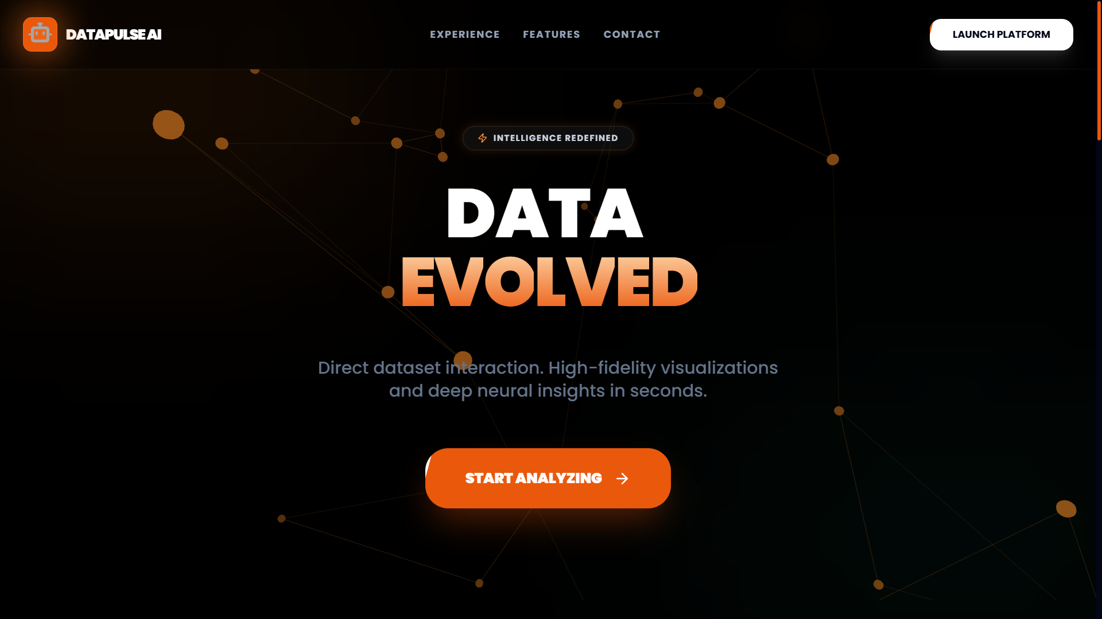
Landing Page

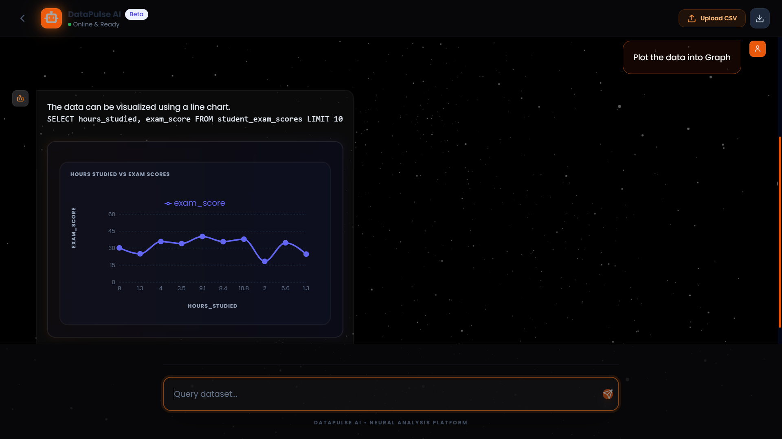
Visualization

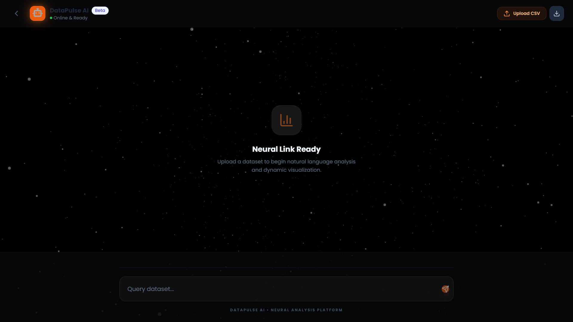
ChatBotUI

8. DAILY WORK DIARY (LOGBOOK)
Day | Date | Topic | Activity Description | Hours
1 | 05-Jan-2026 | Project Kick-off | Selection of topic 'DataPulse AI' and requirement gathering. | 5 Hours
2 | 06-Jan-2026 | Environment Setup | Setting up Python, Node.js, Git and project repository. | 5 Hours
3 | 07-Jan-2026 | Backend Design | Designing database schema and basic FastAPI backend. | 5 Hours
4 | 08-Jan-2026 | Frontend Setup | Setting up Vite + React and Tailwind CSS. | 5 Hours
5 | 09-Jan-2026 | Landing Page | Created landing page structure and hero section. | 5 Hours
6 | 10-Jan-2026 | Animations | Integrated GSAP animations into landing page. | 5 Hours
7 | 12-Jan-2026 | Self Learning | Self-learning Framer Motion animations. | 5 Hours
8 | 13-Jan-2026 | CSV Handling | Implemented CSV upload and Pandas processing. | 5 Hours
9 | 15-Jan-2026 | LLM Integration | Configured Groq API and LangChain agents. | 5 Hours
10 | 16-Jan-2026 | Chat UI | Developed ChatbotUI component. | 5 Hours
11 | 17-Jan-2026 | API Integration | Connected frontend chat with backend APIs. | 5 Hours
12 | 19-Jan-2026 | JSON Parsing | Implemented structured JSON parsing for responses. | 5 Hours
13 | 20-Jan-2026 | Visualization | Created ChartRenderer using Recharts. | 5 Hours
14 | 21-Jan-2026 | Code Review | Code refactoring and optimization. | 5 Hours
15 | 22-Jan-2026 | SQL Agent Testing | Testing SQL generation agent. | 5 Hours
16 | 23-Jan-2026 | Bug Fixing | Resolved database locking and CSV header issues. | 5 Hours
17 | 24-Jan-2026 | UI Enhancement | Applied glassmorphism effects and animations. | 5 Hours
18 | 27-Jan-2026 | Feedback Module | Implemented feedback form in footer. | 5 Hours
19 | 28-Jan-2026 | System Testing | Performed unit and user flow testing. | 5 Hours
20 | 29-Jan-2026 | Documentation | Prepared documentation and screenshots. | 5 Hours
21 | 30-Jan-2026 | Final Review | Final evaluation and report completion. | 5 Hours
22 | 31-Jan-2026 | Frontend Polish | UI improvements and responsiveness fixes. | 5 Hours
23 | 02-Jan-2026 | Integration | Final frontend-backend integration. | 5 Hours
24 | 03-Feb-2026 | Result Analysis | Validated system output and accuracy. | 5 Hours
25 | 04-Feb-2026 | Final Submission | Final documentation | 5 Hours

9. CONCLUSION
The DataPulse AI internship project successfully demonstrates the power of integrating modern Large Language Models with traditional data analysis workflows. By creating an intuitive, natural language interface, we have simplified the process of data extraction and visualization. The project met all its primary objectives, including robust CSV handling, accurate SQL generation, and dynamic charting. Working on this project provided deep insights into Full Stack Development (React/FastAPI) and the emerging field of AI Engineering.

10. Refrences
1. React Documentation: https://react.dev
2. FastAPI Documentation: https://fastapi.tiangolo.com
3. LangChain Python Docs: https://python.langchain.com
4. Groq Cloud API: https://console.groq.com
5. Tailwind CSS: https://tailwindcss.com

