

Translational Biology Center of Excellence
Genomic Report Generation
Installation, Prerequisites and End-to-End User Guide
OncoPanel™ Genomics – automated report generation from OncoPredictor outputs to the final Word report

Document control
Document title | Genomic Report Generation – Installation, Prerequisites and End-to-End User Guide
Document type | User Guide / Work Instruction
Document number | To be assigned by Document Control
Document version | 1.0
Application version | Genomic Report Generation 1.0.0
Effective date | 05 November 2026
Department | Translational Biology Center of Excellence – OncoPanel™ Genomics
Classification | Internal – Confidential

Approval
Role | Name | Function | Signature | Date
Prepared by
Reviewed by
Approved by (QA)

Revision history
Version | Date | Description of change | Author
1.0 | 05 Nov 2026 | First issue: installation, prerequisites, end-to-end procedure with screenshots, inputs, outputs, logs and troubleshooting

Contents
1 Purpose 4
2 Scope 4
3 Definitions and abbreviations 4
4 Responsibilities 4
5 Overview of the application 5
6 Prerequisites 6
6.1 Computer requirements 6
6.2 Software requirements 6
6.3 Packages delivered 6
6.4 Network access 7
7 Installing the application 8
7.1 Option A – Portable package (recommended) 8
7.2 Option B – Auto-install package 8
8 Installing Python and R manually (optional) 10
8.1 Install Python 10
8.2 Install R 10
8.3 Then install the application 11
9 Starting and stopping the application 11
10 Inputs required 12
11 Running a study end to end 13
11.1 Create a project 13
11.2 Step 1 – OncoPredictor Output Collection 14
11.3 Step 2 – Clustering Script Execution 15
11.4 Step 3 – DiffEx Table Generation 16
11.5 Step 4 – Sensitivity Gene Extraction 16
11.6 Step 5 – g:Profiler Pathway Analysis 17
11.7 Step 6 – Word Report Generation 17
11.8 Step 7 – Final Report Packaging 18
11.9 Running all remaining steps at once 19
11.10 Collecting the results 19
12 Expected outputs 21
12.1 Study folder structure 21
12.2 Description of the output files 21
12.3 Examples of the outputs 22
13 Logs and audit trail 23
13.1 Where to find the logs 23
13.2 Live activity panel 23
13.3 Activity Log page 24
13.4 Reading activity_log.txt 24
14 Managing studies 24
15 Settings 26
16 Troubleshooting 28
17 Security and information for IT 29
18 Updating and uninstalling 29
19 Quick reference 29

1 Purpose
This document describes how to prepare a Windows computer for the Genomic Report Generation application, how to install and start it, which input files are required, and how to run a complete OncoPanel™ genomics study from the OncoPredictor outputs to the final Word report and deliverables package. It also explains the output folder structure, where the logs are written and how to resolve common problems.

2 Scope
This guide applies to Genomic Report Generation version 1.0.0 running on Windows 10 or Windows 11 (64-bit). It covers:
- Prerequisites and the installation of Python and R
- Installation of the application (Portable and Auto-install packages)
- The seven-step workflow, from OncoPredictor Output Collection to Final Report Packaging
- Inputs, outputs, logs, settings, troubleshooting and information for IT support
It does not cover the scientific interpretation of the results or the content of the R clustering script, the Excel template or the Word report template; these remain under their own procedures.

3 Definitions and abbreviations
Term | Meaning
DiffEx report | Differential-expression Excel report exported from OncoPredictor
Mutation report | Mutation Excel report exported from OncoPredictor (sheet OncoPanel Results)
Assay data file (.tab) | Tab-delimited assay data read by the clustering R script
GenerateClusteringFile.R | Helper R script that the clustering script loads with source()
g:Profiler / g:GOSt | Public functional-enrichment web service used for the pathway analysis
Project / study folder | The folder that holds all inputs, outputs and logs of one study
Deliverables package | Zip file with all outputs and a SHA-256 checksum manifest
%LOCALAPPDATA% | The current user's local application-data folder, normally C:\Users\<user>\AppData\Local
SOC | Standard of care (reference compounds in the clustering output)

4 Responsibilities
Role | Responsibility
End user (scientist / report author) | Prepares the inputs, runs the workflow, checks and finalises the report
Application owner | Maintains the application package, the default templates and this document
IT support | Approves the installation on company computers and allows the network addresses listed in section 6.4

5 Overview of the application
Genomic Report Generation automates the OncoPanel™ genomics reporting workflow. It runs locally on the user's computer and opens in a Google Chrome or Microsoft Edge window. Nothing is published on the network: the application only listens on this computer (127.0.0.1). Each study is processed in seven steps:
Step | Name in the application | What happens | Input from the user
1 | OncoPredictor Output Collection | Validates the DiffEx and Mutation reports and stores them in the project | Two Excel reports
2 | Clustering Script Execution | Runs the clustering R script with the project paths filled in | R script (helper and .tab optional)
3 | DiffEx Table Generation | Copies DiffEx columns A:P into Table 3 for DiffEx and writes the formulas | Excel template
4 | Sensitivity Gene Extraction | Extracts the top 60 sensitivity and top 60 resistance genes | None
5 | g:Profiler Pathway Analysis | Runs g:GOSt for both gene lists and saves the result files | None (internet needed)
6 | Word Report Generation | Fills Table 3, the gene summaries and the report placeholders | Word template, report details
7 | Final Report Packaging | Packages every deliverable into one zip with a checksum manifest | None

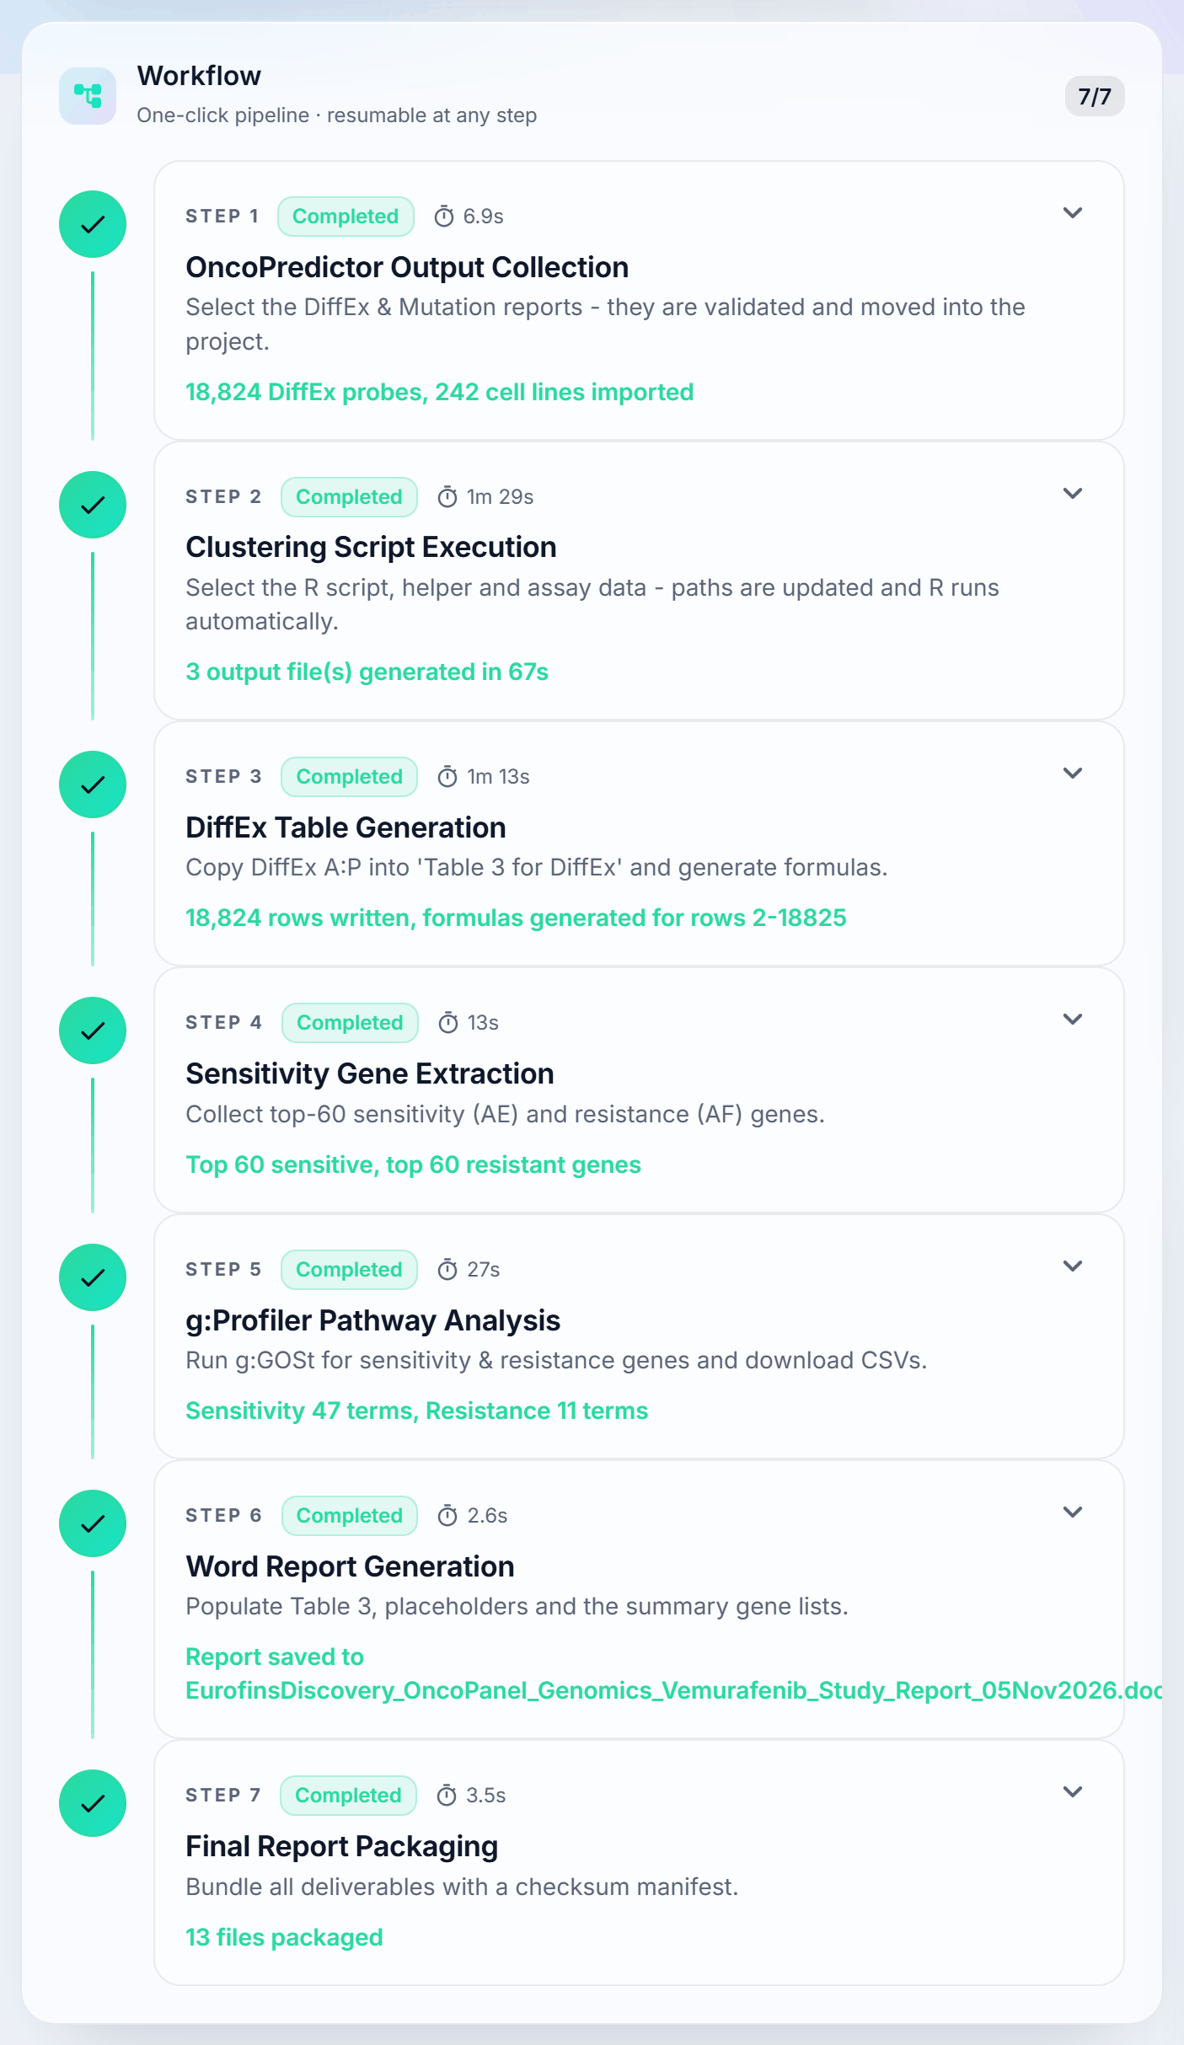
Figure 1: The seven workflow steps as shown on the Dashboard (completed study)
Every completed step is remembered. If a step fails, correct the cause and click Retry; completed steps are never repeated. Steps 2 and 5 can be skipped when R or internet access is not available.

6 Prerequisites

6.1 Computer requirements
Item | Requirement | Remarks
Operating system | Windows 10 (version 1803 or later) or Windows 11, 64-bit
Memory | 4 GB RAM minimum, 8 GB recommended | Large DiffEx files contain about 19,000 rows
Free disk space | 1 GB, plus about 50 MB per study | Portable package: about 600 MB after extraction
Browser | Google Chrome or Microsoft Edge | Edge is part of Windows; Chrome is used when installed
Administrator rights | Not required | Everything installs for the current user only
Microsoft Word and Excel | Optional | Only needed to open and review the outputs

6.2 Software requirements
Software | Version | Used for | Portable package | Auto-install package
Python | 3.10 or newer (3.12.10 validated) | Running the application | Included | Installed automatically
R | 4.x (4.6.2 validated) | Step 2 only | Included | Installed automatically
R package dplyr | Current | Clustering R script | Included | Installed automatically
Python libraries | See backend\requirements.txt | Running the application | Included | Installed automatically

Note: With either package the user does not need to install anything by hand. Section 8 describes the manual installation of Python and R for the cases where IT prefers to install them, or the computer has no internet access during setup.

6.3 Packages delivered
Package | Size | Recommended when | What it needs
GenomicReport_Portable.zip | about 195 MB | Users must not install software, or the computer is offline | Nothing; Python and R are inside the folder
GenomicReport_AutoInstall.zip | about 1 MB | A small download is preferred and the computer has internet | Internet on the first start; Python and R are installed for the current user

6.4 Network access
The application needs internet access only for the following activities. The addresses are given in the steps where they are used:
- First start of the Auto-install package: downloads Python from python.org, R from cloud.r-project.org and the Python libraries from pypi.org and files.pythonhosted.org.
- First run of Step 2: downloads missing R packages (dplyr) from cloud.r-project.org, unless already installed.
- Step 5: uses the g:Profiler service at biit.cs.ut.ee. On its first run the browser driver is downloaded from googlechromelabs.github.io and storage.googleapis.com.
- Launch OncoPredictor (optional, Step 1): opens the internal OncoPredictor portal.

7 Installing the application

7.1 Option A – Portable package (recommended)
The Portable package contains the application together with its own Python and R. Nothing is installed on the computer and nothing is downloaded.
1 Copy GenomicReport_Portable.zip to the computer, for example into Documents.
2 Right-click the zip file and choose Extract All…. Choose a short destination folder such as C:\Users\<user>\GenomicReport and click Extract. Do not start the application from inside the zip file.
3 Open the extracted folder GenomicReport_Portable. It contains:
GenomicReport_Portable\
├── Start-GenomicReport.bat ← double-click to start
├── HOW-TO-RUN.txt
├── backend\ application
├── docs\ this guide (Word, PDF and HTML)
├── R\GenerateClusteringFile.R built-in dummy helper
├── samples\ sample assay (.tab) file
└── runtime\ bundled Python 3.12 and R 4.6.2 (with dplyr)
4 Double-click Start-GenomicReport.bat. After a few seconds the application window opens with the welcome screen (section 9).

7.2 Option B – Auto-install package
The Auto-install package is small. On the first start it installs whatever is missing, for the current user only and without administrator rights. The installers are downloaded from the official sites and their digital signatures are verified before they run.
1 Copy GenomicReport_AutoInstall.zip to the computer, right-click it, choose Extract All… and extract it to a short folder such as C:\Users\<user>\GenomicReport.
2 Open the extracted folder and double-click Start-GenomicReport.bat.
3 A setup window opens. Keep it open. The first start takes about 4 to 10 minutes depending on the internet speed:
- [1/4] If Python 3.10 or newer is not found, Python 3.12.10 is downloaded from https://www.python.org/ftp/python/3.12.10/python-3.12.10-amd64.exe and installed silently to %LOCALAPPDATA%\Programs\Python\Python312.
- [2/4] If R is not found, R 4.6.2 is downloaded from https://cloud.r-project.org/bin/windows/base/R-4.6.2-win.exe (or, after a newer R release, from https://cloud.r-project.org/bin/windows/base/old/4.6.2/R-4.6.2-win.exe) and installed silently to %LOCALAPPDATA%\Programs\R\R-4.6.2. The R package dplyr is then installed from https://cloud.r-project.org.
- [3/4] A private Python environment is created in %LOCALAPPDATA%\GenomicReportGeneration\venv.
- [4/4] The Python libraries are installed from https://pypi.org.
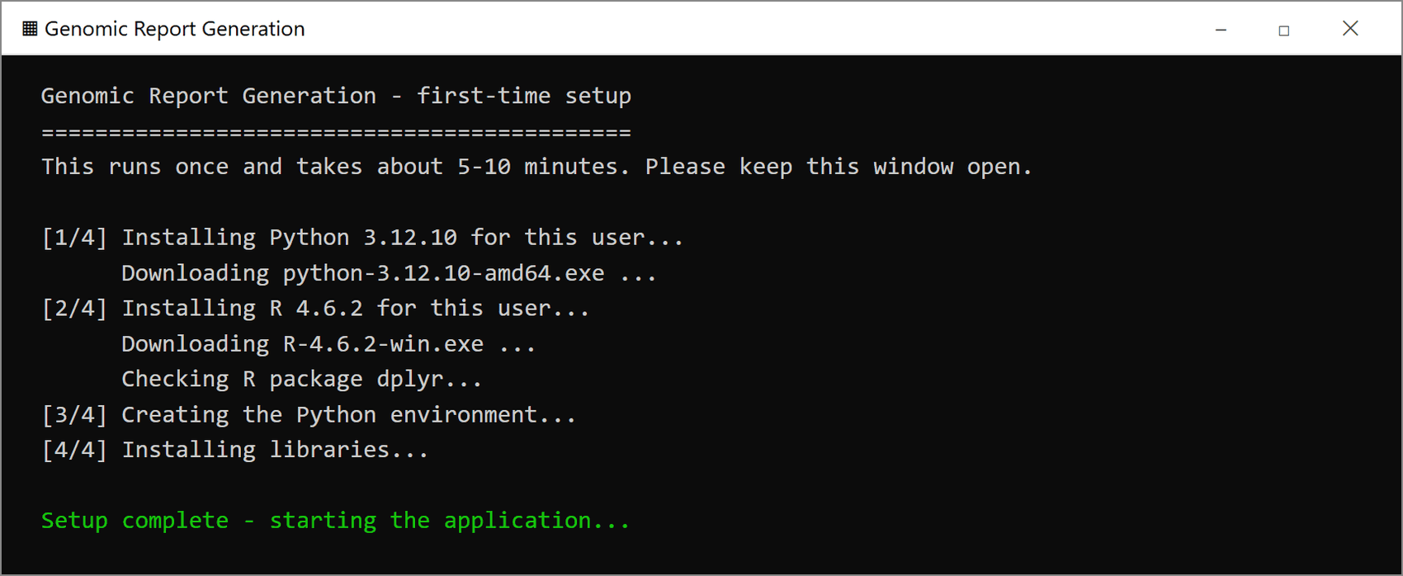
Figure 2: First start of the Auto-install package
4 When Setup complete – starting the application… is displayed, the setup window closes and the application window opens.
5 Later starts skip the setup and open the application within a few seconds.
Important: If the setup reports that a download failed, the computer has no internet access or a company proxy blocks the addresses above. Connect to the internet, or ask IT to allow the addresses, and double-click Start-GenomicReport.bat again; the setup continues where it stopped. If R cannot be installed, the application still starts and Step 2 can be skipped.

8 Installing Python and R manually (optional)
Skip this section when using the Portable or the Auto-install package. Follow it only when Python and R must be installed by hand, for example by IT. No administrator rights are needed when the options below are followed.

8.1 Install Python
1 Open the Python 3.12.10 download page in a browser: https://www.python.org/downloads/release/python-31210/
2 Scroll down to Files and click Windows installer (64-bit). Do not use the Python install manager button at the top of the page. The direct download link is https://www.python.org/ftp/python/3.12.10/python-3.12.10-amd64.exe
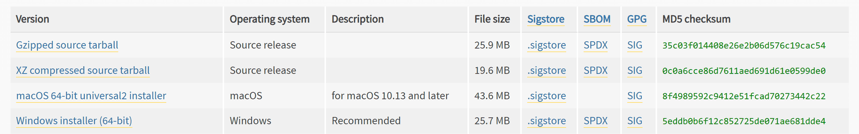
Figure 3: python.org – select “Windows installer (64-bit)” for Python 3.12.10
3 Double-click the downloaded file python-3.12.10-amd64.exe.
4 On the first screen of the installer, untick “Use admin privileges when installing py.exe”. Leaving this option ticked is what triggers the administrator prompt.
5 Tick “Add python.exe to PATH”.
6 Click Install Now. Python is installed to C:\Users\<user>\AppData\Local\Programs\Python\Python312.
7 When Setup was successful is shown, click Close.
8 Check the installation: press Windows + R, type cmd and press Enter. In the Command Prompt type python --version and press Enter. The result must be Python 3.10 or higher.

8.2 Install R
1 Open the CRAN download page for Windows in a browser: https://cloud.r-project.org/bin/windows/base/
2 Click Download R-4.6.2 for Windows. The direct download link is https://cloud.r-project.org/bin/windows/base/R-4.6.2-win.exe. After a newer R version is released, version 4.6.2 is moved to https://cloud.r-project.org/bin/windows/base/old/4.6.2/R-4.6.2-win.exe
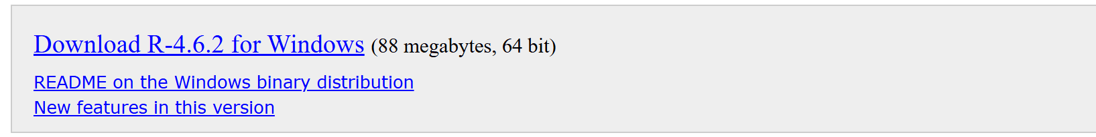
Figure 4: CRAN – download R for Windows
3 Double-click the downloaded file R-4.6.2-win.exe.
4 If the installer asks for the installation mode, choose Install for me only (no administrator rights needed).
5 Select the language and click OK, then keep every default option and click Next on each page until Finish.
6 R is installed to C:\Users\<user>\AppData\Local\Programs\R\R-4.6.2 (per user) or C:\Program Files\R\R-4.6.2 (all users). Both are detected automatically.
7 Check the installation in a Command Prompt: "%LOCALAPPDATA%\Programs\R\R-4.6.2\bin\Rscript.exe" --version
Note: R does not have to be added to PATH and the dplyr package does not have to be installed by hand. The application finds R through the Windows registry and installs missing R packages automatically the first time Step 2 runs.

8.3 Then install the application
With Python and R installed, extract the Auto-install package and double-click Start-GenomicReport.bat (section 7.2). The setup detects the installed Python and R and only creates the Python environment.

9 Starting and stopping the application
1 Double-click Start-GenomicReport.bat in the application folder.
2 The application opens in its own Chrome or Edge window at http://127.0.0.1:8765. If it is already running, the existing window is brought to the front instead of starting a second copy.
3 The welcome screen is shown on every start; no study is opened automatically.
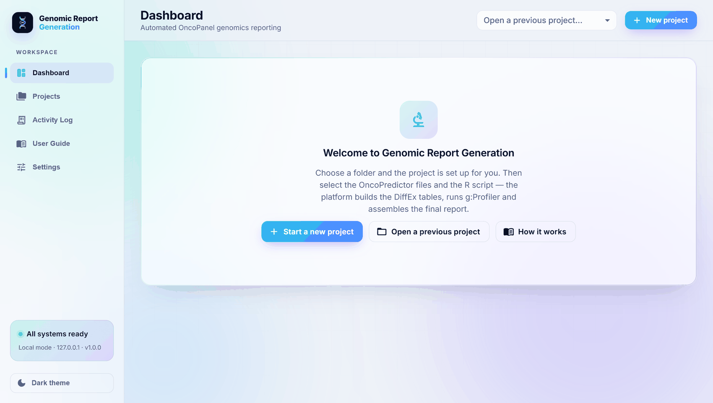
Figure 5: Welcome screen
Element | Purpose
Start a new project | Creates a new study (section 11.1)
Open a previous project | Opens the Projects page to continue an earlier study
How it works | Opens the built-in User Guide page
Left menu | Dashboard, Projects, Activity Log, User Guide and Settings
All systems ready | Green when R, the browser and the default project folder are found
Light theme / Dark theme | Switches the colour scheme

To stop the application, close its window. The background process stops by itself about five minutes later. If a Session expired message appears, close the window and start the application again.

10 Inputs required
Prepare the following files before starting a study. They can be on a local drive, a mapped drive (for example K:) or a network share. The R script and the templates selected last are remembered and pre-filled for the next study.
Input | Format | Required | Used in | Description
Project location | Folder | Yes | New project | Where the study folder is created, for example D:\ or K:\Projects
DiffEx report | .xlsx / .xlsm | Yes | Step 1 | OncoPredictor output, for example …_Vemurafenib_13FEB23-Diffex-PROD.xlsx
Mutation report | .xlsx / .xlsm | Yes | Step 1 | OncoPredictor output with sheet OncoPanel Results; the analysis parameter (for example IC50) is read from cell D1
Clustering R script | .r | Yes* | Step 2 | For example EurofinsDiscovery_OncoPanel_Genomics_Client_Study_Clustering_Script_25Jan2023.r
GenerateClusteringFile.R | .r | Optional | Step 2 | The helper normally stored in K:\LabOperations\Oncopanel\QC support files. Empty: built-in dummy helper
Assay data file | .tab / .txt / .tsv / .csv | Optional | Step 2 | Tab-delimited assay data. Empty: a dummy file is generated from the Mutation report
Excel template | .xlsx / .xlsm | Yes | Step 3 | …_Client_Study_Mutations_and_Hotspots_Tables_Template_25Jan2023.xlsx (sheet Table 3 for DiffEx)
Word template | .docx | Yes | Step 6 | …_Client_Study_Report_Template_25Jan2023.docx
Report details | Text | Optional | Step 6 | Compound, analysis parameter, client name and order ID

* Step 2 can be skipped when R is not available. Every file is checked before it is used: full path, correct extension, not empty, at most 1 GB, and the expected sheets and header rows.

11 Running a study end to end
The screenshots in this section show a complete example study for the compound Vemurafenib, created in P:\Vemurafenib_Study.

11.1 Create a project
1 On the welcome screen click Start a new project, or click New project at the top right.
2 In Project location, type a folder or click the folder icon to browse. The right-hand panel shows the study folder and the sub-folders that will be created.
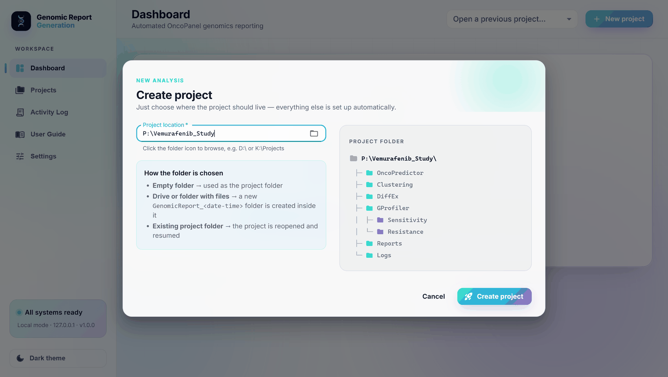
Figure 6: Create project dialog
- Empty folder: used as the study folder.
- Drive or folder that already contains files: a new folder GenomicReport_<date>_<time> is created inside it.
- Existing study folder: the study is reopened and resumed.
3 Click Create project. The Dashboard opens for the new study.
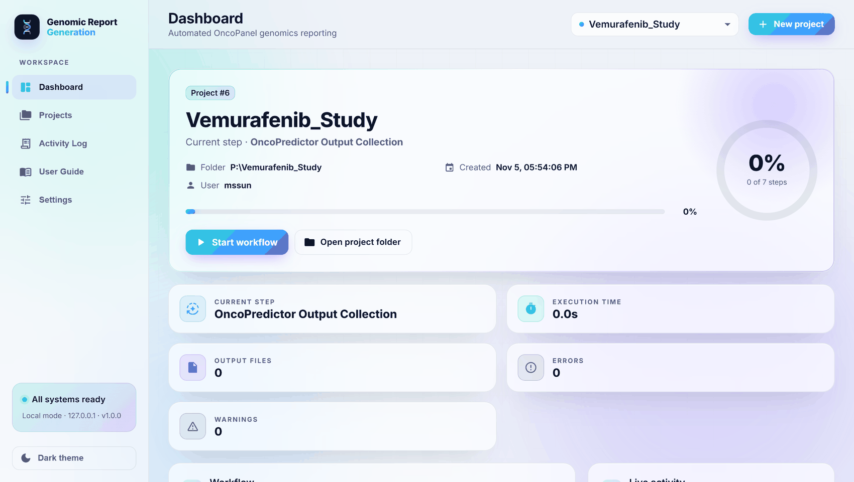
Figure 7: Dashboard of a new study
The Dashboard shows the study name and folder, the overall progress, the current step, the execution time and the number of output files, errors and warnings. Below it are the Workflow with the seven steps, the Live activity panel and the Deliverables list.

11.2 Step 1 – OncoPredictor Output Collection
1 Optional: click Launch OncoPredictor to open the OncoPredictor portal (https://automationtools-panlabsus.eurofinsdiscovery.net/) and download the DiffEx and Mutation reports of the study.
2 In DiffEx report (.xlsx) from OncoPredictor, type the path or click the folder icon and select the DiffEx report.
3 In Mutation report (.xlsx) from OncoPredictor, select the Mutation report.
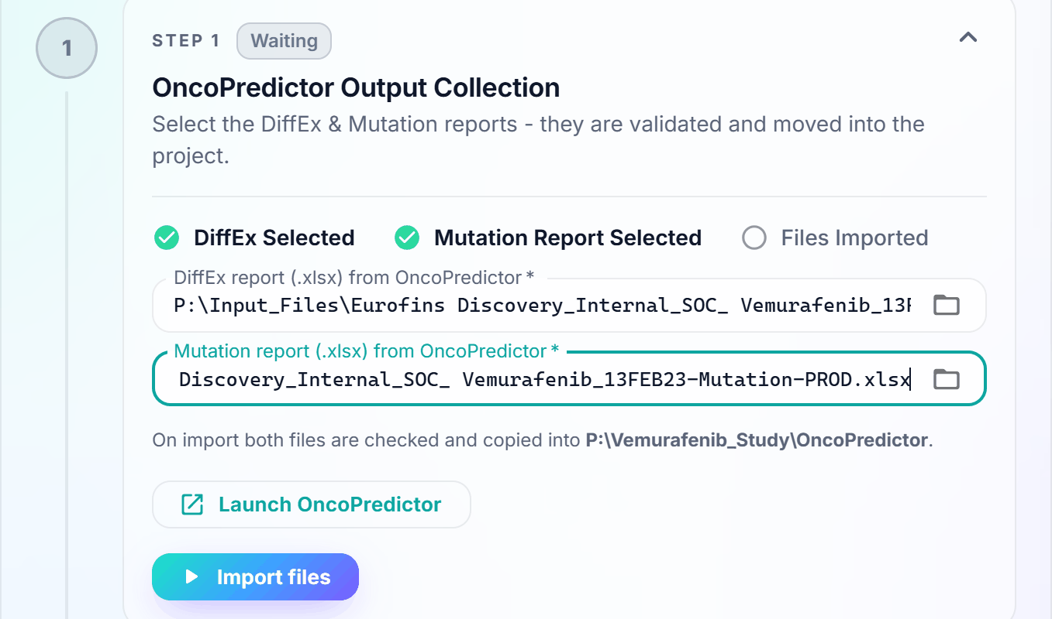
Figure 8: Step 1 with both OncoPredictor reports selected
4 Click Import files. Both files are validated (swapped or wrong files are detected) and moved into <study>\OncoPredictor.
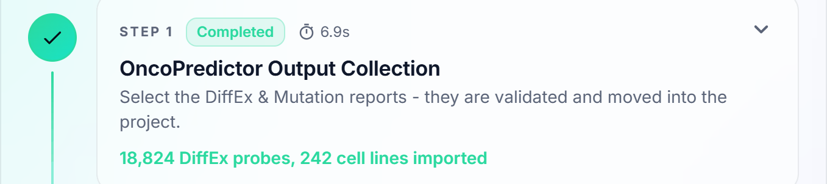
Figure 9: Step 1 completed
Note: By default the selected reports are moved into the study folder. To copy them instead, switch off Move the selected OncoPredictor files into the project in Settings (section 15).

11.3 Step 2 – Clustering Script Execution
1 In 1 · Clustering R script (.r), select the clustering R script.
2 Optional: in 2 · GenerateClusteringFile.R, select the helper script. Leave it empty to use the built-in dummy helper.
3 Optional: in 3 · Assay data file (.tab), select the assay data file. Leave it empty to generate a dummy file from the Mutation report.
4 Check the R line under the fields: it shows the Rscript.exe that will be used.
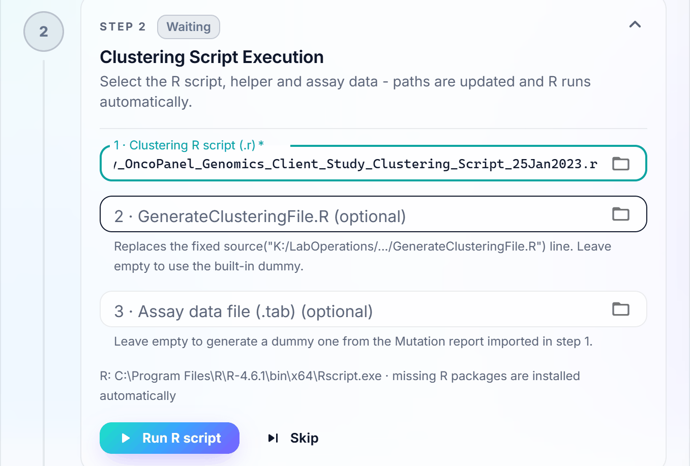
Figure 10: Step 2 with the clustering R script selected
5 Click Run R script. The step shows the elapsed time while R runs (maximum 60 minutes, configurable).
6 When R has finished, the number of output files is shown.
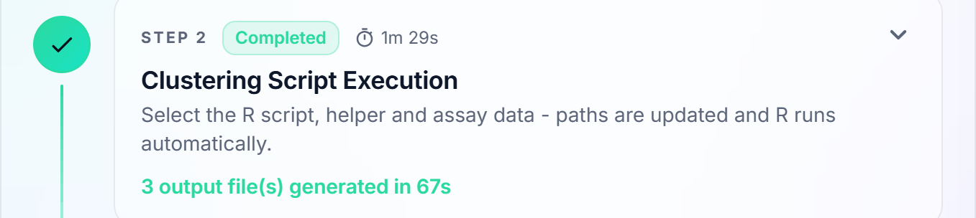
Figure 11: Step 2 completed
The original R script is never changed. A copy is written to <study>\Clustering in which the fixed paths are replaced:
Line in the original script | Line in the copy that is run
working_directory <- "C:/Users/Folder/" | working_directory <- "<study>/Clustering/"
client_data_fn <- paste0(working_directory, "file.tab") | client_data_fn <- paste0(working_directory, "<assay file>")
source("K:/LabOperations/Oncopanel/QC support files/GenerateClusteringFile.R") | source("<selected helper or built-in dummy>")
(added at the top) | Installs missing R packages such as dplyr

Important: The built-in GenerateClusteringFile.R and the generated .tab file are placeholders until the real files are available. Their outputs are marked DUMMY and must not be used in a client report. When the real files are available, select them in Step 2 and click Re-run from here.

11.4 Step 3 – DiffEx Table Generation
1 Check that Mutations & Hotspots Excel template shows the correct template. It is pre-filled from Settings; click the folder icon to choose another one.
2 Click Run step.
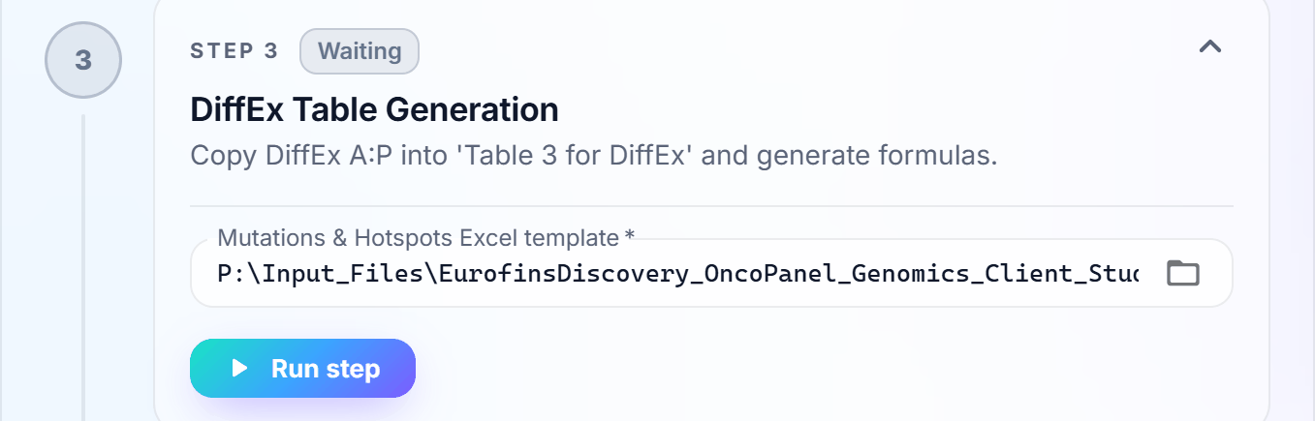
Figure 12: Step 3 with the Excel template
DiffEx columns A:P are copied into the sheet Table 3 for DiffEx and the formulas are generated for every row. The workbook is saved in <study>\DiffEx. This takes about one minute for 19,000 rows.
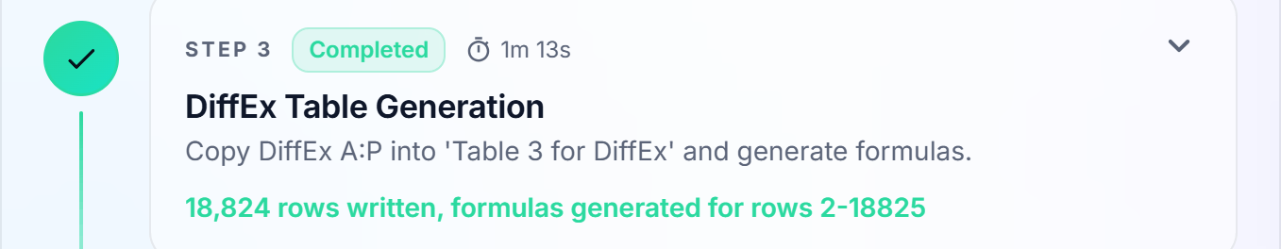
Figure 13: Step 3 completed

11.5 Step 4 – Sensitivity Gene Extraction
1 Click Run step. No input is needed.
The genes are ranked and the top 60 sensitivity genes (column AE) and top 60 resistance genes (column AF) are written to Top60_Sensitivity_Genes.txt and Top60_Resistance_Genes.txt in <study>\DiffEx.

Figure 14: Step 4 completed

11.6 Step 5 – g:Profiler Pathway Analysis
1 Make sure the computer is connected to the internet. The step uses g:GOSt at https://biit.cs.ut.ee/gprofiler/gost
2 Click Run step. A browser window may open briefly while the queries run; do not close it.
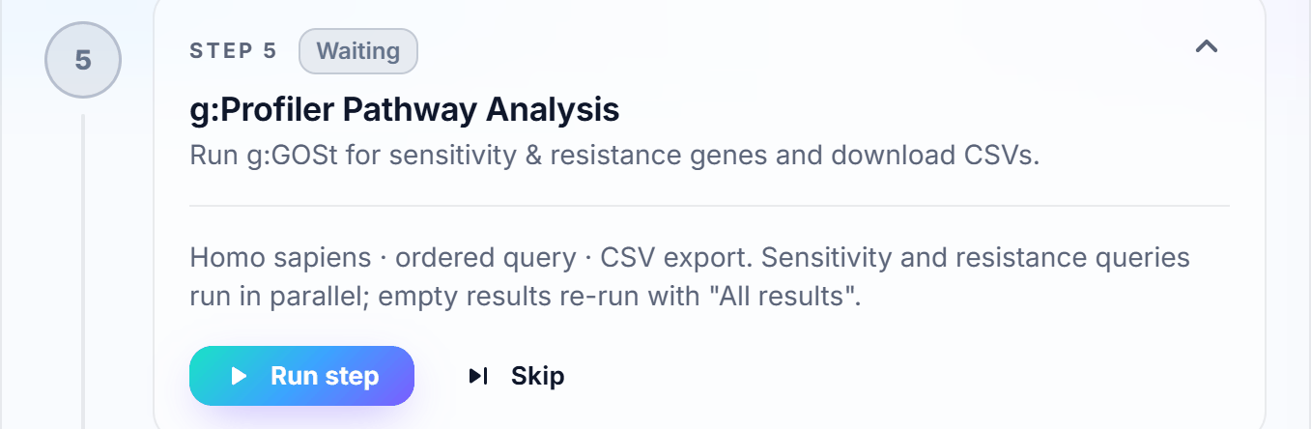
Figure 15: Step 5 before it runs
Both gene lists are submitted in parallel with organism Homo sapiens and ordered query. When there are no significant results, the query is repeated with All results. If the browser automation fails, the official g:Profiler API is used instead. The result CSV files and a snapshot image are saved in <study>\GProfiler\Sensitivity and <study>\GProfiler\Resistance.
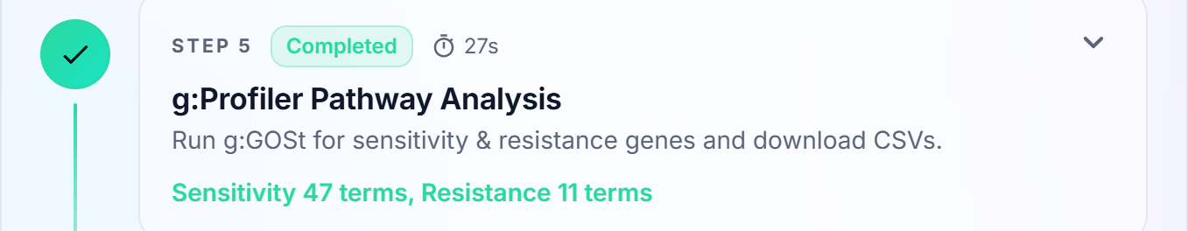
Figure 16: Step 5 completed
Tip: Without internet access, click Skip and run Step 5 later with Retry.

11.7 Step 6 – Word Report Generation
1 Check that Word report template (.docx) shows the correct template.
2 Optional: fill in the report details. Fields left empty are handled as described below.
3 Click Run step.
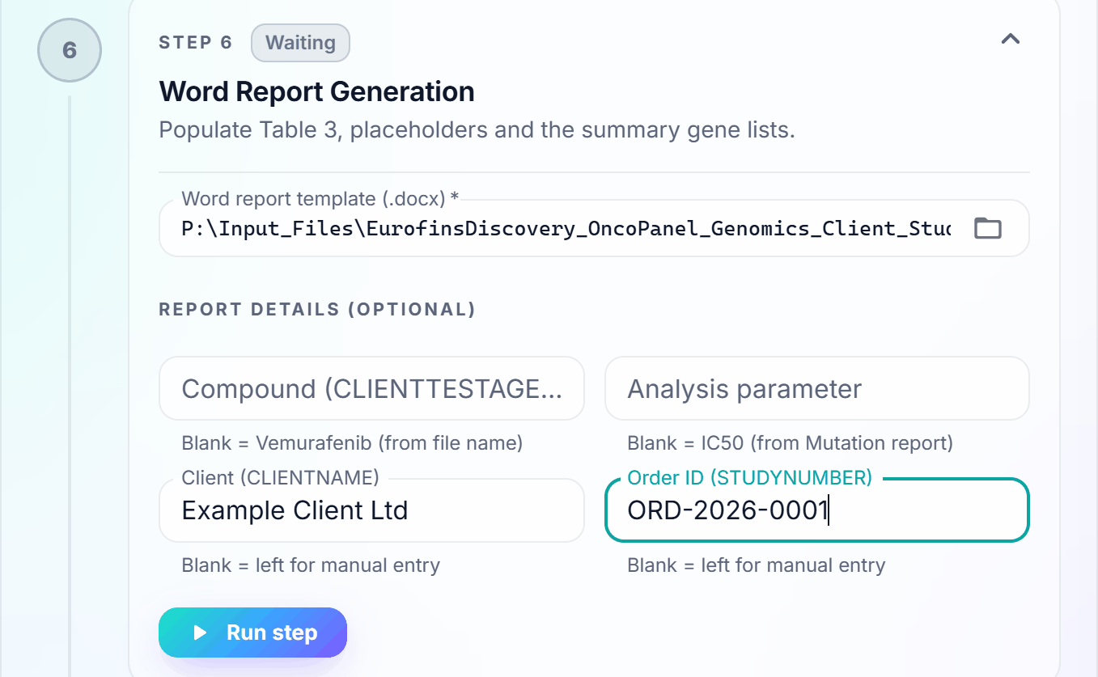
Figure 17: Step 6 with the Word template and report details
Field | Placeholder in the template | If left empty
Compound | CLIENTTESTAGENT | Taken from the DiffEx file name (for example Vemurafenib)
Analysis parameter | ANALYSISPARAMETER | Read from cell D1 of the Mutation report (for example IC50)
Client | CLIENTNAME | Placeholder stays in the report for manual completion
Order ID | STUDYNUMBER | Placeholder stays in the report for manual completion
Date (automatic) | MONTH DAY, YEAR | Always today's date

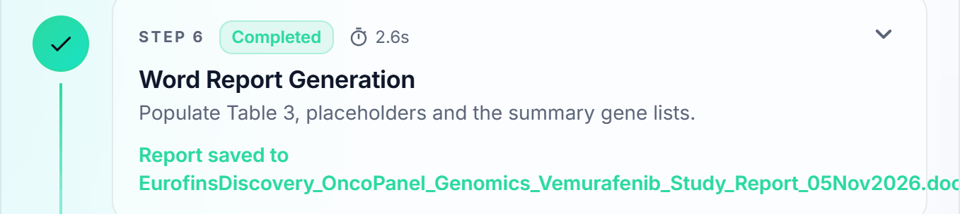
Figure 18: Step 6 completed

11.8 Step 7 – Final Report Packaging
1 Click Run step.
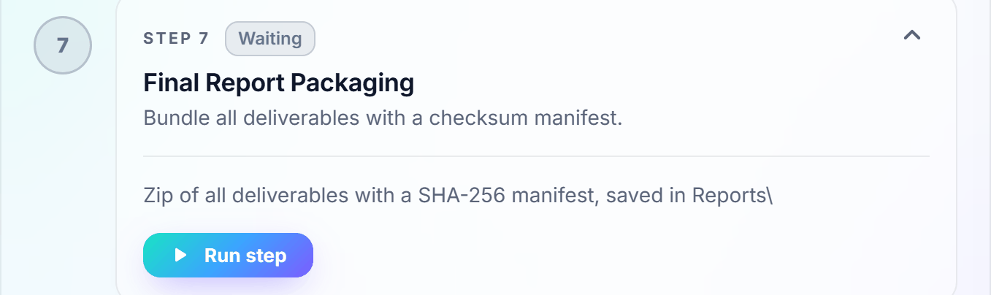
Figure 19: Step 7 before it runs
All deliverables are collected into <study>_Deliverables_<date>_<time>.zip in <study>\Reports, together with a manifest.json that lists the SHA-256 checksum of every file.
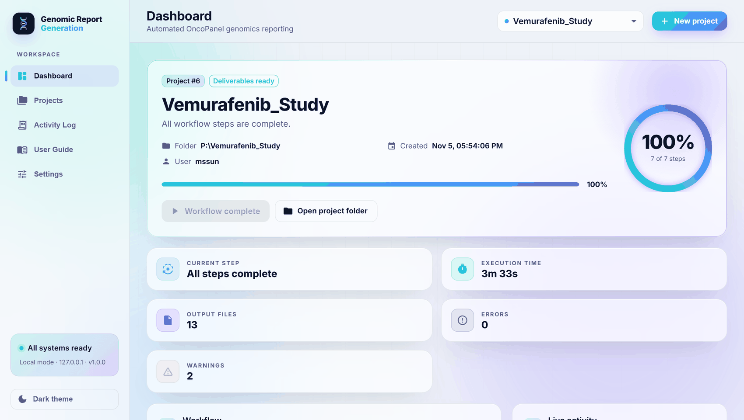
Figure 20: Completed study: all seven steps finished

11.9 Running all remaining steps at once
Instead of clicking Run step on every step, click Start workflow (or Resume workflow) at the top of the Dashboard. The remaining steps run in order and pause only when an input is missing.
Button | Effect
Start workflow / Resume workflow | Runs all remaining steps in order
Run step / Import files / Run R script | Runs only this step
Retry | Runs a failed step again after the cause has been corrected
Skip | Skips an optional step (Step 2 or Step 5)
Re-run from here | Resets this step and all following steps and runs them again
Stop | Stops the running step, including the R process
Open project folder | Opens the study folder in Windows Explorer

11.10 Collecting the results
1 In the Deliverables panel on the right of the Dashboard, click the open icon next to a file to open it, or the folder icon to show it in Windows Explorer.
2 Review the Word report, complete any remaining manual sections and send the deliverables package as required.
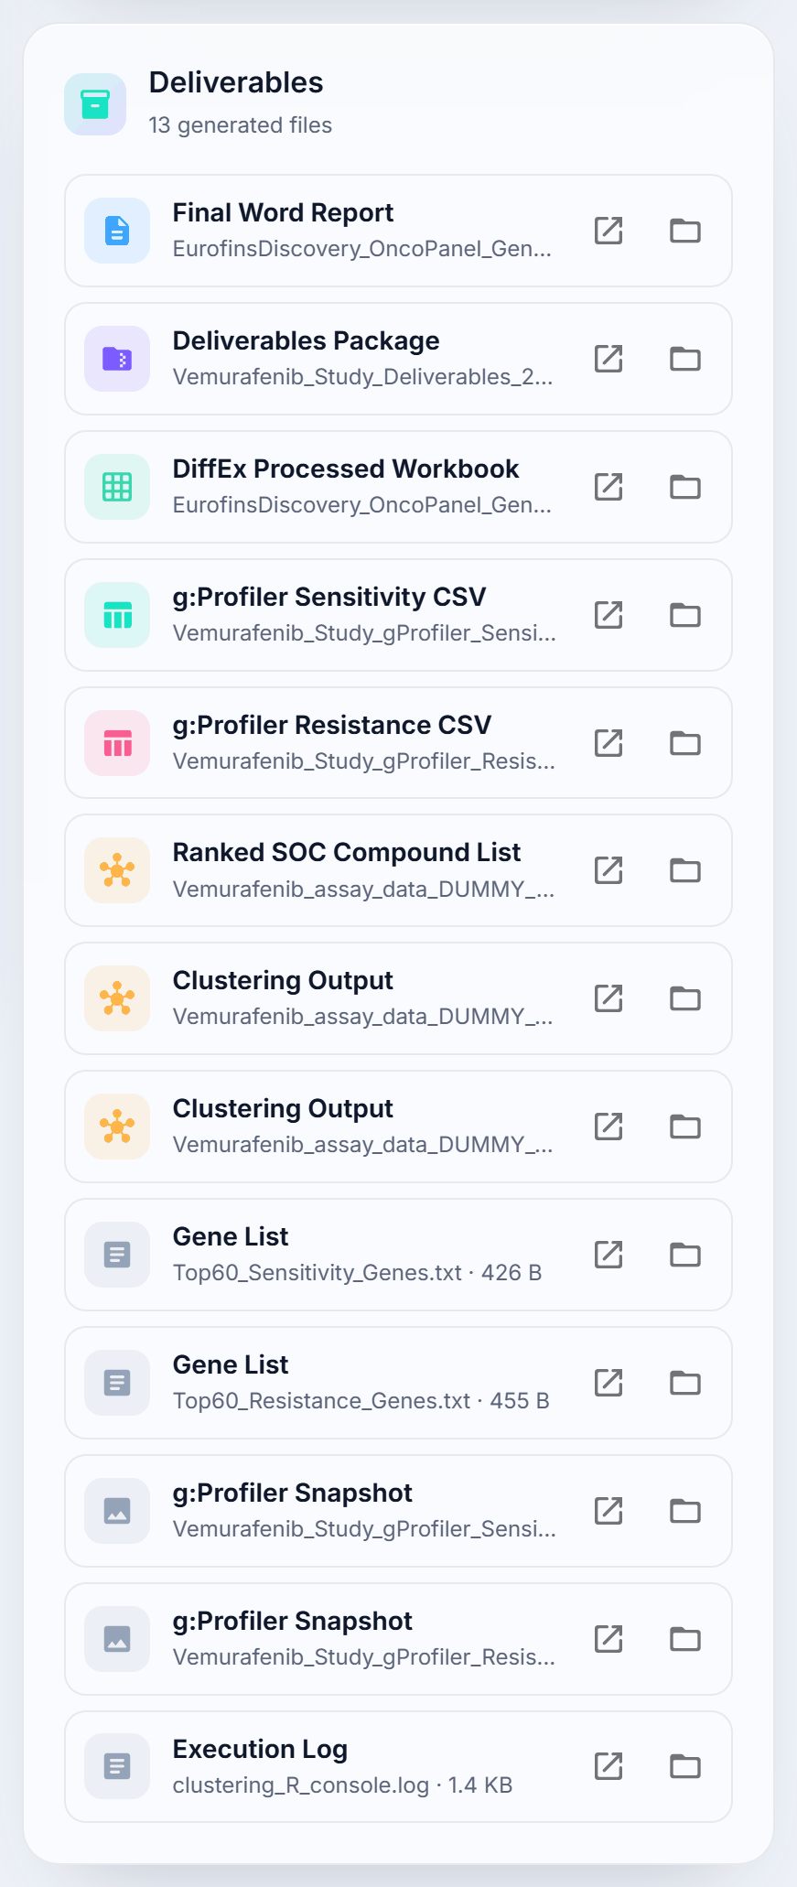
Figure 21: Deliverables panel of a completed study

12 Expected outputs

12.1 Study folder structure
Each study folder contains six sub-folders. The example below is the complete study P:\Vemurafenib_Study:
P:\Vemurafenib_Study\
├── OncoPredictor\
│ ├── Eurofins Discovery_Internal_SOC_ Vemurafenib_13FEB23-Diffex-PROD.xlsx
│ └── Eurofins Discovery_Internal_SOC_ Vemurafenib_13FEB23-Mutation-PROD.xlsx
├── Clustering\
│ ├── EurofinsDiscovery_..._Clustering_Script_25Jan2023_Vemurafenib_Study.r
│ ├── Vemurafenib_assay_data_DUMMY.tab
│ ├── Vemurafenib_assay_data_DUMMY_Clustering_Data.csv
│ ├── Vemurafenib_assay_data_DUMMY_Clustering_Dendrogram.png
│ └── Vemurafenib_assay_data_DUMMY_Ranked_SOC_Compounds.csv
├── DiffEx\
│ ├── EurofinsDiscovery_OncoPanel_Genomics_Vemurafenib_Study_
│ │ Mutations_and_Hotspots_Tables_05Nov2026.xlsx
│ ├── Top60_Sensitivity_Genes.txt
│ ├── Top60_Resistance_Genes.txt
│ └── ranked_genes.json
├── GProfiler\
│ ├── Sensitivity\ Vemurafenib_Study_gProfiler_Sensitivity.csv / .png
│ └── Resistance\ Vemurafenib_Study_gProfiler_Resistance.csv / .png
├── Reports\
│ ├── EurofinsDiscovery_OncoPanel_Genomics_Vemurafenib_Study_Report_05Nov2026.docx
│ └── Vemurafenib_Study_Deliverables_20261105_220135.zip
└── Logs\
├── activity_log.txt
└── clustering_R_console.log

12.2 Description of the output files
Folder | File | Step | Description
OncoPredictor | DiffEx and Mutation reports | 1 | The imported input reports
Clustering | <script>_<study>.r | 2 | The copy of the R script that was run, with the study paths
Clustering | <compound>_assay_data….tab | 2 | The assay data used (selected file or generated DUMMY file)
Clustering | *_Clustering_Data.csv, *_Ranked_SOC_Compounds.csv, *_Dendrogram.png | 2 | Outputs of GenerateClusteringFile (the real helper may use other names)
DiffEx | …_Mutations_and_Hotspots_Tables_<date>.xlsx | 3 | Filled Excel template with Table 3 for DiffEx
DiffEx | Top60_Sensitivity_Genes.txt, Top60_Resistance_Genes.txt | 4 | The two gene lists sent to g:Profiler
DiffEx | ranked_genes.json | 4 | Gene ranking used by Steps 5 and 6
GProfiler | <study>_gProfiler_Sensitivity.csv / .png, …_Resistance.csv / .png | 5 | g:GOSt results and snapshots
Reports | …_Report_<date>.docx | 6 | The completed Word report
Reports | <study>_Deliverables_<date>_<time>.zip | 7 | All deliverables with manifest.json (SHA-256)
Logs | activity_log.txt, clustering_R_console.log | All | Logs of the study (section 13)

- Output names follow the template names: _Template is removed, Client_Study is replaced by the study name and the template date is replaced by today's date (for example 05Nov2026).
- If a full path would be longer than Windows allows, a shorter name such as <study>_Report_05Nov2026.docx is used.
- Running a step again overwrites the outputs of that step; input files are never modified.

12.3 Examples of the outputs
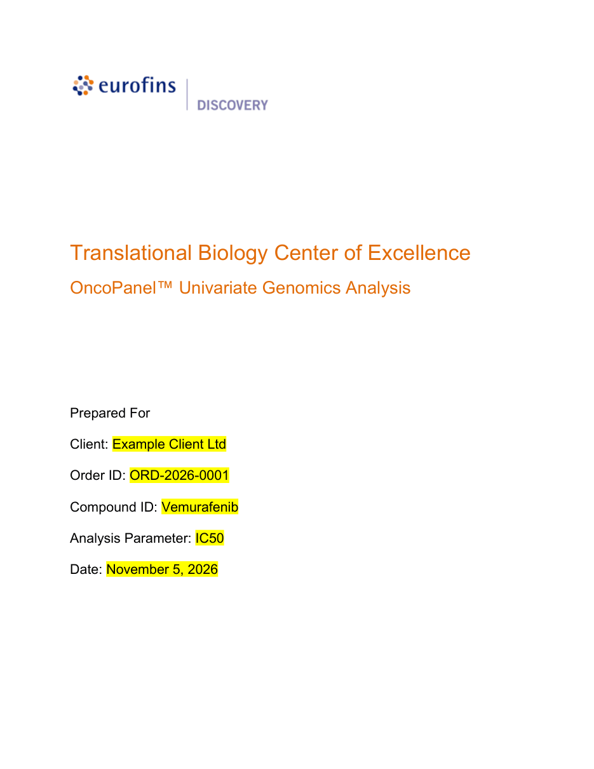
Figure 22: Generated Word report – cover page with the report details filled in
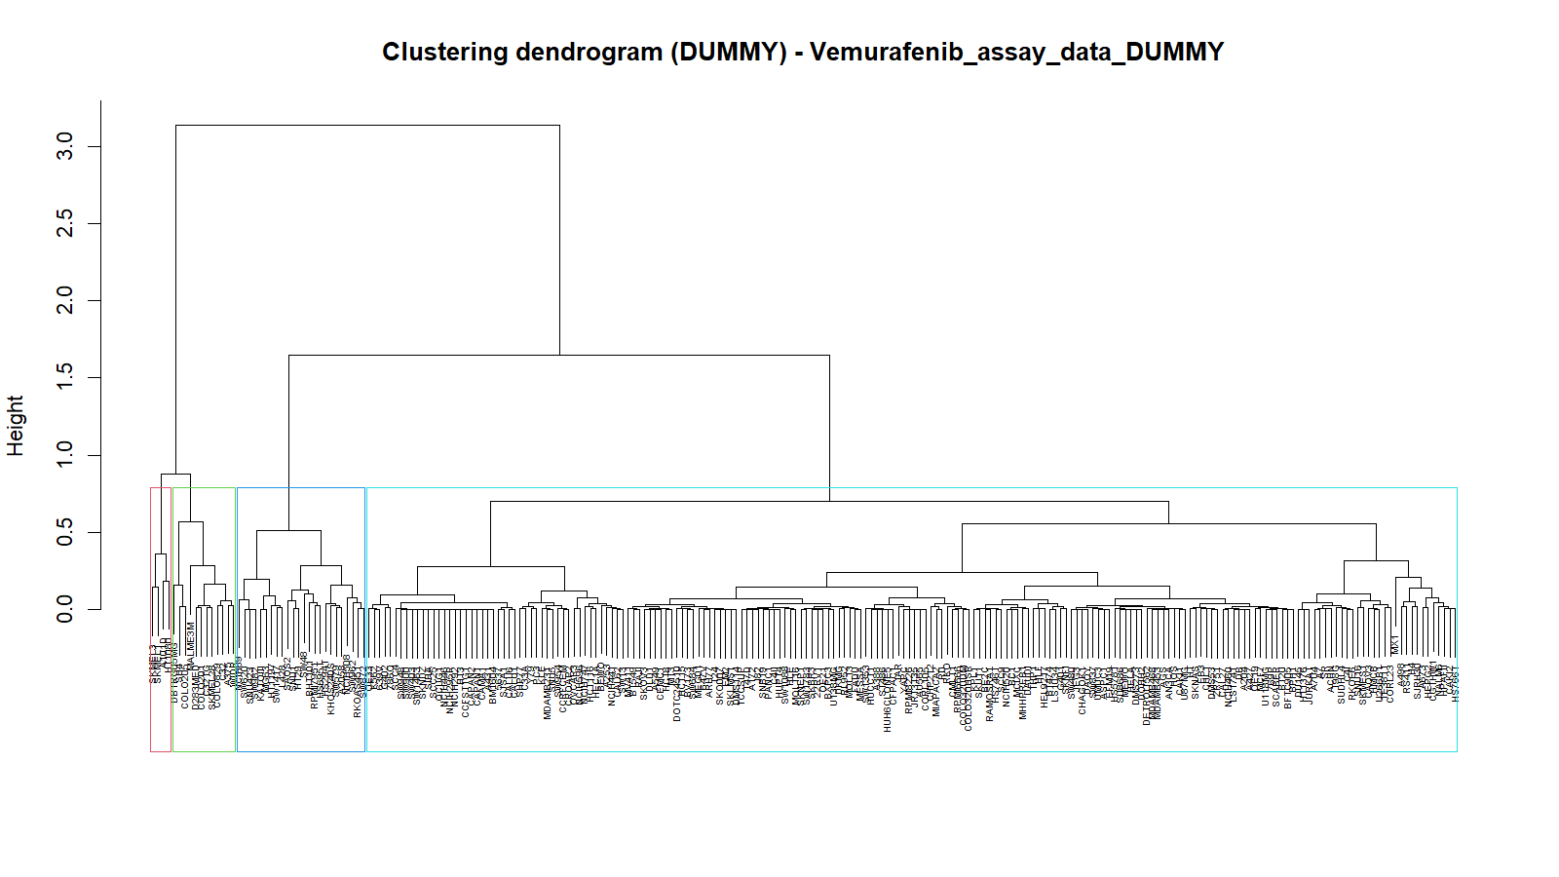
Figure 23: Clustering dendrogram from Step 2 (example produced with the DUMMY helper)

13 Logs and audit trail

13.1 Where to find the logs
Log | Location | Content
Live activity | Dashboard, right-hand panel | Progress of the open study, newest first
Activity Log page | Left menu → Activity Log | Audit trail of all studies; searchable and filtered by level
Study activity log | <study>\Logs\activity_log.txt | Every action of the study with time, level and details
R console log | <study>\Logs\clustering_R_console.log | Everything R printed in Step 2, including R errors
Server log | %LOCALAPPDATA%\GenomicReportGeneration\server.log | Start-up messages and unexpected errors
Audit database | %LOCALAPPDATA%\GenomicReportGeneration\audit.db | Studies, step status, files and audit trail
Settings | %LOCALAPPDATA%\GenomicReportGeneration\settings.json | Saved settings and remembered paths

To open the application-data folder, press Windows + R, type %LOCALAPPDATA%\GenomicReportGeneration and press Enter.

13.2 Live activity panel
While a study runs, every action appears in the Live activity panel on the Dashboard.
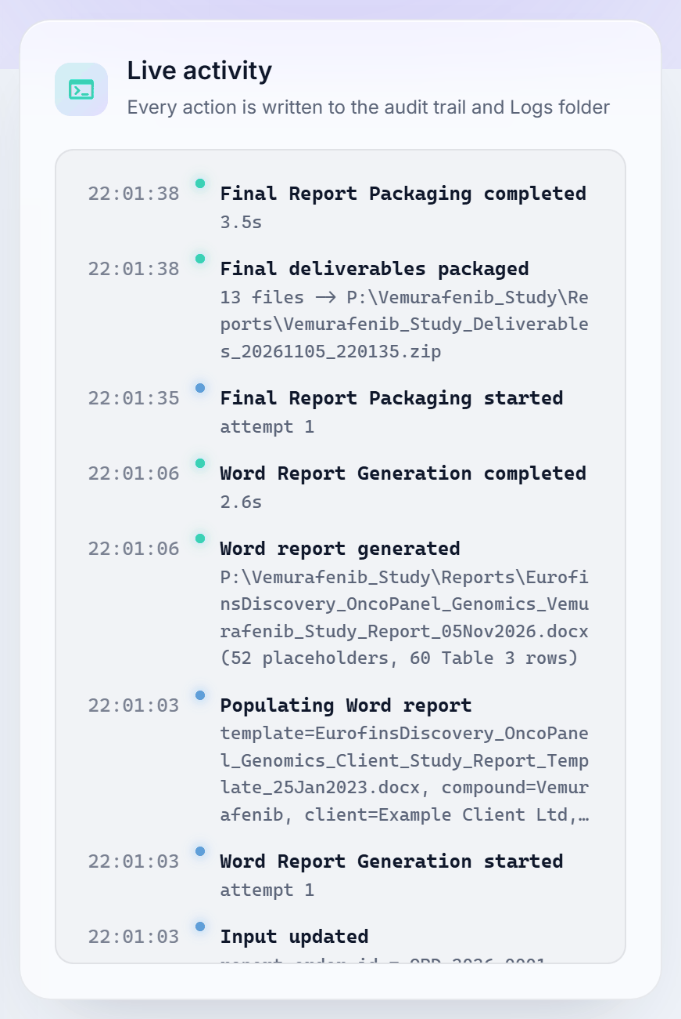
Figure 24: Live activity panel during Step 5

13.3 Activity Log page
1 Click Activity Log in the left menu.
2 Type in the search box to find an action, a file, a study or a user.
3 Click Success, Info, Warning or Error to show only that level.
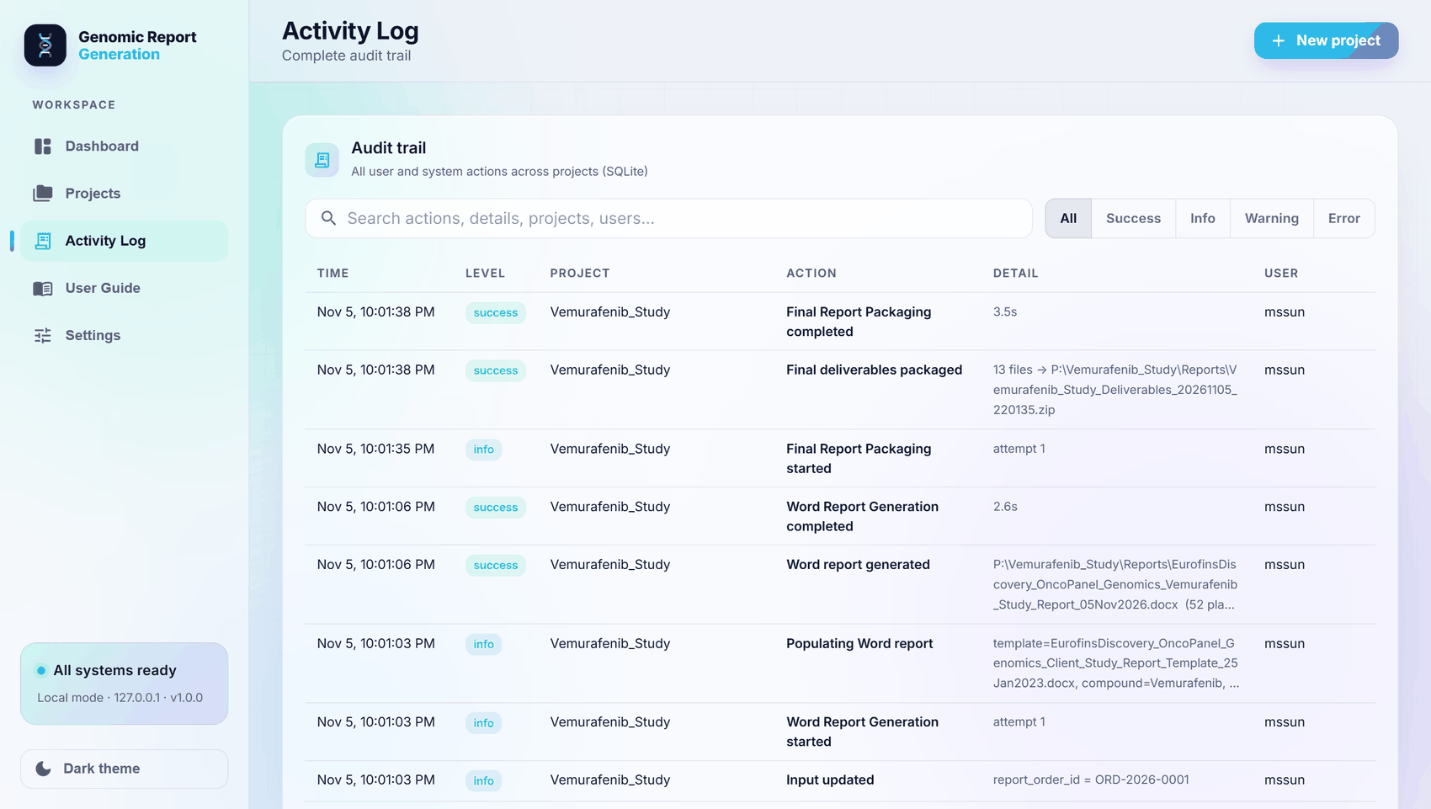
Figure 25: Activity Log page

13.4 Reading activity_log.txt
Each line contains the date and time, the level (INFO, SUCCESS, WARNING or ERROR), the action and the details. Extract from the example study:
2026-11-05 17:54:06 [SUCCESS] Project created | P:\Vemurafenib_Study
2026-11-05 17:55:40 [SUCCESS] DiffEx file found | …Diffex-PROD.xlsx (18,824 probes)
2026-11-05 17:55:44 [SUCCESS] Mutation report found | …Mutation-PROD.xlsx (242 cell lines)
2026-11-05 17:56:15 [WARNING] Using the built-in DUMMY GenerateClusteringFile.R
2026-11-05 17:56:36 [INFO ] R script paths updated | working_directory=P:/Vemurafenib_Study/…
2026-11-05 17:57:43 [SUCCESS] R script completed | 3 output file(s) in 67s
2026-11-05 17:59:37 [SUCCESS] DiffEx Table Generation completed | 72.5s
2026-11-05 18:00:12 [SUCCESS] Sensitivity genes extracted | 60 sensitive / 60 resistant
2026-11-05 18:01:08 [SUCCESS] g:Profiler Sensitivity CSV saved | 47 terms via selenium
2026-11-05 22:01:06 [SUCCESS] Word report generated | …(52 placeholders, 60 Table 3 rows)
Search for [ERROR to find failures. The same message is shown in red on the failed step in the application. For R errors in Step 2, open clustering_R_console.log.

14 Managing studies
1 Click Projects in the left menu. Every study processed on this computer is listed with its status (Complete, In progress or Attention), its folder and its progress.
2 Click a study card to open it on the Dashboard, then click Resume workflow to continue where it stopped.
3 To remove a study from the list, click the bin icon. The study folder on disk is not deleted.
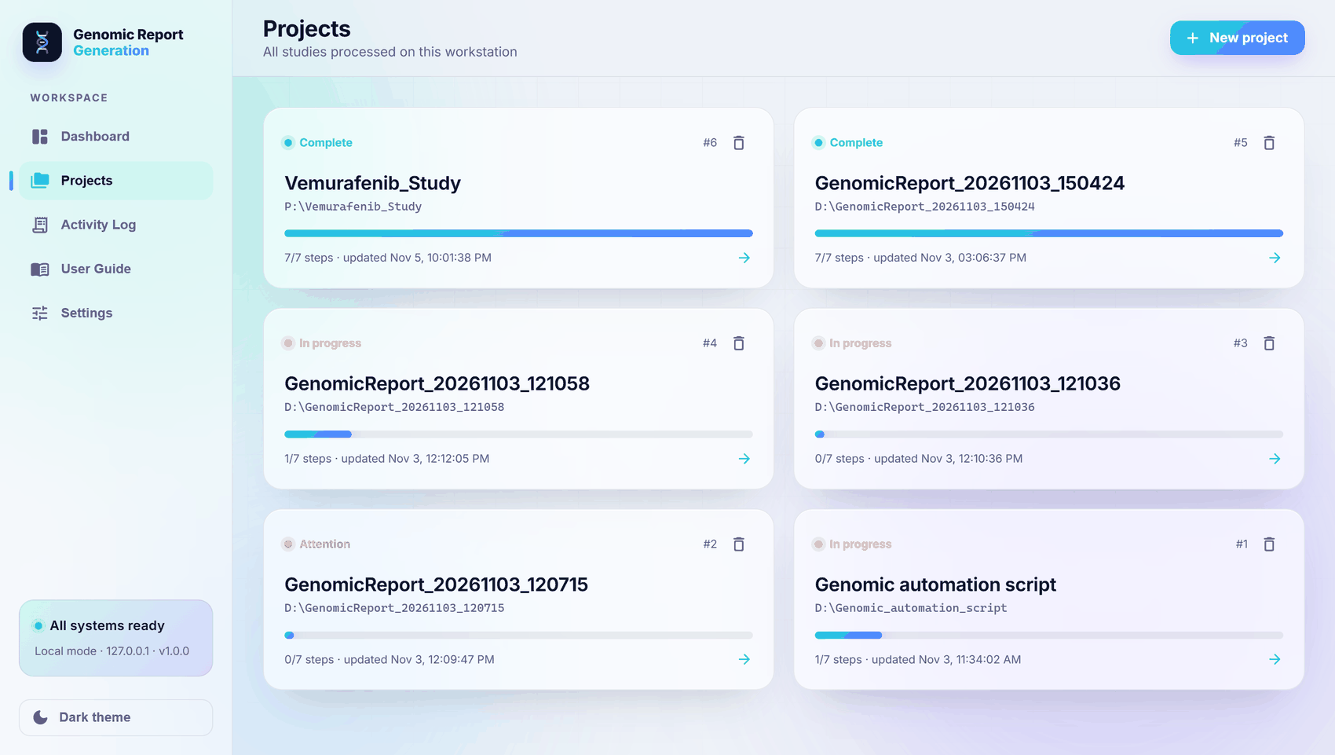
Figure 26: Projects page
Tip: A study can also be opened with the Open a previous project… list at the top of the Dashboard, or by choosing its folder in the Create project dialog.

15 Settings
Click Settings in the left menu, change the values and click Save. The System health panel on the same page shows whether R, the browser and the default project location were found.
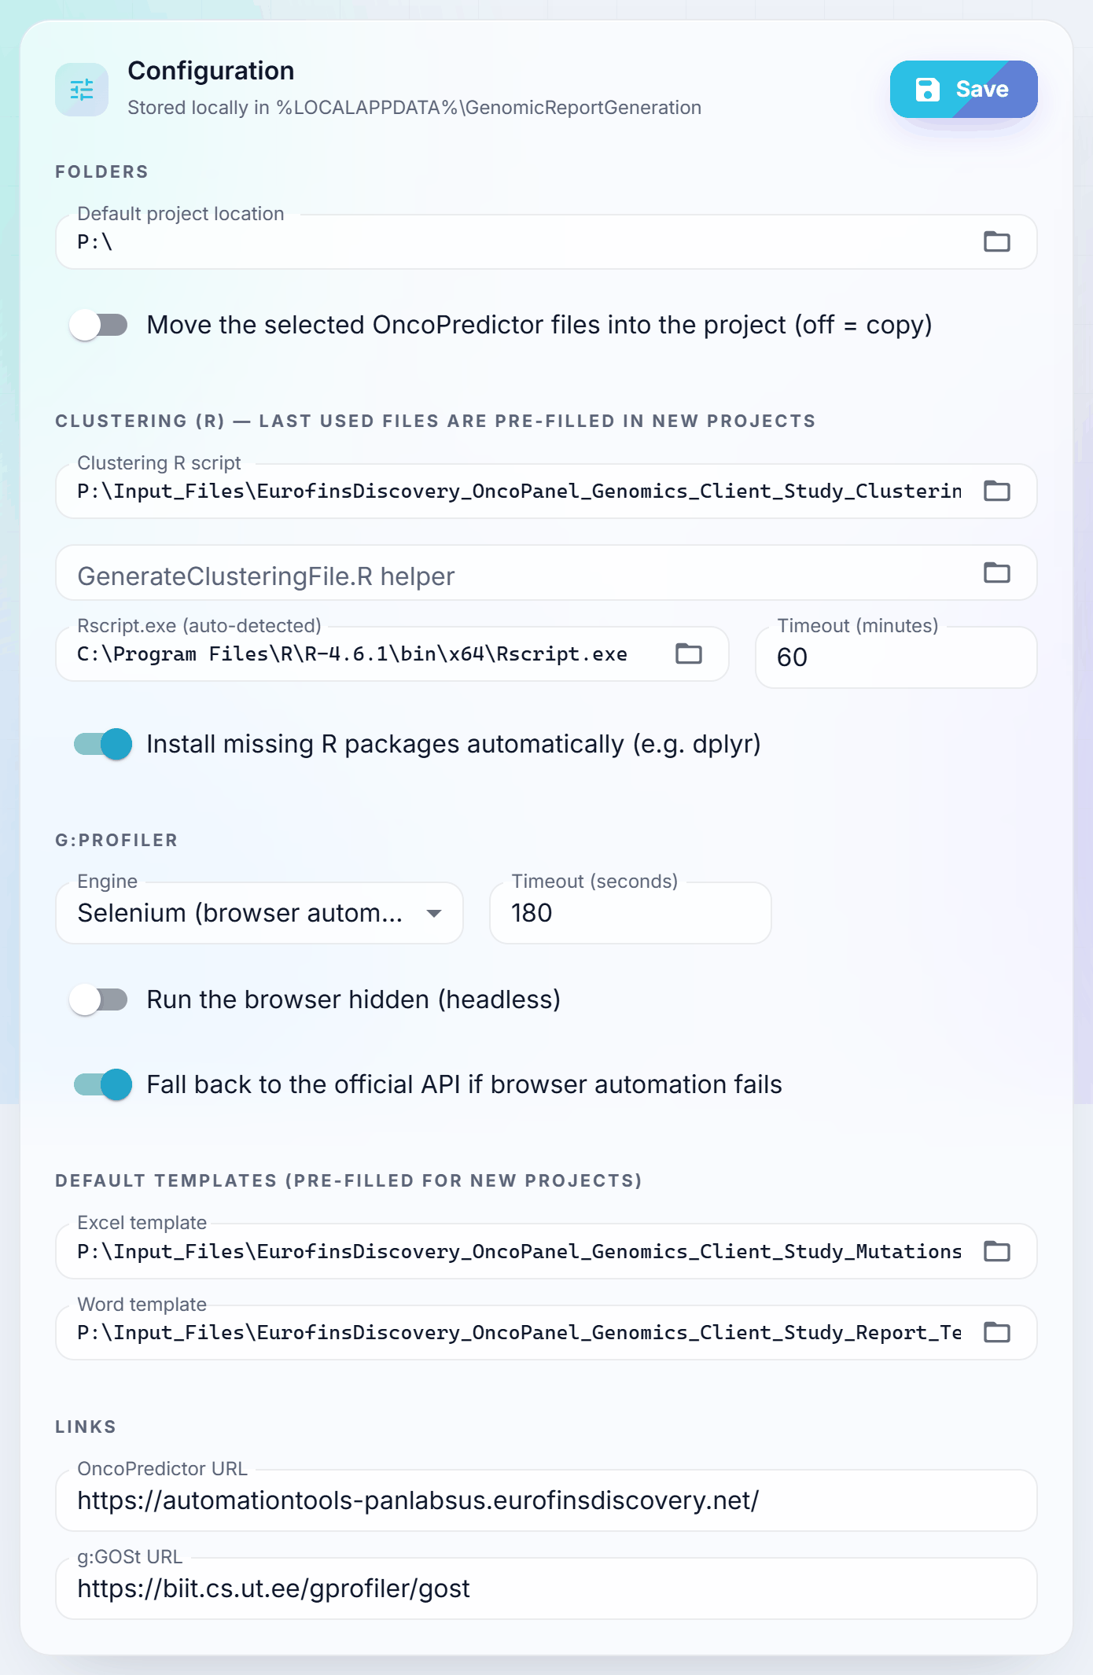
Figure 27: Settings – Configuration (example; Move switched off)
Setting | Purpose | Default
Default project location | Folder proposed in the Create project dialog | Last used
Move the selected OncoPredictor files | On: move the reports into the study. Off: copy them | On
Clustering R script, GenerateClusteringFile.R helper | Pre-filled in Step 2 | Last used
Rscript.exe | Detected automatically; change only if R is in an unusual folder | Detected
Timeout (minutes) | Maximum run time of the R script | 60
Install missing R packages automatically | Installs packages such as dplyr into the user's R library | On
g:Profiler engine, timeout, headless, API fallback | How Step 5 runs | Selenium, 180 s, visible, on
Excel template, Word template | Pre-filled in Steps 3 and 6 | Last used
OncoPredictor URL | Opened by Launch OncoPredictor | https://automationtools-panlabsus.eurofinsdiscovery.net/
g:GOSt URL | Used by Step 5 | https://biit.cs.ut.ee/gprofiler/gost

16 Troubleshooting
Message or symptom | Cause | Action
“Python 3.10 or newer was not found” | Python missing and could not be installed | Install Python (section 8.1) and start again
“Download failed” or “Installing the libraries failed” | No internet, or a proxy blocks the download sites | Connect to the internet or ask IT to allow the addresses in section 6.4
Administrator credentials requested, or the start is blocked | Company security policy | Use the Portable package, or ask IT to approve the application (section 17)
“R is not installed on this computer” | Rscript.exe not found | Install R (section 8.2) or click Skip on Step 2
“Could not find the input path lines in the R script” | The script has no working_directory / client_data_fn lines | Restore those two lines in the script
“Could not find a source("…GenerateClusteringFile.R") line” | The helper file name differs from the name in the script | Select a helper with the same file name
“R script failed (exit code …)” | Error inside the R code | Read Logs\clustering_R_console.log, correct it, click Retry
“… does not look like a Mutation report” | DiffEx and Mutation reports swapped, or wrong file | Select the correct files
“Output path is too long for Windows” | Very long study folder path | Choose a shorter project location
Step 5 fails | No internet, or g:Profiler unavailable | Check the connection and click Retry, or Skip
“Session expired” | The application restarted while the window was open | Close the window and start the application again
The window does not open | Start-up error | Read server.log (section 13.1)

17 Security and information for IT
Topic | Detail
Administrator rights | Not required. All components install and run for the current user
Network listener | 127.0.0.1:8765 only; not reachable from other computers
Access control | Random session token per start, Host and Origin checks, strict Content-Security-Policy
File access | Reads the files the user selects; writes only into the study folders and the application-data folder
Input checks | File type and size limits, sheet and header validation, protection against formula injection
Installers | Official python.org and CRAN installers; the Authenticode signature is verified before they run
Writes to | %LOCALAPPDATA%\GenomicReportGeneration, %LOCALAPPDATA%\Programs\Python and …\R (Auto-install), %TEMP%, and the study folders
Starts | Chrome or Edge (application window and Step 5), Rscript.exe (Step 2)
Audit | Every action is recorded with the Windows user name in audit.db and Logs\activity_log.txt
Allow-listing | By folder, or by file hash (Get-FileHash <file> gives the SHA-256)

Silent installation commands, for IT deployment of Python and R for the current user:
python-3.12.10-amd64.exe /quiet InstallAllUsers=0 PrependPath=1 Include_launcher=0 Shortcuts=0
R-4.6.2-win.exe /VERYSILENT /CURRENTUSER /SUPPRESSMSGBOXES /NORESTART /NOICONS
Important: Step 2 runs the R script selected by the user. Select R scripts only from a controlled, trusted location.

18 Updating and uninstalling
Task | How
Update the application | Close the application and replace the application folder with the new version. Studies, settings and logs are kept
Uninstall the application | Delete the application folder
Remove settings, logs and the Python environment | Delete %LOCALAPPDATA%\GenomicReportGeneration
Remove Python and R (Auto-install) | Windows Settings → Apps → Installed apps → Python 3.12.10 (64-bit) and R for Windows 4.6.2 → Uninstall
Studies | Study folders are never deleted automatically

19 Quick reference
To… | Do this
Start the application | Double-click Start-GenomicReport.bat
Create a study | Start a new project → choose the location → Create project
Run Step 1 | Select the DiffEx and Mutation reports → Import files
Run Step 2 | Select the R script (helper and .tab optional) → Run R script
Run Steps 3 to 7 | Check the templates → Resume workflow
Find the results | Deliverables panel, or <study>\Reports
See what happened | Activity Log page, or <study>\Logs\activity_log.txt
See R errors | <study>\Logs\clustering_R_console.log
Continue an earlier study | Open a previous project → choose the study → Resume workflow
Re-run clustering with the real files | Step 2: select the real helper and .tab → Re-run from here

— End of document —

