IU2541230010 – CPP07 – PROJECT REPORT
Restaurant Management System
Enrollment No.: IU2541230010
Student Name: Thakkar Dev Vinaykumar
Semester: 3
Subject: C++ Guided Project
GitHub Repository Link: [https://github.com/Dev15012008/Restaurant-management-system.git]

1. Introduction
Restaurants deal with a constant flow of small but important records: what is on the menu and at what price, who the customers are, what each customer ordered, how much it costs after tax and discount, and whether it has been paid. When this is done on paper, mistakes in totals, lost order slips and forgotten bills are common.
This project is a console-based Restaurant Management System written in C++ using object-oriented programming. It lets a restaurant keep its menu and customer records, take orders, produce bills with tax and discount, accept payments and view a summary report. Every record is stored in text files, so the data is still there the next time the program is started.
The project was built for the C++ Guided Project (CPP07) to practise classes and objects, encapsulation, constructors and destructors, inheritance, runtime polymorphism, dynamic memory, file handling, validation and exception handling together in one working application.

2. Problem Statement
To design and implement a menu-driven C++ console application that manages a restaurant's records and its daily transaction. The program must store menu items (food and beverages) and customers; allow records to be added, displayed, searched, updated and deleted; process the main transaction (place an order, generate a bill with tax and discount, and record the payment); produce a report; and save and load every record from files so that data persists between runs. It must reject invalid input without crashing and must manage dynamic memory correctly.

3. Objectives
- Build a working console application with the required 9-option main menu (Add, Display, Search, Update, Delete, Main Transaction, Report, Save / Load, Exit).
- Model the restaurant with well-separated classes, each with one clear responsibility (8 classes in this project; the minimum required is 5).
- Demonstrate inheritance and runtime polymorphism with MenuItem as the base class and FoodItem / BeverageItem as derived classes.
- Use dynamic memory (new, delete, delete[]) for every collection of records and release it correctly.
- Keep data permanently in files (menu, customers, orders, bills) and reload it automatically at start-up.
- Validate all user input and use exception handling for business-rule errors, so the program never crashes on wrong input.
- Document the design with UML diagrams (use case, class, two sequence diagrams) and verify it with 15 test cases.

4. Functional Requirements
- FR1 Add menu item: Food (veg / non-veg, spice level) or Beverage (size in ml, hot / cold) with an automatic unique ID; duplicate names are refused.
- FR2 Add customer: name and a 10-digit phone number; a phone number that already exists is refused.
- FR3 Display: menu, customers, orders and bills are shown as formatted tables.
- FR4 Search: menu by ID, name or category (case-insensitive); customer by ID, name or phone; order by ID or customer; bill by ID.
- FR5 Update: item price, name or category; customer name or phone; add more items to an OPEN order.
- FR6 Delete: menu item; customer (only if the customer has no orders); order (only if OPEN or CANCELLED). Each delete asks for confirmation.
- FR7 Place order: choose a customer, add any number of items with quantities; totals include item-wise tax (food 5%, beverage 12%).
- FR8 Generate bill: for an OPEN order with a discount percentage from 0 to 100; the order becomes BILLED.
- FR9 Pay bill: Cash, Card or UPI; the amount received must cover the bill; change is calculated; the order becomes PAID.
- FR10 Cancel order: an OPEN order can be cancelled.
- FR11 Report: counts, revenue collected, outstanding amount, discounts given, best-selling item and top customer.
- FR12 Save / Load: all records are loaded automatically at start-up; saving is available from the menu and offered at exit.
- FR13 Robustness: every input is validated with a clear error message; wrong input, a damaged data line or the end of input never crashes the program.

5. System / Project Flow
Overall flow:
USER → MAIN MENU (main.cpp) → RESTAURANT (system class) → ENTITY CLASSES (MenuItem / FoodItem / BeverageItem, Customer, Order, Bill) → FILE MANAGER → DATA FILES (Data/*.txt)
File flow: START -> load existing records (automatic) -> perform operations -> save updated records -> EXIT.
Main transaction flow: Place order (status OPEN) -> Generate bill (BILLED, discount applied) -> Pay bill (PAID). An OPEN order can instead be cancelled (CANCELLED).
Role of main.cpp: main() only creates the Restaurant object, loads the data, shows the menus and calls Restaurant member functions. It catches exceptions and keeps the menu running; all logic is inside the classes.

6. Class Descriptions
Class | Data Members | Member Functions | Responsibility
Restaurant | restaurantName, fileManager, MenuItem** menu, Customer* customers, Order* orders, Bill* bills, counts and capacities of the 4 arrays, nextItemId / nextCustomerId / nextOrderId / nextBillId | Restaurant(), ~Restaurant(), addMenuItem(), addCustomer(), display*(), search*(), update*(), delete*(), createOrder(), generateBill(), payBill(), cancelOrder(), showReport(), saveData(), loadData() | System class. Owns all dynamic arrays, grows them when full, implements every menu operation and the order > bill > payment process, and frees all memory in its destructor.
MenuItem (abstract base) | itemId, name, category, price | MenuItem(), MenuItem(id, name, category, price), virtual ~MenuItem(), getters, updatePrice(), getFinalPrice(), virtual getTaxRate(), getType(), getDetails(), serialize(), display(), static fromString() | Common data and behaviour of everything on the menu. Declares the virtual interface so Food and Beverage can behave differently when used through a MenuItem pointer.
FoodItem (derived) | isVeg, spiceLevel | FoodItem(), FoodItem(id, name, category, price, isVeg, spice), ~FoodItem(), getTaxRate() (5%), getType(), getDetails(), serialize() | Food on the menu. Adds veg / non-veg and spice level and overrides the virtual functions.
BeverageItem (derived) | sizeMl, isCold | BeverageItem(), BeverageItem(id, name, category, price, sizeMl, isCold), ~BeverageItem(), getTaxRate() (12%), getType(), getDetails(), serialize() | Drinks on the menu. Adds size in ml and hot / cold and overrides the virtual functions.
Customer | customerId, name, phone | Customer(), Customer(id, name, phone), ~Customer(), getters, setName(), setPhone(), display(), serialize(), static fromString() | Stores customer details and validates the name and the 10-digit phone number.
Order (uses struct OrderLine) | orderId, customerId, OrderLine* lines, lineCount, lineCap, subtotal, tax, total, status | Order(), Order(orderId, customerId), copy constructor, operator=, ~Order(), addItem(), calculateTotal(), display(), setStatus(), serialize(), parseHeader(), loadLine() | One customer order. Owns a dynamic array of OrderLine (item copy, quantity, price, tax), keeps the totals and the status, and deep-copies safely (Rule of Three).
Bill | billId, orderId, subtotal, tax, discountPercent, discount, amount, paid, paymentMode, billDate | Bill(), Bill(billId, orderId, subtotal, tax, discountPercent), ~Bill(), calculateTotal(), markPaid(), printBill(), displayRow(), serialize(), static fromString() | Invoice for an order. Applies the discount, stores payment status and mode, and prints the formatted bill.
FileManager | dir (data folder name) | FileManager(dir), save(Restaurant&), load(Restaurant&, int& skipped), pathOf() | The only class that touches files. Writes the four data files and reads them back at start-up; damaged lines are skipped with a warning.
Supporting code: OrderLine (struct inside Order.h) holds one line of an order; Utils (Input:: and Utils:: functions) provides validated console input and string helpers; Common.h defines RestaurantException and InputClosedException.

7. OOP Concepts Used
- Classes and objects: eight classes model the real-world entities (MenuItem, FoodItem, BeverageItem, Customer, Order, Bill, Restaurant, FileManager). Objects are created for every record.
- Encapsulation: data members are private (protected in MenuItem so derived classes can reach them). Other code uses getters and validated setters, for example MenuItem::updatePrice() rejects a price of zero or less and Customer::setPhone() accepts only 10 digits.
- Default and parameterized constructors: every entity class has both, e.g. Order() and Order(orderId, customerId). Parameterized constructors validate their arguments and throw RestaurantException if they are wrong.
- Copy constructor and assignment (Rule of Three): Order owns a dynamic array, so it has its own copy constructor and operator= that make a deep copy; otherwise two orders would share (and double-delete) the same array.
- Destructors: ~Order() calls delete[] lines; ~Restaurant() deletes every MenuItem object and delete[]s all four arrays and prints a memory-release message; ~MenuItem() is virtual.
- Inheritance: FoodItem and BeverageItem inherit id, name, category and price from MenuItem and add their own members (isVeg and spiceLevel; sizeMl and isCold).
- Runtime polymorphism: Restaurant keeps a MenuItem** array holding both kinds of object. Calls such as menu[i]->display(), getTaxRate(), getType() and serialize() are virtual, so each object answers in its own way: food taxed at 5% and beverage at 12%, different Details column, different record type in the file.
- Dynamic memory: arrays of menu pointers, customers, orders and bills are created with new[] (capacity 4) and doubled when full; each order owns a dynamic array of OrderLine; MenuItem objects are created with new FoodItem / new BeverageItem. Everything is released with delete / delete[].
- File handling: FileManager uses ofstream and ifstream to write and read the four data files.
- Validation: Input::readInt, readDouble, readName, readPhone and readYesNo repeat the question until the answer is valid; constructors and setters check their values again.
- Exception handling: errors are thrown as RestaurantException (for example Insufficient amount, Cannot delete: this customer has orders) and caught in main(), which prints the message and shows the menu again. std::bad_alloc and end of input are handled as well.

8. File Handling and Data Persistence
All records are stored as plain text, one record per line with the fields separated by the | character. The program uses four files inside the Data folder:
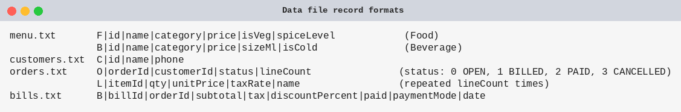
Loading: when the program starts, FileManager::load() clears memory, reads each file with ifstream, rebuilds the objects (MenuItem::fromString() creates a FoodItem or BeverageItem with new depending on the first letter F or B) and calls restoreCounters() so new IDs continue after the highest saved ID. A missing file simply means an empty start; a damaged line is skipped with a warning that names the file and line number.
Saving: FileManager::save() creates the Data folder if needed and rewrites all four files. Saving is available from option 8 and is offered when the user chooses Exit.
Verification: test T15 adds records, exits with save, starts the program again and shows that the menu item, customer, order and bill are all loaded back. Saving a freshly loaded data set produces files that are identical to the originals.

9. UML Diagrams
Figure 1: Use Case Diagram (2 actors, 10 use cases)
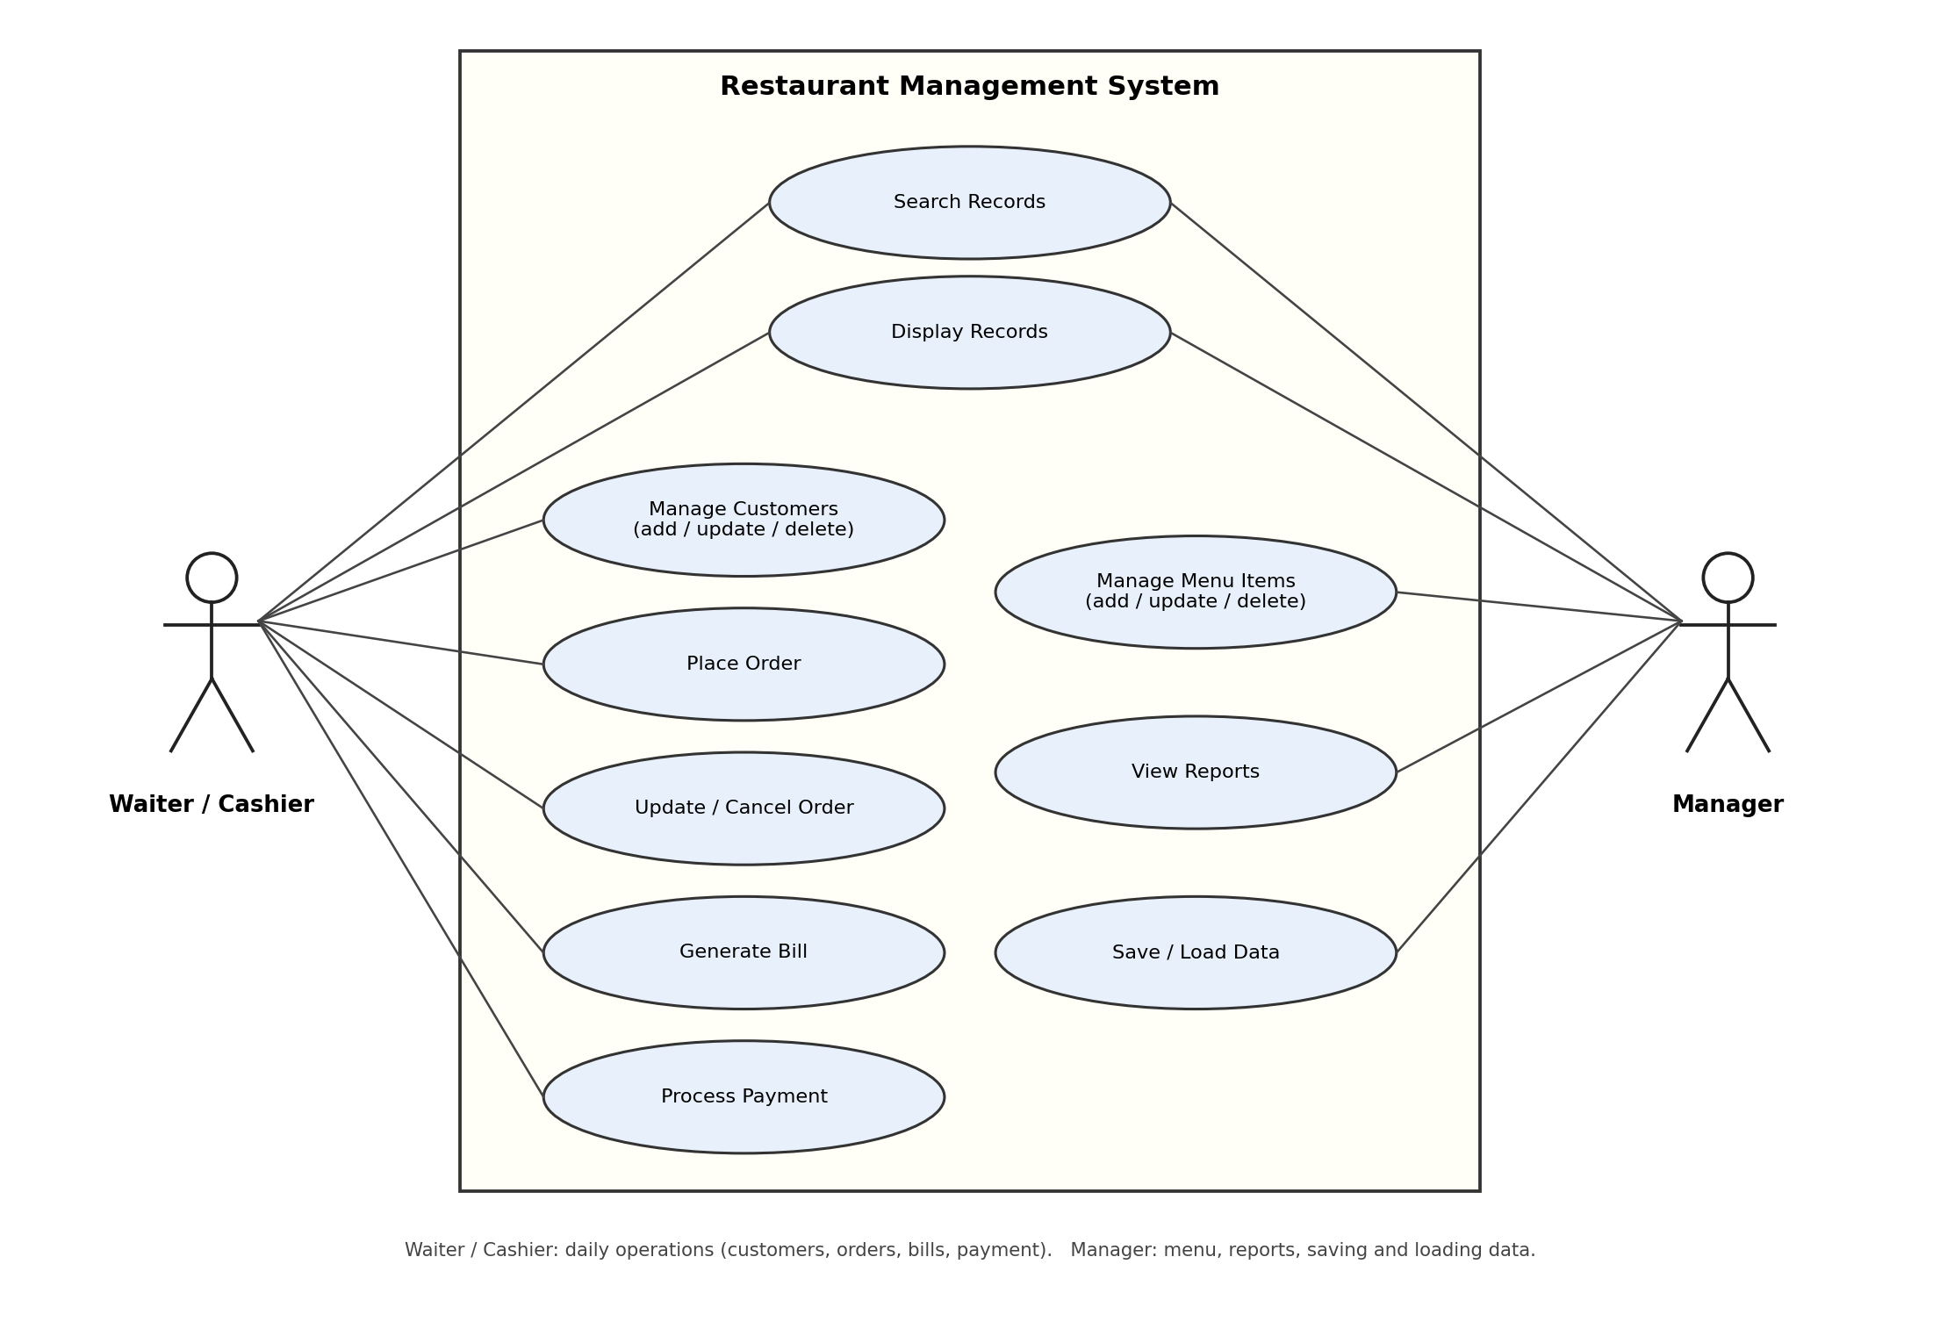
Figure 2: Class Diagram (classes, data members, functions, visibility, relationships)
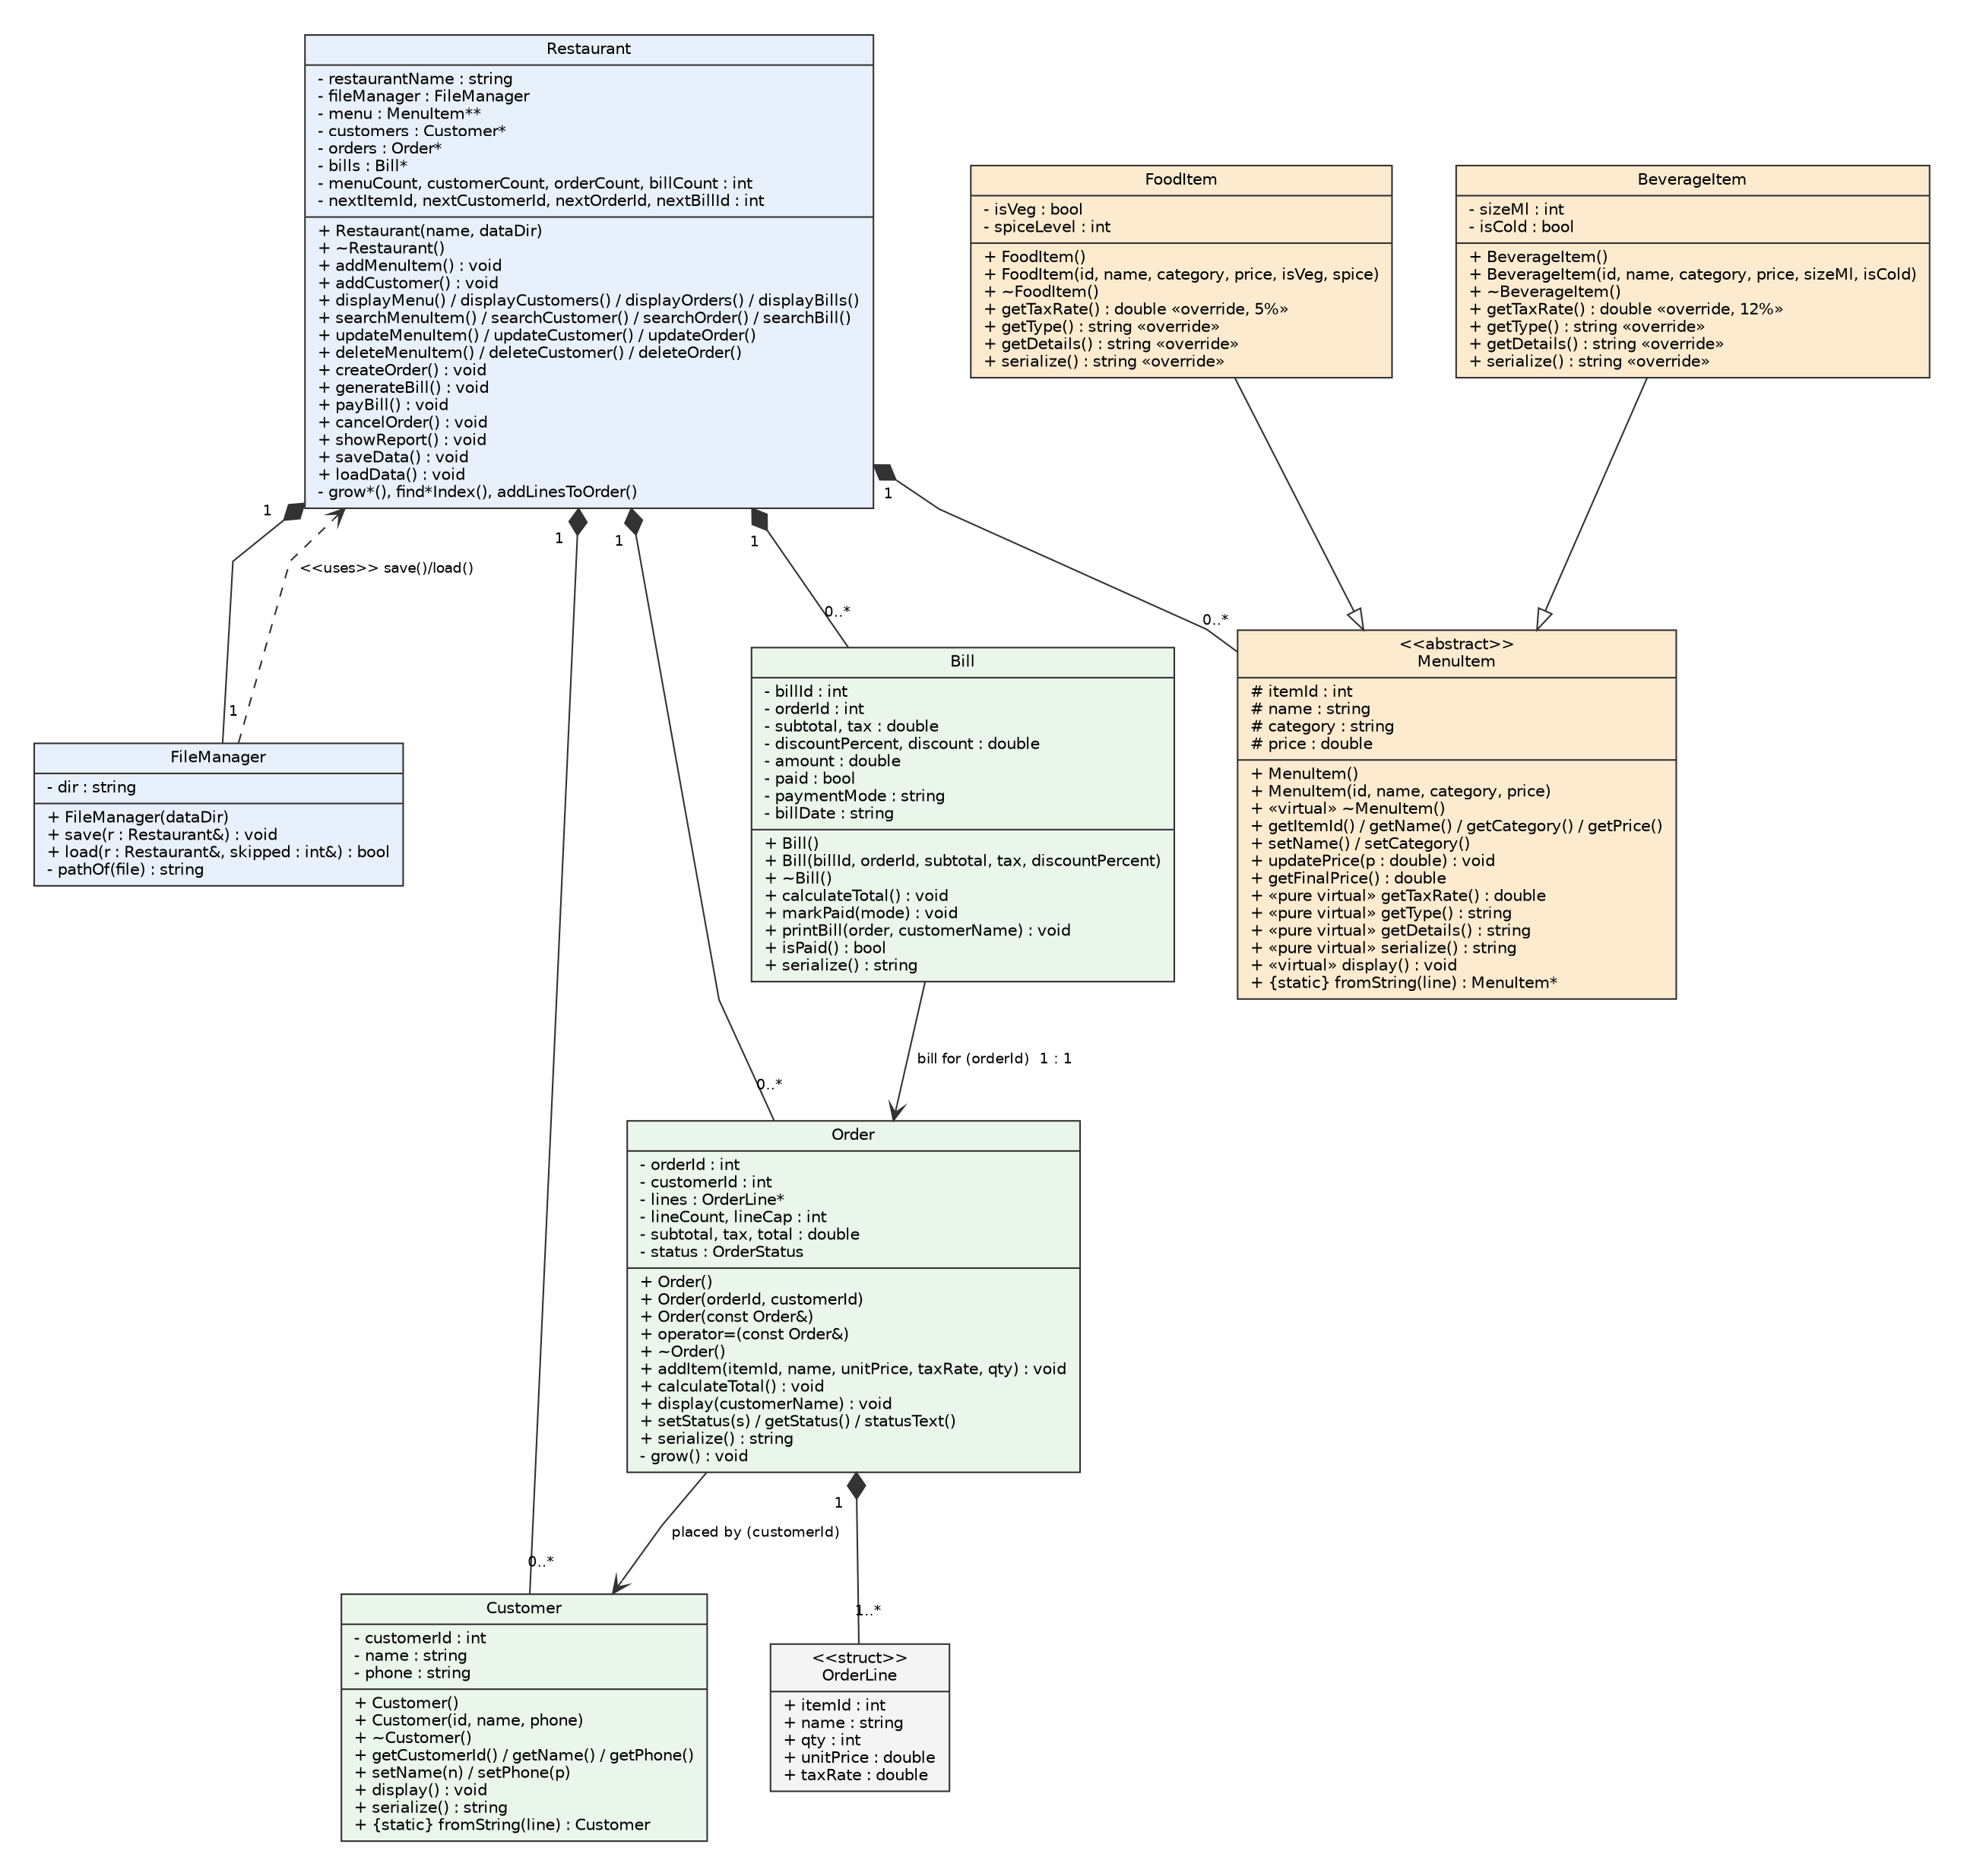
Figure 3: Sequence Diagram 1 - main transaction: place order and generate bill
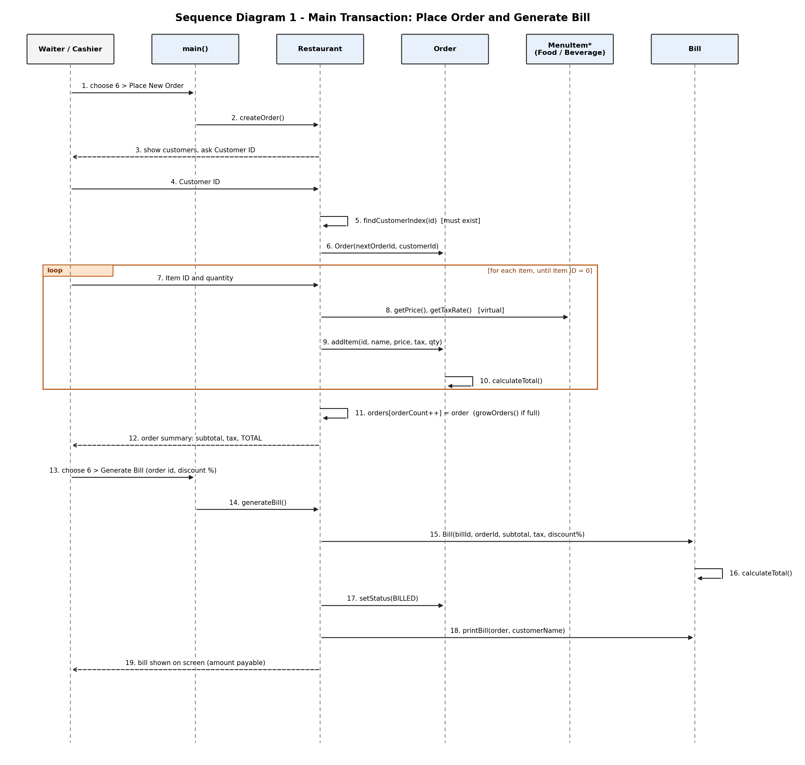
Figure 4: Sequence Diagram 2 - pay bill and save to file
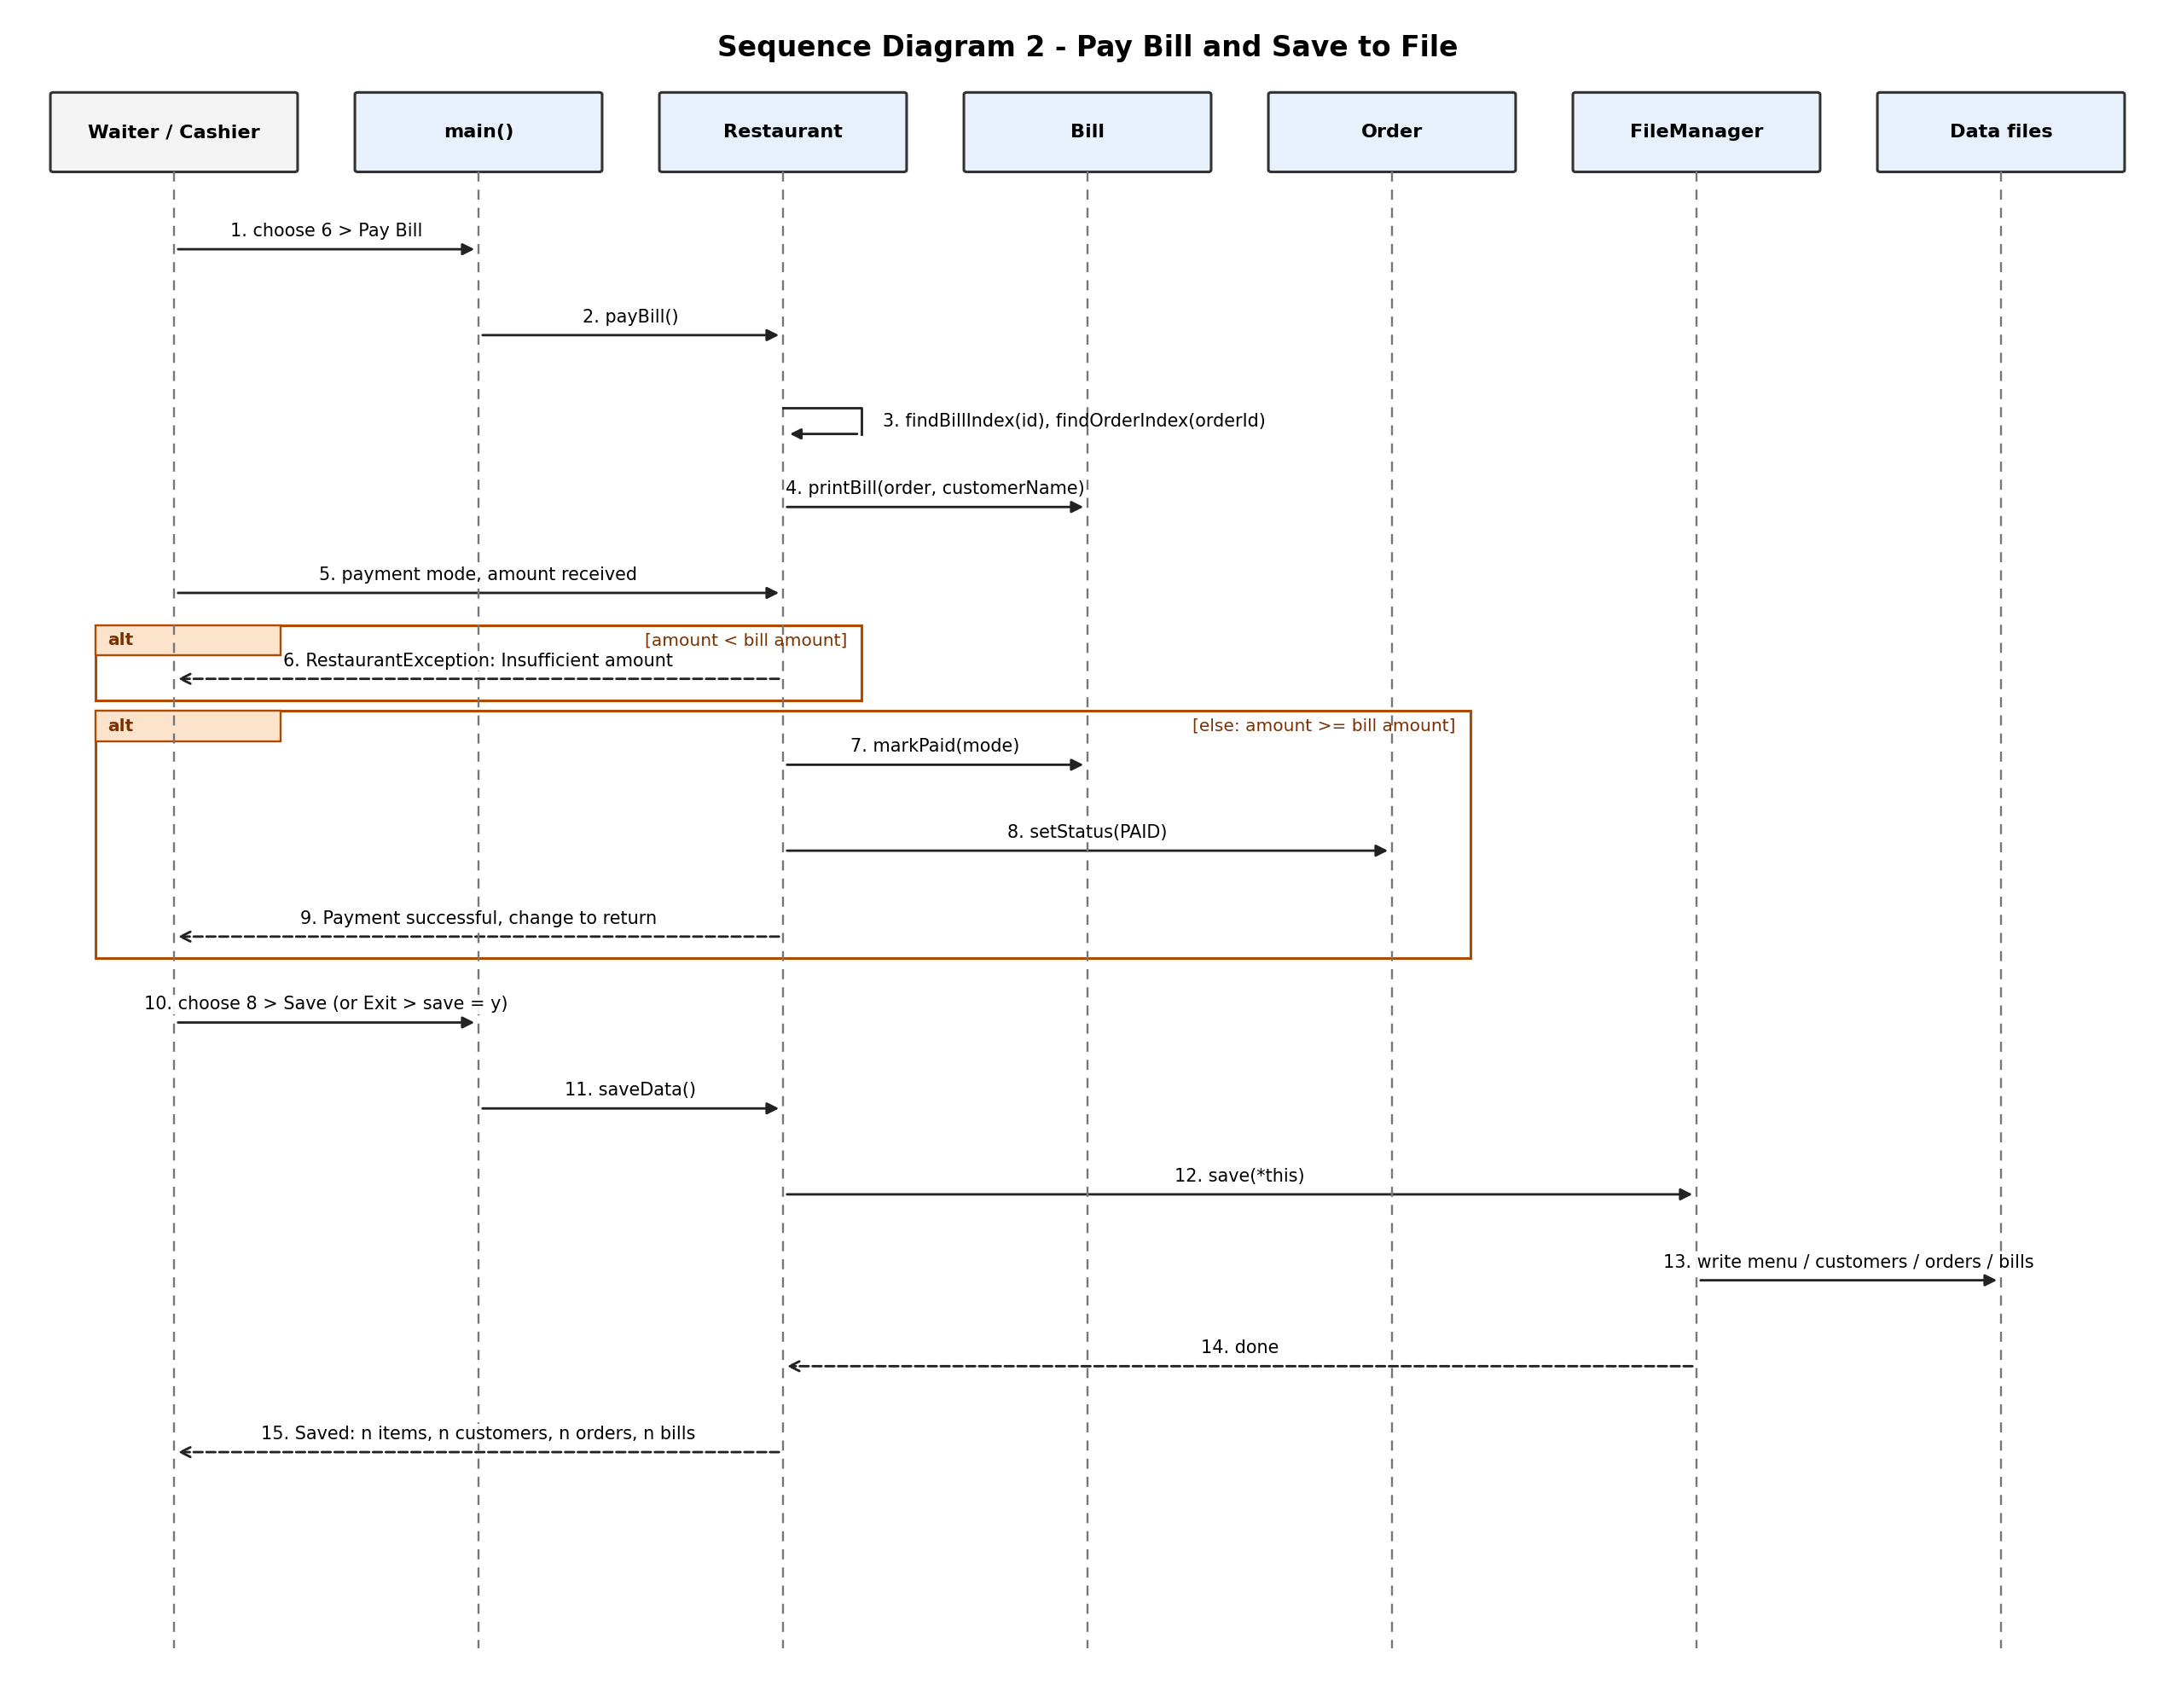
Relationships in the class diagram: FoodItem and BeverageItem inherit from MenuItem (hollow triangle). Restaurant is composed of MenuItem, Customer, Order and Bill collections and of one FileManager (filled diamond): they are created and destroyed with it. Order is composed of one or more OrderLine objects. An Order is placed by one Customer, and a Bill belongs to exactly one Order (associations through customerId and orderId). FileManager depends on Restaurant because save() and load() read and fill it.

10. Implementation Details
Language and tools: C++17, compiled with g++ (GCC 13.3); about 2,000 lines in 20 files (headers and sources). The program was also built with -Wall -Wextra -pedantic without warnings and run under AddressSanitizer and UndefinedBehaviorSanitizer with no memory errors or leaks reported.
Source structure: main.cpp, Restaurant, MenuItem, FoodItem, BeverageItem, Customer, Order, Bill, FileManager (each with .h and .cpp), plus Utils and Common.h. Data files are in Data/.
Dynamic memory (where it is allocated and released):
- Restaurant::initArrays() allocates menu = new MenuItem*[4], customers = new Customer[4], orders = new Order[4], bills = new Bill[4].
- growMenu(), growCustomers(), growOrders(), growBills() allocate an array of double size, copy the records, delete[] the old array and switch the pointer.
- addMenuItem() creates objects with new FoodItem(...) or new BeverageItem(...) and stores the pointer in menu[]; the array is grown before the object is created, so a failed allocation cannot leak.
- deleteMenuItem() calls delete menu[idx] and shifts the remaining pointers left.
- Order allocates its OrderLine array lazily in grow() (4, 8, 16, ...); ~Order() releases it with delete[].
- showReport() allocates temporary arrays to find the best-selling item and releases them with delete[] before returning.
- ~Restaurant() deletes every MenuItem object (the virtual destructor runs the correct class) and then delete[]s all arrays.
Runtime polymorphism (excerpt):
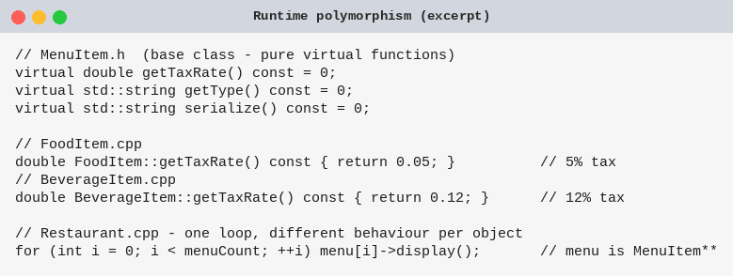
Order lines keep their own copy of the item: when an item is added to an order, its name, price and tax rate are copied into an OrderLine. Changing a price or deleting the item later never changes an old order or bill (shown in test T09 and in the delete message).
Validation and exceptions: every console read goes through the Input functions, which loop until the value is valid (whole number inside a range, positive price, non-empty name without the | character, 10-digit phone, y / n). Rule violations inside operations are thrown as RestaurantException and caught once in main(). If the input stream ends (Ctrl+Z / Ctrl+D), InputClosedException ends the program cleanly and the destructor still frees the memory.
Business rules: customers with orders cannot be deleted; only OPEN orders can be billed, changed or cancelled; BILLED and PAID orders cannot be deleted; a bill can be paid only once and only with an amount that covers it.
Build command: g++ -std=c++17 -Wall -Wextra -o restaurant src/*.cpp (Windows: -o restaurant.exe src\*.cpp)

11. Testing and Results
Test ID | Input / Operation | Expected | Actual | Status
T01 | Add menu item (Food)  Add Record > Menu Item > Food; name 'Chole Bhature', category 'Main Course', price 150, veg = y, spice 2 | Item added with new ID 11 as Food, 5% tax, 'Veg, Medium' | 11 | Chole Bhature | Food | Main Course | 150.00 | 5% | Veg, Medium | PASS
T02 | Add menu item (Beverage)  Add Record > Menu Item > Beverage; name 'Cold Coffee', category 'Beverage', price 120, 300 ml, cold = y | Item added as Beverage with 12% tax and '300 ml, Cold' | 11 | Cold Coffee | Beverage | Beverage | 120.00 | 12% | 300 ml, Cold | PASS
T03 | Input validation / exception handling  Main menu: 'abc' then 12; Add item 'Samosa' with price -5, then 'abc', then 40 | Each wrong value is rejected with an error message; the item is accepted only with price 40 | [Error] Please enter a valid whole number. | [Error] Value must be between 1 and 9. | [Error] Value must be between 1 and 10000. | [Error] Please enter a valid number. | PASS
T04 | Add customer  Add Record > Customer; name 'Neha Joshi', phone 9099912345 | Customer saved with the next free ID (4) | Customer added successfully with ID 4. | PASS
T05 | Customer validation (bad phone, duplicate phone)  Add Customer 'Test User' with phone 12345, then 9876543210 (already used) | Short phone rejected; duplicate phone refused with message | [Error] Phone number must be exactly 10 digits. | [Error] A customer with this phone number already exists (ID 1). | PASS
T06 | Display records (menu)  Display Records > Menu | Table of all 10 seeded menu items, polymorphic Type/Tax/Details columns | --- Menu (10 items) --- | 1 | Paneer Tikka | Food | Starter | 220.00 | 5% | Veg, Medium | PASS
T07 | Search (menu by category keyword, case-insensitive)  Search Record > Menu Item > By category; keyword 'main' | Both 'Main Course' items found (Butter Chicken, Dal Makhani) | 3 | Butter Chicken | Food | Main Course | 340.00 | 5% | Non-Veg, Medium | 4 | Dal Makhani | Food | Main Course | 240.00 | 5% | Veg, Mild | 2 item(s) found. | PASS
T08 | Search with no result  Search Record > Menu Item > By ID; ID 99 | Message that no matching item exists (no crash) | No matching menu items found. | PASS
T09 | Update record (menu price)  Update Record > Menu Item; ID 6 (Garlic Naan), change price to 75 | Price changes from 60.00 to 75.00 | Updated successfully. Existing orders and bills keep the old price. | 6 | Garlic Naan | Food | Breads | 75.00 | 5% | Veg, Mild | PASS
T10 | Main transaction - place order  Transaction > Place Order; customer 1; items 1 x2, 3 x1, 8 x3; finish with 0 | Order 1 created; subtotal 900.00, tax 53.40, TOTAL Rs. 953.40 | ORDER #1 Customer: Aarav Mehta (ID 1) Status: OPEN | Subtotal: Rs. 900.00 Tax: Rs. 53.40 TOTAL: Rs. 953.40 | PASS
T11 | Main transaction - generate bill with discount  Place the order above, then Generate Bill for order 1 with 10% discount | Bill 1 printed; discount 95.34; AMOUNT PAYABLE 858.06; order status BILLED | Discount (10%) -95.34 | AMOUNT PAYABLE 858.06 | 1 | 1 | Aarav Mehta | 3 | 953.40 | BILLED | PASS
T12 | Main transaction - payment (insufficient, then correct)  Pay Bill 1 by Cash with Rs. 500, then again with Rs. 1000 | 500 refused (insufficient); 1000 accepted, change Rs. 141.94, order PAID | [Error] Insufficient amount. Bill is Rs. 858.06 but only Rs. 500.00 was received. | Payment successful via Cash. Change to return: Rs. 141.94 | PASS
T13 | Cancel order and delete rules  Order for customer 2 (item 6 x2) > cancel it; try deleting customer 2; delete order 1; delete customer 2 | Order CANCELLED; customer delete refused while orders exist; allowed after order is removed | Order 1 cancelled. | [Error] Cannot delete: this customer has orders (e.g. order 1). Delete those orders first. | Order deleted. | Customer deleted. | PASS
T14 | Report  One paid order (customer 1) and one unpaid billed order (customer 2: item 9 x4), then Report | Revenue 858.06, outstanding 313.60, best seller Fresh Lime Soda (4), top customer Aarav Mehta | Revenue (paid) : Rs. 858.06 | Outstanding : Rs. 313.60 | Best-selling : Fresh Lime Soda (4 sold) | Top customer : Aarav Mehta (Rs. 858.06 paid) | PASS
T15 | File persistence (close and reopen)  Run 1: add item, customer, order and bill, exit with save. Run 2: start again, display menu and orders | Second run loads 11 menu items, 4 customers, 1 order, 1 bill; new records are still there | Loaded from 'Data': 11 menu items, 4 customers, 1 orders, 1 bills. | 11 | Chole Bhature | Food | Main Course | 150.00 | 5% | Veg, Medium | 1 | 4 | Kabir Nair | 1 | 315.00 | BILLED | PASS
Result: 15 of 15 test cases passed. The tests were run automatically on the real executable (tests/run_tests.py); the keystrokes used for each test are in tests/inputs/ and the full screen output is in tests/Test_Results.txt. The Actual column shows the real output lines from that run.

12. Sample Screens / Output
Source code used for Screenshot 1 (functions that produce the output below):
File: main.cpp
static void showMainMenu() {
std::cout << "\n=============================================\n"
<< " RESTAURANT MANAGEMENT SYSTEM\n"
<< "=============================================\n"
<< " 1. Add Record\n"
<< " 2. Display Records\n"
<< " 3. Search Record\n"
<< " 4. Update Record\n"
<< " 5. Delete Record\n"
<< " 6. Main Transaction (Order / Bill / Payment)\n"
<< " 7. Report\n"
<< " 8. Save / Load\n"
<< " 9. Exit\n"
<< "=============================================\n";
}
int main(int argc, char* argv[]) {
std::string dataDir = (argc > 1) ? argv[1] : "Data"; // optional: restaurant <data-folder>
try {
Restaurant restaurant("Spice Garden", dataDir);
std::cout << "Starting Restaurant Management System...\n";
restaurant.loadData(); // load existing records at start-up
bool running = true;
while (running) {
showMainMenu();
int choice = Input::readInt("Enter your choice (1-9): ", 1, 9);
if (choice == 9) {
if (Input::readYesNo("Save all changes before exit?")) {
try { restaurant.saveData(); }
catch (const RestaurantException& e) { std::cout << " [Error] " << e.what() << "\n"; }
}
std::cout << "Thank you. Goodbye!\n";
running = false;
continue;
}
try {
handleChoice(restaurant, choice);
} catch (const InputClosedException&) {
throw; // input ended: leave the loop
} catch (const RestaurantException& e) {
std::cout << " [Error] " << e.what() << "\n";
} catch (const std::bad_alloc&) {
std::cout << " [Error] Out of memory.\n";
}
}
} catch (const InputClosedException&) {
std::cout << "\nInput closed. Exiting without saving.\n";
} catch (const std::exception& e) {
std::cerr << "Fatal error: " << e.what() << "\n";
return 1;
}
return 0;
}
File: Restaurant.cpp
void Restaurant::loadData() {
int skipped = 0;
bool found = fileManager.load(*this, skipped);
if (!found) {
std::cout << " No saved data found in '" << fileManager.getDirectory() << "'. Starting with empty records.\n";
return;
}
std::cout << " Loaded from '" << fileManager.getDirectory() << "': " << menuCount << " menu items, "
<< customerCount << " customers, " << orderCount << " orders, " << billCount << " bills.";
if (skipped > 0) std::cout << " (" << skipped << " damaged record(s) skipped)";
std::cout << "\n";
}
Screenshot 1: Start-up (records loaded automatically) and main menu
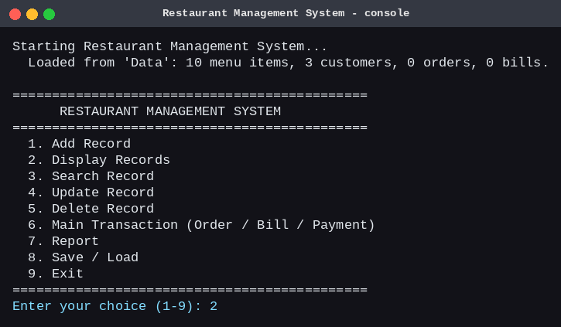
Source code used for Screenshot 2 (functions that produce the output below):
File: Restaurant.cpp
void Restaurant::displayMenu() const {
std::cout << "\n--- Menu (" << menuCount << " items) ---\n";
if (menuCount == 0) { std::cout << " No menu items yet.\n"; return; }
MenuItem::printHeader();
for (int i = 0; i < menuCount; ++i) menu[i]->display(); // runtime polymorphism
std::cout << "+-----+------------------------+-----------+--------------+----------+------+------------------------+\n";
}
File: MenuItem.cpp
void MenuItem::display() const {
std::ios::fmtflags f = std::cout.flags();
std::cout << "| " << std::right << std::setw(3) << itemId
<< " | " << std::left << std::setw(22) << name
<< " | " << std::setw(9) << getType() // virtual call
<< " | " << std::setw(12) << category
<< " | " << std::right << std::setw(8) << std::fixed << std::setprecision(2) << price
<< " | " << std::setw(3) << static_cast<int>(getTaxRate() * 100.0 + 0.5) << "%" // virtual call
<< " | " << std::left << std::setw(22) << getDetails() << " |\n"; // virtual call
std::cout.flags(f);
}
File: FoodItem.cpp
double FoodItem::getTaxRate() const { return 0.05; } // 5% on food
std::string FoodItem::getDetails() const {
const char* levels[] = {"", "Mild", "Medium", "Hot"};
return std::string(isVeg ? "Veg" : "Non-Veg") + ", " + levels[spiceLevel];
}
File: BeverageItem.cpp
double BeverageItem::getTaxRate() const { return 0.12; } // 12% on beverages
std::string BeverageItem::getDetails() const {
std::ostringstream os;
os << sizeMl << " ml, " << (isCold ? "Cold" : "Hot");
return os.str();
}
Screenshot 2: Display Records > Menu (Food and Beverage objects shown through MenuItem pointers)
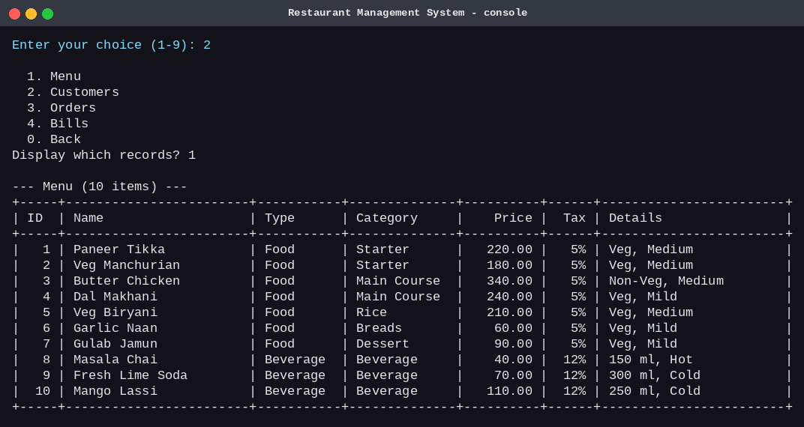
Source code used for Screenshot 3 (functions that produce the output below):
File: Restaurant.cpp
void Restaurant::createOrder() {
std::cout << "\n--- Place New Order ---\n";
if (menuCount == 0) throw RestaurantException("The menu is empty. Add menu items first.");
if (customerCount == 0) throw RestaurantException("There are no customers. Add a customer first.");
displayCustomers();
int cid = Input::readInt("Customer ID: ", 1, 999999);
if (findCustomerIndex(cid) < 0) throw RestaurantException("No customer with ID " + std::to_string(cid) + ".");
Order order(nextOrderId, cid);
addLinesToOrder(order);
if (order.getLineCount() == 0) { std::cout << " No items were added. Order discarded.\n"; return; }
if (orderCount == orderCap) growOrders();
orders[orderCount++] = order; // deep copy into the array
++nextOrderId;
std::cout << " Order placed successfully.";
order.display(customerNameOf(cid));
}
int Restaurant::addLinesToOrder(Order& order) {
int added = 0;
displayMenu();
while (true) {
int id = Input::readInt("Item ID to add (0 = finish): ", 0, 999999);
if (id == 0) break;
int idx = findMenuIndex(id);
if (idx < 0) { std::cout << " [Error] No menu item with ID " << id << ".\n"; continue; }
int qty = Input::readInt("Quantity (1-50): ", 1, 50);
const MenuItem* m = menu[idx];
try {
order.addItem(m->getItemId(), m->getName(), m->getPrice(), m->getTaxRate(), qty);
++added;
std::cout << " Added " << qty << " x " << m->getName() << ". Running total: "
<< Utils::money(order.getTotal()) << "\n";
} catch (const RestaurantException& e) {
std::cout << " [Error] " << e.what() << "\n";
}
}
return added;
}
File: Order.cpp
void Order::addItem(int itemId, const std::string& name, double unitPrice, double taxRate, int qty) {
if (qty <= 0) throw RestaurantException("Quantity must be at least 1.");
for (int i = 0; i < lineCount; ++i) { // same item again? just increase quantity
if (lines[i].itemId == itemId) {
if (lines[i].qty + qty > 100) throw RestaurantException("Quantity of one item cannot exceed 100 per order.");
lines[i].qty += qty;
calculateTotal();
return;
}
}
if (lineCount == lineCap) grow();
lines[lineCount].itemId = itemId;
lines[lineCount].name = name;
lines[lineCount].qty = qty;
lines[lineCount].unitPrice = unitPrice;
lines[lineCount].taxRate = taxRate;
++lineCount;
calculateTotal();
}
void Order::calculateTotal() {
subtotal = 0.0;
tax = 0.0;
for (int i = 0; i < lineCount; ++i) {
double lineBase = lines[i].qty * lines[i].unitPrice;
subtotal += lineBase;
tax += lineBase * lines[i].taxRate;
}
total = subtotal + tax;
}
Screenshot 3: Main Transaction > Place New Order
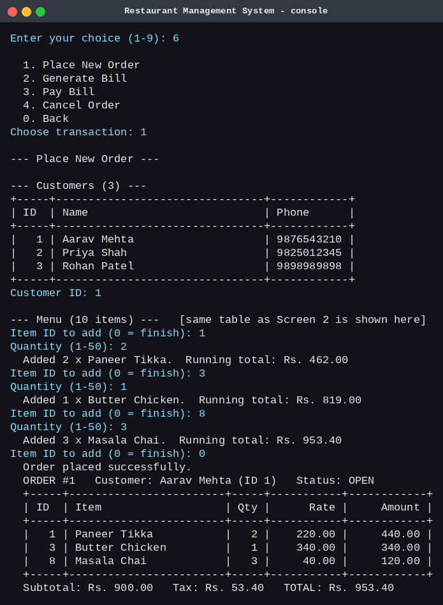
Source code used for Screenshot 4 (functions that produce the output below):
File: Restaurant.cpp
void Restaurant::generateBill() {
std::cout << "\n--- Generate Bill ---\n";
int oid = Input::readInt("Order ID: ", 1, 999999);
int oi = findOrderIndex(oid);
if (oi < 0) throw RestaurantException("No order with ID " + std::to_string(oid) + ".");
Order& order = orders[oi];
if (order.getStatus() != OrderStatus::OPEN)
throw RestaurantException("Only OPEN orders can be billed (this order is " + order.statusText() + ").");
if (order.getLineCount() == 0) throw RestaurantException("This order has no items.");
double pct = Input::readDouble("Discount percent (0 - 100, enter 0 for none): ", 0, 100);
if (billCount == billCap) growBills();
bills[billCount] = Bill(nextBillId, oid, order.getSubtotal(), order.getTax(), pct);
order.setStatus(OrderStatus::BILLED);
++billCount;
++nextBillId;
bills[billCount - 1].printBill(order, customerNameOf(order.getCustomerId()));
}
File: Bill.cpp
void Bill::calculateTotal() {
double gross = subtotal + tax;
discount = gross * discountPercent / 100.0;
amount = gross - discount;
}
void Bill::printBill(const Order& order, const std::string& customerName) const {
std::ios::fmtflags f = std::cout.flags();
std::cout << "\n ==============================================\n"
<< " SPICE GARDEN RESTAURANT\n"
<< " ==============================================\n"
<< " Bill No : " << billId << " Order No: " << orderId << "\n"
<< " Date : " << billDate << "\n"
<< " Customer: " << customerName << "\n"
<< " ----------------------------------------------\n"
<< " " << std::left << std::setw(22) << "Item" << std::right << std::setw(5) << "Qty"
<< std::setw(9) << "Rate" << std::setw(10) << "Amount" << "\n"
<< " ----------------------------------------------\n";
for (int i = 0; i < order.getLineCount(); ++i) {
const OrderLine& l = order.getLine(i);
std::cout << " " << std::left << std::setw(22) << l.name.substr(0, 22) << std::right
<< std::setw(5) << l.qty << std::setw(9) << std::fixed << std::setprecision(2) << l.unitPrice
<< std::setw(10) << l.qty * l.unitPrice << "\n";
}
std::cout << " ----------------------------------------------\n"
<< " " << std::left << std::setw(30) << "Subtotal" << std::right << std::setw(14) << subtotal << "\n"
<< " " << std::left << std::setw(30) << "Tax (GST)" << std::right << std::setw(14) << tax << "\n"
<< " " << std::left << std::setw(30) << ("Discount (" + [&] { std::ostringstream p; p << std::setprecision(4) << discountPercent; return p.str(); }() + "%)")
<< std::right << std::setw(14) << -discount << "\n"
<< " ----------------------------------------------\n"
<< " " << std::left << std::setw(30) << "AMOUNT PAYABLE" << std::right << std::setw(14) << amount << "\n"
<< " Status : " << (paid ? "PAID via " + paymentMode : std::string("UNPAID")) << "\n"
<< " ==============================================\n";
std::cout.flags(f);
}
Screenshot 4: Main Transaction > Generate Bill (10% discount)
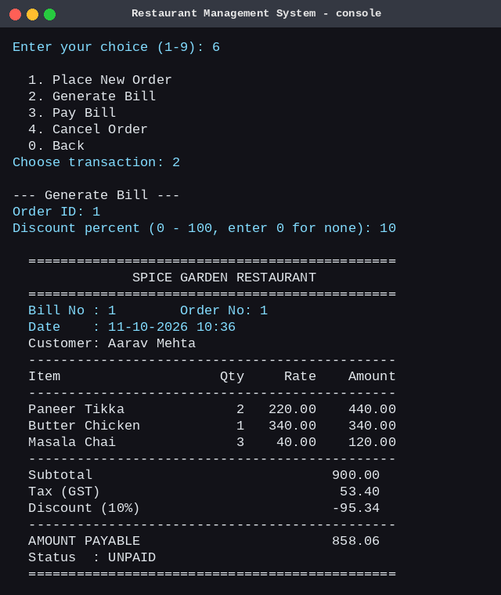
Source code used for Screenshot 5 (functions that produce the output below):
File: Restaurant.cpp
void Restaurant::payBill() {
std::cout << "\n--- Pay Bill ---\n";
int bid = Input::readInt("Bill ID: ", 1, 999999);
int bi = findBillIndex(bid);
if (bi < 0) throw RestaurantException("No bill with ID " + std::to_string(bid) + ".");
Bill& bill = bills[bi];
if (bill.isPaid()) throw RestaurantException("This bill is already paid.");
int oi = findOrderIndex(bill.getOrderId());
if (oi < 0) throw RestaurantException("The order for this bill is missing.");
bill.printBill(orders[oi], customerNameOf(orders[oi].getCustomerId()));
std::cout << " 1. Cash\n 2. Card\n 3. UPI\n";
int mode = Input::readInt("Payment mode (1-3): ", 1, 3);
double given = Input::readDouble("Amount received in Rs.: ", 0, 10000000);
if (given + 0.0001 < bill.getAmount())
throw RestaurantException("Insufficient amount. Bill is " + Utils::money(bill.getAmount()) +
" but only " + Utils::money(given) + " was received.");
const char* modes[] = {"", "Cash", "Card", "UPI"};
bill.markPaid(modes[mode]);
orders[oi].setStatus(OrderStatus::PAID);
std::cout << " Payment successful via " << modes[mode] << ". Change to return: "
<< Utils::money(given - bill.getAmount()) << "\n";
}
void Restaurant::showReport() const {
int foodCount = 0, drinkCount = 0;
for (int i = 0; i < menuCount; ++i) {
if (menu[i]->getType() == "Food") ++foodCount; else ++drinkCount;
}
int open = 0, billed = 0, paidO = 0, cancelled = 0;
for (int i = 0; i < orderCount; ++i) {
switch (orders[i].getStatus()) {
case OrderStatus::OPEN: ++open; break;
case OrderStatus::BILLED: ++billed; break;
case OrderStatus::PAID: ++paidO; break;
case OrderStatus::CANCELLED: ++cancelled; break;
}
}
double revenue = 0, outstanding = 0, discounts = 0;
int paidBills = 0, unpaidBills = 0;
for (int i = 0; i < billCount; ++i) {
discounts += bills[i].getDiscount();
if (bills[i].isPaid()) { revenue += bills[i].getAmount(); ++paidBills; }
else { outstanding += bills[i].getAmount(); ++unpaidBills; }
}
// Best-selling item: count quantities per item over all non-cancelled orders.
int totalLines = 0;
for (int i = 0; i < orderCount; ++i) totalLines += orders[i].getLineCount();
std::string bestName = "-";
int bestQty = 0;
if (totalLines > 0) {
int* ids = new int[totalLines]; // temporary dynamic arrays
int* qtys = new int[totalLines];
std::string* names = new std::string[totalLines];
int distinct = 0;
for (int i = 0; i < orderCount; ++i) {
if (orders[i].getStatus() == OrderStatus::CANCELLED) continue;
for (int j = 0; j < orders[i].getLineCount(); ++j) {
const OrderLine& l = orders[i].getLine(j);
int k = 0;
while (k < distinct && ids[k] != l.itemId) ++k;
if (k == distinct) { ids[k] = l.itemId; qtys[k] = 0; names[k] = l.name; ++distinct; }
qtys[k] += l.qty;
}
}
for (int k = 0; k < distinct; ++k)
if (qtys[k] > bestQty) { bestQty = qtys[k]; bestName = names[k]; }
delete[] ids;
delete[] qtys;
delete[] names;
}
// Top customer by amount actually paid.
std::string topName = "-";
double topSpend = 0;
for (int c = 0; c < customerCount; ++c) {
double spend = 0;
for (int b = 0; b < billCount; ++b) {
if (!bills[b].isPaid()) continue;
int oi = findOrderIndex(bills[b].getOrderId());
if (oi >= 0 && orders[oi].getCustomerId() == customers[c].getCustomerId()) spend += bills[b].getAmount();
}
if (spend > topSpend) { topSpend = spend; topName = customers[c].getName(); }
}
std::cout << "\n==================== RESTAURANT REPORT ====================\n"
<< " Menu items : " << menuCount << " (Food: " << foodCount << ", Beverage: " << drinkCount << ")\n"
<< " Customers : " << customerCount << "\n"
<< " Orders : " << orderCount << " (Open: " << open << ", Billed: " << billed
<< ", Paid: " << paidO << ", Cancelled: " << cancelled << ")\n"
<< " Bills : " << billCount << " (Paid: " << paidBills << ", Unpaid: " << unpaidBills << ")\n"
<< " Revenue (paid) : " << Utils::money(revenue) << "\n"
<< " Outstanding : " << Utils::money(outstanding) << "\n"
<< " Discounts given : " << Utils::money(discounts) << "\n";
if (bestQty > 0) std::cout << " Best-selling : " << bestName << " (" << bestQty << " sold)\n";
else std::cout << " Best-selling : -\n";
if (topSpend > 0) std::cout << " Top customer : " << topName << " (" << Utils::money(topSpend) << " paid)\n";
else std::cout << " Top customer : -\n";
std::cout << "===========================================================\n";
}
File: Bill.cpp
void Bill::markPaid(const std::string& mode) {
if (paid) throw RestaurantException("This bill is already paid.");
paid = true;
paymentMode = mode;
}
Screenshot 5: Pay Bill (Cash) and Report

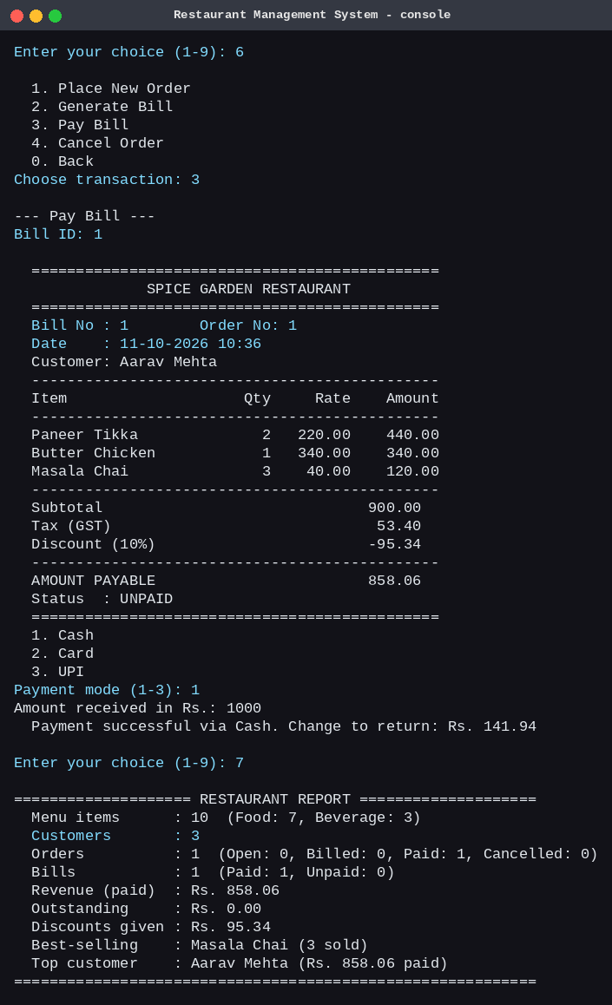

Source code used for Screenshot 6 (functions that produce the output below):
File: Utils.cpp
std::string readPhone(const std::string& prompt) {
while (true) {
std::string s = readLine(prompt);
bool ok = (s.size() == 10);
for (char c : s) if (!std::isdigit(static_cast<unsigned char>(c))) ok = false;
if (ok) return s;
std::cout << " [Error] Phone number must be exactly 10 digits.\n";
}
}
File: Customer.cpp
static void checkPhone(const std::string& p) {
bool ok = (p.size() == 10);
for (char c : p) if (!std::isdigit(static_cast<unsigned char>(c))) ok = false;
if (!ok) throw RestaurantException("Phone number must be exactly 10 digits.");
}
File: Restaurant.cpp
void Restaurant::addCustomer() {
std::cout << "\n--- Add Customer ---\n";
std::string name = Input::readName("Customer name (max 30 chars): ", 30);
std::string phone = Input::readPhone("Phone number (10 digits): ");
for (int i = 0; i < customerCount; ++i)
if (customers[i].getPhone() == phone)
throw RestaurantException("A customer with this phone number already exists (ID " +
std::to_string(customers[i].getCustomerId()) + ").");
if (customerCount == customerCap) growCustomers();
customers[customerCount++] = Customer(nextCustomerId, name, phone);
std::cout << " Customer added successfully with ID " << nextCustomerId << ".\n";
++nextCustomerId;
}
Screenshot 6: Validation: a wrong phone number is rejected and asked again
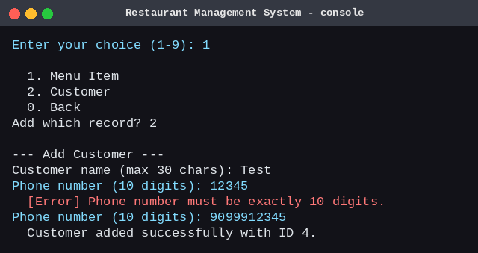

13. Limitations
- Console only: there is no graphical interface.
- Single-user program; the text files are not protected against two copies running at the same time and are not encrypted.
- Tax rates (5% food, 12% beverage) are fixed in the code; a different rate needs a change in getTaxRate().
- Tables, seats, kitchen status, stock and staff are not modelled; there is no login in the program (the two actors in the use case diagram are only roles).
- Searching is linear (it checks every record), which is fine for a small restaurant but would slow down for very large data.
- A customer who has orders cannot be deleted; there is no 'archive' option.

14. Future Scope
- A graphical or web front end (for example Qt) and table-wise ordering.
- A database such as SQLite instead of text files, with indexes for fast search.
- Staff accounts with login and roles (waiter, cashier, manager).
- Stock / inventory tracking and low-stock alerts.
- Printable PDF bills, daily and monthly sales reports by date, and charts.
- Online ordering and reservations; configurable tax and discount rules.
- Refactoring to std::vector and smart pointers (std::unique_ptr) once dynamic memory management is no longer a learning goal, and adding automated unit tests.

15. Conclusion
The Restaurant Management System meets all the points of the project blueprint: it has eight classes, constructors and destructors, inheritance with runtime polymorphism, dynamic memory that is allocated and released correctly, file persistence, the Add / Display / Search / Update / Delete operations, a full order-bill-payment transaction, a report, validation and exception handling. The UML diagrams describe the design, and all 15 test cases pass on the final program. The project gave practical experience in designing classes with clear responsibilities, managing memory by hand, and keeping data safe between runs.

