**Practical Assignment 3**

**Name : Dev Akshaykumar Mevawala**

**Roll no : 18**

**Sub : OSWD**

[**https://github.com/Dev1606/Nodejs_Practical3**](https://github.com/Dev1606/Nodejs_Practical3)

**Admin Site :**

1).Login :

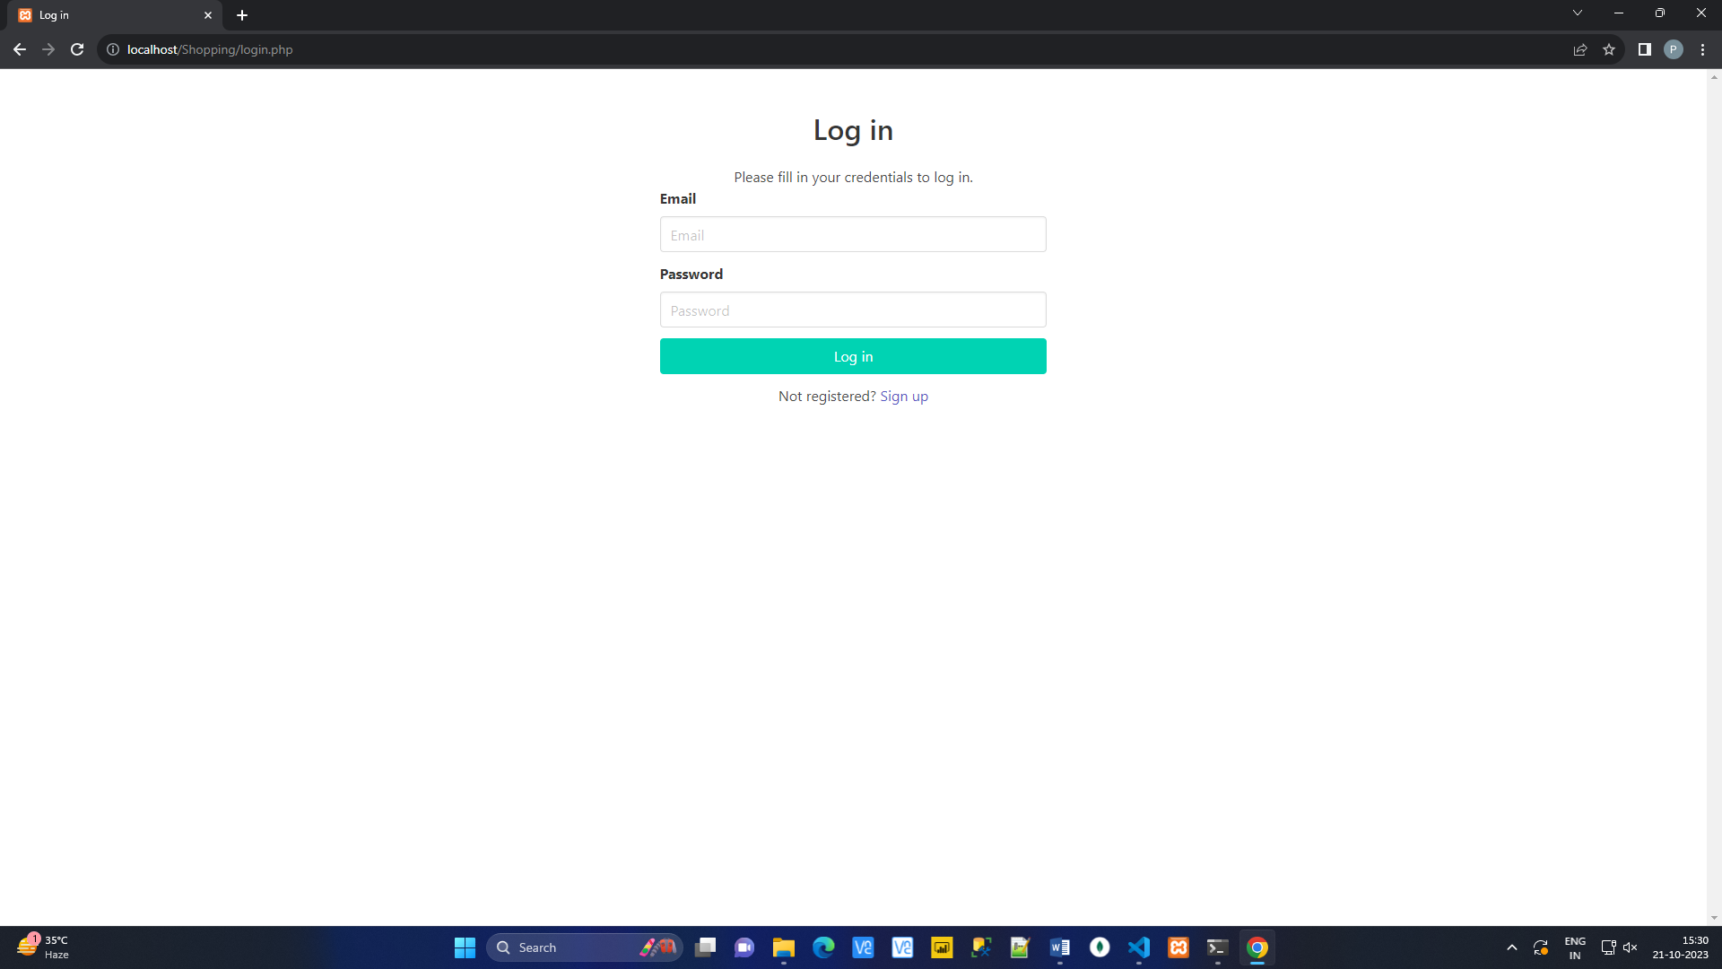

2).Manage category(CRUD)

**LIST:**

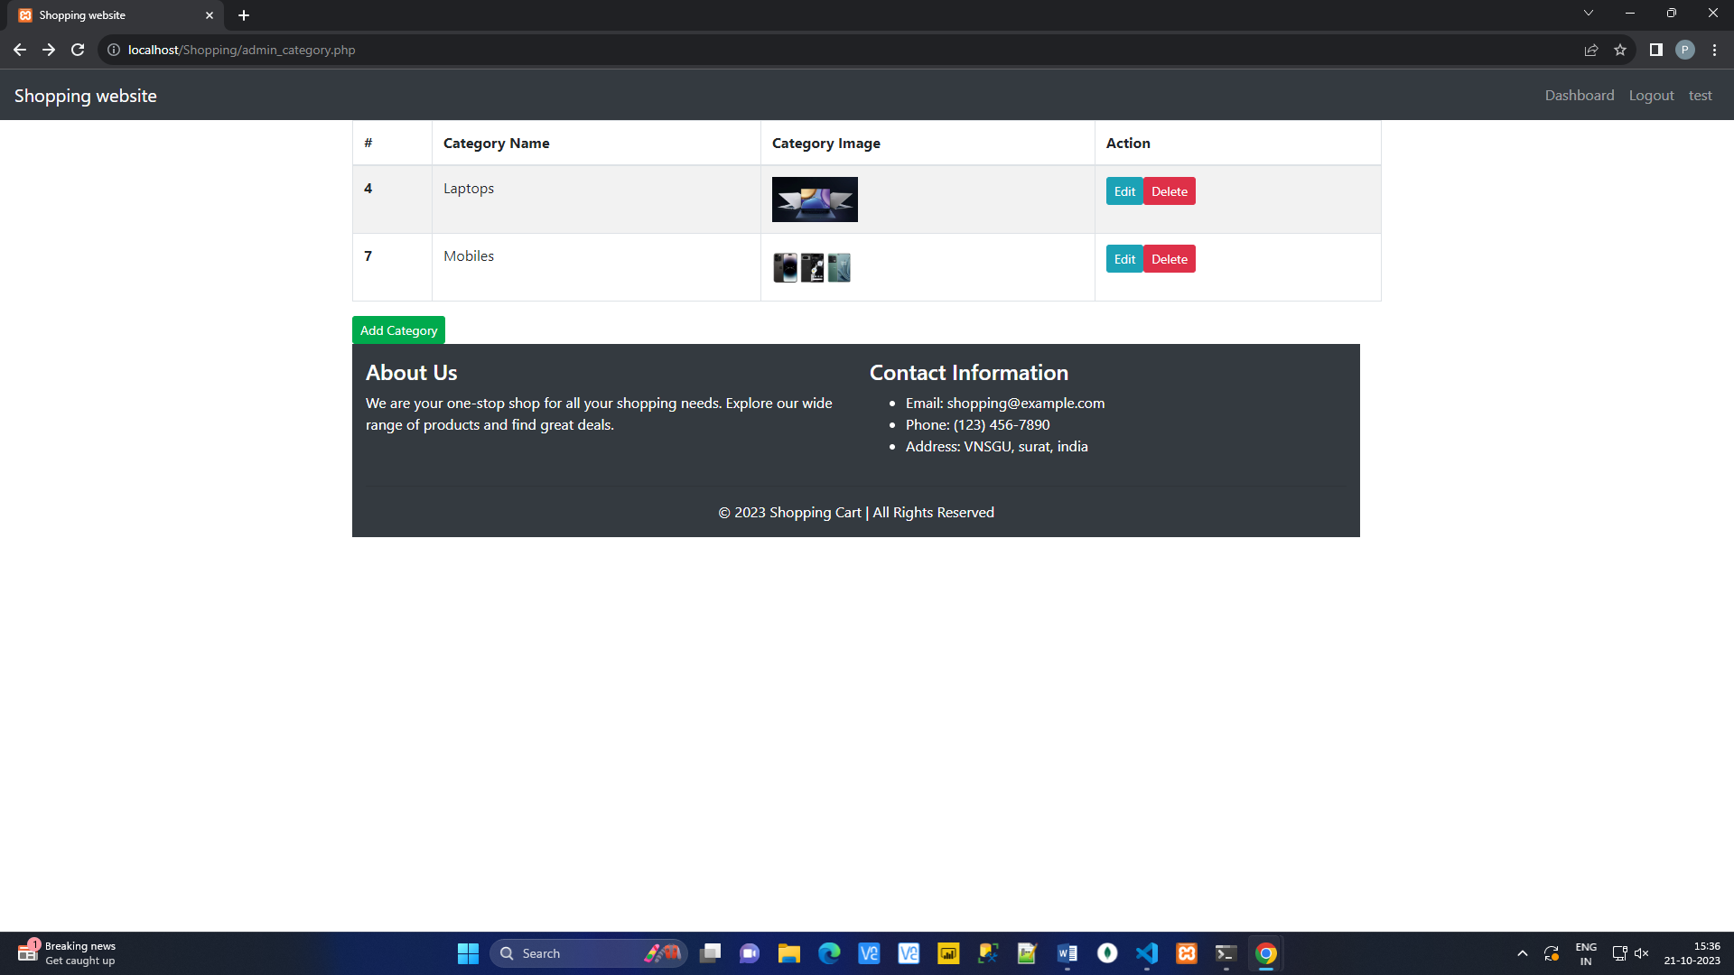

**Add Category :**

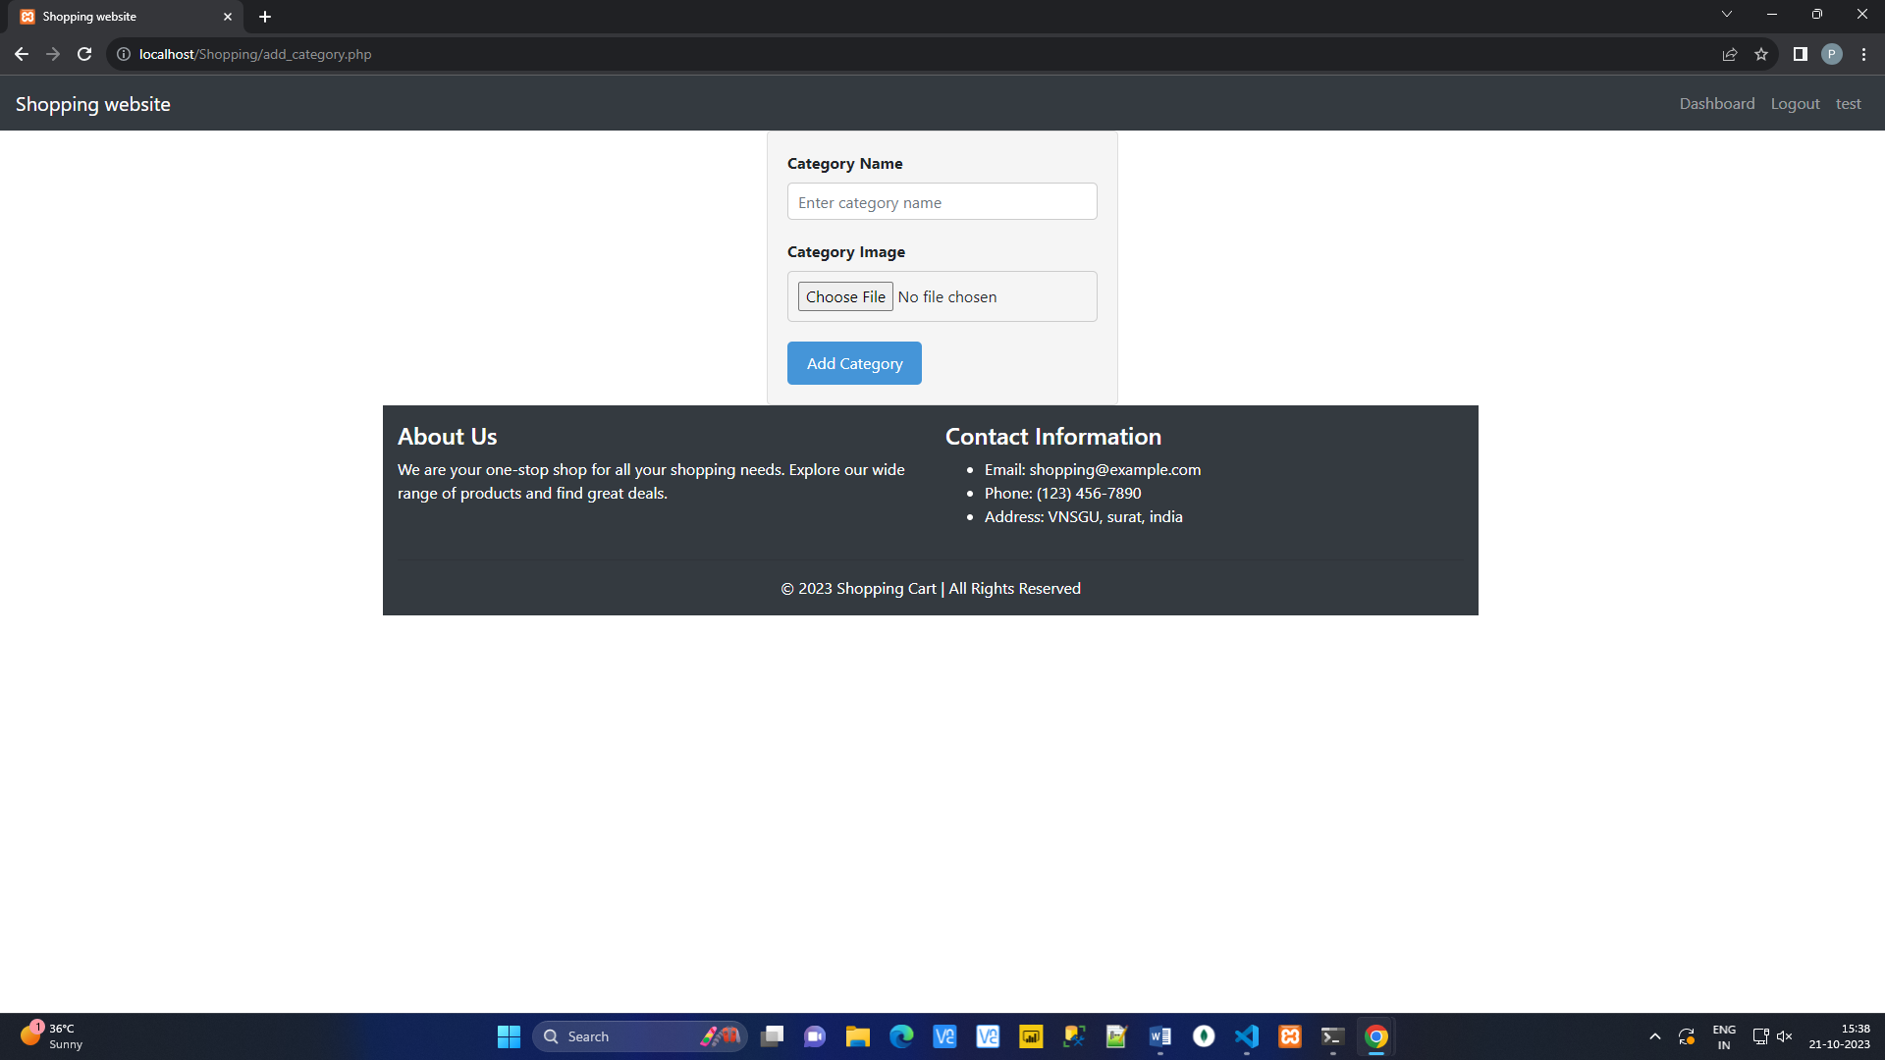

**Update Category :**

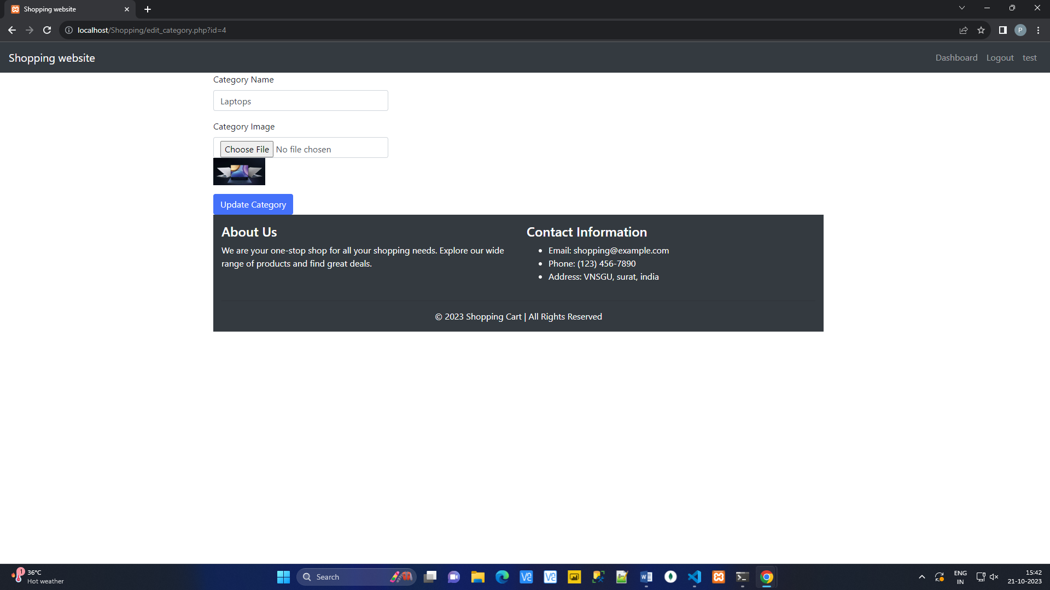

3) Manage Product :

**List Product :**

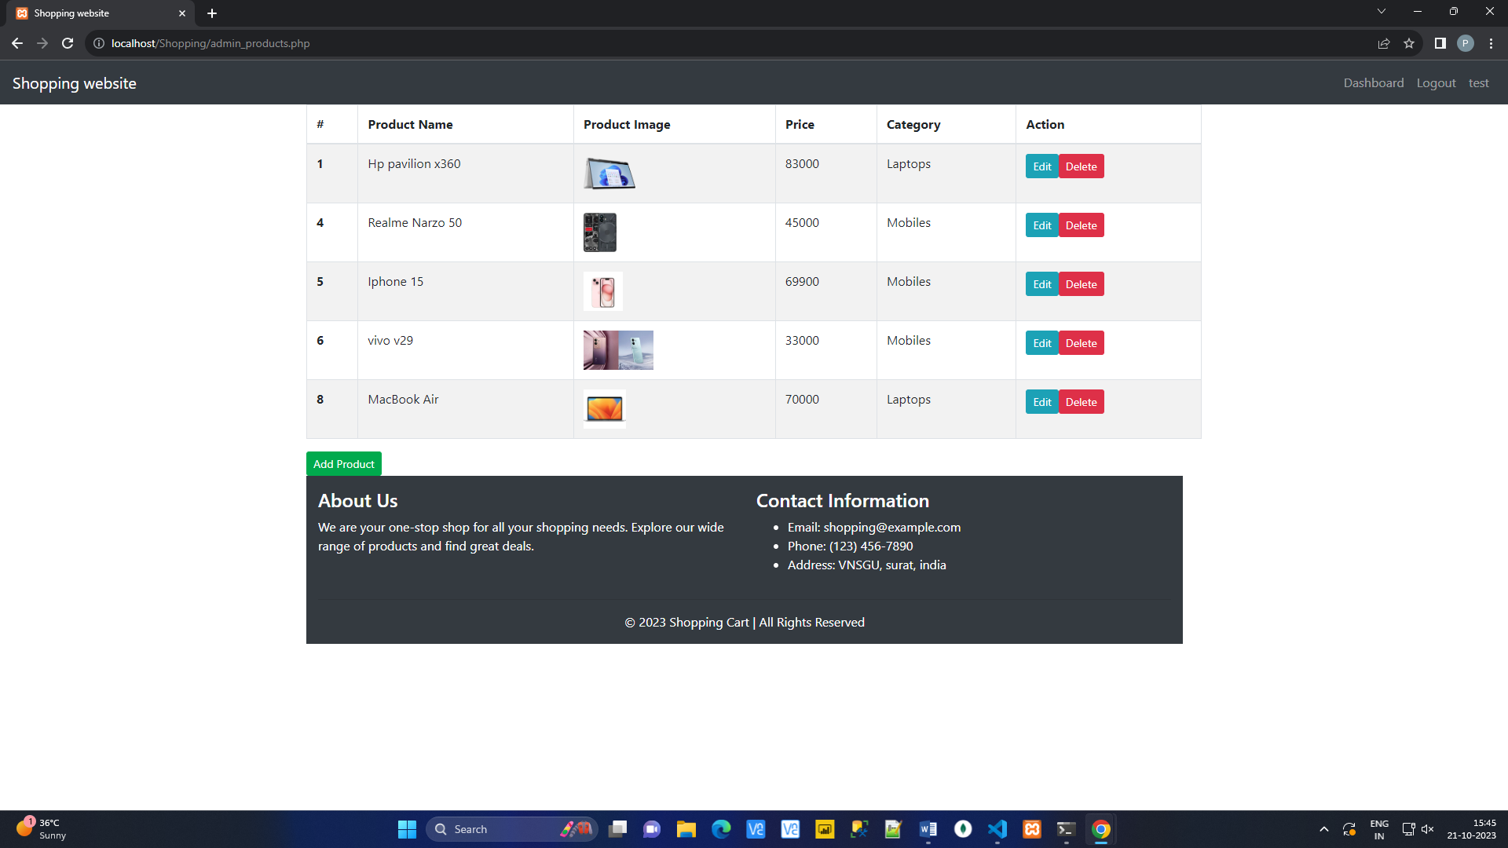

**Add product :**

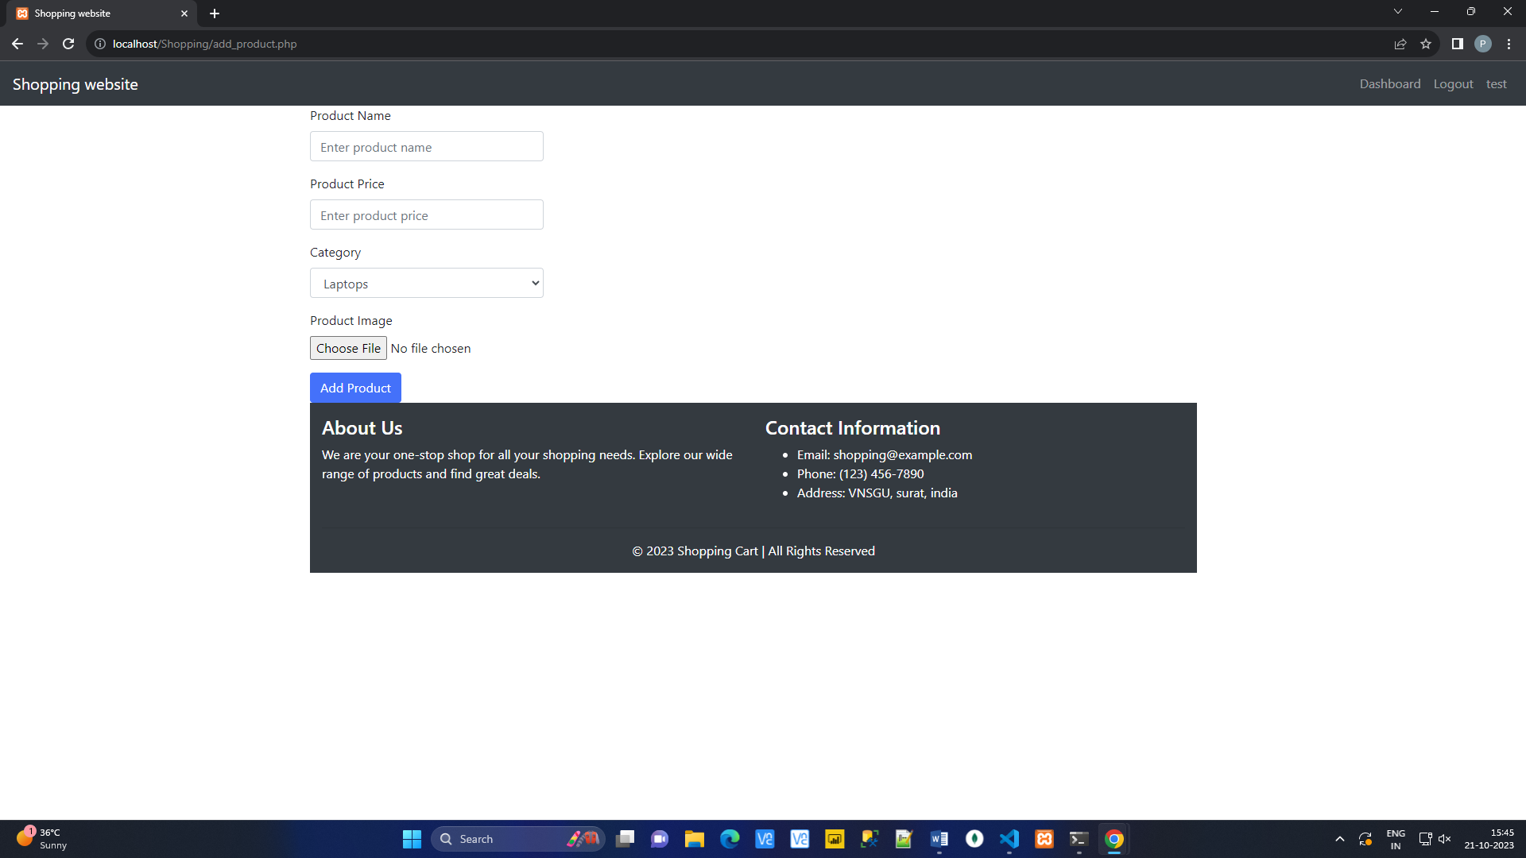

**Edit Product :**

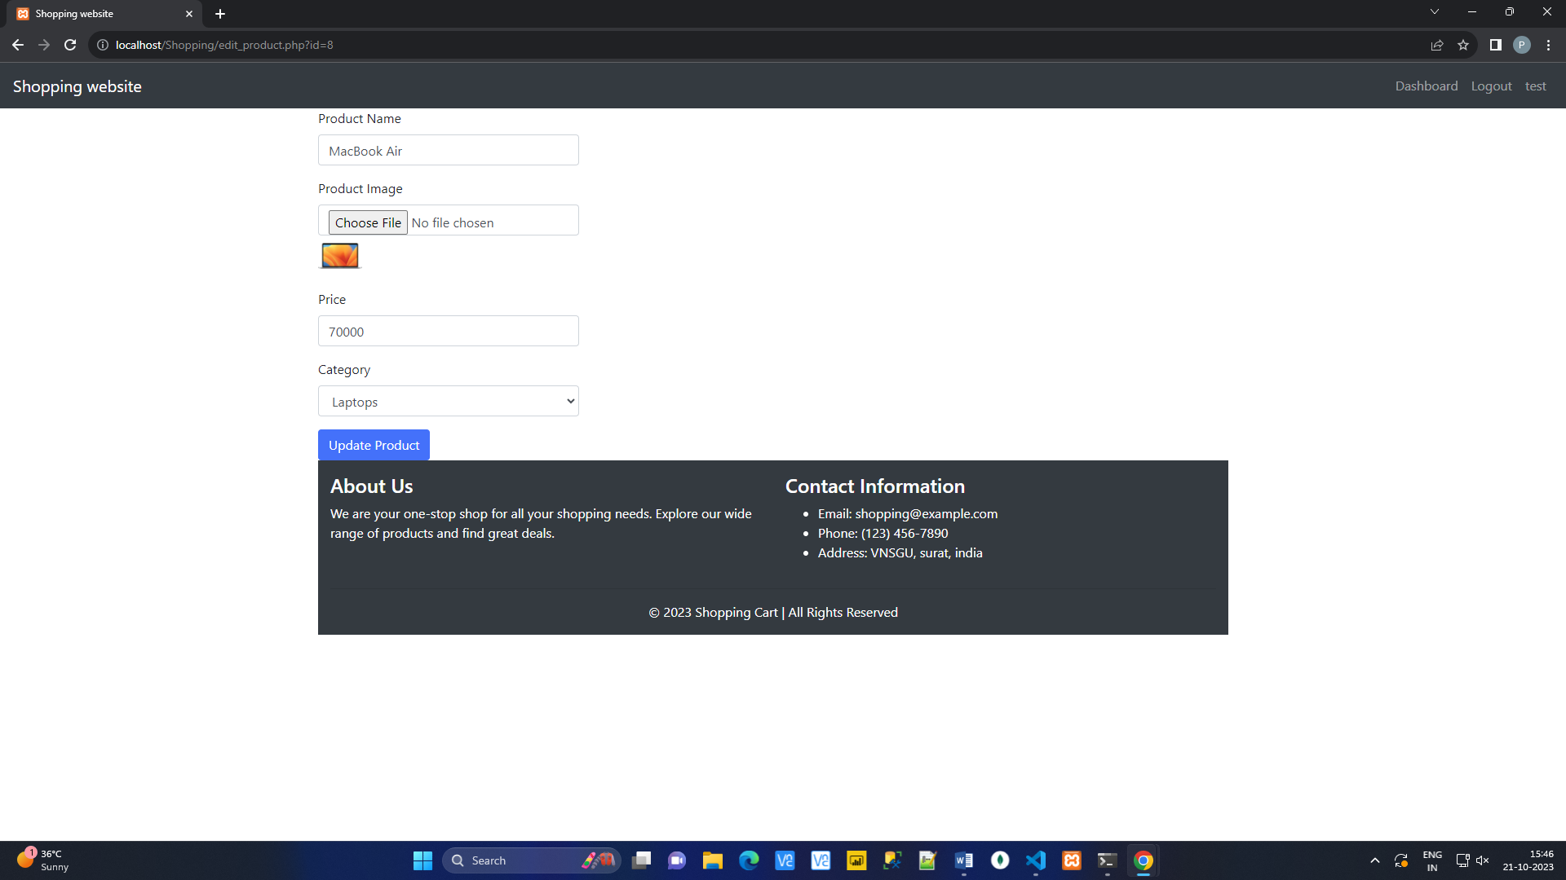

4) Logout :

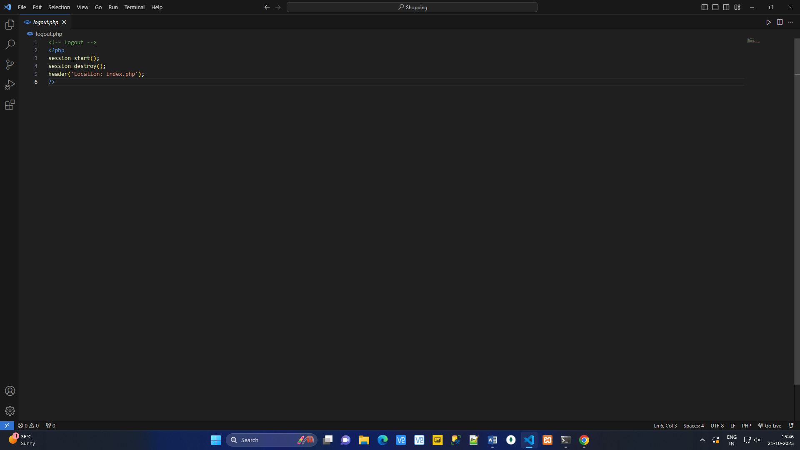

**User Side :**

1. Login :

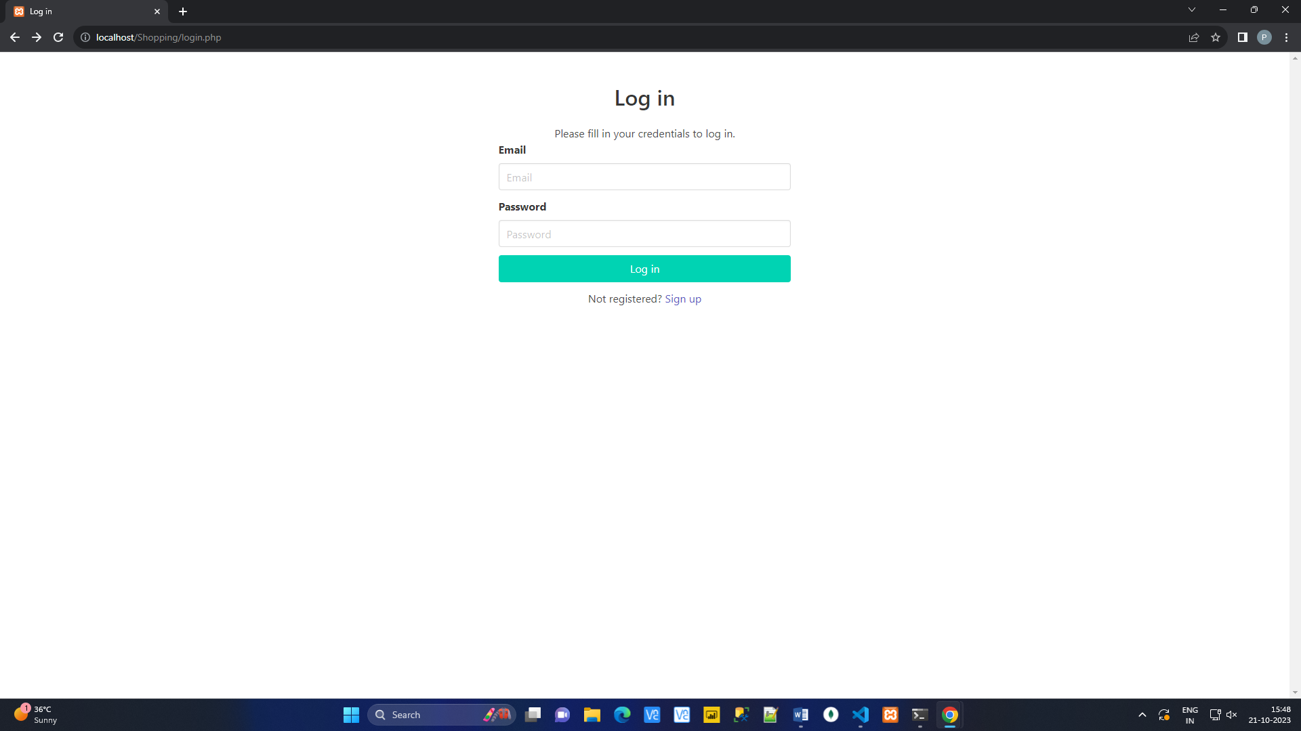

1. Register :

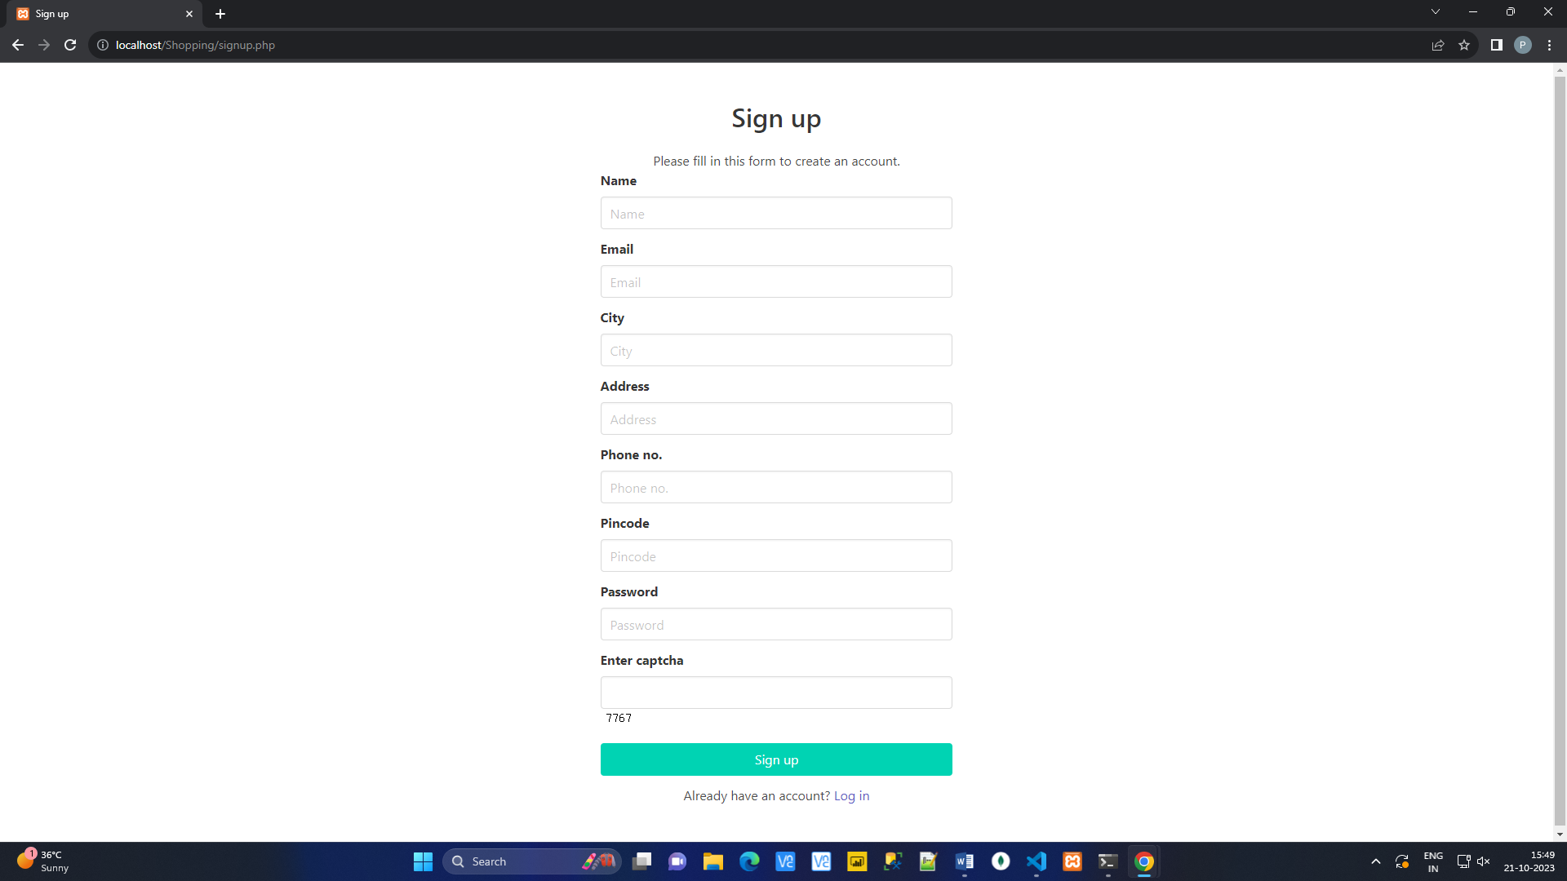

1. List categories :

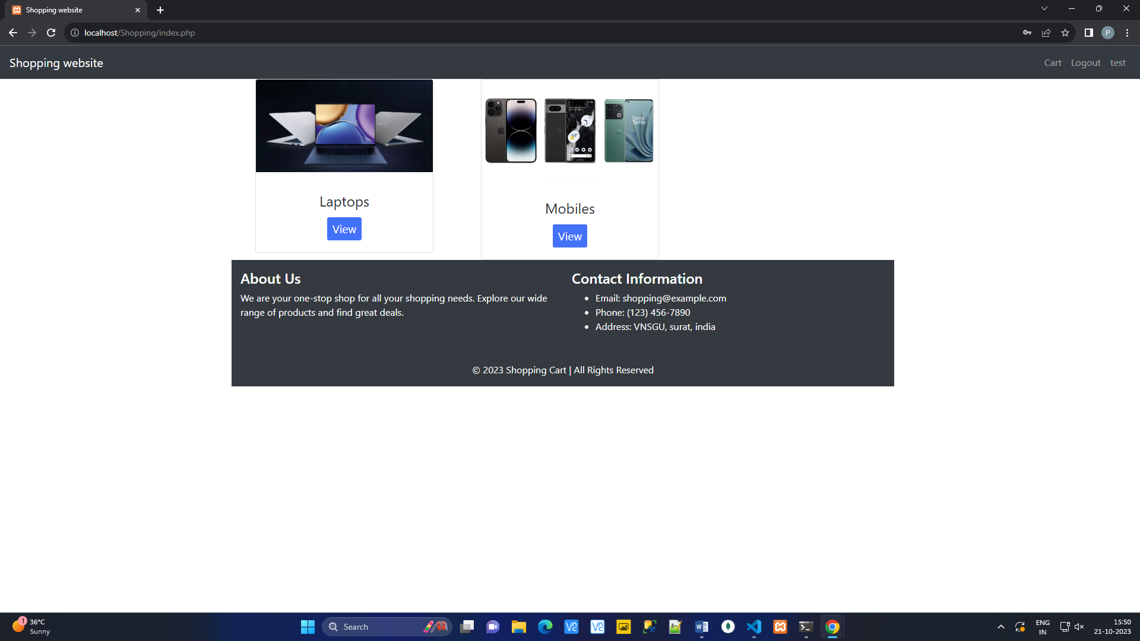

1. Display :

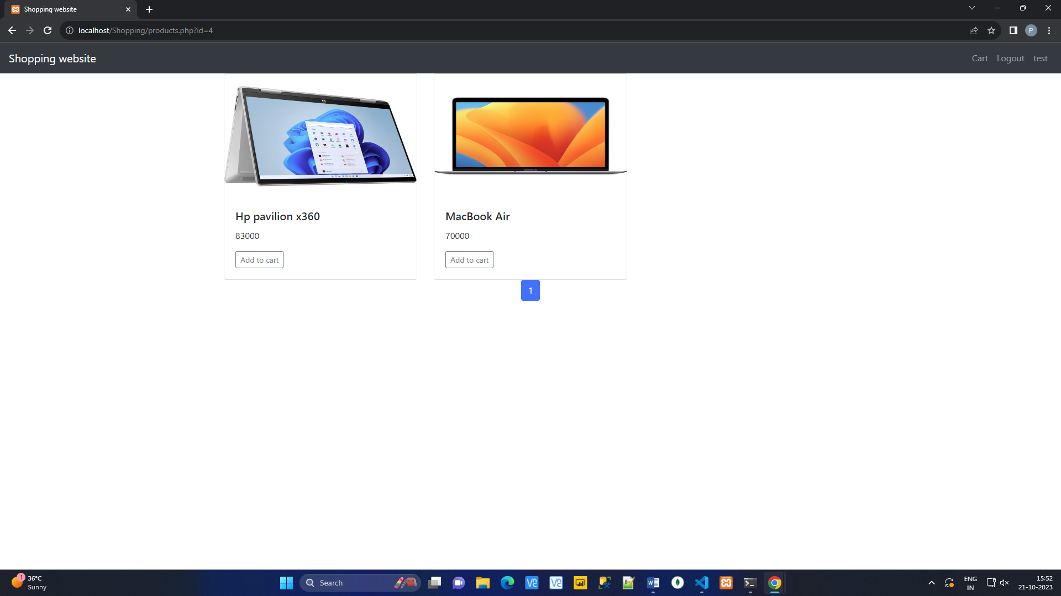

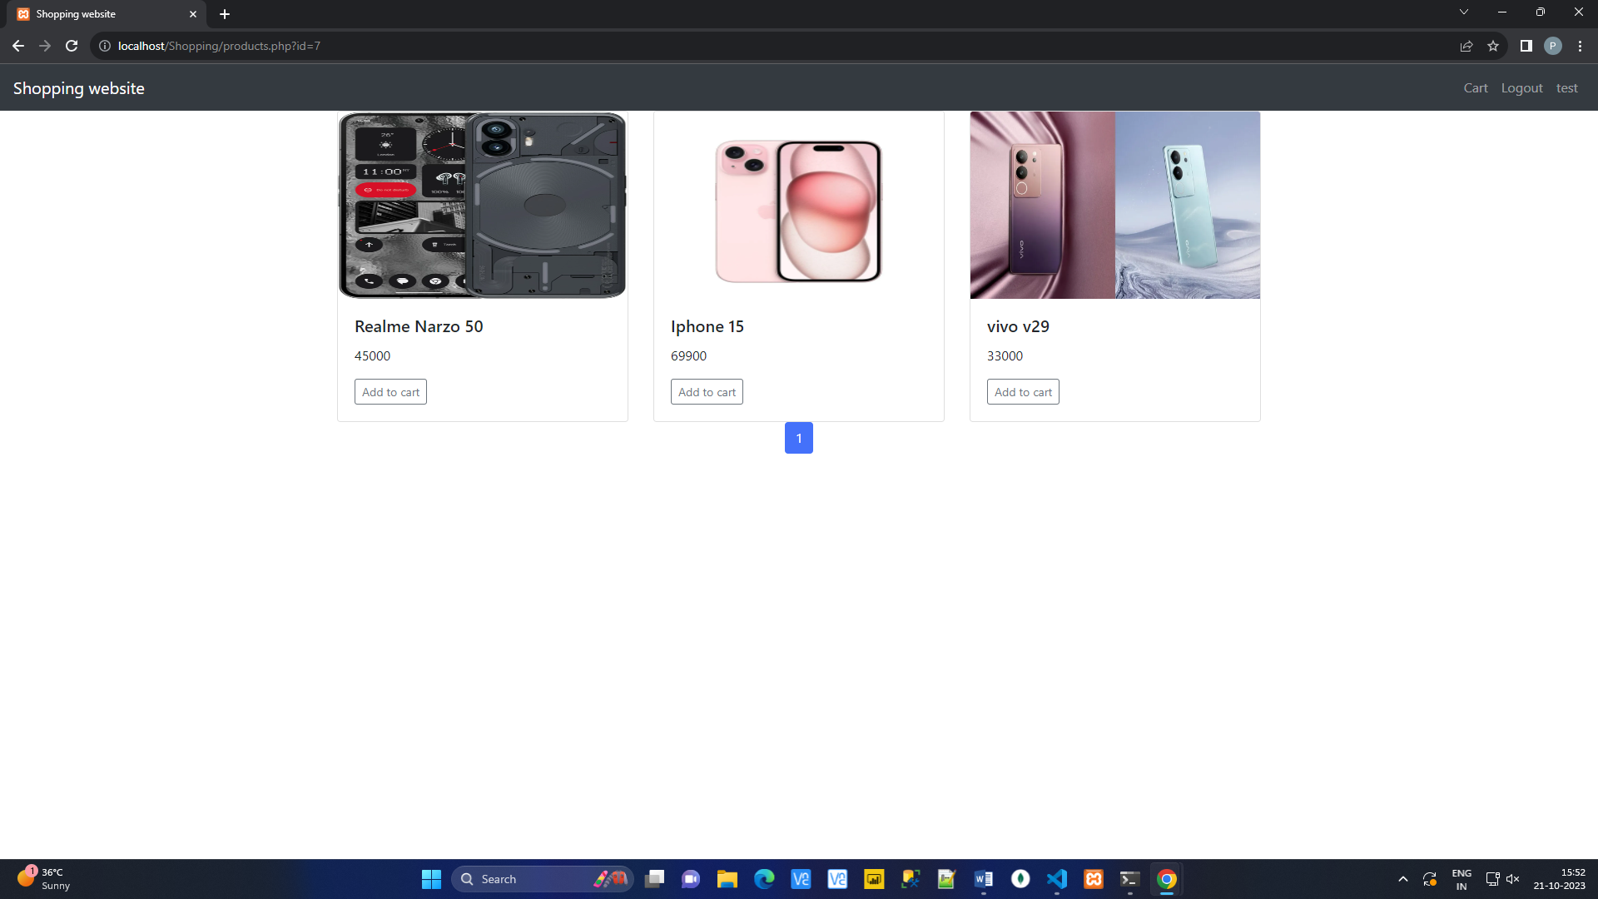

**Read data from student.xml file and store them in student table of MySql.**

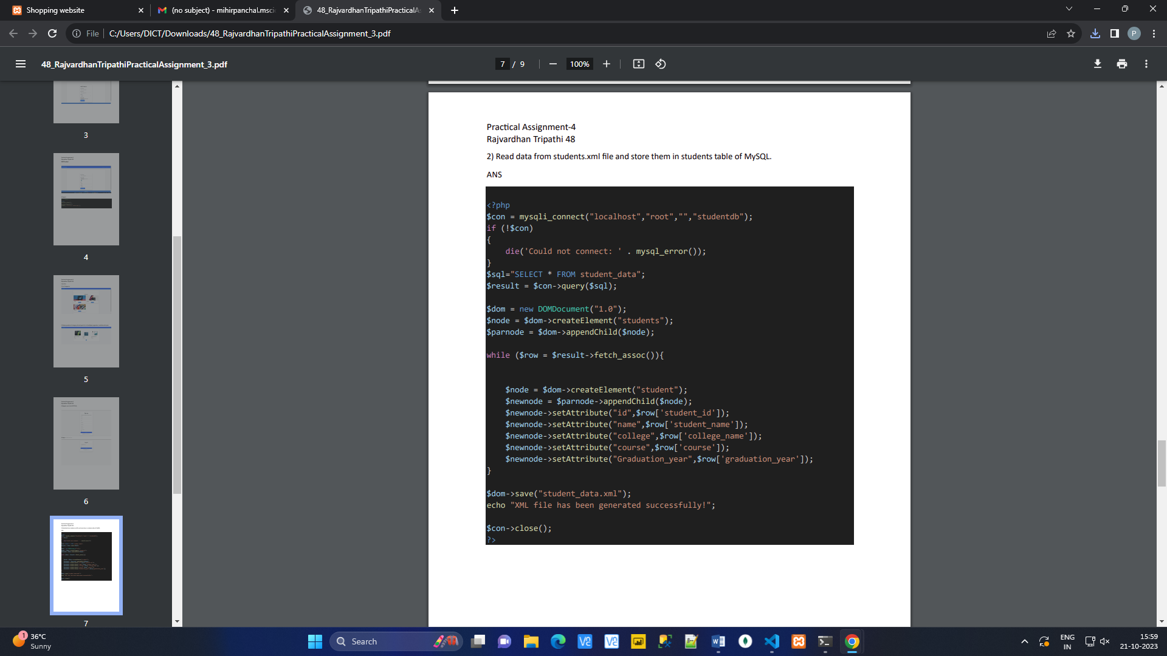

**Read data from students table of MySQL and store them in students.xml file**

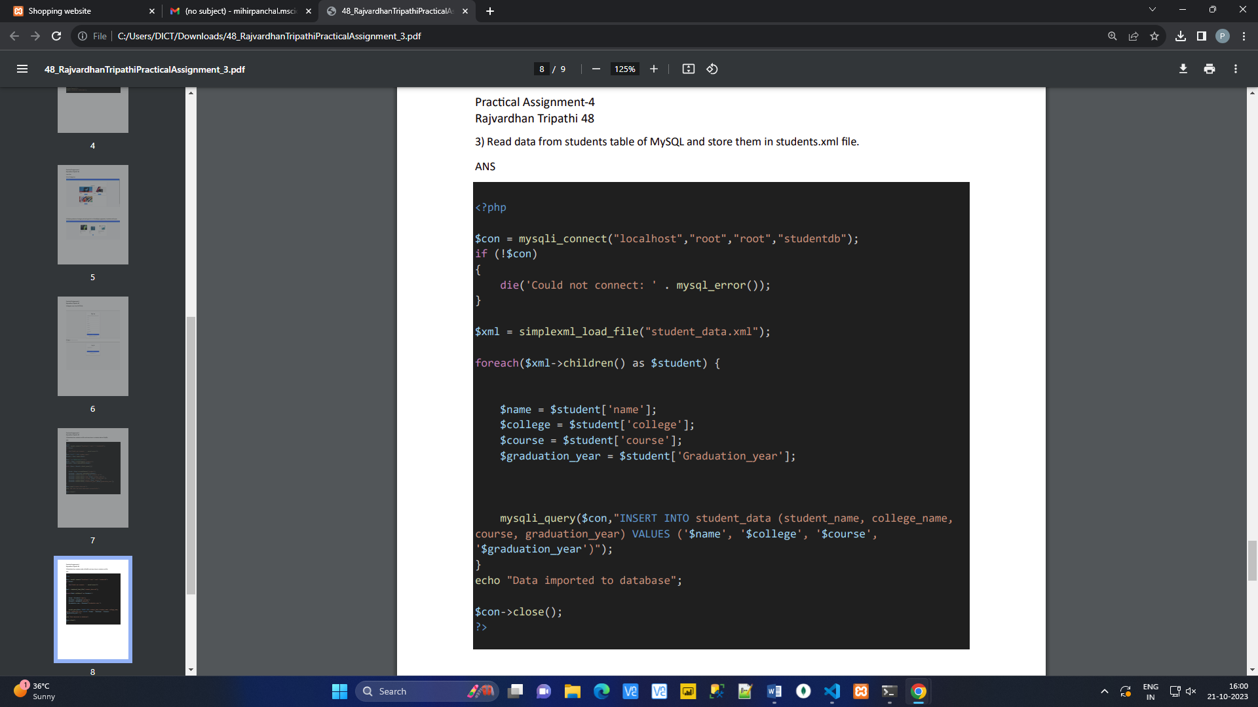

**List files in a directory.**

