Desmos Screenshots - Organized by Information Category
Reference Document for Math Equation Editor Component Library

1. Cursor & Selection States
These screenshots show how Desmos handles cursor positioning, text selection, and editing states.

Text Selection (Blue Highlight)
Shows how selected text is highlighted in blue when user drags to select part of an equation.
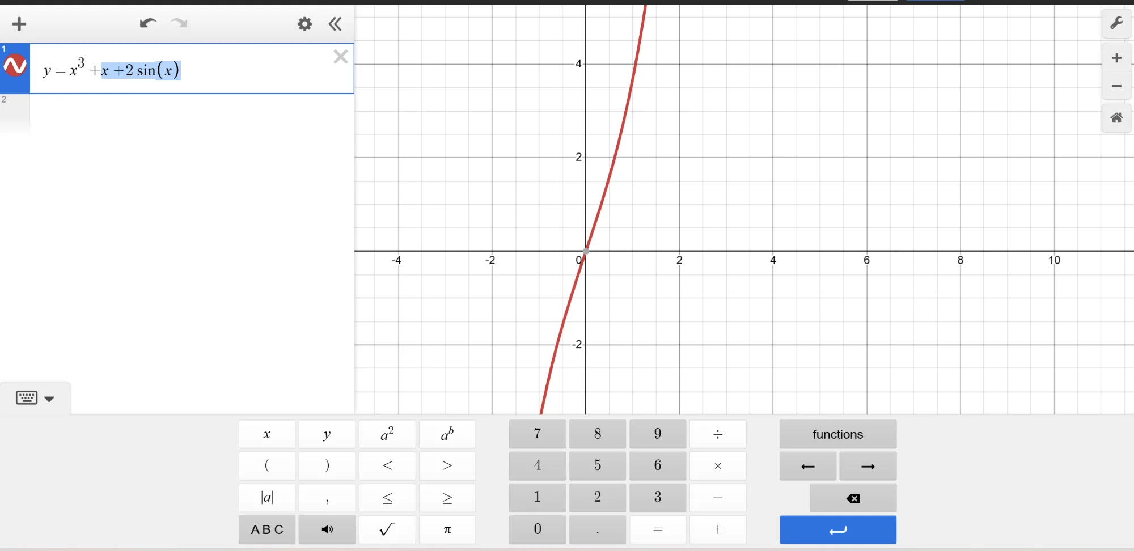

Cursor Blinking Inside Equation
Shows the blinking cursor positioned in the middle of a complex equation (y = x³ + x²ˣ + 2sin(x)).
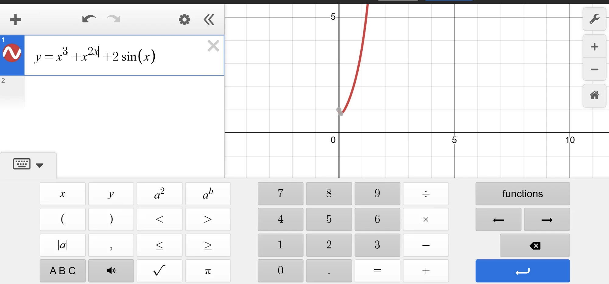

Cursor in Focused Input
Shows cursor positioned inside equation with input field focused (visible cursor line).
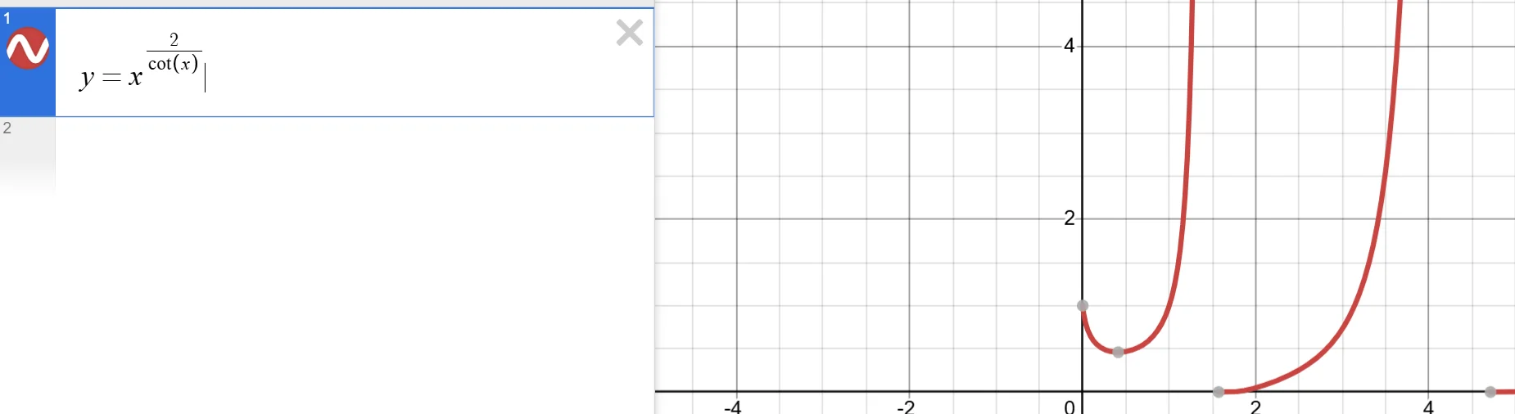

2. Function Categories Panel
Complete catalog of all 13 function categories available in Desmos functions panel.

Category: TRIG FUNCTIONS
Contains: sin, cos, tan, csc, sec, cot
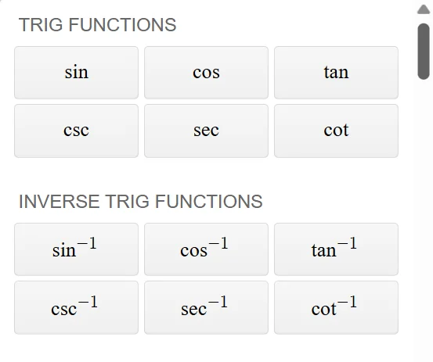

(Same screenshot shows INVERSE TRIG FUNCTIONS: sin⁻¹, cos⁻¹, tan⁻¹, csc⁻¹, sec⁻¹, cot⁻¹)

Category: STATISTICS
Contains: mean, median, min, max, quartile, quantile, stdev, stdevp, var, varp, cov, covp, mad, corr, spearman, stats, count, total
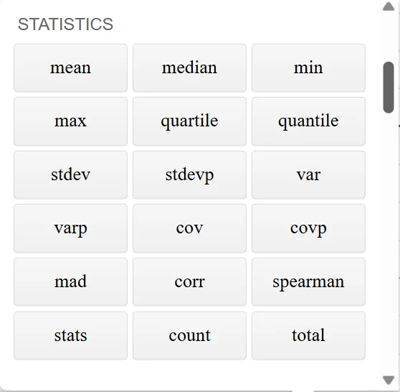

Categories: LIST OPERATIONS & VISUALIZATIONS
List Operations: repeat, join, sort, shuffle, unique, for
Visualizations: histogram, dotplot, boxplot
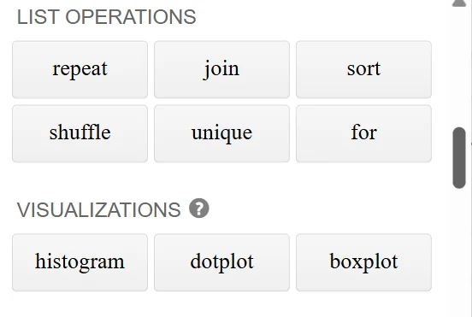

Category: PROBABILITY DISTRIBUTIONS
Contains: normaldist, tdist, chisqdist, uniformdist, binomialdist, poissondist, geodist, pdf, cdf, inversecdf, random
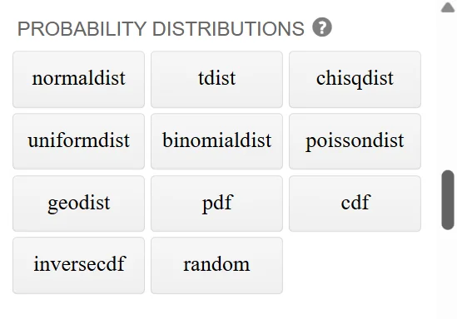

Category: INFERENCE
Contains: ztest, ttest, zproptest, chisqtest, chisqgof, null, p, pleft, pright, score, dof, stderr, conf, lower, upper, estimate
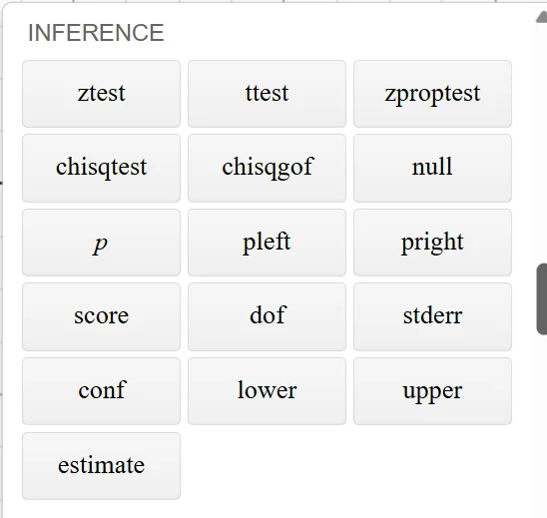

Categories: CALCULUS & HYPERBOLIC TRIG FUNCTIONS
Calculus: exp, ln, log, log_a, d/dx, f', ∫, Σ, Π
Hyperbolic Trig: sinh, cosh, tanh, csch, sech, coth
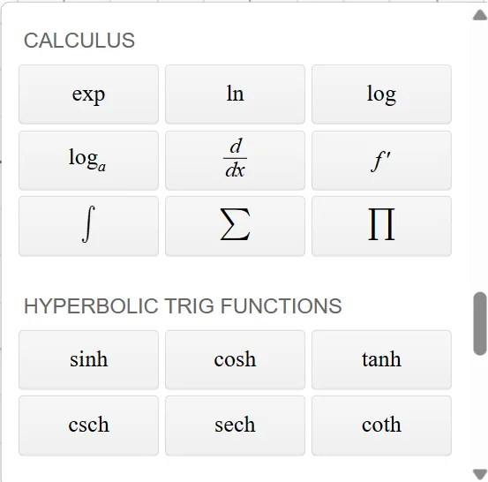

Categories: GEOMETRY, CUSTOM COLORS, SOUND
Geometry: polygon, distance, midpoint
Custom Colors: rgb, hsv, okhsv, oklab, oklch
Sound: tone
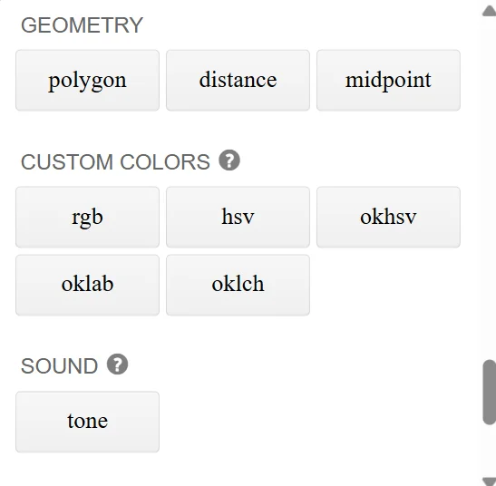

Category: NUMBER THEORY
Contains: lcm, gcd, mod, ceil, floor, round, sign, ⁿ√, nPr, nCr
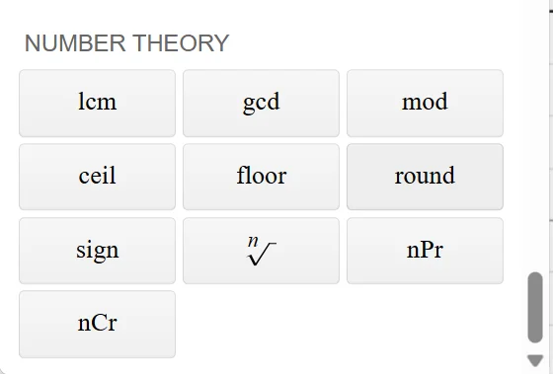

3. Edge Cases & Error States
Screenshots showing how Desmos handles incomplete LaTeX, errors, and keyboard visibility states.

Incomplete LaTeX with Error Indicator
Shows warning triangle (⚠️) and gray placeholder boxes when LaTeX is incomplete.
Example: \frac{x} (missing closing brace and denominator)
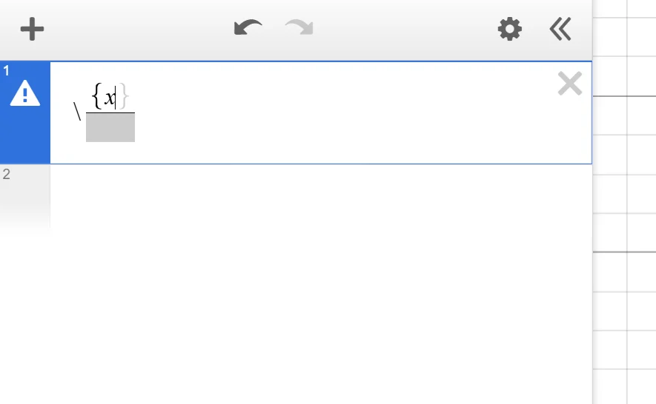

Keyboard Collapsed/Hidden State
Shows the toggle button when keyboard is hidden (only small keyboard icon visible).


4. Keyboard Modes & Layouts
Different keyboard layouts available in Desmos.

Default Keyboard Layout
Main keyboard with numbers, operators, variables, and functions button.
Layout: 4 rows with variables, numbers, operators, and special functions.
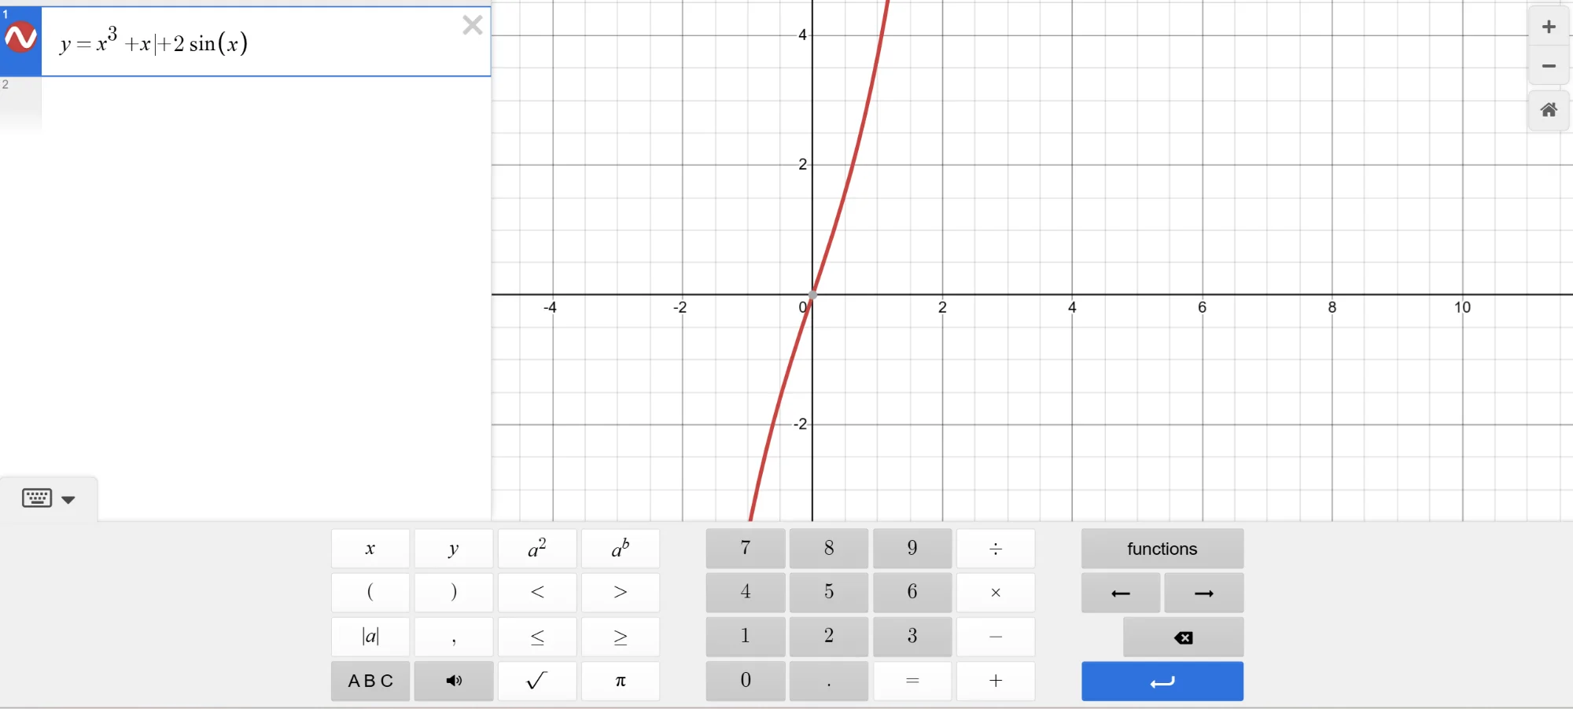

ABC Mode (Alphabet Keyboard)
Alternative layout accessed by clicking ABC button. Shows full QWERTY layout.
Includes: Letters a-z, Greek letters (θ), subscript button, special characters.
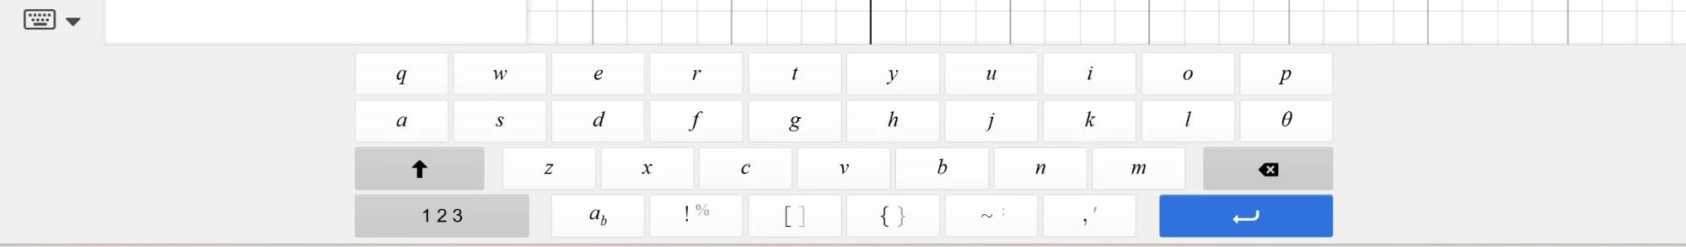

5. Input Field States
Different visual states of the math input field.

Unfocused Input Field
Equation rendered but input not active. No blue border or cursor visible.
Equation shown: y = x^(2/cot(x))
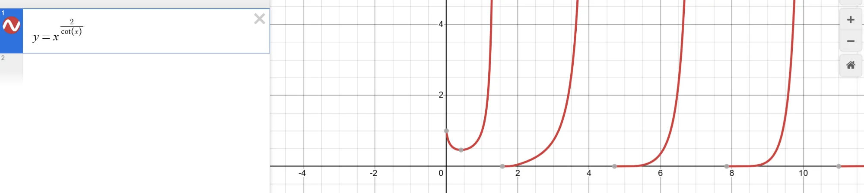

Focused Input Field
Blue left border indicates active/focused state. Cursor visible and blinking.


Multiple Input Fields on Screen
Shows how Desmos handles multiple equation inputs. Second input (y = x) is focused (blue border).
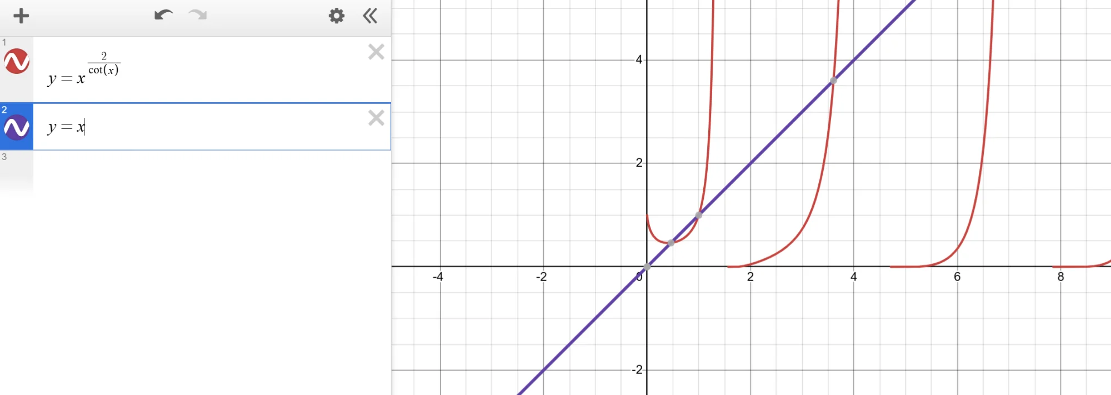

Summary & Key Observations
Key Visual Patterns Identified:
- • Blue left border (3px) indicates focused input
- • Warning triangle (⚠️) appears for incomplete/invalid LaTeX
- • Gray placeholder boxes show missing parts of equations
- • Selection uses light blue background (#C9E1FF)
- • Keyboard has exactly 4 rows in default mode
- • Functions panel has 13 distinct categories
- • ABC mode is a complete keyboard replacement
- • Number buttons have gray background (#E8E8E8)
- • Enter button is blue (#2F7DEF) and spans 2 columns

Recommended Function Categories for JEE (v1.0):
- ✅ Trig Functions (sin, cos, tan, csc, sec, cot)
- ✅ Inverse Trig Functions
- ✅ Calculus (∫, d/dx, Σ, ln, log)
- ✅ Number Theory (lcm, gcd, mod, floor, ceil)
- ⚠️ Statistics (basic only: mean, median, stdev)
- ❌ Probability, Inference, Geometry, Colors, Sound (skip for v1.0)

