**Name: Devishree Jothilingam**

**Student ID: 1193425**

**Flask Python code:**

**It reads the data from the csv file which contains the preprocessed text, keywords and topics to fetch the results based on the search**

from flask import Flask, render_template, request

import pandas as pd

import webbrowser

app = Flask(__name__)

data = pd.read_csv('ConvertedData.csv')

@app.route('/')

def home():

return render_template('home.html')

@app.route('/search', methods=['POST'])

def search():

# Get the search query from the form

query = request.form['query']

# convert topics column to string type

data['topics'] = data['topics'].astype(str)

data['keyphrases'] = data['keyphrases'].astype(str)

# Filter the DataFrame based on the query in both keyphrases and topics columns

relevant_videos = data[data['keyphrases'].apply(lambda x: query in x) | data['topics'].apply(lambda x: query in x)]

print(relevant_videos['video_url'])

# Get a list of relevant video URLs

video_urls = relevant_videos['video_url'].tolist()

print(video_urls)

# Render the search results template with the relevant video names and search query

return render_template('search_results.html', query=query, video_urls=relevant_videos['video_url'].tolist())

@app.route('/play', methods=['POST'])

def play():

# Get the selected video URL from the form

video_url = request.form['video_url']

# Open the video URL in a web browser

webbrowser.open(video_url)

# Render the video player template

return render_template('play.html', video_url=video_url)

if __name__ == '__main__':

app.run(debug=True) **Output:**

The below screenshots are the results of the dashboard.

**Running the app.py in the command prompt:**

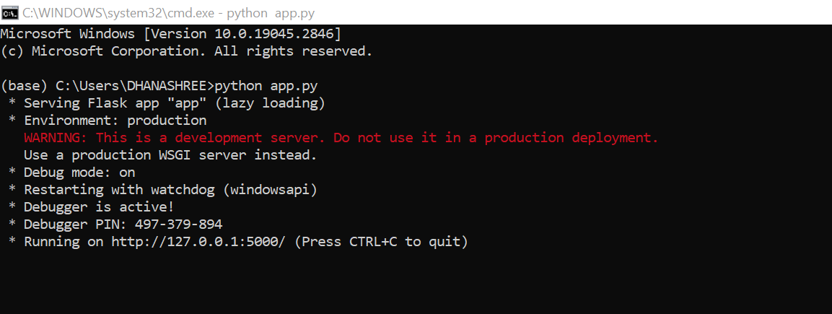

**Note:** I have already placed all the html files in the current directory, templates folder as flask by default checks for that there.

**Once the application is executed, the webpage is displayed:**

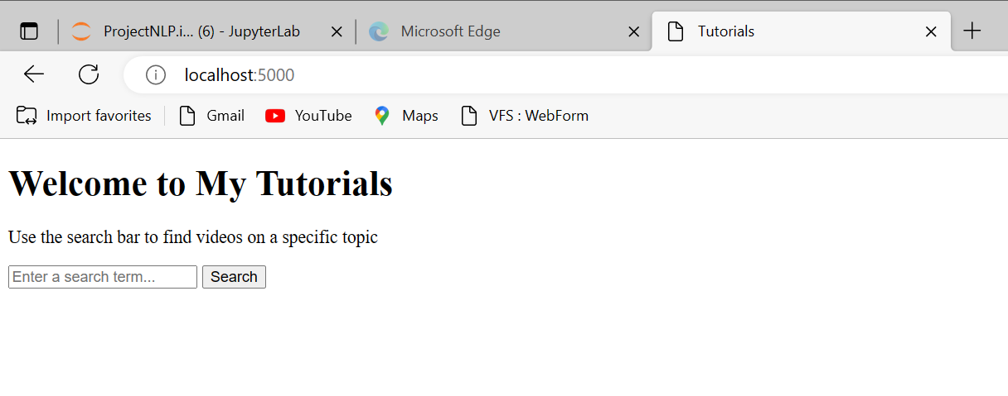

**Searching string “nlp”**

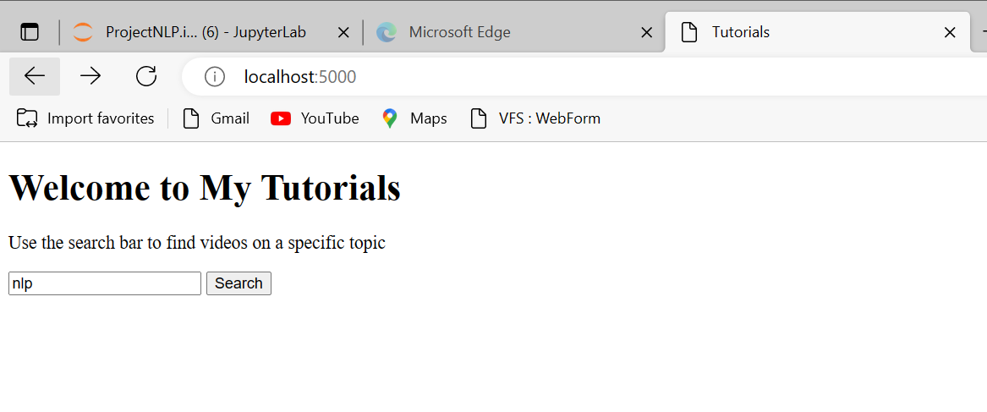

**Results are displayed, and we have the option to move to home:**

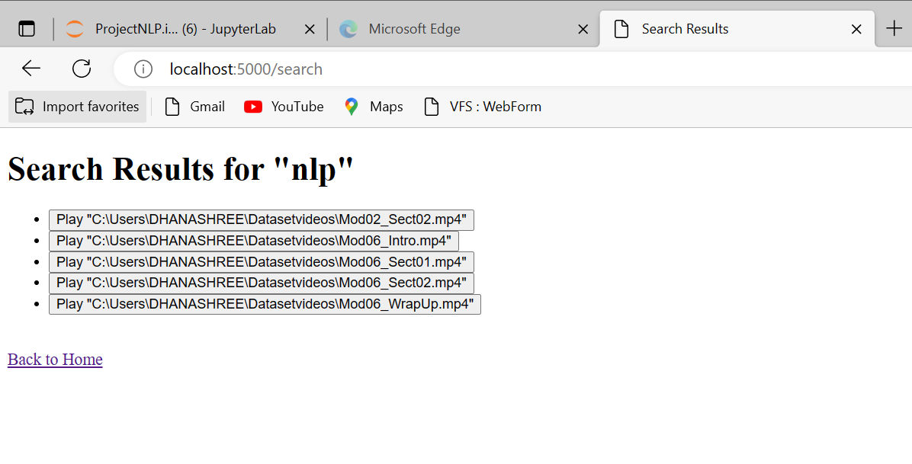

**On clicking the video links, the video plays in the web browser:**

**We also have the option to move back to the search results again.**

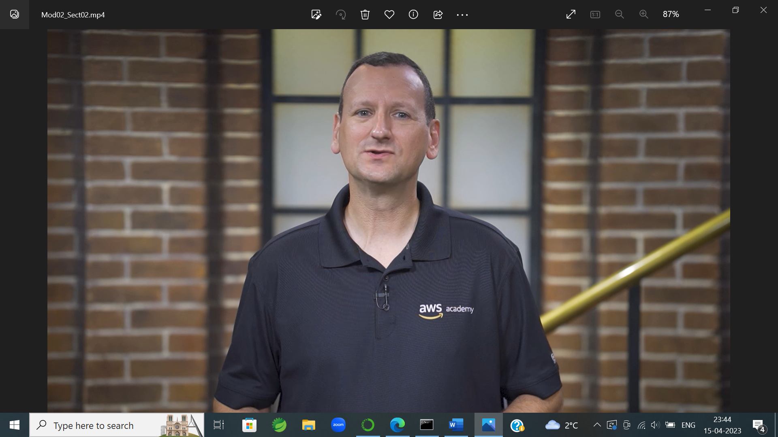

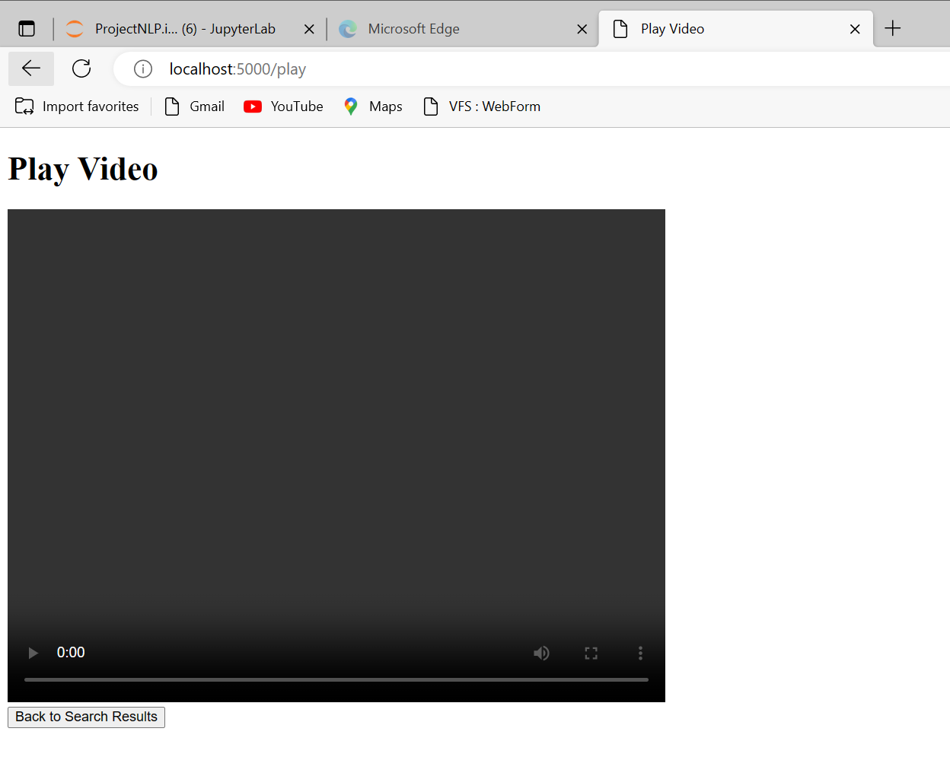

This the back to search results button above, it moves back as below

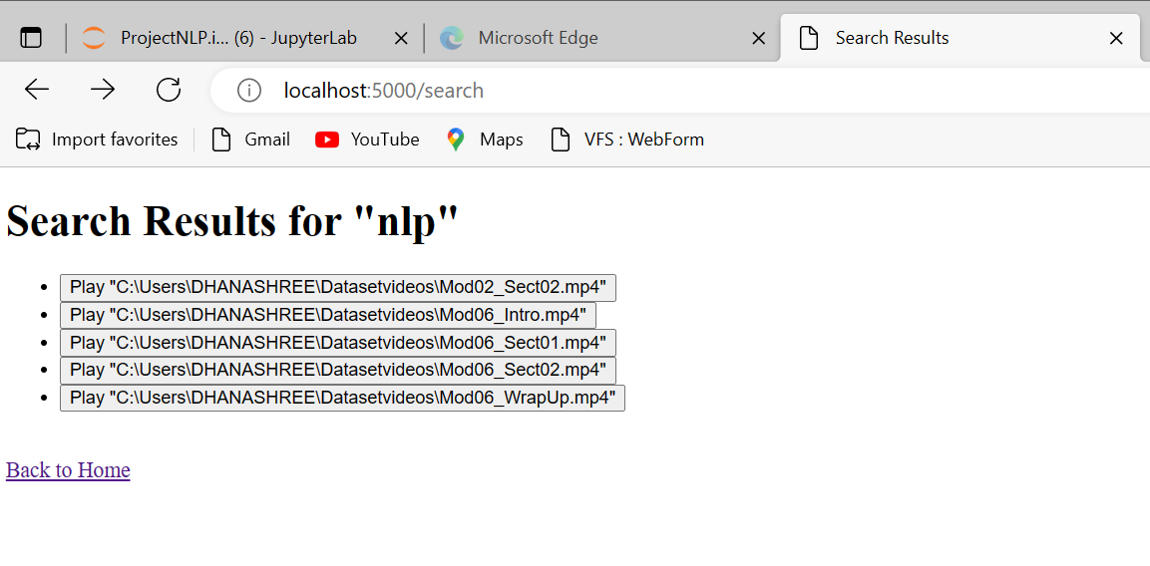

**Searching Keyword “aws” below:**

