

User Manual

Table of Contents
1. INTRODUCTION OF APPLICATION 3
2. PURPOSE 3
2.1 PURPOSE OF THE MANUAL 3
2.2 PURPOSE OF THE TOOL: 3
3. SCOPE 3
4. SYSTEM/SOFTWARE REQUIREMENTS 3
5. PREREQUISITES FOR ON-BOARDING 4
6. GETTING STARTED 4
6.1 WORK INSTRUCTIONS 4
7. AMENDMENT HISTORY 12
8. FEEDBACK/CONTACT DETAILS 12

INTRODUCTION OF APPLICATION

Dev2Ops – Development To Operations is a cost effective, DevOps based platform which is integrated with open source tools (open source tools provides cost efficiency, flexibility and security) providing continuous software delivery process.

PURPOSE

PURPOSE OF THE MANUAL

This section covers the documented purpose of tool which contains information for establishing work. It describes functions that will be provided within the application and the hardware/software requirements of the system. This will guide through each of the major functionalities within Dev2Ops.

PURPOSE OF THE TOOL:

This tool provides a DevOps solution which automates the software delivery process for any on boarded application. Dev2Ops provides a single platform for all the operations starting from check-in of code by the developer to the end testing by the respective test teams and finally deploying final tested code to production. This tool works on the functionality of Continuous Integration & Continuous Deployment where open source tools are integrated to provide continuous software delivery.
Traditional IT delivery process has development, configuration management (CM) and testing teams at different levels of SDLC to perform their respective tasks which are prone to errors and lag collaboration.
Dev2Ops tool is flexible, scalable, provides quality delivery with cost optimization and continuous feedback with graphs and reports hence better at time management.

SCOPE

The main aspect of this tool is to bring DevOps solution by bringing Development, Configuration Management and Testing Teams to same page. This provides features such as zero touch operations from build to test, Continuous and On-Demand delivery, Real Time Status and Reports, multi environment code promotion, Release/App Specific Quality Gates, Integration capabilities with different platform and applications, workflow etc.
This tool can be easily integrated with any open source functionalities, where to provide basic functionality, Jenkins is currently used for continuous integration/deployment/testing etc. Many new feature upgradations will also be implemented/ integrated as per the end user requirement and feedback.

SYSTEM/SOFTWARE REQUIREMENTS

Platform required to host this tool:
- OS - Windows 7 or above / Linux (Ubuntu, Centos etc.)
- AppServer – Apache Tomcat 7.0 and above.
- Java - JDK 1.7.
- Database – Postgres 9
- CI & CD Tool – Jenkins (and its dependencies/plugins as per application)

Client can access this tool by their host machine’s web browsers (IE 9.0 and above/Firefox).

PREREQUISITES FOR ON-BOARDING

To enable the process via Dev2Ops platform, an application is required to be configured on Jenkins. Where, Jenkins should be integrated with continuous integration builds with Maven/Ant and Tomcat.

Dev2Ops platform would require below prerequisites, for on-boarding of new application –

- Jenkins – username/password (Must be same as Dev2Ops login).
- Application/Project configured on Jenkins, with suitable jobs.
e.g.: Application “MyApp” Project may have jobs for Build/Deploy/Sanity/Test/Database etc. defined.

These jobs as configured on Jenkins would be used by Dev2Ops platform while on-boarding process.
e.g.: Job name “MyApp-1702-install” for install/deployments.
- Environment name as configured on Jenkins e.g.: “MyApp_IT1” for IT/TEST environment.
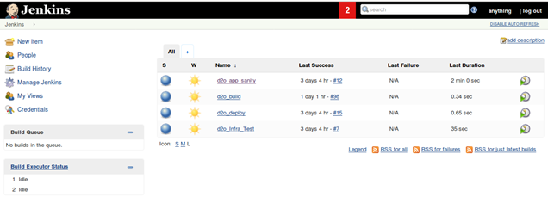
Jenkins jobs

GETTING STARTED

This application being a web based tool and is accessible from Mozilla Firefox & Internet Explorer 8.0 or above. A user should have a role based access on the same. New users can be created upon request by the administrator.

WORK INSTRUCTIONS

- Login Page:
Once access to the tool is provided, user can login with the Dev2Ops credentials.
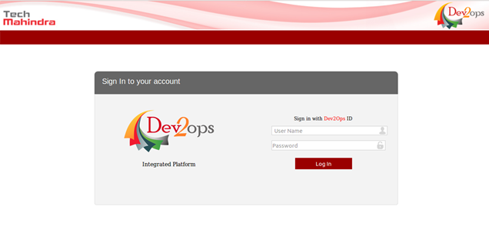
Dev2Ops login page

- On Boarding:

By following below mentioned steps in sequence, any new application can be easily on-boarded on Dev2Ops Tool.
- Application Management: This page is to add any new application on Dev2Ops
- Component Management: An application may have further sub division into components, which can be linked and any new component can be added to existing application.
- Configuration Management: The details of tools for repository management/build and deployment which may be Subversion/Jenkins respectively are provided in this page for particular component under application.
- Release Management: An application/component may have different code releases, where based on requirement any new release can be added/managed to a particular component under this page.
- Environment Management: Different level of environment based suitable to component is added/managed by this page.
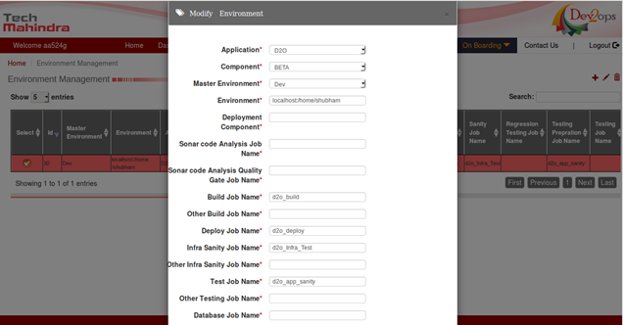
Environment Management page

- Home Page:
Provides real time analysis and monitoring of tasks.

- Overall processed on-demand tasks based on application release can be viewed, where the percentage of success/failure/in-progress can be analyzed.
- Scheduler based tasks, which may be tasks that’s are processed or are upcoming, can be viewed in calendar form with ease and clarity.
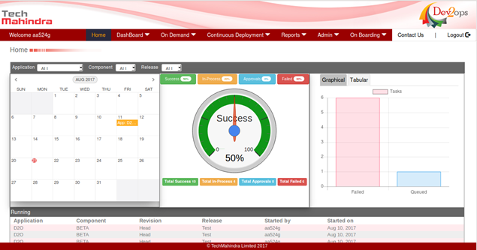
Dev2Ops home page

- On Demand:

- Create/Modify Task: On demand – Unscheduled requirement of code deployment and testing. Software Engineer (Dev/Test/CM) request for deployment on various environments using Task Management. Designated authority to review and approve the task for deployment or reject the same. Dev2Ops will initiate validation of code with its code coverage and Junit Test Success and based on defined parameters the deployment will execute on various environments.
A user can add/modify/delete an existing task before it is submitted for approval. As per the requirement, deployment can have build/deploy/sanity/test tasks on it.

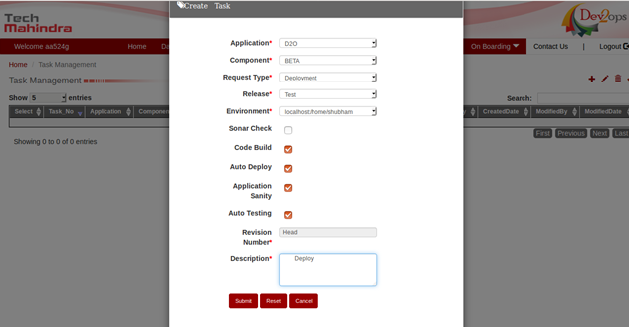
Create/Modify Task

- Task Approval: A role based page that can only be accessed by the users with specific roles of Task approval such as environment owners. This limitation act as a filter so that only the designated user can approve the selected task for deployment on the environment.

- Approve: As soon as the task is selected and this button is clicked, the task moves to task status page and deployment starts immediately.
- Reject: The selected ticket closes automatically without deployment.

- Task Status: This page is used to track the current status for ongoing deployment request by selecting the task. This page has an auto refresh feature and status of task get refreshed automatically and is shown using a progressive chart.
The various stages for the process includes:
    - Code Commit: The code has been committed by dev in repository.
    - Continuous Integration: Checking Jenkins for any module related error and proceeds if all modules dependent and/or independent module are good for that application.
    - Sonar Status: Checks for the defined code coverage % and JUnit pass % and proceeds only if the same for code is equal to or higher than the defined values.
    - Code Build: This shows that the code is being compiled as a whole and build is in progress.
    - Build Provisioning: This shows the code is being copied from build server to the environment.
    - Auto Deploy: Code deployment is in progress for that environment.
    - Infra Sanity: Basic sanity to check if sever and ear status ones the code is deployed.
    - Testing: Application sanity/functional testing performed via Jenkins itself. This is the last phase and task completes on particular environment.

- These progressive bars comes in a three different color codes which are
    - Green: Complete
    - Yellow: In-Progress
    - Red: Error
    - Grey: Not Available

At any point if any status becomes red, the task fails and ticket does not moves further. That task can be selected and assigned to CM Queue where it can be looked upon and closed by CM Team.

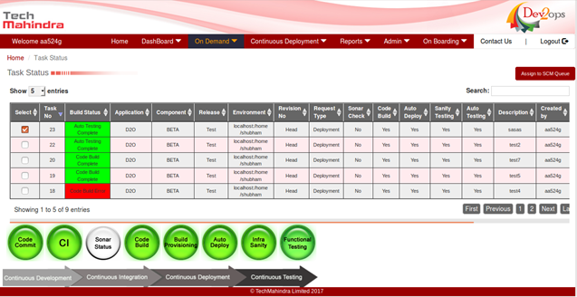
Task Status Page

- Task History: All the completed tasks can be tracked at this page with step by step status. Clicking on Task Status number for particular task shows a table wise step to step detail for that particular task.

- CM Queue: All the unprocessed/failed tasks can be moved from Task Status page to this page for manual processing by CM Team.

- Q Gate Approval: All the task from On Demand request once completed successfully are automatically moved to this page for further code promotion to next environment. Set Environment button is used for the same through which primary and secondary environment can be selected.
Once the environment is set and task is submitted, it goes in pending approval and can be tracked from Task Approval page. Once approved by owner the deployment process starts and can be tracked from Task Status page.

- Admin:

- Scheduler Management: This page is used to create tasks that are used for Agile or Waterfall development process with periodic code delivery for deployment and testing. The tasks created here once executed can be viewed for progress under scheduler tasks page.
Scheduler based auto deployment has two types of scheduler execution - Daily or One-Time. Once the date and time is selected, the task is auto approved and gets deployed on that date and time.
ZTO (Zero Touch Operation) from code deployment to functional (IT/ST/UAT) testing including auto code promotion to next environment. The code is promoted on success of Quality Gate Criteria.
Authorized user can create new task, modify an existing task for Continuous/Scheduled deployment. Tasks under Daily Deployment comes with end date and hence ones that date reaches, auto deployment stops automatically.
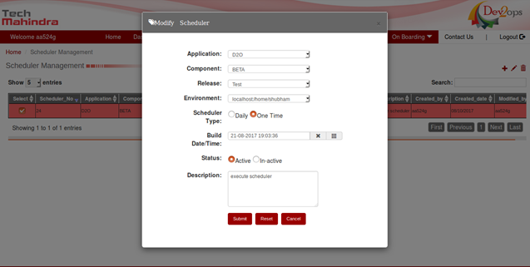 Create/Modify Scheduler Task

- Role Management: All the roles can be added and existing roles can be modified using this page based on requirement. Various permissions can be provided to roles with this functionality.

- User Management: Access of tool for all the new users are provided from this functionality. A new user can be added or existing user credentials can be modified based on requirement.

- Quality Gate Management: Used for automated decision making by setting the pre-defined quality criteria for particular application and release.
The code can be automatically promoted to next environment, as per the quality gate.

- Continuous Deployment:

- Scheduler Task Status: This page is used to track all the scheduled builds defined under Scheduler Management and once the task is completed on first environment, it will then automatically promote the code to next environment as per values of next environment. The next environment can be defined in Quality Gate Management page. This is the page where deployments and code promotion are done without and manual intervention and without taking any approvals before the deployment process can start. This is designed for daily frequency builds in particular maintenance window with ZTO (Zero Touch Operation).
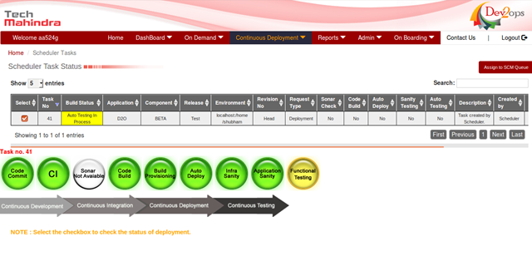
Scheduler Task Status Page

- Dashboard:

- Dev2Ops Dashboard: Contains application and release specific graphs for Task Failure Reason, Status Report, and On-Demand & Scheduler Report.

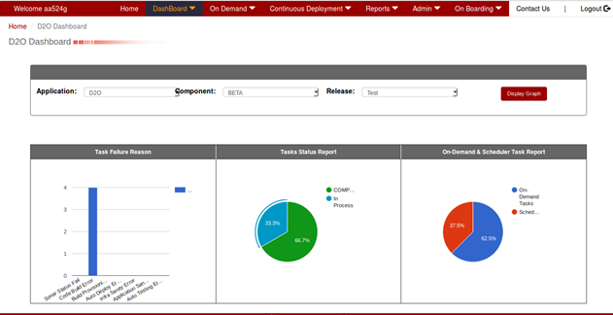
Dev2Ops DashBoard

- Reports:
The deployment report can be viewed or downloaded for data analysis/monitoring of deployments for suitable component and its release.
Also provides graphical/tabular view of environment wise percentage of successful/failed tasks upon selection of component/release for desired period.

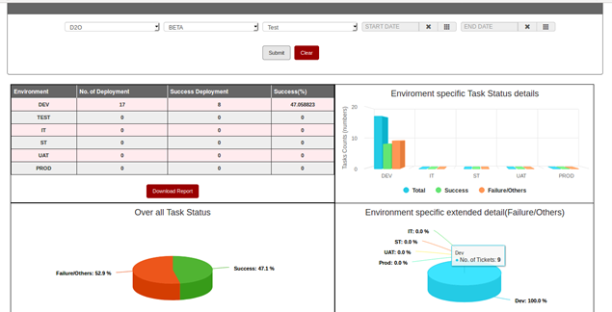
Deployment Reports page

Email Notifications: Emails during the complete flow for Task creation, approved, failed, status change and completed are sent to specified users to notify them with the process going for that particular Task.

FEEDBACK/CONTACT DETAILS

S. No | Name | Email Id
1 | Sanjay Varshaney | svarshaney@TechMahindra.com
3 | Dev2Ops | Dev2Ops@TechMahindra.com

