# **Analysis of Clothing sales trends for revenue maximization and inventory optimization**

**A Mid Term Submission Report for the BDM Capstone Project**

***Submitted by,***

**Name : Debanjan Sahoo**

**Roll number : 23F2000223**



**IITM Online BS Degree Program**

**Indian Institute of Technology, Madras, Chennai**

**Tamil Nadu ,India, 600036**

**Contents**

| **Type** | **Page Number** | **Link to content** |
| --- | --- | --- |
| Executive Summary | 3 | Executive Summary |
| Proof of Originality of Data | 4 | Letter from Organization |
| Image Related to Organization | 4-5 | Image Related to Organization |
| Recorded Video with owner of the Organization | 6 | Recorded Video with owner of the Organization |
| Metadata | 6 | Metadata |
| Descriptive Statistics | 7 | Descriptive Statistics |
| Detailed Explanation of Analysis Process/Method | 8 | Detailed Explanation of Analysis Process/Method |
| Results and Findings | 10 | Results and Findings |

### 

### **Executive Summary**

This proposal outlines a plan to address the business challenges of Karunamoyee Bastralaya, a medium-sized clothing store, is currently encountering challenges in terms of profit and inventory management which is having an indirect impact on the store's net profit and sales in Jhargram District, West Bengal, India. The project aims to understand their current problems and facilitate growth. Data collection began on January 2nd, gathering information from stakeholders and compiling relevant data from January 2nd to January 7th. This involved organizing Excel files containing clothing data and sales data by year. Additionally, profit details were requested to address incomplete purchase data. Also the emergence of online purchasing has brought about significant changes in the modern world, but it has also posed challenges for local stores like Karunamoyee Bastralaya, leading to a decline in their profits. This project is dedicated to addressing the unique business challenges faced by clothing shop. Our main objective is to understand the complexities of managing cash flow and controlling inventory.Through data analysis, we aim to provide practical solutions to overcome these issues and improve the store's overall performance.

**Aim of the Project :**

* To find Which SKU (or goods) contributes more to the net profit and is suitable for continuing in longer run sales.
* To find Which SKU has higher profit margin.
* To examine Pareto Principle for SKUs.
* To examine and determine the revenue and purchase price trend in the market.

### **Proof of Originality of Data :**

*Letter from Organization*

**Image related to Organization :****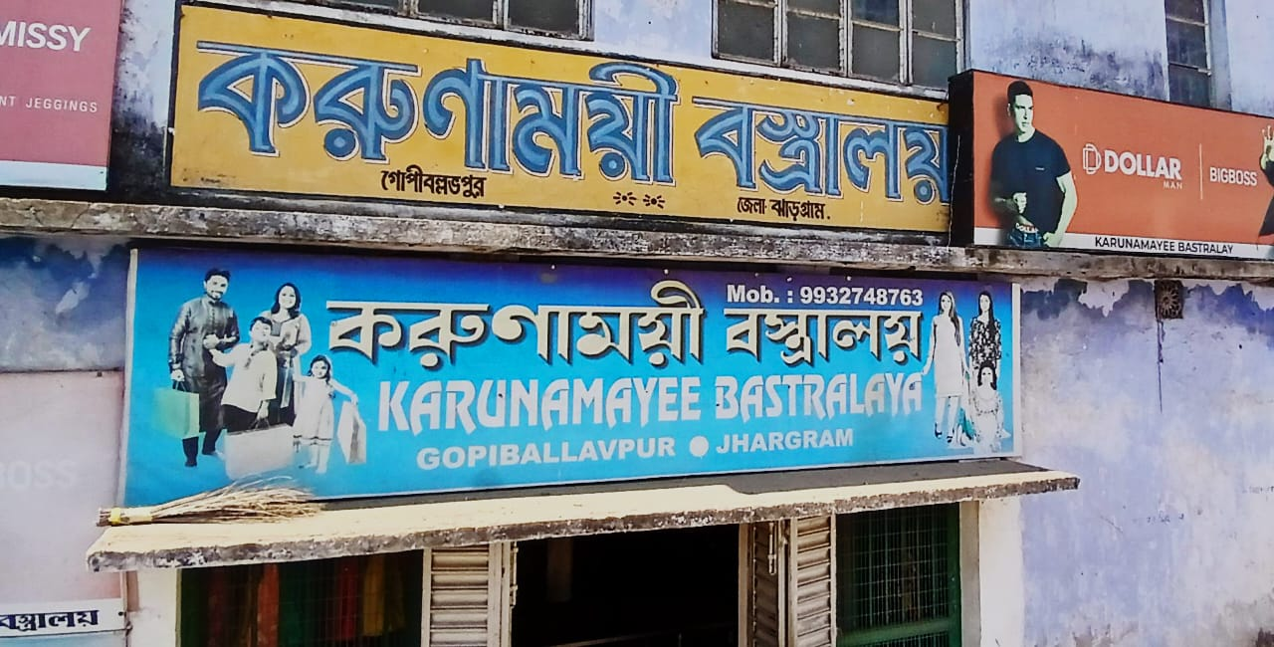**

**Photo for reference of name and location**

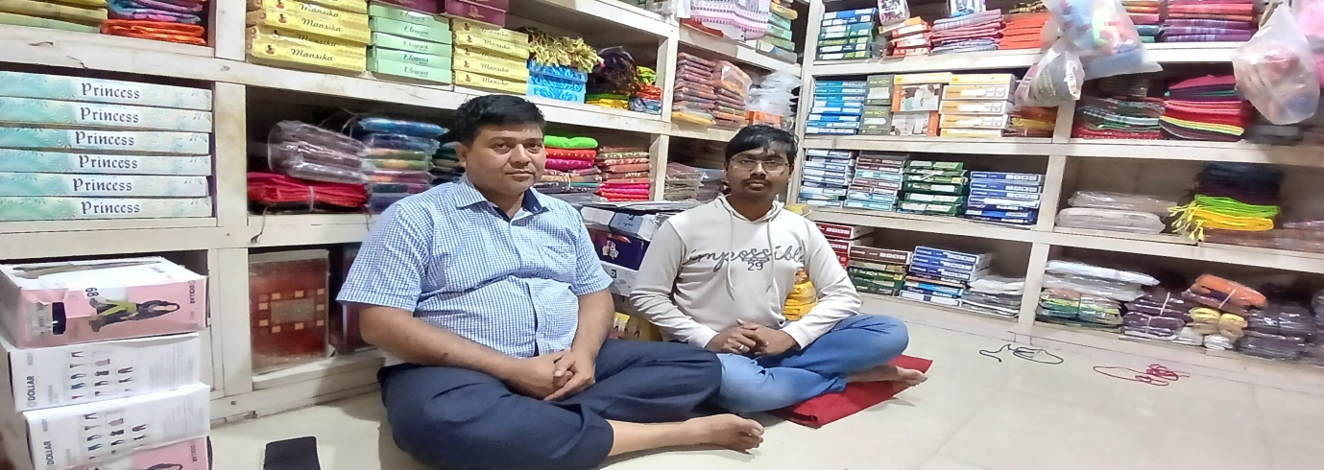

**Photo with Shop Owner**

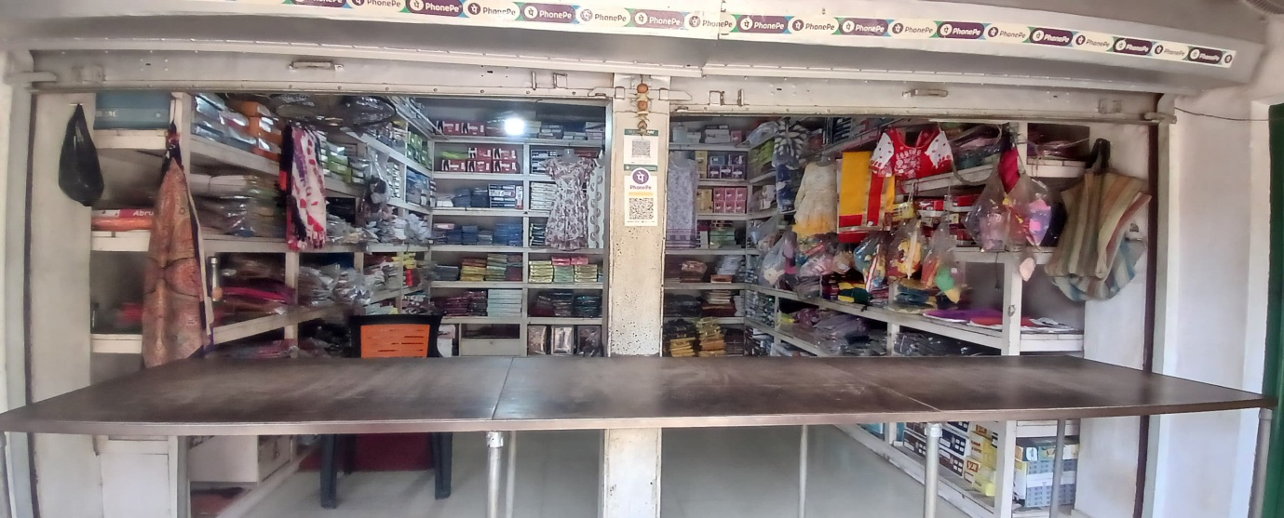

**Main Shop Area**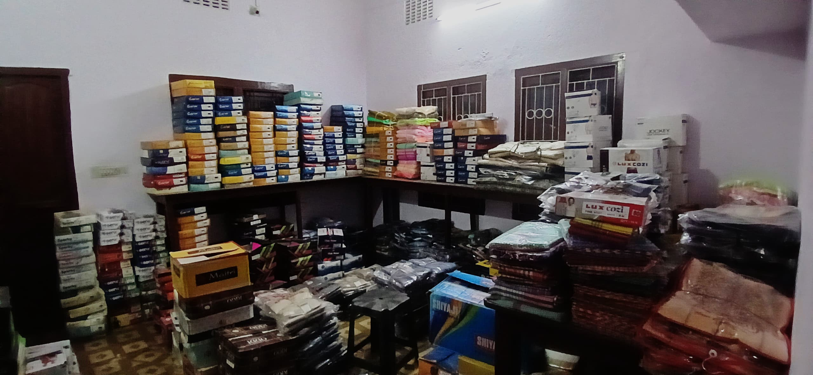

**Shop storage area**

### **Recorded video with owner of the Organization :**

**Link to the Conversational Video :** [**BDM Project Recording**](https://drive.google.com/file/d/1FNLEeFiVsInD2EhTZkgC9gDhRl1OD1fx/view?usp=drive_link)

**Primary Data Survey Link :** [**Primary Link**](https://docs.google.com/spreadsheets/d/1BjotQnjM9vUJBZg1WtJSm9jeSPQvn-qqAKBy8QCO044/edit?usp=drive_link)

### **Metadata :**

Information about the data, including the meaning and context of each variable.

* **Data Source :** This data was provided by a clothing shop named “KARUNAMOYEE BASTRALAYA”, the shop is in the Jhargram District, West Bengal.
* **Data Collection Date :** The data was collected approximately one week from 6th January to 14th January in 2025.
* **Data Collection Method :** The data was collected thoroughly from both offline and online mode. Organization shared their sales data through google drive.
* **Data format :** The data is in a tabular format. Shared raw data was in excel format. Year wise data present in different excel sheets. After transformation and preprocessing of the raw data created a well structured data format.
* **Data fields :**  Total 18 data fields(columns) after transformation of raw data. The data fields are -
* **Bill Number:** Unique identifier for each transaction.
* **Date:** Date of the transaction.
* **Year:** Year of the transaction.
* **Month:** Month of the transaction.
* **Customer Code:** Code assigned to each customer.
* **Customer Name:** Name of the customer.
* **Customer Address:** Address of the customer.
* **Item Code:** Code assigned to each item sold.
* **Product Type :** Type to which the product belongs. Here is few product types i.e. Saree,Kurti,Leggings,Shirt,T-shirt,Half Pant, Full Pant,Dhoti,Polo-T-Shirt,Jacket etc.
* **Brand:** Brand of the product (e.g.Minu,Dollar,Oswal).
* **Cost Price:** Cost price of the product.
* **Selling Price:** Selling price of the product.
* **CG percentage:** Percentage of CG (Cost of Goods) in relation to the Selling Price.
* **CGST Amount:** Amount of Central Goods and Services Tax (CGST) applied.
* **SG percentage:** Percentage of SG (Selling Goods) in relation to the Selling Price.
* **SGST Amount:** Amount of State Goods and Services Tax (SGST) applied.
* **Total Amount:** Total amount including taxes.
* **Profit:** Profit earned from the transaction.
* **Data Quality :** The data is of good quality, with no obvious errors or inconsistencies. There were some missing values and some unnecessary columns in the raw data.
* **Data usage :** This data provides detailed information about each transaction, including the different design, different category products sold, their prices, taxes applied, and profits generated.

**Here is 1st 30 rows of transformed data sample :**

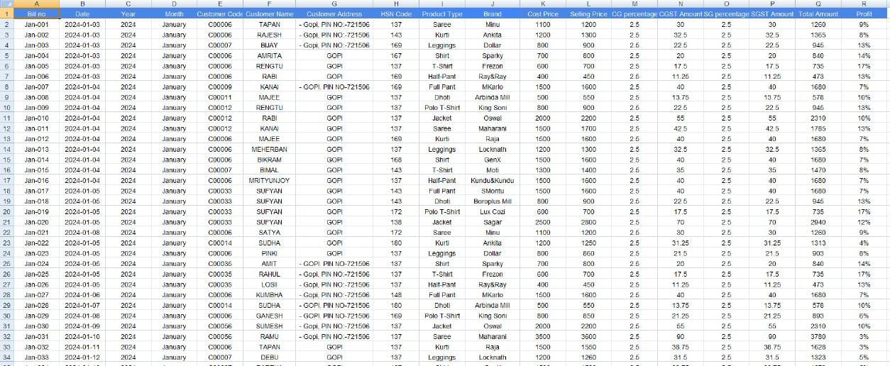**Descriptive Statistics :**

Descriptive statistics encompass concise numerical summaries that capture key characteristics of a provided dataset., whether it represents an entire population or a sample thereof. These statistics can be categorized into indicators of the data’s central tendencies and indicators of its dispersion.

#### **itemse.jpgHighest selling product varied across different years:**

* Saree : 186 sets sold in 2022.
* Kurti : 205 sets sold in 2023.
* Shirt : 300 sets sold in 2024.
* Dhoti : 374 sets sold in 2024.
* Maximum profit was attained in 2024.

#### **Top Performance Analysis in last year (2024):**

* October witnessed the highest sales.
* Top 2 selling clothing categories: Shirt,Dhoti.

#### **Profit Analysis: Month Vs Item Sell**

* Highest profit month on average (2021 to 2024): October.
* In 2021, October, November, and December had approximately similar profits.
* In 2022, 2023 and 2024 October had the highest profit.

#### **Product Analysis:**

* Suman Saree was the top-selling product across all years.
* The most profitable product category overall was Suman Saree. However, in 2024, the most profitable product was GenX Shirt.

#### **Price and Tax Analysis**:

* On average, Shirt was the highest selling clothing group across all years.
* Suman Saree had the highest tax in 2021 and 2022, whereas GenX Shirt had the highest tax in 2023 and 2024.

#### **Performance Metrics:**

* The top three performing months across all years were September, October, and November.
* The top two performing product groups were Saree and Shirt.

Indicators of central tendencies involve metrics such as the mean, median, and mode, while indicators of dispersion encompass measures like standard deviation, variance, the range of values between the minimum and maximum, kurtosis, and skewness.

**Profit over one year of the shop:**

*The descriptive statistics for the Profit the shop are as follows:*

**Count:** Count is count of observations, each observation represents item sell of that month. **Mean:** The mean sell, calculated as average of all selling values, is 192.8333333 per month.

**Standard deviation:** The Standard Deviation, a measure of the dispersion of selling value around the mean is 69.7447728.

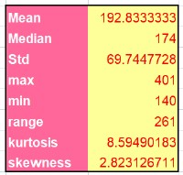**Min:** The minimum value of the sell is 140. This represents the lowest sell by the shop in a single month during the twelve month period.

**Median:** The median sell, representing the middle value of the distribution when sorted in ascending order, 174.

**Max:** The maximum value of the sell is 401. This represents the highest sell by the shop in a single month during the twelve month period.

**Range:** The range of the sell 261 is calculated by subtracting the minimum sell from the maximum sell, indicating the spread or variability of sell across the twelve month.

**Kurtosis:** The kurtosis value is approximately 8.59490183. Kurtosis measures the peakedness or flatness of the distribution of data.

**Skewness:** Skewness measures the asymmetry of the distribution. A skewness value of 2.823126711 indicates a slightly positive skew, meaning that the distribution has a long right tail.

### **Detailed Explanation of Analysis Process/Method :**

I collected 1 year worth of data in Google Sheets, which was then cleaned, organized, and analyzed. Raw data is entered into the spreadsheet, preprocessed for accuracy, and formatted for clarity. Certain columns are derived or removed as needed.

#### **Data Collection and Preprocessing:**

The analysis primarily relies on Google Spreadsheet and Google Collab. Raw data is entered into the spreadsheet, preprocessed for accuracy, and formatted for clarity. Certain columns are derived or removed as needed. The focus is on maximizing profit and revenue for the Karunamoyee Bastralaya.

#### **Data Modification:**

* Modified certain columns as required.
* Checked for missing values in the master DataFrame.
* Filled missing values with appropriate data.
* Handled datetime columns for consistency.

**Sales Table for Identifying Top-Performing Items:**

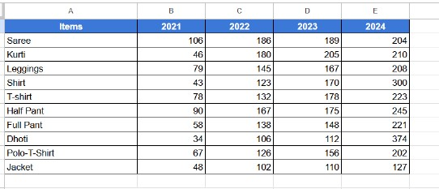The dales table is a crucial tool designed to pinpoint products with higher sales figures, providing valuable insights into the performance of various items within the store’s inventory.

#### **Profit Calculation:**

* Since there was no profit column, consulted Mr. Soumendu about product group-wise profit.
* Performed back calculation using selling and profit values.
* Added a new column for purchased value based on calculations.

#### **Dashboard Creation:**

* Overview Dashboard: Provides an overall trend of the data over time.
* Sales Dashboard: Visualizes sales performance metrics.
* Product Dashboard: Analyzes product-related data.
* Customer Dashboard: Focuses on customer-related insights.
* Tax and Prices Dashboard: Explores tax and price trends.
* Top Performance Dashboard: Highlights top-performing aspects of the data.

**Profit Table:**

The creation of Gross Profit and Cumulative Profit tables provides valuable insights into the profitability of individual products within the store’s inventory.

**Benefits:**

● **Profit Margin Analysis:** The table provides a holistic view of profit margins for each product, aiding in the identification of high-margin items. This facilitates strategic decisions on pricing and cost management.

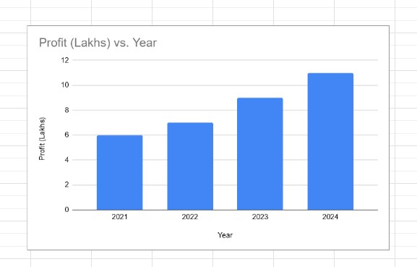● **Profit Maximization**: Focusing on high-margin products allows the business to optimize profitability through pricing adjustments, cost optimization, and targeted promotions, ultimately maximizing overall profit.

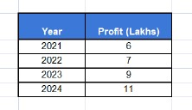

*Through the use of these tables, the business gains a deeper understanding of its profit landscape, empowering it to make data-driven decisions that enhance profitability and support long-term growth objectives.*

### **Results and Findings (Visual Representation) :**

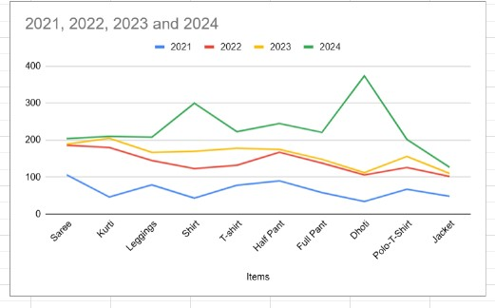

*Line Chart of Selling Items in Each Year*

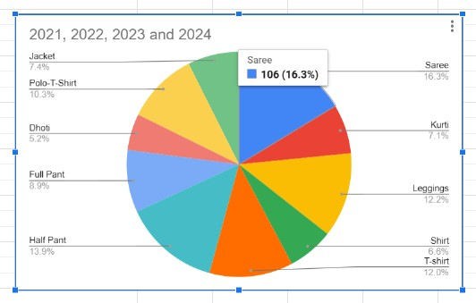

*Pie Chart of Selling Items in Each Year*

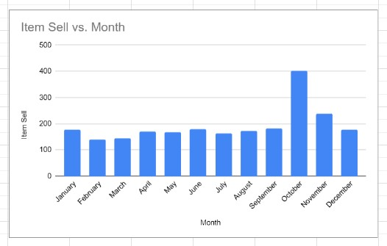

*Bar Chart of Item Sell in Each Month*

By seeing data dashboards we can take below decisions as a result :

* Focus on promoting Saree and Shirt, as they consistently emerged as top-selling products across different years.
* Suman Saree is the top-selling clothing under the Saree product type.
* Capitalize on the profitability trends observed in specific months. For instance, prioritize marketing efforts and promotions during October and November, as they historically yielded the highest profits.
* Implement targeted sales tactics to increase profits further during the identified peak months.
* Explore opportunities to optimize pricing structures without compromising profitability, especially for products with fluctuating tax rates like Saree and Shirt.

*By leveraging these insights and implementing data-driven forecasting strategies, the clothing shop can enhance performance, achieve sales targets, optimize pricing and taxation, and enhance customer engagement for sustained growth and success.*