# **Analysis of clothing sales trends for revenue maximization and inventory optimization**

**A Final Submission Report for the BDM Capstone Project**

***Submitted by,***

**Name : Debanjan Sahoo**

**Roll number : 23F2000223**



**IITM Online BS Degree Program**

**Indian Institute of Technology, Madras, Chennai**

**Tamil Nadu ,India, 600036**

### **Contents**

| **Type** | **Page Number** | **Link to content** |
| --- | --- | --- |
| Executive Summary | 3 | [Executive Summary](#_3znysh7) |
| Detailed Explanation of Analysis Process/Method | 3 | [Detailed Explanation of Analysis Process/Method](#_n2xqrpcufitw) |
| Results and Findings | 7 | [Results and Findings](#_umh9glvu6hif) |
| Interpretation of Results and Recommendations | 16 | [Interpretation of Results and Recommendations](#_bdqhf5abvfv) |
| Conclusion | 18 | [Conclusion](#Con) |

### 

### 

### 

### **Executive Summary**

This final report outlines a plan to address the business challenges of Karunamoyee Bastralaya, a medium-sized clothing store, is currently encountering challenges in terms of profit and inventory management which is having an indirect impact on the store's net profit and sales in Jhargram District, West Bengal, India. The project aims to understand their current problems and facilitate growth. Data collection began on January 2nd, gathering information from stakeholders and compiling relevant data from January 2nd to January 7th.Additionally, profit details were requested to address incomplete purchase data. Data was then cleaned and transformed using Python, ensuring accuracy. Identifying the gaps and areas of improvement in the current strategy will be a critical aspect of this project. The report will also include in depth analysis of the sales data to identify patterns and trends in the sales. This analysis will allow us to identify the best and worst performing SKUs, enabling us to understand and formulate marketing strategies to improve net sales leading to an increase in net profit. After a thorough analysis, the project report will focus on recommendations to combat the problem areas identified above.

To effectively analyze the sales data and make informed business decisions, I will be utilizing various Excel tools such as pivot tables, bar graphs, and line graphs etc. that can provide valuable graphical representations. These tools enable a visual representation of the sales data, making it easier to identify trends, patterns, and key insights. By analyzing the outperforming and underperforming products using these Excel tools, recommendation, marketing strategy and data-driven decisions to optimize revenue generation can be formulated.

### **Detailed Explanation of Analysis Process/Method :**

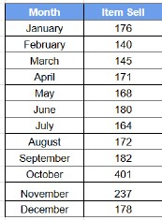The analysis process involved a systematic approach to examining sales and inventory data, leveraging various analytical techniques to derive meaningful insights and inform strategic decision-making for the Karunamoyee Bastralaya. I collected 1 year worth of data in Google Sheets, which was then cleaned, organized, and analyzed. Raw data is entered into the spreadsheet, preprocessed for accuracy, and formatted for clarity.

#### **Data Collection and Preprocessing:**

The analysis primarily relies on Google Spreadsheet and Google Collab. Raw data is entered into the spreadsheet, preprocessed for accuracy, and formatted for clarity. Certain columns are derived or removed as needed. The focus is on maximizing profit and revenue for the Karunamoyee Bastralaya.

* 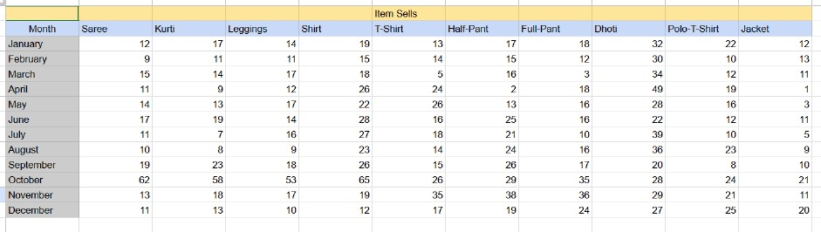The pre-processed sales data have a total of 10 columns represent each SKUs sales quantity along with the month.

**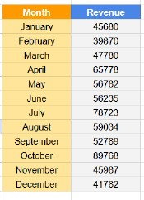**

* Using sales and selling price revenue for the month, average sales , selling price and total revenue can be calculated by formula :

***Revenue = Selling price \* Sale***

***Total Revenue = Summation of all Revenue***

* Similarly purchase data has been collected for every SKUs which consists of purchase quantity and purchase price , using which expenditure is calculated on each SKU.

**Sales Table for Identifying Top-Performing Items:**

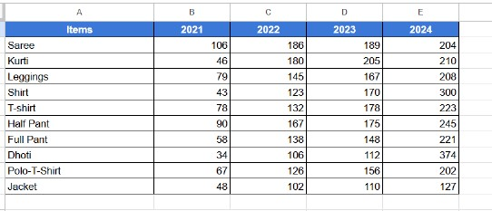The dales table is a crucial tool designed to pinpoint products with higher sales figures, providing valuable insights into the performance of various items within the store’s inventory.

#### 

#### **Profit Calculation:**

* During my discussion with the business owner, Mr. Soumendu Pal, we discovered that due to high competition and entry of new shops and online garment shops profits were declining , were not steady and it's becoming difficult for them to survive.
* Hence first step was to calculate profit / loss for each day , each SKU to determine the authenticity of the owner , for that I used sales and purchase data to calculate profit/loss , profit % for each SKU day using formula :

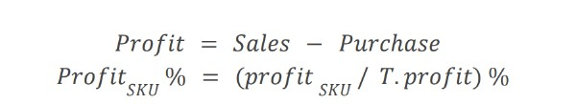

* Considering the fact that there was some inventory for every SKU at the start and end of data collection purchase of each SKU was calculated using formula :

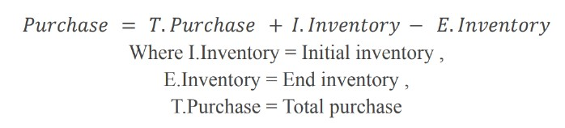

**Optimizing inventory:**

* Upon discussion with the owner we got to know that inventory management was the main concern for the owner as according to owner stock was piled up at the end of the month and also profit were less hence buying new stock was getting difficult due to inflation.
* Inventory data is collected for every SKU at the first day of data collection. Further Inventory data is calculated using sales , purchase and initial inventory using formula:

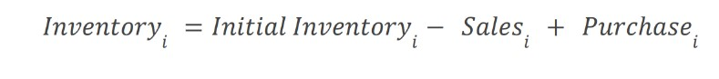

**Sales Data Analysis:**

Sales data were analyzed to assess revenue generation, sales trends, and product performance.

● Cumulative revenue tables were constructed to track total revenue accumulation over the analysis period.

● Graphical representations such as line charts and scatter plots were utilized to visualize sales trends and identify patterns.

**Profit Table:**

The creation of Gross Profit and Cumulative Profit tables provides valuable insights into the profitability of individual products within the store’s inventory.

**Benefits:**

● **Profit Margin Analysis:**

The table provides a holistic view of profit margins for each product, aiding in the identification of high-margin items. This facilitates strategic decisions on pricing and cost management.

● **Profit Maximization**:

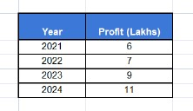 Focusing on high-margin products allows the business to optimize profitability through pricing adjustments, cost optimization, and targeted promotions, ultimately maximizing overall profit.

**Limitations and Drawbacks:**

* The analysis is hindered by the absence of comprehensive market research data. Without insights into market trends, consumer preferences, and competitor strategies, it's challenging to formulate effective marketing and sales strategies.
* The lack of a structured feedback system from customers limits the ability to gather valuable insights into customer preferences, satisfaction levels, and areas for improvement.
* Without understanding the specific needs and preferences of wholesale buyers, the shopkeeper faces challenges in devising targeted strategies to attract this customer segment.

## **Results and Findings (Visual Representation) :**

1. ***Volume Analysis(Sales):***

The below graph is generated for the Sales generated in each year.

***Line Chart of Selling Items in Each Year***

***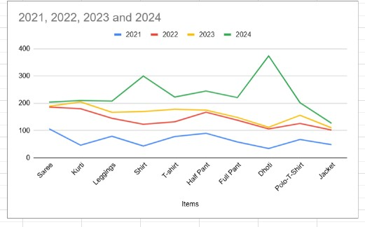***

#### 

* The above analysis shows that 2024 is the highest selling year(Golden Period).
* Selling of Dhoti is the highest in this year.
* While it can also be seen that in 2021 the business is struggling to generate revenue.

***Pie Chart of Selling Items in Each Year***

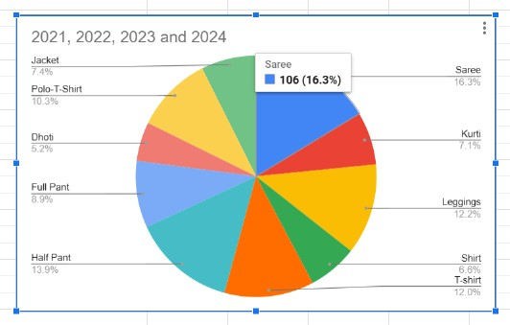

* To analyze each SKU contribution along with this pie chart, the graph is generated to show the proportion of each SKU contribution to Total revenue generated as well as Total sales volume of the shop for different years.

***Bar Chart of Item Sell in Each Month***

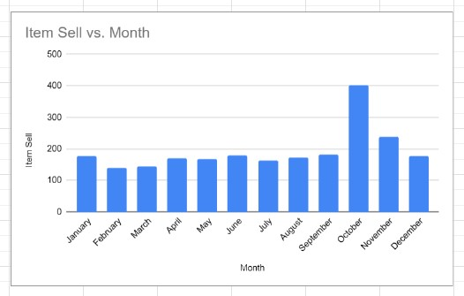

* Above analysis depicts that in the month of October ,the business is generating more revenue for selling maximum SKU which can be seen in this bar chart .In this month, the shop is selling almost 400 SKUs .

**SALES VOLUME PROPORTION**

**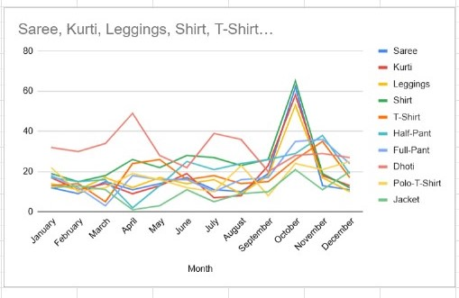**

**From the above graph I can say below statistics:**

Saree**:**

Saree sales showed resilience in 2021 despite the impact of COVID-19, but experienced a notable decline of 16% in 2022. Sales rebounded strongly in 2023 with a year-to-date growth of 8%. Profitability consistently grew over the four-year period, maintaining double-digit increases from 10% in 2021 to 12% in 2024. are At present time four brands are available – Minu ,Maharani ,Suman ,Mala.

Forecasting**:**

The saree segment is expected to continue growing steadily, potentially achieving a 5% profit margin. To sustain this growth, the strategy includes ongoing innovation, expanding market presence, and maintaining high product quality and customer satisfaction.

Kurti:

Kurti sales steadily increased from 46 in 2021 to 210 in 2024 ,accompanied by a significant rise in profit margins from 2% to 5%. The current status reflects substantial improvement and strong market penetration. At present time two brands are always available –Ankita,Raja.

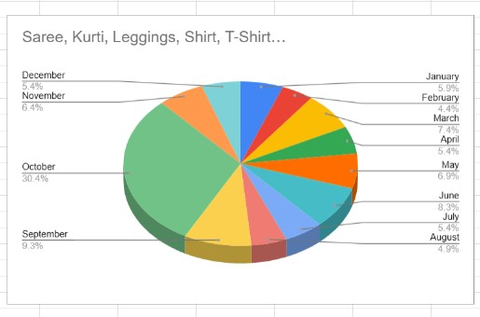

Leggings:

Leggings sales fluctuated from 79 in 2021 to 145 in 2022, with a slight decline to 208 in 2024. The current status shows a marginal increase in profitability. Dollar and Loknath brands are available in leggings section.

Forecasting**:**

Changes include conducting a comprehensive market analysis, considering product repositioning or targeting different market segments, and enhancing product features based on customer feedback.

Shirt, T-Shirt and Polo T-Shirt:

Shirt sales grew incrementally from 43 in 2021 to 300 in 2024, with a moderate increase in profit margin from 2% to 3%. The current status indicates gradual improvement but remains lower compared to other categories brand- Sparky,GenX,Gobs.

Also in T-shirt , sales steadily increased from 78 in 2021 to 223 in 2024, accompanied by a significant rise in profit margins from 2% to 5%. Frezon and Mofi brand collection are present.

Polo T-Shirt sales steadily increased from 67 in 2021 to 202 in 2024, accompanied by a significant rise in profit margins from 2% to 4% with King Soni and Lux Cozi Brands collection. The current status reflects substantial improvement and strong market penetration.

Half-Pant & Full-Pant:

Half-pant sales fluctuated from 90 in 2021 to 167 in 2022, with a slight decline to 245 in 2024.Ray&Ray and Kundu&Kundu brands are available.

Full-pant sales grew incrementally from 58 in 2021 to 221 in 2024, with a moderate increase in profit margin from 2% to 3% with MKarlo and SMontu brands.

Dhoti and Jackets:

Dhoti sells 374 in 2024 with Arabinda Mill and Boroplus Mill Brand collections and Jackets sell fluctuated from 48 in 2021 to 127 in 2024 with Oswal and Sagar brands. The forecast anticipates achieving a 2-3% profit margin. To achieve this, strategies include redesigning products with improved features, enhancing visibility through promotions and discounts, and implementing cost-saving measures to improve profitability.

From the above analysis it can be clearly deduced that Sales and revenue proportion for each SKU are directly related to each other meaning there is no high revenue generating product at low sales volume for the shop.

1. ***Profit Analysis:***

The below graph shows the comparison of profit of SKU’s in various years.

***Pie Chart Representation of Profit***

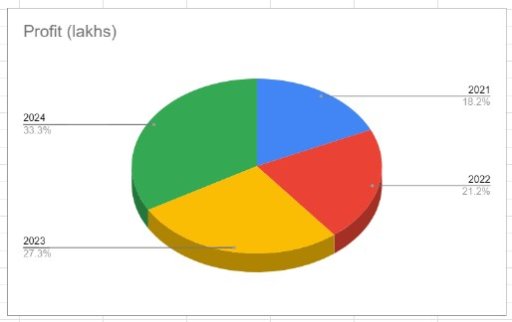

***Graphical Representation of Profit vs. Year***

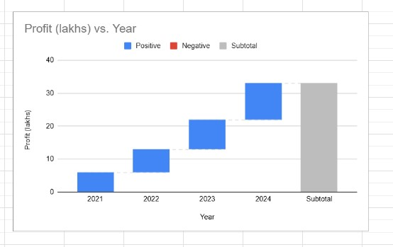

***BAR CHART PROFIT ANALYSIS***

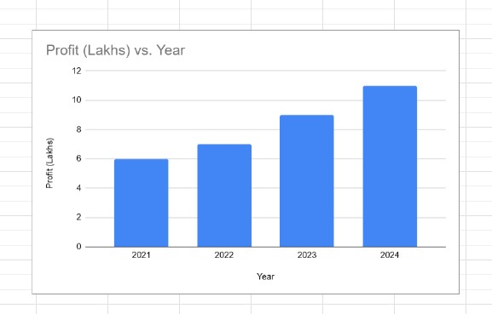

* From the above graph ,it can be seen that in 2024,the shop generates maximum profit.
* In 2024, the shop generates 33.3% profit.
* In 2021, the shop is facing lots of struggle to generate profit.
* In 2021, our analysis began with capturing 5% of the overall sales volume.
* By 2022, the sales volume increased to 10%, showing a 3% growth.

1. ***Revenue Analysis:***

To start with revenue analysis , below graph represents the revenue in each month of the shop of a year.

**Bar Chart Representation of Revenue**

**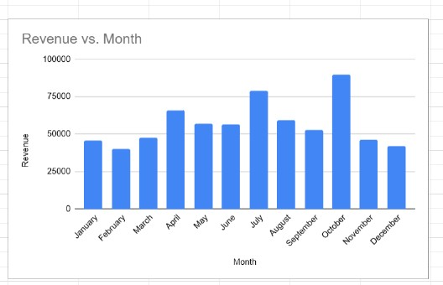**

**Pie Chart Representation**

**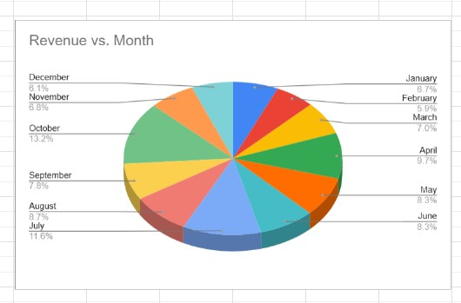**

**Sales Trend :**

* In 2023, the sales volume remained steady at 10%, maintaining the growth achieved in the previous year. This stability indicates that our strategies continued to resonate well with customers. Focused efforts on customer retention, product quality helped in sustaining this performance.
* By 2024, the sales volume saw a significant increase, reaching 12%. This 2% growth reflects the culmination of successful initiatives and market demand. Continued investment in product innovation, enhanced customer satisfaction, and effective marketing strategies contributed to this increase.

#### **Sales Analysis Dashboard :**

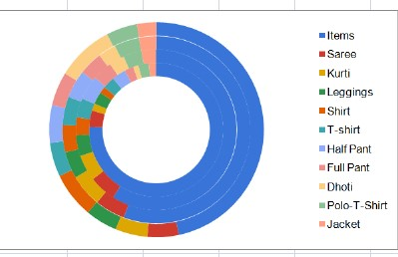

October is consistently the peak month for sales and profits for all products, with profit margins ranging from 8-10%. This indicates a strong seasonal demand likely driven by factors such as festivals, holidays, or end-of-year promotions. The festive season often sees a surge in consumer spending, as people look to make significant purchases during this period. Additionally, end-of-year bonuses and the general celebratory mood contribute to higher sales. Capitalizing on this, it’s crucial to ensure that inventory levels are sufficient to meet the increased demand, and marketing efforts are intensified to capture the attention of potential buyers.

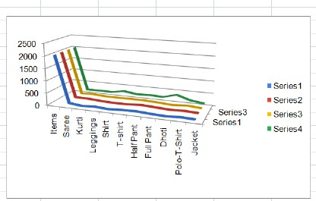

May is the lowest month for sales and profits for Saree and Shirt. This suggests a potential seasonal dip in demand, possibly due to factors like summer vacations or climatic conditions. During this period, the heat might deter people from buying clothing , or they might be allocating their budget to other expenditures like travel.

* February is the lowest month for T-shirt sales, and June is the lowest for Full Sleeve Shirt, indicating different seasonal lows for these products.
* As a clothing shop, exploring the introduction of new design and better quality before October can attract more customers and create excitement in the market. Organizing launch events, offering free trials, and providing exclusive previews can generate significant interest and anticipation among consumers.

**Customer Analysis Dashboard :**

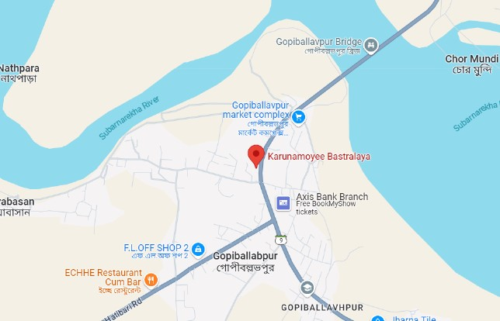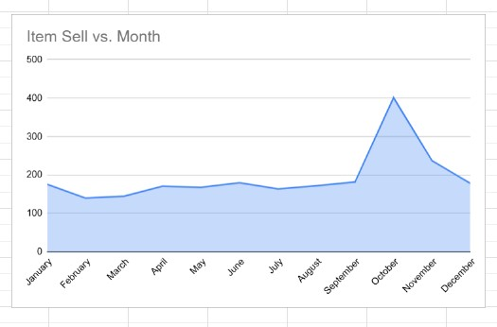

From the above dashboard I can say below statistics:

* The customers, although contributing smaller shares to the overall profit, still play a role in our business landscape. Each of these clients contributes up to 4% of the total profit, which, when aggregated, forms a significant portion of our revenue. By implementing dynamic pricing strategies, we can maintain profit margins and encourage sales during periods of low demand.

## **Interpretation of Results and Recommendation :**

1. **Recommendation 1: Increase the sales of high profit item:**

Based on the analysis, it is evident that Saree and Shirt have significantly higher profit margins compared to other items. The shop owner can take advantage of this by increasing the sales of these items, resulting in higher profits and additional assets for the shop.

*Steps which can be taken to increase the sales of high profit margin items:-*

* **Seasonal Promotion:**  Benarasi Saree are commonly consumed during October and November. The shop can host a sale on saree during this season to capitalize on increased demand and boost sales.
* **B2C Platforms and Business Partnerships:**  Saree and Shirt are essential items for businesses as well. The shop can leverage this by participating in B2C platforms or approaching other businesses to sell these items at a lower rate than what is offered to customers. While this may reduce the profit margin per unit, it can significantly increase overall sales and ultimately lead to higher net profits for the shop.
* **Bulk Sales and Discounts:** Instead of selling small quantities of Shirts, the shop owner can offer larger quantities of shirt at discounted prices to attract customers and other business owners. This strategy can incentivize customers to buy in bulk and increase sales volume.
* Achieving a 3-4% profit margin by redesigning products, promoting visibility, and implementing cost-saving measures.
* Conduct market analysis, consider product repositioning, and enhance features based on customer feedback.

1. **Recommendation 2 : Restock the product earlier than usual or during high sales periods**

The shop owner made poor decisions in purchasing Leggings resulting in significant losses for the shop. These decisions were primarily influenced by high demand and low stock availability at that time.

* **Time-based Restocking:**

Instead of purchasing and selling products based solely on demand, it is advisable to restock the inventory at fixed intervals. The items can be sorted based on perishable and non-perishable goods, considering the shop's facilities and the owner's preferences.

* **Timing Restock with High Sales Periods:**

Analyzing the data, it is observed that the period from the 21st to the 28th of each month exhibits high sales. Therefore, it is recommended to restock inventory slightly earlier than the 21st to avoid making incorrect decisions due to inadequate stock.

* Ramp up production, inventory, and marketing before October to maximize sales and profits.
* Use targeted promotions during low-demand months to maintain steady sales and clear inventory.

1. **Recommendation 3 : Increase Current Ratio**

The analysis reveals that the shop's current ratio (CR) is currently low, indicating potential liquidity issues. The current ratio can be improved by either increasing current assets or decreasing liabilities.

**𝐶𝑢𝑟𝑟𝑒𝑛𝑡 𝐴𝑠𝑠𝑒𝑡𝑠 = S𝑡𝑜𝑐𝑘 + 𝐶𝑎𝑠ℎ**

**𝐶𝑢𝑟𝑟𝑒𝑛𝑡 𝑅𝑎𝑡𝑖𝑜 = 𝐶𝑢𝑟𝑟𝑒𝑛𝑡 *Stock* / 𝐿𝑖𝑎𝑏𝑖𝑙𝑖𝑡𝑖𝑒s**

* Implement dynamic pricing during low-demand periods to maintain profit margins and encourage sales.
* Monitor cost price trends and adjust selling prices to maintain profitability.

1. **Recommendation 4 : Additional Steps**

**Effective Pricing Strategies:**

Another aspect to consider in increasing profitability is implementing effective pricing strategies. The can explore the following shop owner approaches:

* **Promotional Pricing:**

Periodically offer special promotions, such as discounts, buy-one-get-one-free offers, or limited-time offers, to create a sense of urgency and attract customers. These promotional pricing strategies can boost sales during specific periods and generate excitement among customers.

* Keep an eye on tax regulations for optimal pricing and tax compliance.
* Capitalize on peak sales months with special promotions and discounts.

By implementing effective pricing strategies and enhancing store display the shop can create a more enticing and customer-friendly environment, leading to increased sales and profitability.

## **Conclusion :**

The proposed project aims to address key challenges faced by the Karunamoyee Bastralaya in Jhargram by leveraging sales data and external insights to optimize SKU availability, develop targeted pricing strategies, and maximize profitability.

By implementing targeted marketing strategies, such as seasonal promotions and partnerships with other businesses, the shop can tap into the potential of these high-profit items. Additionally, offering bulk sales and discounts can incentivize customers to purchase larger quantities, further boosting sales volume and overall.

Furthermore, the analysis emphasized the significance of making informed purchase decisions. The analysis of fixed costs identified areas of expenditure that require attention, such as electricity and containers. The shop owner should continuously evaluate and optimize these costs to improve cost efficiency and maximize profit margins.

Targeted customer segmentation and personalized pricing models will enhance customer satisfaction and revenue. Dynamic pricing strategies and cost reduction measures will further improve profitability. Focused marketing efforts and product innovations will drive market expansion and customer loyalty.

In addition, the recommendations to enhance store display and utilize effective pricing strategies can contribute to increased customer attraction and sales. Eye-catching displays, sample stations, and promotional pricing can create a positive shopping experience and encourage customers to make additional purchases, leading to higher revenue and profitability.

By implementing these recommendations, Karunamoyee Bastralaya can improve its financial performance, increase profitability, and establish a stronger position in the market. It is important for the shop owner to continually monitor and evaluate the effectiveness of these strategies, making necessary adjustments to ensure long-term growth and sustainability.

**Important Link:**

[Google_Sheets_2020_Logo.svg.png](https://docs.google.com/spreadsheets/d/1AHiR6Ex-Iufj_nqsJrOfpNiLwBq-G_uxT9nsd5q6LJQ/edit?usp=drive_link)

***Spreadsheet:***  [**23F2000223 BDM CAPSTONE**](https://docs.google.com/spreadsheets/d/1AHiR6Ex-Iufj_nqsJrOfpNiLwBq-G_uxT9nsd5q6LJQ/edit?usp=drive_link)