Azure Data Factory – Blob to Blob Data Copy Using Azure Storage

Objective
The objective of this task is to create an Azure Data Factory pipeline that copies a CSV file from a source Azure Blob Storage container to a destination Azure Blob Storage container.

Services Used:-
- Microsoft Azure for Students
- Azure Resource Group
- Azure Storage Account
- Azure Blob Storage
- Azure Data Factory (V2)

Resource Details:-
- Resource Group :- Name: RG-Celebal-Week4
- Storage Account :- Name: zaidstorage2026
- Azure Data Factory :- Name: adfzaidweek4
- Source Container :- source-container
- Destination Container :- destination-container
- Source File :- Sample - Superstore.csv
- Copied File :- Sample - Superstore-Copy.csv

Implementation Steps

Step 1: Create Resource Group
A resource group named RG-Celebal-Week4 was created to organize and manage all Azure resources used in the project.
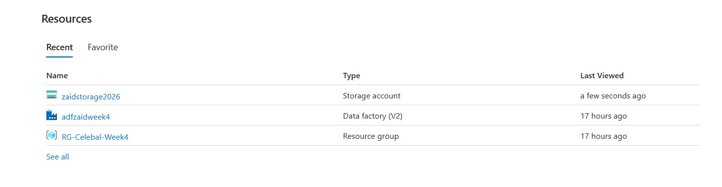

Step 2: Create Storage Account
A storage account named zaidstorage2026 was created using Azure Blob Storage with Locally Redundant Storage (LRS).

Step 3: Create Blob Containers
Two blob containers were created:
- source-container
- destination-container
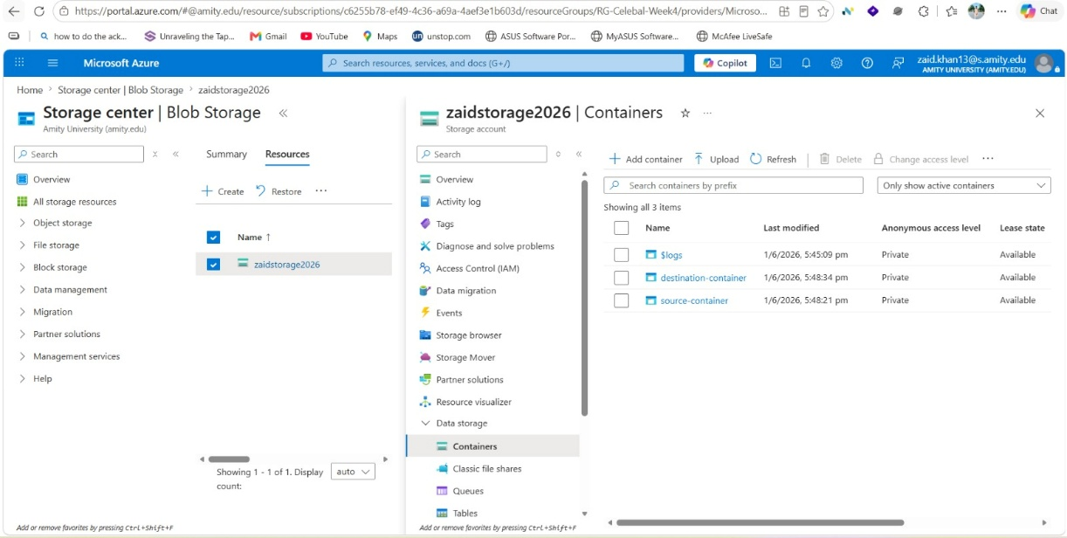

Step 4: Upload Source File
The CSV file "Sample - Superstore.csv" was uploaded to the source-container.

Step 5: Create Azure Data Factory
An Azure Data Factory instance named adfzaidweek4 was created.
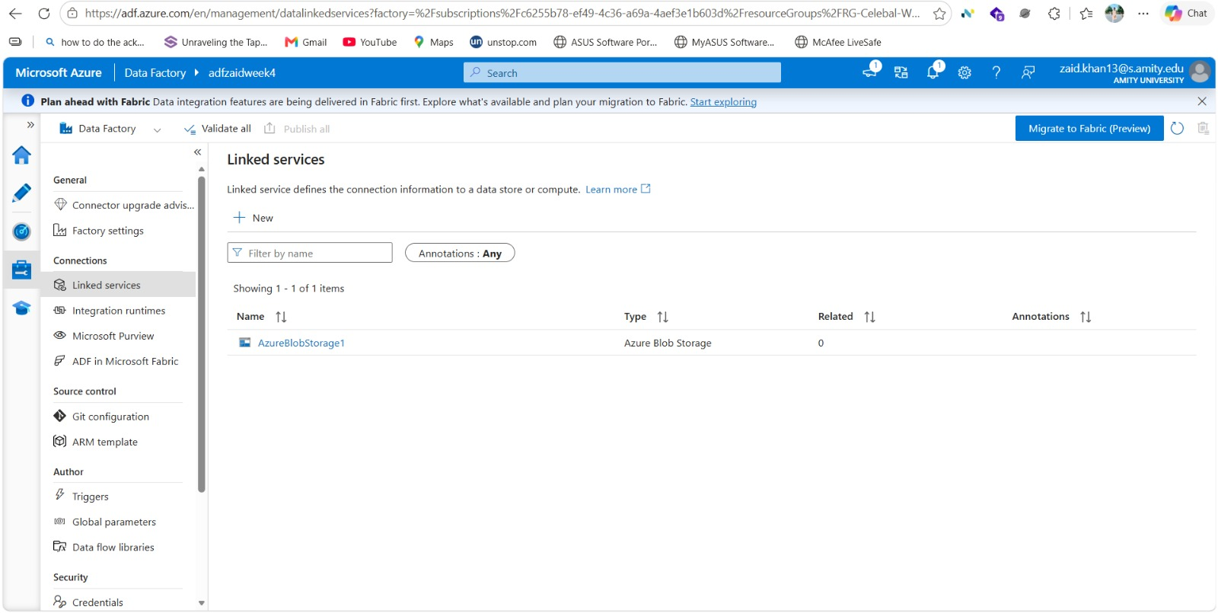

Step 6: Configure Linked Service
A linked service was configured to connect Azure Data Factory with Azure Blob Storage.


Step 7: Create Datasets
Two datasets were created:
- SourceDataset
- DestinationDataset
These datasets were connected to the respective source and destination containers.

Step 8: Create Pipeline
A pipeline named BlobToBlobPipeline was created. The pipeline contained:
- Get Metadata Activity
- Copy Data Activity
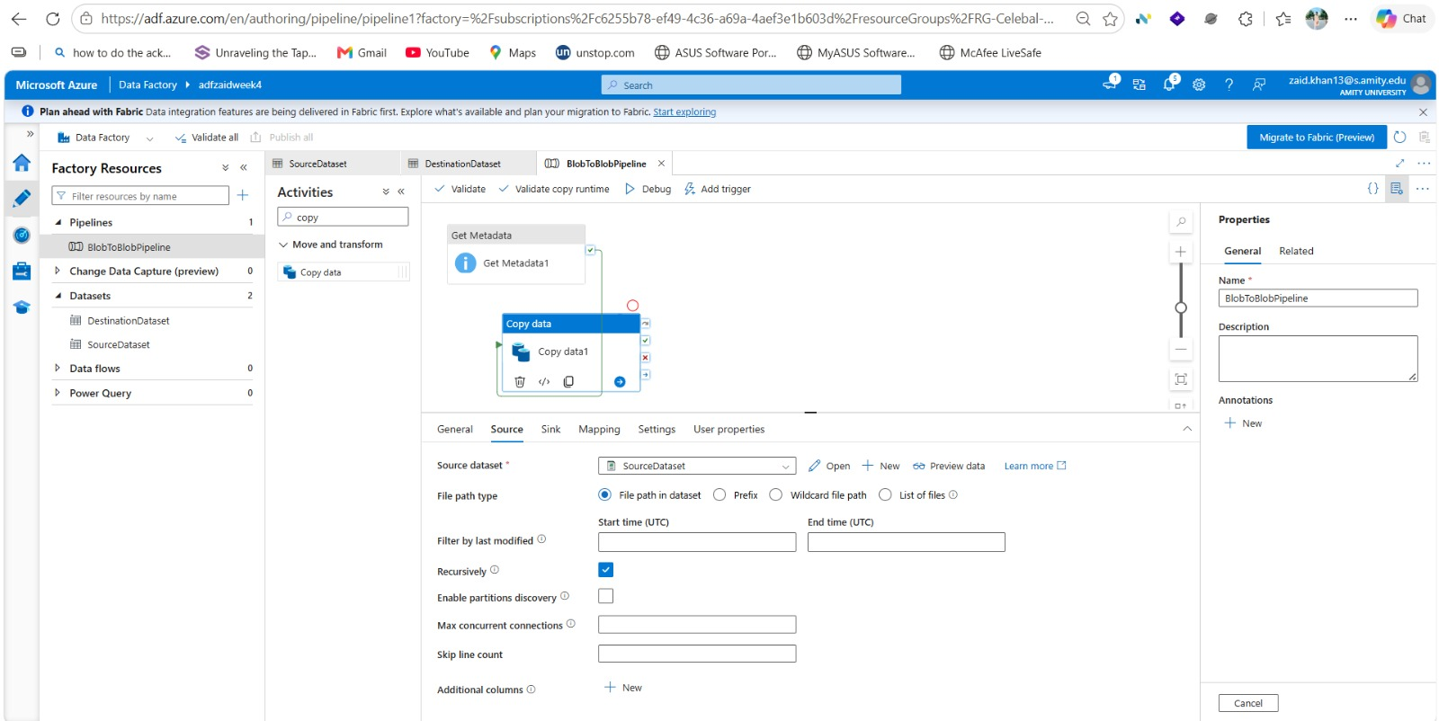

Step 9: Configure Copy Activity
The Copy Data activity was configured to:
- Read data from SourceDataset
- Write data to DestinationDataset
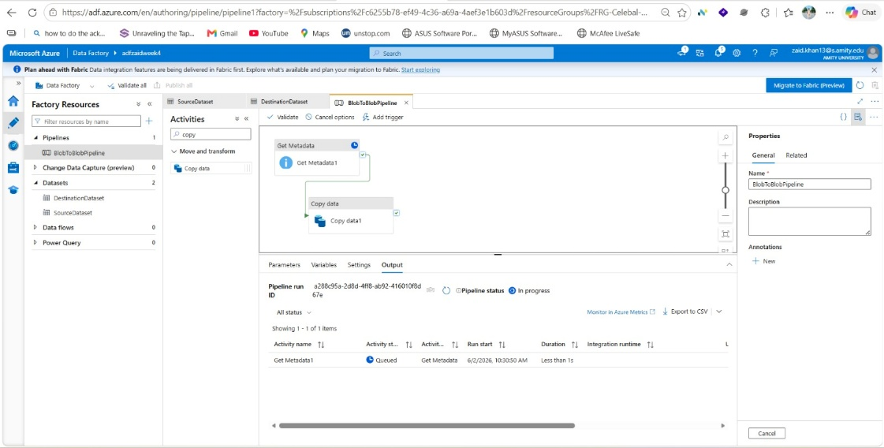

Step 10: Execute Pipeline
The pipeline was validated, published, and executed successfully.
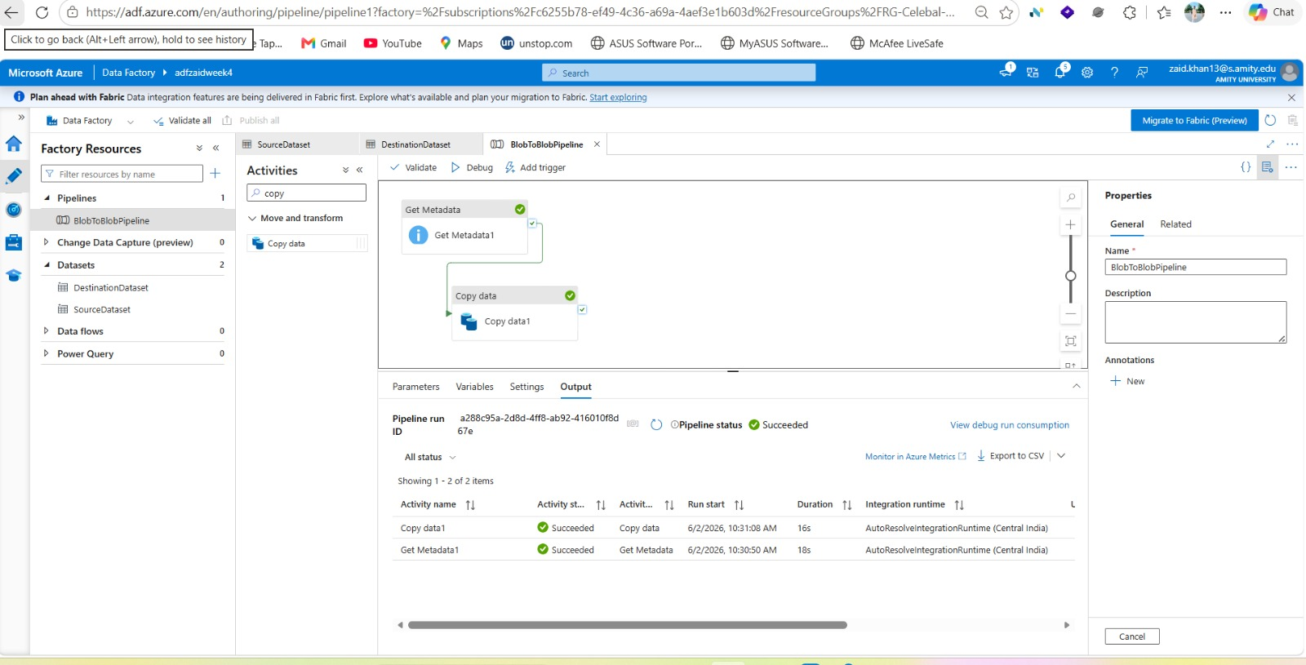

Step 11: Configure IAM Roles
Reader and Contributor roles were assigned through Azure IAM (Access Control) to provide the required access between Azure Data Factory and Azure Storage Account.
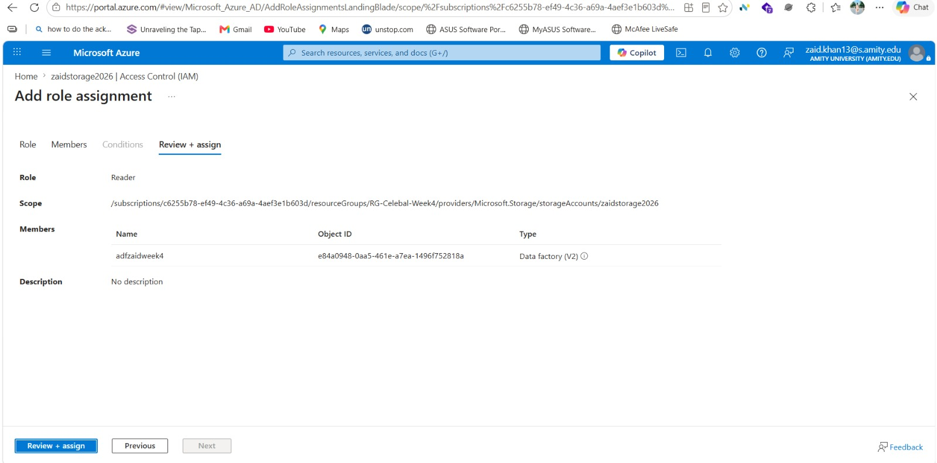

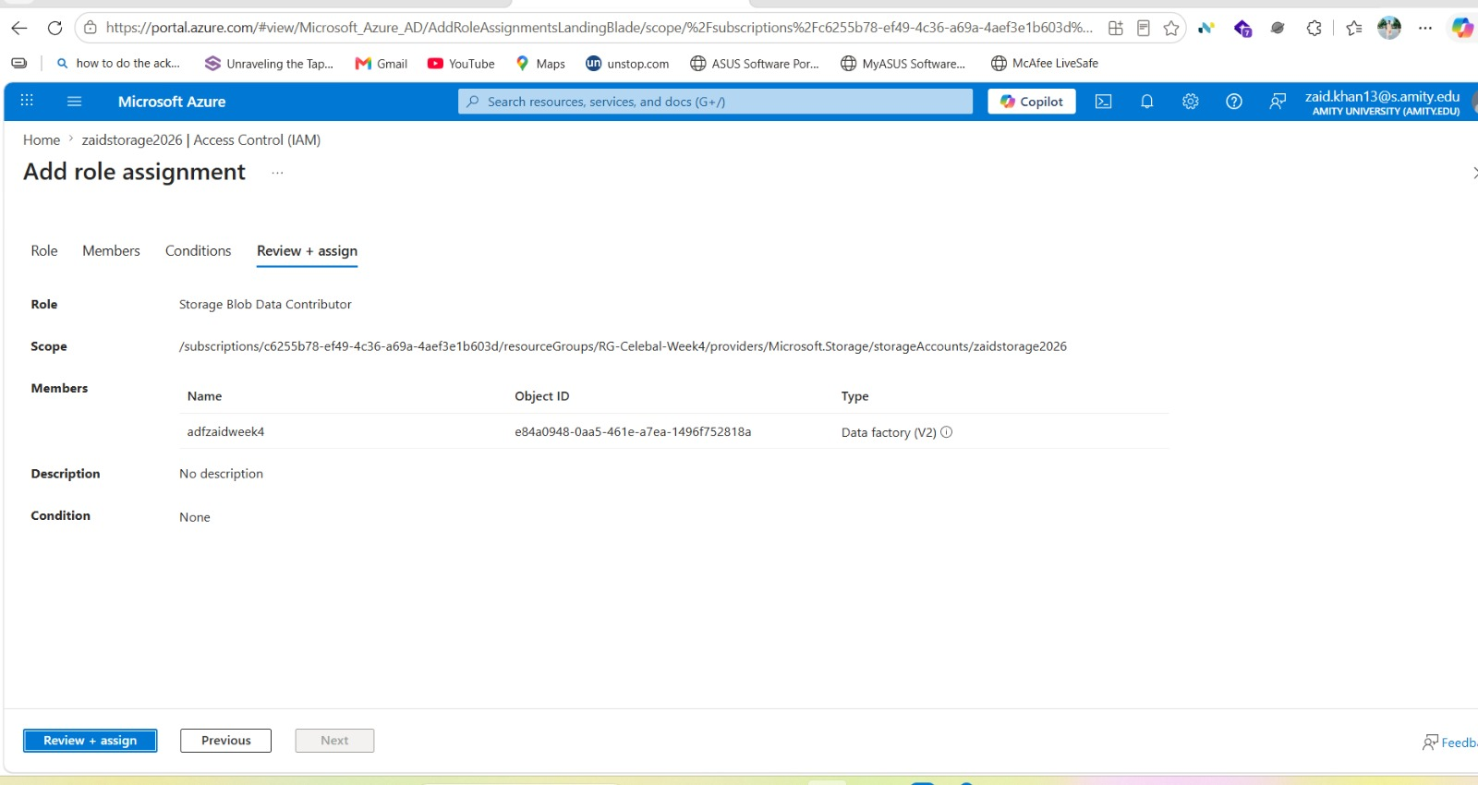

Step 12: Verify Role Assignments
The assigned roles were verified in the IAM dashboard to ensure that Azure Data Factory had the necessary permissions to access and process data stored in Blob Storage.
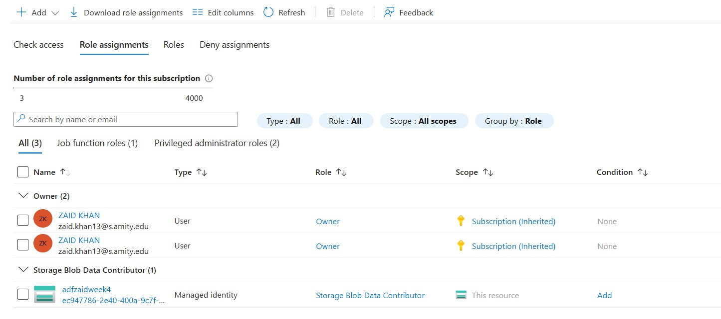

Output
The pipeline execution completed successfully and copied the file from the source container to the destination container.
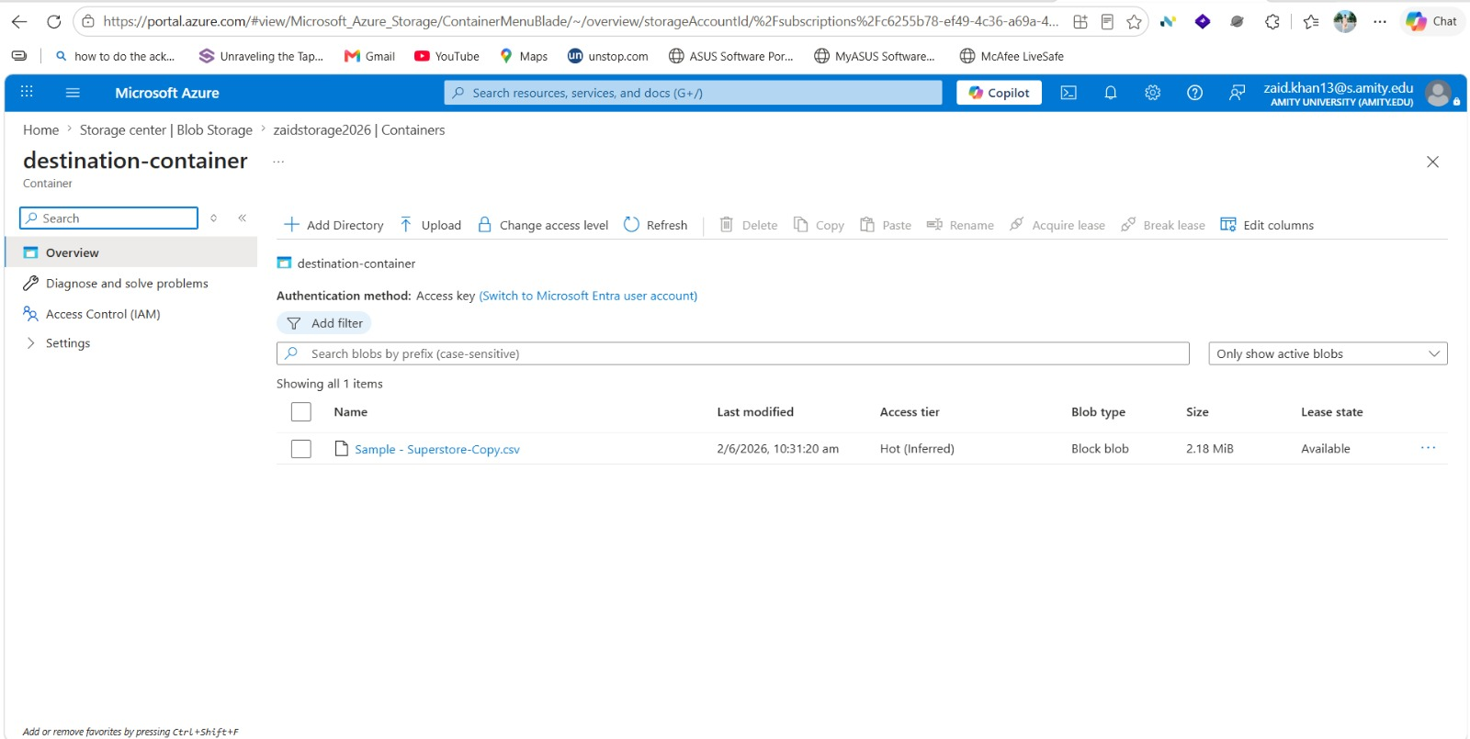

Result:-
The Azure Data Factory pipeline successfully copied the CSV file from the source Azure Blob Storage container to the destination Azure Blob Storage container.
This demonstrates the use of Azure Data Factory for data movement and orchestration in cloud-based ETL workflows.

Conclusion:-
The project successfully implemented a Blob-to-Blob data transfer pipeline using Azure Data Factory. The exercise provided practical experience in working with Azure Storage Accounts, Blob Containers, Datasets, Linked Services, and Data Factory Pipelines.

