**AIM** : Generate PDF file of your 3rd Semester Mark-sheet

**CODE** :

Language : Python.

*# 20CS089 DIVYARAJ SUNVA  
# PRACTIAL -10  
import* img2pdf  
*from* PIL *import* Image  
*import* os  
  
imp_path = "E:\\Unviversity Result\\sem-3.png"  
  
pdf_path = "E:\\Unviversity Result\\sem-3.pdf"  
  
image = Image.open(imp_path)  
  
pdf_bytes = img2pdf.convert(image.filename)  
  
file = *open*(pdf_path, "wb")  
  
file.write(pdf_bytes)  
  
image.close()  
  
file.close()  
  
*print*("Success!!")

OUTPUT :

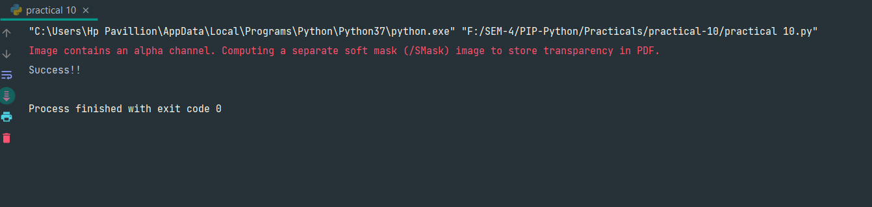

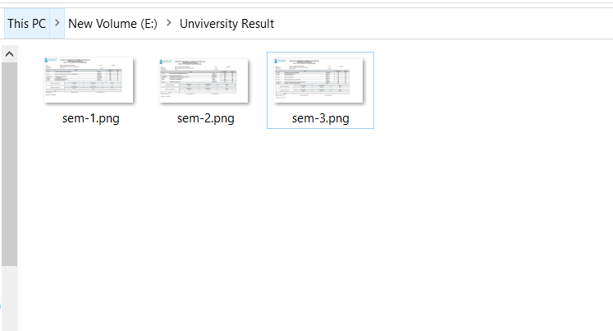

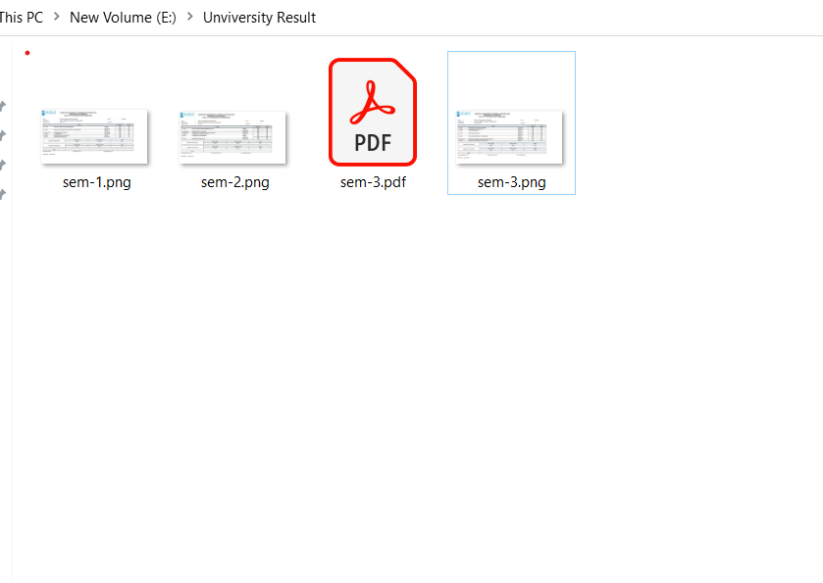

**GITHUB:** [**https://github.com/Dev5577/Programming_In_Python.git**](https://github.com/Dev5577/Programming_In_Python.git)