Practical Exam | Set B
Mathematics & Advanced Statistics
Dataset: employee_performance.csv (4,000 records, AI-generated)
Deliverable: PDF/Word report — Part A theory answers, Part B outputs, and key insights.

Part A — Theory (Short Questions)
Q1. Define Mean, Median, Mode with an example in the context of employee salaries.
Mean is the arithmetic average of all values — sum of all salaries divided by the number of employees. Median is the middle value when salaries are sorted in order (or the average of the two middle values for an even count) — it splits the data exactly in half. Mode is the most frequently occurring salary value in the dataset.
Example (from this dataset): Mean Salary ≈ 64,891.66, Median Salary ≈ 64,350.00, and Mode Salary ≈ 51,750.00. The mean and median are close, which suggests a roughly symmetric salary distribution. The mode being lower simply reflects that one particular salary value happens to repeat most often — it doesn't necessarily represent a 'typical' employee the way mean/median do.
Q2. Differentiate between Range and Variance with examples.
Range is the simplest measure of spread: the difference between the maximum and minimum values (Range = Max − Min). It only considers the two extreme values and ignores everything in between, so it's very sensitive to outliers.
Variance measures how far, on average, every value is from the mean, using squared deviations: Variance = Σ(x − mean)² / n. It uses every data point, not just the extremes, so it gives a fuller picture of spread.
Example: For Projects_Completed in this dataset, Variance ≈ 5.85 (Std Dev ≈ 2.42). If the minimum were 0 and the maximum were 25, the Range would be 25 — a single number that says nothing about how the other 3,998 employees are distributed in between, unlike variance.
Q3. What is the difference between Normal Distribution and Poisson Distribution?
Normal Distribution is a continuous, symmetric, bell-shaped distribution defined by two parameters — mean (μ) and standard deviation (σ). It's used for continuous measurements (e.g., height, salary, performance scores) where values cluster around a central point.
Poisson Distribution is a discrete distribution that models the number of times an event occurs in a fixed interval (e.g., number of projects completed in a month), defined by a single parameter λ (the average rate of occurrence). It is typically right-skewed for small λ and only takes non-negative integer values.
Example: Performance_Score in this dataset behaves like a Normal distribution (continuous, bell-shaped, confirmed by the Gaussian-fitted histogram in Part B). Projects_Completed behaves like a Poisson distribution (discrete counts, generated with a Poisson process, and its Q-Q plot confirms it deviates from normality).
Q4. Explain Skewness and give one workplace-related example.
Skewness measures the asymmetry of a distribution around its mean. A skewness of 0 indicates a perfectly symmetric distribution. Positive (right) skew means a longer tail on the higher-value side — a few very large values pull the mean above the median. Negative (left) skew means the opposite.
Workplace example: Salary in this dataset has a skewness of approximately +0.22 — a mild positive skew. This is typical in real organizations: most employees earn within a moderate range, but a small number of senior/executive earners with much higher salaries stretch the right tail, pulling the mean slightly above the median.
Q5. Define Conditional Probability and explain how it applies in promotions.
Conditional probability is the probability of an event A occurring given that another event B has already occurred, written as P(A | B) = P(A and B) / P(B). It updates our probability estimate using additional information.
Application to promotions: The overall probability of promotion in this dataset is P(Promotion) ≈ 0.108 (about 11%). But the conditional probability P(Promotion | Performance_Score > 80) ≈ 0.683 (about 68%). Knowing an employee's performance score dramatically changes the probability estimate of promotion — this is exactly what conditional probability captures: promotion is not independent of performance.
Q6. Explain Independent vs Mutually Exclusive Events with examples.
Independent events are events where the occurrence of one does not affect the probability of the other: P(A and B) = P(A) × P(B). Example: An employee's Department and their Age group could be roughly independent — knowing someone works in IT doesn't necessarily tell you their age bracket.
Mutually exclusive events cannot both happen at the same time: P(A and B) = 0. Example: Promotion_Status = 'Yes' and Promotion_Status = 'No' for the same employee in the same review cycle are mutually exclusive — an employee can't be both promoted and not promoted simultaneously.
Important distinction: mutually exclusive events are actually a strong form of dependence (if A happens, B definitely cannot), so mutually exclusive events (other than impossible events) are never independent.
Q7. What does Bayes Theorem help us in real-world decision-making?
Bayes' Theorem lets us update the probability of a hypothesis as new evidence becomes available: P(A | B) = [P(B | A) × P(A)] / P(B). It formalizes how prior beliefs should be revised in light of new data.
Real-world use: In HR analytics, Bayes' Theorem could be used to estimate P(High Performer | Promoted) using known values of P(Promoted | High Performer), P(High Performer), and P(Promoted) — helping refine predictions as more performance-review data comes in. It's widely used in spam filtering, medical diagnosis, fraud detection, and recommendation systems for the same reason: it combines prior knowledge with new evidence systematically.
Q8. Write a short note on PCA (Principal Component Analysis) in simple words.
PCA is a dimensionality-reduction technique that transforms many correlated variables into a smaller set of new, uncorrelated variables called principal components, while retaining as much of the original variance (information) as possible. The first principal component captures the direction of maximum variance in the data, the second captures the next-most variance orthogonal to the first, and so on.
In this dataset, PCA could be applied to numeric features like Age, Salary, Projects_Completed, Working_Hours, and Performance_Score to compress them into 2 principal components — making it possible to visualize employees on a 2D scatter plot while still capturing most of the meaningful variation, or to reduce redundancy before feeding features into a machine learning model.

Part B — Practical (Python Programming) — Outputs
Full working code for all steps below is provided in the accompanying Jupyter notebook (Practical_Exam_Set_B.ipynb).

Step 1: Central Tendency & Dispersion
- Mean Salary = 64,891.66 | Median Salary = 64,350.00 | Mode Salary = 51,750.00
- Variance of Projects_Completed = 5.8476 | Std Dev of Projects_Completed = 2.4182

Step 2: Probability & Events
- P(Promotion) = 0.1083 (≈ 10.83%)
- P(Promotion | Performance_Score > 80) = 0.6827 (≈ 68.27%)
Contingency table — Promotion_Status vs Department:
Department | No | Yes | Promotion Rate %
Finance | 553 | 71 | 11.38
HR | 336 | 43 | 11.34
IT | 890 | 102 | 10.28
Marketing | 471 | 50 | 9.60
Operations | 529 | 60 | 10.19
Sales | 788 | 107 | 11.96

Step 3: Distributions & Visualization
- Skewness of Salary = 0.2200 (mild positive/right skew)
- Kurtosis of Salary (excess) = -0.3894 (slightly flatter than normal)
Histogram of Performance_Score with fitted Gaussian curve:
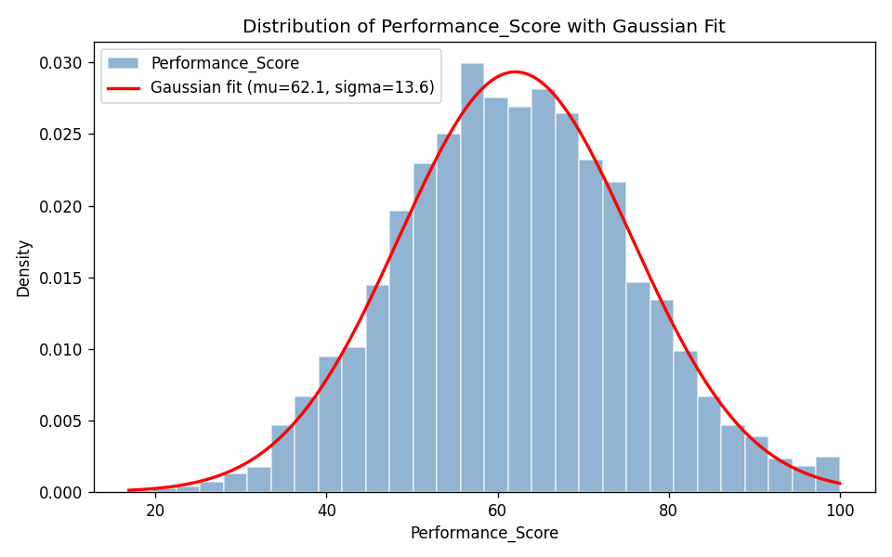
Q-Q Plot of Projects_Completed (deviation from the reference line shows it is not normally distributed):
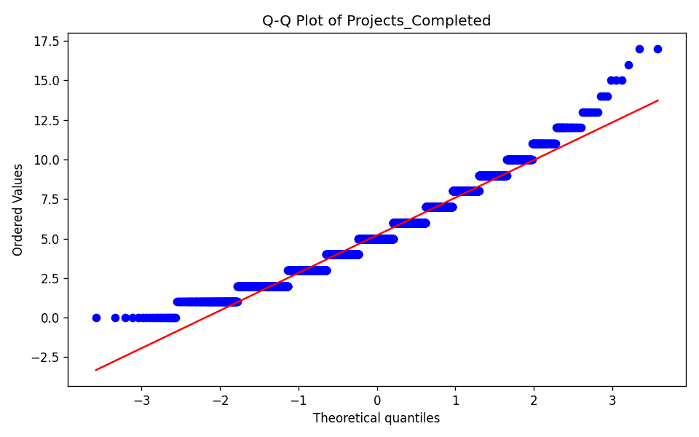

Step 4: Linear Algebra Application
First 5 employees' [Projects_Completed, Working_Hours] vectors — EMP00001: [3, 35.7], EMP00002: [4, 44.3], EMP00003: [5, 37.0], EMP00004: [4, 38.9], EMP00005: [5, 30.0].
- Dot product (EMP00001 · EMP00002) = 1593.51
- Norm 1 (Manhattan) of EMP00001's vector = 38.70
- Norm 2 (Euclidean) of EMP00001's vector = 35.83
- Angle between EMP00001 and EMP00002 vectors ≈ 0.36° (nearly identical direction — very similar output-to-hours ratio)

3–5 Key Insights
- Promotion is strongly performance-linked: overall promotion probability is ~11%, but rises to ~68% for employees scoring above 80 on Performance_Score.
- Salary is fairly symmetric with only a mild right skew (0.22) — most employees earn near the median, with a small number of higher earners extending the upper tail.
- Performance_Score closely follows a Gaussian (normal) distribution, while Projects_Completed does not — its Q-Q plot clearly deviates from the reference line, consistent with count-type (Poisson-like) data.
- Department has only a modest effect on promotion rate — rates across departments stay roughly in the 10–12% range, indicating individual performance is a stronger driver of promotion than which department someone is in.
- Employees with similar work-vector 'direction' (ratio of projects completed to hours worked) can have very different magnitudes — e.g., EMP00001 and EMP00002 point in almost the same direction (angle ≈ 0.36°) despite different absolute workloads.

