**EBS**

* IT is a Root volume in which the OS will be run, It is also called a Boot Volume.

**BLOCK STORAGE TYPES:**

1. EBS

* Persistence: If you stop or reboot then data will not be deleted.
* If you terminate then it will be deleted.
* N/w Attached Virtual Drive.
* N/w attached is slow than physical attached.

1. INSTANCE STORE BACKED EC2:

* The virtual Hard Drive on the host is allocated to EC2 Instances.
* It is limited to some instances.
* Limited to 10 GB Per Device.
* Non-Persistence (Ephemeral)
* Can only be rebooted, if you stop or terminate data will be lost.

**EBS:**

* It is a Raw, Un-formatted, external block storage that you can attach to EC2 instances.
* Ebs attached to EC2 through the AWS Network, like a virtual Hard drive.
* Multiple EBS Volumes can be attached to a single EC2 instance.
* But you can attach a single EBS Volume to an instance once at a time.
* EBS Volumes and instances must be in the same Availability Zone.
* The Data in EBS Volume will be replicated in multiple copies in the same AZ to prevent Data loss.

**VOLUME TYPES:**

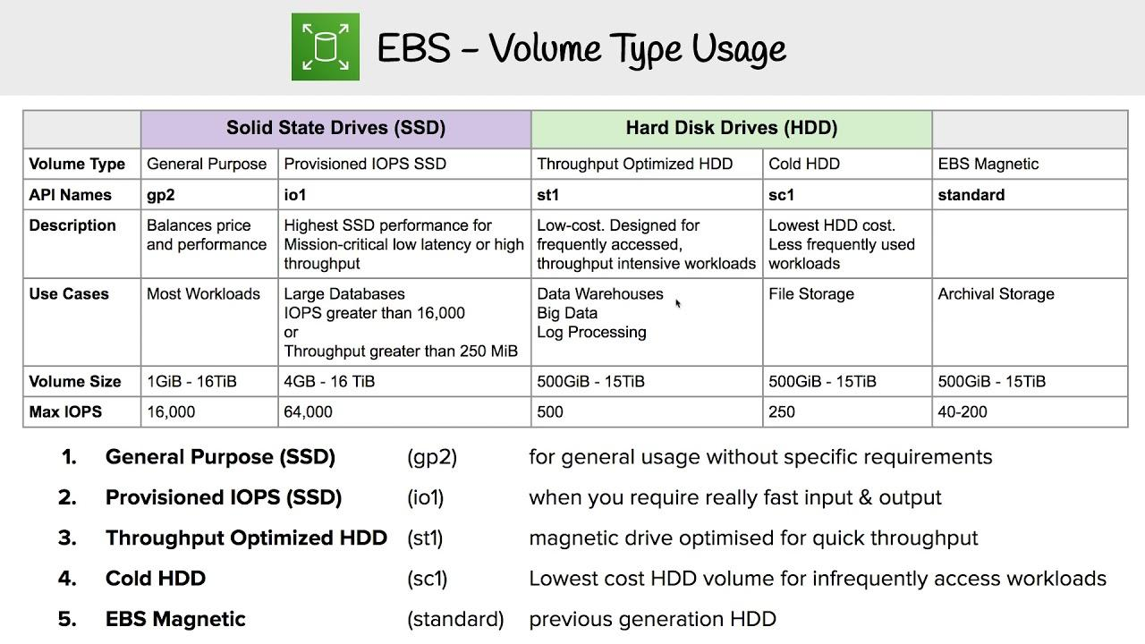

Throughput: How to speed the data transferred in MB per Second

IOPS: How speed the data read and write.

**SNAPSHOT:**

* EBS Snapshots are point-in-time images/copies of your EBS Volumes.
* Any data written to that volume after the snapshots process is initiated, will not be included in the resulting snapshot(But will be included in future, incremental updates).
* We can create up to 5000 EBS Volumes in a single account.
* We can create up to 10000 EBS snapshots in a single account.
* Snapshots can be stored on S3 (not ours) but can only be accessed through EC2 API’S.
* Snapshots are Region Specific only not AZ specific.
* To migrate EBS Volume from one region to another we can create a snapshot and create EBS volume from the snapshot in the intended AZ.
* You can create a snapshot to an EBS Volume of the same or larger size than the original volume size, from which the snapshot was initially created.
* You can take a snapshot of non-root volume while the volume Is used in running the EC2 instance.
* That means you can still access it while the snapshot is being processed.
* However, the snapshot will include data that is already written to your volume.
* A snapshot will be created immediately but will be pending until the full snapshot is completed.
* While the snapshot is in pending status you can access non-root volume, but I/O might be slower because of the snapshot activity.
* To take a complete snapshot of your non-root Ebs volume stop or unmount the Volume.
* To create a snapshot of a root EBS volume, you must stop the EC2 Instance.

**INCREMENTAL VOLUME:**

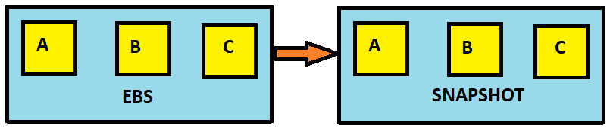

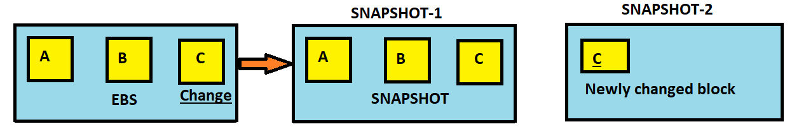

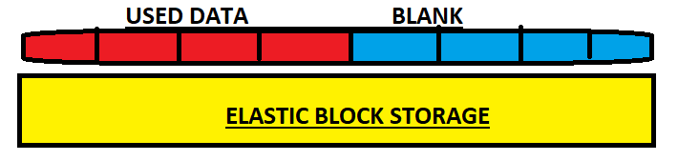

* For example, if you change the content in only one block and if you want to take a snapshot then it will not take whole blocks, whatever u made changes it will be taken as a snapshot.
* If you delete snapshot-1 then the blocks in snapshot-1 (a & b) will be shifted to snapshot-2 automatically then you get all the data by creating volume from that snapshot.
* The AWS will take a snapshot of user data but will not take a backup of unused data.

**EBS ENCRYPTION:**

* EBS Encryption will be supported by all EBS Volumes and all Instance family types.
* Snapshots of encrypted volumes are also encrypted.
* Creating EBS Volumes from Encrypted Snapshots will result in encryption Volume.
* When data is moving from EBS to EC2 that is called data in transit.
* Data encryption in rest means encryption of data while it is stored on the data storage device.
* We can attach both encrypted and unencrypted EBS Volumes to an EC2 Instance.

**EBS ENCRYPTION WAYS:**

* Use 3rd part EBS Volumes.
* Encryption Tools.
* Use Encrypted EBS Volumes.
* Use Encryption at O.S Level

LAB: TAKING A SNAPSHOT OF ROOT VOLUMES

STOP THE SERVER FIRST

SNAPSHOT -- > CREATE -- > INSTANCE : ID -- > CREATE -- > IT WILL TAKE SOME TIME

SNAPSHOT -- > CREATE -- > VOLUME : ID -- > CREATE -- > IT WILL TAKE SOME TIME

DELETE THE VOLUME SNAPSHOT & TERMINATE THE SERVER

SELECT INSTANCE SNAPSHOT -- > CREATE VOLUME -- > DEFAULT VALUES

CREATE AN INSTANCE ON THE SAME REGION and STOP INSTANCE

GO TO VOLUMES & DETACH THE VOLUME AND ATTACH THE PREVIOUS VOLUME.

1. LAUNCH AN INSTANCE AND CREATE FILES
2. CREATE A SNAPSHOT OF VOLUME
3. CREATE A VOLUME FROM SNAPSHOT
4. CREATE A NEW INSTANCE IN SAME AZ
5. ATTACH THE NEWLY CREATED VOLUME FROM SNAPSHOT
6. LSBLK OR FDSIK TO SHOW THE TWO DISKS
7. STOP INSTANCE & DETACH THE ROOT VOLUME
8. NOW START INSTANCE NOW IT WILL FAIL
9. GO TO VOLUME AND DETACH NEWLY ATTACHED VOLUME FROM SNAPSHOT
10. ATTACH THE SAME VOLUME AS ROOT DEVICE BY USING XVDA NOW IT WILL SHOW FILES.