**ELASTIC LOAD BALANCER**

ELB Distributes the Web Traffic to the available server.

It will distribute the incoming traffic across a group of the backend server.

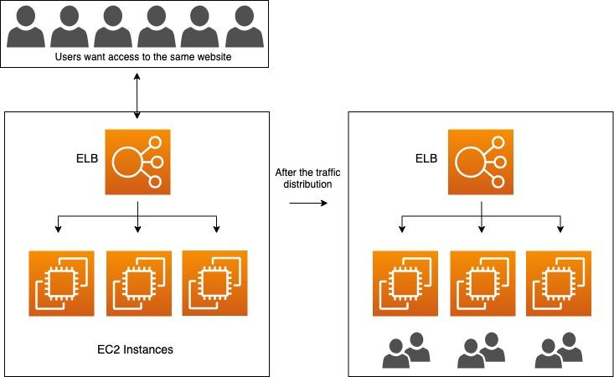

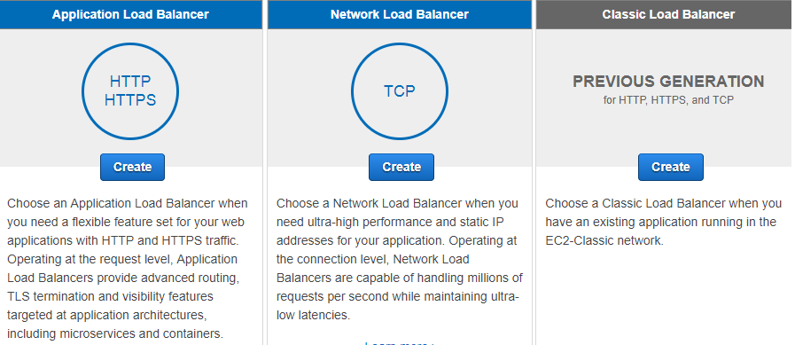

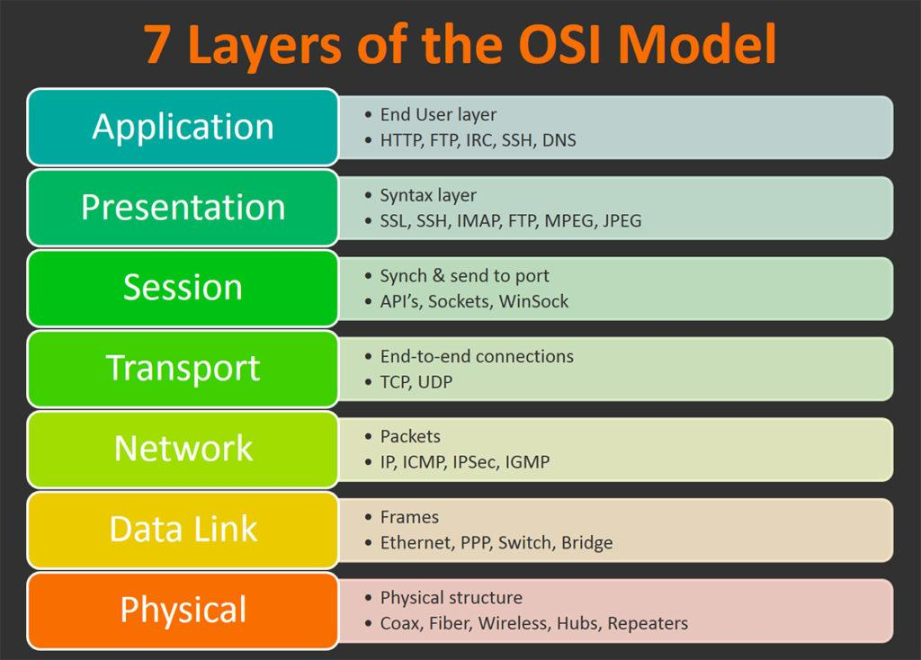

APPLICATION LB : Works ON 7th Layer of OSI Model. Supports HTTP & HTTPS

NETWORK LB : Works on 4th Layer of OSI Model. Supports TCP, UDP, TLS.

CLASSIC LB : Works on 7th & 4th Layer of OSI Model. Supports HTTP, HTTPS, TCP, SSL.

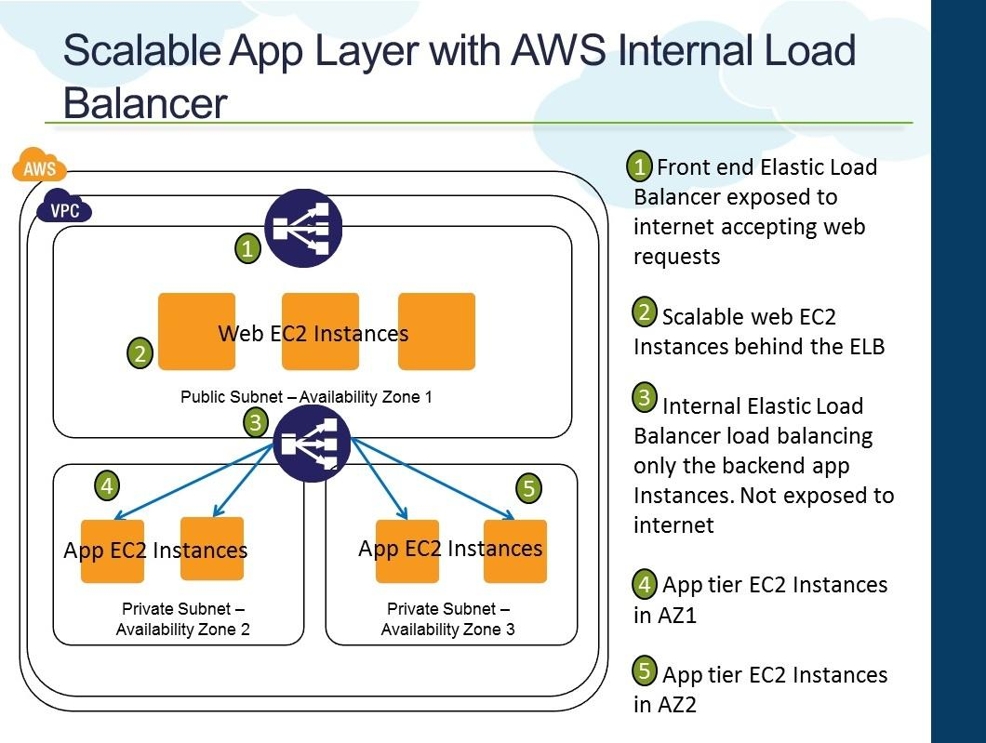

NOTE: It is not required that every EC2 instance must have a Public IP. ELB can communicate through Private address. Only to communicate We need public IP in internet. But we need Private IP Definitely.

If you use Application LB then it will only enable HTTP & HTTPS Requests only.

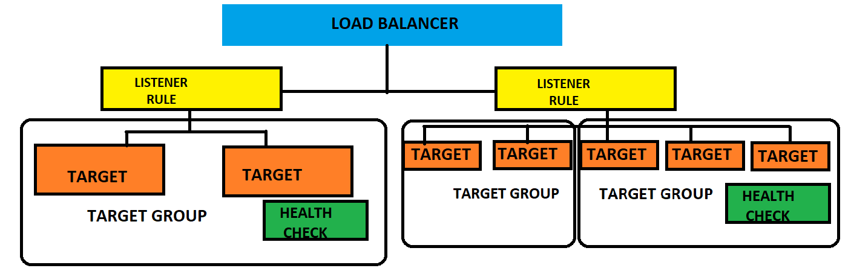

**LISTNER**: It will listen to the request and checks where the request wants to go & decides to send which Target Group.

**TARGET GROUP**: It is a cluster of EC2 instances if you want to connect LB to some specific instances then you make a group of that instances, It is called as Target group.

It is better to make more availability zones if one fails then other will serve.

**TARGET**: Individual Instance is called as Target. We have IP/LAMBDA/INSTANCE based TG’s.

**HEALTH CHECK**: Checks the Health on the instance after 300 seconds for monitoring purpose.

We can only use 4 CIDR blocks of the load balancer

10.0.0.0/8, 100.64.0.0/10, 172.16.0.0./12, 192.168.0.0/16

You cannot Assign publicly IP address as Target IP.

THEORY:

* An internet facing Load Balancer has a publicly resolvable DNS name.
* website name Is converted into DNS and that DNS will be resolved into Load Balancer DNS and Load Balancer converts it into IP.
* This is how traffic from the internet Is directed to the ELB frontend.
* Classic Load Balancer Supports (HTTP, HTTPS, TCP, SSL)
* Protocol ports supported are 1-65535
* It supports IPV4, IPV6 and Dual Stack.
* Application Load Balancer distributes incoming application traffic across multiple target such as EC2 instances in multiple AZ’s.
* Application Load Balancer was introduced in year 2016.
* Before Application Load Balancer we sue Classic or Network Load Balancer.
* This increases the high availability of your application.
* Network Load Balancer has ability to handle millions of requests per seconds.

LISTNER:

* An ELB listener is the process that checks for the Connection Request.
* You can configure the Protocol/Port on which your ELB listener listen for Connection request
* Frontend listener check for the traffic from client to the listener.
* Backend listener are configured with protocol/port to check for traffic from the ELB to EC2.
* It may take sometime to the registration of the EC2 instances under the ELB to Complete.
* If you register your instance then traffic will go into it otherwise it will not go.
* If you don’t want that ELB you can delete it.
* Before deleting ensure that you point Route 53 to somewhere else other than the ELB.
* Deleting ELB does not affect the EC2 instance registered with it.
* ELB forwards traffic to “ETH0” of your registered instances.
* In case your EC2 registered instances has multiple IP address on ETH0, ELB will route the traffic to its primary IP address.

PRACTICAL:

APPLICATION LOAD BALANCER:

SERVICES -- > EC2 -- > CREATE 2 SERVERS IN DIFFERENT AZ (TAKE IIS WINDOWS 2012) -- > SG: RDP, HTTP, HTTPS (ANYWHERE) -- > NEW KP -- > LAUNCH

SELECT INSTANCE -- > CONNECT -- > RDP CLIENT -- > DOWNLOAD RREMOTE RDP FILE -- > GET PASSWORD -- > BROWSE -- > SLECET THE PEM FILE -- > DECRYPT -- > COPY THE PASSWORD

OPEN RD FILE -- > CONNECT -- > PASSWORD -- > YES -- > SERVER MANAGER -- > ADD ROLE & FEATURES -- > NEXT -- > ROLE BASED OR FEATURE BASED INSTALLATION -- > NEXT -- > NEXT -- > WEBSERVER IIS -- > ADD FEATURES -- > NEXT -- > NEXT -- > NEXT -- > NEXT -- > INSTALL

SERVER MANAGER -- > INETPUB -- > WWWROOT -- > DELET ALL FILES -- > CREATE A NEW FILE ADD SOME CONETNT -- > SAVE IT AS index.html By SELECTING ALL FILES -- > NOW DELETE TEXT FILE.

APPLY SAME THINGS TO SERVER 2 AS WELL

LOAD BALANCER -- > CREATE -- > APPLUCATION LB -- > NAME -- > INTERNET FACING -- > MAPPING

SELECT THE AZ WHERE YOU CREATED -- > SECURITY GROUP: SELECT YOU GAVE TO THE INSTANCE LISTENER : HTTP -- > CREATE TARGET GROUP -- > SELECT INSTANCE -- > NAME -- > NEXT -- > SELECT 2 INSTANCES -- > INCLUDING AS PENDING BELOW -- > CREATE -- > BACK TO TAB -- > CREATE

TARGET GROUPS -- > CHECK ITS HEALTH OR NOT -- >

LOAD BALANCER -- >DNS NAME -- > PASTE ON BROWSER -- > YOU CAN SEE THE TEXT

NOW REFRESH AFTER 5 SECONDS IT WILL SHOW ANOTHER TEXT

CREATE ANOTHER INSTANCE LIKE PREVIOUS CONFIG

SELECT THE LB -- > EDIT SUBNETS -- > ADD 1-C

TARGET GROUPS -- > SELECT 1-C -- > INCLUDE AS PENDING BELOW -- > REGISTER

WAIT UNTILL IT GETS HEALTHY

NOW REFRESH THE BROWSER YOU CAN SEE THE NEW CONTENT

NOW DELETE THE APPLICATION LB.

NOTE: IT WONT EFFECT THE INSTANCES AND TARGET GROUPS.