**SONARQUBE**

1. SonarQube (formerly Sonar) is an open-source platform developed by Sonar-Source for continuous inspection of code quality
2. To perform automatic reviews with static analysis of code to detect bugs, code smells, and security vulnerabilities on 20+ programming languages.
3. SonarQube offers reports on duplicated code, coding standards, unit tests, code coverage, code complexity, comments, bugs, and security recommendations.
4. SonarQube is available for free under the GNU Lesser General Public License. An enterprise version for paid licensing also exists, as well as a data center edition that supports high availability.

**ADVANTAGES**

**Detects And Alerts**

SonarQube detects bugs in the code automatically and gives alerts to the developers to resolve the issues before rolling it out for production.

**Raise Quality**

SonarQube performs multi-dimensional analysis and can generate results on seven sections of code quality mentioned above. It helps developers in avoiding code redundancy, maintain low code complexity.

Developers can create customizable dashboards to focus on the areas which are more important. It helps in on-time delivery of the quality product.

**Sustainability**

SonarQube platform significantly increases the lifetime of applications by reducing complexities, duplications and potential bugs in the code, by keeping neat and clean code architecture and increased unit tests. It increases software maintainability. It also has the ability to handle changes.

**Productivity**

SonarQube facilitates the team members to reduce the size of the application, code complexity, maintenance time and cost and make code easy to read and understand.

**Increase Developer Skills**

SonarQube provides enormous value to the development teams and hence it can be adopted easily. Developers receive regular feedback on coding standards and quality issues which helps in increasing the programming skills. It creates a good understanding of software quality and ensures code transparency.

**Scale With Business Needs**

There has been no limit discovered to its scalability yet as it is designed to scale with business needs.

SonarQube has been tested in environments. It performs daily analysis on more than five thousand projects with more than four million lines of code and twenty developers.

**Enable Continuous Code Quality Management**

Adopting SonarQube make code quality a well-recognized part of the development process. It enables continuous code quality management and decreases the cost and risk associated with software management. Developers receive valuable insights to ensure that this is broadly adopted.

**Define And Increment Requirements Efficiently**

It has a set of predefined standards that enable developers and software managers to get immediate insight into application quality. To adapt to the organization or team specific requirements, it can be configured easily.

**Foster Innovation**

As more companies migrate to the SonarQube platform, they increase in size as well as in diversity. This platform enables these companies to customize and extend its functionality. Companies can get an increasing number of plugins and an extensive developer’s network.

**Reduce Risk with Vendor Support and Services**

To enable customers to get maximum value from their investment, SonarQube provides additional value and professional support. Services including development, technical support, consulting and training are designed to help companies get long term benefits.

Fully integrated with DevOps tool chains it comes with:

* built-in integration with most build tools, which enables in most cases a no configuration approach
* easy integration with continuous integration engines such as Jenkins, Azure DevOps, TeamCity, Bamboo,…
* support for numerous source configuration management tools such as Git, Subversion, CVS, Mercurial, …

**INSTALLATION:**

1. Install JAVA-11 : sudo amazon-linux-extras install java-openjdk11
2. Wget <https://binaries.sonarsource.com/Distribution/sonarqube/sonarqube-8.9.6.50800.zip>
3. unzip sonarqube-8.9.6.50800.zip
4. cd sonarqube-8.9.6.50800/bin /linux-x86-64/
5. vi conf/sonar.properties

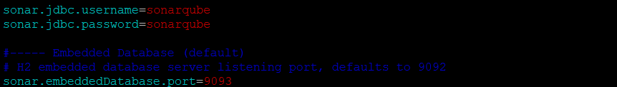

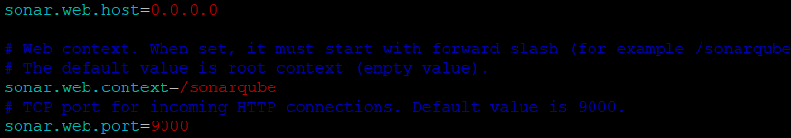

1. find / -name java

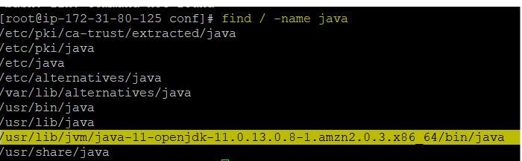

1. vim wrapper.conf



1. cd ~ && cp -R sonarqube-8.9.6.50800 /home/ec2-user/ && chown -R ec2-user:ec2-user /home/ec2-user/ && logout && ll &&
2. cd sonarqube-8.9.6.50800/ bin/linux-x86-64/
3. ./sonar.sh console
4. Now give Publicip:9000/sonarqube in a browser (username: admin password: admin).

**JFROG**

**INSTALLATION:**

AMI: LINUX AMI INSTANCE: T2 MEDIUM S.G : 8081 & ANYWHERE

* wget [https://releases.jfrog.io/artifactory/artifactory-rpms/artifactory-rpms.repo -O jfrog-artifactory-rpms.repo](https://releases.jfrog.io/artifactory/artifactory-rpms/artifactory-rpms.repo%20-O%20jfrog-artifactory-rpms.repo)
* mv jfrog-artifactory-rpms.repo /etc/yum.repos.d/
* yum update && yum install jfrog-artifactory-oss
* systemctl start artifactory.service
* systemctl enable artifactory.service
* systemctl status artifactory.service

creds: admin password: password

LAMP

LAMP installations (Linux + Apache + MySQL + PHP/Perl/Python) are a popular setup for Ubuntu servers. There is a plethora of Open Source applications written using the LAMP application stack. Some popular LAMP applications are Wiki’s, Content Management Systems, and Management Software such as phpMyAdmin.

One advantage of LAMP is the substantial flexibility for different database, web server, and scripting languages. Popular substitutes for MySQL include PostgreSQL and SQLite. Python, Perl, and Ruby are also frequently used instead of PHP. While Nginx, Cherokee and Lighttpd can replace Apache.

apt upgrade -y

apt install apache2 -y

apt install mysql-server -y

sudo mysql

ALTER USER 'root'@'localhost' IDENTIFIED WITH mysql_native_password by ‘my-secret-password';

exit

mysql -u root -p

apt install php libapache2-mod-php php-mysql -y

php - -version

mysql - -version

apache2 -version

cd /var/www/html

copy public ip and paste it on browser

VENV:

*virtualenv* allows you to create and manager virtual environments for python and its packages. It allows you to create an isolated environment for same/different python codebase. You can create separate virtual environments for development and production, allowing you to run your application in virtual environment without breaking anything. In this article, we will look at how to install virtualenv in Ubuntu.

sudo apt-get install python3-pip

sudo pip3 install virtualenv

cd $YOUR_PROJECT_DIRECTORY

virtualenv .staging

source .staging/bin/activate

(.staging) ~/project$

pip install <package_name>

deactivate