Understanding Win Probability & Pricing Recommendations
A Practical Commercial Guide for Sales Representatives & Billing Teams

1. Quick Summary: What Is This Number?
When you generate a quote in the Air Export Pricing Engine, you will see a metric called Win Probability (e.g., 32%, 55%, or 85%).
RECOMMENDED QUOTE: ₹128,800 | MARGIN: 14.5% | WIN PROB: 34%

The Golden Rule:
A 30% Win Probability does NOT mean the quote is "bad" or "failing." In fact, on spot inquiries, quoting at a 30%–35% win rate is usually the exact strategy that maximizes your commission and company profit.
This guide explains why that is, how the math works in your favor, and when to use different quoting strategies.

2. The Common Misconception: Why 30% Is NOT "Failing"

The Sales Psychology Trap
As a sales professional, your natural instinct is: "If the app gives me a 30% win chance, that means I have a 70% chance of losing! Why wouldn't I drop the price until my win chance is 80% or 90%?"
Here is why that instinct hurts your revenue in freight forwarding:

Reality Check: The 4-Way RFP
In international air export, when a shipper sends a spot inquiry, they almost never ask just you. They send the exact same RFQ to 3, 4, or 5 competing forwarders simultaneously:
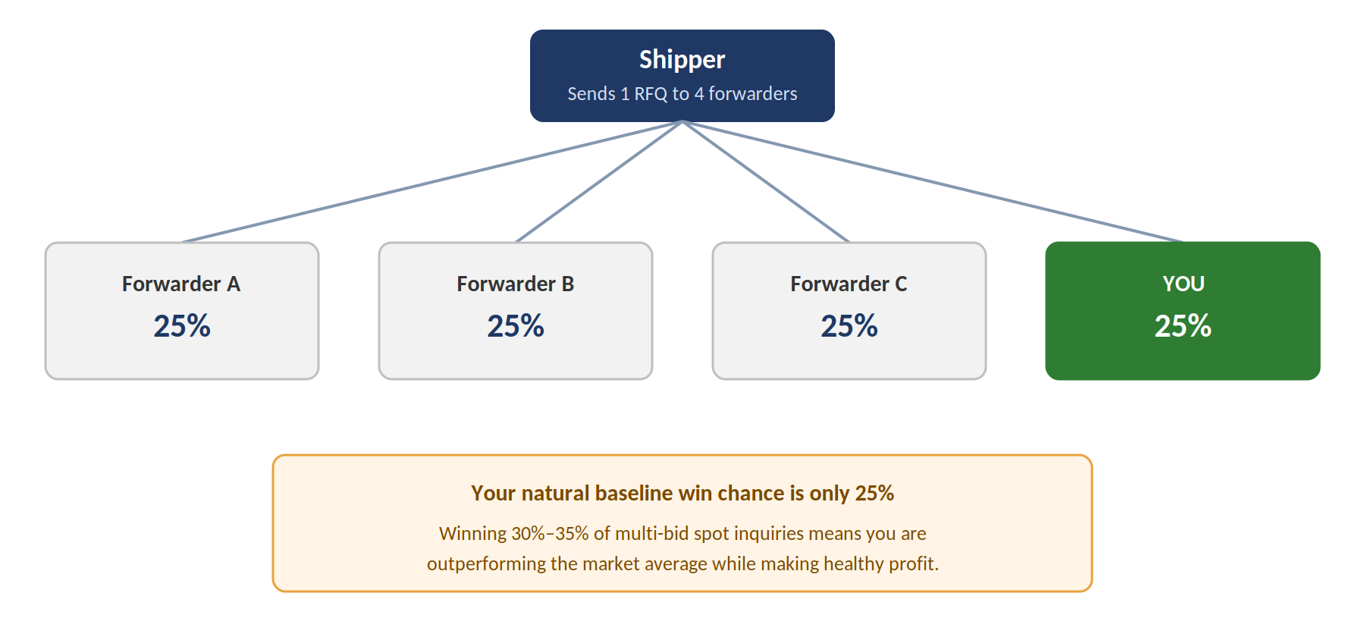
Figure 1 — A shipper's RFQ typically goes to four forwarders at once, so your natural baseline win chance is 25%.
- In a 4-way bid, your natural baseline chance of winning is only 25% (1 out of 4).
- Even if you quote at zero profit (cost price), you will still lose deals because another forwarder has a direct airline contract, cheaper consolidations, or looser payment terms.
- Therefore, winning 30% to 35% of multi-bid spot inquiries means you are outperforming the market average while making healthy profit.

The Danger of an 80% Win Rate ("The Winner's Curse")
If a sales rep boasts an 80% win rate on spot freight, the company is almost certainly leaving massive money on the table. To win 80% of open market tenders, your prices must be so absurdly cheap that competitors aren't even bothering to bid against you. You win every deal because you are working for free.

3. Expected Value vs. Win Rate: How to Make More Money with Less Work
Our pricing engine does not try to win every quote at all costs. Instead, it solves for Expected Profit:
Total Expected Profit = Profit per Shipment (₹) × Win Rate (% prob)

Real-World Example: Rep A vs. Rep B
Look at what happens across 100 spot inquiries for ₹100,000 shipments:
Comparison Factor | Rep A: "Win Every Deal" | Rep B: "Engine Optimized"
Quoted Margin | 3.5% (Slashed Price) | 15.0% (Engine Value Price)
Win Rate | 80% (80 Won / 20 Lost) | 32% (32 Won / 68 Lost)
Profit Per Shipment | ₹3,500 | ₹15,000
TOTAL GROSS PROFIT | ₹280,000 | ₹480,000
The Result | Burned out with ₹2.8 Lakhs | ₹200,000 MORE PROFIT (+71%)
Workload on Operations | 80 AWBs, customs entries, billing calls | 32 AWBs, customs entries, billing calls
Airline Credit Exposure | ₹80 Lakhs tied up with carriers | ₹32 Lakhs tied up with carriers

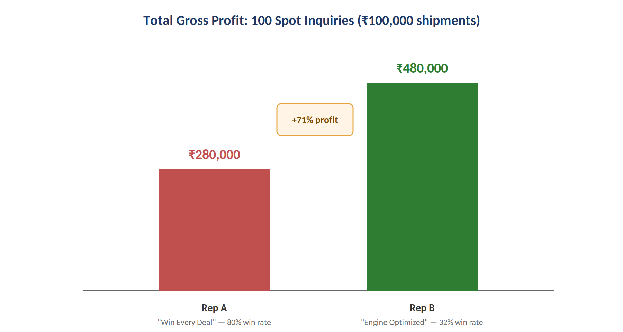
Figure 2 — Rep B earns 71% more gross profit than Rep A despite winning far fewer deals.

Why Rep B Wins
- Rep B made 71% more profit while doing less than half the operational work.
- Rep A spent their entire month chasing documentation, solving customs delays, and managing collection calls for 80 shipments, only to make a fraction of the profit.
- Rep B worked smarter, not harder.

4. Practical Logistics Scenarios: When to Quote High vs. Low Win Rates
The engine adapts its recommendations depending on who you are quoting and what you are shipping:
Scenario 1: The One-Off Spot Shipper (Rate-Shopper)
The Situation: A shipper you have never heard of calls asking for a spot rate on 500 kg to Frankfurt.
Customer Behavior: They have zero loyalty. If you quote them at 3% today, they will still leave you next week for another forwarder who is 50 paise cheaper.
Engine Recommendation: High Margin (16%–22%), Win Prob ~30%.
Why You Use It: Why give away your margin to a stranger? If they accept, you make great money. If they decline, you didn't waste operations capacity on junk freight.
Scenario 2: The Core Key Account (Contract Shipper)
The Situation: A major enterprise client who ships 30+ times a year with you (e.g., Skynet Express or Allanasons).
Customer Behavior: They value your reliable space access, dedicated account rep, and tracking support.
Engine Recommendation: Low/Fair Margin (4%–7%), Win Prob 75%–90%.
Why You Use It: The engine automatically activates the Account Retention Guardrail. It protects long-term relationship value and never risks losing a key client over a temporary price spike.
Scenario 3: Breaking into a Dream Target Account ("Land & Expand")
The Situation: A massive pharma manufacturer you have been trying to sign for 6 months finally gives you one trial shipment.
What You Should Do in the App: Change the Strategy Dropdown from "Balanced" to "Volume."
Engine Recommendation: Margin flexes down (3%–5%), Win Prob jumps to 55%–70%.
Why You Use It: Your goal here is not immediate profit; it is getting an approved vendor code and proving operational excellence.
Scenario 4: Peak Season / Constrained Airline Space
The Situation: Mid-May mango flush or October pre-holiday surge. Cargo flights are packed, airlines are offloading freight, and rates are surging daily.
What You Should Do in the App: Change the Strategy Dropdown to "Skimmer."
Engine Recommendation: High Margin (20%–30%), Win Prob 15%–25%.
Why You Use It: Airline capacity is scarce. Shippers will pay top dollar for guaranteed space. Only take the most profitable cargo.

5. Sales Rep Cheat Sheet: 4 Golden Rules for Everyday Quoting
QUICK REFERENCE CARD
1. 30% ON SPOT IS NORMAL
In a 4-way RFQ, winning 1 in 3 quotes at healthy profit is a win.
2. DO NOT CHASE 90% WIN RATES
Winning 90% of spot deals means you are underpricing and working for free.
3. USE THE STRATEGY DROPDOWN
- Balanced (Default 80% of time): Best overall profit
- Volume (15% of time): New accounts & space filling
- Skimmer (5% of time): Urgent, peak & spot cargo
4. HEAVY VS LIGHT RULES
- Cargo >1,000kg: Thin % margin is fine (rupee profit is huge).
- Cargo <100kg: High % margin is mandatory (covers overhead).

6. Frequently Asked Questions (FAQ)
Q: "What should I tell my customer if they say my quote is too high?"
A: Remind them of your service differentiation: "Our rate includes guaranteed airline uplift, dedicated customs clearance oversight, and 24/7 proactive milestone tracking. If you need a deferred 4-day transit option at a lower price point, I can check if secondary carrier space is available." (Do not immediately drop margin on the primary flight).
Q: "Can I manually adjust the quote below the engine recommendation?"
A: Yes, the engine is a smart recommendation tool, not a handcuff. If you have unique market intelligence (e.g., you know a competitor has an exclusive charter on that route), you can adjust. But if you find yourself discounting on every single deal, check whether you are giving away profit unnecessarily.
Q: "Why does the model suggest a 20% margin on small parcels (<50kg)?"
A: Because operational overhead (airway bill generation, carting, customer service, billing) is fixed. A 4% margin on a ₹10,000 shipment is only ₹400—which does not cover your team's administrative costs. Small shipments must support higher percentage margins.

