**Mini Project Report on**



**HEART DISEASE PREDICTION**

**WITH PYTHON**

**MACHINE LEARNING**



**Submitted in partial fulfillment of the requirement for the award of the degree of**

**BACHELOR OF TECHNOLOGY**

**IN**

**COMPUTER SCIENCE & ENGINEERING**

**Submitted by:**

**Abhinav Shukla**  **University Roll No. 2016561**

***Under the Mentorship of***

**Dr. Sharon Christa**



**Department of Computer Science and Engineering**

**Graphic Era (Deemed to be University)**

**Dehradun, Uttarakhand**

**January 2023**



**CANDIDATE’S DECLARATION**

I hereby certify that the work which is being presented in the project report entitled **“Heart disease prediction with python in Machine learning”** in partial fulfillment of the requirements for the award of the Degree of Bachelor of Technology in Computer Science and Engineeringof the Graphic Era (Deemed to be University), Dehradun shall be carried out by the under the mentorship of **Dr. Sharon Christa,** Department of Computer Science and Engineering, Graphic Era (Deemed to be University), Dehradun.

Name: Abhinav Shukla University Roll no: 2016561

**Table of Contents**

|  |  |  |
| --- | --- | --- |
| **Chapter No.** | **Description** |  |
| Chapter 1 | Introduction |  |
| Chapter 2 | Methodology |  |
| Chapter 3 | Tools used |  |
| Chapter 4 | Result and Discussion |  |
| Chapter 5 | Conclusion and Future Work |  |
|  | References |  |

**Chapter 1**

**Introduction**

In the following sections, a brief introduction and the problem statement for the work has been included.

* 1. **Introduction**

Due to poor lifestyle heart diseases are increasing at a rapid rate. A build up of fatty plaques in the arteries is one of the most common cause of heart diseases.

Treatment of heart disease is very complex and hard and because of this it is very important and very concerning to predict any such disease beforehand so that it can be prevented.

This project mainly focuses on the patients who are most likely to have heart diseases. The model uses a supervised algorithm by which we can predict if anyone has a heart disease on the basis of various medical attributes.

Algorithms like logistic regression is used in this heart disease prediction machine to predict and classify the patient with heart disease.

Accuracy more than 75 % is considered very good in machine learning models and this model shows a accuracy of 85.6% on the training data and accuracy of 82.4% on the test data.

The parameters used in this model to predict the diseases are Blood test result, cholesterol level, chest pain level , age, sex etc.

There are several risks involved in the manual treatment of a heart diseases.

With such well defined parameters and such advance technology in machine learning and data science , a data driven approach can surely help in Heart disease prediction.

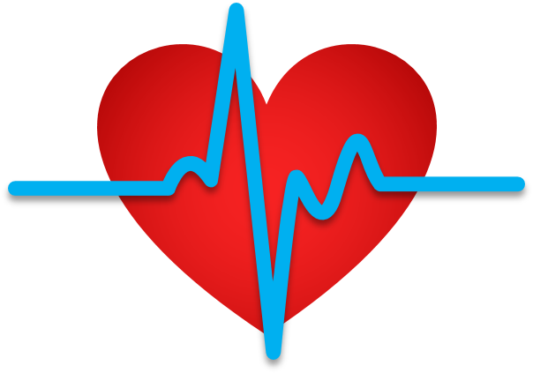

**Chapter 2**

**Methodology**

The methodology by which the model was made is given below: -

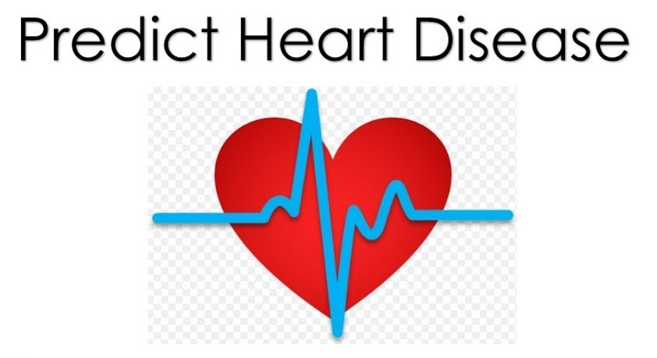

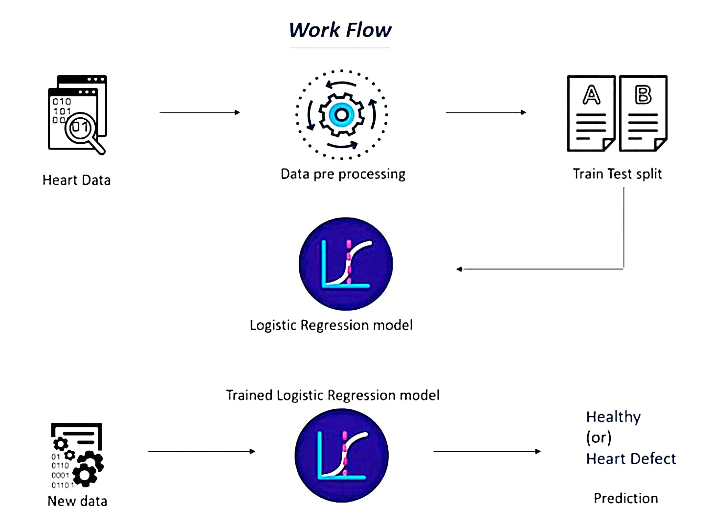

1. **Import the required packages**

**--**Import numpy and pandas libraries.

--From sklearn import train test split , logistic regression and accuracy score.

1. **Load the heart attributes dataset.**

**--**https://drive.google.com/file/d/1--0kdIeTvN9OE2ga5bu8OdSSYXFp-B91/view?usp=share_link

1. **Split the data into training and test data.**
2. **Train the model with the help of logistic regression algorithm.**
3. **Evaluate the accuracy of the model.**
4. **Input the data to be tested and build a predictive system to predict output.**

**Chapter 3**

**Tools used**

1. Python language is used to create the model.
2. Numpy, pandas and sklearn kit is used.
3. Py_charm and google collab integrated development environment is used.

**Chapter 4**

**Result and Discussion**

This project gives us a very powerful trained machine to predict heart diseases.

Normally an accuracy of 75 % is considered very good in machine learning models but in this model we get an accuracy of 85.6 % on training data and an

accuracy of 82.4 % on the test data.

The predictive system in this model predicts output as binary numbers i.e. 0 and 1

**0=>** Healthy heart

**1**=> Defective heart

The output get is on the basis of the data the machine is trained with.

If the output is 0 then the heart of the patient is healthy but if the output is 1 then the patient has heart disease and there are high chances of heart problems.

**Chapter 5**

**Conclusion and Future Work**

The above project tells us about the importance of computer science, specially machine learning, in this age of advancement.

We can now train various model with the help of datasets for either detection of any defects in the heart or the risks of any heart problem in future.

Machine leaning models can be fast in predicting diseases.

Looking at such models we get to see the importance of computer science machine learning in the healthcare field.

In the future, machine learning can be mixed with artificial intelligence and brain computer interfaces. It will be a very big step in the healthcare domain.

We will be able to get neural data and predict multiple diseases much faster and more efficiently.

**References**

**[1]** Article contributed by : Venugopalkamba, “Multiple disease prediction in machine learning” <https://www.geeksforgeeks.org/disease-prediction-using-machine-learning/>

**[2]** Research gate.net articles on various machine learning techniques.

**[3]** JavaTpoint <https://www.javatpoint.com/machine-learning> to get a ‘Introduction to Machine learning’.

**[4]** Md. Redwan Karim Sony on Kaggle heart disease data.