

Practices for Secure Software Report

Table of Contents
Document Revision History 3
Client 3
Instructions 3
Developer 4
1. Algorithm Cipher 4
2. Certificate Generation 4
3. Deploy Cipher 4
4. Secure Communications 4
5. Secondary Testing 4
6. Functional Testing 4
7. Summary 4
8. Industry Standard Best Practices 4

Document Revision History

Version | Date | Author | Comments
1.0 | 02/18/2026 | David Silva | Initial secure refactor and verification

Client



Instructions

Submit this completed practices for secure software report. Replace the bracketed text with the relevant information. You must document your process for writing secure communications and refactoring code that complies with software security testing protocols.

- Respond to the steps outlined below and include your findings.
- Respond using your own words. You may also choose to include images or supporting materials. If you include them, make certain to insert them in all the relevant locations in the document.
- Refer to the Project Two Guidelines and Rubric for more detailed instructions about each section of the template.

Developer
David Silva

Algorithm Cipher

To improve data integrity within the Artemis Financial application, I implemented the SHA-256 cryptographic hashing algorithm. The goal of this change was to provide a mechanism for verifying that data transmitted through the application has not been altered or tampered with.
SHA-256 belongs to the SHA-2 family of cryptographic hash functions and produces a fixed 256-bit output (represented as 64 hexadecimal characters). This algorithm was selected because it provides strong collision resistance and preimage resistance. Collision resistance means that it is computationally infeasible for two different inputs to produce the same hash output. Preimage resistance means that it is not practical to reverse the hash to determine the original input.
Older hashing algorithms such as MD5 and SHA-1 are known to have documented weaknesses and are vulnerable to collision attacks. Because of this, they are no longer recommended for cryptographic integrity verification in modern systems. SHA-256 remains widely accepted in industry standards and regulatory environments for secure hashing.
It is important to distinguish hashing from encryption. Encryption is reversible when the correct key is provided and is used to protect confidentiality. Hashing, on the other hand, is one-way and is used for integrity verification. In this project, SHA-256 is used strictly to verify that transmitted data has not been modified.
To verify correct implementation, I confirmed that the generated checksum output was 64 hexadecimal characters long, which confirms proper 256-bit operation. Additionally, modifying even a single character in the input produced a completely different hash output, demonstrating the avalanche effect characteristic of secure cryptographic hash functions.

Certificate Generation

To enable secure communication over HTTPS, I generated a self-signed SSL certificate using the Java Keytool plugin. During the initial attempt to run the application, the server failed to start because the application.properties file was already configured for HTTPS on port 8443, but all SSL values were placeholders and no keystore file had been created yet. This required troubleshooting to identify that the application was attempting to load a non-existent keystore.
A PKCS12 keystore (keystore.p12) was generated with the following configuration:
- Alias: snhu
- Algorithm: RSA
- Validity: 5 years
- Organization: SNHU
PKCS12 was selected instead of the older JKS format because PKCS12 is the modern industry standard and offers improved interoperability across platforms.
After generating the certificate, the keystore file was initially saved in the project root directory. However, Spring Boot loads SSL configuration files from the classpath. As a result, the keystore needed to be moved into src/main/resources so that it could be located at runtime. Once moved and referenced correctly in application.properties, the embedded Tomcat server started successfully on port 8443.
When accessed in the browser, a “Not Secure” warning was displayed. This behavior is expected because the certificate is self-signed and not issued by a trusted Certificate Authority. In a production deployment, Artemis Financial would use a CA-signed certificate to establish browser trust and eliminate this warning.

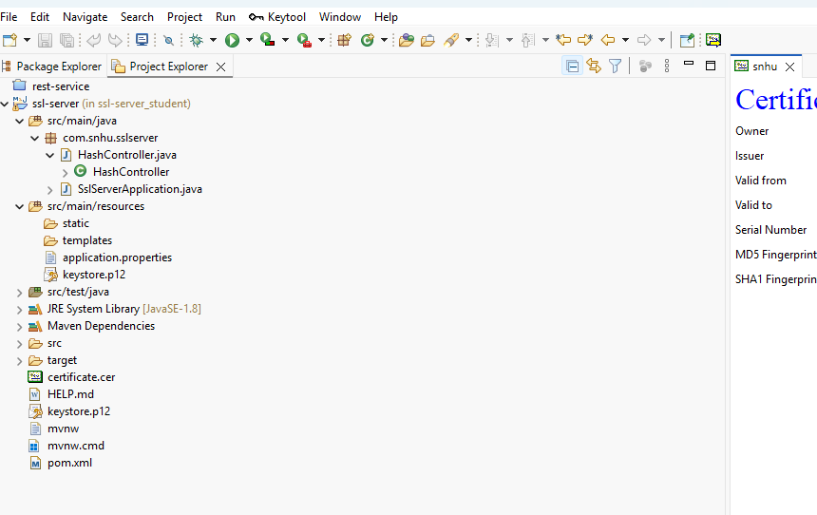

Deploy Cipher

The HashController class was implemented to expose a /hash endpoint that generates a SHA-256 checksum. The controller uses Java’s MessageDigest class to compute the hash and converts the resulting byte array into a hexadecimal string.
The endpoint was tested by navigating to:
https://localhost:8443/hash
The output displayed:
- Student name
- Original data string
- SHA-256 checksum
To confirm correct functionality, I modified the input string and observed that even a one-character change produced a completely different checksum. This confirms the avalanche property of SHA-256 and demonstrates proper implementation.
The final checksum produced was:
d80e284cdfe0f818207e8ee9b2e011a12931f3e4e34fac9b485c9219156c0b52
The 64-character output verifies correct SHA-256 operation and confirms the integrity verification functionality works as intended.

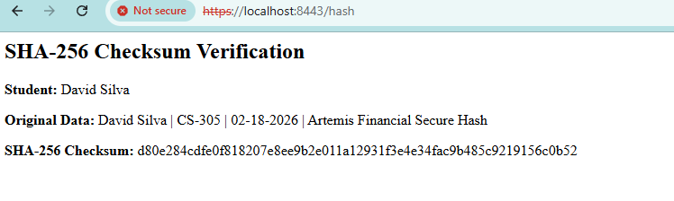

Secure Communications
The application was refactored to use HTTPS instead of HTTP. HTTP transmits data in plaintext, which makes it vulnerable to interception and man-in-the-middle attacks. HTTPS uses TLS (Transport Layer Security) to encrypt communication between client and server.

After configuring the keystore and updating application.properties, the application successfully started on port 8443 using HTTPS. I verified secure communications by accessing:

https://localhost:8443/hash

Although the browser displays a “Not Secure” warning due to the self-signed certificate, the presence of the https:// protocol confirms that communication is encrypted via TLS. The warning indicates a lack of trusted certificate authority validation, not a lack of encryption.

In a production environment, Artemis Financial would deploy a certificate signed by a trusted Certificate Authority to establish full browser trust. However, for development and testing purposes, the self-signed certificate provides encrypted transport and satisfies the security objective of protecting data in transit.

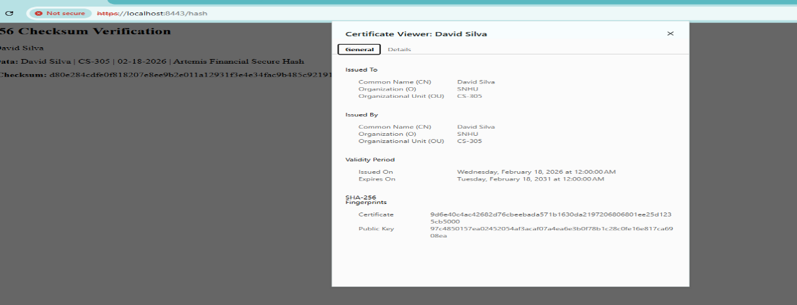

Secondary Testing

To evaluate third-party dependency risk, OWASP Dependency-Check was integrated into the Maven build process.
The project initially included dependency-check-maven version 5.3.0, which failed with a 403 error due to outdated NVD API access requirements. To resolve this issue, the plugin was upgraded to version 12.2.0 in the pom.xml file. This update allowed successful retrieval of vulnerability data from the National Vulnerability Database.
Two scans were performed:
BEFORE refactoring
AFTER refactoring
The first scan downloaded approximately 333,000 vulnerability records and required over 20 minutes to complete because the vulnerability database was not cached locally. The second scan completed in under 20 seconds due to cached data.
The vulnerabilities identified in both scans were identical. These vulnerabilities were associated with older framework components, including Spring Boot 2.2.4 and its related dependencies such as Tomcat, Jackson Databind, and Log4j.
Most importantly, the AFTER scan confirmed:
- No new dependencies were introduced.
- The SHA-256 implementation did not introduce new vulnerabilities.
- The HTTPS configuration did not expand the attack surface.
The remaining vulnerabilities are tied to outdated framework versions and would require upgrading the Spring Boot parent dependency, which is outside the scope of this assignment.

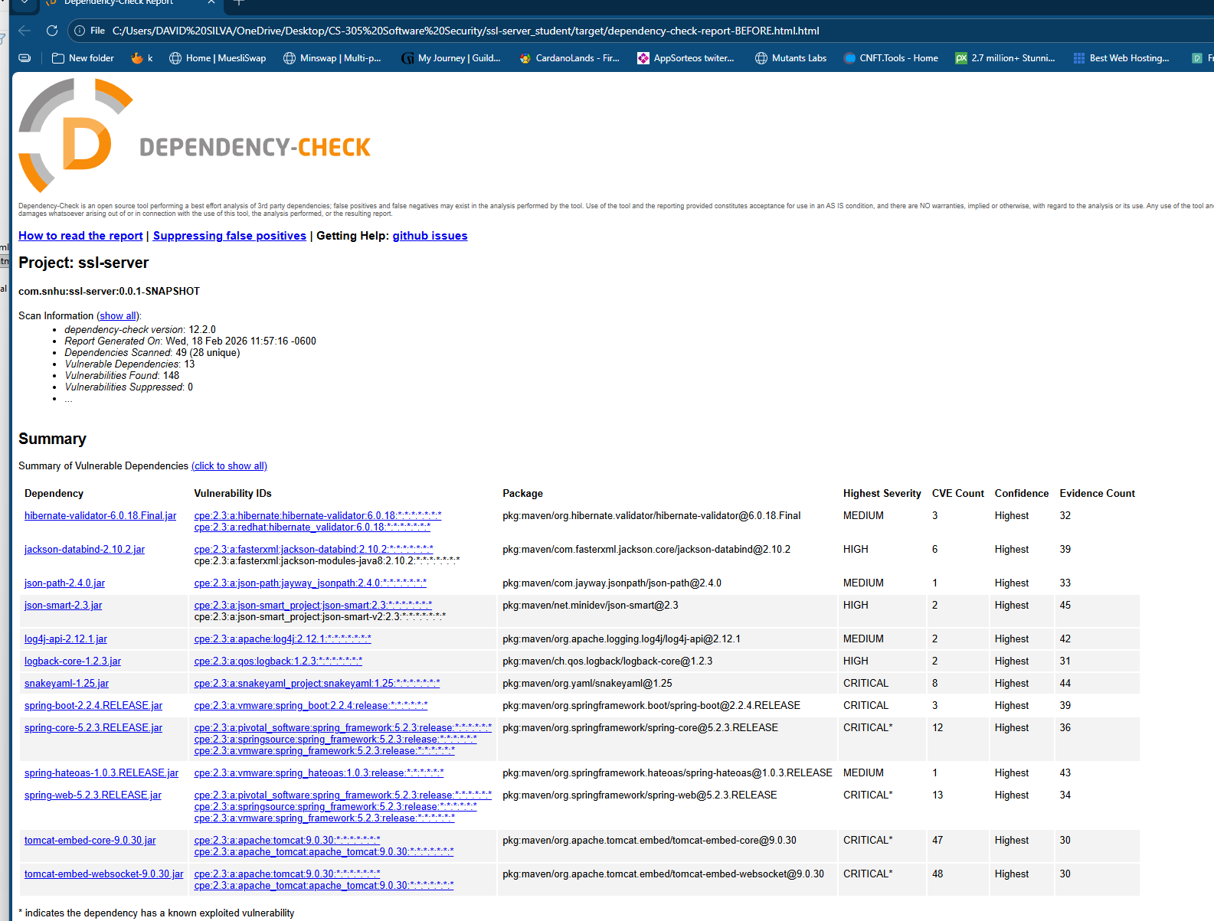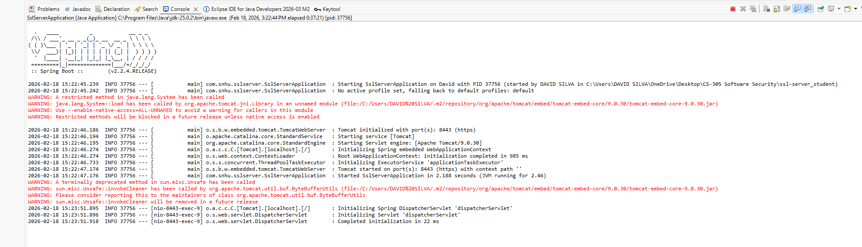

Functional Testing
Insert a screenshot below of the refactored code executed without errors.

After completing the refactor, I performed manual functional testing to verify that the application executed without runtime errors and that all security enhancements worked correctly.
The embedded Tomcat server successfully started on port 8443 without errors. The /hash endpoint returned the expected SHA-256 output over HTTPS.
Using the Vulnerability Assessment Process Flow Diagram
CS 305 Vulnerability Assessment…
as guidance, I evaluated the following areas:
- Architecture Review: Verified secure HTTPS configuration.
- Input Validation: Confirmed input is handled as data and does not expose execution paths.
- APIs: Confirmed only required endpoint is exposed.
- Cryptography: Verified correct SHA-256 implementation.
- Client/Server: Confirmed TLS encryption in transit.
- Error Handling: Ensured exceptions are handled safely.
- Code Quality and Encapsulation: Verified clear structure and proper visibility.
The application executed successfully without errors, confirming correct integration of security improvements.

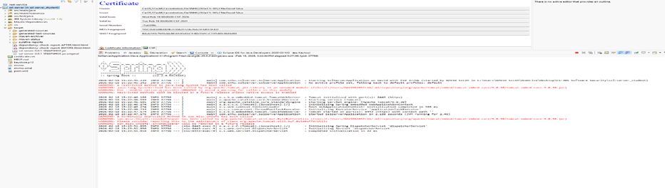

Summary

This project strengthened the security posture of the Artemis Financial application by improving both data integrity and transport security. The implementation of SHA-256 provides reliable checksum verification to detect data modification. The transition from HTTP to HTTPS ensures encrypted communication between client and server.
Throughout the process, several technical issues were encountered, including keystore configuration errors, outdated dependency-check plugin failures, and Maven build folder locking. Each issue was resolved through systematic troubleshooting and verification.
The OWASP dependency-check comparison confirmed that no additional vulnerabilities were introduced by the refactoring. While legacy framework vulnerabilities remain, those are tied to outdated Spring Boot components and are outside the scope of the current refactor.
Overall, the application now demonstrates improved compliance with secure coding standards and best cryptographic practices.

Industry Standard Best Practices

The following secure development practices were applied:
- Use of modern cryptographic hashing (SHA-256).
- Avoidance of deprecated algorithms (MD5, SHA-1).
- Encryption of data in transit via TLS.
- Static analysis of third-party components using OWASP Dependency-Check.
- Verification of security changes through before-and-after comparison.
- Proper certificate storage using PKCS12 format.
- Limited endpoint exposure to reduce attack surface.
These measures align with OWASP Top 10 categories, particularly:
- A02: Cryptographic Failures
- A06: Vulnerable and Outdated Components
By implementing these practices, the application better protects customer financial information and reduces risk to Artemis Financial’s operations and reputation.

