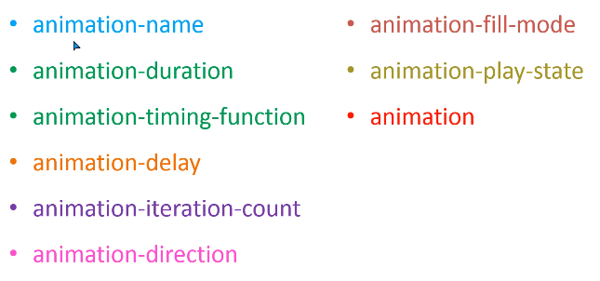

@keyframes *animationname*{*keyframes-selector*{*css-styles;}*}

@keyframes fram {

   from{

    color: red ;

}

    to{

        color: blue ;

    }

}

* Animation-name:

it declare the which animation you want to use for the selected element.

* Animation-duration:

It use to set the duration of animation effect in sec, milisec

Ex. Animation-duration:3s;

It will show the changes in 3 seconds

* animation-iteration-count:3;

it decide that who many times we want to repeat the animation.

animation timing function

