Name: Anurag Kumar Singh
Roll No:- 202401100100057
Branch:- CS
Sec:- A

GitHub repository URL:- https://github.com/DevAnurag9/github-skills-challenge

Screenshot showing the GitHub Actions workflows

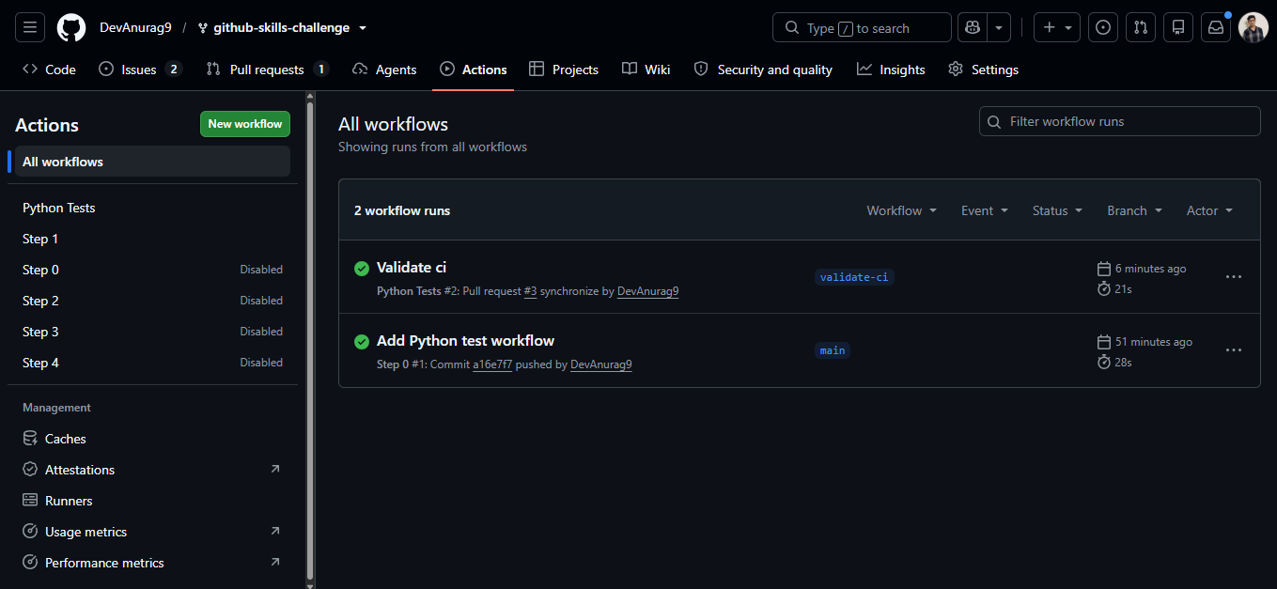

Screenshot showing a successful test workflow execution
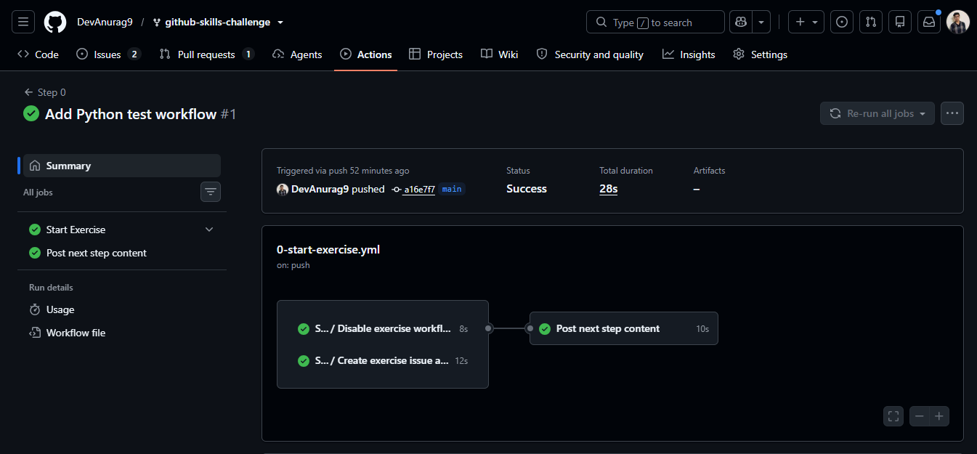
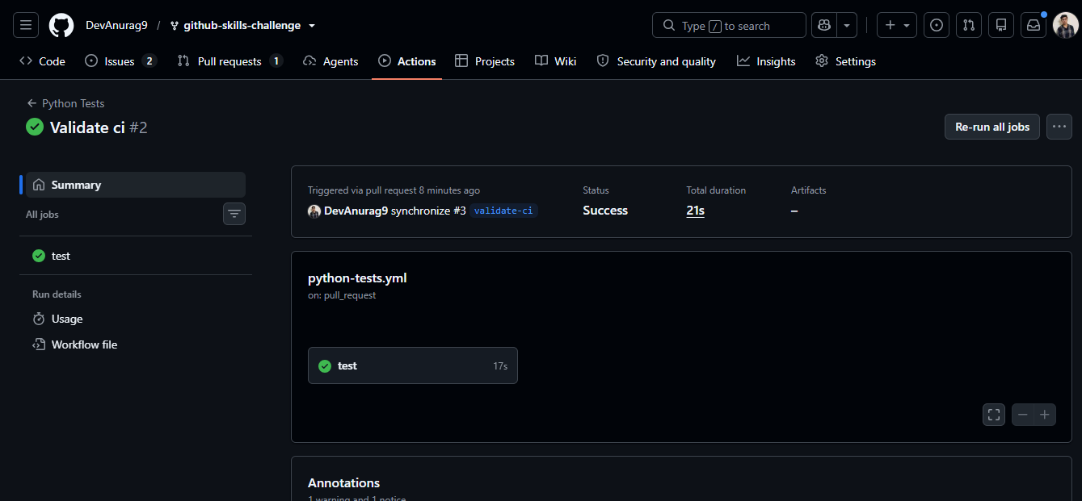

Screenshot showing the coverage result/comment on the pull request
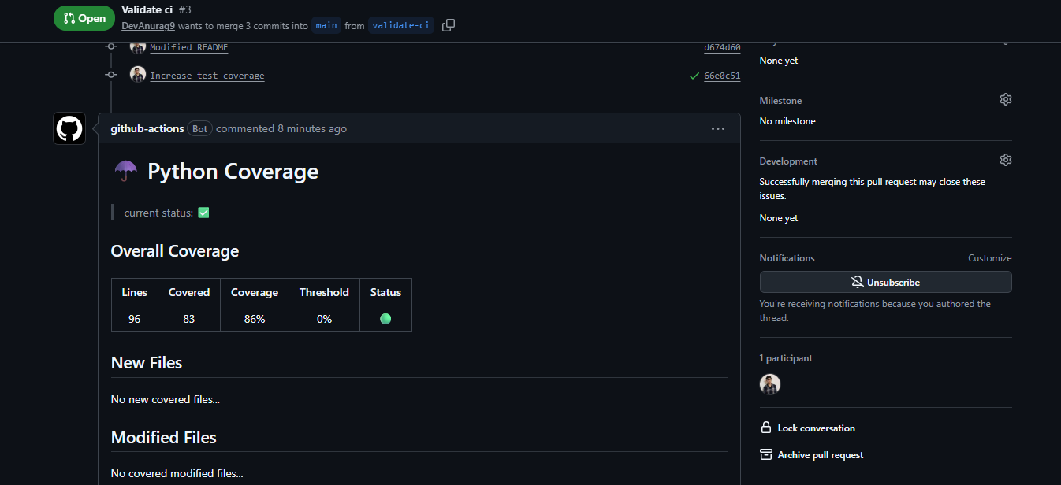

Screenshot showing the final repository/workflow files
