LSTM Architecture Changes for Stockout Prediction
A beginner-friendly explanation of what we changed, why we changed it, and what worked best
Plain idea: We started from a normal LSTM, then changed the architecture step by step to make it more suitable for stockout prediction. Our final best model does not just remember history. It also directly looks at the latest inventory state.

1. Final architecture in simple words
Mentor-ready explanation: Our final model is a dual-stream LSTM with an inventory-only shortcut. One branch learns demand and context history, the second branch learns inventory history, and a direct shortcut gives the model the most recent inventory signal. This helps because next-day stockout depends on both temporal behavior and the latest inventory state.
- Input to the model: last 14 days of data for one SKU-series.
- Demand/context branch sees: sale_amount, discount, holiday_flag, hours_sale_sum.
- Inventory branch sees: stock_hour6_22_cnt, hours_stock_status_sum.
- Shortcut adds only the latest inventory features from the most recent day.
- Output is 24 values for the next day, one for each hour.
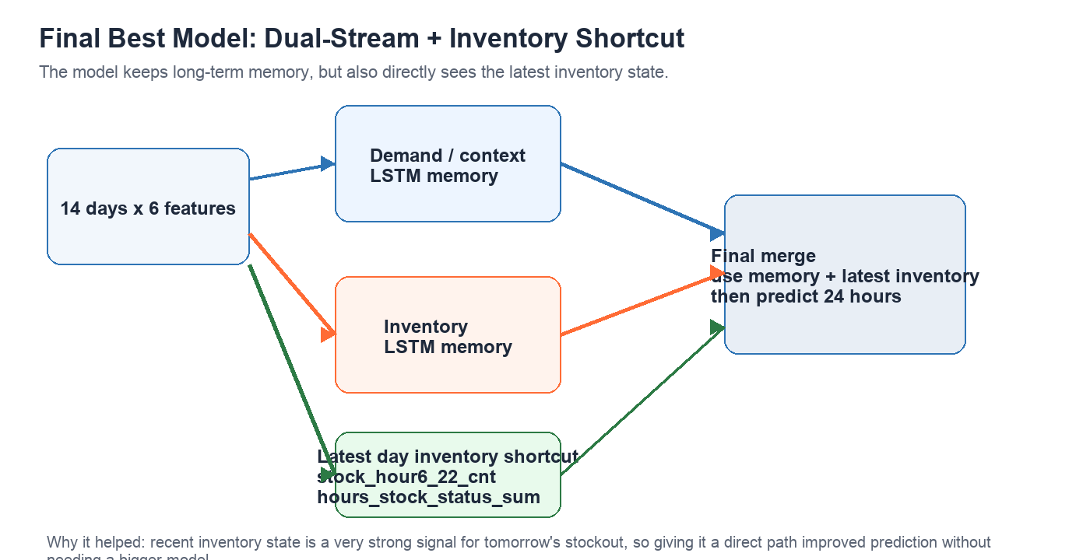

2. What an LSTM is doing
An LSTM is a sequence model. It reads one day after another and tries to build a memory of what matters. In our case, that means it watches the recent sales and stock pattern, then predicts tomorrow's stock behavior.
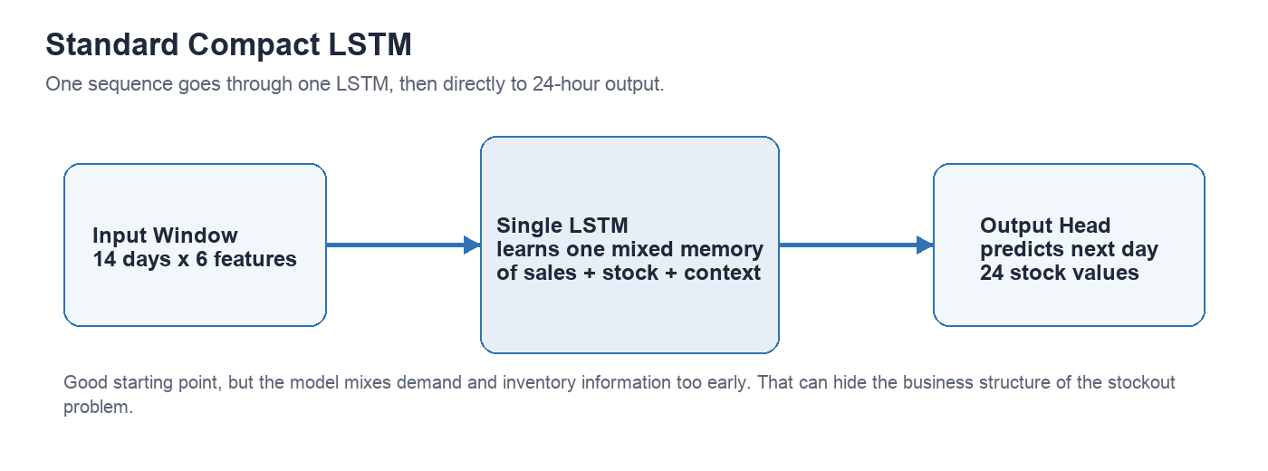
- Standard LSTM is useful because it can learn temporal patterns.
- But it mixes all features together very early.
- That can hide an important fact: stockout is caused by interaction between demand and inventory, not by one generic signal.

3. Architectural changes we tried
We did not change everything at once. We changed one idea at a time, checked the result, and kept only what helped.

3.1 Compact feature-reduced baseline
Before trying custom architectures, we first simplified the original LSTM. We reduced the hidden size and kept only the 6 most useful features. This already gave a very strong baseline.
- Result: F1 = 0.7897, parameters = 5,912.
- Lesson: a smaller LSTM was enough for this short-window problem.

3.2 CIFG-LSTM
CIFG means Coupled Input-Forget Gate. In a normal LSTM, input gate and forget gate are learned separately. In CIFG, forget gate becomes 1 minus input gate. So the model is simpler.
- What changed: fewer learned gates inside the recurrent cell.
- Why we tried it: reduce complexity without losing much performance.
- Result: F1 = 0.7650, parameters = 4,536.
- What happened: it became smaller, but performance dropped too much.

3.3 Dual-stream LSTM
Instead of sending all 6 features into one LSTM, we split them into two groups. This makes the model closer to the real business logic of stockout.
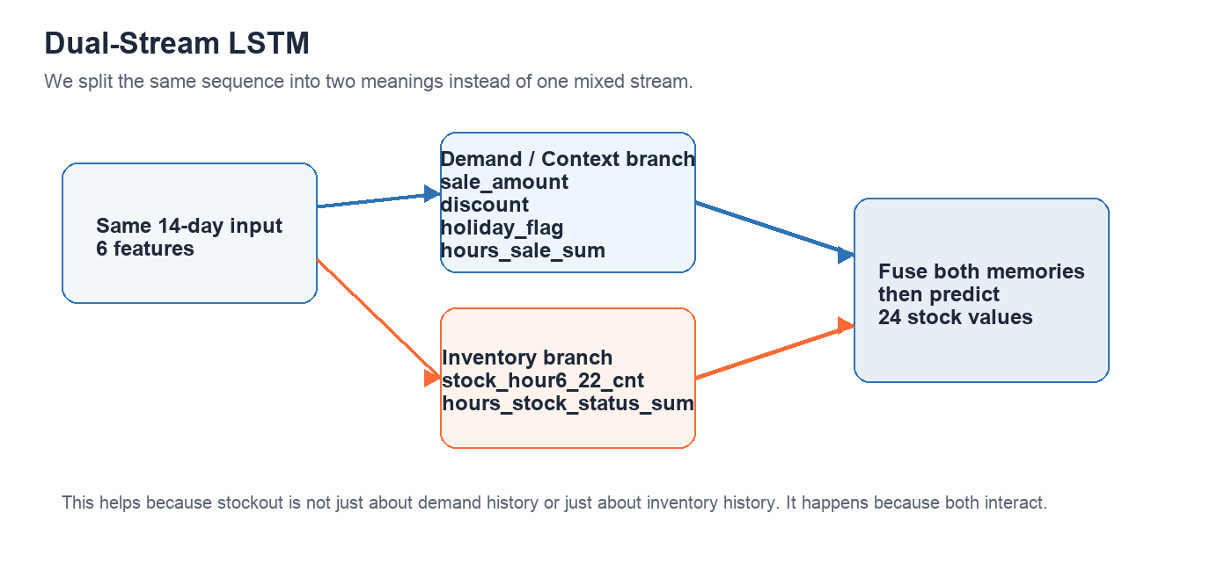
- What changed: one branch learned demand/context history and one branch learned inventory history.
- Why we tried it: stockout depends on both, and they play different roles.
- Result: F1 = 0.7879, parameters = 4,536.
- What happened: the model stayed compact and became more meaningful for this use case.

3.4 Full shortcut from latest day
Next we asked: what if long memory is not enough? Maybe the latest day itself contains a very strong clue for tomorrow. So we added a direct shortcut from the last day's raw features to the final prediction stage.
- What changed: final prediction used both branch memory and all latest-day features.
- Result: F1 = 0.7914, parameters = 4,728.
- What happened: performance improved. This showed that direct current-state information helps.

3.5 Inventory-only shortcut
Then we made the shortcut more selective. Instead of sending all latest-day features directly, we only passed the latest inventory features. This was our most important idea.
- What changed: shortcut kept only stock_hour6_22_cnt and hours_stock_status_sum from the latest day.
- Why we tried it: tomorrow's stockout should depend more on latest inventory state than on every raw feature.
- Result: F1 = 0.7926, parameters = 4,600.
- What happened: this became the best model overall.

3.6 Smaller shortcut model
We also checked whether we could shrink the shortcut model further and still keep similar performance.
- What changed: branch hidden sizes reduced from 16+16 to 12+12.
- Result: F1 = 0.7891, parameters = 2,976.
- What happened: performance stayed close to baseline while parameter count dropped a lot. This is a good lightweight option.

4. Results table
Model | Main change | Parameters | F1 | Beginner takeaway
Compact reduced LSTM | Smaller baseline | 5,912 | 0.7897 | Strong baseline
CIFG-LSTM | Simpler gates | 4,536 | 0.7650 | Smaller, but weaker
Dual-stream LSTM | Demand and inventory split | 4,536 | 0.7879 | More meaningful structure
Dual-stream + full shortcut | Latest day full shortcut | 4,728 | 0.7914 | Current state helps
Dual-stream + inventory shortcut | Latest inventory shortcut only | 4,600 | 0.7926 | Best overall model
Dual-stream + smaller shortcut | 24 hidden units total | 2,976 | 0.7891 | Best light model

5. Final takeaway
- A plain large LSTM was not the best answer for our problem.
- Splitting demand history and inventory history was a useful architectural change.
- The latest inventory state mattered more than a generic shortcut from every latest feature.
- Our best model is the dual-stream LSTM with inventory-only shortcut.
- If we want a lighter model, the 12+12 shortcut version is a good compact alternative.

6. One-line summary for mentor
We started from a compact LSTM baseline, then redesigned the architecture around the stockout problem. The best result came from a dual-stream LSTM that separately learns demand and inventory history, and then adds only the latest inventory features through a shortcut path. This improved F1 while keeping the model smaller than the earlier compact baseline.

