Skin Disease Classifier
Student Group Project Report
Applied Image Processing
Academic Year: 2025-2026
Submission Date: 21 April 2026

Prepared by: Group 19
Anurag Thakur 2023IMG-008
Baviskar Pratik Subhash 2023IMG-014
Kshitij Dhamanikar 2023IMG-029
Kushagra Agarwal 2023IMG-030
Vibhor Kumar 2023IMG-054

Abstract
This report presents a complete machine learning workflow for automated skin disease image classification. The final system uses a Vision Transformer (ViT)-based weighted ensemble for 8-class prediction. Compared to a single promoted ViT baseline, the final ensemble improves overall accuracy and macro-level metrics substantially. The deployment-ready artifacts were integrated into a Flask web application runtime and validated through class-wise metrics, confusion analysis, and leakage-aware evaluation checks.
Final ensemble metrics on the main test split: Accuracy=0.8533, Macro Precision=0.8610, Macro Recall=0.8533.

Keywords
Skin disease classification, Vision Transformer, Ensemble learning, Medical image analysis, Deep learning

1. Introduction
Skin disorders are common and often require timely assessment. Automated classification tools can support screening, education, and decision support when designed with clear limitations. This project focuses on building a practical, reproducible image classification pipeline under CPU-only constraints while maintaining strong model quality.

1.1 Problem Statement
Given an input skin image, classify the disease category among 8 predefined classes: acne, bcc, bkl, eczema, ak, melanoma, psoriasis, and tinea.

1.2 Objectives
- Build CPU-friendly ViT training and evaluation workflows.
- Improve model quality through controlled ensemble optimization.
- Integrate final model configuration into application runtime.
- Produce clear metrics, plots, and report artifacts for academic submission.
- Validate performance with leakage-aware checks for reliability.

1.3 Scope and Limitations
The system is intended for educational and research use and is not a replacement for clinical diagnosis. Model performance is dataset-dependent and can degrade on unseen data domains.

2. Dataset and Experimental Setup
Experiments were run on curated split folders with balanced class representation in the test split. The final evaluated split consists of 184 total images with 23 images per class.
Item | Value
Primary evaluation split | datasets/hf_hybrid_150/splits/test
Number of classes | 8
Total test samples | 184
Samples per class | 23
Runtime environment | CPU-only training/evaluation
Model family | Vision Transformer (ViT)

2.1 Leakage-Aware Evaluation Note
Because some dataset versions may share source images, leakage-safe subset checks were used to validate whether gains persist after excluding overlapping train/validation references from expanded dataset variants.

2.2 Experimental Protocol
- Train multiple ViT checkpoints with varied augmentation and regularization profiles.
- Evaluate checkpoints on common split for comparability.
- Search ensemble weights for improved accuracy and stability.
- Promote best-performing ensemble into runtime config.

3. Model Architecture and Pipeline
The final predictor is a weighted softmax ensemble over four ViT checkpoints. Each member contributes probabilities according to fixed weights, and the class with maximum weighted probability is selected.
Ensemble Member | Model Path | Weight
strict80_tiny160 | artifacts/vit_strict80_tiny160/best_model.pt | 0.50
220_tiny224_lowaug | artifacts/vit_220_tiny224_lowaug/best_model.pt | 0.40
150_tiny224_lowaug | artifacts/vit_150_tiny224_lowaug/best_model.pt | 0.05
150_tiny160 | artifacts/vit_150_tiny160/best_model.pt | 0.05
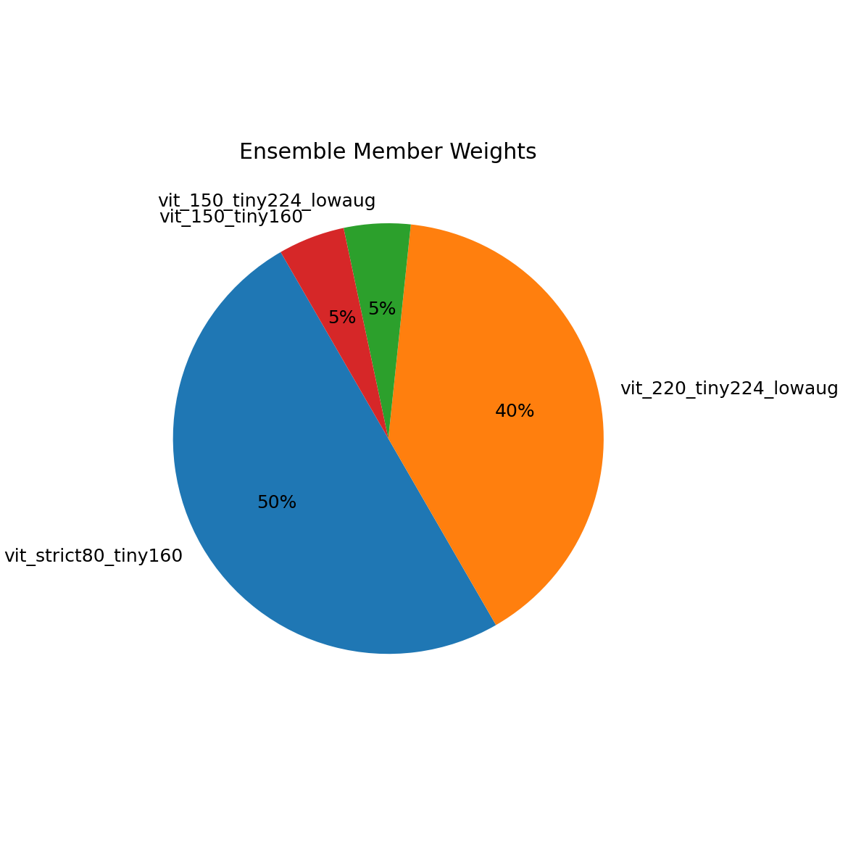
Figure 1: Final ensemble member weight distribution.

3.1 Deployment Path
- Runtime config: website/models/vit_ensemble.json
- Metrics export: website/models/vit_ensemble_metrics.json
- Confusion export: website/models/vit_ensemble_confusion.csv
- Serving interface: Flask application inference route

4. Final Quantitative Results
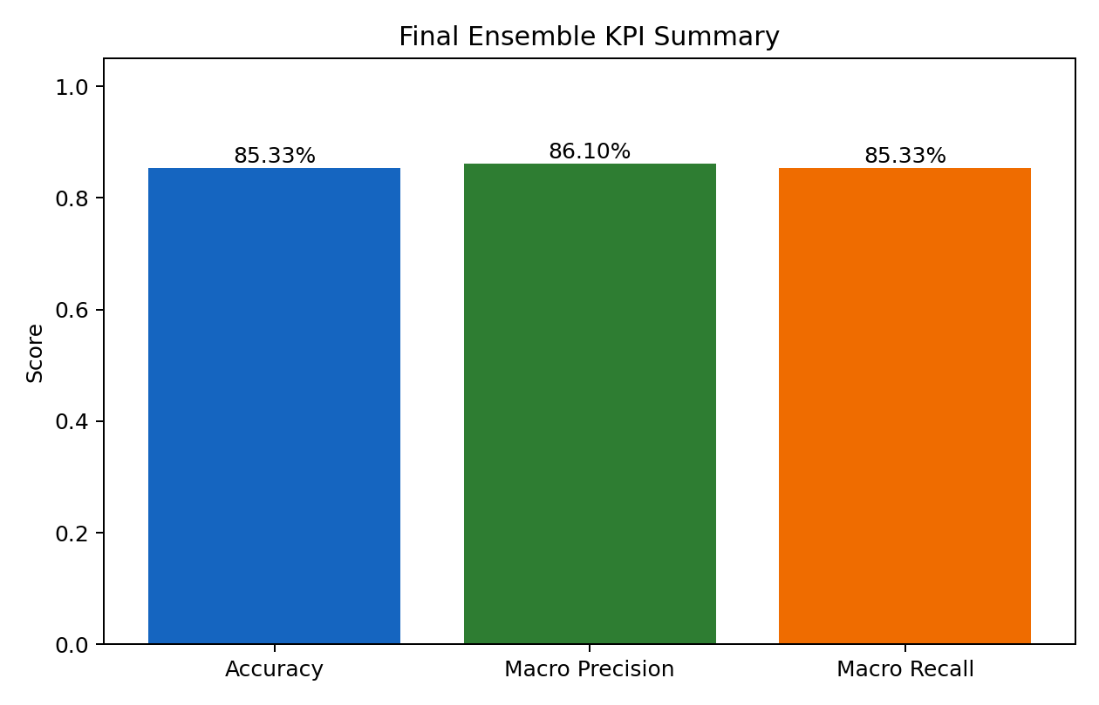
Figure 2: KPI summary of final ensemble.
Metric | Final Ensemble | Single ViT Baseline | Absolute Gain
Accuracy | 0.8533 | 0.7120 | +0.1413
Macro Precision | 0.8610 | 0.7036 | +0.1575
Macro Recall | 0.8533 | 0.7120 | +0.1413
The ensemble gives a clear and consistent improvement over the single baseline model across all primary aggregate metrics.

4.1 Class-wise Metrics
Class | Precision | Recall | Support
acne | 0.7931 | 1.0000 | 23
bcc | 0.8800 | 0.9565 | 23
bkl | 0.9091 | 0.8696 | 23
eczema | 0.8750 | 0.6087 | 23
ak | 0.9130 | 0.9130 | 23
melanoma | 0.9091 | 0.8696 | 23
psoriasis | 0.7143 | 0.8696 | 23
tinea | 0.8947 | 0.7391 | 23

5. Diagnostic Analysis
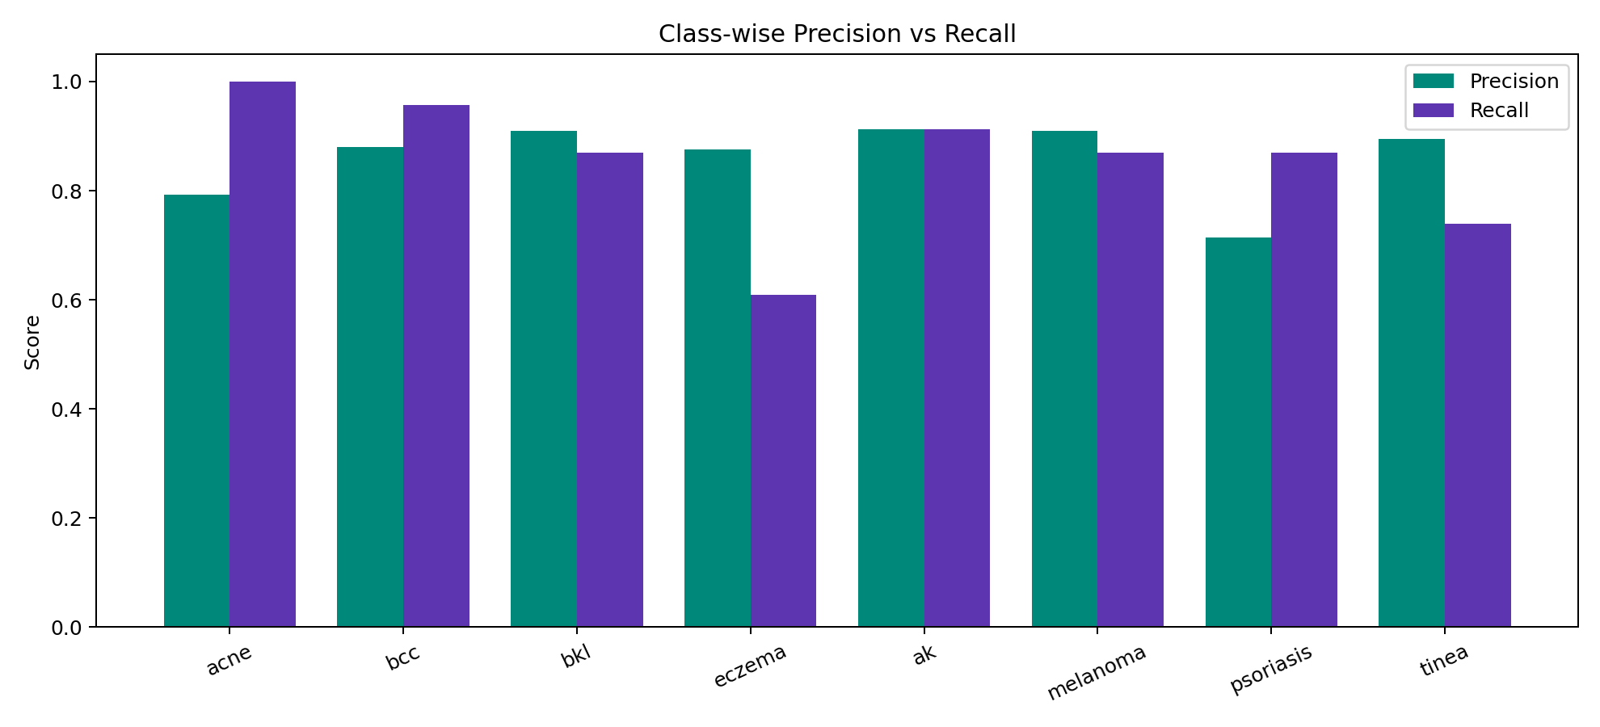
Figure 3: Precision and recall by class.
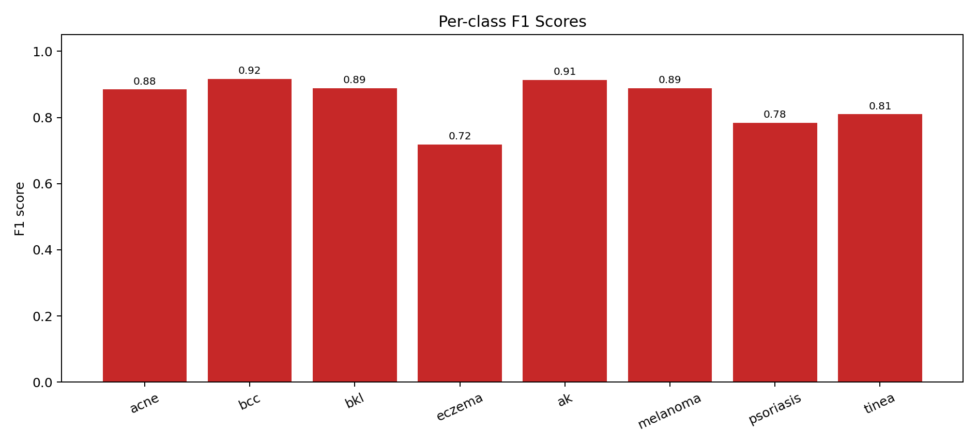
Figure 4: Per-class F1 score.

5.1 Key Findings
- Acne and BCC show strong recall and stable precision.
- AK and Melanoma maintain balanced performance.
- Eczema remains the most difficult class in recall.
- Tinea has high precision but lower recall, suggesting conservative prediction behavior.

6. Confusion and Prediction Distribution
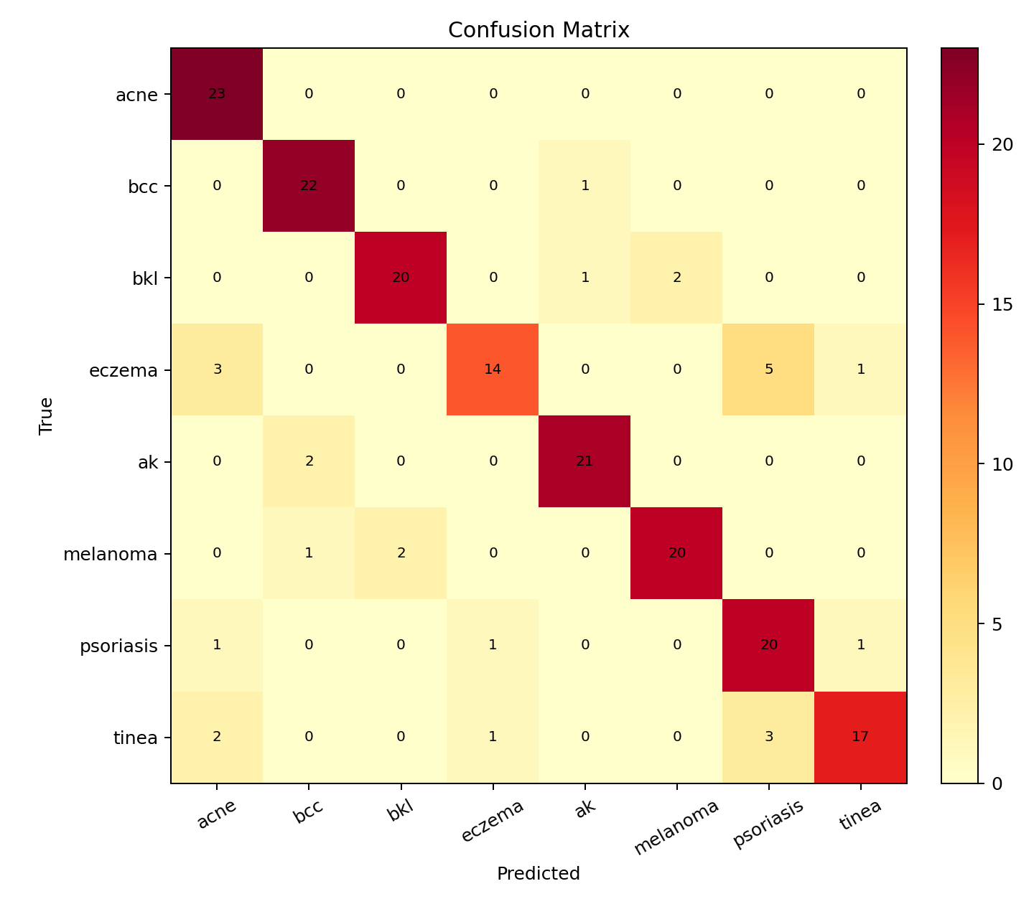
Figure 5: Confusion matrix heatmap.
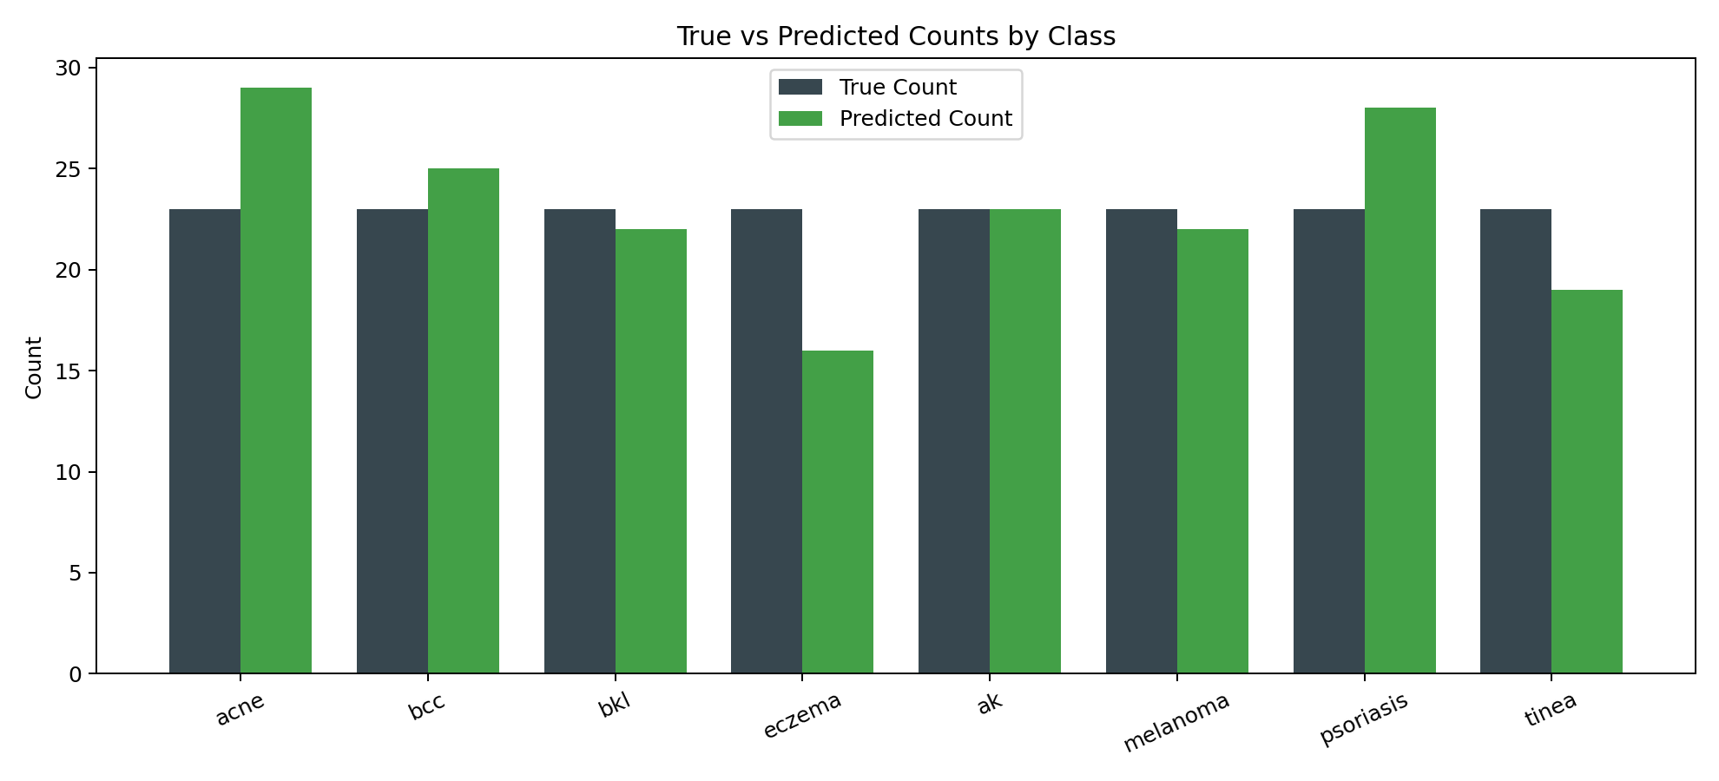
Figure 6: True vs predicted class counts.

6.1 Confusion Patterns
- Eczema has notable confusion with Psoriasis and Acne.
- AK occasionally overlaps with BCC.
- Tinea has occasional confusion with Psoriasis and Acne.
- Acne reached perfect recall in the final run.

6.2 Raw Confusion Table
true/pred | acne | bcc | bkl | eczema | ak | melanoma | psoriasis | tinea
acne | 23 | 0 | 0 | 0 | 0 | 0 | 0 | 0
bcc | 0 | 22 | 0 | 0 | 1 | 0 | 0 | 0
bkl | 0 | 0 | 20 | 0 | 1 | 2 | 0 | 0
eczema | 3 | 0 | 0 | 14 | 0 | 0 | 5 | 1
ak | 0 | 2 | 0 | 0 | 21 | 0 | 0 | 0
melanoma | 0 | 1 | 2 | 0 | 0 | 20 | 0 | 0
psoriasis | 1 | 0 | 0 | 1 | 0 | 0 | 20 | 1
tinea | 2 | 0 | 0 | 1 | 0 | 0 | 3 | 17

7. Risks, Ethics, and Limitations
- Performance remains below 90% target under CPU constraints.
- Visually similar classes can still produce boundary errors.
- Dataset overlap management remains critical for fair benchmarking.
- Uncertainty calibration and abstention are not yet implemented.

7.1 Ethical Note
This model is intended for educational and research use only. It is not a medical device and should not be used as a standalone diagnostic tool.

8. Conclusion and Future Work
The project successfully delivered an integrated ViT ensemble pipeline with strong improvements over baseline. The generated artifacts include deployable configuration files, quantitative reports, confusion diagnostics, and reproducible scripts.
- Train higher-capacity ViT backbones on strict non-overlap datasets.
- Introduce confidence calibration for safer prediction handling.
- Perform external benchmark validation for robustness estimation.
- Add monitoring hooks for model drift in deployment.

Appendix A: Artifact References
Artifact | Purpose
website/models/vit_ensemble.json | Final runtime ensemble configuration
website/models/vit_ensemble_metrics.json | Primary final metrics
website/models/vit_ensemble_confusion.csv | Confusion matrix values
docs/report_assets/*.png | Figures used in report and presentation
scripts/generate_project_report_docx.py | DOCX report generator

