
A Secure Next-Generation Solution for Seamless Payroll Compliance

# What we are?
WPS Nexus is a comprehensive and innovative business management solution that delivers unparalleled value to its customers. With its modular design, seamless integration capabilities, and exceptional customer support, WPS empowers businesses to streamline their operations, boost productivity, and drive strategic growth.
#solution
What we offer
Ensure seamless integration with financial institutions and banks by supporting multiple data formats and industry standards
Provide user-friendly interface for diverse users, from technical experts to non-technical stakeholders
Support scalable processing capabilities, efficiently handling both small datasets and large-scale operations

Key Features & Capabilities
Data upload & Management
Banking Integration
API Access
Visualization Tools

Batch Processing
User Management and Permissions
Reporting, Monitoring & collaboration
Reporting & Exporting
- Generate reports summarizing processing results.
- Export processed data in various formats for further use
Monitoring & Logging
- Track processing tasks and monitor performance
- Maintain logs for auditing and troubleshooting
Collaboration
- Allow multiple users to collaborate on projects
- Share results and datasets with stakeholders easily

Data Protection features


Ensures sensitive payroll data is secure
Data Encryption



Added layer of security for employers accessing the System
Two factor Authentication

99 % Accuracy in Payroll Validation – Automated compliance checks eliminate human error and enhance trust

Call to action
Talk to our Experts
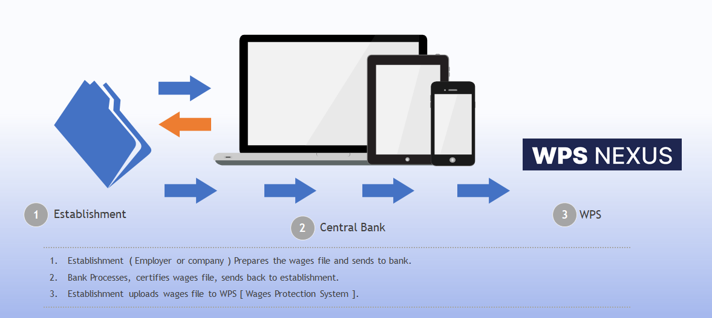
Work Flow

Salary Processing through WPS Nexus
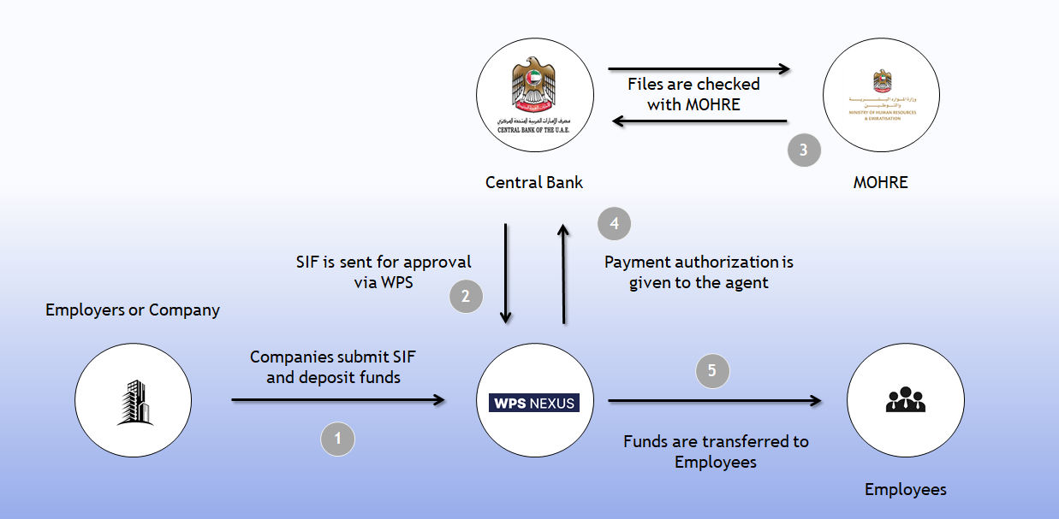
Real-Time Salary Disbursement – Ensure timely payments with instant transaction tracking and reporting

Let’s talk solution
Request a demo
Dashboard
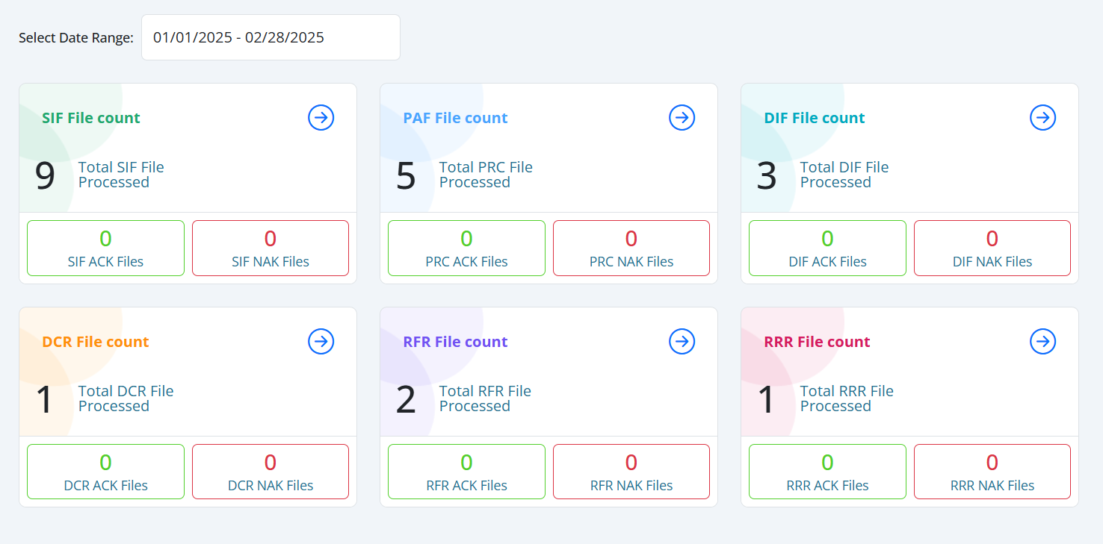

- Experience the Future of Business Efficiency with WPS Nexus.
- Ready to elevate your business operations and achieve greater efficiency?
- Explore the WPS Nexus solution and witness the power of integrated, intelligent business management firsthand.
- Schedule a personalized demo and see how WPS Nexus can transform the way you work.

Intuitive Dashboard – All your payroll and compliance data in one clean, user-friendly interface.

One click start your journey

