

A Secure Next-Generation Solution for Seamless Payroll Compliance

**# What we are?**

**WPS Nexus is a comprehensive and innovative business management solution that delivers unparalleled value to its customers. With its modular design, seamless integration capabilities, and exceptional customer support, WPS empowers businesses to streamline their operations, boost productivity, and drive strategic growth.**

**#solution**

**What we offer**

**Ensure seamless integration with financial institutions and banks by supporting multiple data formats and industry standards**

**Provide user-friendly interface for diverse users, from technical experts to non-technical stakeholders**

**Support scalable processing capabilities, efficiently handling both small datasets and large-scale operations**



**Key Features & Capabilities**

**Data upload & Management**

**Banking Integration**

**API Access**

**Visualization Tools**

**Batch Processing**

**User Management and Permissions**

**Reporting, Monitoring & collaboration**

**Reporting & Exporting**

* **Generate reports summarizing processing results.**
* **Export processed data in various formats for further use**

**Monitoring & Logging**

* **Track processing tasks and monitor performance**
* **Maintain logs for auditing and troubleshooting**

**Collaboration**

* **Allow multiple users to collaborate on projects**
* **Share results and datasets with stakeholders easily**

**Data Protection features**



Ensures sensitive payroll data is secure

**Data Encryption**



Added layer of security for employers accessing the System

**Two factor Authentication**

99 % Accuracy in Payroll Validation – Automated compliance checks eliminate human error and enhance trust

Call to action

Talk to our Experts

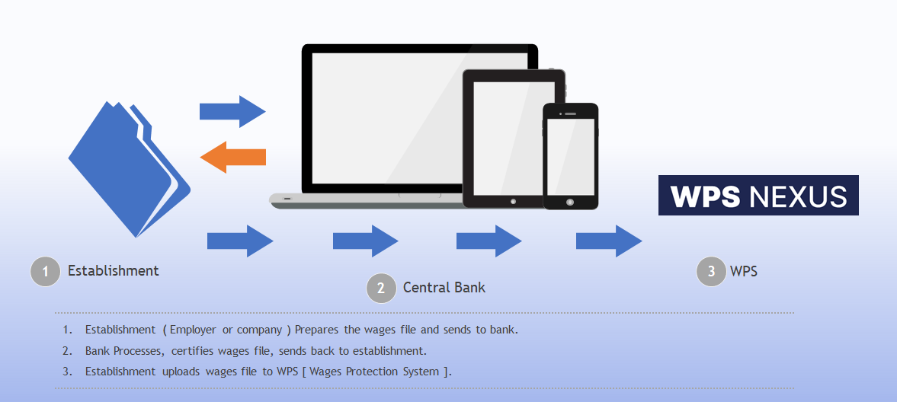Work Flow

Salary Processing through WPS Nexus

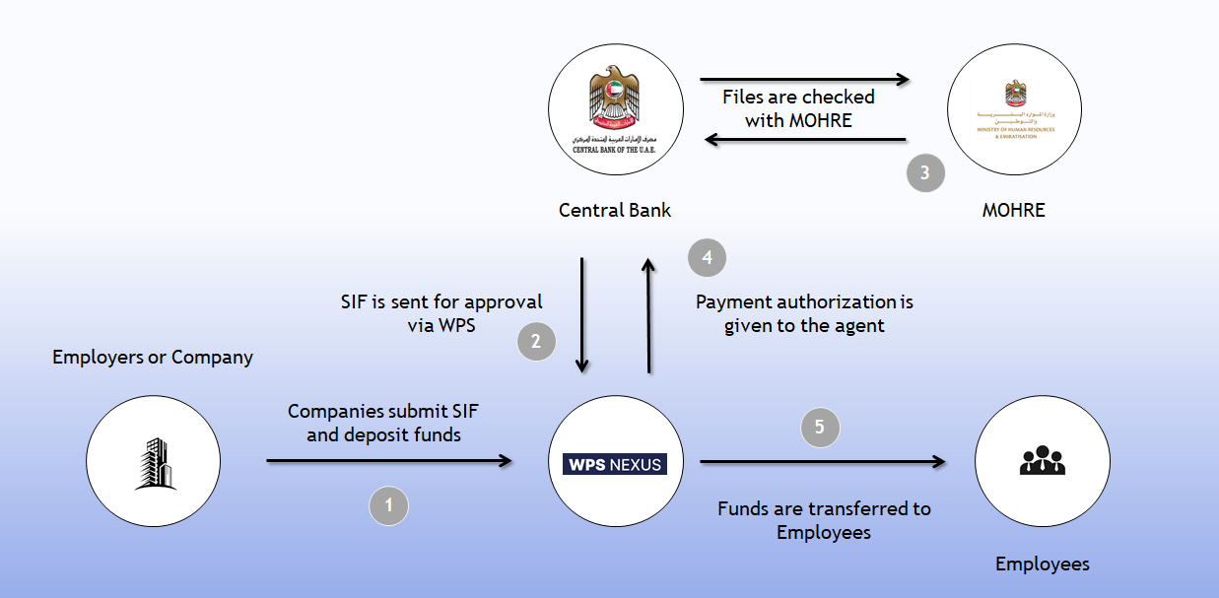

Real-Time Salary Disbursement – Ensure timely payments with instant transaction tracking and reporting

Let’s talk solution

Request a demo

**Dashboard**

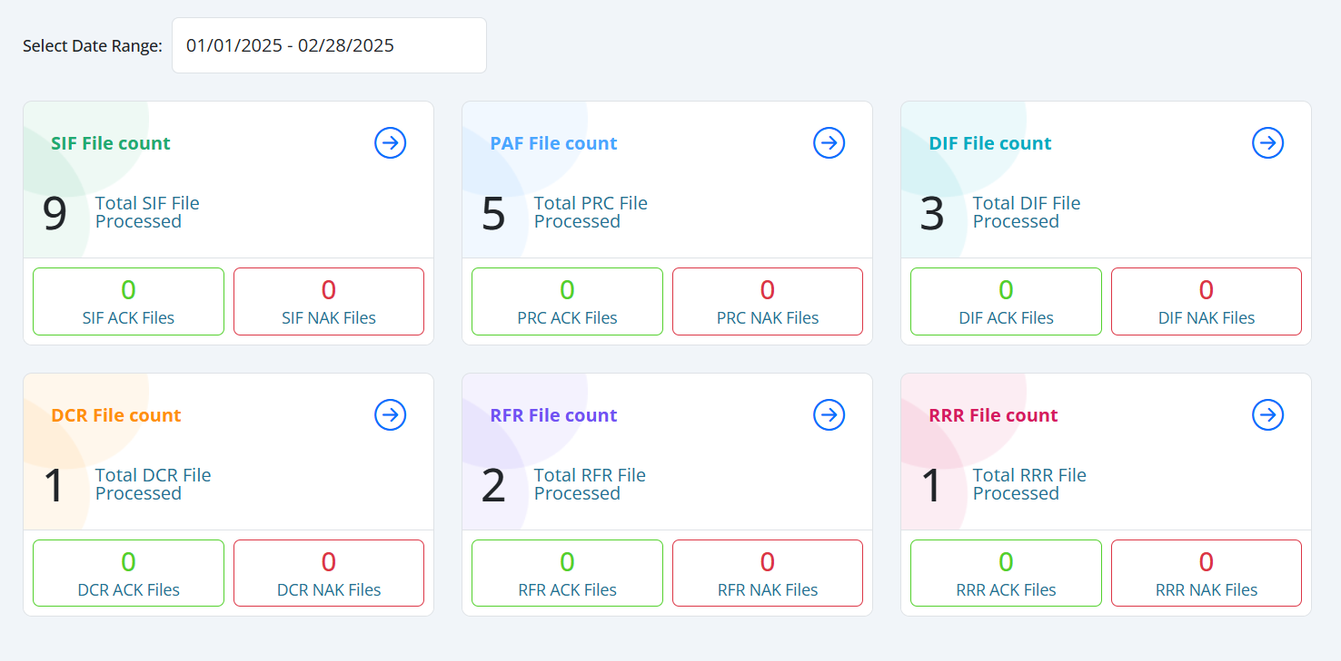

* Experience the Future of Business Efficiency with WPS Nexus.
* Ready to elevate your business operations and achieve greater efficiency?
* Explore the WPS Nexus solution and witness the power of integrated, intelligent business management firsthand.
* Schedule a personalized demo and see how WPS Nexus can transform the way you work.

Intuitive Dashboard – All your payroll and compliance data in one clean, user-friendly interface.

One click start your journey