Bash Scripting Suite for System Maintenance
Automating backup, system updates, and log monitoring using Linux Bash scripts.
Name: Asish Mohanty
System: Ubuntu (via WSL)
Language: Bash
Date: November 2025

Objective
The main goal of this project is to create a smart System Maintenance Suite using Bash scripting that works like a digital assistant for your Linux system. It automatically takes care of important tasks such as data backups, software updates, cleaning unused packages, and monitoring system logs — all without needing constant human effort. With built-in features like timestamped logs, centralized reporting, and error handling, the system ensures everything runs smoothly and efficiently. The menu-driven interface makes it simple and user-friendly, allowing even non-technical users to manage complex maintenance operations easily, just like having a helpful humanoid assistant keeping the system healthy and secure.

Tools and Environment
• Operating System: Ubuntu (WSL or Linux)
• Language: Bash shell scripting
• Text Editor: Nano or VS Code
• Scheduler: Cron
• Log files: Plain text (.log)

Source Code

backup.sh
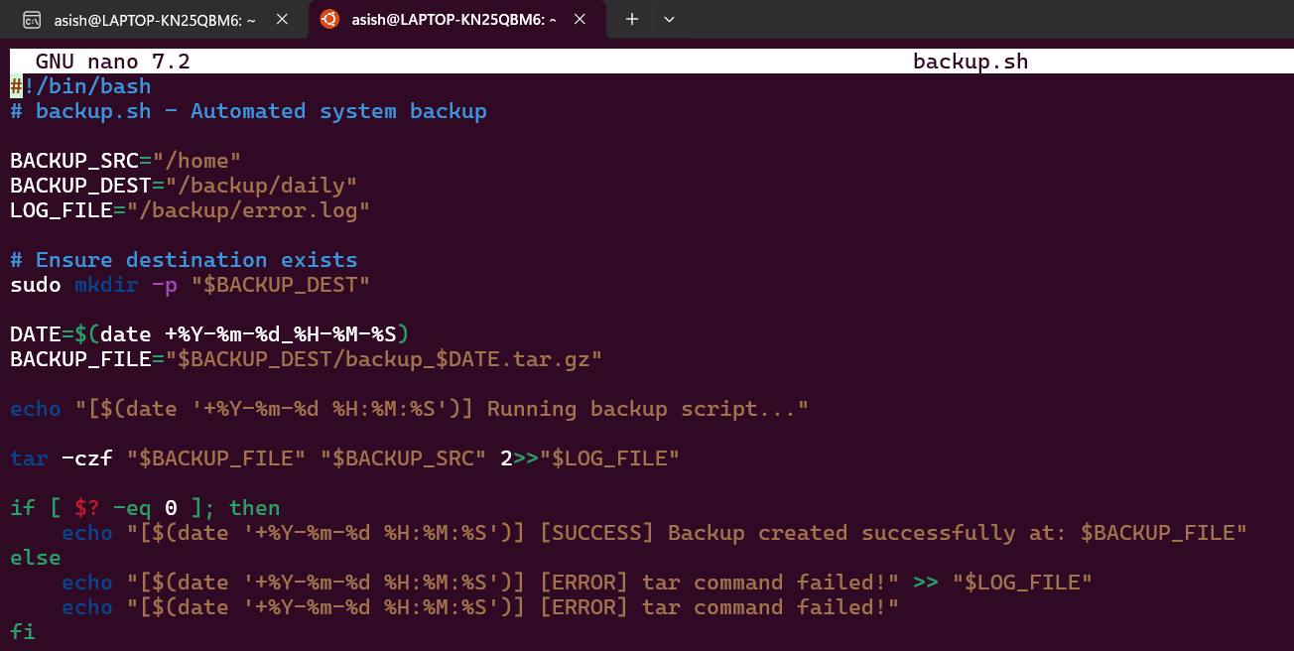

update.sh
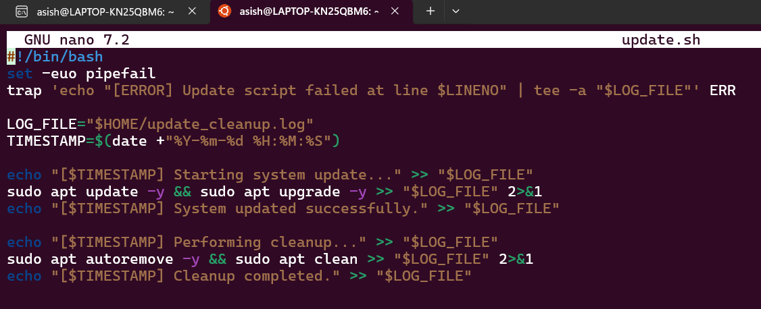

logmonitor.sh
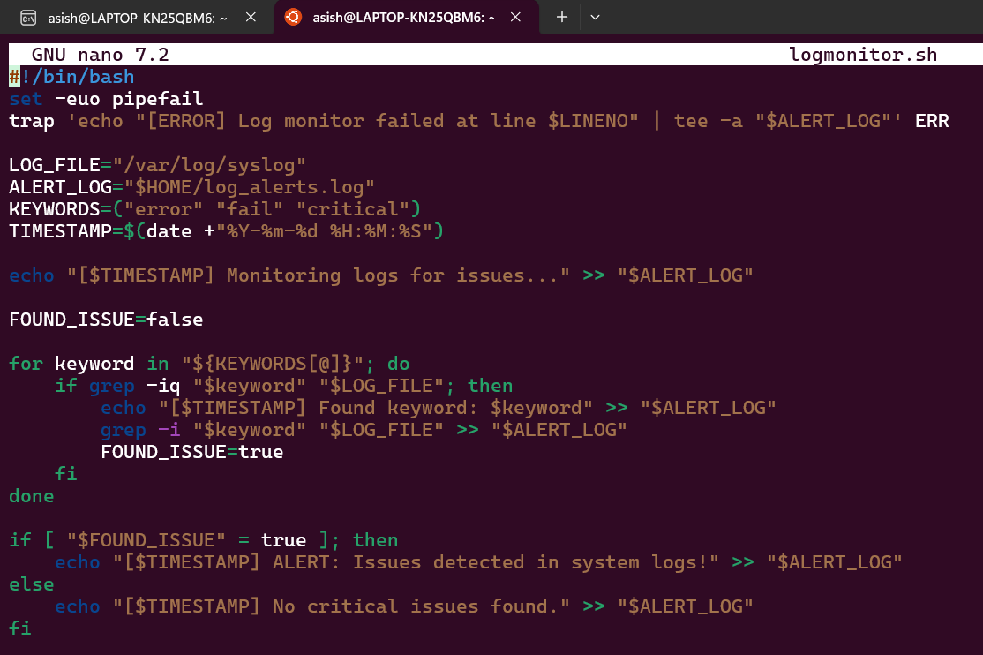

menu.sh
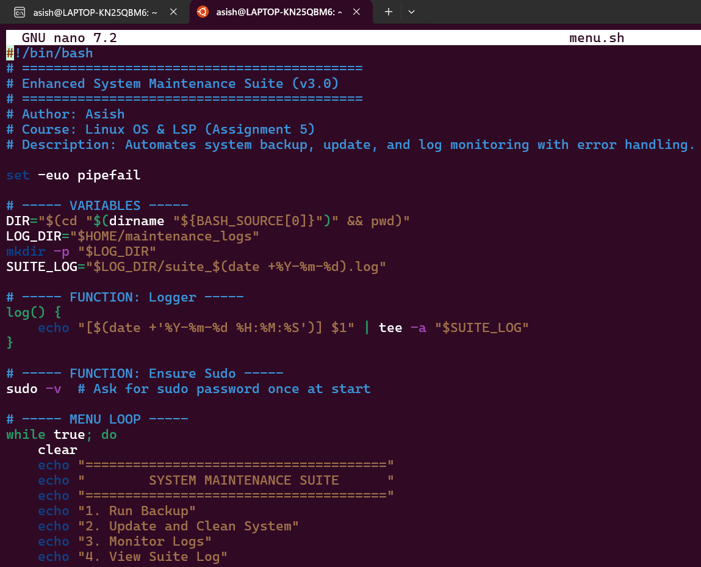

Screenshots
1. Folder structure (maintenance_suite and maintenance_logs)
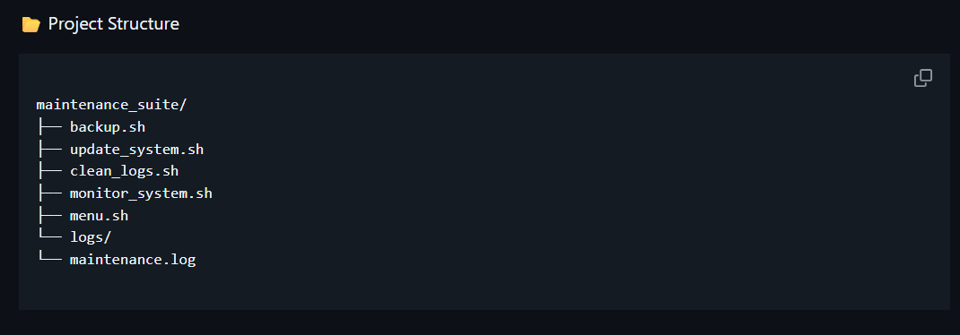
2. Editing scripts in Nano
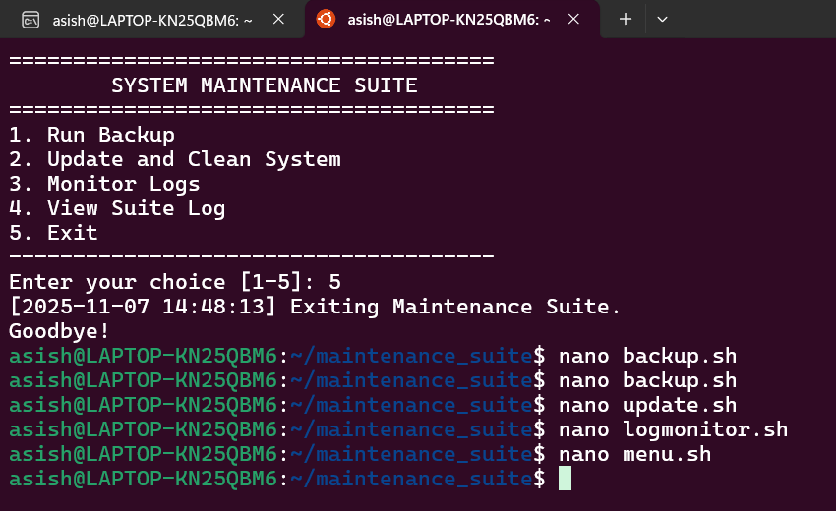
3. List of all .sh files in directory
4. Running backup.sh successfully
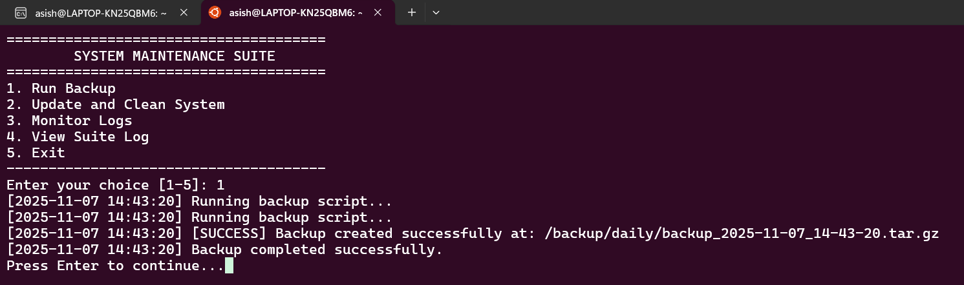
5. Contents of backup.log

6. Running update_cleanup.sh
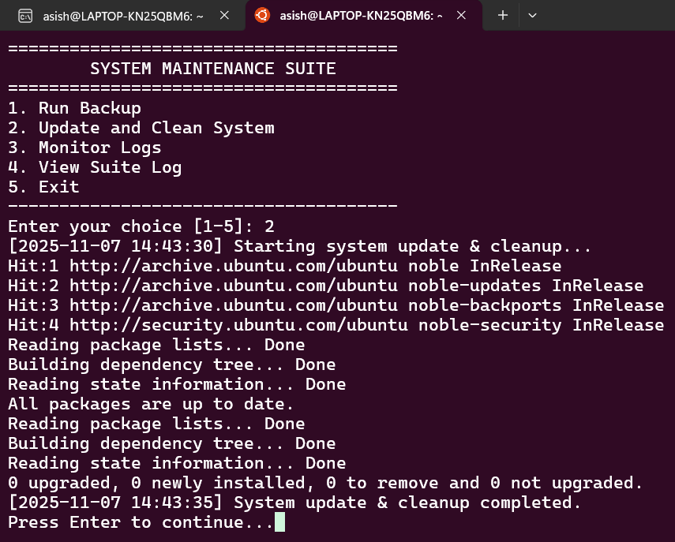
7. Running log_monitor.sh
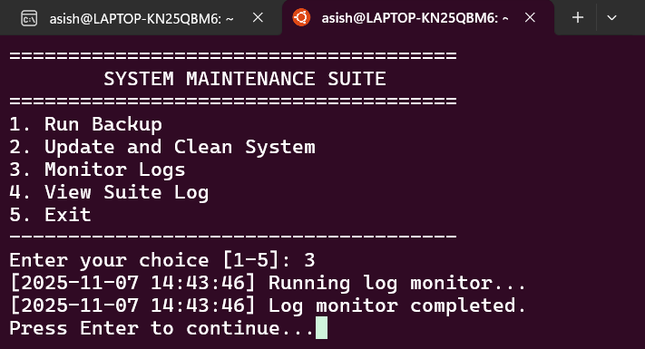
8. Menu of maintenance_suite.sh
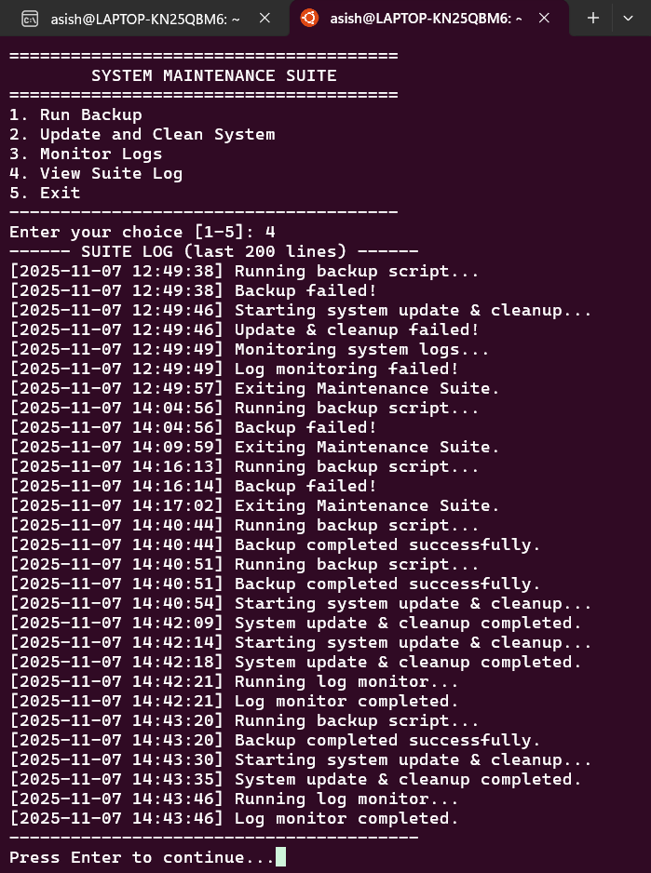
9. Executing menu options
10. Viewing suite log
12. Log files inside ~/maintenance_logs/

Conclusion
The System Maintenance Suite acts like a smart humanoid assistant for your computer — it performs routine maintenance tasks automatically, just like a system caretaker. It takes care of backups, software updates, cleaning unnecessary files, and keeping logs — all without constant human supervision. With built-in error handling and detailed logs, it ensures everything runs smoothly and transparently. This project shows how automation through Bash scripting can make a system more self-sufficient, efficient, and reliable — much like giving your computer a human-like ability to maintain itself.

