Application of Business Analytics in Power and Renewable Energy Sector Problem Solving in Sri Lanka

Table of Contents
1 Table of Figures 5
2 Tables 6
3 Introduction 7
4 Task 1 - Business Analytics and Business Intelligence 7
4.1 Operational-Level Decision Making 7
4.2 Tactical-Level Decision Making 8
4.3 Strategic-Level Decision Making 8
5 Task 2 - Tools, Techniques and Methodology 9
5.1 Analytical Tool 9
5.2 Dataset and Data Preparation 9
5.3 Descriptive and Exploratory Analysis 10
5.4 Inferential Statistical Techniques 10
5.5 Regression Analysis 11
5.6 Overall Analytical Methodology 11
6 Task 3 – Central Tendency Analysis 12
6.1 Results 13
6.1.1 Cooling Load 13
6.1.2 Surface Area 13
6.1.3 Wall Area 13
6.1.4 Roof Area 14
6.2 Graphical Analysis 14
6.2.1 Distribution of Cooling Load 14
6.2.2 Distribution of Surface Area 15
6.2.3 Distribution of Wall Area 15
6.2.4 Distribution of Roof Area 16
6.3 Interpretation 16
7 Task 4 – Effect of Building Orientation on Cooling Load 16
7.1 Descriptive Analysis by Orientation 17
7.2 Hypothesis Formulation 18
7.3 One-Way ANOVA 18
7.4 Testing the ANOVA Assumption 19
7.4.1 Homogeneity of Variance 19
7.4.2 Normality of Residuals 19
7.5 Kruskal-Wallis Test 20
8 Task 5 – Relationships Between Cooling Load and Building Structural Factors 21
8.1 Normality Analysis 21
8.2 Relationship Between Cooling Load and Surface Area 23
8.3 Relationship Between Cooling Load and Wall Area 24
8.4 Relationship Between Cooling Load and Roof Area 25
8.5 Simple Linear Regression: Cooling Load and Roof Area 26
8.6 Simple Regression Diagnostics 27
8.6.1 Residual Normality 28
8.6.2 Homoscedasticity 28
8.6.3 Influential Observations 28
8.7 Predictor Correlation and Multicollinearity 28
8.8 Multiple Regression Model 29
8.9 Multicollinearity Assessment 30
8.10 Final Regression Diagnostics 31
8.11 Robust Regression Inference 32
9 Task 6 - Conclusion and Recommendations 33
9.1 Conclusion 33
9.2 Recommendations 34
9.2.1 Recommendation 1 – Consider roof design during energy planning 34
9.2.2 Recommendation 2 – Give attention to wall-area configuration 34
9.2.3 Recommendation 3 – Do not priorities orientation alone 34
9.2.4 Recommendation 4 – Use statistical modelling as a decision-support tool 34
9.2.5 Recommendation 5 – Validate findings using Sri Lankan data 35
10 References 35
11 Appendices 36
11.1 Appendix A – R Analysis Script 36
11.2 Appendix B – Dataset Inspection and Data Quality Evidence 36
11.3 Appendix C – Central Tendency Analysis 37
11.4 Appendix D – Distribution and Normality Analysis 37
11.5 Appendix E – Orientation Analysis 38
11.6 Appendix F – Correlation Analysis 40
11.6.1 Surface Area 41
11.6.2 Wall Area 41
11.6.3 Roof Area 42
11.7 Appendix G – Simple Linear Regression 42
11.8 Appendix H – Predictor Correlation and Multicollinearity 43
11.9 Appendix I – Final Multiple Regression Model 44
11.10 Appendix J – Final Regression Diagnostics 45

Table of Figures
Figure 1 RStudio Dataset Structure and Initial Data Inspection 10
Figure 2 Overall Analytical Methodology Flowchart 12
Figure 3Central tendency and standard deviation results generated using R 13
Figure 4 Central Tendency Analysis Results 13
Figure 5 Cooling Load Distribution 14
Figure 6 Surface Area Distribution 15
Figure 7 Wall Area Distribution 15
Figure 8 Roof Area Distribution 16
Figure 9 Distribution of Cooling Load by Building Orientation 18
Figure 10 Bartlett test of homogeneity of variances 19
Figure 11 Shapiro-Wilk normality test of ANOVA residuals 20
Figure 12 Kruskal-Wallis test results 21
Figure 13 Shapiro-Wilk normality test results 23
Figure 14 Relationship between Cooling Load and Surface Area 24
Figure 15 Relationship between Cooling Load and Wall Area 25
Figure 16 Relationship between Cooling Load and Roof Area 26
Figure 17 Simple linear regression results for Cooling Load and Roof Area 27
Figure 18 Initial multiple regression model showing an aliased Roof Area coefficient 29
Figure 19 Final Multiple Regression Model 30
Figure 20 VIF results for the final regression model 31
Figure 21 Diagnostic plots for the final multiple regression model 32
Figure 22 Multiple regression coefficients with HC3 robust standard errors 33
Figure 23 analysis script used for dataset preparation and statistical analysis 36
Figure 24 Dataset structure, missing-value and duplicate inspection, and orientation frequencies 37
Figure 25 R output for central tendency and variability statistics 37
Figure 26 Shapiro-Wilk normality test results for selected numerical variables 38
Figure 27 Orientation descriptive statistics 39
Figure 28 ANOVA output 39
Figure 29 Bartlett's test 40
Figure 30 Shapiro-Wilk residual test 40
Figure 31 Kruskal-Wallis test 40
Figure 32 Spearman correlation between Cooling Load and Surface Area 41
Figure 33 Spearman correlation between Cooling Load and Wall Area 41
Figure 34 Spearman correlation between Cooling Load and Roof Area 42
Figure 35 Simple linear regression model summary for Cooling Load and Roof Area 42
Figure 36 Diagnostic plots for the simple linear regression model 43
Figure 37 Spearman correlation matrix of numerical predictors 43
Figure 38 Initial multiple regression model showing the aliased Roof Area coefficient 44
Figure 39 Final multiple regression model using Roof Area and Wall Area 45
Figure 40 Shapiro-Wilk test of final model residuals 45
Figure 41 Cook's distance diagnostic results 45
Figure 42 Diagnostic plots for the final multiple regression model 46

Tables
Table 1 Advantages of Business Analytics and Business Intelligence at Different Decision-Making Levels 7
Table 2 5.1 Descriptive Analysis by Orientation 16
Table 3 calculated skewness values 20
Table 4 Shapiro-Wilk Normality Tests 21
Table 5 Regression Results 29
Table 6 Variance Inflation Factor (VIF) values 30

Introduction
The increasing demand for electricity has created challenges for the efficient management of energy resources. Buildings are an important area for energy-efficiency improvements, as characteristics such as surface area, wall area, roof area and orientation can influence heating and cooling requirements. Analyzing these relationships can therefore support more effective energy planning and building design (Tsanas & Xifara, 2012).
Business Analytics uses data, statistical techniques and analytical tools to identify patterns and relationships that support informed decision-making. In the power and renewable energy sector, it can help decision-makers understand energy requirements, identify influential factors and develop strategies to improve efficiency (Stubbs, 2011) (Mashingaidze & Backhouse, 2017).
This report analyses the Energy Efficiency Data (EED) dataset, which contains 768 observations and 10 variables describing building characteristics and their heating and cooling loads. The dataset contained no missing or duplicate records. The analysis focuses on Cooling Load, representing the energy required to cool a building.
Using R, the study applies descriptive statistics, distribution analysis, hypothesis testing, correlation analysis and regression modelling. It examines whether building orientation significantly affects Cooling Load and investigates the relationships between Cooling Load and Surface Area, Wall Area and Roof Area.
Finally, the findings are considered in the context of the Sri Lankan power and renewable energy sector, with recommendations provided on how data-driven insights can support energy-efficient building design and informed decision-making.

Task 1 - Business Analytics and Business Intelligence
Business Analytics (BA) and Business Intelligence (BI) provide organizations with the ability to transform collected data into useful information for decision-making (Mashingaidze & Backhouse, 2017) (Stubbs, 2011). In the power and renewable energy sector, these approaches can support decisions at operational, tactical and strategic levels. The benefits differ according to the responsibilities and time horizon of each level of management.

Operational-Level Decision Making
At the operational level, Business Analytics supports the day-to-day monitoring and management of energy consumption and building performance. Energy data can be analyzed to identify unusual consumption patterns, buildings with high cooling requirements and factors contributing to increased electricity demand (Stubbs, 2011) (Mashingaidze & Backhouse, 2017).
For example, buildings with unusually high Cooling Loads can be identified through data analysis, allowing facility managers to investigate potential causes such as building-envelope characteristics, cooling-system performance and inefficient design.
BI dashboards can present key energy indicators in an accessible format, enabling operational staff to monitor energy usage, identify changes in demand and take timely corrective actions.

Tactical-Level Decision Making
At the tactical level, Business Analytics supports planning, resource allocation and performance improvement. Managers can use historical and current data to identify building characteristics associated with energy requirements and evaluate potential efficiency measures (Stubbs, 2011) (Mashingaidze & Backhouse, 2017).
The analysis in this study demonstrates how statistical techniques can identify relationships between Cooling Load and structural characteristics. These insights can help managers priorities areas for improvement and allocate resources more effectively.
For example, buildings with characteristics strongly associated with higher Cooling Loads can be prioritized for energy-efficiency improvements. BI tools can also enable comparisons between buildings, helping managers identify better- and poorer-performing cases.

Strategic-Level Decision Making
At the strategic level, Business Analytics (BA) and Business Intelligence (BI) support long-term planning and policy development. Energy-sector decision-makers can use reliable data to develop strategies for energy efficiency, electricity demand management and sustainable development (Stubbs, 2011) (Mashingaidze & Backhouse, 2017).
Data-driven analysis helps identify important factors affecting energy requirements, supporting decisions related to energy-efficient construction, building standards and demand-management policies.
For Sri Lanka, these approaches can help address increasing electricity demand by supporting evidence-based decisions and evaluating potential energy-efficiency interventions rather than relying solely on assumptions.
Table 1 Advantages of Business Analytics and Business Intelligence at Different Decision-Making Levels
Decision-Making Level | Main Use of BA/ BI | Example in Energy Sector | Potential Benefit
Operational | Monitoring and identifying patterns | Monitor building Cooling Load | Faster identification of inefficient energy use
Tactical | Planning and resource allocation | Compare building characteristics and energy requirements | Better targeting of energy-efficiency initiatives
Strategic | Long-term planning and policy | Support energy-efficiency and building-design strategies | Evidence-based strategic decision-making

Task 2 - Tools, Techniques and Methodology

Analytical Tool
The analysis was conducted using R, with RStudio used to write, execute and document the analysis. R was selected because it supports statistical analysis, data manipulation, visualization and reproducible scripting, making it suitable for analyzing the Energy Efficiency Data (EED) dataset (Team, 2024).
Several R packages were also used for specific analytical requirements. The moments package was used for skewness analysis, car for Variance Inflation Factor (VIF) analysis, and lmtest and sandwich for regression diagnostics and heteroscedasticity-robust inference (Komsta & Novomestky, 2015) (Fox & Weisberg, 2019) (Zeileis, 2004).

Dataset and Data Preparation
The analysis used the Energy Efficiency Data (EED) dataset provided for the assessment. The dataset contains building characteristics, Heating Load and Cooling Load, with data collected from a survey in the United States (Tsanas & Xifara, 2012).
The dataset includes 10 variables, including Relative Compactness, Surface Area, Wall Area, Roof Area, Overall Height, Orientation, Glazing Area, Glazing Area Distribution, Heating Load and Cooling Load. Surface Area, Wall Area and Roof Area are measured in square feet, while Cooling Load is measured in BTU.
The dataset was imported into R as EED and checked using dim(), str(), colSums(is.na()) and duplicated(). The dataset contained 768 observations and no missing or duplicate records. Orientation consisted of four categories—East, North, South and West—with 192 observations per category.
Figure 1 RStudio Dataset Structure and Initial Data Inspection
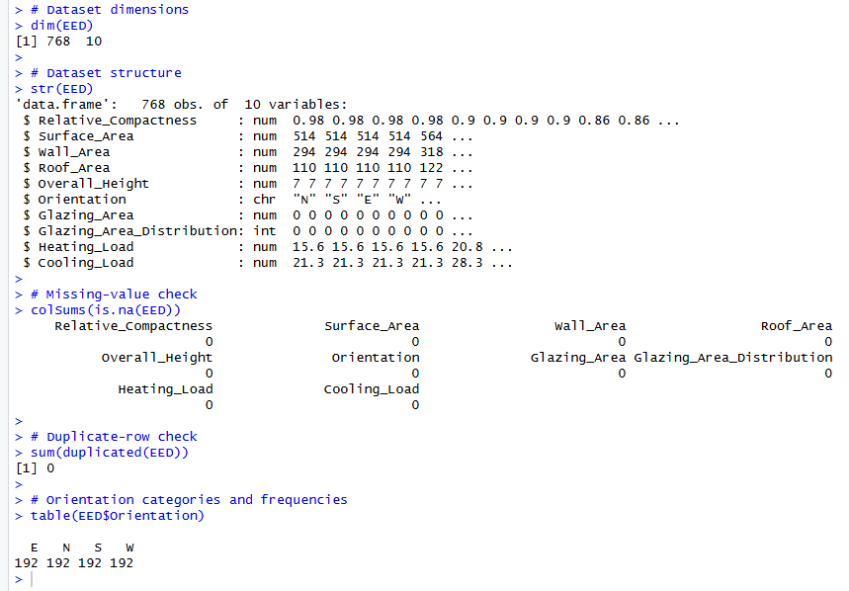

Descriptive and Exploratory Analysis
Descriptive statistical techniques were first applied to understand the characteristics of the dataset. Measures of central tendency were calculated for Cooling Load, Surface Area, Wall Area and Roof Area, including the mean, median and mode. Standard deviation was also calculated to assess the dispersion of each variable (Field, 2018).
Graphical analysis was conducted using bell-curve representations to visually examine the distributions of the selected variables. Skewness was subsequently calculated to provide a numerical indication of distributional asymmetry.
These procedures were appropriate because the assessment specifically requires central tendency analysis for Cooling Load, Surface Area, Wall Area and Roof Area, together with graphical representation using bell curves.

Inferential Statistical Techniques
Inferential statistical techniques were used to determine whether observed differences and relationships were statistically significant.
To examine the relationship between Orientation and Cooling Load, group-level descriptive statistics were calculated, followed by one-way ANOVA. Bartlett's test assessed variance homogeneity, while the Shapiro-Wilk test assessed residual normality. As the normality assumption was violated, the Kruskal-Wallis test was also applied as a non-parametric alternative.
For the relationships between Cooling Load and Surface Area, Wall Area and Roof Area, normality testing was first conducted. As the variables did not satisfy the normality assumption, Spearman's rank correlation was used to determine the strength and direction of the relationships (Field, 2018).

Regression Analysis
Regression analysis was used to provide additional predictive and explanatory insights into Cooling Load. A simple linear regression was first developed using Roof Area as the predictor, followed by a multiple linear regression model using Roof Area and Wall Area (Field, 2018) (Fox & Weisberg, 2019).
Model performance was assessed using R² and adjusted R², while predictor significance was evaluated using coefficients and p-values. Regression assumptions were examined using residual normality tests, the Breusch-Pagan test, Cook's distance and VIF.
As heteroscedasticity was identified, HC3 robust standard errors were applied to the final model to provide more reliable inference when error variance was unequal (MacKinnon & White, 1985) (Zeileis, 2004).

Overall Analytical Methodology
Figure 2 Overall Analytical Methodology Flowchart
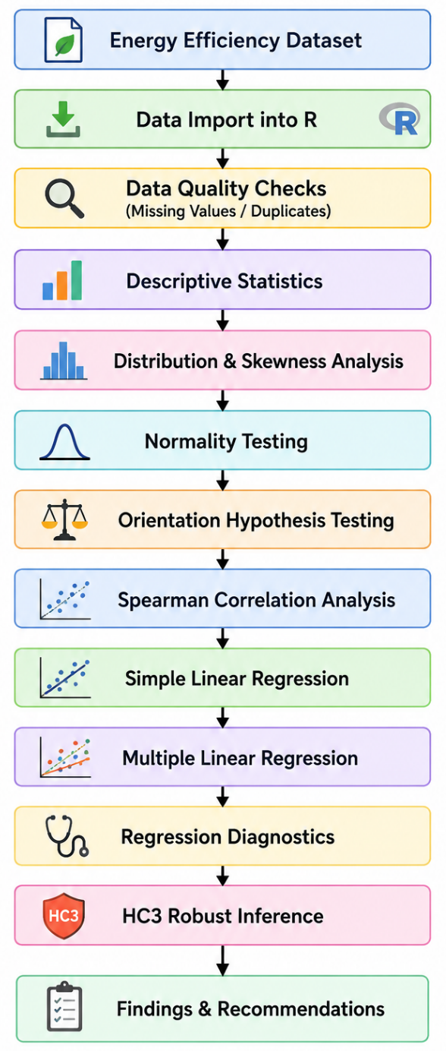

Task 3 – Central Tendency Analysis
The central tendency and variability of the selected numerical variables were analyzed to understand their typical values and the extent to which observations vary around those values. Four variables were selected for detailed analysis: Cooling Load, Surface Area, Wall Area, and Roof Area. Mean, median, mode, and standard deviation were calculated using R.
Figure 3Central tendency and standard deviation results generated using R
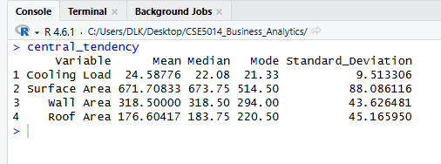

Results
Figure 4 Central Tendency Analysis Results
Variable | Mean | Median | Mode | Standard Deviation
Cooling Load | 24.59 | 22.08 | 21.33 | 9.51
Surface Area | 671.71 | 673.75 | 514.50 | 88.09
Wall Area | 318.50 | 318.50 | 294.00 | 43.63
Roof Area | 176.60 | 183.75 | 220.50 | 45.17

Cooling Load
The mean cooling load is 24.59, while the median is 22.08 and the mode is 21.33. The mean is higher than the median, suggesting some higher cooling-load observations are pulling the average upward. The standard deviation of 9.51 indicates a relatively substantial variation in cooling requirements across the buildings.

Surface Area
The mean surface area is 671.71, compared with a median of 673.75. These values are very close, indicating that the center of the distribution is relatively stable. The standard deviation is 88.09, which represents the largest absolute variability among the four selected variables.

Wall Area
The mean and median wall areas are both 318.50, while the mode is 294.00. The equality between the mean and median indicates that the central location of the distribution is relatively balanced. The standard deviation of 43.63 indicates moderate variation.

Roof Area
The mean roof area is 176.60, while the median is 183.75 and the mode is 220.50. The difference between these measures indicates that the distribution is not perfectly symmetric. The standard deviation of 45.17 indicates considerable variation in roof area.

Graphical Analysis
The distributions of the four variables were also visualized using graphs generated in R.

Distribution of Cooling Load
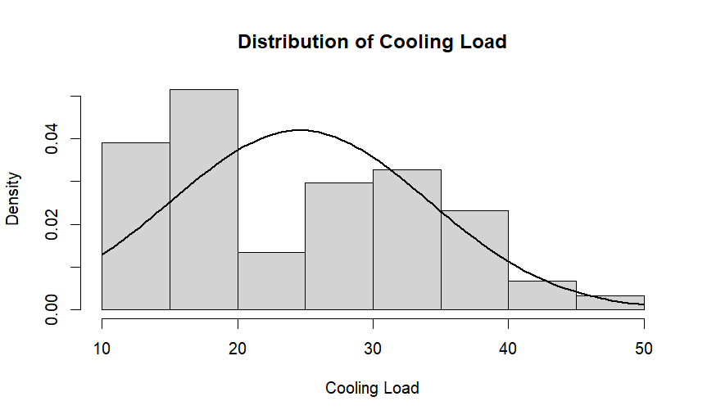
Figure 5 Cooling Load Distribution

Distribution of Surface Area
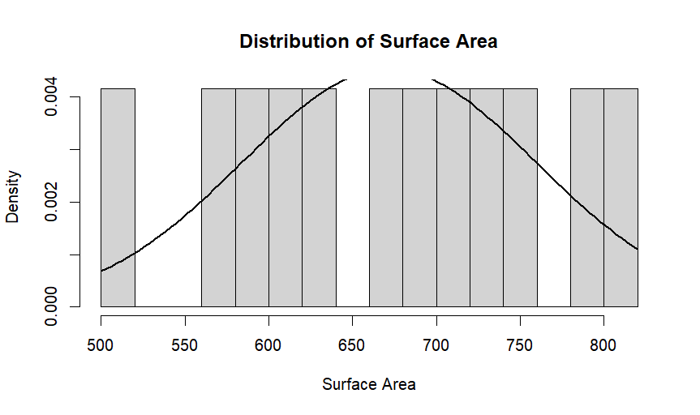
Figure 6 Surface Area Distribution

Distribution of Wall Area
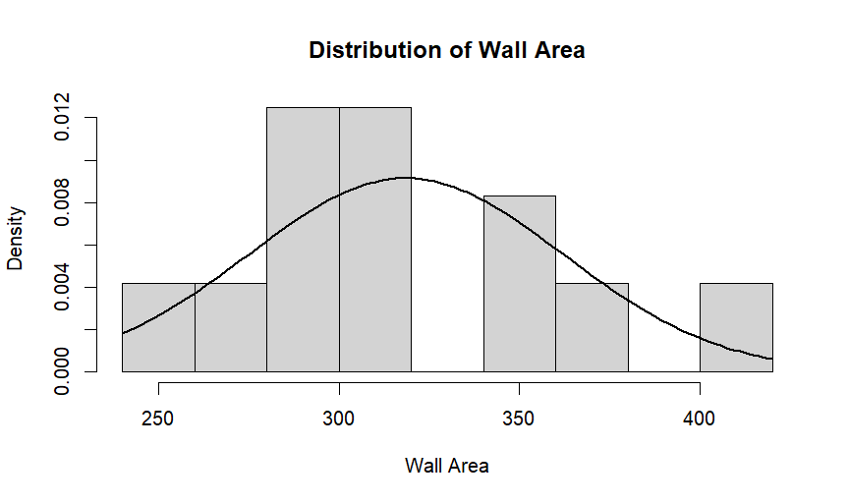
Figure 7 Wall Area Distribution

Distribution of Roof Area
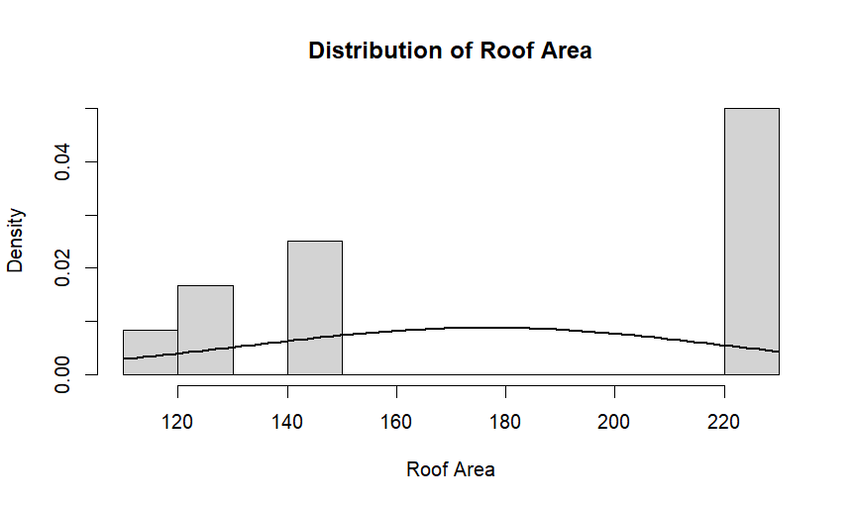
Figure 8 Roof Area Distribution

Interpretation
Overall, the four variables show different levels of variation. Cooling Load has a mean greater than its median, which is consistent with the positive skewness identified later in the analysis. Surface Area has a mean and median that are almost identical, while Wall Area has exactly equal mean and median values. Roof Area shows a noticeable difference between its mean and median.
The standard deviations demonstrate that the physical building characteristics have substantial variation within the dataset. These differences are important because variations in building characteristics may influence energy requirements, particularly cooling demand.

Task 4 – Effect of Building Orientation on Cooling Load
The objective of this analysis is to determine whether building orientation has a statistically significant effect on cooling load. The EED dataset contains four building orientations: East (E), North (N), South (S), and West (W). Each orientation contains 192 observations, resulting in a balanced dataset of 768 observations.
The analysis was conducted using descriptive statistics followed by hypothesis testing. Since the normality assumption for the ANOVA residuals was not satisfied, a non-parametric Kruskal-Wallis test was also conducted to provide a more appropriate assessment of whether cooling load differs between the four orientation groups.

Descriptive Analysis by Orientation
The mean, median and standard deviation of cooling load were calculated separately for each building orientation.
Table 2 5.1 Descriptive Analysis by Orientation
Orientation | Number of Observations | Mean Cooling Load | Median Cooling Load | Standard Deviation
East | 192 | 24.480 | 22.170 | 9.375
North | 192 | 24.605 | 22.220 | 9.609
South | 192 | 24.313 | 21.755 | 9.310
West | 192 | 24.954 | 22.510 | 9.813

The mean cooling load was highest for buildings with a West orientation (24.954), followed by North (24.605), East (24.480), and South (24.313). Although the West-oriented buildings had the highest average cooling load, the difference between the group means was relatively small. The South orientation had the lowest mean cooling load.
The standard deviations ranged from 9.310 to 9.813, indicating that the variability of cooling load was relatively similar across the four orientation groups.
Figure 9 Distribution of Cooling Load by Building Orientation
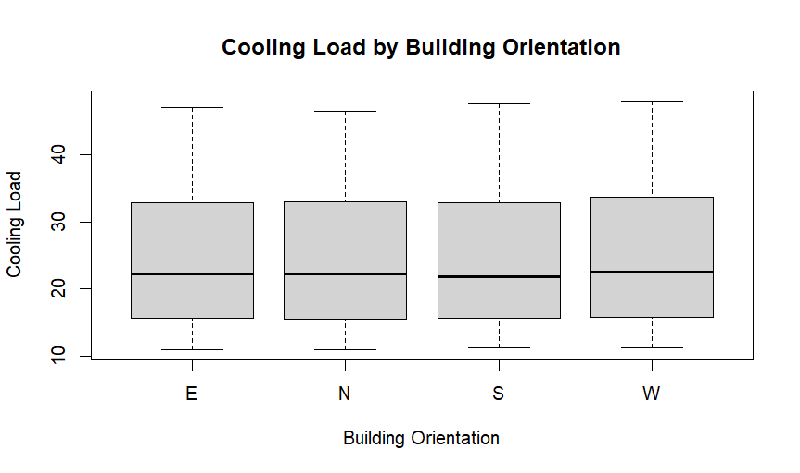

Hypothesis Formulation
To statistically determine whether orientation affects cooling load, the following hypotheses were formulated:
- Null hypothesis (H₀): There is no statistically significant difference in mean cooling load among buildings with East, North, South and West orientations.
- Alternative Hypothesis (H₁): There is a statistically significant difference in cooling load among at least one of the building orientations groups.
A significance level of α = 0.05 was used for the hypothesis tests.

One-Way ANOVA
A one-way Analysis of Variance (ANOVA) was initially performed using building orientation as the independent categorical variable and cooling load as the dependent variable.
The resulting ANOVA was:
F (3, 764) = 0.156, p = 0.926
Since the p-value of 0.926 is considerably greater than the significance level of 0.05, there is insufficient statistical evidence to reject the null hypothesis based on the ANOVA.
However, before relying on the ANOVA result, its underlying assumptions were assessed.

Testing the ANOVA Assumption

Homogeneity of Variance
Bartlett's test was conducted to determine whether the variance of cooling load was approximately equal across the four orientation groups (Field, 2018).
The result was: Bartlett's K² = 0.6643, df = 3, p = 0.8816
Since p = 0.8816 > 0.05, there is no evidence of a statistically significant difference in variances between the orientation groups. Therefore, the homogeneity of variance assumption was considered reasonable.
Figure 10 Bartlett test of homogeneity of variances
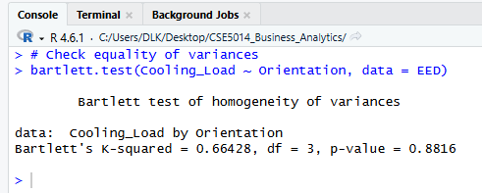

Normality of Residuals
The Shapiro-Wilk test was then applied to the residuals from the ANOVA model (Field, 2018).
The result was: W = 0.90961, p < 2.2 × 10⁻¹⁶
Since the p-value is below 0.05, the null hypothesis of normally distributed residuals is rejected. Therefore, the normality assumption required by the conventional ANOVA was not satisfied.
Figure 11 Shapiro-Wilk normality test of ANOVA residuals
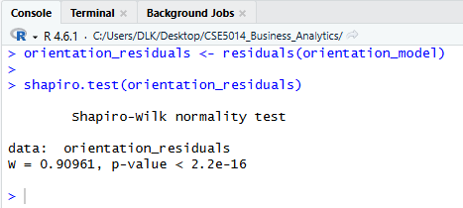

Kruskal-Wallis Test
The Kruskal-Wallis rank-sum test was conducted because it does not require the same normality assumption as one-way ANOVA (Field, 2018).
The hypotheses were:
- H₀: The distributions of cooling load are the same across the four orientation groups.
- H₁: At least one orientation has a different distribution of cooling load.
The test produced:
χ² (3) = 0.41514, p = 0.9371
Since:
p = 0.9371 > 0.05
the null hypothesis is not rejected.
Therefore, there is no statistically significant evidence that cooling load differs according to building orientation in the EED dataset.
Figure 12 Kruskal-Wallis test results
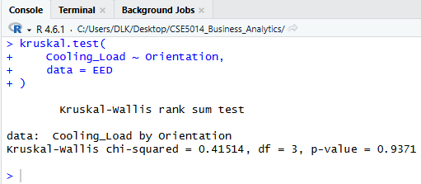

Task 5 – Relationships Between Cooling Load and Building Structural Factors
The objective of this analysis is to investigate the relationships between Cooling Load and three structural characteristics of buildings: Surface Area, Wall Area and Roof Area.

Normality Analysis
Before conducting correlation and regression analysis, the distributions of Cooling Load, Surface Area, Wall Area and Roof Area were examined. Skewness and Shapiro-Wilk normality tests were used to assess the distributions (Field, 2018).
The calculated skewness values were:
Variable | Skewness
Cooling Load | 0.3952
Surface Area | -0.1249
Wall Area | 0.5324
Roof Area | -0.1624
Table 3 calculated skewness values
Cooling Load and Wall Area showed slight positive skewness, while Surface Area and Roof Area showed slight negative skewness.
The Shapiro-Wilk tests produced the following results:
Variable | W statistic | p-value
Cooling Load | 0.90904 | < 2.2 × 10⁻¹⁶
Surface Area | 0.94967 | 1.628 × 10⁻¹⁵
Wall Area | 0.92690 | < 2.2 × 10⁻¹⁶
Roof Area | 0.74595 | < 2.2 × 10⁻¹⁶
Table 4 Shapiro-Wilk Normality Tests
For each variable, the p-value is below the significance level of 0.05. Therefore, the null hypothesis of normality is rejected for all four variables.
Consequently, a non-parametric correlation method was considered more appropriate for examining the relationships between Cooling Load and the structural variables. Spearman's rank correlation was therefore selected (Field, 2018).
Figure 13 Shapiro-Wilk normality test results
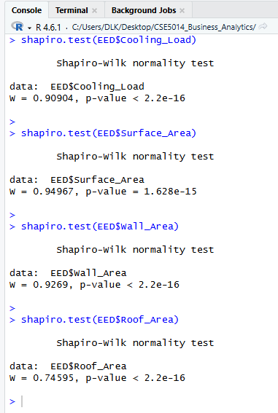

Relationship Between Cooling Load and Surface Area
A Spearman rank correlation test was conducted to determine the relationship between Cooling Load and Surface Area.
The result was:
ρ = -0.6510, p < 2.2 × 10⁻¹⁶
The negative correlation indicates that higher Surface Area values tend to be associated with lower Cooling Load values in the EED dataset. The absolute correlation coefficient of approximately 0.65 indicates a relatively strong negative monotonic relationship.
Since the p-value is substantially below 0.05, the relationship is statistically significant. Therefore, there is strong evidence of an association between Surface Area and Cooling Load.
Figure 14 Relationship between Cooling Load and Surface Area
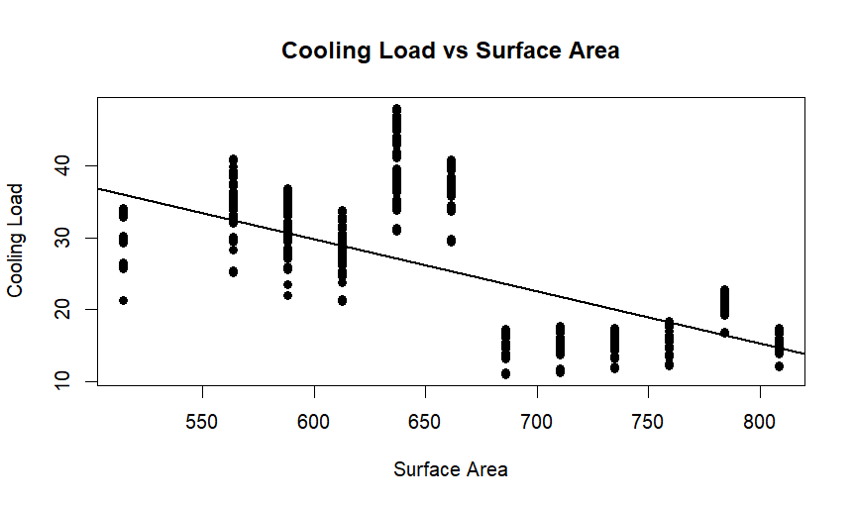

Relationship Between Cooling Load and Wall Area
The positive correlation indicates that buildings with larger Wall Areas tend to have higher Cooling Loads. The correlation coefficient of 0.4160 represents a moderate positive monotonic relationship.
The p-value is considerably below 0.05, indicating that the relationship is statistically significant.
Therefore, the analysis provides strong evidence of an association between Wall Area and Cooling Load.
Figure 15 Relationship between Cooling Load and Wall Area
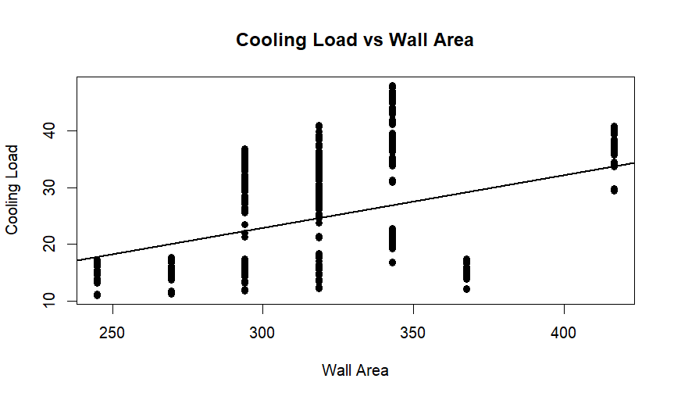
Compared with Surface Area and Roof Area, the relationship with Wall Area is weaker. This indicates that Wall Area is related to Cooling Load, but its monotonic association is not as strong as that observed for Roof Area.

Relationship Between Cooling Load and Roof Area
Spearman's rank correlation was also used to examine the relationship between Cooling Load and Roof Area.
The result was:
ρ = -0.8032, p < 2.2 × 10⁻¹⁶
The correlation coefficient indicates a strong negative relationship between Roof Area and Cooling Load. In this dataset, larger Roof Area values tend to be associated with lower Cooling Load values.
The p-value is substantially below 0.05, so the relationship is statistically significant.
Among the three structural variables investigated, Roof Area demonstrated the strongest correlation with Cooling Load in absolute terms.
Figure 16 Relationship between Cooling Load and Roof Area
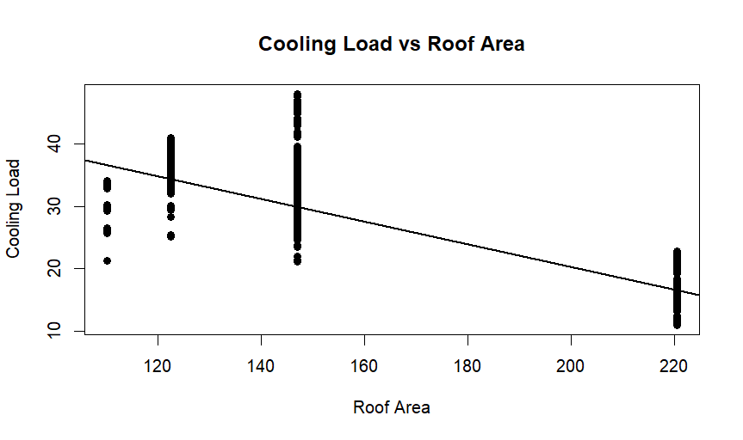
The results of the three correlation analyses can be summarized as follows.
Predictor | Spearman’s p | p-value | Direction | Strength
Surface Area | -0.6510 | <2.2 × 10⁻¹⁶ | Negative | Relatively strong
Wall Area | 0.4160 | <2.2 × 10⁻¹⁶ | Positive | Moderate
Roof Area | -0.8032 | <2.2 × 10⁻¹⁶ | Negative | Strong

Simple Linear Regression: Cooling Load and Roof Area
Since Roof Area showed the strongest relationship with Cooling Load, a simple linear regression model was developed (Field, 2018) (Fox & Weisberg, 2019).
The model was specified as:
Cooling Load = β0 ​+ β1 ​(Roof Area) + ϵ
The fitted model was:
Cooling Load=56.6729−0.1817(Roof Area)​
The regression results showed:
Term | Estimated | p-value
Intercept | 56.6729 | <2.2 × 10⁻¹⁶
Roof Area | -0.1817 | <2.2 × 10⁻¹⁶
Roof Area had a negative and statistically significant coefficient (p < 2.2 × 10⁻¹⁶), indicating that a one-unit increase in Roof Area was associated with an estimated 0.1817-unit decrease in Cooling Load.
The model produced an R² of 0.744 and an adjusted R² of 0.7437, indicating that Roof Area alone explained approximately 74.4% of the variation in Cooling Load.
Figure 17 Simple linear regression results for Cooling Load and Roof Area
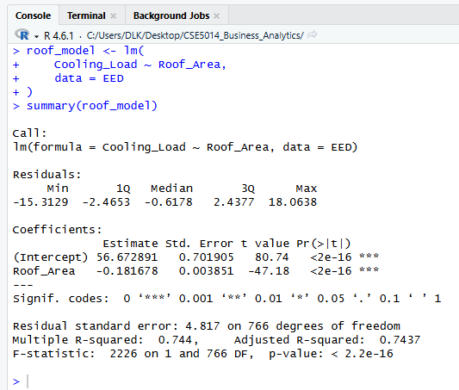

Simple Regression Diagnostics
The simple regression model was assessed for residual normality, homoscedasticity and influential observations (Field, 2018) (Fox & Weisberg, 2019).

Residual Normality
The Shapiro-Wilk test for the regression residuals produced:
W = 0.93743, p < 2.2 × 10⁻¹⁶
The p-value is below 0.05, indicating that the residuals do not follow a normal distribution.

Homoscedasticity
The studentized Breusch-Pagan test produced:
BP = 83.765, df = 1, p < 2.2 × 10⁻¹⁶
Therefore, the null hypothesis of constant variance is rejected. This indicates evidence of heteroscedasticity in the regression residuals.

Influential Observations
The maximum Cook's distance was:
0.02097
Using the screening threshold of 4/n, where n=768, 53 observations exceeded the threshold.

Predictor Correlation and Multicollinearity
Before developing a multiple regression model, the relationships between the numerical predictors were examined using Spearman correlation (Fox & Weisberg, 2019).
The analysis identified very strong relationships between several predictors. For example:
- Relative Compactness and Surface Area: -1.000
- Relative Compactness and Roof Area: -0.871
- Surface Area and Roof Area: 0.871
- Roof Area and Overall Height: -0.937
- Surface Area and Overall Height: -0.869
These strong correlations indicate substantial redundancy among some of the structural variables.
In particular, the initial model containing Surface Area, Wall Area and Roof Area produced an aliased coefficient for Roof Area: Roof_Area = NA
This indicates that the predictors could not all be independently estimated in that model because of linear dependence among the variables.
Figure 18 Initial multiple regression model showing an aliased Roof Area coefficient
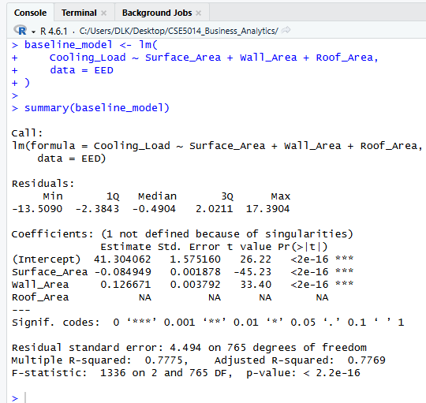

Multiple Regression Model
The final regression model was:
Cooling Load = β₀ ​+ β₁ ​(Roof Area) + β₂ ​(Wall Area) + ϵ
The fitted equation was:
Cooling Load= 41.3041 − 0.1699 (Roof Area) + 0.0417 (Wall Area)​
The regression results were:
Predictor | Estimate | Standard Error | t-value | p-value
Intercept | 41.3041 | 1.5752 | 26.22 | <2.2 × 10⁻¹⁶
Roof Area | -0.1699 | 0.0038 | -45.23 | <2.2 × 10⁻¹⁶
Wall Area | 0.0417 | 0.0039 | 10.73 | <2.2 × 10⁻¹⁶
Table 5 Regression Results
Figure 19 Final Multiple Regression Model
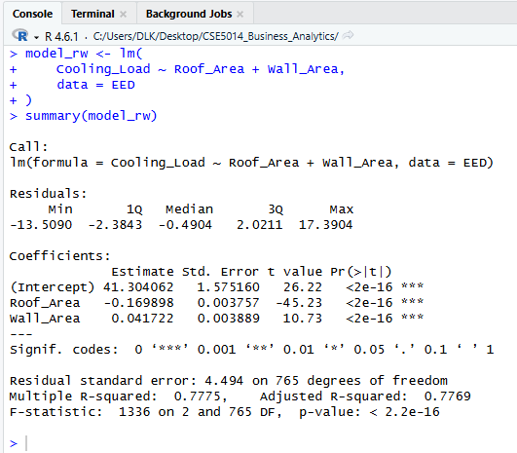

Multicollinearity Assessment
Variance Inflation Factor (VIF) values were calculated for the final regression model.
Predictor | VIF
Roof Area | 1.093
Wall Area | 1.093
Table 6 Variance Inflation Factor (VIF) values
Both VIF values are very close to 1, indicating that there is no substantial multicollinearity between Roof Area and Wall Area in the final model.
Figure 20 VIF results for the final regression model
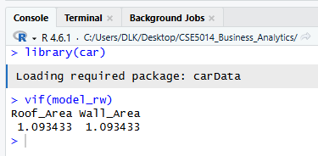

Final Regression Diagnostics
The assumptions of the final multiple regression model were also examined.
The Shapiro-Wilk test for the residuals produced:
W = 0.93685, p < 2.2 × 10⁻¹⁶
Therefore, the residuals were not normally distributed.
The Breusch-Pagan test produced:
BP = 66.251, df = 2, p = 4.11 × 10⁻¹⁵
This provides evidence of heteroscedasticity because the p-value is below 0.05.
The maximum Cook's distance was:
0.01680
and 52 observations exceeded the 4/n screening threshold.
Figure 21 Diagnostic plots for the final multiple regression model
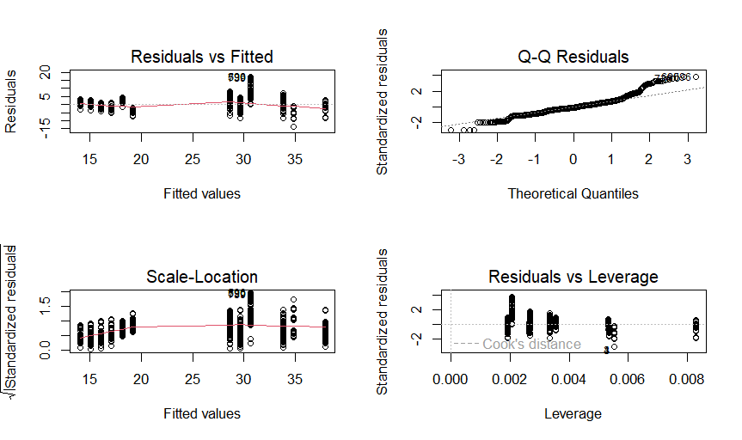
These results indicate that the final regression model should not rely solely on the conventional standard errors because the constant-variance assumption is violated.

Robust Regression Inference
To address the detected heteroscedasticity, HC3 heteroscedasticity-consistent standard errors were used.
The robust results were:
Predictor | Estimate | HC3 Standard Error | t-value | p-value
Intercept | 41.3041 | 1.5316 | 26.968 | <2.2 × 10⁻¹⁶
Roof Area | -0.1699 | 0.0038 | -44.538 | <2.2 × 10⁻¹⁶
Wall Area | 0.0417 | 0.0033 | 12.736 | <2.2 × 10⁻¹⁶
Figure 22 Multiple regression coefficients with HC3 robust standard errors
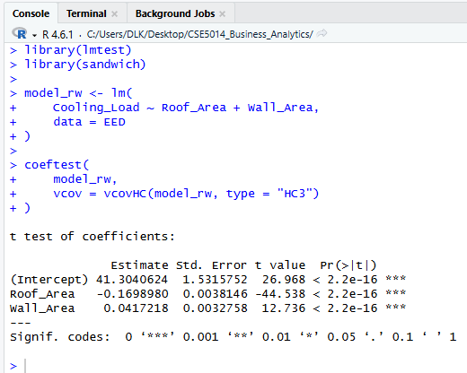

Task 6 - Conclusion and Recommendations

Conclusion
This study analyzed the Energy Efficiency Data (EED) dataset to examine the relationship between building characteristics and Cooling Load. The dataset contained 768 observations and 10 variables, with no missing or duplicate records. The analysis used descriptive statistics, graphical analysis, hypothesis testing, correlation analysis and regression modelling.
The results showed that building orientation had no significant effect on Cooling Load. The mean Cooling Loads were similar across the four orientations, and both ANOVA (p = 0.926) and the Kruskal-Wallis test (p = 0.9371) confirmed that the differences were not statistically significant.
In contrast, Roof Area, Surface Area and Wall Area showed significant relationships with Cooling Load. Roof Area had the strongest relationship (ρ = −0.803), followed by Surface Area (ρ = −0.651) and Wall Area (ρ = 0.416), with all relationships significant at p < 0.001.
The final regression model using Roof Area and Wall Area explained approximately 77.75% of the variation in Cooling Load (R² = 0.7775). However, residual diagnostics identified non-normality and heteroscedasticity. HC3 robust standard errors confirmed that both predictors remained statistically significant.
Overall, the findings suggest that building structural characteristics, particularly roof and wall areas, are more relevant to Cooling Load than orientation within this dataset.

Recommendations
Based on the findings of the analysis, the following recommendations can be made.

Recommendation 1 – Consider roof design during energy planning
Roof Area showed the strongest relationship with Cooling Load. However, the negative relationship should not be interpreted as meaning that larger roofs always reduce cooling requirements. Further engineering analysis is required before applying this finding to real buildings.

Recommendation 2 – Give attention to wall-area configuration
Since Wall Area showed a positive relationship with Cooling Load, planners should consider wall configuration together with insulation, shading and ventilation to improve energy efficiency.

Recommendation 3 – Do not priorities orientation alone
Since orientation was not statistically significant, it should not be treated as the primary factor for cooling-energy decisions. It should instead be considered alongside other building-design factors.

Recommendation 4 – Use statistical modelling as a decision-support tool
The regression model's 77.75% explanatory power demonstrates the potential of statistical modelling as a decision-support tool. Similar models could be developed using local building and climate data.

Recommendation 5 – Validate findings using Sri Lankan data
The dataset is based on a USA case study, so the findings should not be directly generalized to Sri Lankan buildings. Future studies should use local data covering climate, materials, insulation, occupancy, air-conditioning usage and electricity consumption.

References
Erl, T., 2005. Service-Oriented Architecture: Concepts, Technology, and Design. 1 ed. Upper Saddle River, NJ: Prentice Hall.
Field, A., 2018. Discovering Statistics Using IBM SPSS Statistics. 5 ed. London: SAGE Publications.
Fielding, R. T., 2000. Architectural Styles and the Design of Network-based Software Architectures, Irvine, CA: s.n.
Fowler, M., 2002. Survey Researching Methods. 3 ed. s.l.:s.n.
Fox, J. & Weisberg, S., 2019. An R Companion to Applied Regression. 3 ed. Thousand Oaks, California: SAGE Publications.
Komsta, L. & Novomestky, F., 2015. moments: Moments, cumulants, skewness, kurtosis and related tests. [Online]
Available at: https://cran.r-project.org/web/packages/moments/index.html
MacKinnon, J. G. & White, H., 1985. Some heteroskedasticity-consistent covariance matrix estimators with improved finite-sample properties. Journal of Econometrics, 29(3), pp. 305 - 325.
Mashingaidze, K. & Backhouse, J., 2017. The relationships between definitions of big data, business intelligence and business analytics: a literature review. International Journal of Business Information Systems, 26(4), pp. 488-505.
Stubbs, E., 2011. The Value of Business Analytics: Identifying the Path to Profitability. 1 ed. Hoboken, New Jersey: John Wiley & Sons.
Stubbs, E., 2013. The Value of Business Analytics: Identifying the Path to Profitability. Hoboken, New Jersey: Willey.
Team, R. C., 2024. R: A language and environment for statistical computing, Vienna, Austria: R Foundation for Statistical Computing.
Tsanas, A. & Xifara, A., 2012. Accurate quantitative estimation of energy performance of residential buildings using statistical machine learning tools. Energy and Buildings, Volume 49, pp. 560-567.
Zeileis, A., 2004. Econometric Computing with HC and HAC Covariance Matrix Estimators. Journal of Statistical Software, 11(10), pp. 1-17.

Appendices

Appendix A – R Analysis Script
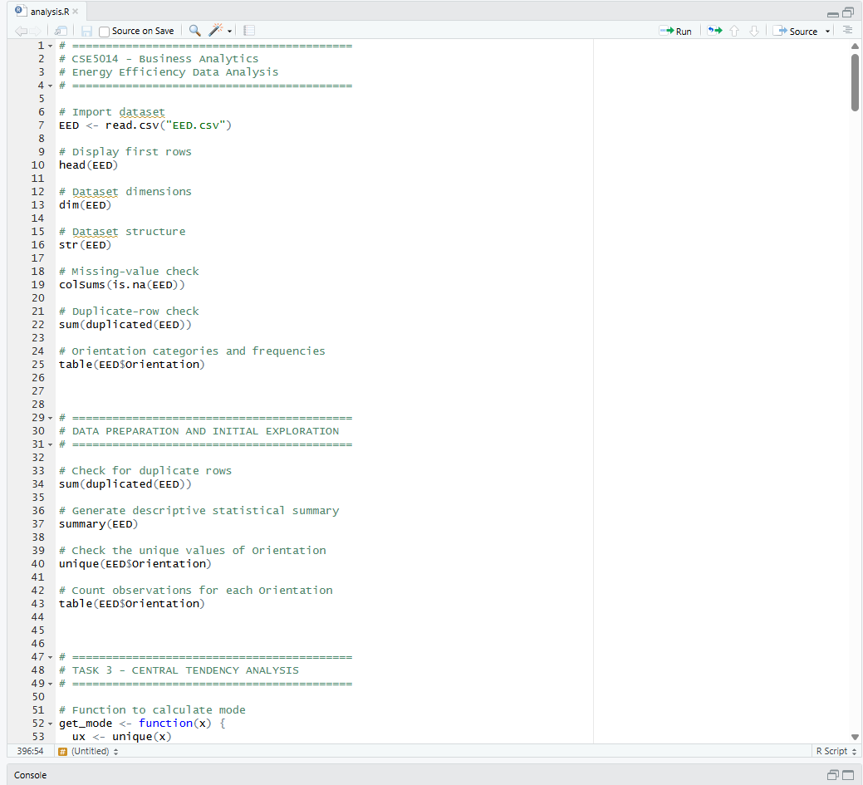
Figure 23 analysis script used for dataset preparation and statistical analysis

Appendix B – Dataset Inspection and Data Quality Evidence
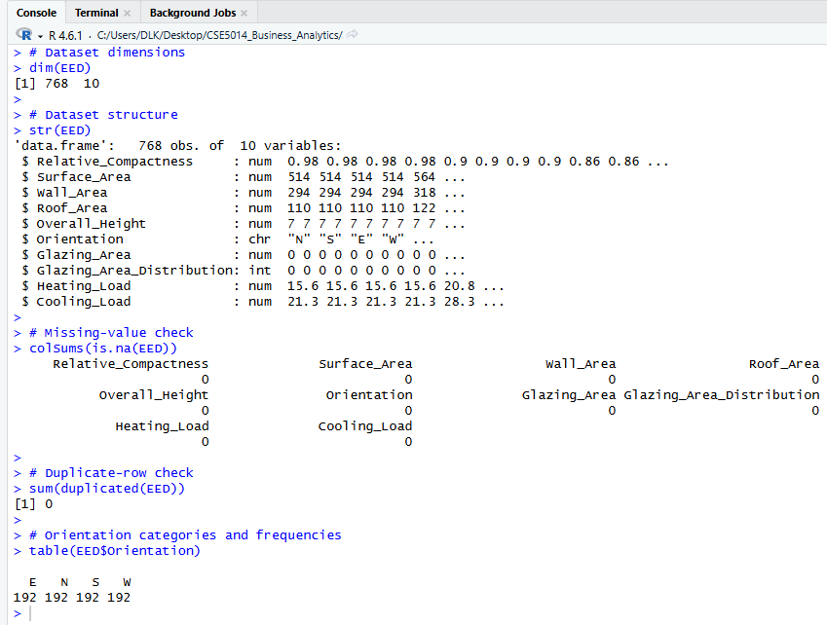
Figure 24 Dataset structure, missing-value and duplicate inspection, and orientation frequencies

Appendix C – Central Tendency Analysis
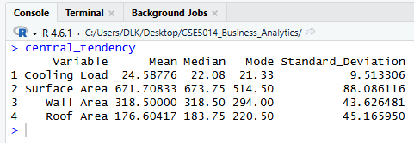
Figure 25 R output for central tendency and variability statistics

Appendix D – Distribution and Normality Analysis
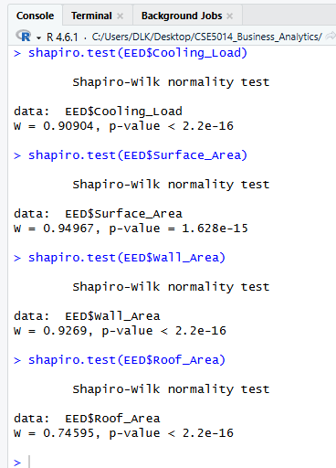
Figure 26 Shapiro-Wilk normality test results for selected numerical variables

Appendix E – Orientation Analysis
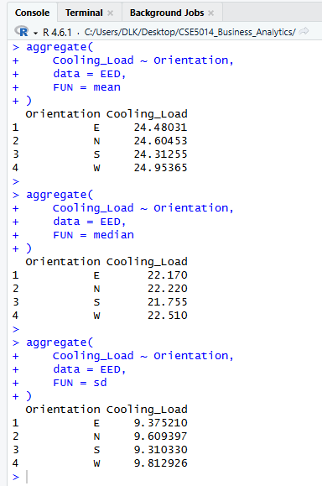
Figure 27 Orientation descriptive statistics

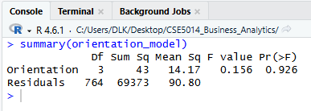
Figure 28 ANOVA output

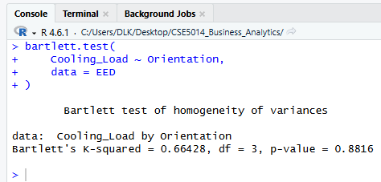
Figure 29 Bartlett's test

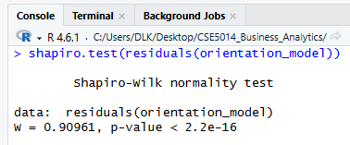
Figure 30 Shapiro-Wilk residual test

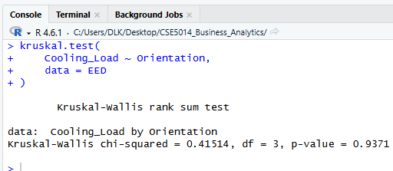
Figure 31 Kruskal-Wallis test

Appendix F – Correlation Analysis

Surface Area
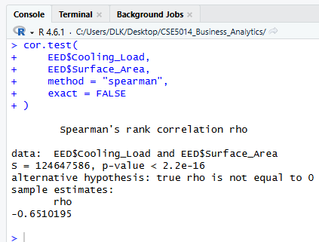
Figure 32 Spearman correlation between Cooling Load and Surface Area

Wall Area
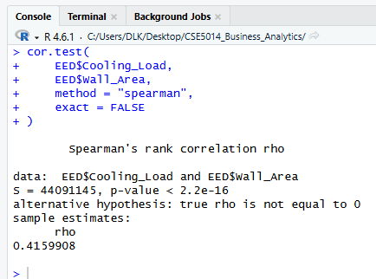
Figure 33 Spearman correlation between Cooling Load and Wall Area

Roof Area
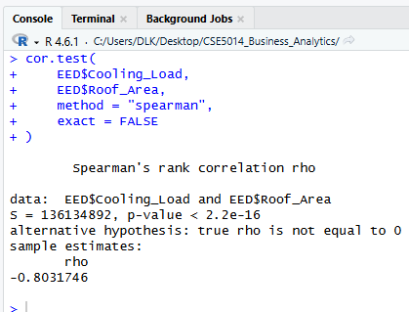
Figure 34 Spearman correlation between Cooling Load and Roof Area

Appendix G – Simple Linear Regression
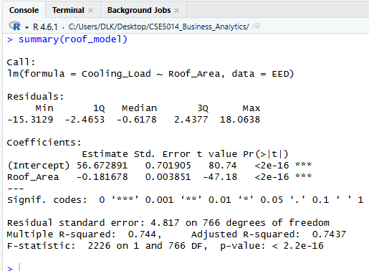
Figure 35 Simple linear regression model summary for Cooling Load and Roof Area

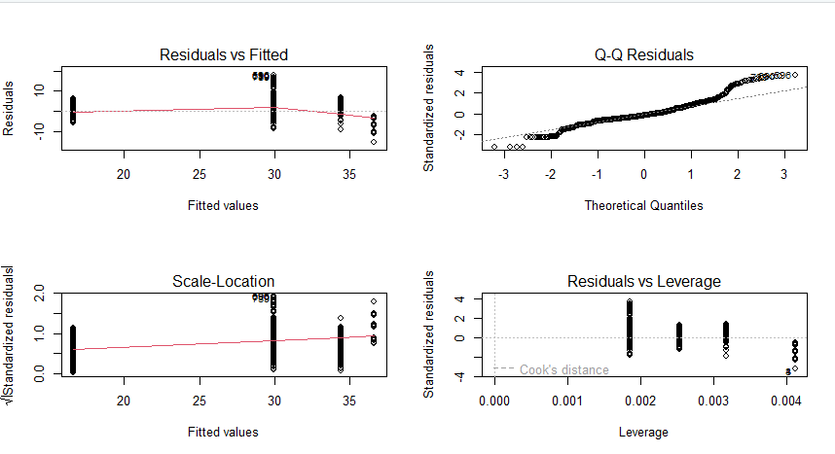
Figure 36 Diagnostic plots for the simple linear regression model

Appendix H – Predictor Correlation and Multicollinearity
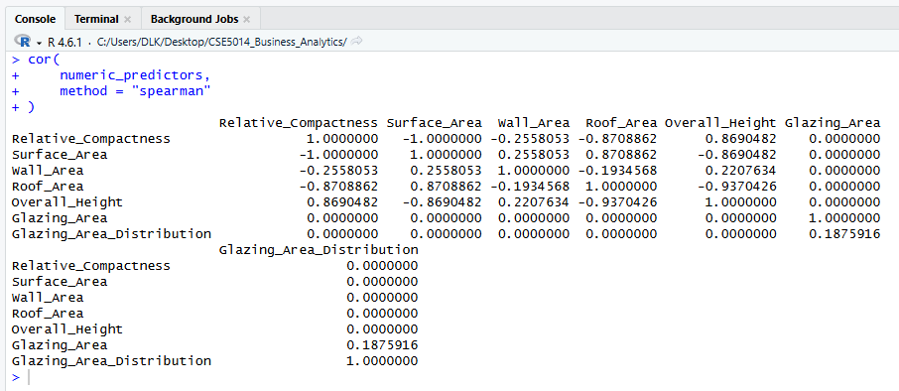
Figure 37 Spearman correlation matrix of numerical predictors

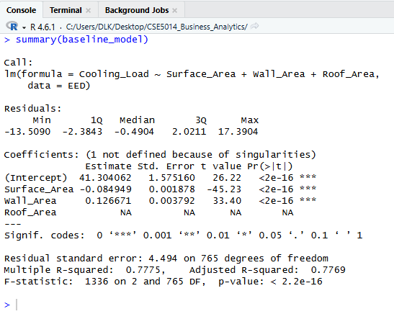
Figure 38 Initial multiple regression model showing the aliased Roof Area coefficient

Appendix I – Final Multiple Regression Model
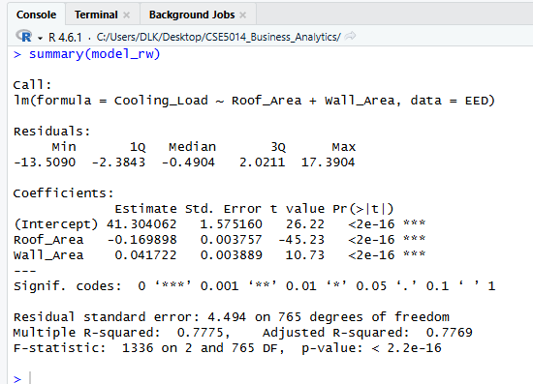
Figure 39 Final multiple regression model using Roof Area and Wall Area

Appendix J – Final Regression Diagnostics
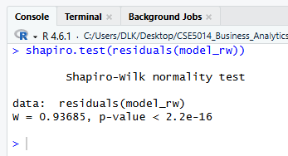
Figure 40 Shapiro-Wilk test of final model residuals
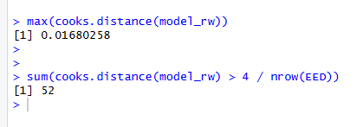
Figure 41 Cook's distance diagnostic results
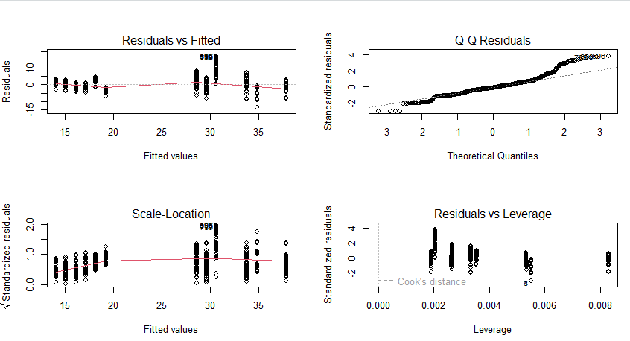
Figure 42 Diagnostic plots for the final multiple regression model

