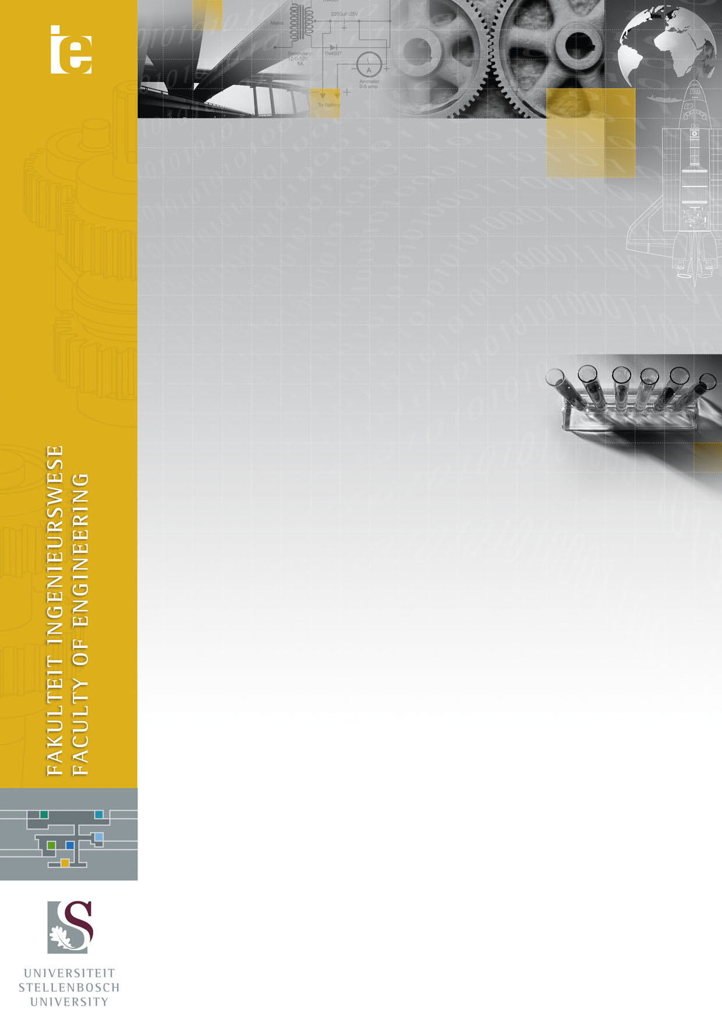
© 2010 Fakulteit Ingenieurswese, Universiteit Stellenbosch

© 2010 Faculty of Engineering, Stellenbosch University
Two-Dimensional, Single Subset based Digital Image Correlation Using the Inverse Compositional Lucas-Kanade Algorithm

Devan Atkinson
17732913

2017

