PROJECT REPORT
HOUSE PRICE PREDICTION
USING MACHINE LEARNING
An Interactive Machine Learning Web Application
Technologies: Python | Pandas | Scikit-learn | Streamlit
GitHub Repository: DevBamba155/House_Price_Prediction

Table of Contents
1. Introduction
2. Problem Statement
3. Objectives
4. Technologies Used
5. Dataset
6. Methodology
7. Machine Learning Model
8. Model Evaluation
9. Web Application
10. Repository Structure
11. Advantages of the Project
12. Limitations
13. Future Scope
14. Conclusion
15. References
Note: Page numbers can be updated after final editing in Microsoft Word.

1. Introduction
House price prediction is a common machine learning problem in which historical housing data is used to estimate the selling price of a property. House prices depend on several factors such as the size of the property, overall quality, number of rooms, garage facilities, basement area, and other property characteristics.
This project develops an interactive House Price Prediction Web Application using Python, Pandas, Scikit-learn, and Streamlit. The application allows users to enter property-related information and receive an estimated house price from a trained machine learning model.
The project uses the Ames Housing Dataset, which contains information about residential properties and their sale prices.

2. Problem Statement
Determining an appropriate house price can be difficult because property prices are affected by many different factors. Manual estimation may not consistently consider all these factors.
The objective of this project is to develop a machine learning system that can analyze historical housing data and predict the approximate selling price of a house based on its characteristics.

3. Objectives
- To study and preprocess housing data.
- To identify important features affecting house prices.
- To develop a machine learning regression model.
- To train a Random Forest Regressor for house price prediction.
- To evaluate the model using appropriate regression metrics.
- To develop an interactive web interface using Streamlit.
- To allow users to obtain predictions by entering property details.
- To demonstrate an end-to-end machine learning application.

4. Technologies Used
Technology | Purpose
Python | Main programming language
Pandas | Data manipulation and analysis
Scikit-learn | Machine learning and model evaluation
Streamlit | Web application interface
Matplotlib / Seaborn | Data visualization and analysis
Pickle | Saving the trained model
GitHub | Source-code management and project hosting

5. Dataset
The project uses the Ames Housing Dataset, a commonly used dataset for house-price prediction. It contains numerous characteristics describing residential properties.
Examples of features used in the project include:
- Overall property quality
- Living area
- Lot size
- Garage characteristics
- Basement dimensions
- Number of rooms
- Other property-related attributes
The target variable is the Sale Price, which represents the selling price of the house.
The repository contains the following dataset files:
data/
├── train.csv
├── test.csv
└── submission.csv

6. Methodology
The project follows a typical machine learning workflow:
Housing Dataset
↓
Data Cleaning
↓
Data Preprocessing
↓
Feature Engineering
↓
Feature Selection
↓
Train-Test Data
↓
Random Forest Regressor
↓
Model Evaluation
↓
Save Trained Model
↓
Streamlit Web Application
↓
House Price Prediction

6.1 Data Collection
The Ames Housing Dataset is used as the source of historical housing information.

6.2 Data Preprocessing
The housing data is prepared before training the model. This stage may include handling missing values, converting variables into a suitable format, selecting relevant features, and preparing the final feature set.

6.3 Feature Selection
Relevant property characteristics are selected as inputs for the prediction model. Examples include property quality, living area, lot size, garage information, basement dimensions, and room counts.

6.4 Model Training
A Random Forest Regressor is used for prediction. Random Forest is an ensemble machine learning algorithm that combines predictions from multiple decision trees. It can model non-linear relationships between property characteristics and house prices.

6.5 Model Evaluation
The model is evaluated using Mean Absolute Error (MAE), Root Mean Squared Error (RMSE), and R² Score. These metrics help measure how closely the predicted prices match the actual prices.

7. Machine Learning Model

7.1 Random Forest Regressor
The main prediction model used in this project is the Random Forest Regressor from Scikit-learn.
Instead of relying on a single decision tree, Random Forest builds multiple decision trees and combines their predictions. This allows the model to capture more complex relationships within the data.
For this project, the model receives property characteristics as input and produces an estimated sale price as output.
Example input features:
- Overall Quality
- Living Area
- Lot Area
- Garage Information
- Basement Area
- Number of Rooms
Output:
Predicted House Sale Price

8. Model Evaluation

8.1 Mean Absolute Error (MAE)
MAE measures the average absolute difference between the actual and predicted prices. A lower MAE indicates that predictions are, on average, closer to the actual values.

8.2 Root Mean Squared Error (RMSE)
RMSE measures prediction errors while giving greater weight to larger errors. A lower RMSE indicates fewer or smaller large prediction errors.

8.3 R² Score
R² indicates how much of the variation in the target variable is explained by the model. A value closer to 1 generally indicates that the model explains more of the variation in the data.

8.4 Results
Metric | Result
R² Score | 0.84-0.86
Note: The evaluation values should be taken directly from the actual model-training/evaluation output. No values have been assumed in this report.

9. Web Application
The trained model is integrated into a Streamlit web application. The application provides an interactive interface where users can enter property characteristics instead of directly interacting with Python code.
The basic prediction process is:
User enters property details
↓
Streamlit collects inputs
↓
Inputs are preprocessed
↓
Saved Random Forest model
↓
Prediction generated
↓
Estimated house price displayed
The application also provides visualizations and basic analysis of the housing data.

10. Repository Structure
House_Price_Prediction/
│
├── data/
│ ├── train.csv
│ ├── test.csv
│ └── submission.csv
│
├── models/
│ ├── house_price_model.pkl
│ └── model_columns.pkl
│
├── src/
│ └── preprocessing.py
│
├── app.py
├── requirements.txt
└── README.md

10.1 File Description
- app.py — Contains the Streamlit web application.
- preprocessing.py — Handles data preprocessing, feature engineering and model-training-related operations.
- house_price_model.pkl — Contains the trained machine learning model.
- model_columns.pkl — Stores the feature-column information required when making predictions.
- requirements.txt — Contains the Python packages required to run the project.
- README.md — Provides project documentation and setup instructions.

11. Advantages of the Project
- Provides an automated method for estimating house prices.
- Uses multiple property characteristics instead of relying on a single factor.
- Demonstrates a complete machine learning workflow.
- Provides an interactive user interface through Streamlit.
- Separates the trained model from the web application.
- Can be run locally and potentially deployed online.

12. Limitations
- Predictions depend on the quality and representativeness of the training dataset.
- The Ames Housing Dataset represents a particular housing market and may not directly represent other locations.
- Predicted prices should be treated as estimates rather than guaranteed market prices.
- Housing prices can be affected by factors that are not present in the dataset, such as current market conditions, exact location, economic conditions, and changes in buyer demand.
- Model performance depends on the selected features and preprocessing methodology.

13. Future Scope
- Hyperparameter tuning can be performed to optimize the Random Forest model.
- Other algorithms such as Gradient Boosting, XGBoost, or other regression models can be compared.
- Additional relevant housing and location features could be incorporated.
- The application could be deployed as a publicly accessible web application.
- More advanced visualizations could be added.
- Model monitoring could be introduced to track prediction performance after deployment.
- The application could provide additional information such as feature importance and prediction explanations.

14. Conclusion
This project demonstrates the development of an end-to-end machine learning application for house price prediction. The project starts with housing data preprocessing and feature preparation, followed by training a Random Forest regression model and evaluating its performance using MAE, RMSE, and R² Score.
The trained model is integrated into a Streamlit web application, allowing users to enter property characteristics and obtain an estimated house price through an interactive interface.
Overall, the project demonstrates the practical application of Python, data preprocessing, machine learning, model evaluation, and web application development in a single project.

15. Screenshots of The Project:
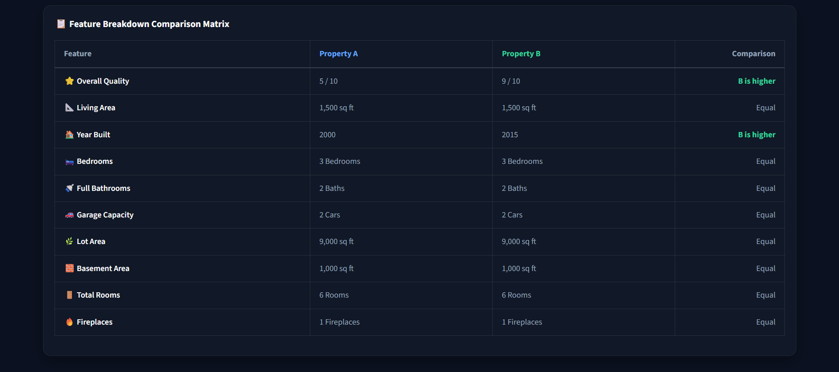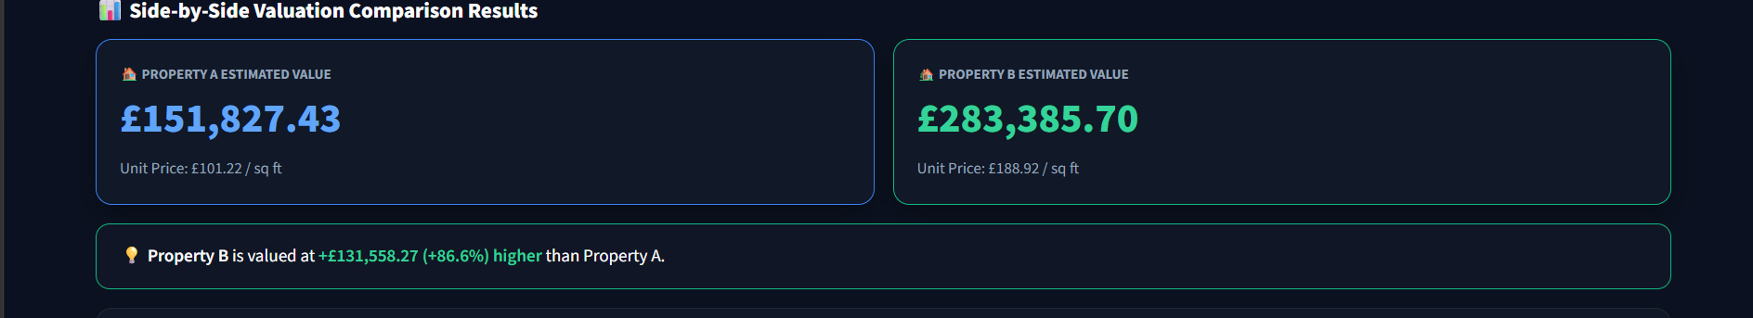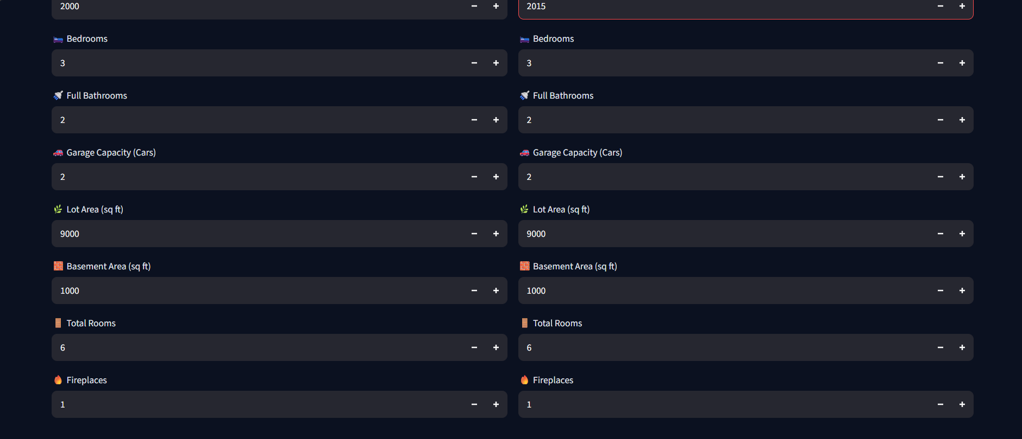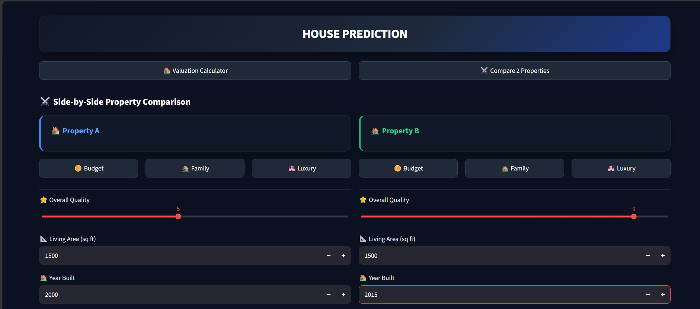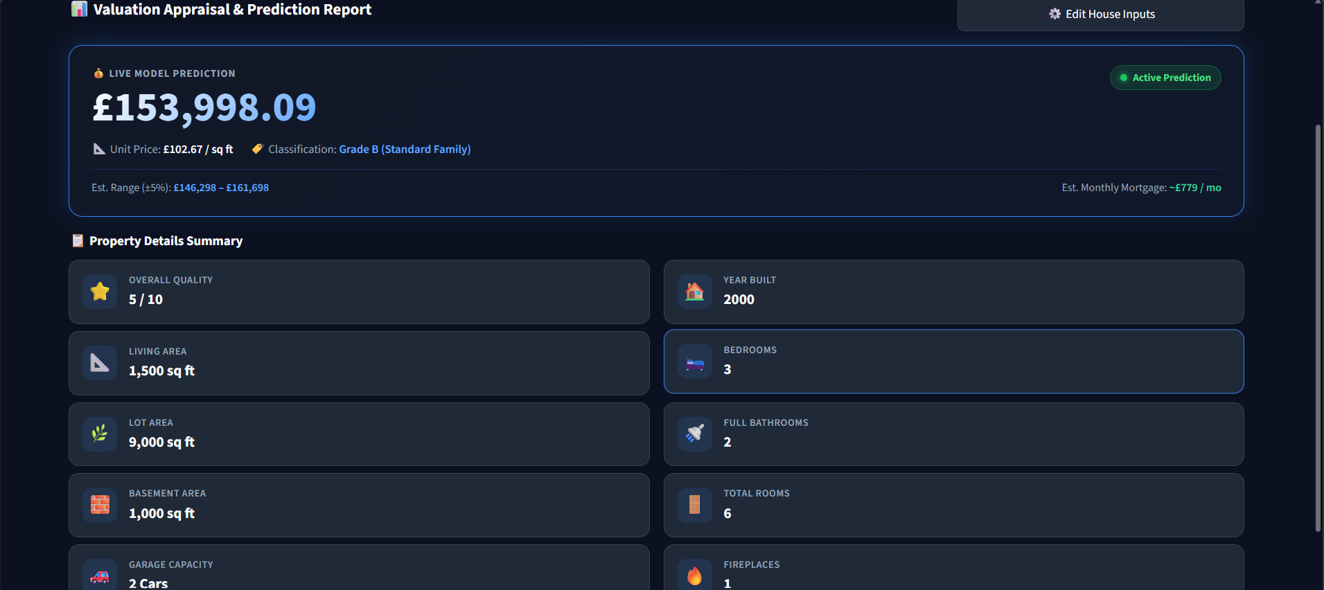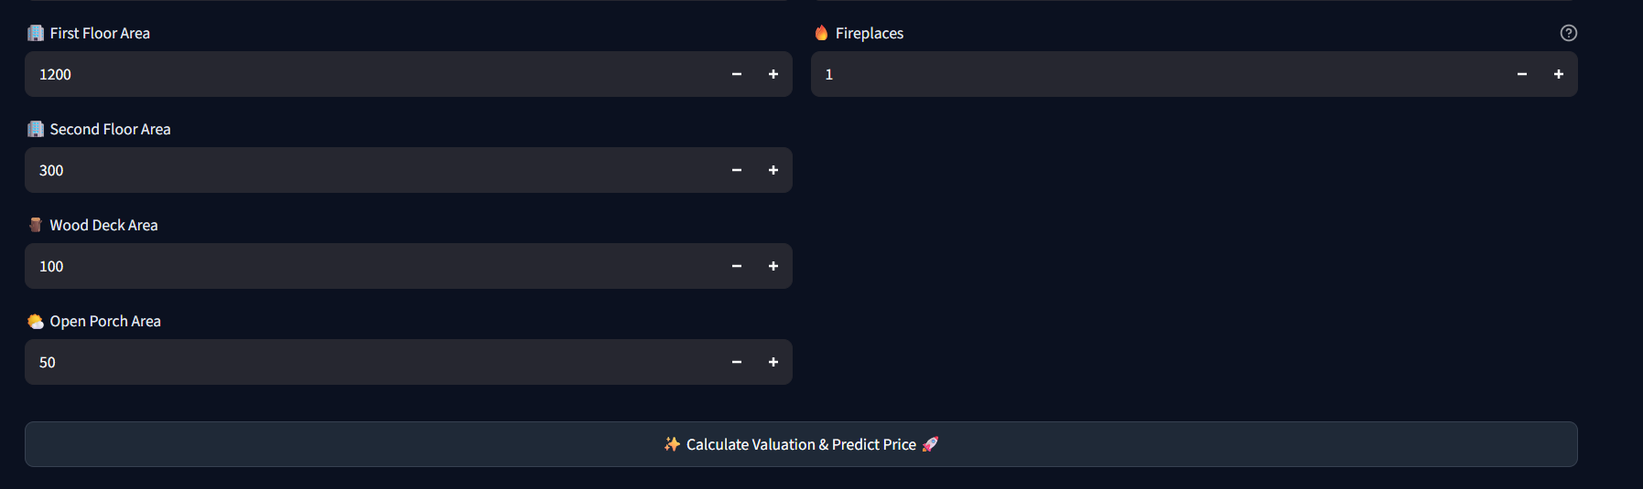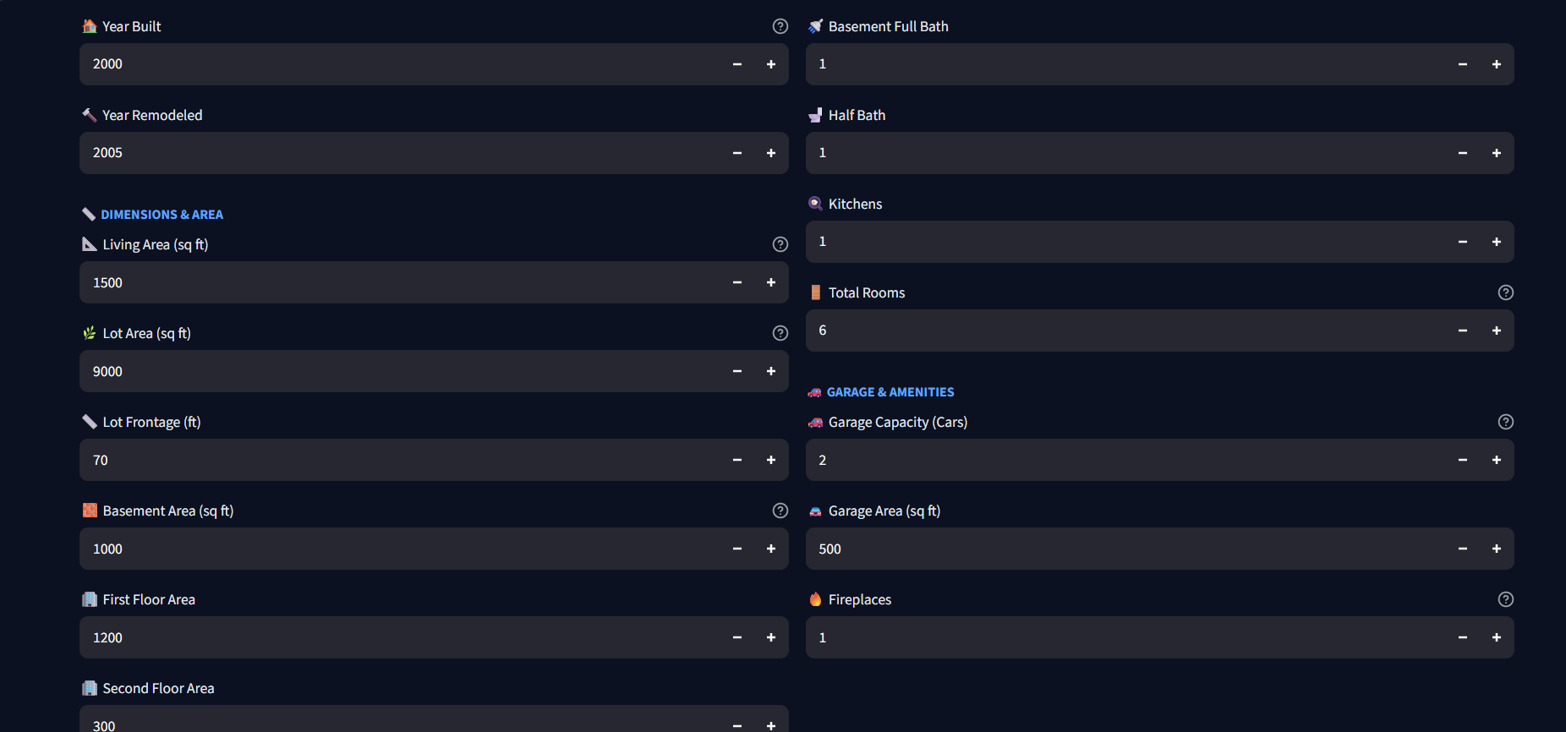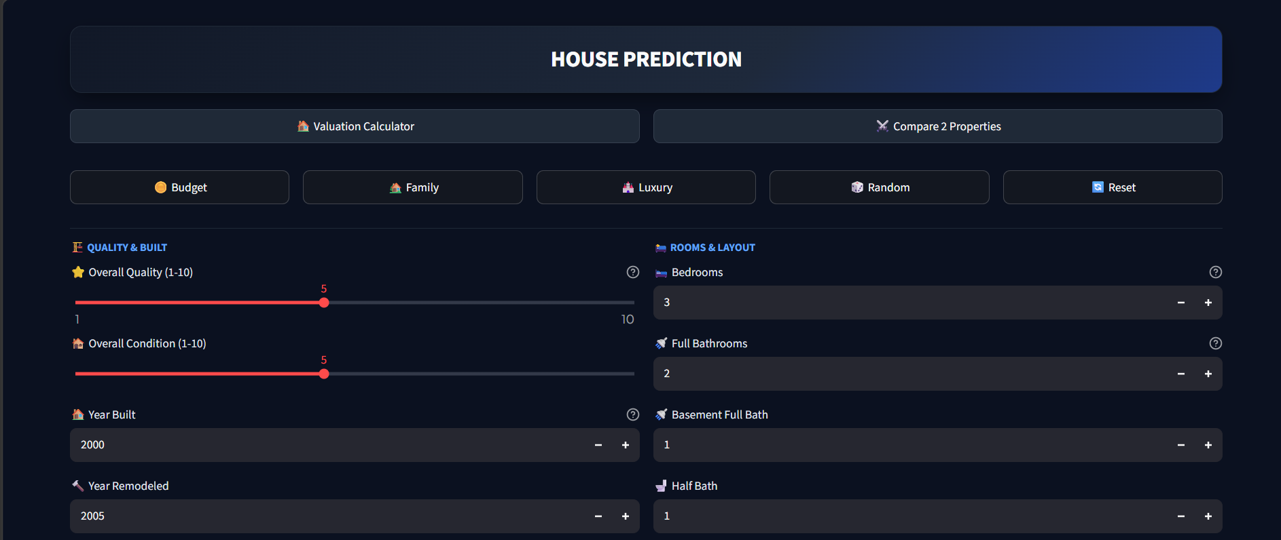

16. References
- Python Documentation — https://docs.python.org/
- Pandas Documentation — https://pandas.pydata.org/docs/
- Scikit-learn Documentation — https://scikit-learn.org/
- Streamlit Documentation — https://docs.streamlit.io/
- Kaggle — Ames Housing / House Prices dataset resources — https://www.kaggle.com/
- GitHub Repository — https://github.com/DevBamba155/House_Price_Prediction

