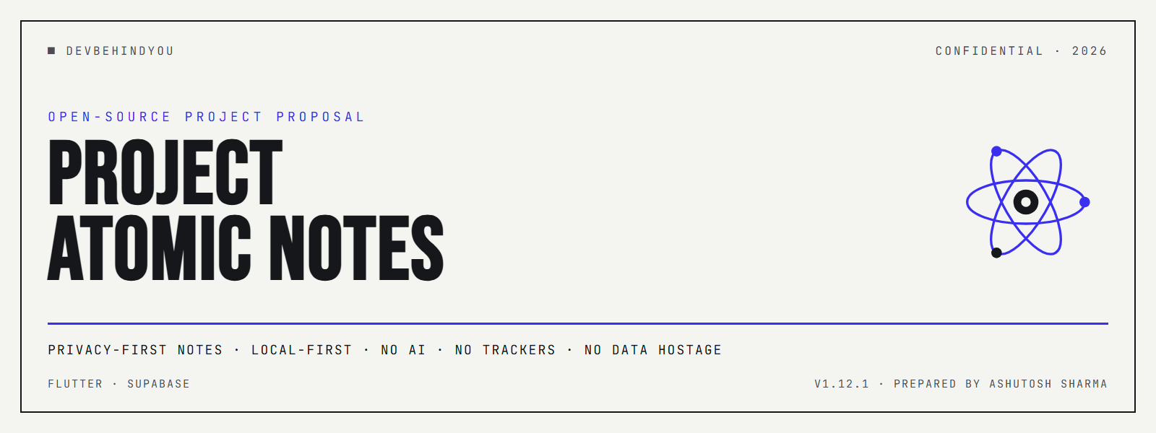
A complete proposal for a privacy-first, local-first notes app.
Prepared by Ashutosh Sharma (DevBehindYou) · 2026 · Version 1.12.1
Confidential. Shared for evaluation and mission-aligned support.
CONTENTS
01 Executive summary 02 The problem 03 The product 04 Why now 05 Differentiation 06 Business model & sustainability 07 What we deliberately rejected 08 Technology & security 09 Status & traction 10 Roadmap & future scope 11 How to support & partner 12 Risks & honest disclosures 13 Team & contact

01 Executive summary
Atomic Notes is a local-first notes app that refuses the deal the rest of the category quietly made: hand over your private text for a free app, and let it be read, profiled, and fed into AI training.
It runs on a Flutter client with a Supabase backend, stores every note on your device first, and syncs to the cloud only when you choose. There is no AI, no analytics, no ad SDK, and no third-party tracker in the shipped app. The business model is designed so that reading your notes can never be the incentive.
The project was built roughly three years ago, archived when the economics did not line up, and revived in 2026 with a modern stack and a re-architected sync engine. It is pre-launch and solo-built.
The headline: demand for tools that visibly do not exploit personal data is rising, and Atomic Notes is built from the ground up to prove the claim rather than just make it. What follows covers the product, the timing, the funding model, the paths rejected, the honest state of the security work, and what support would accelerate.

02 The problem: your notes became training data
Over the last few years, “free” in the notes category came to mean “your content is the product.” Terms-of-service updates now routinely reserve the right to use what people write to improve services and train AI models. The shift was quiet, and most users never agreed to it in any way that felt like a choice.
Notes are the most personal text a person creates: passwords they should not have saved, health details, unfinished ideas, private drafts. Turning that into a training corpus is a real cost borne by the user and captured by the vendor. The result is a growing trust deficit, and people increasingly assume their notes are being read. They are often right.
That assumption is the opening. A notes app that can honestly say “we cannot monetize your content, by design” offers what incumbents cannot match without rebuilding their revenue around it.

03 The product
Atomic Notes keeps the surface simple and the guarantees strong. Text notes and checklists are the same object type, so a list is just a note you can tick off. Every keystroke saves on-device instantly, with no spinner and no way to lose work by closing the app or dropping signal. With sync on, changes propagate per note in realtime across devices. An optional biometric lock gates the app, and a plain “Database” screen shows how many notes live on the device versus the cloud. The interface is strict editorial design: ink on paper, one accent color, no noise.
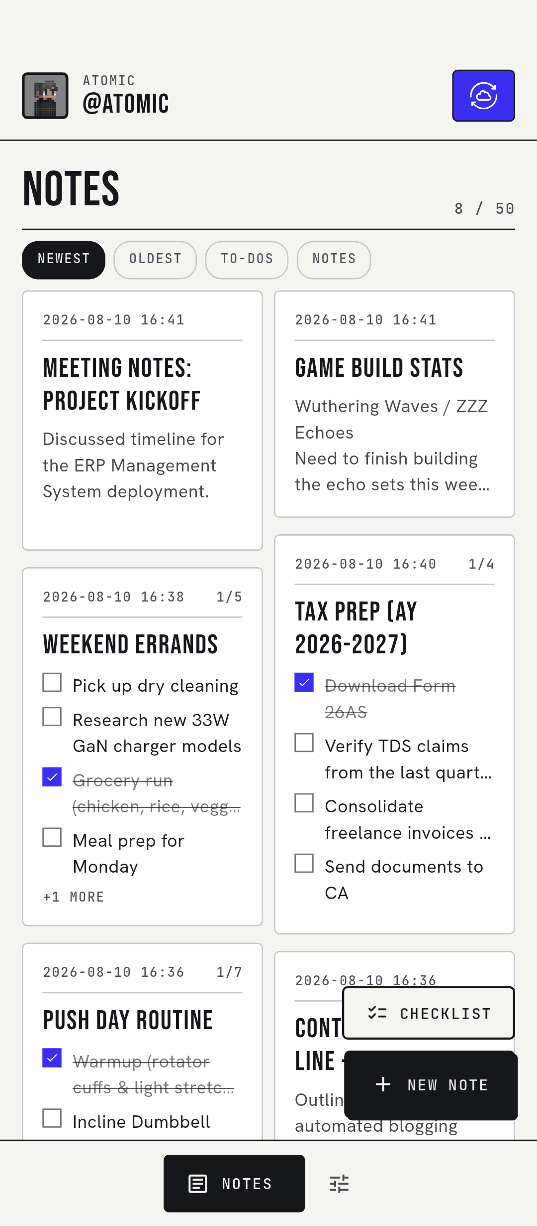 | 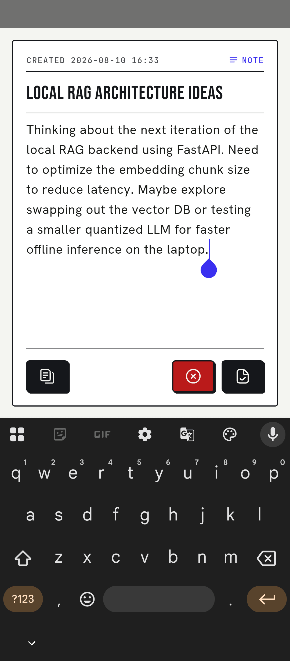 | 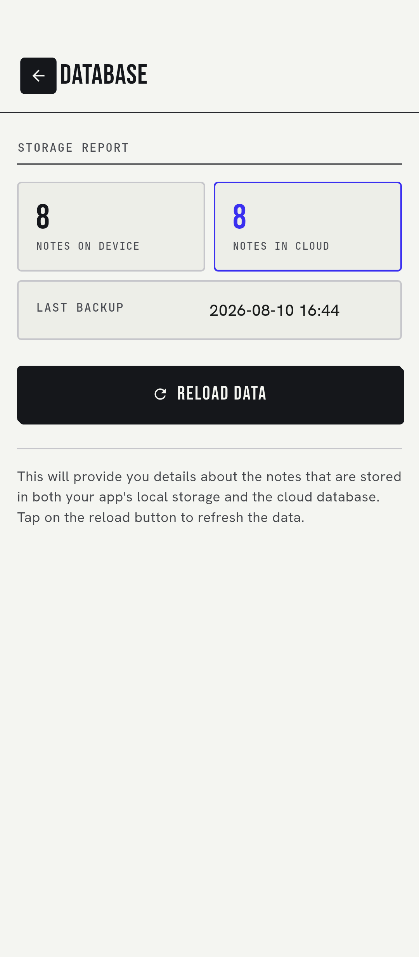
Notes grid · note editor · the Database stats screen. Real screens, Technical Editorial design system.

04 Why now
Three currents make the timing good, and Atomic Notes is positioned to ride all three rather than fight any of them.
- Awareness. AI-training disclosures pushed data practices into mainstream awareness. Privacy is no longer a niche preference; it is a mass-market expectation, and users now actively look for tools that opt out of the arrangement.
- Tooling. The tooling finally supports a solo builder shipping a genuinely local-first, cross-platform app. Flutter provides reach, Supabase provides a managed backend where row-level security does the access-control work a custom server used to require, and an actively maintained on-device store handles local persistence.
- Distribution. Distribution is opening up. Sideloading, alternative stores, and the slow move away from a single gatekeeper mean a small team can reach users without paying a platform's entry toll.

05 Differentiation
The difference is structural, not cosmetic. The comparison below is the pitch in one view.
TYPICAL “FREE” NOTES APP | ATOMIC NOTES
Content used to improve services and train AI | No AI in the app; notes are never training data
Analytics and crash SDKs profile behavior | Zero telemetry shipped
Ad SDKs read context to target you | No ad SDKs in the app today
Cloud-first; their servers hold the primary copy | Local-first; your device holds the primary copy
Subscription funnels and lock-in | Free; funded by optional ads that buy sync speed
These are not features a competitor can toggle on next quarter. They are consequences of an architecture and a business model chosen so that reading your notes is never the incentive.

06 Business model & sustainability
Atomic Notes stays free. Cloud infrastructure does not, so the plan funds it in two honest ways.
The first is the Atomic Coin system, an opt-in, gamified rewarded-ad economy. It is on the roadmap and is not built yet. A user who wants faster sync can watch a rewarded ad to earn particles that form an Atom, and Atoms that mint a Coin, and a Coin buys one instant sync.
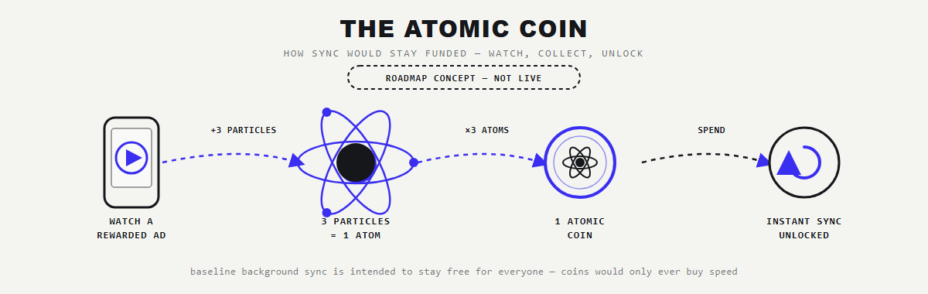
The Atomic Coin flow. Roadmap concept, not live.
The non-negotiable rule: a free, periodic background sync stays free for everyone regardless of coins. Coins only ever buy speed, never the guarantee that a note is saved, and never access to note contents. Ad completions are verified server-side.
The second path is direct support: GitHub Sponsors, Ko-fi, and Open Collective. Users of privacy tools are often willing to fund them directly, and open-source projects earn that goodwill honestly.
ILLUSTRATIVE LEVER | ASSUMPTION | NOTE
Rewarded ad (eCPM) | modest, region-dependent | only for users who opt in
Cost per synced user | low; RLS-scoped Postgres | no custom server to run
Direct support | small recurring base | no ads required
These figures are illustrative assumptions for modeling only, not actuals. The app is pre-launch with no revenue yet. The design goal is a model that covers infrastructure at modest scale and never depends on selling data to survive.

07 What we deliberately rejected
A proposal is only as credible as the options it turned down. An earlier version of this project modeled two conventional paths in real depth, including full written proposals with architecture and financials, and rejected both.
AI-assisted note features (rejected). Summarize, rewrite, generate, billed against usage. Dropped entirely. Adding AI means sending note contents to a model, the exact exposure the app exists to prevent, and the economics only worked on the cheapest tier. The whole point is that no server needs to read your notes.
Paid subscriptions (rejected). Tiered monthly plans. Also dropped. Subscriptions push toward funnel incentives that erode trust, carry roughly a fifteen percent platform commission, and contradict the “free and yours” promise. A separate proposal leaning on both AI and subscriptions was set aside as too much like a data-and-revenue business and not enough like the tool this is meant to be.
Rejecting these was not caution. It was choosing a smaller, cleaner model on purpose, so the product can make a promise it can actually keep.

08 Technology & security
The engineering is deliberately conservative where trust is involved. A single repository object is the source of truth and the sync engine: one row per note, realtime updates, tombstones for deletes, and last-write-wins on a server-set timestamp so a device with a wrong clock cannot win a conflict. Note limits are enforced in the database, not just hidden in the interface. The app launches from its local copy and never blocks on the network.
// merge, without clobbering an edit that has not been pushed yet
if (local.dirty && local.updatedAt.isAfter(remote.updatedAt)) continue;
if (remote.updatedAt.isAfter(local.updatedAt)) {
_notes[remote.id] = remote; // remote is newer, take it
}
On security, this proposal is exact rather than flattering.
Today notes are protected in transit by HTTPS and at rest by Supabase row-level access control. They are not yet end-to-end encrypted. Client-side encryption (AES-256-GCM under a key derived from the user's credentials, so the server stores only ciphertext) is in active development and is the prerequisite for opening the source. An app born from a data breach does not get to overclaim.

09 Status & traction
Atomic Notes is pre-launch and solo-built, and this proposal is honest about it. What exists is real: a working app across the core flows (notes, checklists, per-note sync, biometric lock, stats), a rebuilt sync engine, a full performance pass, a design system, a public showcase site, and CI that produces installable Android artifacts. What does not exist yet is a public release, users, or revenue. The asset today is a credible product and a defensible position, not a growth chart.

10 Roadmap & future scope
The near-term roadmap is ordered by trust first, then reach, then sustainability.
PHASE | FOCUS | STATUS
Now | Client-side end-to-end encryption (AES-256-GCM) and a review of it | In development
Next | Publish the source; first public release via GitHub Releases | Planned
Then | Developer verification; Amazon Appstore listing for ad eligibility | Planned
Later | Atomic Coin system with server-side verification; task and reminder notifications | Concept
Beyond that, the future scope includes wider platform coverage (the codebase already carries iOS and desktop scaffolding), direct support channels, and, only if it can be done without reading user content, optional on-device intelligence that never leaves the device.

11 How to support & partner
This is an open-source proposal, so the ask is framed as backing a mission rather than buying a growth engine. Support accelerates concrete, checkable milestones, and every use of funds maps to a milestone a supporter can verify. That is the same standard the product holds itself to with users.
- Trust milestone. Ship client-side encryption and fund an independent review of it.
- Reach milestone. Register for developer verification and stand up the recognized-store listing that ad funding requires.
- Launch milestone. Cover the first public release and its infrastructure headroom.
Backers can participate through GitHub Sponsors, Ko-fi, or Open Collective, through a small mission-aligned pre-seed for the launch runway, or as collaborators once the source is public.

12 Risks & honest disclosures
- Distribution. Distribution without a major app store is harder and slower, and it depends on channels that are still shifting.
- Revenue. Ad-funded revenue requires a recognized store listing and careful anti-fraud, and it will always be modest by design.
- Key person. A solo builder is a single point of failure until the source is public and others can contribute.
- Security. The encryption commitment is real work that must ship before the strongest claims can be made.
None of these are hidden in this document, because the entire proposition is a project that tells the truth about itself, to its users and to its backers alike.

13 Team & contact
Atomic Notes is built by Ashutosh Sharma under the DevBehindYou brand, working across web development, SEO, and applied AI. The project is intentionally small and intentionally principled, and the plan is to keep it that way even as it opens up to collaborators.
devbehindyou.vercel.app · github.com/DevBehindYou · Medium and X: @devbehindyou
Atomic Notes. Local-first. No tracking. No ads. No AI. Your notes are yours.

