***Practical-2☺***

**Area and Perimeter:**

**Only Printf:**

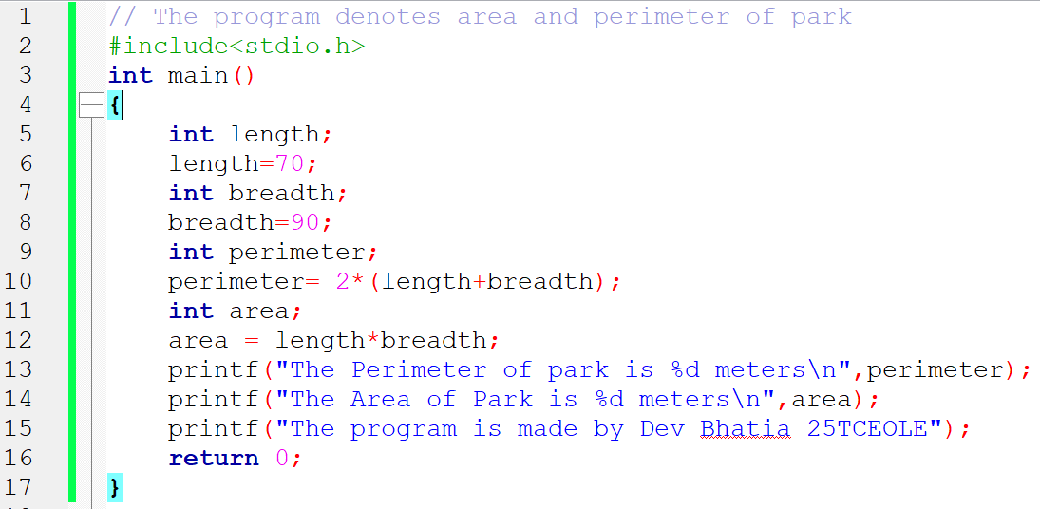

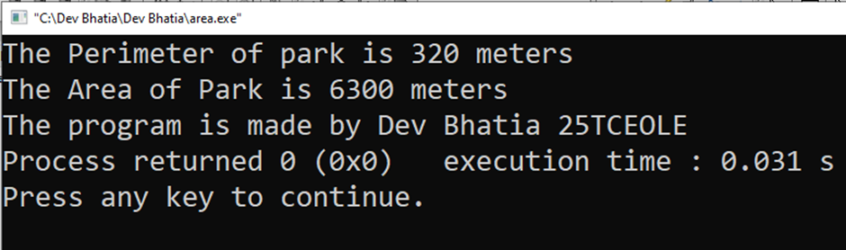

**With Scanf:**

